WORLD METEOROLOGICAL ORGANIZATION  COMMISSION FOR BASIC SYSTEMS  OPAG on DPFS  MEETING OF THE CBS (DPFS) TASK TEAM ON SURFACE VERIFICATION  Geneva, switzerland  20-21 oCTOBER 2014 |  | DPFS/TT-SV/Doc. 4.1e  (16.X.2014)  _______  Agenda item : 4.1  ENGLISH ONLY

Recent activities in surface verification at JMA

(Submitted by Akira Okagaki)

Summary and purpose of document

This document provides a report on the recent activities in surface verification at JMA.

Action Proposed

The meeting is invited to note the information provided in the document.

References:
- Coordination group on forecast verification (CG-FV), READING, UK, 15-17 May 2012 : Final Report
http://www.wmo.int/pages/prog/www/CBS-Reports/documents/CG-FV_Final-Report_May2012.pdf
- Haiden, T., M.J. Rodwell, D.S. Richardson, A. Okagaki, T. Robinson and T. Hewson, 2012 : Intercomparison of global model precipitation forecast skill in 2010/11 using the SEEPS score. ECMWF Tech. Memo., 665, 23p

1. Introduction

This document describes recent activities in surface verification at JMA. Some recommendations for standard procedures are also included.

2. Verification of surface temperature and wind

JMA upgraded its global model on 18 March 2014. The upgrade includes enhancement of the vertical resolution from 60 to 100 and revision of several physical processes. Figure 1 shows an example of verification result for surface temperature using the SYNOP observations. Monthly mean of forecast error at each station are plotted. The old model (CNTL; JMA operational global model as of June 2013) shows high temperature bias in wide area of night time region. The new model (TEST) mitigates the bias, and the improvement is clear in north east asia. The mitigation of biases was originated from revision of stable boundary layer scheme.

Figure 2 shows the time series of the monthly mean error for surface wind speed of JMA operational meso-scale model (MSM), verified using domestic observation network. Diurnal variations are also shown along the longitudinal axis. It is shown that the ME shows negative bias on daytime and positive bias on night time, with seasonal variation in which negative bias get clear during summer period. We have not identified the mechanism of such variations.

As shown above, diurnal oscillations account for a certain portion of forecast error for surface temperature / wind speed. It is expected that verifying such parameters at several times in a day provides us insights into problematic points of NWP models. Thus, it is preferable that forecast steps for verification is 6 hourly. 12 hourly could be applied as mandatory if 6 hourly is difficult for some centres. We also found that scores for each station help us to understand the characteristics of forecast error (Figure 1).

In summary, we recommend;
- Forecast steps for verification should be 6 hourly. If 6 hourly is difficult for some centres, 12 hourly should be applied as mandatory.
- Scores for each station should be exchanged. (see also 4.)

3. Verification of precipitation; SEEPS

Since precipitation is one of the most interested parameters among NWP users, it is desired that standard procedures include verification of the precipitation. SEEPS has the benefit that one does not have to decide thresholds. If SEEPS is difficult to be implemented at each centre, traditional contingency table scores (Threat score / Bias score) with the simple threshold (e.g. 1mm/24hour) may be enough to first step.

The work aimed at routinely computation of the SEEPS is in progress at JMA. Preliminary results are shown in Figure 3 and Figure 4.

In summary, we recommend;
- Precipitation should be included in standard verification parameters.
- SEEPS, or TS and BI with threshold 1mm/24hour, could be first step.

4. Sensitivity of verification results to differences in observation usage between centres

In the standard procedures for verification of deterministic NWP products using radiosonde observation, each centre should screen poor data. Though it is necessary to exclude such data from statistics, an equality use of samples in verification is not guaranteed. In this context, CG-FV had decided to study sensitivities of verification results to differences in observation usage between centres (CG-FV 2012). ECMWF, UKMO, CMC and JMA took part in the study and exchanged list of stations used in each centre’s verification for specified periods. Though the study intended to verification of upper fields, it is expected that the results are similar to that of surface fields. The result of the study conducted in JMA are briefly presented here.

Figure 5 shows influences of list differences on forecast error RMS of JMA global model for temperature at 850hPa geopotential height. Thick lines show scores for ECMWF, UKMO and JMA using their own list. In the southern hemisphere, the influences of list difference are as much as differences between centres at the beginning of the forecast. In the tropics, scores with each list spread even at 240 hour forecast. Scores using CMC list show large values during forecast period. It was caused by an observation which has unrealistic value and was screened in JMA quality control. The differences are the smallest in the northern hemisphere.

Figure 6 shows time series for number of used data in each centre. For example, differences between thick green line and thin green line come to 10~20%. It means that some observation data used in ECMWF were not received in JMA. Furthermore, the number used in UKMO jumps at a certain day of the period. We might guess some kind of configuration change were done at the day.

It is found that 1) the influences of list difference could be as much as differences between centres depending on the parameter and region, 2) the number of observation data received in each centre could be different and fluctuate. Such differences might make interpretation of the exchanged scores difficult. In dealing with the problems, we propose exchanging scores for each station with no screen at the each centre. This will save exchanged score from get contaminated by poor data, and allow each centre to construct areal mean according to their preferences.

In summary, we recommend;
- Scores for each station should be exchanged with no selection.

5. Estimation of the data volume

The volume of score data exchanged are roughly estimated here.

In the upper air verification frame, data volume sent by JMA are about 16MB per 1 month. It consist of about 1.1E6 lines of a dedicated text format.

The line number of surface verification data are;
- Number of observation station (under conditions that scores for each stations were exchanged) : 5000
- Number of forecast steps (12h,24h,...,240h) : 20
- Number of forecast times (00 and 12UTC) : 2
- Number of parameters (T, Wind, Rain) : 3
- Number of scores (ME, RMSE, MAE, SEEPS) : 3 for T,Wind, 1 for Rain
Total :
5000 x 20 x 2 x (2 x 3 + 1 x 1) ~ 1.4E6.

If we assume that the data volume of 1 line are equal between surface and upper air verification, the data volume exchanged for 1 month are :
16(MB) x 1.4E6 / 1.1E6 ~ 20MB.
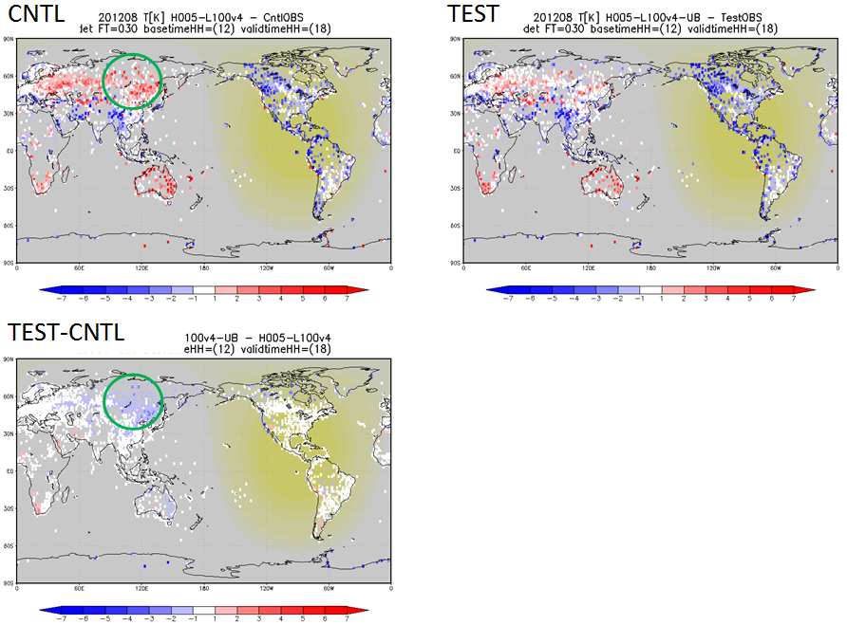
Figure 1. Mean error for surface temperature forecast verified against SYNOP observations. ME are produced during 18UTC of Aug 2012. Two version of JMA global model are compared. CNTL) JMA operational global model as of Jun. 2013. TEST) Same as CNTL but boundary layer scheme are revised. Yellow fill area has incoming solar radiation. TEST – CNTL shows differences of mean error.
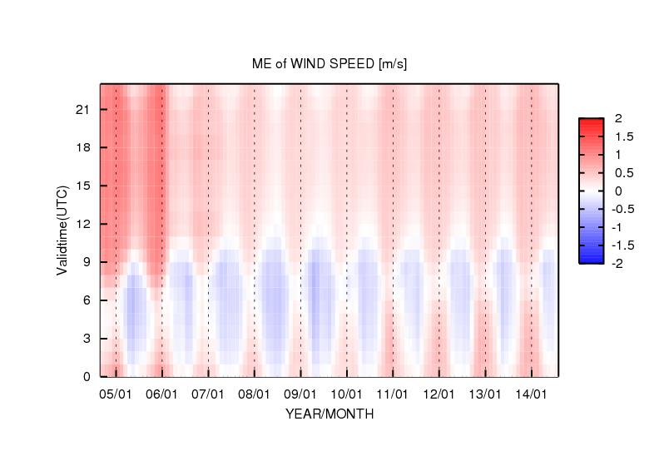
Figure2. Time series of the monthly mean error for surface wind speed of JMA operational meso-scale model (MSM) since 2004 using domestic observation network. Diurnal variations are also shown along the longitudinal axis.
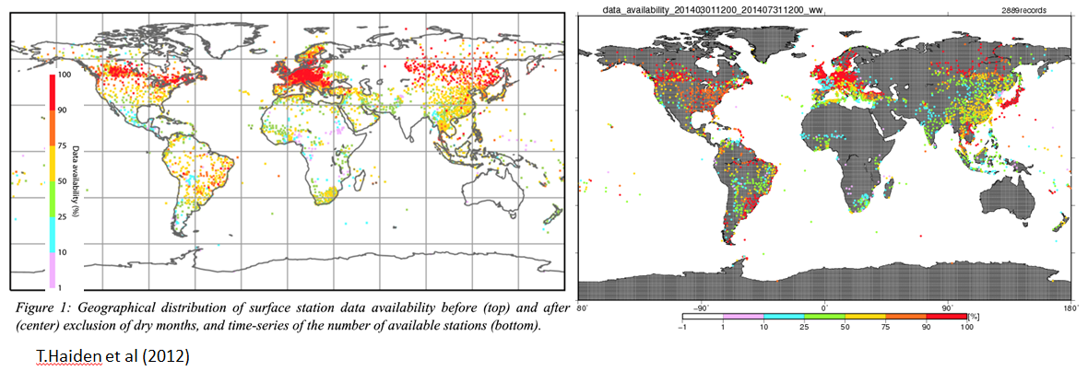
Figure 3. Geographical distribution of surface station data availability (left) at ECMWF from 1 June 2010 to 30 April 2011 (Haiden et.al. 2012), (right) at JMA from 1 March 2014 to 31 July 2014.
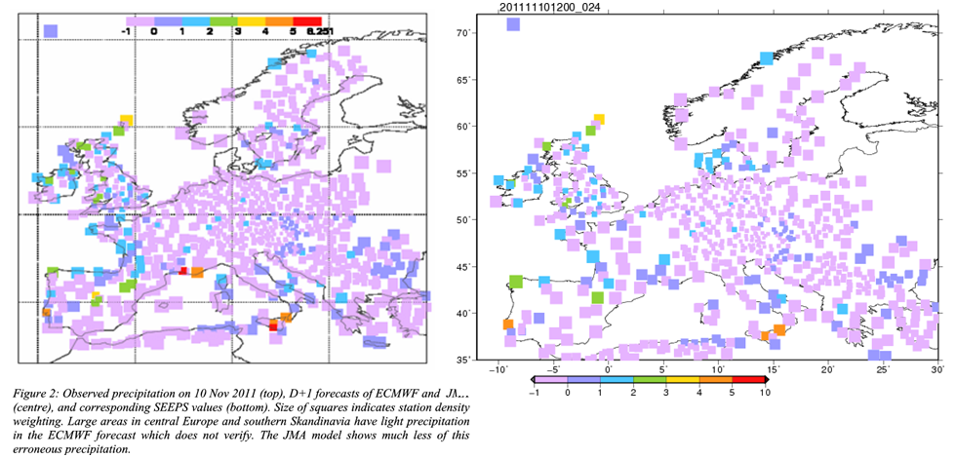
Figure 4. SEEPS of JMA global model forecast for 10 November 2011 at 12UTC. (left) Computed at ECMWF (Haiden, personal communiction), (left) computed at JMA.
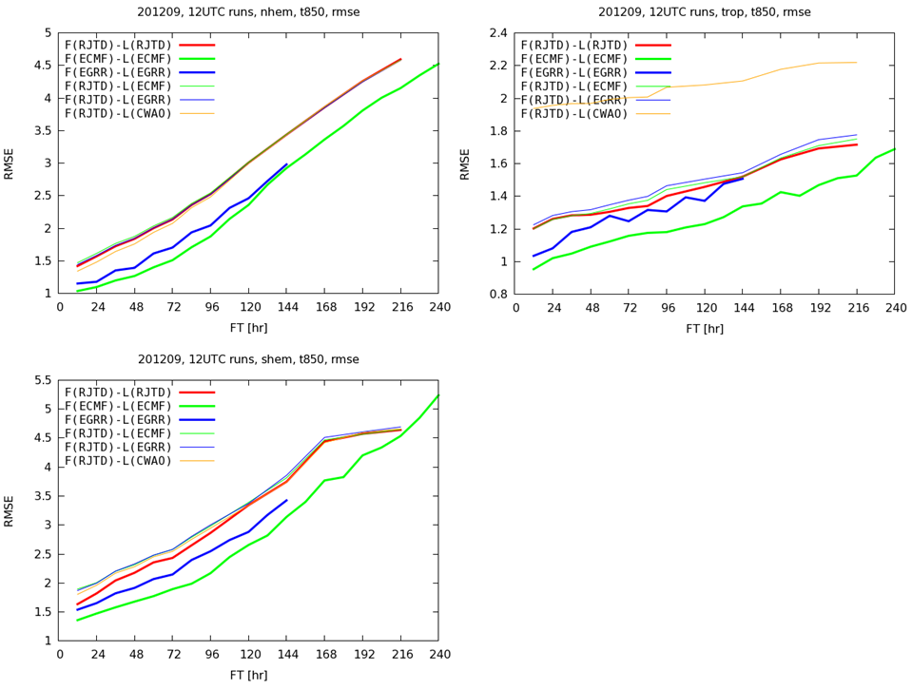
Figure 5. Forecast error RMS temperature at 850hPa geopotential height. Thick lines show scores for each centre which are already exchanged; UKMO(blue), ECMWF(green), CMC(yellow), JMA(red). Thin lines show scores for JMA global model using observation list exchanged for this study, with same colours as thick lines . Upper left) northern hemisphere, Bottom left) southern hemisphere, Upper right) tropics.

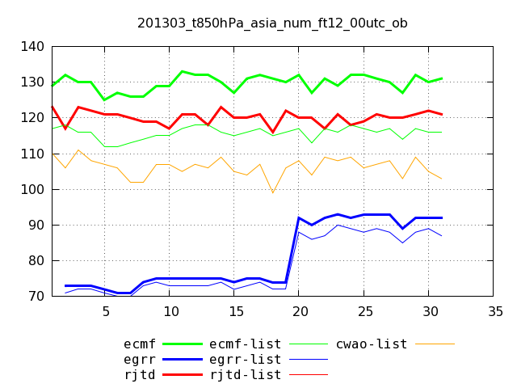
Figure 6. Time series of data number used for verification of temperature at 850hPa in asia region, 00UTC Mar 2013. Line thickness and colours are same as Figure 3.

