WORLD METEOROLOGICAL ORGANIZATION  TECHNICAL-PLANNING WORKSHOP ON SEVERE  WEATHER FORECASTING DEMONSTRATION PROJECT (SWFDP) DEVELOPMENT  FOR THE BAY OF BENGAL REGION  (RA II – SOUTH ASIA)  New Delhi, India, 23-27 January 2012 |  | BB-TPW-SWFDP/Doc. 7.2  (19.I.2012)  _______  Agenda item : 7  ENGLISH ONLY

ACTIVITIES OF REGIONAL SPECIALIZED METEOROLOGICAL CENTRE – TROPICAL CYCLONES, NEW DELHI

1. INTRODUCTION

Regional Specialized Meteorological Centre (RSMC) - Tropical Cyclones, New Delhi, which is co-located with Cyclone Warning Division has the responsibility of issuing Tropical Weather Outlook and Tropical Cyclone Advisories for the benefit of the countries in the World Meteorological Organization (WMO)/ Economic and Social Co-operation for Asia and the Pacific (ESCAP) Panel region bordering the Bay of Bengal and the Arabian Sea, namely, Bangladesh, Maldives, Myanmar, Pakistan, Sultanate of Oman, Sri Lanka and Thailand. It has also the responsibilities as a Tropical Cyclone Advisory Centre (TCAC) to provide Tropical Cyclone Advisories to the designated International Airports as per requirement of International Civil Aviation Organization (ICAO).

The broad functions of RSMC- Tropical Cyclones, New Delhi are as follows:

● Round the clock watch on weather situations over the entire north Indian Ocean.
● Analysis and processing of global meteorological data for diagnostic and prediction purposes.
● Detection, tracking and prediction of cyclonic disturbances in the Bay of Bengal and the Arabian Sea.
● Running of numerical weather prediction models for tropical cyclone track and storm surge predictions.
● Interaction with National Disaster Management Authority and National Disaster Management, Ministry of Home Affairs, Govt. of India to provide timely information and warnings for emergency support services. RSMC-New Delhi also coordinates with National Institute of Disaster Management (NIDM) for sharing the information related to cyclone warning.
● Implementation of the Regional Cyclone Operational Plan of WMO/ESCAP Panel.
● Issue of Tropical Weather Outlook and Tropical Cyclone Advisories to the Panel countries in general.
● Issue of Tropical Cyclone advisories to International airports in the neighbouring countries for International aviation.
● Collection, processing and archival of all data pertaining to cyclonic disturbances viz. wind, storm surge, pressure, rainfall, damage report, satellite and Radar derived information etc. and their exchange with Panel member countries.
● Preparation of comprehensive annual reports on cyclonic disturbances formed over North Indian Ocean every year.
● Preparation of annual review report on various activities including meteorological, hydrological and disaster preparedness and prevention activities of panel member countries.
● Research on storm surge, track and intensity prediction techniques.

2 Area of Responsibility

The area of responsibility of RSMC- New Delhi covers Sea areas of north Indian Ocean north of equator between 45⁰ E and 100⁰ E and includes the member countries of WMO/ESCAP Panel on Tropical Cyclones viz, Bangladesh, India, Maldives, Myanmar, Pakistan, Sri Lanka, Sultanate of Oman and Thailand as shown in Fig. 1.1.
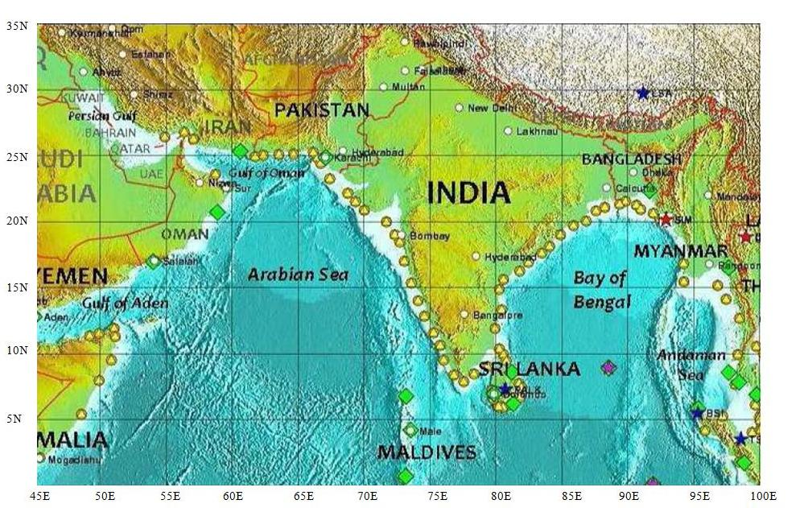

Fig. 1.1 Area of responsibility of RSMC- Tropical Cyclone, New Delhi

3 Naming of tropical cyclones over north Indian Ocean:

The WMO/ESCAP Panel on Tropical Cyclones at its twenty-seventh Session held in 2000 in Muscat, Sultanate of Oman agreed in principle to assign names to the tropical cyclones in the Bay of Bengal and Arabian Sea. After long deliberations among the member countries, the naming of the tropical cyclones over north Indian Ocean commenced from September 2004. RSMC New Delhi is continuing the naming of Tropical Cyclones formed over North Indian Ocean since October 2004. The first name was ‘ONIL’ which developed over the Arabian Sea (30 September to 03 October, 2004). According to approved principle, a list of 64 names in eight columns has been prepared. The name has been contributed by Panel members. The RSMC tropical cyclones New Delhi gives a tropical cyclone an identification name from the above name list. The Panel member’s name is listed alphabetically country wise in each column. The names are used sequentially column wise. The first name starts from the first row of column one and continues sequentially to the last row in column eight. The identification system covers both the Arabian Sea and the Bay of Bengal. These lists are used sequentially, and they are not rotated every few years as are the Atlantic and Eastern Pacific lists. Out of 64 approved names, 26 names have been utilized till the end of year 2010.

4 Observational System

A brief description of different types of observational network of India Meteorological Department (IMD) and observations collected from networks are given below.

4.1 Surface Observatories

IMD has a good network of surface observatories satisfying the requirement of World Meteorological Organization. There are 559 surface observatories in IMD. The data from these stations are used on real time basis for operational forecasting. Recently a number of moored ocean buoys including Meteorological Buoy (MB), Shallow Water (SW), Deep Sea (DS) and Ocean Thermal (OT) buoys have been deployed over the Indian Sea, under the National Data Buoy Programme (NDBP) of the Ministry of Earth Sciences, Government of India. A number of Automated Weather Stations (AWS) are also in operation along the coast and provide surface observations on hourly basis which are utilized in cyclone monitoring and forecasting.

4.2. Upper Air Observatories

There are at present 62 Pilot Balloon Observatories, 39 Radiosonde/ Radiowind observatories and 01 Radiosonde Observatory. The upper air meteorological data collected all over the country are used on real time basis for operational forecasting.
A Wind Profiler/Radio Acoustics Sounding System has been installed at Pashan, Pune in collaboration with M/S SAMEER, Mumbai and IITM, Pune. The instrument is capable of recording upper air temperature up to 3km and upper wind up to 9 km above Sea level. The performance of the instrument is being monitored.

4.3. Radar

There are 11 S-band radars for Cyclone detection located at Kolkata, Chennai,Visakhapatnam,Machilipatnam,Sriharikota, Paradip, Karaikal, Kochi, Goa, Mumbai and Bhuj. Out of these 11 stations, 6 stations (except Kolkata, Chennai,Visakhapatnam,Machilipatnam,Sriharikota) are using conventional S-band radars. Four nos of S-band Doppler Weather Radars (Meteor 1500 S) imported from M/s Gematronik, Germany were installed,commissioned and made operational at Chennai,Kolkata, Machilipatnam and Visakhapatnam respectively with effect from 22.02.2002.,29.01.2003, 08.12.2004 and 27.07.2006 respectively. One indigenous Doppler Weather Radar developed by Indian Space Research Organization (ISRO) under IMD-ISRO collaboration has also been installed and made operational at SHAR Centre, Sriharikota (Andhra Pradesh) with effect from 9 April,2004. Old conventional Radar at Kolkata was dismentaled and was re-installed at Goa. As the radars at Goa, Mumbai, Paradip, Karaikal, Bhuj and Kochi has become old/obsolete, these radars are under the process of replacement.

IMD is modernizing its observational network in the phased manner. In the first phase, 12 No. Doppler Weather Radar have been procured from M/s Beijing Metstar co. Ltd., China. Out of these, 3 DWRs meant for Goa, Karaikal and Paradip could not be installed at coastal site due to Ministry of Defence objection and these are planned for re-location at inland locations.

2 S-band DWRs procured from M/s BEL, Bangalore have been installed at Mumbai & Bhuj and are likely be commissioned by end of January, 2012. Four DWRs meant for Kochi, Goa, Karaikal and Paradip are under process of procurement.

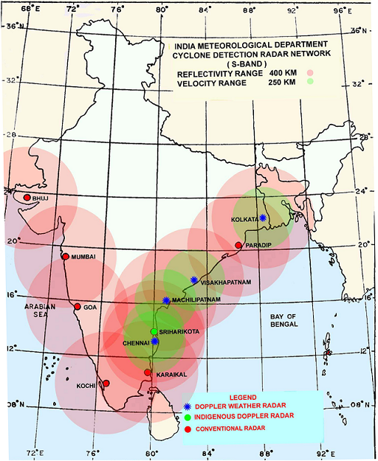
Fig. 1.2. S-Band Cyclone Detection Radar Network

Doppler Weather Radars Provide vital information on radial velocity and spectral width, in addition to reflectivity which is only available from conventional radars. Reflectivity estimates obtained from these radars are more accurate in comparison to those from conventional radars as the Doppler Weather Radars have capability for correcting the values for clutters, bright band etc. Surface Rainfall Intensity (second level product derived from reflectivity) and other hydrological products like Precipitation Accumulation (PAC), Vertical Integrated Liquid (VIL) are very important for issuing warnings for heavy rain, flesh flood and hail. The algorithms for generation of these products employ some adaptable parameters which depends on Drop Size Distribution (DSD) present in the precipitation (DSD is different for different season, geographical location and type of precipitation).

4.4 Satellite Monitoring
4.4.1 Current status:
At present IMD is receiving and processing meteorological data from two Indian satellites namely Kalpana-1 and INSAT-3A. Kalpana-1 was launched on 12th September, 2002 and is located at 74⁰ E. INSAT-3A was launched on 10 April, 2003 and is located at 93.5⁰ E. Kalpana-1 and INSAT-3A both have three channel Very High Resolution Radiometer (VHRR) for imaging the Earth in Visible (0.55-0.75 µm), Infra-Red (10.5-12.5µm) and Water vapour (5.7-7.1µm) channels having resolution of 2X2 km in visible and 8X8 km in Water Vapour (WV) and Infra red (IR) channels. In addition, the INSAT-3A has a three channel Charge Coupled Device (CCD) payload for imaging the earth in Visible (0.62-0.69um), Near IR (0.77-0.86µm) and Short Wave IR (1.55-1.77µm) bands of Spectrum. The Resolution of CCD payload in all the three channels is 1kmX 1 km. At Present about 48 numbers of satellite images are taken daily from Kalpana-1 which is the main operational satellite and 9 images are taken from INSAT-3A. Imaging from CCD is done 5 times during daytime only. All the received data from the satellite are processed and archived in National Satellite Data Centre (NSDC), New Delhi.
Indian Meteorological Data Processing System (IMDPS) is processing meteorological data from INSAT VHRR and CCD data and supports all operational activities of the Satellite Meteorology Division on round the clock basis. Cloud Imagery Data are processed and transmitted to forecasting offices of the IMD as well as to the other users in India and foreign countries.
Apart from generating half hourly cloud imagery, IMDPS produces derived products from the processed data as follows:
- Cloud Motion Vectors (CMV) are derived using three consecutive half hourly images from the operational Kalpana-I Satellite. WVWs are generated at 00, 03, 06, 09, 12, 15 & 18 UTC using IR imagery daily.
- Water Vapour Winds (WVWs) are derived using three consecutive half hourly images from the operational Kalpana-I Satellite. CMV are generated at 00, 03, 06, 09, 12, 15 & 18 UTC using water vapour imageries data.
- Sea Surface Temperatures (SST) are computed at 1⁰ x 1⁰ grid intervals from all Kalpana-I data on half hourly /daily /weekly/monthly basis.
- Outgoing Longwave Radiation (OLR) are computed at 0.25⁰ x 0.25⁰ grid intervals from all Kalpana-I data on half hourly /daily /weekly/monthly basis.
- Quantitative Precipitation Estimation (QPE) is generated at 1⁰ x 1⁰ Grid from Kalpana-1 imagery on half hourly/daily/weekly/monthly basis.
At present Dvorak technique is widely used but manually applied. Recently efforts have been made for automation of this technique. Automated Dvorak technique is running in experimental mode at Synoptic Application Unit, Satellite Meteorology Division.
Satellite Application Unit issues three hourly bulletins in general and hourly and half hourly bulletins in case of tropical cyclones. The unit has modified these bulletins and included the forecast part also since 2009.
The Satellite Meteorology Division updates twelve images on the IMD website every half hour from the VHRR payload. It also updates images of various geophysical products as and when available.
With the Web Archival System developed at IMD KALPANA/INSAT3A data products and imageries are being archived since January 2009. The automatic script is being used to keep and update the images/products on the website upto 2 months. These are available to all users.
On 23rd Sept 09, polar orbiting satellite OCEANSAT–II has been launched by ISRO which carries a ku-Band pencil beam scatterometer to provide ocean surface winds at 10 m ht for early detection of tropical cyclones.
Recently three-ground stations have been installed in New Delhi, Guwahati and Chennai for receiving real time MODIS and NOAA data. The following products are being received regularly:

A) Geophysical Products derived from NOAA

- Atmospheric temperature profile
- Atmospheric water vapour profile
- Surface emmissivity
- Surface Temperature
- Fractional cloud cover
- Cloud Top Temperature
- Cloud Top Pressure
- Tropopause height
- Cloud Liquid Water Content
- Total Column Precipitable Water
- Cloud Type (including Fog)
- Total Ozone from GOME
- Total Ozone from HIRS
- Ozone Profiles
- Land Surface Temperature
- Sea Surface Temperature
- Normalized Difference Vegetation Index (NDVI)
- Fog detection

B) Geophysical Products derived from MODIS
MODIS Level 2 geophysical products (Terra and Aqua)
- MODIS cloud mask (MOD35)
- MODIS cloud top properties (MOD06CT)
- MODIS atmospheric profiles, precipitable water and stability indices (MOD07)
- MODIS aerosol product (MOD04)
- MODIS Sea Surface Temperatures (IMAPP product)
- Normalized Difference Vegetation Index (NDVI)
- Enhance Vegetation Index (EVI)
- Land Surface Temperature (LST)

4.4.2. IPWV measurements by GPS Satellites:
At present five GPS receiving stations are installed at New Delhi, Kolkata, Guwahati, Chennai, and Mumbai for measurements of Integrated Precipitable Water Vapour.

4.4.3. Digital Meteorological Data Dissemination:

IMD transmits processed imagery, meteorological and facsimile weather charts to field forecasting offices distributed over the country using the Digital Meteorological Data Dissemination (DMDD) facility, through INSAT in broadcast mode. The bulletins providing description of the cloud organization and coverage are also sent as advisory to forecasting offices every synoptic hour. When cyclones are detected in satellite imagery, these bulletins are sent every hour. Such advisories are also transmitted to the neighbouring countries.
Processed satellite imagery, analyzed weather charts and conventional synoptic data are up-linked to the satellite in C-band. Satellite broadcasts these data to DMDD receiving stations in S-band. DMDD receiving stations analyze weather imagery and other data to generate required forecast. There are 37 Nos. of DMDD stations installed in India. Three DMDD receiving stations are also operating in neighbouring SAARC countries at Sri Lanka, Nepal and Maldives. These stations are receiving direct broadcast of cloud imagery, weather facsimile charts and meteorological data on an operational basis. The frequency of transmission from ground to satellite (uplink) is 5886 MHz and that of downlink is 2586 MHz.

4.4.4. Future Plan:

Under INSAT-3D programme, a new Geostationary Meteorological Satellite INSAT-3D is being designed by ISRO. It will have an advanced imager with six imagery channels (VIS, SWIR, MIR, TIR-1, TIR-2, & WV) and a nineteen channel sounder (18 IR &1 Visible) for derivation of atmospheric temperature and moisture profiles. It will provide 1 km. resolution imagery in visible band, 4 km resolution in IR band and 8 km in water vapour channel. This new satellite is scheduled for launch in 2010 and will provide much improved capabilities to the meteorological community and users. In preparation for the reception and processing of this data, SAC-ISRO has installed a data reception and processing system to process the data from the INSAT 3A and Kalpana 1 satellites. After full commissioning, the system will be able to receive and process the data from all the above three satellites on real time mode and produce the following products with respect to cyclone monitoring:

- Outgoing Long wave Radiation (OLR)
- Quantitative Precipitation Estimation ( QPE)
- Sea Surface Temperature (SST)
- Cloud Motion Vector (CMV)
- Water Vapor Wind (WVW)
- Upper Tropospheric Humidity (UTH)
- Temperature, Humidity profile
- Value added parameters from sounder products
  - Geo-potential Height
  - Layer Perceptible Water
  - Total Perceptible Water
  - Lifted Index
  - Dry Microburst Index
  - Maximum Vertical Theta-E Differential
  - Wind Index
- Flash Flood Analyzer
- Tropical Cyclone-intensity /position

- Analysis and Prediction

Cloud imageries from Geostationary Meteorological Satellites INSAT-3A and METSAT (KALPANA-1) are the main sources of information for the analysis of tropical cyclones over the data-sparse region of north Indian Ocean. Data from Ocean buoys also provide vital information. Ship observations are also used critically during the cyclonic disturbance period.
The analysis of synoptic observations is performed four times daily at 00, 06, 12, and 18 UTC. During cyclonic disturbance ( depression and above intensity), synoptic charts are prepared and analysed every three hour to monitor the tropical cyclones over the north Indian Ocean.
The direction and speed of the movement of a tropical cyclone are determined primarily from the three hourly displacement vectors of the centre of the system and by analyzing satellite imageries. When the system comes closer to the coastline, the system location and intensity are determined based on hourly observations from CDR and DWR stations as well as from coastal observatories. The AWS stations along coast are also very useful as they provide hourly observations on real time basis. The WVWV and CMV in addition to the conventional wind vectors observed by Radio Wind (RW) instruments are very useful for monitoring and prediction of cyclonic disturbance, especially over the Sea region.

5.1. Modernisation of cyclone analysis and prediction system

Various strategies were adopted for improvement of analysis and prediction of cyclone. The tropical cyclone analysis, prediction and decision-making process was made by blending scientifically based conceptual models, dynamical & statistical models, meteorological datasets, technology and expertise. Conventional observational network, automatic weather stations (AWS), buoy & ship observations, cyclone detection radars and satellites were used for this purpose. A new weather analysis and forecasting system in a digital environment was used to plot and analyse different weather parameters, satellite, Radar and numerical weather prediction (NWP) model products. An integrated fully automated forecasting environment facility was thus set up for this purpose.

The manual synoptic weather forecasting was replaced by hybrid systems in which synoptic method could be overlaid on NWP models supported by modern graphical and GIS applications to produce

- high quality analyses
- Ensemble of forecasts from NWP models at different scales - global, regional and mesoscale
- Prediction of intensity and track of tropical cyclone

A schematic representation of the monitoring and analysis, forecast and warning procedure is given in Fig.1.3.


Action
Synopic
analysis
Users*
End
forecast
Initial conditions (Observations)
Synoptic
Satellite
Radar
Forecaster
NWP Model
Numerical
forecasts
Runs of different Models,
Consecutive runs from the same model,
Ensemble runs ("choosing the best member")
*Central / State Govt/ Media/ Public

Fig.1.3.. Strategy adopted for cyclone analysis and forecasting

The Tropical Cyclone Module installed in this forecasting system has the following facilities.

- Analysis of all synoptic, satellite and NWP model products for genesis, intensity and track monitoring and prediction
- Preparation of past and forecast tracks upto 120 hrs
- Depiction of uncertainty in track forecast

All the available data and products form various national and international sources were systematically considered for analysis and prediction of cyclones. Various data and products utilized for this purpose are as follows.

- Data and analysis Products through digitized system as mentioned above.
- Radar data and products from IMD’s radar network and neighbouring countries
- Satellite imageries and products from IMD and international centres
- Dynamical and statistical Model products from various national and international centres
- Data, analysis and forecast products from various national and international centres through internet

6. NWP Models in operational use during the year 2011

  - Global Forecast System

The Global Forecast System (GFS), adopted from National Centre for Environmental Prediction (NCEP), at T382L64 (~ 35 km in horizontal) resolution (incorporating Global Statistical Interpolation (GSI) scheme as the global data assimilation for the forecast up to 7 days) was implemented at India Meteorological Department (IMD), New Delhi on IBM based High Power Computing Systems (HPCS) in May 2010. Currently, it runs twice in a day (00 UTC and 12 UTC). The upgraded version of the GFS (GSI 3.0.0 and GSM 9.1.0) model at T574L64 (~ 25 km) resolution has been also operated in the experimental mode since 1 June 2011 and real-time outputs are made available to the national web site of IMD (www.imd.gov.in).

6.2. Quasi-Lagrangian Model (QLM)

The QLM, a multilevel fine-mesh primitive equation model with a horizontal resolution of 40 km and 16 sigma levels in the vertical, is being used for tropical cyclone track prediction in IMD. The integration domain consists of 111x111 grid points centred over the initial position of the cyclone. The model includes parameterization of basic physical and dynamical processes associated with the development and movement of a tropical cyclone. The two special attributes of the QLM are: (i) merging of an idealized vortex into the initial analysis to represent a storm in the QLM initial state and (ii) imposition of a steering current over the vortex area with the use of a dipole. The initial fields and lateral boundary conditions from the IMD GFS-382. The model is run twice a day based on 00 UTC and 12 UTC initial conditions to provide 6 hourly track forecasts valid up to 72 hours. The track forecast products are disseminated as a World Weather Watch (WWW) activity of RSMC, New Delhi.

6.3. Regional Forecast System

IMD operationally runs three regional models WRFDA-WRFARW(v3.2), WRF(NMM) and Quasi-Lagrangian Model (QLM) for short-range prediction during cyclone condition.

6.4. Non-hydrostatic mesoscale modeling system WRFDA-WRF-ARW

The mesoscale forecast system Weather Research and Forecast WRFDA (version 3.2) with 3DVAR data assimilation is being operated daily twice to generate mesoscale analysis at 27 km and 9 km horizontal resolutions using IMD GFS-T382L64 analysis/forecast as first guess. Using initial and boundary conditions from the WRFDA, the WRF (ARW) is run for the forecast up to 3 days with double nested configuration with horizontal resolution of 27 km and 9 km and 38 Eta levels in the vertical. The model mother domain covers the area between lat. 25º S to 45º N long 40º E to 120º E and child covers whole India. The performance of the model is found to be reasonably skilful for cyclone genesis and track prediction. At ten other regional centres, very high resolution mesoscale models (WRF at 3 km resolution) are also operational with their respective regional setup/configurations. The latest version of NCEP HWRF is also implemented at IMD for the Indian basins with the assimilation of local observations. The model has the provision for vortex re-location and moving nesting procedure. In this direction action has been already initiated and the model is exceeded to be available in the operational mode by the end of 2011.

6.5. Genesis Potential Parameter (GPP)

A cyclone genesis parameter, termed the genesis potential parameter (GPP), for the North Indian Sea is developed (Kotal et al, 2009). The parameter is deﬁned as the product of four variables, namely vorticity at 850 hPa, middle tropospheric relative humidity, middle tropospheric instability, and the inverse of vertical wind shear. The parameter is operationally used for distinction between non-developing and developing systems at their early development stages. The composite GPP value is found to be around three to ﬁve times greater for developing systems than for non-developing systems. The analysis of the parameter at early development stage of a cyclonic storm found to provide a useful predictive signal for intensiﬁcation of the system.

The grid point analysis and forecast of the genesis parameter up to seven days is also generated on real time (available at http://www.imd.gov.in/section/nhac/dynamic/Analysis.htm). Higher value of the GPP over a region indicates higher potential of genesis over the region. Region with GPP value equal or greater than 30 is found to be high potential zone for cyclogenesis. The analysis of the parameter and its effectiveness during cyclonic disturbances in 2010 affirm its usefulness as a predictive signal (4-5 days in advance) for cyclogenesis over the North Indian Ocean.

6.6. Statistical Dynamical model for Cyclone Intensity Prediction (SCIP)

A statistical-dynamical model (SCIP) (Kotal et al, 2008) has been implemented for real time forecasting of 12 hourly intensity up to 72 hours. The model parameters are derived based on model analysis fields of past cyclones. The parameters selected as predictors are: Initial storm intensity, Intensity changes during past 12 hours, Storm motion speed, Initial storm latitude position, Vertical wind shear averaged along the storm track, Vorticity at 850 hPa, Divergence at 200 hPa and Sea Surface Temperature (SST). For the real-time forecasting, model parameters are derived based on the forecast fields of ECMWF model. The method is found to be promising for the operational use.

6.7. Multi-model ensemble (MME) technique

The multi model ensemble (MME) technique (Kotal and Roy Bhowmik, 2011) is based on a statistical linear regression approach. The predictors selected for the ensemble technique are forecasts latitude and longitude positions at 12-hour interval up to 72-hour of five operational NWP models. In the MME method, forecast latitude and longitude position of the member models are linearly regressed against the observed (track) latitude and longitude position for each forecast time at 12-hours intervals for the forecast up to 72-hour. The outputs at 12 hours forecast intervals of these models are first post-processed using GRIB decoder. The 12 hourly predicted cyclone tracks are then determined from the respective mean sea level pressure fields using a cyclone tracking software. Multiple linear regression technique is used to generate weights (regression coefficients) for each model for each forecast hour (12hr, 24hr, 36 hr, 48hr, 60hr, 72hr) based on the past data. These coefficients are then used as weights for the ensemble forecasts. 12-hourly forecast latitude (LAT^{f}) and longitude (LON^{f}) positions are defined by multiple linear regression technique. In the updated version, MM5 model in the ensemble member is replaced by IMD WRF model. IMD also makes use of NWP products prepared by some other operational NWP Centres like, ECMWF (European Centre for Medium Range Weather Forecasting), GFS (NCEP), JMA (Japan Meteorological Agency), UKMO etc. The MME is developed applying multiple linear regression technique using the member models WRF(ARW), QLM, GFS (NCEP), ECMWF and JMA. All these NWP products are routinely made available on the IMD web site www.imd.gov.in. The MME technique has been implemented from 2009 for real time forecasting of tropical cyclones.

6.8. Storm Surge Model

For the operational storm surge prediction, IMD uses both nomograms developed by IMD and Dynamical Storm Surge Model developed by Indian Institute of Technology (IIT), Delhi. The nomograms are based on the numerical solution to the hydrodynamical equations governing motion of the Sea. The nomograms are prepared relating peak surge with various parameters such as pressure drop, radius of maximum wind, vector motion of the cyclone and offshore bathymetry. The dynamical model of IIT Delhi is fully non-linear and is forced by wind stress and quadratic bottom friction following the method of numerical solution to the vertically integrated mass continuity and momentum equations. The updated version of the model currently in operational use covers an analysis area lying between lat. 2.0⁰ N and 22.25⁰ N and long. 65.0⁰ E & 100.0⁰ E. The method uses a conditionally stable semi-implicit finite difference stair step scheme with staggered grid for numerical solution of the model equation. The bottom stress is computed from the depth-integrated current using conventional quadratic equation. The bathymetry of the model is derived from Naval Hydrographic charts applying cubic spline technique. The storm surge models developed by IIT, Delhi for different Panel member countries have been installed at RSMC, New Delhi. RSMC, New Delhi is providing storm surge guidance to member countries in tropical cyclone advisory bulletin since April, 2009 (with effect from cyclone BIJLI).

7. Products Generated By RSMC, New Delhi

RSMC, New Delhi prepares and disseminates the following bulletins.

7.1. Tropical Weather Outlook

Tropical Weather Outlook is issued daily at 0600 UTC based on 0300 UTC observations in normal weather for use of the member countries of WMO/ESCAP Panel. This contains description of synoptic systems over north Indian Ocean along with information on significant cloud systems as seen in satellite imageries and ridge line at 200 hPa level over Indian region. In addition, a special weather outlook is issued at 1500 UTC based on 1200 UTC observations when a tropical depression lies over north Indian Ocean. The special tropical outlook indicates discussion on various diagnostic and prognostic parameters apart from the 72 hours track and intensity forecast from the stage of deep depression. The track and intensity forecast are issued for +06, +12, +18, +24, +36, +48, +60 and +72 hours or till the system is likely to weaken into a low pressure area. It also includes the description of current location & intensity, past movement and description of satellite imageries. The time of issue of this bulletin is HH+03 hours. The cone of uncertainty in the track forecast is also included in the graphical presentation of the bulletin.

Tropical weather outlooks are transmitted to panel member Countries through global telecommunication system (GTS) and are also made available on real time basis through internet at IMD's website: http://www.imd.ernet.in and http://www.imd.gov.in. RSMC, New Delhi can also be contacted through e-mail or cwdhq2008@gmail.com) for any real time information on cyclonic disturbances over north Indian Ocean.

7.2. Tropical Cyclone Advisories

Tropical cyclone advisory bulletin is issued when a deep depression intensifies into a tropical cyclone (wind speed= 34 knots or more). It replaces the ‘special tropical weather outlook’ bulletin.

Tropical cyclone advisories are issued at 3 hourly intervals based on 00, 03, 06, 09, 12, 15, 18 and 21 UTC observations. The time of issue is HH+03 hrs. These bulletins contain the current position and intensity, past movement, central pressure of the cyclone, description of satellite imageries, cloud imageries, expected direction and speed of movement, expected track and intensity of the system upto 72 hours like that in special tropical weather outlook. The expected point and time of landfall, forecast winds, squally weather and state of the Sea in and around the system are also mentioned. Storm surge guidance is provided in the bulletin as when required. Tropical cyclone advisories are transmitted to panel member Countries through GTS and are also made available on real time basis through internet at IMD's website: http://www.imd.gov.in . RSMC, New Delhi can also be contacted through e-mail or cwdhq2008@gmail.com) for any real time information on cyclonic disturbances over north Indian Ocean.

7.3. Global Maritime Distress Safety System (GMDSS)

Under Global Maritime Distress Safety System (GMDSS) Scheme, India has been designated as one of the 16 services in the world for issuing Sea area bulletins for broadcast through GMDSS for MET AREA VIII (N), which covers a large portion of north Indian Ocean. As a routine, two GMDSS bulletins are issued at 0900 and 1800 UTC. During cyclonic situations, additional bulletins (up to 4) are issued for GMDSS broadcast. In addition, coastal weather and warning bulletins are also issued for broadcast through NAVTEX transmitting stations located at Mumbai and Chennai.

7.4. Tropical Cyclone Advisories for Aviation
Tropical Cyclone Advisories for aviation are issued for international aviation as soon as any disturbance over the north Indian Ocean attains or likely to attain the intensity of cyclonic storm (sustained surface wind speed ≥ 34 knots) within next six hours. These bulletins are issued at six hourly intervals based on 00, 06, 12, 18 UTC synoptic charts and the time of issue is HH+03 hrs. These bulletins contain present location of cyclone in lat./long., max sustained surface wind (in knots), direction of past movement and estimated central pressure, forecast position in Lat./Long and forecast winds in knots valid at HH+6, HH+12, HH+18 and HH+24 hrs in coded form. The tropical cyclone advisories are transmitted on real time basis through GTS and AFTN channels to designated International Airports of the region prescribed by ICAO.

7.5. Bulletin for India coast
These bulletins are issued from the stage of depression onwards during the stage of depression/deep depression; it is issued based on 00, 03, 06, 12, and 18 UTC observations.
When the system intensifies into a cyclonic storm over north Indian Ocean, these bulletins are issued at 00, 03, 06, 09, 12, 15, 18 and 21 UTC (every three hourly interval) based on previous observations. This bulletin contains present status of the system i.e. location, intensity; past movement and forecast intensity & movement for next 72 hours or till the system weaken into a low pressure area, likely landfall point & time and likely adverse weather including heavy rain, gale wind & storm surge. Expected damage and action suggested are also included in the bulletins. This bulletin is completely meant for national users and these are disseminated through various modes of communication including All India Radio, Telephone/Fax, Print and electronic media. It is also posted on cyclone page of IMD website.

  - Wind forecast for different quadrants
The forecast of maximum wind in four quadrants of a cyclone commenced with effect from cyclone, GIRI during October 2010. In this forecast, the radius of 34, 50 and 64 knot winds are given for various forecast periods like +06, +12, +18, +24, +36, +48, +60 and +72 hrs.

7.7. Introduction of new PWS system
A new public weather service (PWS) system has been set up in IMD with the collaboration of Meteo France International for automatic production of cyclone warning bulletins, graphical display of warnings and automatic warning dissemination to various users through different telecommunication channels. There is a Tropical Cyclone Module, specially for PWS of cyclone. An example of product generated from this system is shown in Fig.1.4.

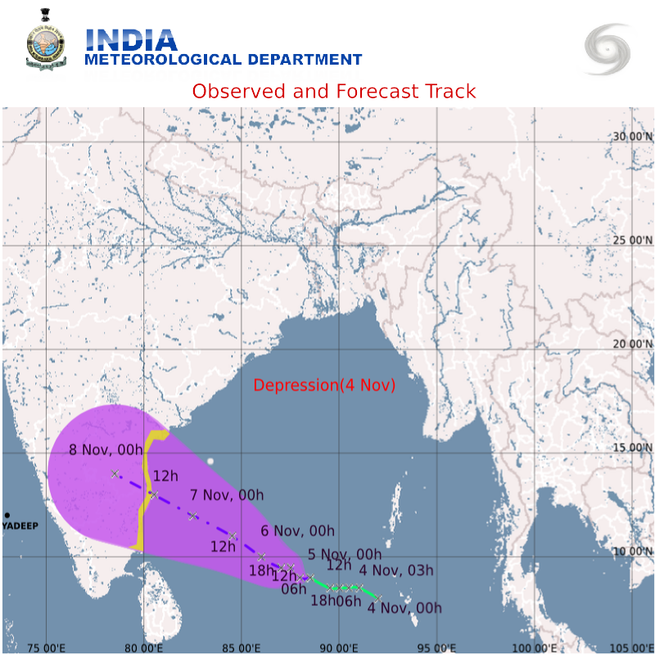
Fig.1.4. A typical example of observed and forecast track of depression which later on became the severe cyclonic storm, ‘JAL’

8. Cyclone Warning Dissemination

Cyclone warnings are disseminated to various users through telephone, fax, e-mail and GTS, All India Radio, Television and the print & electronic media. These warnings/advisories are also put in the website www.imd.gov.in of IMD. Another means to transmit warning is IVRS (Interactive Voice Response system). The requests for weather information and forecasts from general public are automatically answered by this system. For this purpose, the person has to dial a toll free number “18001801717” from anywhere in the country. This system has been installed at 26 Meteorological Centres/ Regional Meteorological Centres. High Speed Data Terminals (HSDT) are installed at almost all MCs and RMCs. HSDTs are capable of sending short warning message as SMS and the whole warning message as email. Local weather warnings are put in IMD website for common people. GMDSS message is also put in IMD website as well as transmitted through GTS.

In addition to the above network, for quick dissemination of warning against impending disaster from approaching cyclones, IMD has installed specially designed receivers within the vulnerable coastal areas for transmission of warnings to the concerned officials and people using broadcast capacity of INSAT satellite. This is a direct broadcast service of cyclone warning in the regional languages meant for the areas affected or likely to be affected by the cyclone. There are 352 Cyclone Warning Dissemination System (CWDS) stations along the Indian coast; out of these 101 digital CWDS are located along Andhra coast. The IMD’s Area Cyclone Warning Centres (ACWCs) at Chennai, Mumbai & Kolkata and Cyclone Warning Centre (CWCs) at Bhubaneswar, Visakhapatnam & Ahmedabad are responsible for originating and disseminating the cyclone warnings through CWDS. The bulletins are generated and transmitted every hour in three languages viz English, Hindi and regional language. The cyclone warning bulletin is up-linked to the INSAT in C band. For this service, the frequency of transmission from ground to satellite (uplink) is 5859.225 MHz and downlink is at 2559.225 MHz. The warning is selective and will be received only by the affected or likely to be affected stations. The service is unique in the world and helps the public in general and the administration, in particular, during the cyclone Season. It is a very useful system and has saved millions of lives and enormous amount of property from the fury of cyclones. The digital CWDS have shown good results and working satisfactorily. This CWDS network will be replaced shortly by 500 new CWDS, which are modern and easy to maintain.

9. Forecast Demonstration Project (FDP) on Landfalling Tropical Cyclones over the Bay of Bengal

A Forecast Demonstration Project (FDP) on landfalling tropical cyclones over the Bay of Bengal has been taken up. It will help us in minimizing the error in prediction of tropical cyclone track and intensity forecasts. The programme has been divided into three phases
(i) Pre- pilot phase : Oct-Nov. 2008, 2009
(ii) Pilot phase : Oct-Nov. 2010, 2011
(iii) Final phase : Oct-Nov 2012

During pilot phase (15 Oct- 30 Nov. 2011), several national institutions participated for joint observational, communicational & NWP activities, like during 2008, 2009 and 2010. However there was improved observational campaign with the observation from Sea with the help of Sagarkanya cruise in 2010. There was intense observation period for 10 days during the field phase 2010 and 02 days in 2011. The daily reports prepared during this period will be helpful to find out the characteristics of genesis, intensification and movement of the systems over the Bay of Bengal.

10. Modernised Forecast and Warning System of IMD

India Meteorological Department has taken up an extensive modernisation programme (2008-12) with the following objectives and expected outcomes.

Objectives
- Induction of advanced technology for observational systems with induction of automatic weather station (AWS), Doppler Weather Radar (DWR) etc
- Digital data communication and data base integration
- Assimilation of non-conventional data into NWP systems
- Improved data dissemination and better public access
- Induction of more objective forecasting system
- Improvement in public weather services (PWS) and early warning system

The detailed observational system upgradation taken up in the programme are as follows.
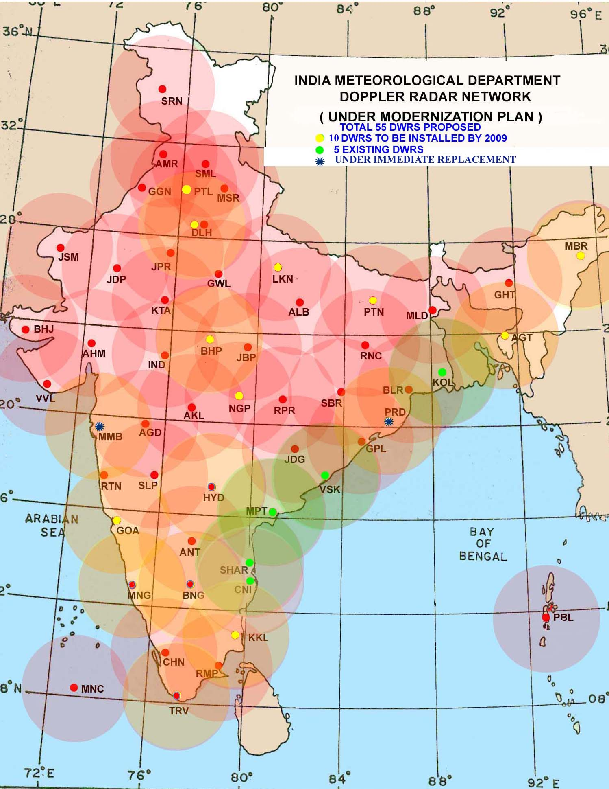

Fig. 1.5. Enhancement of Doppler Weather Radar (DWR) Network

Radar :
- Enhancement of DWR network as shown in the figure 1.5
- Assimilation of Radar data in NWP Models
- Utility of Radar in Nowcasting
- Mosaicing of Radar imagery

Automatic weather Stations / rain gauges
- Phase I : AWS 550 and automatic raingauge (ARG) 1350
- Phase II : AWS 400 and ARG 2000

Upper air systems
- GPS based Radiosonde - 10
- Optical Theodolites - 70

Forecast System

- Global Forecast System (GFS T-382): 7 days
- Regional Forecast System (WRF): 3 days
- Mesoscale Forecasting System (WRF, ARPS & HWRF-high resolution): 48 hours
- Nowcasting

Outcomes of the programme

- Improved Forecast Services at district level with more accuracy
  - Nowcasting of severe weather events
  - Extended range (10-20 days or a month) Forecast .
  - Increased accuracy of short, medium and long range forecasts
  - Multi hazard early warning
- Real Time Data Availability -
- Rapid updation of data,
- Quicker response time for management,
- Easy accessibility,
- Opportunities for value addition
- Spatial & Temporal Coverage
- Better Service Delivery

