WORLD METEOROLOGICAL ORGANIZATION  COMMISSION FOR BASIC SYSTEMS  OPAG on DPFS  STEERING GROUP SEVERE WEATHER FORECASTING DEMONSTRATION PROJECT (SWFDP)  GENEVA, SWITZERLAND, 23 - 26 February 2010 |  | CBS-DPFS/ SG-SWFDP /Doc. 4.3  (11.II.2010)  _______  Agenda item : 4.3  ENGLISH ONLY

Severe Weather Forecasting Demonstration Project
Contribution from RA III

(Submitted by Reinaldo Silveira, SIMEPAR-Brazil)

Summary and purpose of document

This document presents the severe weather and NWP forecasting context in RA III, and proposes a demonstration project.

Action Proposed

The meeting is invited to review the progress of the activities in RA III and discuss how SWFDP would be relevant in the region. It is also invited to consider the possibility of developing a SWFDP in RA III.

SEVERE WEATHER FORECASTING DEMONSTRATION PROJECT
CONTRIBUTION FROM RA III

Introduction

Severe weather non related to tropical cyclones are very common in South America, specially those related to deep convection systems, in the Southeast and South parts of Region III (Southwest and south of Brasil, Northeast of Argentina, Paraguay, Uruguay and Chile), usually as consequence of strong frontal episodes and intense extratropical and subtropical cyclones close to east cost. Besides, in the Amazonian rainforest the equatorial monsoon has caused serious floods in Bolivia and Peru, during summer time at South Hemisphere. Such atmospheric systems have caused intense winds and rainfall and consequently social disruption and loss of life in the Region III, as innumerous examples have been reported on specific journals and general newspapers. Thus, countries from Region III have settled mechanisms for mitigation and risk reduction due to such events. Examples of efforts include a virtual system for discussion and dissemination of early warnings, the contribution to the Southern Hemisphere THORPEX Science Plan and two projects for climate studies of severe weather and organization of numerical weather prediction of such events. This report gives the status of the preparation of Region III for tackle these problems.

The NWP organization

Most of countries in Region III do not realize global assimilation for initialization of numerical models, though some have the capability to store global data of many sources (Brazil and Argentina) and execute a preliminary assimilation. The main difficulty is to assemble satellite data and upper data from GTS and other sources at a minimum time and with good quality control checking during the assimilation cycle, as the assimilation vector would be at a reasonable size for the analysis of a global domain. Thus, receiving the boundaries from Global Centers (NCEP, DWD, JMA) is common practice in the region. CPTEC in Brazil is becoming more and more independent but still uses the NCEP analysis for initiate its global model. INMET, on the other hand, receives twice a day boundaries for the analysis and forecasting from DWD, Germany global NWP center. The same applies to Argentina and Chile who uses the NCEP forecast data for initiate regional models. In summary, the organization of NWP at Region III is as Figure 1.

In Brazil, INMET is running the High Resolution model from DWD (Majewski, 2003), which is a hydrostatic model of primitive equations, solved in an Arakawa-C grid, being processed twice a day for 120 hours. A local analysis is performed to improve the initialization, by incorporating AWS hourly data, METAR data, ATOVS and other satellite data which are not provided in the GTS. There are two grid domain schemas for running the HRM model, with horizontal grid spacing of 0.25 degrees (~ 25km) covering South America and small domains in Brazil with ~7km grid
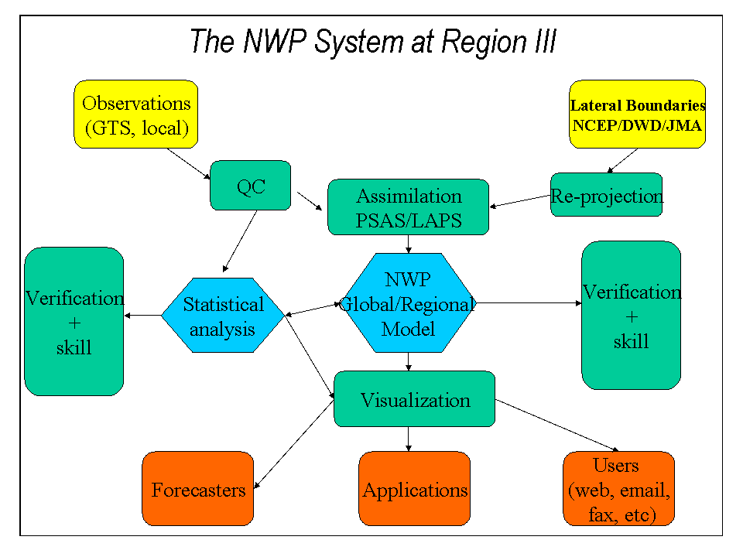
Figure 1: Usual organization of NWP at Region III. Global or regional models are usually driven by analysis of Global Centers elsewhere, as NCEP or DWD for example. But regional model are used for drive local models for short and very short forecasting.

spacing. The first intends the forecasting of synoptic scale patterns and the small grids are for local forecasting. The models and observations are integrated through at ALTIX 3700 BX2 ITANIUM SGI, with 64 nodes and 2 SGI Origins with 32 and 80 nodes, respectively. Besides, there are the use of many weather radars, integrate lightening network and derived satellites tools for short range forecasting and nowcasting. CPTEC has developed an important tool for tracking convective systems based on GOES satellite image (the FORTRACC: http://moingatu.cptec.inpe.br/paginas/fortracc/fortracc.php) and runs innumerous model configurations, including, besides its spectral global model, ETA and RAMS regional models. Whereas INMET has 10 regional districts it cooperate closely with state govern institutes, such SIMEPAR from Parana state, which is in charge of hydrological and meteorological applications for monitoring and nowcasting severe weather, in the South of Brazil (http://www.simepar.br). SIMEPAR pursue a S-band radar, about 90 AWS, integrate the Brazilian lightning network and has developed many tools for integration and interpretation of atmospheric and meteorological data. Figures 2 and 3 depict applications of monitoring and forecasting severe weather, by using nowcasting tools as the integration of satellite, radar and lightning data.

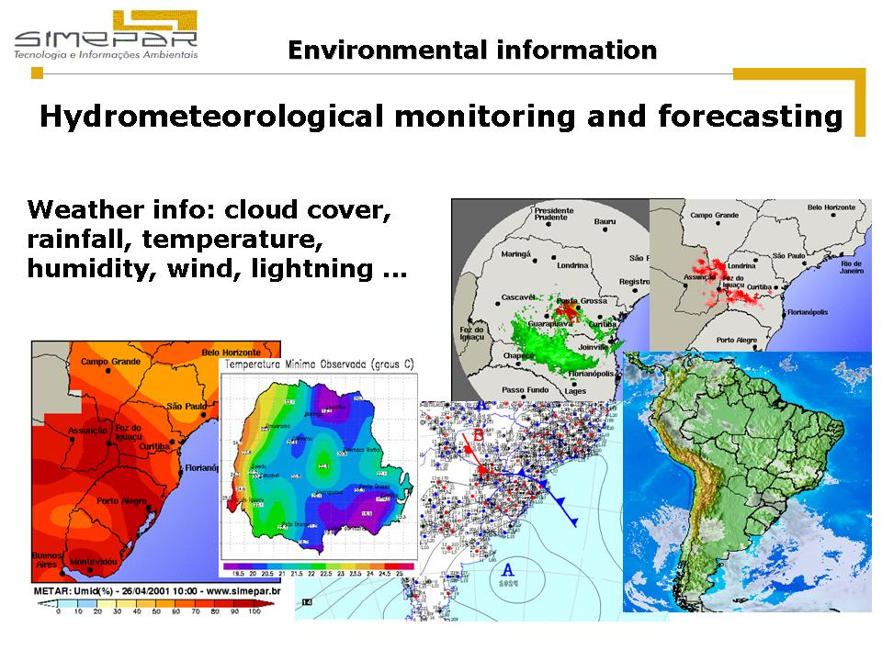
Figure 2: Applications provides by SIMEPAR, local meteorological institute of Paraná state of Brazil, for monitoring and forecasting of atmospheric and hydrological parameters.

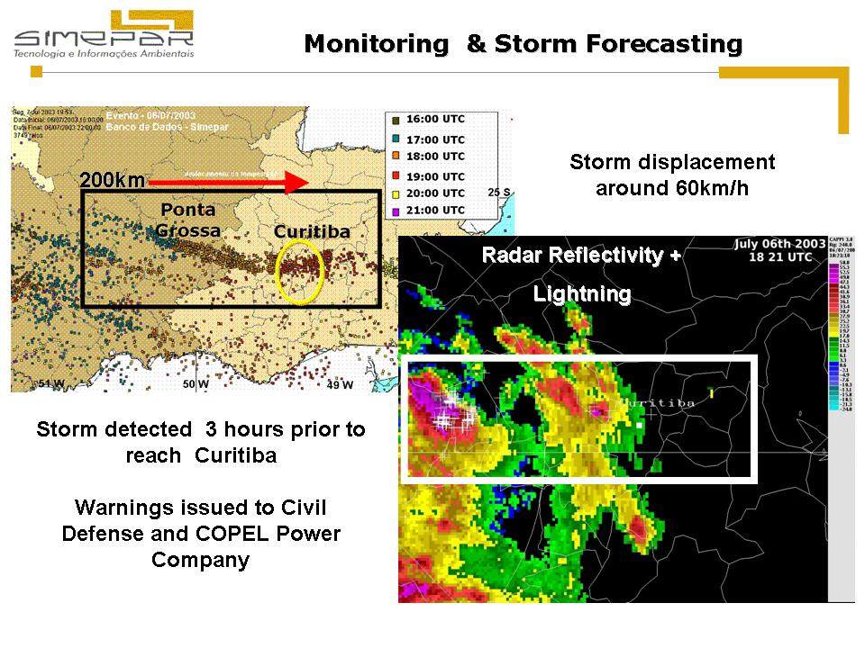
Figure 3: A specific severe weather case, happened on July, 2003 in the South of Brazil. The data represent the integration of lightning and radar data.

Regarding severe weather, an important example in Brazil is the extratropic cyclone CATARINA (Silveira, R.B et alli, INMET, Brasília, Brazil, April 2004, at http://www.inmet.gov.br/html/biblioteca/portaria_inmet_39_16042004.pdf - link for revisão técnica dos métodos e rotinas de previsão de tempo do INMET: Relatório Final (Portaria 39/16.04.2004)) happened during autumn 2004, in the south of Brazil, in the states of Santa Catarina and Rio Grande do Sul, between 27 and 28 March 2004, producing intense winds, up to 180 km/h. About 1500 houses were destroyed and more than 40000 damaged, at a cost of more than US$350 million. Three people died and seven are still missing. On hypothesis states that it was a cut-off low pressure system with strong cyclonic circulation, which intensified severely and acquired a hurricane shape in the Atlantic Ocean displacing to the Brazilian South coast very quickly. This “hurricane like” system caused very strong winds and heavy precipitation, causing floods, destroying houses, streets and victims.

Figure 4, shows a satellite picture of a moment of major activity of the system at the cost of Brazil and observations of pressure and wind. Figure 5 brings some HRM outputs for this event, a horizontal slice of pressure and temperature for specific latitude and the vorticity field for 850 hPa. There were many warnings from the forecasters about the possibility of the cyclone to head the coast, but the dissemination of such alerts to the civilian protection agents was at some extent imprecise, regarding direction, intensities and timing. Besides, there were not many information for the Ocean side, which made the diagnostic of wind strength and precipitation more complicated. Moreover, the numerical models did not capture well the system and specially the hurricane characteristic of it. Given these situations and the serious impact to the population, many activities were initiated as way to minimize the effects of such catastrophes. These were headed by the two operational centers for Meteorology in Brazil, INMET and CPTEC which, together the state Meteorological centers, received support for two important projects for better understanding severe weather in South America. The first one headed by INMET, will reinforce the observation network in Brazil, through cooperation of the states and prepare an integration of multiple observation systems (radar, satellite lightning and so on). The second project, coordinated by CPTEC will investigate the severe weather in Brazil and South America, by using climate studies and numerical weather prediction techniques. Besides, Brazil has also engaged at THORPEX initiative, at a specific module for South Hemisphere.

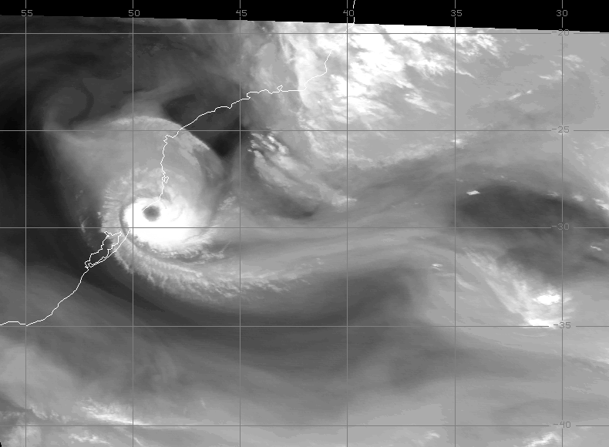
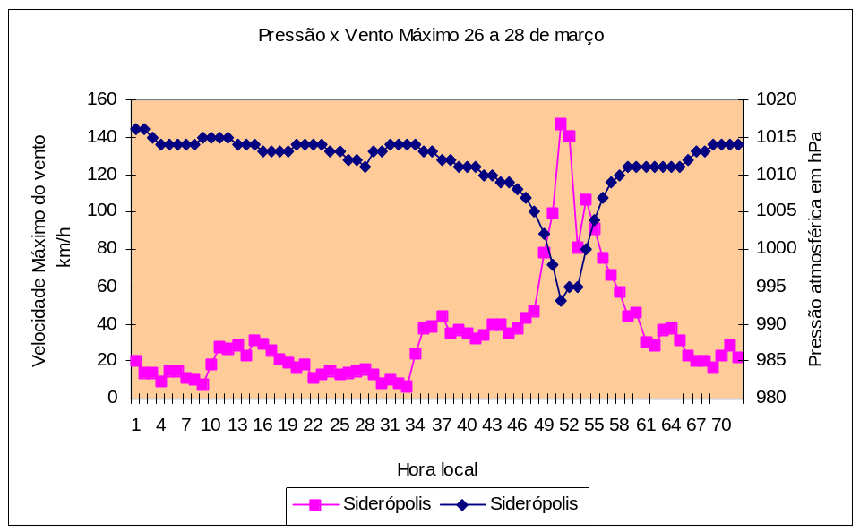
Figure 4: GOES image (above) for the final stage of the extratropic cyclone CATARINA, reaching the South Coast of Brazil on March, 28th, 2007. Time evolution of wind strength and surface pressure registered at an inland automatic station.

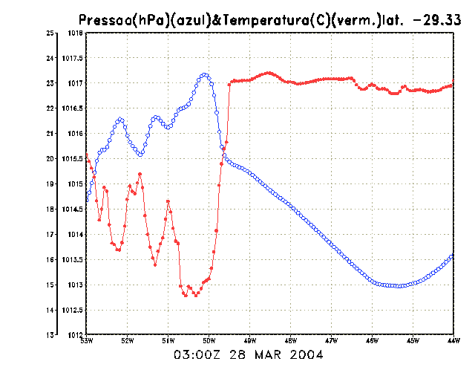

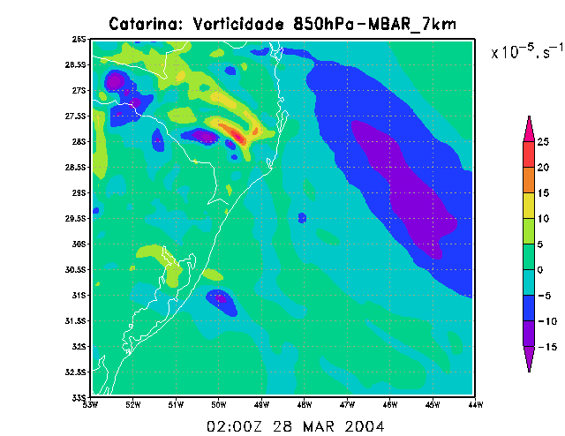
Figure 5: Some outputs of HRM model running on INMET, with 7km grid mesh size for the final stage of the cyclone CATARINA. Above is shown a horizontal section for specific latitude of pressure (blue) and temperature (red) and below is shown the vorticity field at 850hPa.

User needs

Region III is affected by manifestation of atmospheric phenomena of tropical origin, such as oscillations of the South Atlantic Convergence Zone (SACZ), strong convective activities related to Amazonian regimes, the Bolivian High, and extratropical (and subtropical) origins, such as mesoscale convective complexes, which causes strong winds and heavy precipitation, cold fronts, squall lines. Whereas, such systems are well known in the Region, appropriate mechanisms for better dissemination of alerts and warnings to the public are needed. Also, since such systems usually reaches two or various countries it is important to establish a good synergy among users and forecasters on these countries, in order to guarantee better dissemination of information and to receive user’s feedback.

Training on numerical weather prediction tools and nowcasting is also important as some countries do not have complete understanding of nowcasting tools or sophisticate NWP products. Tools as ensemble forecasting, radars, lightning are known but not much used in operation and sometimes they are not available during severe weather events. Thus an adequate training on interpretation and development of user-end applications would be useful.

Projects

At least four important projects related to short range forecasting and climate studies of severe weather events are running in Region III. Chile and Brazil are participating actively on Southern Hemisphere THORPEX science plan (McBridge, M.J, Puri, K., Steinle, P., Simmonds, I., Gordon, N., Uddstrom, M.J., Tennant, W. J, Poolman, E., Gan, M., Rosseau, C.P., Ngari, A., 2006: http://www.wmo.ch/pages/prog/arep/thorpex/documents/Shem_THORPEX_fin4.pdf), building up an implementation plan for countries below equator line, which is relate to predictability and dynamical processes, observing systems, data assimilation and observing strategies and societal and economical applications. Although it is a science plan, the goals of THORPEX address many of questions of understanding and prediction of severe weather patterns.

Brazilian Meteorological Agencies, at Federal and State levels, received a federal grant for the development of two projects for improvement of the network observing system, for better understanding of severe weather climatology and mechanisms and for building an information network among countries of South America to improve the predictability of severe weather and communication to the civilian protection agencies. These projects have being coordinated by INMET and CPTEC in Brazil. Besides, various countries of South America are undertaking a joint activity to settle up a virtual centre for disaster reduction (Moura, A.D, 2007: A virtual centre for disaster reduction in South America: monitoring, prediction and early warning of severe weather events. In "Elements of Life". WMO. ). Thus, some experiments have already been started through the use of VisitView software, which allows the participants of different countries discuss among others about changes on weather related to severity and the possibility of issuing warnings and alerts for areas related to theirs centers, respectively.

These Projects have resulted on major improvement of observational network in the states of Brazil, as well as in the borders of the country, though this was also a continuity of INMET´s challenge on improve meteorological surface network. The integration of radar, lightning and satellite systems is another result of the Project.

Moreover, the above mentioned project, had produce a good climatology of severe weather events in Brazil, as well a comprehensive revision of the historical 24hr rainfall accumulated dataset, as published by Sugahara, et. al., (2008) and Sugahara and Silveira (2009) and Lucio et. al. (2009). These article address issues about the data used for determining classes of severity of precipitation, which will be taken in account for the implementation of the Virtual Centre for early alert of severe weather events. Example of such classification is given in table I and figure 6. The first column of table I gives codes used by the Secretary of Civil Defense and each one means a different category of severe weather. For example, CODAR 4 is relate to strong wind events, CODAR 5 to CODAR 8 are related to excess of precipitation, CODAR 9 to 11 are relate to dryness conditions, CODAR 12 to 15 are relate to excess of temperature and CODAR 16 to 20 are relate to geomorphologic events, such erosion and soil movements. The other two columns give results of the PCA classification, where the most relevant variables are associate to the CODAR, for two distinct periods of the year, winter and summer, respectively. The variables are anomalies taken from surface observation only, such 10m wind speed (VV), 24hr accumulate rainfall (PP-1), thirty days of accumulate rainfall (PP30), relative humidity (UR-1 and UR1), local pressure (PL) and temperature (TT), all relate to a large period average. Figure 6 brings almost the same information, but added by a location of the occurrences. Table I presents results of PCA using occurrences of severe weather events, related by the Civil Defense authorities.

Issues and challenges

Building synergy among the many national meteorological institutes and the civilian protection agencies is the main challenge for Region III. This can be tackle by exercises such as the proposal of the demonstration project, were a hierarchical chain will reach all players of the different organizations and countries, as shown in the Figure 7. Bolivia will also be added to the national centers participating in the SWFDP for region III. Language is a problem at some extent (writing and speaking) as most of countries work in Spanish and Brazil in Portuguese, but this is minor problem given the similarities between these two languages, though some care is required during warning and alert issue. The ongoing projects will help the execution of the demonstration as some of its activities for preparation have already being performed in the countries. There is a
Table I
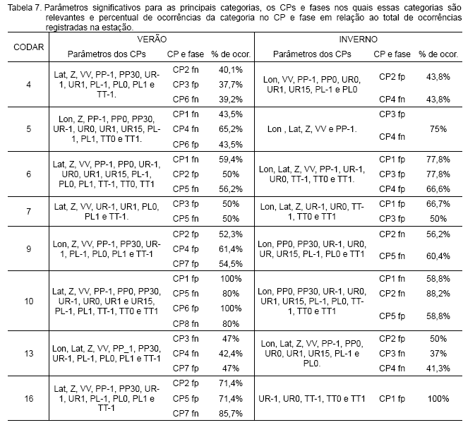

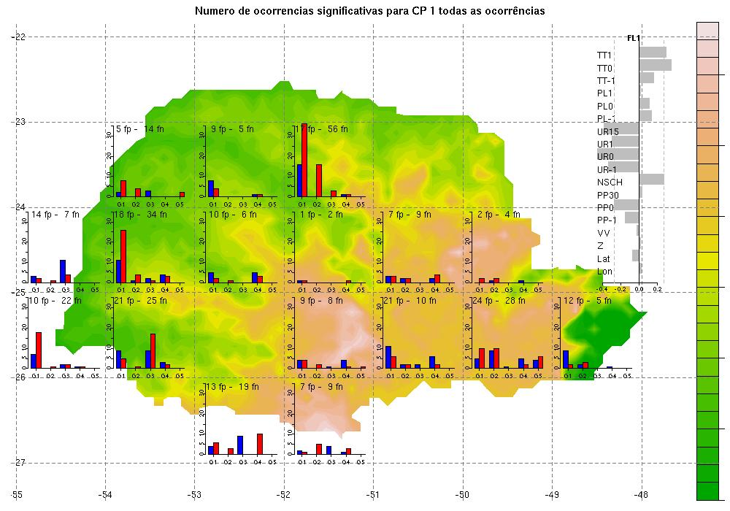
Figure 6: Results of the PCA for state of Paraná, South of Brazil, for events related to strong winds.
need for exchange of information with society and the various users of meteorological information, especially on regime of alerts and emergency. Figures 8 and 9 illustrate part of products to be delivered during the SWFDP at Region III on 2008. The basic elements for composing the tests are already in place and the challenge will be the local arrangements and some training to prepare local teams.

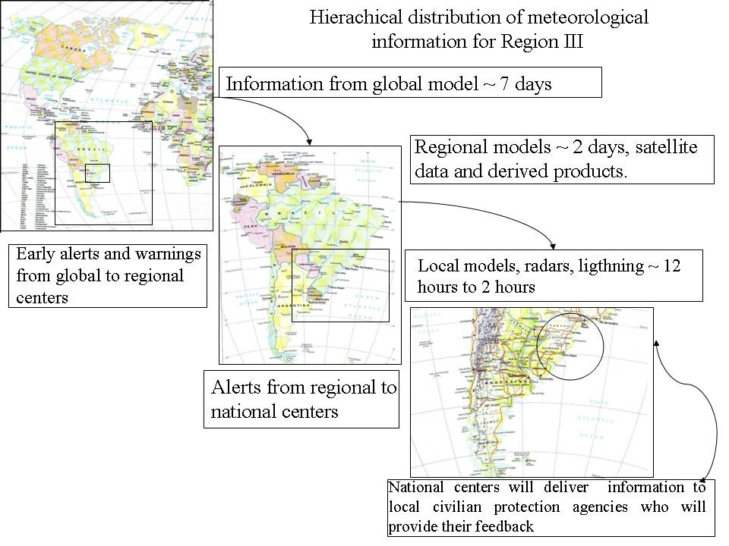
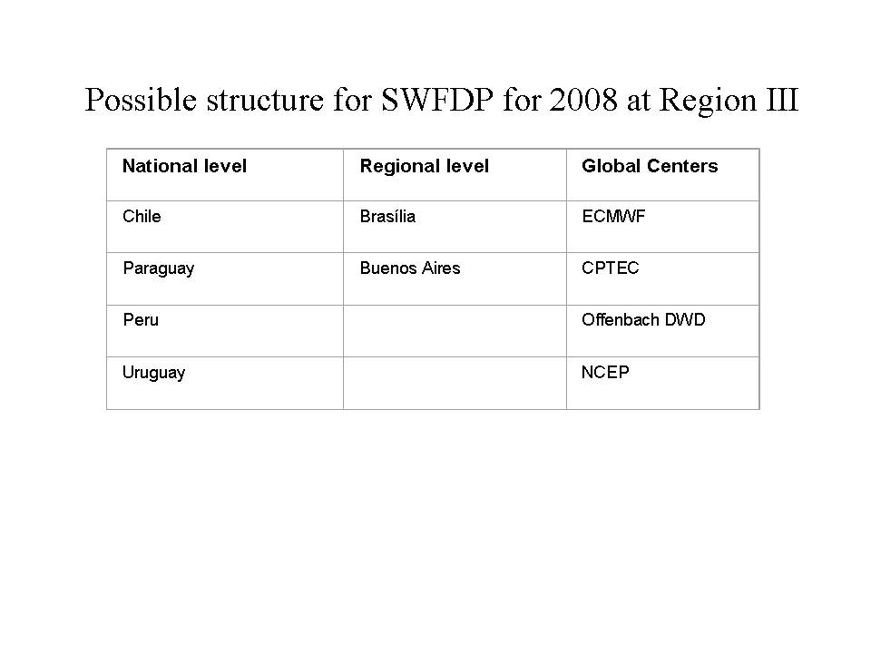
Figure 7: Organization chart for SWFDP at Region III on 2008.
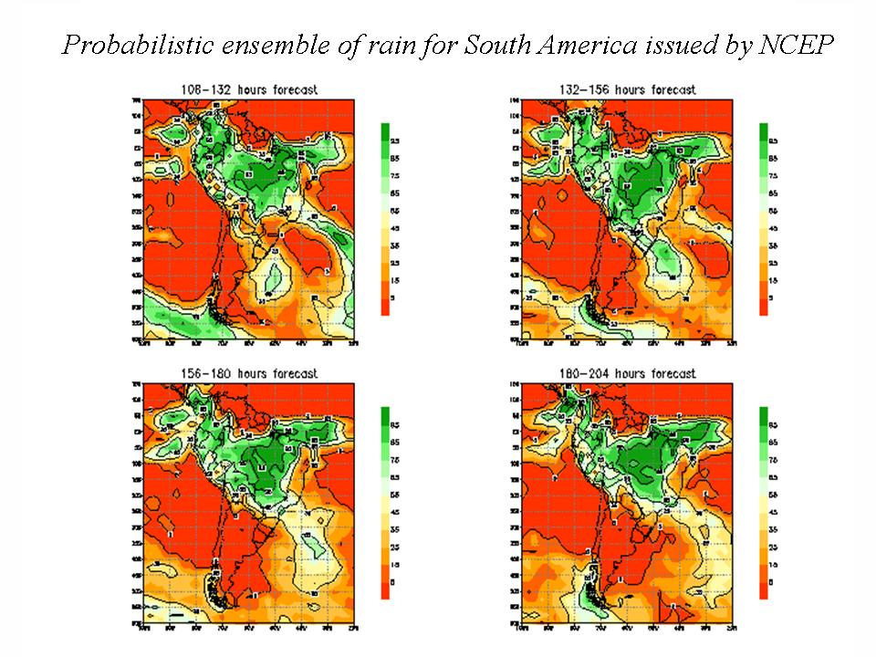
Figure 8: Probabilistic ensemble for rain for South America as available at CPTEC.

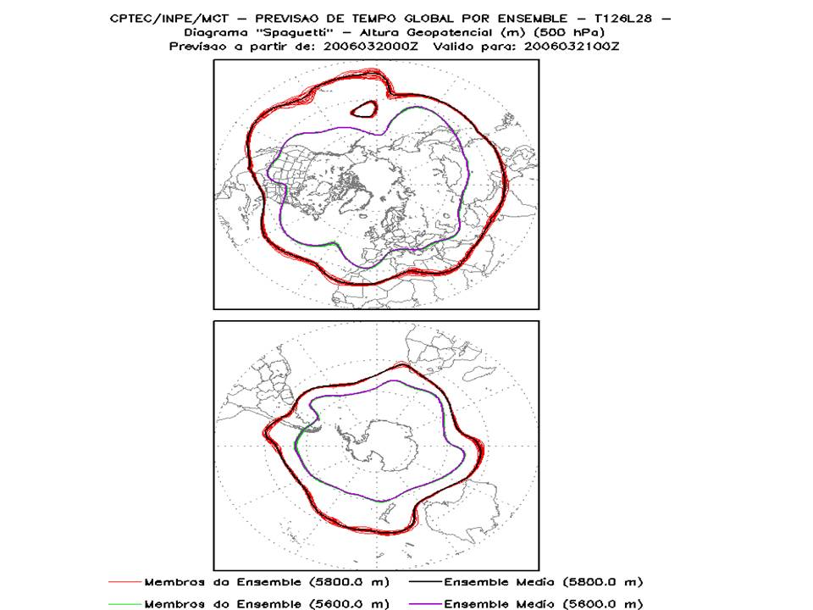
Figure 9: Ensemble information as available at CPTEC global center.

REMARKS FROM SWFDP-RAIII WORKSHOP-GDPFS ASPECTS
By Joel Martellet, Reinaldo Silveira, Richard Grumm and Anders Person

During the period from 15th to 25th of September 2008, Brazil hosted a training Workshop for SWFDP at RA-III, sponsored by INMET, SIMEPAR and WMO. The Workshop happened at Curitiba, the capital city of Paraná State in the South of Brazil and it was divided in two parts: the use GDPFS tools and PWS, including media aspects and dissemination of information to the public. A great number of information is available for this Workshop and can be found in the respective CD. The classes were very important for the participants, especially those related to the PWS, as the subjects that were taught were almost new to them. The following points were outlined as results of the Workshop:

- A clear distinction from severe and extreme event is needed, including classification among types of severe or extreme events.
- Threshold and impacts of severe events need to be determined.
- There is a need for refining products to assist forecasting.
- Focus: Improve Forecasts/Warnings for Heavy Rain (Snow)/Strong Winds/Cold advection.

Summary of the week

During this week training we had a large number of important talks for reviewing GDPFS tools and techniques and undoubted that the level of lectures given by the instructors were of high level quality as well as the good level of knowledge of the participants.

We summarize here the main topics of the lessons stressing the link with the SWFDP. We hope you have enjoyed this SWFDP-RAIII Training and can share with your colleagues from the work the information you have gathered. We also expect that you have understood the purpose of the Training as well as that you can maintain the cooperation among the participants being established here, so we can proceed to the next steps of the SWFDP-RAIII and the Virtual Centre.

Day 1:

The GDPFS description by Joël Martellet explained the terminology of SWFDP as well as the role of the System within WMO structure -> understanding the aspects of cascading process and the purpose of the Demonstration Project.

Reinaldo Silveira briefed the participants about the SWFDP and its preparation in the Region-III, explaining the exchanging of the information among the involved Centres at South America and Global centres -> organization of the SWFDP for RA-III.
The description of NWP activities at Global centres, ECMWF, NCEP was given by Anders Persson, Richard Grumm and Marcos Mendonça, respectively -> demonstration of available products from Global centres, with a large number of tools available (DON’T forget to ask for EPSgrams for your country). Richard Grumm provided many links for accessing special products from NCEP, with integration of derived satellite parameters and also NWP.

Day 2:

The regional NWP system at Regional Level, from INMET and CPTEC, was presented by Reinaldo Silveira and Chou Sin Chan, respectively -> Both HRM (INMET) and ETA models (CPTEC) are quite reliable and many tools are available at regional level.

Anders Persson talked about sources of errors on forecasting, the theory of EPS and the ECMWF products -> he stated that EPS is the ultimate method to do WF, stressing that one should use it also in conjunction with other existing tools. Main products showed during the class were stamps maps and clusters, probability maps, EPSgrams, EFI. Cyclone tracking was also demonstrated.

Day 3:

Anders Persson gave a lecture on Probabilistic forecasting -> differences between deterministic and EPS products were discussed as well as the concept of probabilities and probabilistic forecasting was also taught. A nice dice game was played to illustrate the concepts of PF for rain events and the risks (costs/benefits) of a decision-making process on taking the probabilistic forecasting advice, having a insurance protection on hands (ECMWF Marbouty money).

Anders Persson reviewed the concepts of synoptic forcing concepts -> it was explained how NWP can be useful for diagnosing this mechanism.

Richard Grumm illustrated the use of NWP and EPS to prepare probabilistic forecasts and he also showed explained about QPF -> the class showed several cases and applications of the available tools, which can be reviewed by the participants, so they can interpret by themselves the medium-range forecasting products.

CPTEC (Gustavo Escobar) demonstrate the available products from CPTEC for the use on severe weather forecasting -> it was shown many tools based on the combination of thermodynamic indexes and NWP outputs that can be used as guidance for many applications on severe weather forecasting. These tools are quite relevant to our subject, as their outputs stress readily the significant events.

Ricardo Reinke exploit a case study of a severe event occurred at South Brazil (RS) on May 2008 -> the case study was presented through a demonstration on the use of guidance products provided by INMET.

Day 4:

The forecast process for the forecasting of SW was introduced by Richard Grumm, who also conducted a practical session -> the session illustrated the use of NWP and EPS products as well as the early warning issues.

Nowcasting tools were demonstrated by Luiz Machado from the CPTEC, Cesar Beneti from SIMEPAR -> the use of several satellite available satellite tools was demonstrate as well as FORTRACC system for identification and tracking of convective systems. Radar and Lightning system applications were illustrated as well as the products available at SIMEPAR.

Marcia Seabra and Ricardo Reinke from INMET presented the VisitView, which is a online panel for discussions that can be done remotely by the participants of SWFDP-RAIII.

Day 5:

Lesson on statistical post-processing of NWP outputs was given by Anders Persson, who explained about MOS and Kalman Filter and the advantages and disadvantages -> MOS needs long data set (at least 3 years) whereas KF needs just few days; Missing data is a problem for MOS implementation, but KF can cope with this problem; MOS need to be calibrate after every model change.

Anders Persson presented several ways to deal with verification, by also showing applications to KF -> absolute he discussed about three types of verification: absolute measures; relative measures and utility.

Reinaldo Silveira presented a extreme event analysis applied to a case study of flood at SP -> the identification and classification levels of return period of flood events was demonstrated, illustrating the difference between the extreme and severe events.

Reinaldo Silveira presented an application of factor analysis for Civil Defense data set for Parana state -> identification of precursors of severe events.

Leonardo Calvetti present a severe event of hail at Curitiba -> the use of radar and lightning data was demonstrate, as well as parameters that can be useful for this type of application.

Reinaldo Silveira and Richard Grumm conducted a hands-on section, challenging the participants to make forecasting for 4 regions at South America -> a verification table was presented to the participants. Four groups presented the forecasts by filling the table.

Concluding remarks from GDPFS for SWFDP-RAIII

We propose a Severe Weather Forecasting Demonstration Project (SWFDP) for improving Severe Weather Forecasting in the Countries of the Region.

Vision-Goal:
“NMHSs in the Countries of the Region should be able to implement and maintain reliable and effective routine forecasting and severe weather warnings programmes through enhanced use of NWP products and delivery of timely and authoritative forecasts and early warnings, thereby contributing to reducing the risk of disasters from natural hazards.”

According to the recommendations of the CBS-XIII (2005), the goals of a SWFDP are the following:

to improve the ability of NMCs to forecast severe weather events;

to improve the lead time of alerting of theses events;

to improve interaction of NMCs with DMCPA* before and during events;

to identify gaps and areas for improvements to increase the skill of products from GDPFS Centres, using feedback (evaluation) from NMCs.

*Disaster Management and Civil Protection Authorities

Following the success of a first Severe Weather Forecasting Demonstration project in Southern Africa, a similar project is proposed for Southern South America.

Goal: to improve severe weather forecasting and warning in Southern South America improving the availability and use of NWP output:

Focus: Improve Forecasts/Warnings for Heavy Rain (Snow)/Strong Winds/Cold advection;

NMHS improving its confidence in their warnings;

NMHS improving relations with civil protection authorities.

Performance Targets:

Improved accuracy of severe weather warnings
Improved lead-time for severe weather warnings
Reduced false alarms
Improved collaboration: between RSMCs and NMCs, and: between NMCs and DPM decision makers

Demo Project Duration: Nov. 2008 to Nov. 2010?

Concept of Operations:

Global NWP products provided by Global Centres to RSMCs and NMHSs daily
Some Centres run Limited Area NWP Models for all or part of southern South America.
RSMC Brasilia and Buenos Aires, prepare, distribute severe weather forecasting guidance products to NMHSs daily (out to day-5).
Some NMCs runs Mesoscale Models for their Country: Brasilia, Buenos Aires Lima, Montevideo, Santiago and SIMEPAR and can share results.
All NMHSs use guidance to forecast severe weather and produce severe thunderstorms, rain, snow, wind or cold warnings, and deliver services to public and civil/DPM authorities.

Supporting infrastructure

International data exchange through WIS/GTS, INTERNET, VISIT VIEW
Local processing and display to use observations and NWP output
Coordination forum in real time between Southern South American Centres
Initial focus: Improved use of existing NWP products (e.g. EPS)
Option to acquire, install, operate/sustain limited area NWP models to meet unique needs

Global and Regional Partnership

Regional Centres: RSMCs Brasilia & Buenos Aires, CPTEC, SIMEPAR?

NWP Product users: NMCs of Argentina, Bolivia, Brazil, Chile, Paraguay, Peru, Uruguay

Collaboration with global NWP providers: NCEP (Washington), ECMWF, DWD, CPTEC

Lead Regional Centre?: RSMC Brasilia?

Liaison with WMO: Dr Reinaldo Silveira (Curitiba, SIMEPAR; Brazil)

WMO Secretariat: Peter Chen (DPFS Division), Haleh Kootval (PWS Division)

CBS OPAG DPFS: Bernard Strauss (France)

The cascading process

Global NWP centres to provide available NWP products, including in the form of probabilities;
Regional centres to interpret information received from global NWP centres, run limited-area models to refine products, prepare, distribute severe weather forecasting guidance products to targeted NMHSs daily (out to day-5), liaise with the participating NMCs;
NMCs to run meso-scale models, issue alerts, advisories, severe weather warnings; to liaise with DMCPAs and to contribute to the evaluation of the project.
Then, we have to define tasks and products (Content, time of availability) for:
Global Model centres?
Regional centres?:
NMHSs (internal cascading process)?

To define wished products from:
Global NWP centres to provide available NWP products, including in the form of probabilities;
DWD: boundary conditions for HRM, extend it to South America countries.
ECMWF?: Usual Maps for WMO Members plus Tailored EPSGRAMs (Content, time of availability)
NCEP?: boundary conditions for ETA, MM5, WRF, other? (Content, time of availability)
EPSgrams? Anomalies?
CPTEC?:(Content, time of availability)
FORTRACC, EPSgrams

To define tasks and wished products from:

Regional centres: to interpret information received from global NWP centres, run limited-area models to refine products, distribute severe weather forecasting guidance products to NMHSs daily (out to day-5), liaise with the participating NMCs

Then what tasks for (e.g. define thresholds?) and products of:

RSMC Brasilia?: Virtual Centres – Use of Visit view? (Content, time of availability), Run coordination forum between Centres?

RSMC Buenos Aires? (Content, time of availability),

CPTEC? (Content, time of availability),

SIMEPAR? (Content, time of availability),

NMCs: prior to project to express thresholds and to organize internal national cascading process: medium range, short range, very-short range, nowcasting.

During project: contribute to coordination forum, issue alerts, advisories, severe weather warnings; to liaise with DMCPAs and to contribute to the evaluation of the project.

To define content of evaluation forms of NMCs (Ascension, Buenos Aires, Brasilia, La Paz, Lima, Montevideo, Santiago)? (methodology of reporting events? And pass reports?)

The first week of the Workshop was mainly dedicated to the use of GDPFS tools, though some insights on dealing with severe weather events were also covered by the participants. Furthermore, the second week of the Workshop the talks were related to the PWS aspects, and the participants had the opportunity to understand how to better communicate severe weather events to the public and the media, and how to advise them about the significance of the events and its status, on hourly/daily basis. The instructors (Haleh Kootval-WMO and Sandy Song-Hong Kong Observatory) passed outstanding lectures to the participants on most variety of subjects related to role of Public Weather Service in the business of communicate their jobs to the public, as well as for those participants that are from civil protection agencies. These concepts were also reinforced by many exercises that were provided to the participants. The lessons gathered during PWS were considered very important by the participants, as these subjects are not of normal or common dissemination in the NMHs or even for the Civil Protection agencies in South America.

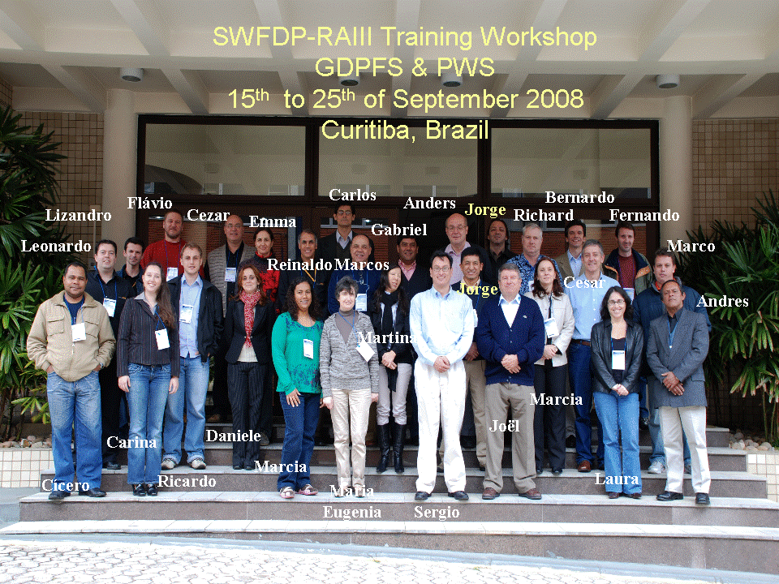

The Virtual Centre for South of South America

The Virtual Centre is an information center for helping participant members on preparing and disseminating their early alert on severe events and discuss among them about weather situation according their needs. The methodology of the Virtual Centre is twofold:

- Diagnose and Forecasting of severe weather. This part is automatic and provided by meteorological information and numerical weather prediction tools. The system provides pre-alerts to the operational forecasting centers, on the basis of the nomenclature used by the Secretary of Civil Defense, i.e, CODAR. The users (qualified forecasters) have to adjust such pre-alerts or accept them if that is the case.

- Publication and dissemination of early warnings of severe weather events. Under the consensus among the forecasting centers, the alerts are then published, according to region, states and cities. Moreover, the system produces a verification of such alerts, using station observations, radar, satellite, lightning and reports from users.

Figure 10 depicts the WEB interface of the Virtual Centre for South of South America.

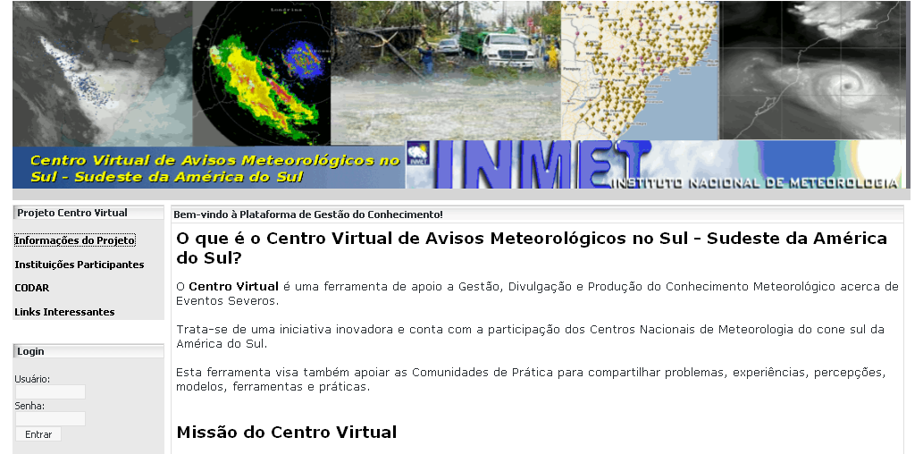
Figure 10: WEB interface of Virtual Centre at INMET, Brazil.

