WORLD METEOROLOGICAL ORGANIZATION  COMMISSION FOR BASIC SYSTEMS  OPAG on DPFS  STEERING GROUP SEVERE WEATHER FORECASTING DEMONSTRATION PROJECT (SWFDP)  GENEVA, SWITZERLAND, 23 - 26 February 2010 |  | CBS-DPFS/ SG-SWFDP /Doc. 4.1, REV. 1  (10.II.2010)  _______  Agenda item : 4.1  ENGLISH ONLY

Report on the Severe Weather Forecasting Demonstration Project (SWFDP) in RA I

(Submitted by James G. Kongoti, Chairman of the Working Group on Planning and Implementation of the WWW in Region Association I (RAI, Africa), Kenya Meteorological Department)

Summary and purpose of document

This document is about the status of the Severe Weather Forecasting Demonstration Project (SWFDP) in Southern Africa, Regional Association I (RA I, Africa). It highlights some of the activities that have been achieved. It also draws attention to the possibility of replicating the same activities to other regions of RA I.

Action Proposed

The meeting is invited to review the progress of the activities of the RSMC-Pretoria in support of the SWFDP in Southern Africa and also consider the possibility of establishing other RSMCs in support of the SWFDP in East/Central Africa and West Africa.

Annexes:
I Examples of model output products from KMD
II Examples of disasters caused by thunderstorms and strong winds in December 2009, in Kenya
III Flood in Dakar Suburb, September 2009
III Damaged road due to flash flood event in September 2009
IV Graphical User Interface (GUI) developped for local Eta model output
V Web page developed to disseminate model outputs with a choice on two different models Eta and HRM
VI Example of model Eta model output, 48-hour forecast of Relative Humidity above 70% at 850 hPa.
VII Evaluation of Eta Model forecast precipitation during 2006 Monsoon season : Hovmuller diagram of daily rainfall avaraged between 10°^{W} and 10°^{E}, from May to October, 1°^{N} to 24°^{N} ; At the top the Ctrl Model, at the middle, FEWS estimated satellite rainfall, at the bottom Eta used with another convective scheme for sensitivity studies.
REPORT ON THE SEVERE WEATHER FORECASTING DEMONSTRATION PROJECT (SWFDP) IN RA I

Introduction

Numerical Weather Prediction (NWP) models have become increasingly relevant and indeed essential to the severe weather forecasting process, with a growing number and variety of sophisticated outputs, currently available from NWP producing Centres, which could be beneficial to many National Meteorological and Hydrological Services (NMHS) in Regional Association I (RA I – Africa).

The Severe Weather Forecasting Demonstration Project (SWFDP) was organized as potentially a series of regional subprojects to explore and test the usefulness of the products currently available from NWP Centres, or products which could be readily made available from current NWP models of global and regional meteorological centres, with the goal to improving severe weather forecasting services in countries where sophisticated model outputs are not currently used. The principal focus of the project is on the phenomena of heavy precipitation that could cause serious flooding, and strong destructive winds.

According to the recommendations of the CBS-XIII (2005) the goals of the SWFDP were defined by SWFDP Steering Group in Geneva (14-16 December 2005) as follows to:

- improve the ability of NMHSs to forecast severe weather events;
- improve the lead time of alerting of these events;
- improve interaction of NMHSs with Disaster Management and Civil Protection Authorities (DMCPAs) before and during events;
- identify gaps and areas for improvements;
- improve the skill of products from Global Data-Processing and Forecasting System (GDPFS) Centres through feedback from NMHSs.

SWFDP - Southern Africa

The first SWFDP regional subproject demonstration was implemented in the Southern Africa region, and hosted at RSMC Pretoria by November 2006.

Regional Specialized Meteorological Centre (RSMC) Pretoria made available on a dedicated Web site and portal the required datasets from the Global Products Centres and output from its own limited area called Unified Model at 12 km resolution (UM-SA12 model). The web address is www.weathersa.co.za/RSMC and it’s password protected. Moreover RSMC Pretoria prepared and issued the RSMC Daily Guidance Products including descriptive text, maps and risk and probability tables, satellite-based 0-12 hours products according to the agreed format, in order to help forecasters to prepare their own forecasts and warnings in their areas of jurisdiction.

The centres that participated in the “SWFDP – Southern Africa” project, include the following:

NMHSs (15): Angola, Botswana, D.R. Congo, Lesotho, Madagascar, Malawi, Mauritius, Mozambique, Namibia, Tanzania, Seychelles, South Africa, Swaziland, Zambia, Zimbabwe;
Note: Additionally, Comoros participated in the training workshops.

Regional Centres (2): RSMC Pretoria, RSMC La Réunion;

Global Products Centres (3): Exeter (Met Office UK), Washington (NCEP USA), and ECMWF.

Establishment of RSMCs in Support of the SWFDP for East/Central Africa and West Africa

SWFDP - East/Central Africa

From the success story of the RSMC Pretoria, Numerical Weather Prediction (NWP) products have been found to improve significantly weather forecasting skill in the Southern African countries. NWP models improve, many NMHSs, especially those of developing countries, seek similar benefits to meteorological services, especially for the provision of advisories and warnings of severe weather events with increased lead-times, already being realized by other countries. The SWFDP represents an approach that facilitates improved access to, training in the interpretation and use, of existing NWP/EPS products by forecasters in developing countries. In this regard, there is need to set-up RSMCs of the same status in East/Central Africa and West Africa regions in support of the SWFDP. The RSMCs identified will implement the SWFDP regional subproject demonstration with a consortium of member countries and research institutes in their respective regions (RA I).

Kenya Meteorological Department (KMD) would support the proposal of establishing Regional Specialized Meteorological Center (RSMC) in Nairobi for use of SWFDP conceptual model to improve forecasting and warning services to the Great Lake region, East/Central Africa region, which include Uganda, Rwanda, Burundi, Ethiopia, Sudan, Somalia, Congo and Kenya among others. With this establishment of RSMC Nairobi then Ethiopia would benefit from improved weather forecasting as a result of the implementation and use of NWP.

Currently, KMD is running High Resolution Regional Model (HRM) from Germany at 14 and 28 km resolution and Weather Research Forecasting Model (WRF EMS) from the United States of America at 15.5 km resolution initialized at 00 and 12 UTC. The current domain covers 12⁰N 26⁰E and 12⁰S 50⁰E. However, this domain can be extended to any size depending on the computer processing capability. KMD is running the HRM models on a 2-node cluster while WRF runs on a Workstation. The model output products are precipitation, temperature, wind, vertical velocity and relative humidity among others (Annex I). The region is prone to severe thunderstorms resulting to destructive winds and flooding (Annex II).

The Internet is fast enough to download initial and boundary condition data and regional and global guidance forecasts from other developed Centres for example DWD, ECMWF, NCEP, UK Met Office.

SWFDP - West Africa

Senegal Meteorological Agency (ANAMS, French acronym, former DMN) is willing to support the proposal of establishing a Regional Specialized Meteorological Centre (RSMC) at Dakar to support the SWFDP project to improve forecasting and warning services in West Africa sub-region, which includes Senegal, Burkina Faso, Gambia, Guinea, Mali, Mauritania, and Niger.

These West African countries, mostly in the Sahelian region, have experienced severe droughts in the 70s, 80’ and early 90’s, but since the end of the 90’s heavy rainfall events are being also encountered. For example, in 2009 these countries experienced flash floods and/or flooding which caused damages and resulted in displacement of people and sometimes death (source International Federation of Red Cross/Crescent). The negative impacts (Annex III) of these events are enhanced by high rate of urbanization and population growth including settlement in informal areas and also by general lack of preparedness with clear defined procedures between meteorological services and relief/emergency services.

Regarding model products, the Senegal Meteorological Service has experience in running Limited Area Models (LAMs), data post-treatment and products dissemination. The German High Resolution Model (HRM) with a resolution of 20km in a domain of 1°N-24°N, 28°W-17°E (see annexes below) has been run operationally for 2 years, 2005 and 2006. The Eta Model with the same characteristics has been run operationally between 2006 and 2009. Sensitivity tests regarding convective parameterization schemes were conducted for the whole 2005 year and the best statistically convective scheme for the region of interest chosen. The LAMs models were initiated and laterally driven with the global German model and by the US GFS model for the HRM and Eta model respectively but without any additional data assimilation. The two models products were used in addition to products from global models to issue weather bulletins and warnings.

To facilitate the ease of access of model products and interpretation, a graphical user Interface (GUI) based on Grads software was developed, which produced diagnostics defined by the forecasters (see annex IV below). Additionally a web page was developed, it was intended for the forecasters in aviation industry, working at ASECNA (the agency for the security of civil aviation which regroups 18 countries members in West, Central Africa and Madagascar) and potentially to forecasters in neighbouring countries (Annexes V and VI).

From 2009, the Weather Research Forecasting Model (WRF) model has been implemented in Senegal in research mode. A few case studies have been compared with the Eta Model and have shown more accuracy in predicting mesoscale convective systems which bring the quasi-totally of rainfall in the Sahel region. The WRF model is run operationally at 15 km for Africa by NOAA/NCEP/CPC/African Desk. Other studies on evaluation of the Eta model were conducted for the year 2006; that permits to conclude that the Eta model has a tendency to overestimate storms activity near the coast and then rainfall over the East Atlantic Basin but also in the West African Guinean region (see annex VII).

From this experience, the lesson learned was that running NWP model for operational purpose is a demanding task that requires organisation in team with dedicated tasks for each member and sustainability in the actions. On the other hand, the global forecasting centres are upgrading continuously their model resolution (e.g. ECMWF model operational at 16 km since 2010) and given the capacity in global forecasting centres, it is difficult to compete with them. It is worthwhile noting that in West Africa, rainfall is essentially convective and convection is usually organized in mesoscale convective systems, such as squall lines, embedded or not in synoptic waves. Rainfall prediction in the models depends highly on the convective scheme parameterization and there is no consensus in convective schemes. A consequent added value in predicting rainfall would be to run a cloud resolving model (resolution of about 1 km) for which convection is explicitly resolved. Such models would be highly costly for operational purpose on a big domain. The Senegal Meteorological Service plans to run later a cloud resolving model for its national domain.

In the perspective of developing a SWFDP in West Africa with Dakar as the regional Centre, the strategy proposed in terms of model products is to have a routine access to all needed model outputs from some global centres. Dedicated diagnostics will be automatically derived and made available to participating countries. The programs developed to derive diagnostics from the local LAMs will be updated for the global model outputs that will be received at Dakar RSMC in the framework of the SWFDP. Other products developed in centres such as NCEP/CPC/ African Desk in support to the SWFDP and at ACMAD (located in Niger) in the framework of the African Monsoon Multidisciplinary Analyses programme will be also used. Then Dakar Centre will put more emphasis in post-treating model outputs, deriving more diagnostics, disseminating and evaluating products. Training will be needed for “new” products such as Ensemble prediction Systems products.

Conclusion
In conclusion, the use of the SWFDP conceptual model in East/Central Africa and West Arica would improve weather forecasting skill including marine weather services. These regions are prone to severe weather such as:

- Strong destructive winds;
- Thunderstorms;
- Heavy rain resulting in floods and land/mudslides;
- Lightning;
- Severe storms over the lakes and ocean;
- Frost in high ground areas.
Annex I

Examples of model output products from KMD
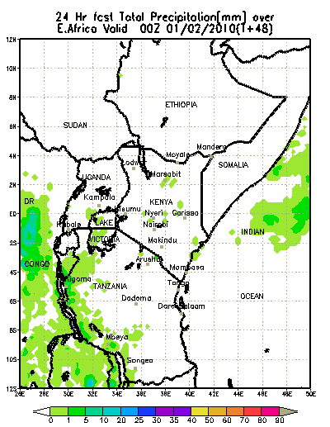
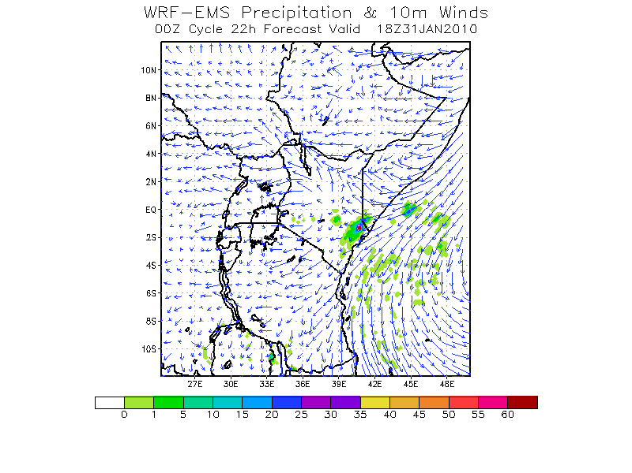

Annex II
Examples of disasters caused by thunderstorms and strong winds
in December 2009, in Kenya
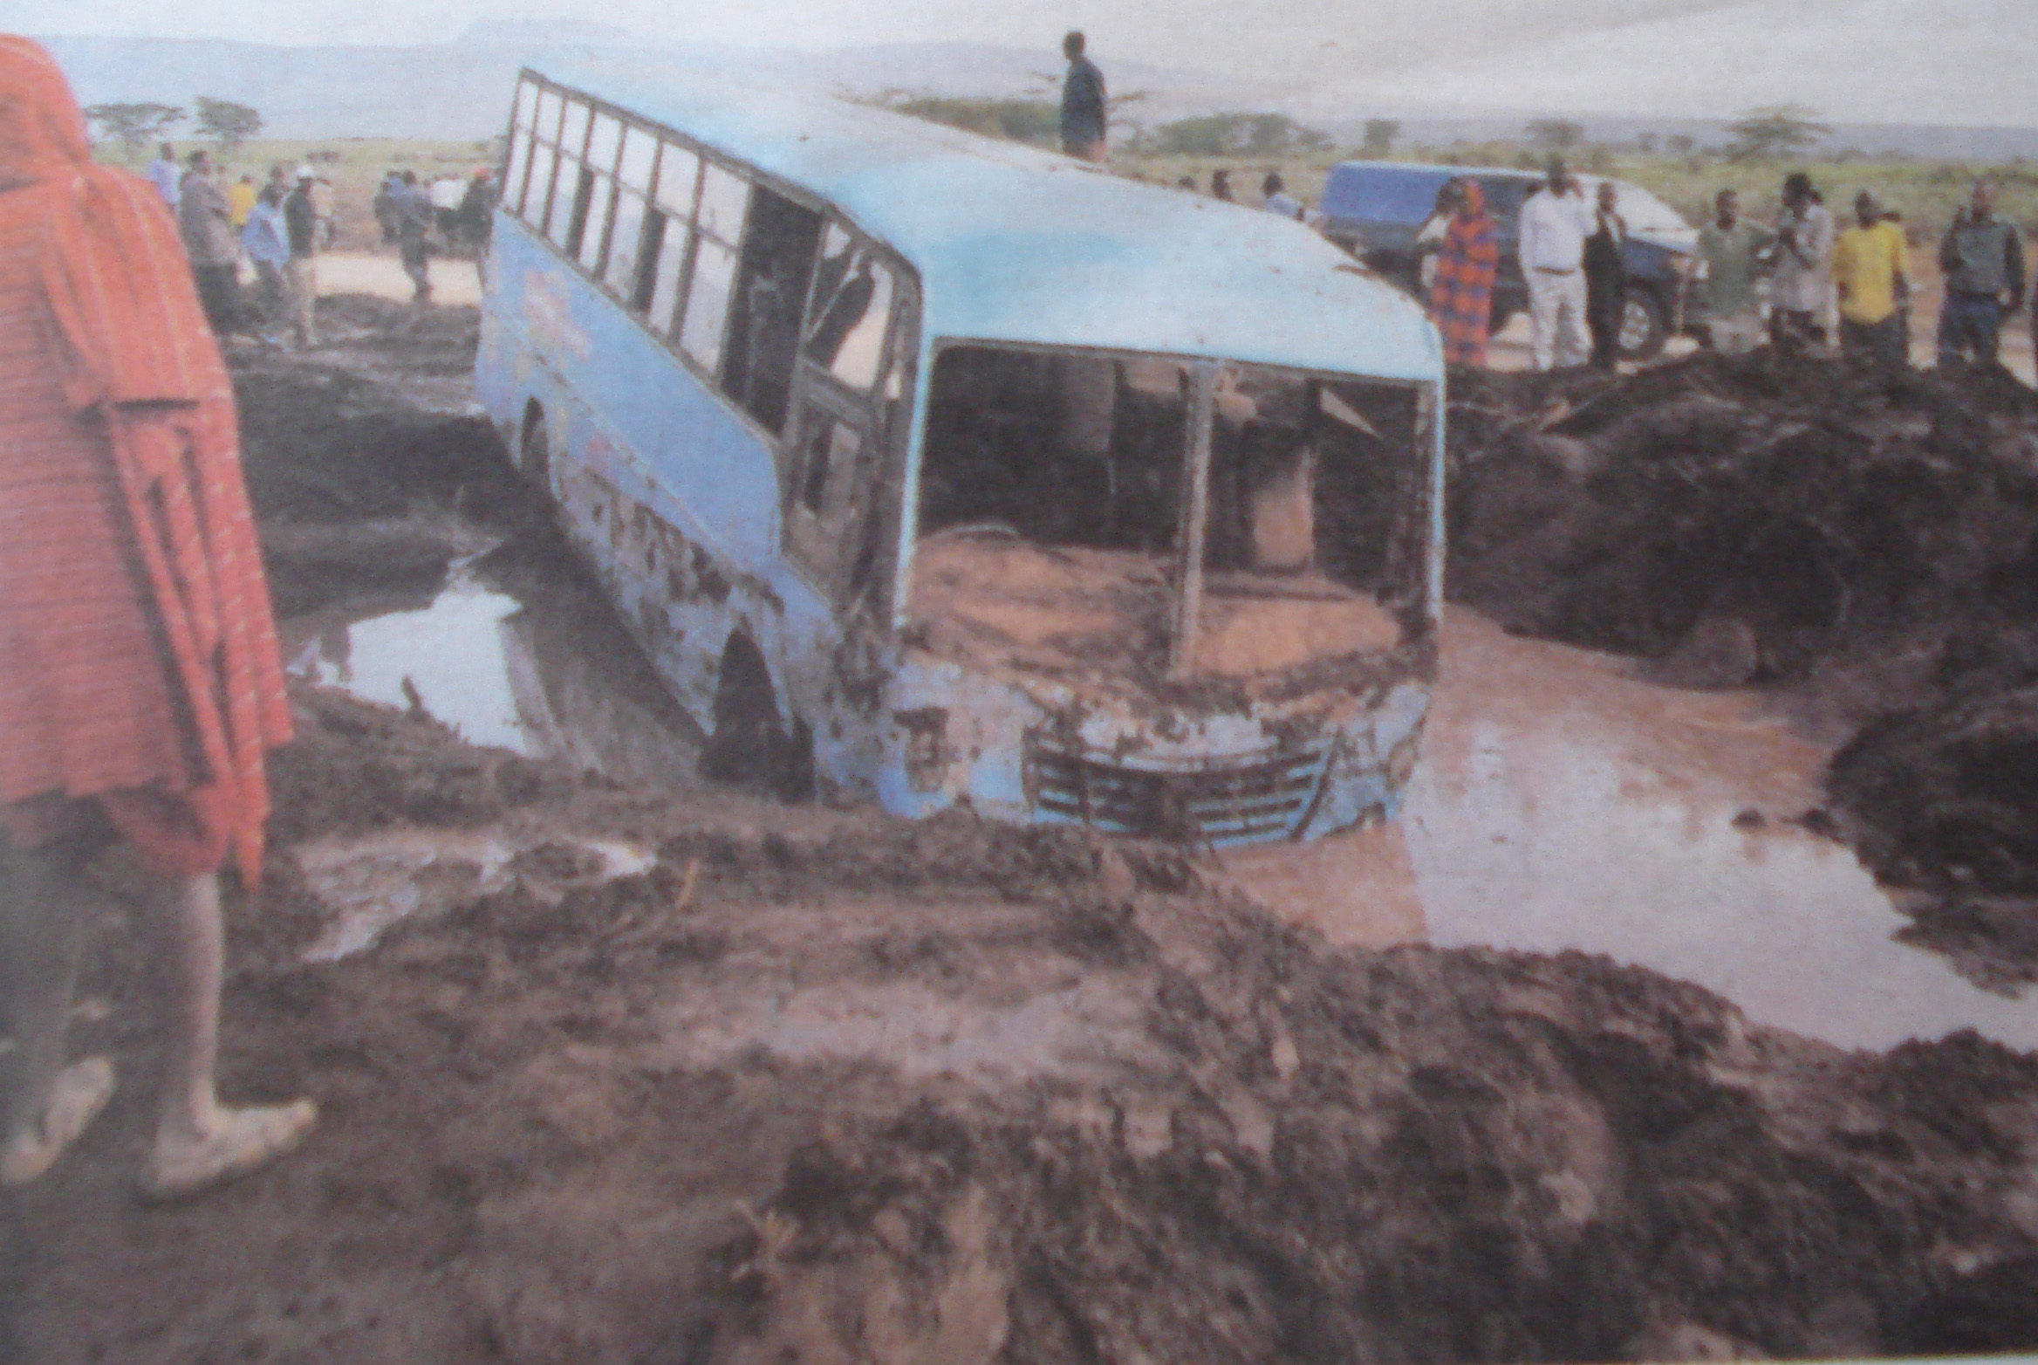
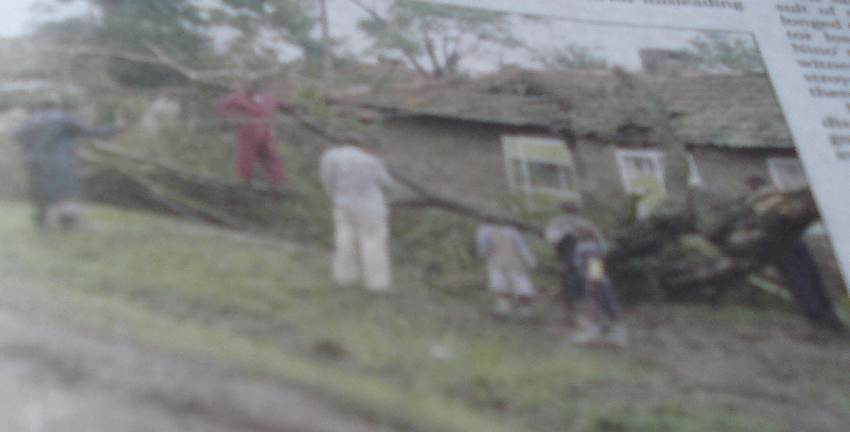
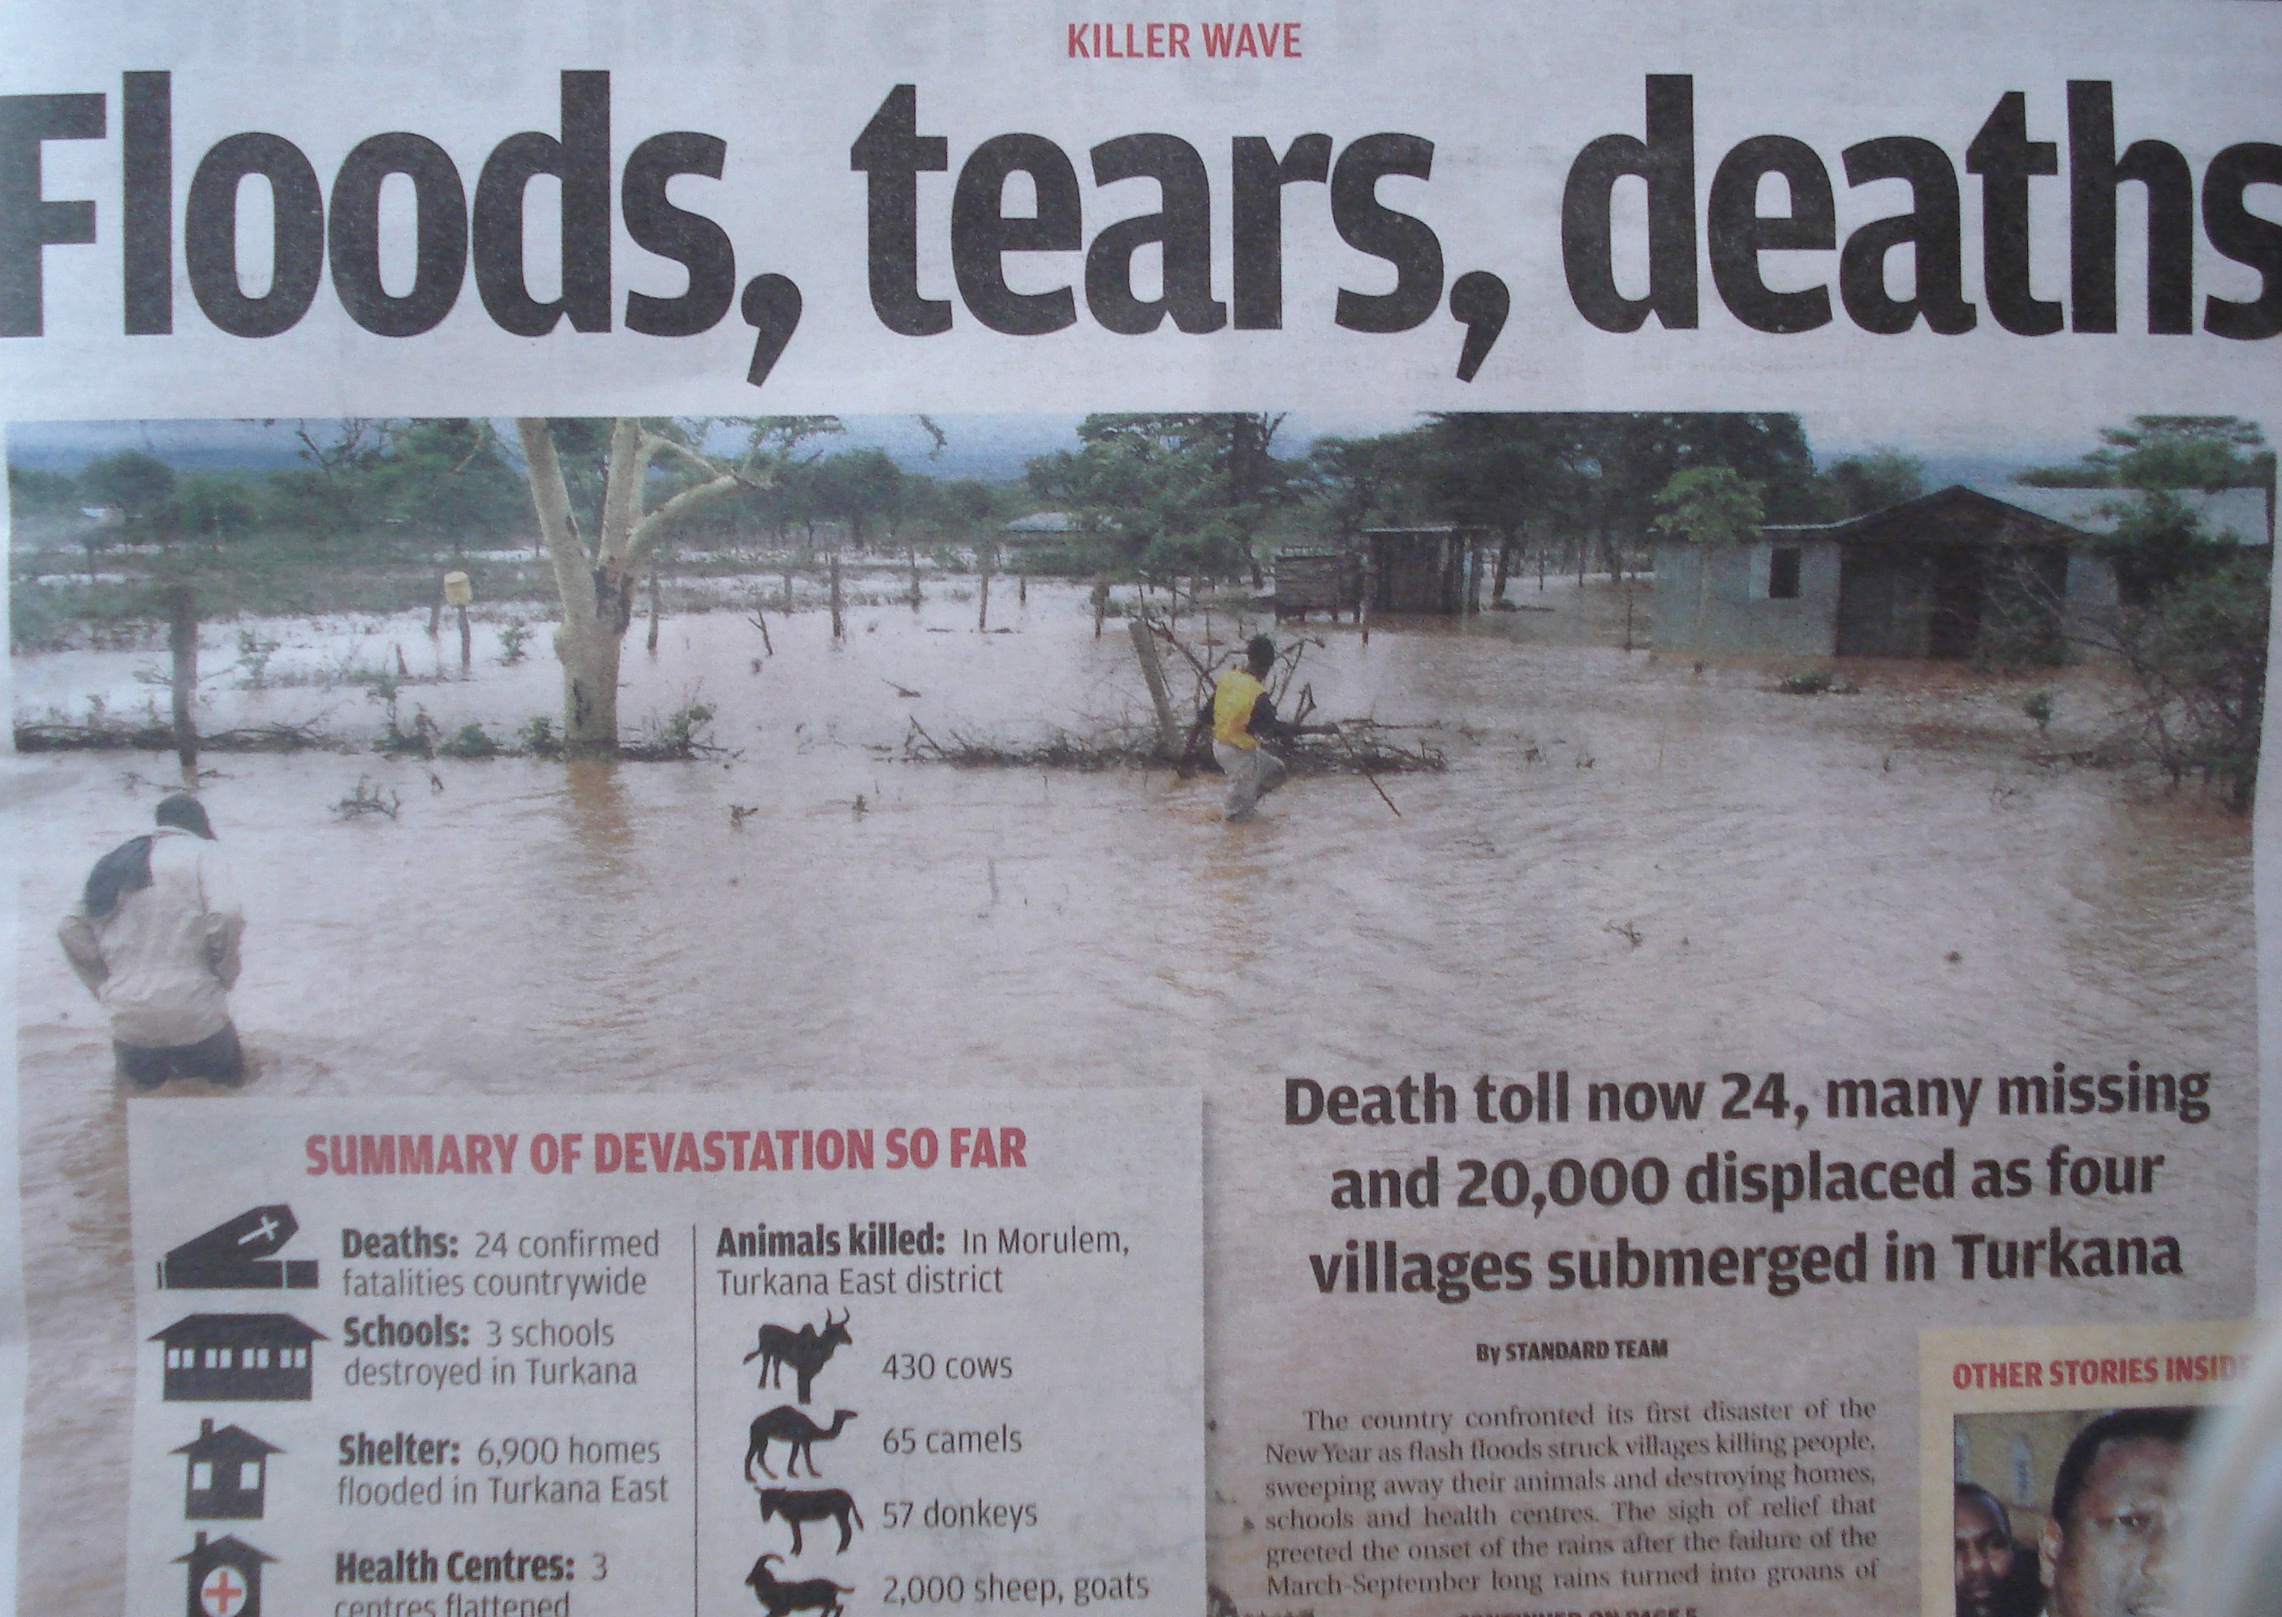

Annex III

Flood in Dakar Suburb, September 2009 Damaged road due to flash flood event in
September 2009
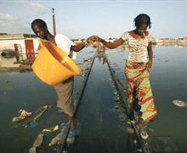
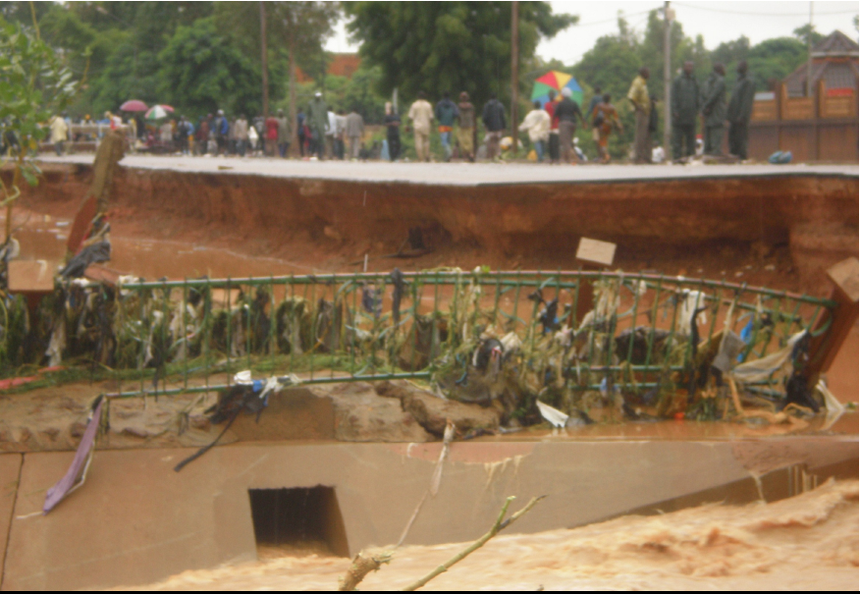

Annex IV

Graphical User Interface (GUI) developed for local Eta model output
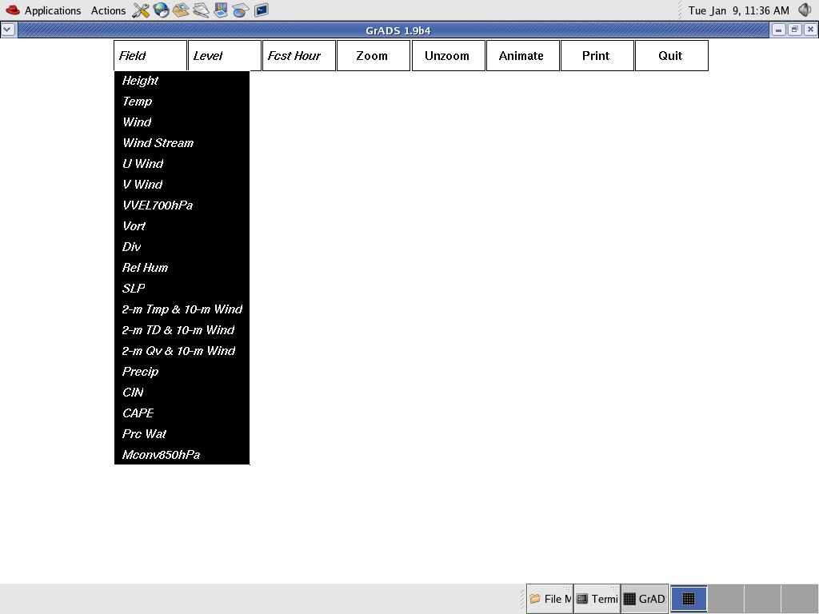
Annex V

Web page developed to disseminate model outputs with a choice on two different models Eta and HRM
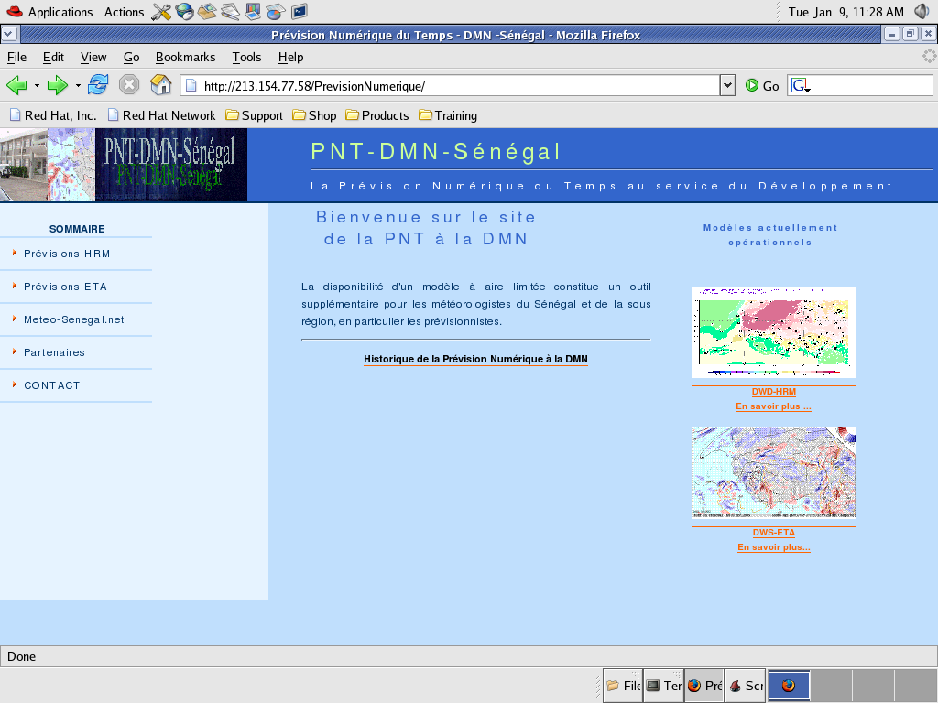

Annex VI

Example of model Eta model output, 48-hour forecast of Relative Humidity above 70% at 850 hPa.

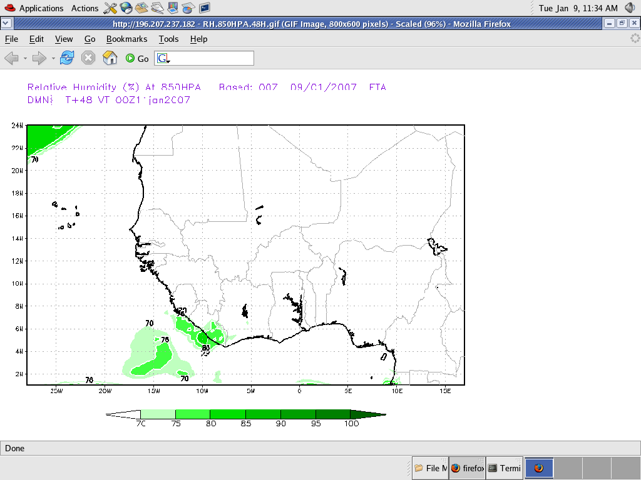

Annex VII

Evaluation of Eta Model forecast precipitation during 2006 Monsoon season : Hovmuller diagram of daily rainfall avaraged between 10°^{W} and 10°^{E}, from May to October, 1°^{N} to 24°^{N} ; At the top the Ctrl Model, at the middle, FEWS estimated satellite rainfall, at the bottom Eta used with another convective scheme for sensitivity studies.



