WORLD METEOROLOGICAL ORGANIZATION  COMMISSION FOR BASIC SYSTEMS  OPAG on DPFS  STEERING GROUP SEVERE WEATHER FORECASTING DEMONSTRATION PROJECT (SWFDP)  GENEVA, SWITZERLAND, 23 - 26 February 2010 |  | CBS-DPFS/ SG-SWFDP /Doc. 3.5  (16.II.2010)  _______  Agenda item : 3.2/3.3  ENGLISH ONLY

SUPPORT PROVIDED TO SWFDP FROM MET OFFICE GLOBAL CENTRE

(Submitted by Ken Mylne)

Summary and purpose of document

This document summarizes briefly the support provided to the SWFDP sub-projects in Southern African and the South Pacific from the UK Met Office in its role as a Global Centre.

Action Proposed

The meeting is invited to offer feedback on the value of the products and propose any modifications or upgrades which might improve the support provided.

References:
Bowler NE, Mylne KR (2009) Ensemble transform Kalman filter perturbations for a regional ensemble prediction system, QUARTERLY JOURNAL OF THE ROYAL METEOROLOGICAL SOCIETY, 135, 757-766.

Bowler NE, Arribas A, Beare SE, Mylne, K R and Shutts, G J (2009) The local ETKF and SKEB: Upgrades to the MOGREPS short-range ensemble prediction system, QUARTERLY JOURNAL OF THE ROYAL METEOROLOGICAL SOCIETY, 135, 767-776.

Bowler NE, Arribas A, Mylne KR, Robertson KB and Beare SE (2008) The MOGREPS short-range ensemble prediction system QUARTERLY JOURNAL OF THE ROYAL METEOROLOGICAL SOCIETY 134, 703-722.
SUPPORT PROVIDED TO SWFDP FROM MET OFFICE GLOBAL CENTRE

1. MOGREPS Global Ensemble

MOGREPS is a 24-member ensemble run by the UK Met Office. The primary aim of the MOGREPS project is to run a mesoscale regional ensemble over Europe for short-range forecasting, but the system includes a global ensemble with a resolution of around 60km in mid-latitudes and 70 vertical levels. This global ensemble actually runs in two modes, a fully operational MOGREPS-G which runs to 3 days and a non-operational research MOGREPS-15 which runs to 15 days at ECMWF as part of the THORPEX TIGGE project. Products for the SWFDP are generated from both MOGREPS-G and MOGREPS-15.

MOGREPS initial perturbations are generated using an Ensemble Transform Kalman Filter (ETKF) which is localized in both horizontal and vertical to optimize the perturbation scaling regionally around the globe. Model uncertainties are accounted for by a Random Parameters scheme and a Stochastic Kinetic Energy Backscatter (SKEB) scheme. Both the ETKF localization and the SKEB scheme are being upgraded around the time of writing with the upgraded versions being operational from March 2010. More details of MOGREPS are given in a number of papers by Bowler et al.

2. Ensemble Probability Charts

Probability charts are generated for a number of severe weather thresholds of wind speed and precipitation for use in SWFDP. Figure 1 shows two examples, one for winds exceeding 20kt in the southern Africa region and one for precipitation exceeding 50mm/24h in the South Pacific. (These examples are not for particularly interesting situations as we do not keep an archive of significant events, but illustrate the general look of the charts)

These charts are generated using direct model output from the global model ensembles and probabilities are estimated using a simple ensemble-member counting method.

3. Site-specific MOGREPS Forecasts

MOGREPS is also used to generate site-specific forecasts for sites around the SWFDP regions. Figure 2 illustrates the current locations of sites generated and two Meteogram examples. The meteogram provides a time-series forecast of precipitation, wind speed and temperature in the form of box and whisker plots illustrating the range of possible solutions in the ensemble forecast. The lower example for Port Moresby gives an interesting example for Sun 14 Feb of a low probability of a very large amount of precipitation (80mm/24h).

4. Tropical Cyclone Tracking

Tropical cyclones are tracked in MOGREPS-15 and a variety of products generated (Figure 3). These products fall into two categories. Figure 3a shows track products for existing storms which have been identified by the TC RSMCs and notified in TC bulletins. Figure 3b provides an objective identification of storms in the MOGREPS-15 fields, and therefore includes genesis of storms which form during the forecast period.

As part of future collaboration between SWFDP and the GIFS-FDP being developed under the THORPEX GIFS-TIGGE project it is hoped to provide multi-model TC track products following the TIGGE principal of multi-model ensemble forecasts. This principal has already been demonstrated over the North Pacific in the THORPEX T-PARC experiment, and the Met Office is experimenting with multi-model TC track products using the CXML data format developed for T-PARC in the Atlantic basin.

5. Extra-tropical Cyclone Tracking (S. Pacific)

The idea of feature-tracking forecast tools can also be applied to extra-tropical cyclones. For the S. Pacific SWFDDP we have implemented our extra-tropical cyclone database and tracking system with the MOGREPS-15 ensemble in the S. Pacific region. This is a system which is run operationally over the North Atlantic for use in Europe, and which was previously demonstrated as part of the THORPEX T-PARC experiment. Figure 4a shows an example of the features identified at initial time, and Figure 4b shows the ensemble feature-tracking of one developing low pressure system.

It should be noted that interpretation of feature-based tracking is not so intuitively simple for extra-tropical cyclones as it is for Tropical Cyclones, because the storms are larger but less intense systems. Many extra-tropical cyclones are not severe weather features, and even where there are intense winds or precipitation associated with them, this may only affect a small part of the area under the influence of the storm. It is therefore recommended that these products should always be used in conjunction with products such as those shown in Figures 1 and 2 which help to locate the areas of severe weather hazard.

6. Deterministic Model Charts

The Met Office also runs a higher resolution deterministic model over Africa which helps support the SWFDP, the 20km resolution Africa LAM. Figure 5 illustrates examples of deterministic forecast charts from the Africa LAM.

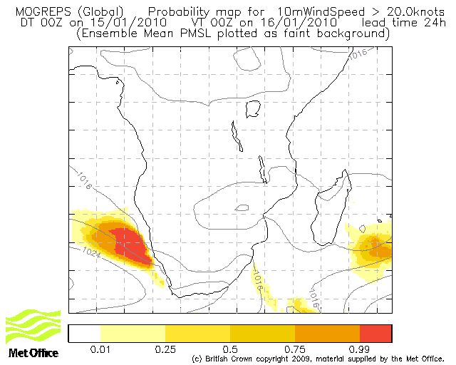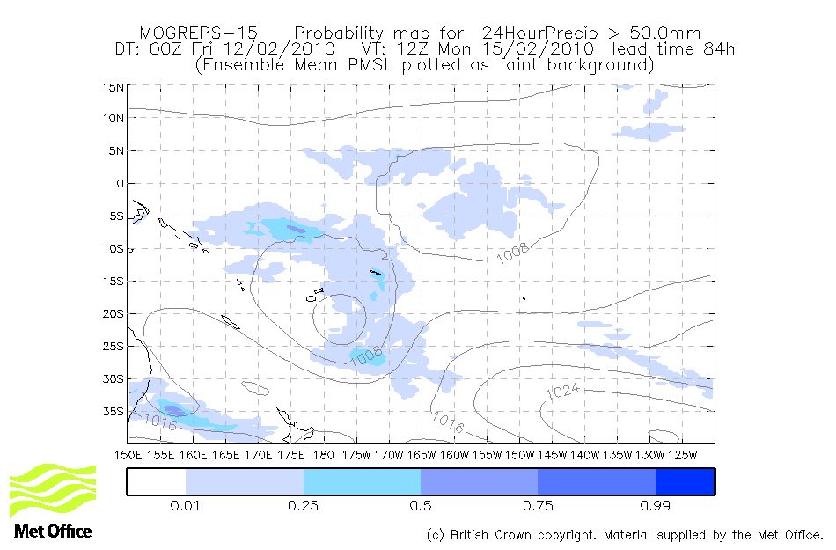
Figure 1: Probability maps from MOGREPS for the SWFDP. Top: 72h forecast of 10m Wind exceeding 20kt in southern Africa region from MOGREPS-G. Bottom: 84h forecast of 24-hour Precipitation exceeding 50mm in the South Pacific region from MOGREPS-15.
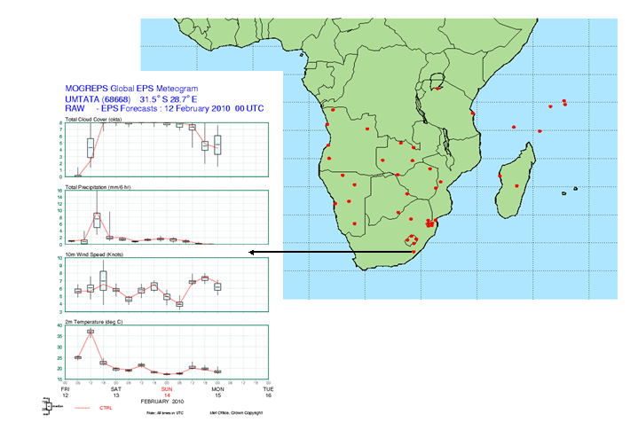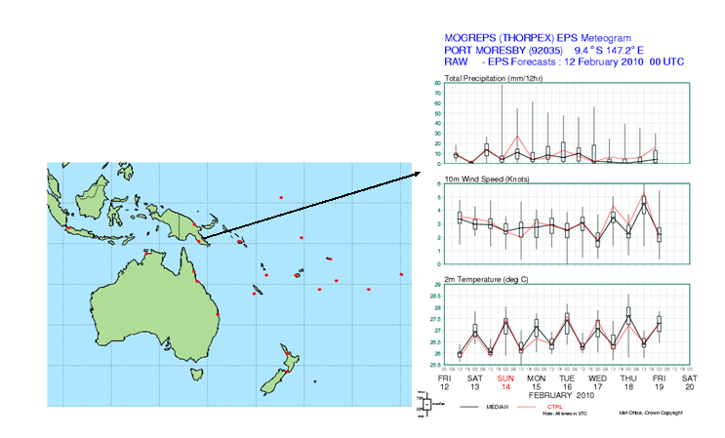
Figure 2: Examples of site-specific MOGREPS forecasts provided for the SWFDP.

a)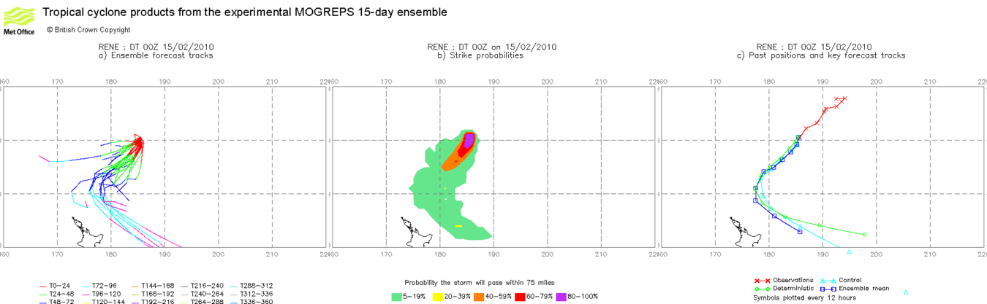

b)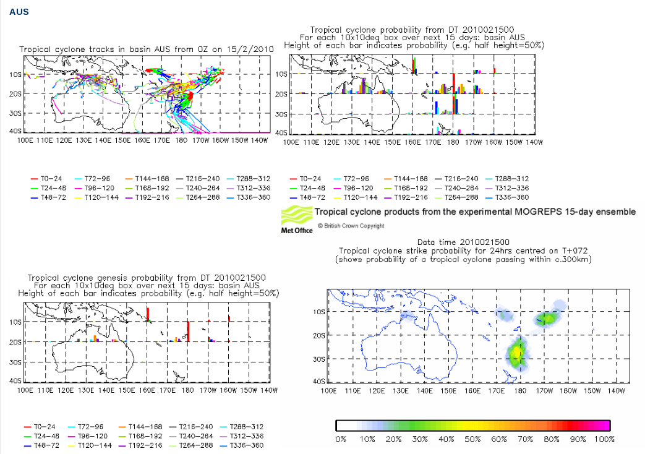

Figure 3: Tropical cyclone tracking products supplied to the S. Pacific SWFDDP. a) Storm-specific product, in this case for storm Rene, showing cyclone tracks in all ensemble members (left), strike probability (centre) and summary track information (right). b) Standard daily products for the Australiasian area showing ensemble member tracks (top-left), cyclone probability per 10 degree lat/long box (top-right), cyclone genesis probability per 10 degree lat/long box(bottom-left) and animated cyclone strike probability (bottom-right). This strike probability chart at the bottom-right is animated through time on the website, and includes probabilities due to storm genesis.

a)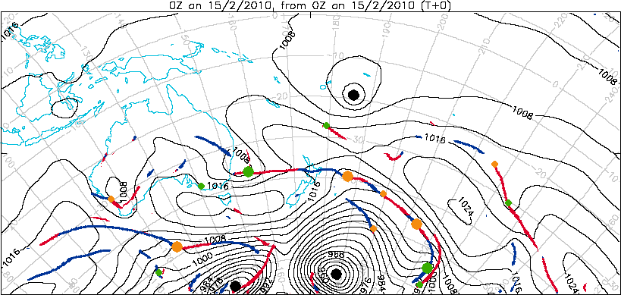
b)
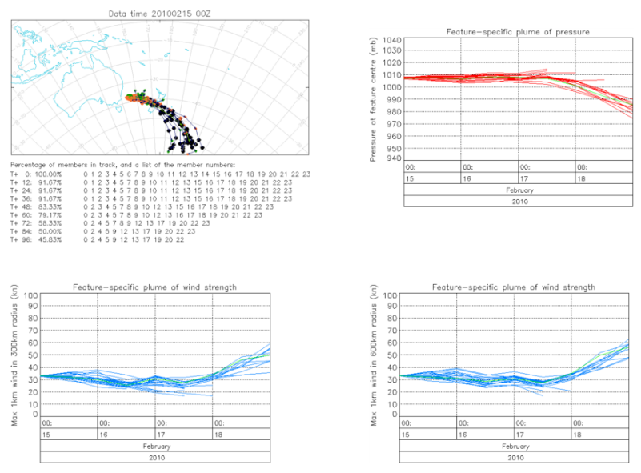
Figure 4: Example of extra-tropical cyclone tracking system for S. Pacific region based on MOGREPS-15. Figure 4a illustrates the features identified at initial time (T+0) while figure 4b tracks features of the cyclone which is initially shown in green to the east of SE Australia in fig 4a. Characteristic tracked for all ensemble members are location (top-left), central pressure (top-right), max gradient wind-speed within 300km of storm centre (bottom-left) and within 600km (bottom-right). Not shown but also available are feature-specific plumes of relative vorticity and 300mb jet strength.

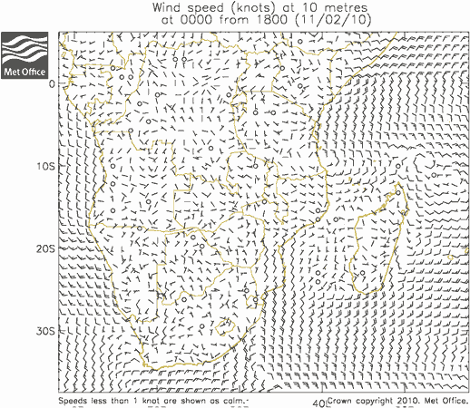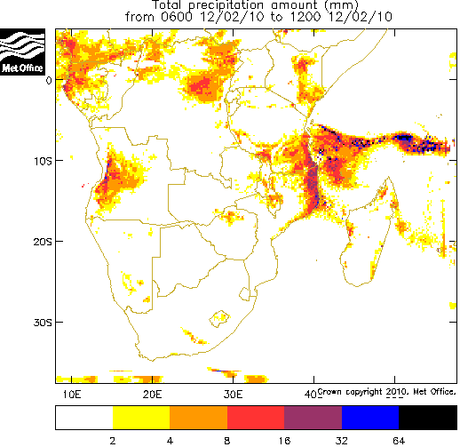
Figure 5: Example of surface wind and precipitation charts for southern Africa from the Africa LAM model.

Note the resolutions quoted here are the new enhanced resolutions under trial at the time of writing and due for operational implementation in March 2010. Product examples shown in this paper are actually generated from the lower resolution (90km and 38 levels) version of MOGREPS operational before this date, but for future reference it is more relevant to give the new resolutions in the body of the paper.

