WORLD METEOROLOGICAL ORGANIZATION  ________________________________________  RA V TROPICAL CYCLONE COMMITTEE  SEVENTEENTH SESSION  NOUMEA, NEW CALEDONIA, FRANCE, 23-26 JULY 2018  MEETING OF THE REGIONAL SUBPROJECT MANAGEMENT TEAM (RSMT) FOR THE SEVERE WEATHER FORECAST AND DISASTER RISK REDUCTION DEMOSTRATION PROJECT (SWFDDP) FOR THE SOUTH PACIFIC ISLANDS  NOUMEA, NEW CALEDONIA, FRANCE, 27-28 JULY 2018 |  | RA V TCC-17 & RSMT/SWFDDP/INF.1  (2.V.2018)  ___________________  ENGLISH ONLY

INFORMATION NOTE FOR PARTICIPANTS

Time and Place of Meetings

1. At the kind invitation of the Government of France, the seventeenth session of the RA V Tropical Cyclone Committee for the South Pacific and South-East Indian Ocean (RA V TCC) and the Meeting of the Regional Subproject Management Team (RSMT) for the Severe Weather Forecast and Disaster Risk Reduction Demonstration Project (SWFDDP) for the South Pacific will be held in Noumea, New Caledonia, France, from 23 to 26 July 2018 and from 27 to 28 July, respectively.

2. Both meetings will take place at the headquarters of the Pacific Community (SPC) (website: www.spc.int) in Noumea, New Caledonia.

Meeting Arrangements

3. Both meetings will be conducted in English only, including provision of all working documents, as well as the provisional and final reports of the meetings.

4. The opening ceremony for the seventeenth session of the RA V TCC is planned to commence at 9:00 a.m. on 23 July 2018. Registration of participants will start at 8:00 a.m. on 23 July 2018 at the registration desk located at the entrance to the meeting room. Participants will receive identification badges at the time of registration.

5. For the Meeting of the RSMT for the SWFDDP for the Pacific Islands, the opening ceremony will begin at 9:30 a.m. on 27 July 2018. Registration of participants will start at 8:00 a.m. on 27 July 2018 at the registration desk located at the entrance to the meeting room. Participants will receive identification badges at the time of registration.

Entry/Visa Requirements

6. Although part of the French Republic, New Caledonia is an overseas collectively with special provisions, in particular concerning the conditions of entry and residence of foreigners. Unless expressly exempted from the visa requirement (see below), any foreigner wishing to travel to New Caledonia is subject to the visa requirement. The visa can be obtained at the nearest French Embassy or Consulate. To obtain precise information on regulations and deadlines for submission of visa applications, participants are advised to begin the visa process and to contact the Embassy or Consulate as early as possible.

In all cases, foreigners must be in possession of a valid travel document. The participants from following countries/regions are exempt from visa requirement for short-stay:

- of a Member State of the European Union ;
- the European Economic Area (Iceland, Liechtenstein, Norway);
- of Switzerland ;
- holders of a valid residence permit or long-stay visa issued by France or another State party to or associated with the Schengen area;
- of the countries listed below: Andorra, Antigua and Barbuda, Argentina, Australia, Bahamas, Barbados, Bolivia, Brazil, Brunei, Canada, Chile, Colombia, Costa Rica, Dominica, El Salvador, Fiji, Grenada, Guatemala, Honduras, Hong Kong/China, Israel, Japan, Kiribati, Macao/China, Malaysia, Marshall Islands, Mauritius, Mexico, Monaco, Nauru, New Zealand, Nicaragua, Northern Mariana Islands, Palau, Panama, Papua New Guinea, Paraguay, Republic of Korea, Saint Kitts and Nevis, Saint Lucia, Saint Vincent and the Grenadines, San Marino, Senegal, Seychelles, Singapore, Solomon Islands, Timor Leste, Tonga, Trinidad and Tobago, Tuvalu, United Arab Emirates, United States of America, Uruguay, Vanuatu, Venezuela, Western Samoa

Special exemptions may be granted to holders of diplomatic or service passports of certain States.

Local Coordination

- The Local Coordinator for the seventeenth session of the RAV TCC and the meeting of the RSMT for the SWFDDP for the South Pacific Islands is:

Mr Patrice LECHANTEUR
New Caledonia Met Service
BP M2 – 98849 NOUMEA CEDEX
Tel: + 687 27 93 02 (office)
Mob: +687 79 64 95 (mobile)
Email: tcc.nouvelle-caledonie@meteo.fr

Banking and Currency

8. New Caledonia’ currency is the Pacific Francs (XPF).
There is a fixed exchange rate between XPF and euro: 1 000 XPF = 8.38 Euros
Notes are issued in denominations of XPF 500, 1 000, 5 000 and 10 000.
Coins come in denominations of 1, 2, 5, 10, 20, 50 and 100.

9. Banks in New Caledonia no longer accept travellers cheques.
Most banks in Noumea have foreign exchange counters in their downtown branches, open Monday to Friday from 7.30 a.m. to 3.45 p.m., except on bank holidays.

You’ll find 24 hour currency exchange machines outside the following banks:
- BNP - 111 promenade Roger Laroque, Anse Vata, Noumea
- BCI - 55 promenade Roger Laroque, Baie des Citrons, Noumea

The simplest way is to withdraw some cash from the BNC or BCI branch ATMs on your arrival at the airport (if you have an ATM card) or go to the BCI foreign exchange office.

VISA and MASTERCARD cards are widely accepted in hotels, shops and stores.
AMERICAN EXPRESS cards are fairly widely accepted in New Caledonia but you won’t be able to use your AMERICAN EXPRESS card to withdraw cash from an ATM.

Arrival and Transport Arrangements

10. Transportation from and to the hotel will not be provided.
Taxis are usually not available at the airport. Shuttles are making the line just outside the main entrance of the airport terminal. The rate for one way, airport-hotel is around 2 000 XPF (17 Euros).

It is recommended to book your shuttle in advance with “Arc en Ciel Services”, by sending an e-mail at info@arcenciel.nc or on line www.lanavette.nc

11. The electric supply in New Caledonia is 220volts/50Hz with plugs as shown as below

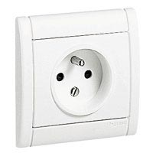

Please bring an extra adaptor if you want to use your laptops, etc.

Local Climate in July

12. Average climate in July in New Caledonia:

Monthly average rainfall, numbers of rainy days
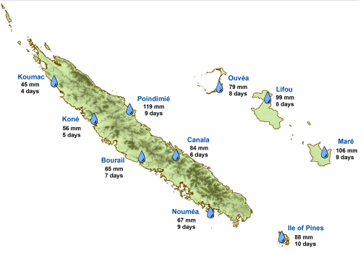

Monthly average min/max temperature
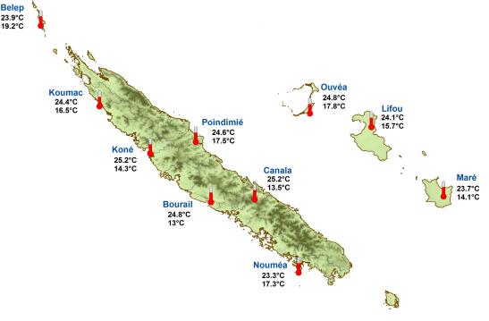

Accommodation and Food

13. Appendix A contains two recommended hotels in Noumea, of which both are within ten minutes walking distance to the meeting venue, with special rates attached to “Tropical Cyclone Committee”.

Both recommended hotels have internet access.

Daily transportation between the hotel and the meeting place is not provided.

14. Participants are requested to make their own hotel bookings well in advance. Participants are requested to make their own bookings by e-mail (clearly mentioning “Tropical Cyclone Committee 2018”) at both addresses: commercial@glphotels.nc & sc@glphotels.nc

15. Participants will find food for their meals in nearby restaurants which are very close to the meeting place (See plan in Appendix A).

LIST OF RECOMMENDED HOTELS

Hotel names | Contact details for reservation | Special Prices “Tropical Cyclone Committee”  (XPF /Euros) |  |  | Distance from Meeting  Place
NOUVATA  123 Promenade Roger Laroque, Noumea  Web: www.nouvata.nc | E-mail : commercial@glphotels.nc  & sc@glphotels.nc | Standard  Room*  (1 or 2 people) | Confort  Room*  (1 or 2 people) | Premium  Room*  (1 or 2 people) | 0.5 km
 |  | 9 500 XPF/  80 euros | 10 600 XPF/  89 euros | 11 600 XPF/  97 euros
HILTON  109 Promenade Roger Laroque, Nouméa  Web: www.hiltonhotels.com | E-mail : commercial@glphotels.nc  & sc@glphotels.nc | 1 bedroom apartment*  (1 or 2 people) | 2 bedroom apartment*  (2 or 4 people) | 1 bedroom apartment*  (3 or 6 people) | 0.4 km
 |  | 18 600 XPF/  156 euros | 24 900 XPF/  209 euros | 28 200 XPF/ 236 euros

*Breakfast not included
**3nd sup. People = 4 700 XPF/39 euros

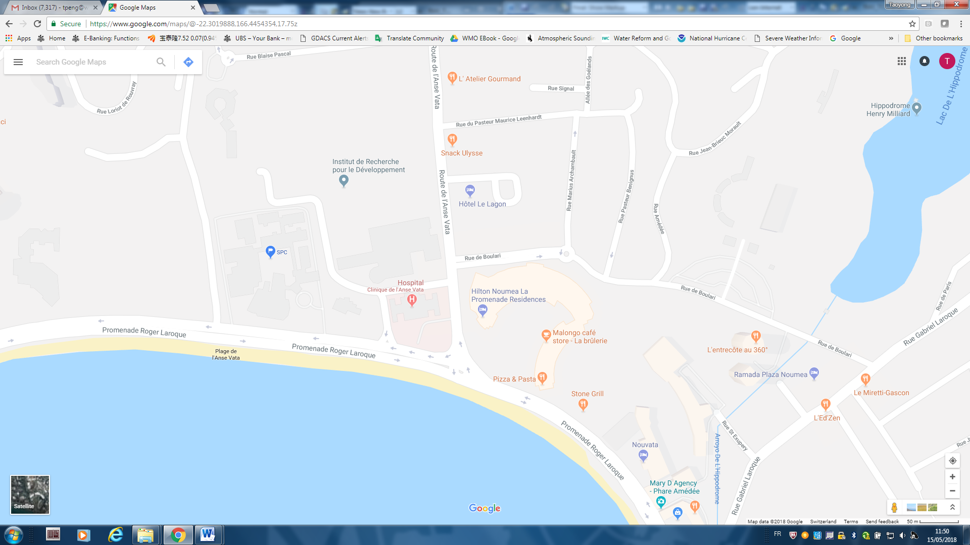

The place marked as “SPC” is the meeting place.

