Severe Weather Forecasting DISASTER RISK REDUCTION Full Demonstration Project (SWFDDP)
REGIONAL SUBPROJECT RA V

PROGRESS REPORT

Full Demonstration phase 1 November 2010 – 28 February 2013

(12 August 2013)




Part of SWFDDP website banner

- Overview:

  - Introduction:

The meeting of the Regional Subproject Management Team (RSMT) of the RA V Severe Weather Forecasting Disaster risk reduction Demonstration Project (SWFDDP) for the planning of the expansion of the Regional Subproject to include nine South Pacific Islands was held from 1 to 4 November 2010, in Wellington, New Zealand. The meeting report can be found at:
Meeting of the Regional Subproject Management Team (RSMT) of the SWFDDP - South Pacific Islands
Based on the success of the Pilot phase of the SWFDDP (1 November 2009 to 31 October 2010), it was concluded that the RSMT will implement a full Demonstration Phase with expanded participation, from 1 November 2010 to 31 October 2012. This was extended beyond this time to tie in with delays in hosting the next RSMT meeting.

The Regional Subproject Implementation Plan (RSIP) can be found at:
Regional Subproject Implementation Plan (RSIP) for the full Demonstration phase of the SWFDDP - South Pacific Islands (pdf).

The principles and the goals of the Project were well outlined in section 1.1 of the plan. The Cascading Forecasting Process of global centres providing products through a lead RSMC to NMHSs is described in section 1.2. The overall framework of the Project in RA V is presented in section 1.3.

Full demonstration phase participants:

A Pilot phase involving a group of 4 participating countries in 2009/10 (Samoa, Vanuatu, Solomon Islands, and Fiji) was completed on 31 October 2010. It was followed by a full Demonstration phase in 2010/12 which includes the 4 Pilot phase NMHSs plus the following five NMHSs: Cook Islands, Niue, Kiribati, Tonga and Tuvalu.

The Regional centres include: RSMC Wellington as lead RSMC for this Subproject (having responsibility for the development and management of a dedicated project Portal), RSMC Darwin (Geographic), and RSMC Nadi (Activity – Tropical Cyclone Centre (TCC)). Fiji also participates in the project as a NMHS.

The Global centres (ECMWF, UK Met Office, USA and JMA) continue to put information on MetConnect Pacific, the Project website. The UK Met Office has tailor made products for the area 150E – 120W, 10N – 40S, which is larger than the 'South Pacific window' - 150E - 150W, 2N -30S for the RSMC Wellington South Pacific Guidance (SPG) charts (see below).

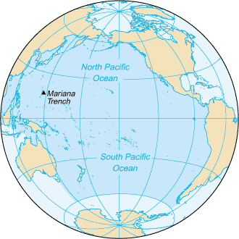

SWFDDP 'South Pacific Window' (subset of the above map)

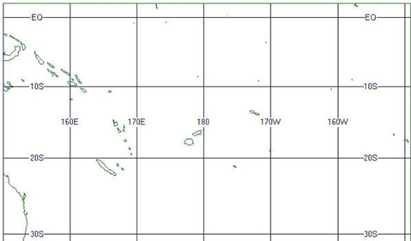

South Pacific Ocean Map (showing location of participating NMHSs)
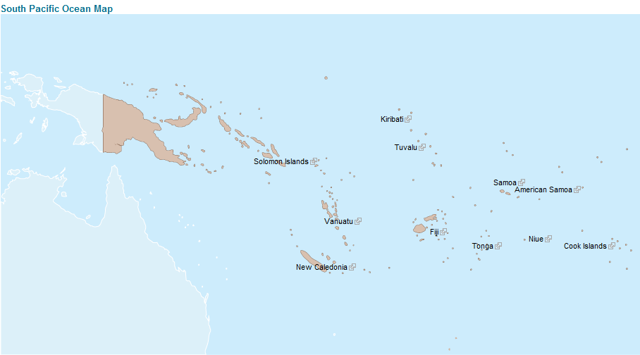

This Progress Report for the full Demonstration phase spans the period 1 Nov 2010 to 28 February 2013. The previous Progress Reports can be found at: http://www.wmo.int/pages/prog/www/CBS-Reports/DPFS-index.html. Comment: Not all reports are here!

This report summarizes the feedback received from the RSMCs and the NMHSs in order to determine the quality of the guidance provided by RSMC Wellington and the NWP data from various global and regional centres. There is also feedback in relation to the SWFDDP goals which refers to the relevance and the quality of the warnings issued, and the level of service provided by the NMHSs to the Disaster Management and Civil Protection Authorities (DMCPAs) and the media.

Of the participating countries, Kiribati, Tuvalu, Tonga, Niue and Cook Islands depend on RSMC Nadi for some or all of their forecasts and warnings. This poses a challenge in how these forecasts and/or warnings should be evaluated when they are issued by somebody else. It was decided each country should accept some degree of responsibility for what goes out to their public and any feedback should be passed on to RSMC Nadi. In this way, it makes sense for each of them to evaluate the forecasts and warnings just as if they had produced them.

2. Input from RSMCs and Global centres:

  - RSMC Wellington:

As the lead RSMC for this project, Wellington continued to provide a platform (MetConnect Pacific at www.swfddp.metservice.com) for the SWFDDP products. This web site also provides helpful background material and links to global centres, other RSMCs and the NMHSs. Twice daily the RSMC forecasters produce a set of severe weather forecasting guidance known as the South Pacific Guidance (SPG) charts.

As agreed in the Implementation Plan, the criteria for including heavy rainfall, strong wind and large wave guidance on these charts were changed from 1 December 2010. The new criteria provide more realistic thresholds in terms of what ranks as a severe weather event, taking into account the vulnerabilities of low-lying islands. The criteria thresholds for rain, wind and waves were raised to: rain ≥ 100mm/24hrs, winds ≥ 30 knots and waves ≥ 2.5m along and north of 15°S, and ≥ 3.5m south of 15°S. Note that the dashed line along 15⁰S on the South Pacific Guidance charts marks the boundary for the change in wave criteria.
The following table shows the number of South Pacific Guidance Charts produced during the full Demonstration phase (except for November 2010 when the criteria for including heavy rain, strong winds and large waves were different) from 1 December 2010 to 28 February 2013 ( 2.25 years) under the various categories. On comparing reports 4 and 7 (brown) covering the active part of those cyclone seasons, note the significant amount of large wave guidance for the more recent period. Note the similarities in the guidance for all phenomena in reports 3 and 6 (green), covering a big slice of the traditional cooler season.
Entire SWFDDP area | Full Demo Report 1 | Full Demo Report 2 | Full Demo Report 3 | Full Demo Report 4 | Full Demo Report 5 | Full Demo Report 6 | Full Demo Report 7
Phenomena | 1 Dec 10 to 28 Feb 11 | 1 Mar to 30 Jun 11 | 1 Jul to 31 Oct 11 | 1 Nov to 29 Feb 12 | 1 Mar to 30 Jun 12 | 1 Jul to 31 Oct 12 | 1 Nov to 28 Feb 13
Heavy rain | 418 | 446 | 458 | 834 | 591 | 450 | 807
Strong wind | 299 | 216 | 62 | 339 | 250 | 85 | 484
Large waves | 392 | 847 | 928 | 541 | 743 | 930 | 833
TC references | 171 | 45 | 0 | 207 | 28 | 0 | 214
Combination of one or more of above | 546 | 949 | 1071 | 962 | 938 | 1009 | 1043
NIL SIG | 354 | 266 | 154 | 248 | 282 | 221 | 157
Total | 900 | 1215 | 1225 | 1210 | 1220 | 1230 | 1200

MetConnect Pacific: MetConnect Pacific website continued to operate without any major hitches throughout the full Demonstration phase. The only upgrade to MetConnect Pacific was released on 15 December 2010. The RSMC Darwin images on MetConnect Pacific were updated twice daily without any hitches throughout the period.
Notable exceptions:
- the RSMC Darwin page was out of action from 19 August 2010 to 15 December 2010 until MetConnect Pacific, version 2 was available.
- the SPG charts weren’t updated at 0300 UTC on 8 September 2012 due to a technical reason.
- the MetConnect Pacific website was down between 0300 and 0630 UTC on 30 June 2012 due to Amazon Cloud server issues otherwise the website continued to be available uninterrupted. As a result, the 0300 UTC issue of the SPG charts was delayed.

  - RSMC Darwin:

RSMC Darwin continued to offer regional NWP guidance and tropical climate monitoring information on the RSMC Darwin web site with a selection of products posted directly on MetConnect Pacific.
The Australian Bureau of Meteorology provided support for SWFDDP by way of in-country training on 'Tropical Cyclone Module' software for forecasters at the Meteorological Services in Fiji, Samoa, Tonga and Vanuatu between February and April, 2011. Other SWFDDP training was also given at the 9th WMO/Bureau of Meteorology Southern Hemisphere Course on Tropical Cyclones and Public Weather Services held in Melbourne, 5-23 September 2011.
ACCESS-TC, the moveable-domain high-resolution tropical cyclone model and its vortex tracker was released in November 2011. Track bulletins are now being sent to RSMC Nadi for use in TC track forecasts, and ACCESS-TC charts and tracks are available on the RSMC Darwin web page.
Upgrading of ACCESS NWP model suite APS1 (Australian Parallel Suite 1) from APS0 commenced early in 2012. The previous ACCESS-G model (80 km horizontal resolution) was replaced by a higher resolution (40 km) model with improved physics and an increased number of vertical levels from 50 to 70.

  - RSMC Nadi
RSMC Nadi (TCC) continued to provide access to its web site through MetConnect Pacific.
RSMC Nadi produces tropical cyclone alerts, warnings, advisory bulletins, Tropical Cyclone Outlook, Track and Threat maps for the South Pacific area.
In addition, RSMC Nadi produces Special Weather Bulletins and Damaging Swell Warnings for Fiji, Cook Islands, Niue, Tuvalu, and Kiribati.

  - Products from global centres:

ECMWF: The ECMWF products continued without interruption during the reporting period and were well received by SWFDDP forecasters.

UK Met Office (UKMO): UKMO products continued without interruption during the reporting period and were well received by SWFDDP forecasters.

JMA: The JMA started contributing to SWFDDP from 15 November 2010 and continue to provide a full suite of NWP data on MetConnect Pacific and SWFDDP forecasters have found it very useful. JMA has also been trialling a heavy rainfall potential product derived from MTSAT on MetConnect Pacific since 30 March 2011. This has been useful for participating countries without access to radar.

NOAA: NOAA started contributing to SWFDDP from March 2011 and continued to provide a full suite of NWP data via a link on MetConnect Pacific. The US NOAA NWS began providing a link in May 2012 to experimental NWP fields extracted from a WRF NWP model nested in the GFS model over a 12km resolution Fiji domain and a 4km Samoa-American Samoa-Niue domain.

3. Comments about the SPG and the NWP products.

RSMC Wellington
US Satellite hydro-estimation data have proved useful in estimating how much rainfall has occurred up to the start of the forecast period or an indication of how much might have fallen during an event just completed.
The UKMO and ECMWF precipitation probability charts continue to give a weak signal at 100mm over 24 hours and a good signal for 50mm. Wellington forecasters rely on both these products, together with the help of pattern recognition, to estimate rainfall totals ≥ 100mm in 24 hours.
The change in the SPG chart wind criteria ties in better with the guidance produced by both UKMO and ECMWF and consequently the number of over-forecast strong wind areas has been kept to a minimum. Forecasters continue to rely on local observations to help determine the areal extent of 30 knot winds on days one and two.
Wave guidance continues to appear on the charts in high frequency, but the change in criteria has made a significant difference to the amount of wave guidance south of 15⁰S. Forecasters continue to access ECMWF wave data specifying each half metre, allowing easier determination of waves ≥ 2.5m, north of 15⁰S and ≥ 3.5m, south of 15⁰S. The model guidance has proved to be very reliable with forecasters picking large wave events from 4 days out.

NMHSs:

South Pacific Guidance charts were useful in forecasting major events. Severe local convective events not forecast on the SPG charts (or in the NWP models) continue to pose a challenge for a number of NMHSs. Usage of NWP products by NMHSs differed from centre to centre depending on the level of skill but there is a tendency to utilise UKMO, ECMWF and RSMC Darwin products more frequently.

4. Project evaluation against SWFDDP goals:

- To improve the ability of NMHSs to forecast severe weather events

All NMHSs agreed that the SWFDDP products and, in particular, the SPG charts have helped to give NMHSs more confidence in forecasting a significant weather or large wave event.

4.2 To improve the lead time of alerting these events

All NMHSs (who issue warnings) agreed that the SWFDDP products helped them provide a good lead time (Generally, 24 to 48 hours, for alerts and 12 to 24 hours, for warnings) or enabled them to issue warnings which wouldn’t have been issued in the past.

4.3 To improve the interaction of NMHSs with Disaster Management and Civil Protection Authorities (DMCPAs) before, during and after severe weather events

Many did not have regular interactions with their DMCPAs. A few had interactions in relation to a major event. Fiji had annual briefings. Vanuatu stated that the NMHS works closely with their DMCPA.

4.4 To identify gaps and areas for improvements

Vanuatu and Fiji found it difficult to verify their forecasts;in particular, large damaging swells without observations. A few NMHSs cited resource problems (e.g. equipment, human resources). NMHSs were very appreciative of the in-country training provided and found the individual tuition very helpful in their understanding of how to use the SWFDDP products effectively.

4.5 To improve the skill of products from Global Centres and RSMCs through feedback from NMHSs

NMHSs found it difficult to forecast localized severe convective events from the guidance provided. They also found it challenging to deal with variations amongst the various global NWP products.

5. Evaluation of the weather warnings:

5.1 Feedback from the public

Outside the TC season, many NMHSs received little or no feedback from the public. For particular events, some NMHSs have been acknowledged for issuing timely warnings.
5.2 Feedback from the DMCPAs

The Vanuatu National Disaster Management Office is appreciative of the warning service provided by the Vanuatu Meteorology and Geo-Hazards Department (VMGD) and a MOU has been signed to re-inforce this close working relationship.
Most NMHSs report little on-going feedback outside of the TC season.
Fiji is playing a leading role in the Coastal Inundation Forecast Demonstration Project (CIFDP) and the organisational setup means Fiji has been drawn into a closer role with its Disaster Management Centre.

5.3 Feedback from the Media

The Fiji media have found the Meteorological Service website very useful for obtaining the latest forecasts and warnings. Generally, there was little feedback from the media except during and after major events. Solomon Islands, Vanuatu and Samoa noted that media promptly relayed warnings.

5.4 Objective verification by the NMHSs

There was no objective verification done by any of the NMHSs.

6. Case studies:

- Solomon Islands: for a wave event in June 2011
- Kiribati: for a wave event on 27-29 August 2011
- New Caledonia: for heavy rain event on 24-25 December 2011 associated with ex-tropical cyclone Fina
- Fiji: on ‘Heavy rainfall and Severe Flooding’ during 30 March to 1 April 2012 presented at the WMO RA V Tropical Cyclone Committee meeting in Samoa 16-20 July 2012.

7. Concluding remarks:

- Progress reports
Some of the NMHSs had difficulties with meeting all the requirements for these reports. In particular, many did not meet the reporting deadline (the middle of the 1st month following the end of the reporting period) notably in reports, number 1 and 7. The reports generally followed the format prescribed except for the first 4 month period. Samoa has made few or no comments with respect to the SWFDDP goals.

- Communications
Outside of the cyclone season, a number of NMHSs didn’t have any interaction with the DMCPAs, media or the public. However during cyclone season, it was a different matter. For example, the March 2012 flood event was a very serious one for Fiji and gave high visibility to the Fiji Meteorological Service. The drenching rain and strong winds were associated with tropical depression 17F. Floods affected most of the western Viti Levu, claiming 5 lives and the Government of Fiji declared a state of Natural Disaster for parts of the Western Division. As a result of a post mortem of this event, the responsibility for issuing flood advisories and warnings was shifted to the Fiji Meteorological Service. In general, the number and quality of interactions between NMHSs and agencies at the end of the Cascading Forecasting Process (e.g. Disaster Management Offices) have been poor given that one of the main goals of SWFDDP is to improve these relationships.

- RSMC Wellington guidance
All NMHSs agreed that the NWP products and SPG charts provided through MetConnect Pacific were very useful in helping to compile their forecasts and warnings. Lead times were increased and the SPG charts gave forecasters confidence in issuing forecasts. Forecasting severe localised storms (below the scale of the SPG or the global products) continue to be an issue for several of the NMHSs. In the absence of radar and a good network of rain gauges, satellite hydro-estimators are a poor man’s tool for helping NMHSs monitor synoptic and smaller-scale convective systems.

- Training
The initial round of in-country training was completed in 2010 for 4 of the additional five countries that joined the Project at the full Demonstration phase. Only Niue missed out and that was addressed during the second round in 2012.
The New Zealand Meteorological Service completed the second round of in-country training for all participating countries between May and November 2012. The training was comprehensive and covered all aspects of the ‘Cascading Forecasting Process’ including a half or full day workshop involving several agencies connected to emergency response. In this regard, MetService would like to acknowledge the role of the New Zealand Ministry for the Environment (MfE) and the New Zealand Ministry of Foreign Affairs and Trade (MFAT) in funding the entire SWFDDP in-country training programme during 2012. The MetService would also like to acknowledge the support provided by USA NOAA NWS staff in helping with and contributing to components of the training in Samoa and Fiji during 2012. The NMHSs were very appreciative of the opportunity to engage in the in-country training and requested that this type of training be conducted again in the near future.

- Sustainability of SWFDDP
Before the Project can move forward into Phase 4, the operational or continuing development phase, there are a number of issues that need to be addressed

Project management: how the Project will be managed within WMO circles once it moves out of the Demonstration phase.

Sources of funding: for future training and IT development work on MetConnect Pacific given that previous sponsors are not likely to be available next time round.

Criteria for assessing the status of SWFDP projects: Apart from the SWFDP goals related to the operational side of the Project, there are no hard data for assessing the current status of the Project and whether it is fitting and right to progress to Phase 4.

Warning systems: There are gaps in the warning system especially in relation to non-tropical cyclone warnings and a table of existing and proposed responsibilities will be presented at the RSMT meeting in Nadi, 26-29 August 2013.

Verification work: There is still no objective verification of warnings produced by any of the NMHSs. A verification table was demonstrated during the in-country training in 2012.

Case Studies: There have been very few case studies done so far (See above). New Caledonia demonstrated how a case study could be done quite simply by following the template provided without any graphics. Case study creations were demonstrated during the in-country training of 2012.

