WORLD METEOROLOGICAL ORGANIZATION

COMMISSION FOR BASIC SYSTEMS

SEVERE WEATHER FORECASTING DEMONSTRATION PROJECT (SWFDP)

GUIDEBOOK ON PLANNING REGIONAL SUBPROJECTS TOWARDS IMPLEMENTATION OF A
MECHANISM TO STRENGTHEN OPERATIONAL CENTRES

Updated March 2016



CBS SEVERE WEATHER FORECASTING DEMONSTRATION PROJECT (SWFDP)

GUIDEBOOK ON PLANNING REGIONAL SUBPROJECTS

TABLE OF CONTENTS

1 - Purpose of the Guidebook

2 – Background to SWFDP and its Cascading Forecasting Process

3 – Vision, Objectives and Scope of the SWFDP

4 – The Four Phases of the SWFDP Regional Subprojects

Phase I – Overall Project Planning
Phase II – Regional Subproject Implementation Planning and Execution
Phase III – Regional Subproject Evaluation
Phase IV – Regional Subproject Long-term Sustainability and Future Developments

5 – Expected Benefits

6 – Responsibilities of the Centres in the Framework of SWFDP Regional Subprojects

6.1 – The Global Centres
6.2 – The Regional Centre(s)
6.3 – The National Meteorological Centres (NMCs) of the NMHSs

7 – Preparation of a SWFDP Regional Subproject

7.1 – Subproject Approval
7.2 – Setting up of a Management Structure
7.3 – Regional Subproject Implementation Plan (RSIP): guide for structure and content

8 – Expansion of SWFDP to a Global Mechanism or Programme to Strengthen Operational Centres

1. Purpose of the Guidebook

1.1 The purpose of this Severe Weather Forecast Demonstration Project (SWFDP) Guidebook is to provide participating centres in the Project with the basic information they need to guide in the planning and the organization of a SWFDP regional subproject and its transition into operational service. The Guidebook includes an introductory section then explains how to prepare the subproject and the expected milestones during its execution.

1.2 This Guidebook has been developed by the Secretariat under the guidance and review of the CBS Steering Group for the SWFDP, also known as the Project Steering Group (PSG),

2. Background to SWFDP and its Cascading Forecasting Process

2.1 The Severe Weather Forecasting Demonstration Project (SWFDP) was initiated to enable all NMHSs to issue effective severe weather warnings to disaster management and civil protection authorities in their respective countries. Using a Cascading Forecasting Process, the Project makes global-scale products available to Regional Specialized Meteorological Centres (RSMC) that integrate and synthesize them in order to provide daily guidance for NMHSs in their geographical region. Thus, the NMHSs have greater capability to identify hazardous weather conditions in the short- and medium-range and issue forecasts and warnings accordingly. Because NMHSs in a geographical region typically need similar products, the Project makes efficiency gains by coordinating their requirements. Where possible, the limited bandwidth of many of the receiving NMHSs is taken into account, with the file sizes of guidance products being minimal..

2.2 The Project contributes to capacity building by helping developing countries access and make use of existing NWP products for improving hazardous weather warnings. It encourages operational forecasters to use relevant standard or newly developed products and procedures, which have already been introduced in many Centres of the Global Data-Processing and Forecasting System (GDPFS). The initial aim was to show how further cooperative work among operational meteorological centres could enhance the forecasting process of several types of severe weather phenomena, which in turn would improve the warning services provided by the NMHSs. However, the concept has evolved and the expected outcomes now include:

- Enhanced capability for NMHSs to forecast severe weather and issue warnings at the national level, including improved accuracy and longer lead-times;
- Established warning processes agreed with national disaster management and civil protection authorities, along with planned responses for protection of lives and property;
- Established forecast processes and Quality Management Systems (QMS), and strengthened forecast capabilities in support of other user sectors in society (such as water, DRR, agriculture and food security, aviation, marine safety and transportation, etc.) at the national level;
- Raised awareness of the value of NMHSs with national governments and their agencies, leading in the long-term to greater national support and investment and leading, in turn, to improved supply of observations and feedback into the GDPFS; and
- Reduced loss of life and damage to property and infrastructure, and contributions to the UN 2030 Agenda for Sustainable Development (Sustainable Development Goals) and Sendai Framework for DRR in achieving their respective goals and targets.

2.3 The SWFDP is implemented in close collaboration with the Public Weather Services (PWS) Programme in order to improve severe weather forecasting and warning services. It has also been coordinating with other WMO technical commissions and programmes to extend the range of applications and broaden the benefits to other user sectors in society.

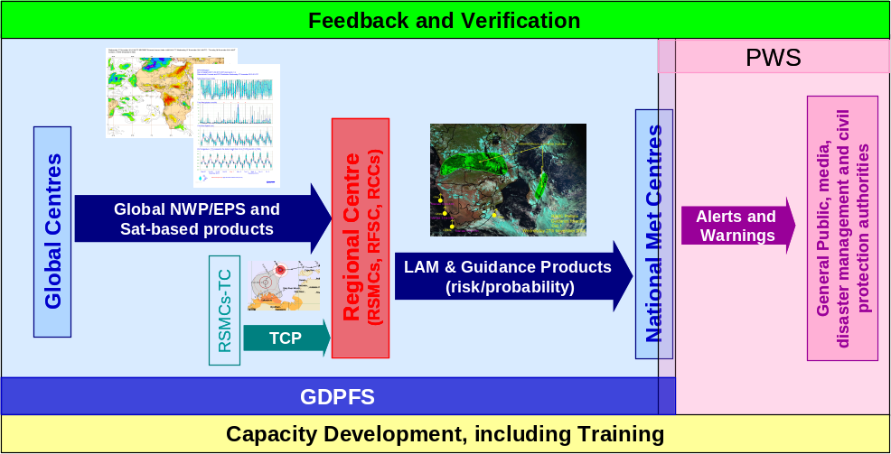
Figure – The Cascading Forecasting Process of the SWFDP.

2.4 Regular training is a critical component of the Project. Forecasters need to know how to make optimal use of the various products coming from the GDPFS Centres. Training is also carried out in service delivery principles and practices including user focus, communication skills and user satisfaction assessment.

SWFDP as an end-to-end cross-programme collaborative activity

2.5 The SWFDP as a demonstration project has demonstrated the value of the Cascading Forecasting Process in strengthening NMHSs, supporting their capability to issue severe weather warnings and to build effective relationships with disaster management and civil protection authorities for disaster risk reduction. This had led the World Meteorological Congress, at its sixteenth session (Cg-XVI, May 2011), to agree that SWFDP should be an end-to-end cross-programme collaborative activity that engages with all WMO programmes that concern the real-time prediction of hydro-meteorological hazards, through their respective technical commissions: from observations, to information exchange, to delivery of services to the public and a range of targeted applications/user sectors, education and training, capacity development and support to LDCs, and to the transfer of relevant promising research outputs into operations.

2.6 The SWFDP develops regional projects in a phased approach, with three phases of development and demonstration followed by a transition to sustainable operations in Phase IV (as explained in Para 4 below). In order to provide the resources to support expansion to cover additional regions towards global coverage, and to maintain a sustainable service in the regions which have reached Phase IV, the project should become a strategic programme of WMO supported by core funding and a permanently staffed Project Office. The SWFDP will continue to be guided by a Steering Group led from the CBS/DPFS, but now involving all relevant technical commissions and programmes.

3. Vision, Objectives and Scope of the SWFDP

3.1 The Cg-XVI (2011) approved a vision for the SWFDP as an end-to-end cross-programme collaborative activity led by the GDPFS, in which the participants in the Projects:

- Make best possible use of all existing and newly developed products and facilities at the global, regional and national levels, including high-resolution NWP and ensemble prediction products, and very-short-range forecasting, including nowcasting, tools;
- Establish sustainable services of reliable and effective early warnings tailored to the needs of the general public and a wide range of socio-economic sectors in developing countries including specially least developed countries (LDCs), Small Island Developing States (SIDSs) ;
- Ensure a continuous improvement cycle and quality assurance of services, including efficient and responsive feedback loops between the NMHSs and the end users at the national level.

3.2 According to the recommendations of the CBS-XIII (2005) the goals of the SWFDP are defined as follows:

- to improve the ability of NMCs to forecast severe weather events;
- to improve the lead time of alerting of these events;
- to improve interaction of NMCs with DMCPA before and during events;
- to identify gaps and areas for improvements;
- to improve the skill of products from GDPFS centres through feedback from NMCs.

3.3 The scope of the SWFDP is to test the usefulness of the products currently available from NWP centres, including EPS products to improve severe weather forecasting services in WMO Members especially where the use of NWP model outputs is limited. Such a demonstration project would make use of the cascading forecasting approach to provide greater lead-time for severe weather warnings and would at the same time contribute to capacity development of the participating NMHSs and improving links with users including especially Disaster Management and Civil Protection Authorities (DMCPA). Given the need to work with DMCPA and media organizations to improve delivery of severe weather warning services to end users, the Public Weather Services (PWS) and DRR aspects are integrated into the SWFDP. Further, as part of WMO Strategy for Service Delivery (approved by Cg-17 , 2015), impact-based forecast and risk-based warnings will be introduced and strengthened through improved engagement of NMHSs with users as part of SWFDP implementation. Ultimately, SWFDP regional subprojects are expected to provide operational support to Multi-Hazard Early Warning Systems (MHEWS) at regional and national levels as envisioned in WMO Road Map for DRR.

3.4 Following ‘Cascading Forecasting Process’ Approach

3.4.1 In the framework of the general organization of the Global Data-Processing and Forecasting System (GDPFS), a SWFDP regional subproject implies a coordinated functioning among three types of GDPFS centres. Conceptually, it should involve one or more global centres, one regional centre and a number of NMHSs located within the area of responsibility of the regional centre. In practice, a project could involve additional regional centres, if beneficial and practical to do so. In case more than one regional centres are involved, one of the regional centres will serve as a lead Centre for regional forecast guidance support and coordination with participating NMCs/NMHSs. Such a regional centre shall preferably be selected from within the geographical area of SWFDP regional subproject.

3.4.2 The SWFDP is a way to apply the cascading approach for forecasting severe weather in three levels, as follows:

- global centres to provide available NWP including EPS products, satellite imagery, nowcasting system etc.;
- regional centres to interpret information received from global centres, run limited-area models to refine products, liaise with the participating NMCs including provision of forecast guidance;
- NMCs to issue alerts, advisories, severe weather warnings; to collaborate with Media, and DMCPA; and to contribute to the evaluation of the project.

3.4.3 The participating centres will be required to adjust and tailor the list of products to the requirements of the particular regional subproject.

4. The Four Phases of the SWFDP Regional Subprojects

The development and implementation of SWFDP regional subprojects involves following four phases:

Phase I: Overall Project Planning. This phase includes:
- identification of the needs for support for NMHSs in consultation with concerned Regional Association;
- the preparatory work necessary to prepare the project specifications;
- to identify the possible participating centres;
- to select suitable regional subproject according to the geographical area, the type of severe weather and the chosen period for the demonstration;
- engagement of funding organizations; and
- the list of types of products to be exchanged.

Phase II: Regional Subproject Implementation Planning and Execution. This phase involves:
- preparation of the detailed specifications, for example: data and products to be exchanged, performance measurements, reviewing and reporting etc.;
- allowing the participants (representatives of the participating GDPFS centres) forming a regional subproject management team to develop the specific regional subproject implementation plan, including a training programme, and to manage its implementation;
- starting demonstration of the subproject which is likely to continue for 1-2 years;
- start submission of progress reports;
- identification of regional entity to take responsibility; and
- engagement with other projects providing similar support for related hazards (e.g. FFGS).

Phase III: Regional Subproject Evaluation. This phase includes:
- the analysis and the evaluation of the entire subproject as well as its contributions to the evaluation of the overall SWFDP with respect to the goals proposed initially;
- to identify gaps and deficiencies, and areas for improvement in order to ensure a sustainability of the organization tested during the demonstration; and
- to provide improved specifications including for other similar regional subprojects.

Phase IV: Regional Subproject Long-term Sustainability and Future Developments. This phase includes:
- long-term sustainability of the benefits gained and a process of continual improvement;
- to continuously take advantage of future capability and technology developments, and to foster broadening of activities in synergy with other WMO projects and programmes; and
- the responsibility for management, including seeking funding, lies with the relevant regional association or a regional entity identified by the regional association , while the PSG continues to be informed of developments and to provide advice as appropriate.

5. Expected Benefits

5.1 The SWFDP aims to demonstrate the benefits of applying the cascading forecast process for severe weather forecasting in the NMHSs, with the intention of not incurring research and development costs. It is viewed as a way to explore how the concept could benefit several NMHSs in the same geographical region while facilitating a certain level of harmonization of forecasts and warnings to render them consistent across the region.

5.2 The SWFDP will help strengthen the links between the NMHS, the DMCPA and the media. This in turn will increase the efficiency and effectiveness of the public warning services in case of severe weather events.

5.3 The SWFDP will provide the opportunity to encourage forecasters to use and experiment with standard products and recommended procedures, which have already been introduced in GDPFS centres and could be relevant to a number of NMHSs that have not yet used them.

5.4 The SWFDP will be a cross-programme activity lead by GDPFS in coordination with other related WMO programmes including AgM, AeM, HWR, TCP, MMO, ETR, SAT and WWRP to ensure that desired, sustainable and relevant outcomes are achievable through implementation of SWFDP regional subprojects in synergy with other projects (e.g. FFGS, CIFDP, METAGRI etc.) as appropriate. Similar SWFDP cascading forecasting process can be applied to improve forecast and warnings for different hazards with multi hazard early warning system (MHEWS) approach including application of the process to benefit widest possible range of sectors such as agriculture and aviation.

The SWFDP underpins basic forecasting capabilities which also enable forecasting for other applications such as aviation and agriculture.

5.6 The SWFDP framework shall be used to implement modernizing enhancements to the forecasting process, as well as to provide a channel for the transfer of relevant promising S&T research and development outputs through trials, such as from the WWRP/THORPEX TIGGE project “Global Interactive Forecast System” (GIFS), and involves the WWRP/SERA to support effective propagation of benefits to society. Other examples include:
- Establish synergies with the High-Impact Weather (HIWeather) project, which aims to develop new forecast and weather impact tools, and seek to trial them with SWFDP as an operational platform and link to end-users;
- Link with Sub-seasonal to Seasonal (S2S) project for seamless forecasts;
- Continue to implement new verification methods through the SWFDP;
- Strengthen synergies with the Nowcasting research activities.

5.7 SWFDP regional subprojects represent the regional infrastructure to support national warnings programmes, including in collecting and conveying the requirements for the “Basic Systems” (including coordination with WIGOS and WIS), while addressing aspects related to severe weather forecasting and warning services. Examples of possible engagement of the other CBS OPAGs and CIMO include:
- WIGOS (e.g. Support for planning and developing/rehabilitating observing networks, education and training in managing observing networks, support for improved integration of satellite data into operational work of NMHS, support for development of regional radar mosaics etc.)
- WIS (e.g. support to enhance data collection, explore options for exchanging information between NMHSs and RTHs or/and send information to centres by means alternative to GTS)
- SAT (e.g. SCOPE-NWC Nowcasting to support SWFDP with nowcasting capabilities, distribution of global and regional centre products through GEONETCAST)
- Observations from WIGOS and SAT used in verification of severe weather forecast

2.3.7 In case a new development project (e.g. regional FFGS) under a WMO Programme is planned to be implemented in a geographical area of SWFDP, it should be appropriately reflected and included in the Regional Sub-Project Implementation Plan of SWFDP in that area. The geographic areas for the new project and the SWFDP should be aligned to meet the requirements of both, wherever feasible.

6. Responsibilities of the Centres in the Framework of SWFDP Regional Subprojects

Specific tasks are attributed to the three types of centres involved in the cascading forecasting process of a SWFDP regional subproject .

6.1 The Global Centres

- to provide the regional and national centres with medium-range NWP including EPS guidance and probabilistic products specially adapted to the concerned severe weather event;
- to suggest suitable existing satellite imagery and satellite-based information that are helpful in assessing the current meteorological situation, and therefore also assess the quality of global NWP including EPS products;
- to evaluate the efficiency of products dedicated to medium-range severe weather forecasting through the feedback provided by the other centres.
- to provide consultations and training support on interpretation of the NWP including EPS products and its usage in severe weather forecasting

6.2 The Regional Centre(s)

- to redirect toward the NMHSs relevant products issued from the global centre(s) (if necessary);to provide NMHSs with its own interpretation of the medium-range guidance, including EPS products if required by the NMHSs and agreed in the regional subproject implementation plan;
- to provide the NMHSs with the short-range NWP guidance (including products adapted to severe weather events), if possible;
- to indicate existing satellite/radar imagery and satellite-/radar-based information that could be used for nowcasting purposes;
- to issue a severe weather daily bulletin (called the RSMC Daily Guidance) summarizing interpretation of NWP including EPS products with respect to severe weather over the responsibility area of the NMHSs if required by the NMHSs and agreed in the regional subproject implementation plan;
- to conduct post event reviews and evaluate its own interpretation of NWP including EPS products and guidance if applicable;
- to provide global centres with a feedback about the usefulness and efficiency of the global products;
- to facilitate the flow of all forecasting guidance information to all participating centres in the SWFDP through a dedicated password protected Web site and portal (Ideally this Web site would be maintained on a 24/7 basis and dedicated for the regional subproject); to coordinate real-time 24/7 communications among the participating centres in the region of the subproject when necessary.
- to provide training support for the regular specialized training programme as designed for the participating NMCs/NMHSs based on the subproject needs.
- to ensure maintenance of its resources (infrastructure, human, technical etc.) to successfully continue its role as a regional centre for the SWFDP regional subproject including adapting to the new technological advancements and capacity development of its staff.
- to share information as digital data in supplement to images where required to support specific applications including for flash flood warning system and agriculture.
- To share higher resolution data where available and required by any new project initiated by a WMO programme.

6.3 The National Meteorological Centres (NMCs) of the NHMSs

- to ensure maintenance of good speed internet at the NMCs to have easy access to all the available products from Global and Regional centres including especially from the lead Regional Centre;
- to interpret the guidance provided by the global centre(s) and the regional centre(s);
- to issue special bulletins and warnings as required by the users (hydrological services, DMCPA services, media, etc.) for dissemination to end users when severe weather is expected;
- to exchange information on warnings with participating NMHSs, and between NMHS and regional centre(s);
- to provide regional and global centres with a feedback on the efficiency of the global and regional products;
- to ensure that the designated Public Weather Services (PWS) Focal Point accesses training opportunities within SWFDP, focused on the delivery of alert and warning services;
- to develop a communication strategy and plan with the media and end users to ensure effective response when warnings are issued;
- to develop skills and procedures to enable NMHSs work effectively with the media including how to write effective press releases, conduct interviews, host press conferences and provide efficient communication channels for the media;
- to establish contacts with DMCPA services and end users prior and during severe weather events;
- to develop if necessary a generic basic set of standard operational procedures between NMHS and DMCPA to ensure effective use of the SWFDP products (to be developed and included as an annex to the regional subproject implementation plan)
- to obtain feedback from users after the event (opportunity of warning, usefulness of warnings, lead time, degree of impacts);
- to obtain feedback from the public, disaster risk management agencies and media on utilization/benefits of warnings issued by NMHS under the SWFDP (templates for user assessment questionnaires are available as annex to this Guidebook);
- to prepare a compiled report on the severe weather events that contains all the data needed to perform the evaluation of both RSMC Daily Guidance relevant to the country, and warnings issued by the NMC;
- to provide training on how to improve communication with the users;

7. Preparation of a SWFDP Regional Subproject

7.1 Subproject Approval

The establishment of a SWFDP regional subproject requires a formal agreement from the participating centres. The WMO Secretariat sends the invitation to participate:

- to the RA President, to seek his consent,
- to the Heads of the participating centres, to request their commitment.

The interested NMHSs in a geographical area can also request to the relevant Regional Association and/or WMO Secretariat for their need to having a SWFDP regional subproject for the area. The WMO Secretariat then can initiate the formal process for development planning of the subproject including exploring availability of necessary funds from extra-budgetary resources for execution of the subproject development activities.

7.2 Setting up of a Management Structure

A regional subproject management team (RSMT) is to be set up with the aim of preparing the implementation of the subproject and managing and controlling its execution.
7.2.1 Role of the Regional Subproject Management Team (RSMT)

The responsibilities of the RSMT are defined as follows:

- to prepare the Regional Subproject Implementation Plan (RSIP);
- to manage and monitor the implementation of the regional subproject.;

7.2.2 Identification of responsible organization in the region

A regional entity should be identified which will take responsibility for ensuring sustainable support for the subproject through into operations (Phase IV). This may be done in collaboration with relevant Regional Association.

7.2.3 Members of the RSMT

The RSMT mainly comprises the following members:

- a Chairperson of RSMT;
- a lead person in each of the participating centres;
- a project Steering Group (PSG) contact person.
- a representative of the regional entity (taking responsibility of the subproject)
- a representative of any other collaborating development project

7.2.4 Responsibilities of the Members of the RSMT

The tasks of the members of the RSMT are as follows:

The chairperson or the RSMT:

- to draft a detailed regional subproject development plan and to share with participating centres;
- to coordinate training requirements that support the demonstration project and to provide information to WMO Secretariat;
- to report on the project to PSG.

The lead persons/members of RSMT from participating global centres:

- To coordinate efforts as appropriate in discharge of responsibilities by their respective global centres as mentioned in Para 6.1;
- to coordinate all aspects of project implementation and execution at their respective global centres;
- to evaluate possible data-processing developments (e.g. work required to adjust or tailor NWP products);
- to identify training support requirements, and prepare regular evaluation of the products during the demonstration phase.

The lead persons/members of RSMT from participating regional centre(s):

- To coordinate efforts as appropriate in discharge of responsibilities by their respective regional centre(s) as mentioned in Para 6.2;
- to coordinate all aspects of project implementation and execution at their respective regional centre(s);
- to evaluate possible data-processing developments (e.g. work required to adjust or tailor NWP products);
- to identify training support requirements, and prepare regular evaluation of the products during the demonstration phase;
- to analyse the feedback/case studies as submitted by the NMHSs/NMCs and evaluate the use of products by NMHSs/NMCs and suggest advice to improve the use of products and carry out case studies.

The lead persons/members of RSMT from NMHSs/NMCs from participating Members:

- To coordinate efforts as appropriate in discharge of responsibilities by their respective NMHS/NMCs as mentioned in Para 6.3
- to coordinate all aspects of project implementation and execution at national and local levels;
- to evaluate possible data-processing developments (e.g. work required to adjust or tailor NWP products);
- to arrange for forecasters in NMHSs/NMCs to receive or have access to the agreed products;
- to define the information to be exchanged with DMCPAs and other end users at national and local levels;
- to define the information to be transmitted to the media;
- to identify training requirements;
- to prepare regular evaluation of the forecasts and warnings during the demonstration phase and ensure submission of feedback including case studies and regular progress reports by NMHSs/NMCs to global and regional centres.

7.3 Regional Subproject Implementation Plan (RSIP): guide for structure and content

7.3.1 RSIP development and required Milestones

The RSMT is responsible for the elaboration of an implementation plan for the regional subproject. The regional subproject implementation plan (RSIP) shall be developed taking into considerations the guidelines as mentioned in this “SWFDP Guidebook” which has been developed to meet the requirements of “SWFDP Overall Plan”. The RSIP should contain description of overall framework following the four phase approach as mentioned above for its implementation including its key objectives and responsibilities of RSMT members and of participating global, regional and national centres. The plan should also contain illustration of the subproject domain and description of targeting severe weather events with thresholds and required products from global and regional centres, timeline of subproject activities and subproject phases, PWS delivery aspects and strategy of NMCs, and the list of regional projects in synergy with SWFDP regional subproject. The four phase approach will facilitate the cascading forecasting process to ensure sustainability of the subproject into operations including future developments.

The SWFDP, in its application of a cascading forecasting process, implies close cooperation and coordination between the centres. The start of the demonstration phase should be defined by the RSMT to preferably encompass the period when selected severe weather events are normally expected to occur. In order to be able to make a significant evaluation of the regional subproject the minimum duration of the demonstration phase should be at least one year. From a practical point of view, electronic correspondence using reliable e-mail accounts is the principle ongoing method for project management and control.

The RSIP should include the following milestones:

- submit a project proposal or plan to the Project Steering Group (PSG);
- convene a kick-off meeting of the RSMT to clearly and precisely define the work to be carried out in each participating centre;
- completion of preparatory training for participants;
- start of the demonstration phase;
- conduct mid-term project review if required;
- end of the demonstration phase or continue demonstration if so necessary to achieve the desired results;
- evaluation of the subproject
- complete the final report for submission to the PSG.

During the demonstration phase it is indispensable to regularly report about the efficiency of the cascading forecast process and the pertinence of the warnings issued by the participating NMHSs. To this aim it is proposed that each participating NMHS prepares a progress report as explained in para 7.3.2.3. It is also strongly recommended to convene a RSMT meeting at mid-term to review the ongoing status of Regional Subproject implementation, to identify the current problems and to decide on immediate adjustments and solutions.

7.3.2 Technical Preparation

In the technical preparation of the SWFDP regional subproject, the RSMT needs to finalize the list and the frequency of the products to be exchanged between the concerned GDPFS centres and to finalize the details of the evaluation procedures. It is also essential to verify the existing telecommunication and data-processing capability and capacity that would allow the transmission and display of the SWFDP requested information. If it is necessary to implement new tasks, the additional work must be carefully evaluated for consideration and decision by the RSMT.

7.3.2.1 Products to be exchanged

To assist participating centres in the demonstration project to define the products (NWP including EPS and satellite-based products etc.) to be exchanged between the various participating centres, a list of sample products for reference and consideration in the forecasting of severe weather is given in the Annex A of this Guidebook. A sample of the content of the RSMC Daily Guidance to be issued by the lead Regional Centre, if applicable, including an example of the Daily Guidance issued from RSMC Pretoria for the SWFDP-Southern Africa is given in the Annex B of this Guidebook. The information to be transmitted by the NMHS toward the end-users when severe weather occurs remains under the responsibility and decision of the NMHS. Nevertheless, the implementation of a SWFDP Regional Subproject is a good opportunity to cooperate with DMCPA and other end users to clearly define the content and the format of the warnings, the preferred lead-times and updates, the communication and the dissemination procedures. NMHSs are also encouraged to engage with users to introduce impact-based forecasts and risk-based warnings for improved decision making process by users.

7.3.2.2 Development of project website and portal

A dedicated and password-protected project website and portal shall be developed and maintained on a 24/7 basis by the lead Regional Centre of SWFDP regional subproject. The website and portal shall be made ready before start of the demonstration phase of the regional subproject and it will facilitate the flow of all forecasting guidance information to all participating Centres.
7.3.2.3 Evaluation of the SWFDP process

The aim of the SWFDP evaluation is:

- to assess the performances of available NWP including EPS products
- to assess the performances of the RSMC Daily Guidance product where applicable;
- to assess the performances of the NMHS warning system;
- to inform about the efficiency of the SWFDP system and the level of satisfaction of the users.

To ensure that the needed information is reliably completed it is proposed that the information for the evaluation may be collected by using an “evaluation form. This evaluation form has to be completed by the NMHS when a severe weather event has been observed or when a severe weather event has been forecast. A sample template of the evaluation form and evaluation table are given in Annex C to this Guidebook. To keep regularly informed the RSMT it is proposed that each participating NMHS shall prepare a quarterly progress report and submit to the WMO Secretariat online through SWFDP database after the end of each quarter. The national focal points for SWFDP (i.e. members of the RSMT) shall be responsible for implementation of the tasks related to the project at national levels including submission of progress reports.

A progress report should contain information about the way the SWFDP is being implemented, such as the NWP/EPS products used in preparing severe weather forecasts and warnings, severe weather events observed, number of warnings issued during the reporting period, probability of detection and false alarms, dissemination channels, clients/users’ feedback etc. The list of key elements and information that need to be reported in progress reports is given in Annex D. To obtain feedback from the users (public, disaster risk management agencies and media) on utilization/benefits of warnings issued by NMHS (under the SWFDP), templates for user assessment questionnaire are available as Annex E to this Guidebook.

7.3.2.4 Telecommunications

It is necessary to verify that the existing telecommunication means are capable to transmit the full amount of information in a timely manner as agreed between the centres participating to the demonstration project. This includes both the current GTS capabilities, broadband Internet access for displaying web pages or for file transmission using FTP. For several regions the possibilities to use satellite broadcast (EUMETCAST, for example in Africa) should be also investigated. If the amount of data to be transmitted exceeds the capabilities of the existing telecommunication means it will be necessary to either enhance the telecommunication capabilities or reduce the list of products to be exchanged. However, with regards to the duties of the NMHS, it is particularly important to ensure that the transmission of the weather warnings to the DMCPA services and media is carried out without delay.

7.3.2.5 Data-processing Capabilities

The data-processing capabilities of each of the centres have to be able to produce and provide the forecasters with the products transmitted to it by the “upstream” centre. Depending on the kind of products, the exchange of new products may imply some additional workload in the regional centres and in the NMHSs. Storage capacity has also to be considered to allow the saving of the relevant products and information for project evaluation purposes.

7.3.2.6 Training

Training is necessary to ensure that forecasters from Regional Centres and NMHSs are able to correctly interpret the various NWP including EPS and guidance products and satellite-based information made available for the SWFDP regional subproject and to prepare user-focused information. Also, the training will inform forecasters of all responsibilities as outlined in the RSIP.

As an additional focus, the training should involve where possible interactions with DMCPAs in each country and others in the field of Public Weather Services (including media organizations) and any other relevant agencies (e.g. Government or non-Government). Such training should take place with reference to any documented guidelines about service delivery principles and practices.

For each SWFDP regional subproject, specialized training programme will be designed based on the regional needs and national requirements. The specialized training programme may include but not limited to the following:

- Two-week training workshops (with week-1 mainly focusing on forecasting and week-2 on service delivery). Such training workshops may preferably be rotated among participating countries of the regional subproject to train maximum Met. personnel and engage national stakeholders in each country;
- Training desk at lead Regional Centre inviting forecasters from selected participating countries;
- In-country visits to pass on the training locally especially to centres with limited human resources (forecasters) and limited capability.

A combination of any two or more of the above options would be ideal in the implementation of the project. It is important to note that any special training session devoted to a regional subproject could be planned in conjunction with existing training programmes organized by the WMO Secretariat or WMO Members. In case if SWFDP regional subproject is aligned to any other project(s) being implemented in the region through a WMO programme (e.g. Regional FFGS), the training activity of such project(s) may be designed and run in conjunction with the SWFDP training programme to complement each other and fulfil the objectives of all projects.

7.3.3 Resourcing and sustainability issues

The cost evaluation of the SWFDP regional subproject will be carried out on the following way:
- in-kind contributions from all participating centres. These may include technical facilities and staffing;
- the RSMT provides costing for all aspects of the subproject, which would mainly be incurred for holding meetings and conducting the trainings;
- the Project Steering Group (PSG) reviews the costing.

Strong commitment shall be needed from all participating centres for the regional subproject development, continuity of its demonstration and for its sustained operations after the end of its successful demonstration and evaluation.

In addition, the WMO Secretariat through its Regional Programme (RP) – Regional Offices, including the Programme for LDCs, Voluntary Cooperation Programme (VCP), and the Resource Mobilization Office (RMO), shall explore seeking extra budgetary funding from donors to support on-going activities the SWFDP regional subproject.

7.3.4 The SWFDP regional subprojects, which have completed the three development and demonstration phases of SWFDP and likely to be ready to become fully operational will require a number of non-operational activities to be supported and funded to ensure they are sustainable as mentioned in the following para.

8. Expansion of SWFDP to a Global Mechanism or Programme to Strengthen Operational Centres

8.1 Once SWFDP transforms from project level to sustainable operational activity (Phase IV), this programme should be named the Severe Weather Forecasting programme (SWFP) which would still retain a close link with the well-established acronym, SWFDP during Phases I-III. There is also a strong emphasis on operational capability through the term forecasting.

8.2 A fully operational regional component of the severe weather forecasting programme, supported by the cascading forecasting process, requires:

- A Regional Management Team (RMT) comprising the PRs (or their representatives) of global, regional and national centres of participating countries, which reports to a Steering Group and the respective regional associations;
- A regional entity (e.g. Meteorological Association for Southern Africa (MASA) for the SWFDP – Southern Africa) to oversee and coordinate, in collaboration with the Secretariat, the subproject activities, including support activities such as training, organizing meetings and resource mobilization. This regional entity requires to be identified before a new SWFDP is initiated to ensure long-term sustainability of subprojects;
- Global centres providing input data and products to the regional and national centres, as agreed through discussions at the RMT;
- A regional centre providing forecast guidance to NMHSs in the region through the cascading forecasting process, and operating and maintaining a dedicated website, as agreed through discussions at the RMT;
- National centres ensuring that appropriate warnings of severe weather are issued.

8.3 In addition to the activities listed above, the sustainability of operational regional components requires a number of non-operational activities to be supported and funded. These activities include:

8.3.1 The Regional Management Team is in charge of:

- The strategic leadership for the region;
- Evaluating Phases I to III of the SWFDP regional subproject, and decide on its transition to operations (Phase IV);
- Defining the criteria for the regional severe weather guidance, based on the NMHS criteria for severe weather warnings;
- Assessing every opportunity to combine with existing activities of other programmes and technical commissions related to hazardous weather, such as for flash flood forecasting, marine and aviation;
- Encouraging the use of the cascading forecasting process by other regional projects to facilitate the implementation of multi-hazard impact-based forecast and risk-based warning services.

8.3.2 The regional entity, in collaboration with the Secretariat, is in charge of organizing:

- RMT meetings around every two years;
- Training for RSMC and NMHS staff on a regular basis, combining on-site training and making use of e-learning facilities;
- Resource mobilization, including sustainable funding for the implementation of new, and further development of the existing, subprojects.

8.3.3 The Steering Group is responsible for:

- Providing strategic oversight for the further development of the cascading forecasting process;
- Monitoring and evaluating the progress of existing SWFDP regional subprojects and their transition to operations; and provide guidance on the planning, implementation and execution of new SWFDP regional subprojects;
- Facilitating the use of the cascading forecasting process by other WMO Programmes and technical commissions’ activities, based on the SWFDP model;
- Developing recommendations to NMHSs, especially those from LDCs, SIDS and MITs, for their full engagement in and benefit from the cascading forecasting process.

8.3.4 The NMHSs should contribute to:

- The evaluation of products and provide feedback to global and regional centre(s);
- Keeping up-to-date their criteria for severe weather warnings, according to the feedback provided by the end-users, and inform the RMT as appropriate.

8.3.5 The regional centre should:

- Be in charge of the routine website maintenance, including upgrades as required;
- Provide regional severe weather guidance, based on the NMHS criteria for severe weather warnings;
- Contribute to the monitoring, evaluation and reporting.

8.3.6 The global and regional centres which contributed to the demonstration phases of the SWFDP regional subprojects are expected to continue to provide support, on the understanding that their data and products would be used only for the intended purpose by the participating regional centres and NMHSs, fulfilling the requirements for designation described in the draft new Manual on the Global Data-processing and Forecasting System (WMO-No. 485).
ANNEX A

SAMPLE LIST OF PRODUCTS TO BE EXCHANGED IN A REGIONAL SUBPROJECT
FOR FORECASTING SEVERE WEATHER

1 - Data and Products issued from the Global Centre to the other Centres.

Products which are not routinely transmitted through the GTS should be provided in graphical form (Web pages) via Internet for rapid display and dissemination, and may also be made available by other methods (e.g. FTP).

1.1 - Current Deterministic NWP Fields up to 5 days – at 6-h Intervals up to 2 days, 12-h intervals after 2 days).

The recommended products include:

- charts to depict the large-scale flow (e.g. 500 hPa , 700 hPa, 850 hPa geopotential height, 850 hPa temperature, upper air winds, MSLP);
- surface weather elements (e.g. 6-hour accumulated precipitation, surface (10m) wind-speed).

In tropical regions other relevant products could also include:

- charts to depict the large-scale flow (e.g. surface streamlines, 850 hPa, 700 hPa, 500 hPa, 200 hPa wind flow and relative humidity, surface streamlines);
- charts to assist with forecasts of tropical cyclone formation, movement and intensification (e.g. 850 hPa, 200hPa relative vorticity and convergence, 850-400 hPa deep layer mean flow, 850-200 hPa vertical wind shear, vertical motion);

Frequency of products and minimum products set for daily distribution should be decided at the kick-off meeting.

1.2 - Probabilistic Forecast Products based on EPS

The recommended products include:

- probability of severe weather events such as precipitation and wind higher than given thresholds;
- “spaghetti” plots (e.g. 500 hPa geopotential height in extra-tropics, precipitation and wind higher than given thresholds);
- stamp maps (e.g. streamlines in the tropics, wind speed, accumulated precipitation);
- dispersion diagrams (plumes and EPSgrams) for weather elements at specific locations;
- representative members of a classification of weather pattern such as clustering or tubing (optional product depending on possibilities of Global Centre);
- severe weather risk index such as Extreme Forecast Index (where available).

If severe weather is associated with a Tropical Cyclone other relevant products could include:

- surface or 850hPa vortex track charts;
- tropical cyclone position fix and track forecast spread (strike probability);
- tropical cyclone formation probability.

1.3 - Satellite Imagery and Satellite based Products
The satellite imagery and satellite based products could include:
- Satellite Images of VIS, IR and WV Channels;
- Diagnostic products, e.g. Imagery with Heavy Rainfall Potential Areas; RGB Composite Imagery;
- Special products for Nowcasting.

2 - Data and Products issued from the Regional Centre to the NMHS

Products which are not routinely transmitted through the GTS should be provided in graphical form (Web pages) via Internet for rapid display and dissemination, and may also be made available by other methods (e.g. FTP).

2.1 To the NMHSs

2.1.1 - Current deterministic Limited Area Model fields up to 2 days at 6-hour intervals

Products could include, for example:

- charts to depict the large-scale flow (e.g. 500 hPa, 700 hPa, 850 hPa geopotential height, 850 hPa temperature, tropopause height, upper air winds, MSLP);
- surface weather elements (e.g. 6-hour accumulated precipitation, surface (10m) wind-speed and gusts (if available), 2m temperature, 850 hPa specific humidity);
- maps of vertical motion, potential vorticity or height of specified PV surface;
- maps of convective indices such as CAPE, Lifting Index, helicity…,
- relevant satellite images (where NMHSs do not have satellite receiving capability);
- special products derived from satellite images (e.g. derived precipitation or images annotated with guidance notes).

In tropical regions other relevant products could also include:

- charts to depict the large-scale flow (e.g. surface streamlines, 850 hPa, 700 hPa, 500 hPa, 200 hPa wind flow and relative humidity, surface streamlines);
- charts to assist with forecasts of tropical cyclone formation, movement and intensification (e.g. 850 hPa, 200hPa relative vorticity and convergence, 850-400 hPa deep layer mean flow, 850-200 hPa vertical wind shear, vertical motion);

Frequency of products and minimum products set for daily distribution should be decided at the kick-off meeting.

2.1.2 – Daily Severe Weather Forecasting Guidance product by RSMC (where applicable) containing the interpretation of products from the Global Centres and Regional Centre with a commentary, containing (as required):

- interpretation of EPS and deterministic products;
- severe weather predictions (risk or probability estimates).
- tropical cyclone formation probability (if necessary)

A detailed content of the RSMC Severe Weather Forecasting Daily Guidance bulletin issued by RSMC Pretoria in the framework of the SWFDP Regional Subproject in RA I (Southern Africa), is given in the Annex B of the Guidebook.

  - Toward the Global Centre

- Feedback on usefulness of the Global NWP products based on the evaluation of case studies and progress reports

3 - Data and products issued from the NMHS(s)
3.1 Toward the users (hydrological services, DMCPA services and other users).

Products should be agreed in the planning stage of the project according to the needs of the users, but might typically include:

- outlook bulletin for potential threats ahead;
- warning bulletin in case of severe weather, including information on probability;
- additional specific maps (if necessary);
- specific nowcasting products to update the warnings.

If severe weather is associated with a tropical cyclone:

- outlook bulletin for potential tropical cyclone formation, tropical cyclone alert or watch containing possible tropical cyclone movement or intensification scenarios;
- tropical cyclone warnings;
- additional specific maps (if necessary, e.g. forecast track maps, strike probability).

3.2 Toward the Regional Centre

- acknowledgement of the RSMC Severe Weather Forecasting Daily Guidance;
- near-real-time information on severe events (including false alarms and non-forecast events) via a Severe Weather Event Evaluation Form (sample template provided in Annex C of the Guidebook).
- the progress report (see Annex D of the Guidebook).

It is very important to prepare carefully the quarterly report and to fill the associated quarterly evaluation table to allow the RSMC to gather the information and to evaluate the pertinence of the RSMC Severe Weather Forecasting Daily Guidance.
ANNEX B

SEVERE WEATHER FORECASTING DAILY GUIDANCE SAMPLE

TO BE ISSUED BY THE RSMC/RFSC/RFSF TOWARD THE NMHSs
FOR SHORT-RANGE SEVERE WEATHER FORECASTING UP TO 48 H
AND MEDIUM-RANGE SEVERE WEATHER OUTLOOK FROM 72 H TO 120 H

The Severe Weather Forecasting Daily Guidance issued by RSMC/RFSC/RFSF may comprise the following parts:

- Part A: Text; depiction of the expected evolution of the weather for the concerned range and comments about the more representative products that are used with reference to figures included in the part B, to charts clearly identified (model, parameter, level, forecast range) or to graphics (EPS charts or meteograms).

- Part B: Figures; charts or graphics coming essentially from deterministic models (global or LAM) for short range forecasts and from Ensemble Prediction Systems (EPS) for medium range outlooks.

- Part C: The assessment of the degree of confidence of the forecast by the forecaster.

- Part D: Tables summarizing the risk of severe weather as assessed by the RSMC. (for short range forecasts) and the probabilities of the relevant parameter higher than a given threshold.

- Part E: Geographical maps (one map/forecast day including the boundaries of the countries with contours identifying the areas which are likely to be hit by the severe weather event (for short range forecasts) or probabilities areas for its occurrence.

The following pages of this Annex give an example of the Severe Weather Forecasting Daily Guidance issued from RSMC Pretoria in the framework of the SWFDP Regional Subproject in RA I (Southeast Africa) focused on heavy precipitation and strong wind forecasting.

(to be replaced by the latest Guidance at later stage)
RSMC-PRETORIA
SWFDP GUIDANCE PRODUCTS

SHORT-RANGE (DAY 1 AND DAY 2)

Issue Date: Friday 22nd December 2006
Valid for: 22nd, 23rd December 2006

- SYNOPSIS OF EXPECTED WEATHER PATTERNS
Day 1: 22nd December 2006
RSMC / TROPICAL CYCLONE CENTRE / LA REUNION
Tropical Cyclone warning (South-West Indian Ocean)
Position 2006/12/22 at 0600 UTC : within 20 NM radius of point 10.2S / 50.0E.Cntral pressure: 980 HPA
Max average win d speed (10 MN) : 55 KT
The system is rapidly weakening in a strongly southeasterly sheared environment.
It has slow down and is expected to curve.

Day 2: 23rd December 2006
TS BONDO near 11S 47E by midday tomorrow.

2. SATELLITE IMAGES AND SYNOPTIC DATA.
Tropical cyclone visible north of Madagascar.

2. DISCUSSION OF GUIDANCE PRODUCTS FROM GLOBAL AND REGIONAL CENTRES
Regional Models (UM SA 12, UM African LAM)

Forecaster: Evert Scholtz.

GRAPHICAL ADDITIONS
F ig 1. Quicksat surface winds DAY 1

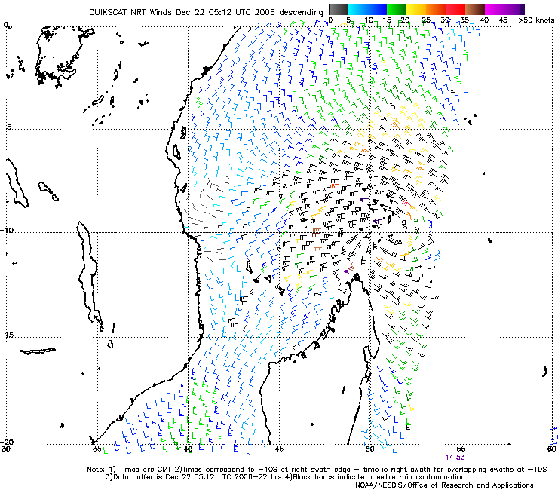

Fig 2. Satellite image and 150-300 Hpa divergence DAY 1

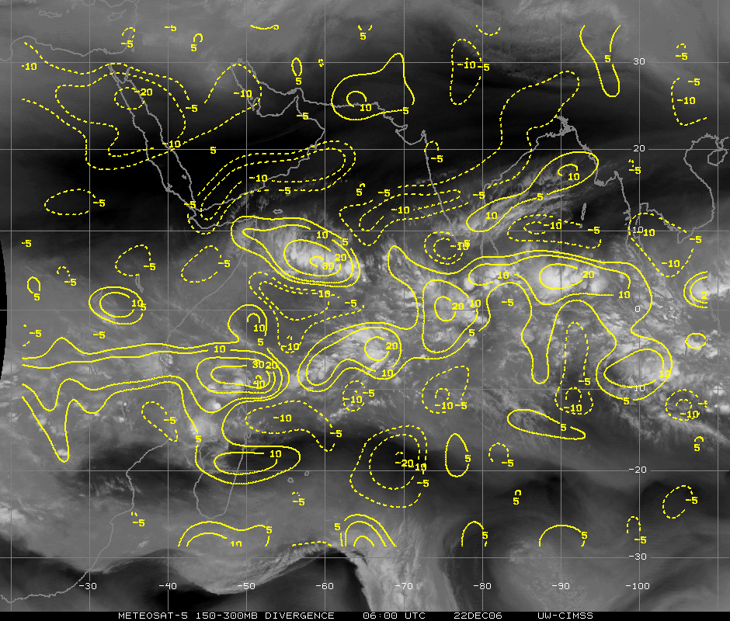
Fig 3. Shear tendency over past 24 h on DAY 1

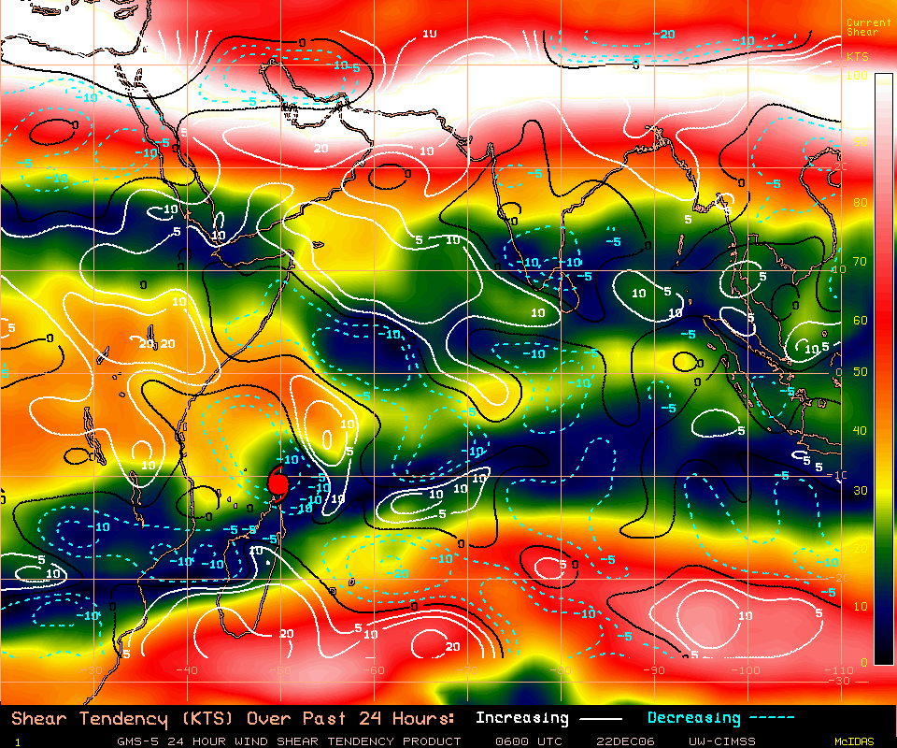

RSMC-PRETORIA
SWFDP GUIDANCE PRODUCTS
RISK TABLES

SHORT-RANGE (DAY 1 AND DAY 2)

Issue Date: 22nd December 2006
In order to provide more information about the geographical location of the severe event the following convention is adopted when filling in the cells: X for the whole country, N for the northern part, S for the southern part, W for the western part and E for the eastern part.

DAY 1: Friday 22nd December 2006
 | HEAVY PRECIPITATION |  |  |  | STRONG WINDS
RISK | No risk | Low risk | Medium risk | High risk | No risk | Low risk | Medium risk | High risk
Botswana | X |  |  |  | X
Madagascar |  |  |  | N |  |  |  | NE
Mozambique | X |  |  |  | X
Tanzania | X |  |  |  | X
Zimbabwe | X |  |  |  | X

DAY 2: Saturday 23rd December 2006
 | HEAVY PRECIPITATION |  |  |  | STRONG WINDS
RISK | No risk | Low risk | Medium risk | High risk | No risk | Low risk | Medium risk | High risk
Botswana | X |  |  |  | X
Madagascar |  |  |  | N |  |  |  | N
Mozambique | X |  |  |  | X
Tanzania | X |  |  |  | X
Zimbabwe | X |  |  |  | X

SEVERE WEATHER RISK MAP
FOR SHORT RANGE (DAY 1 AND DAY 2)

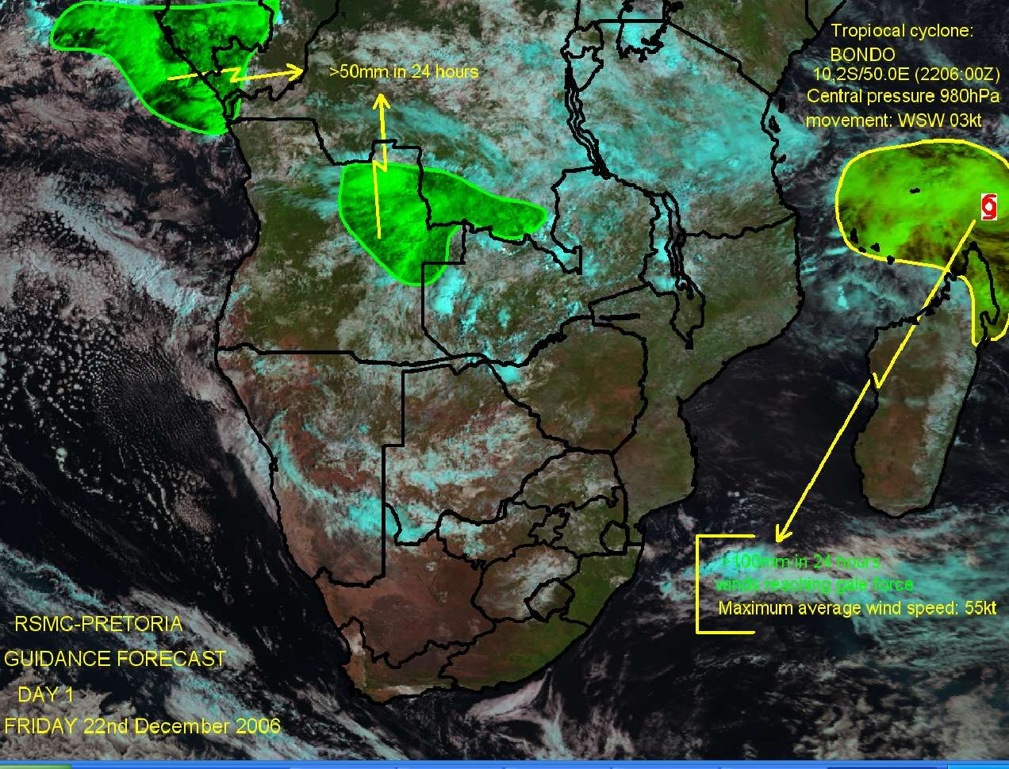

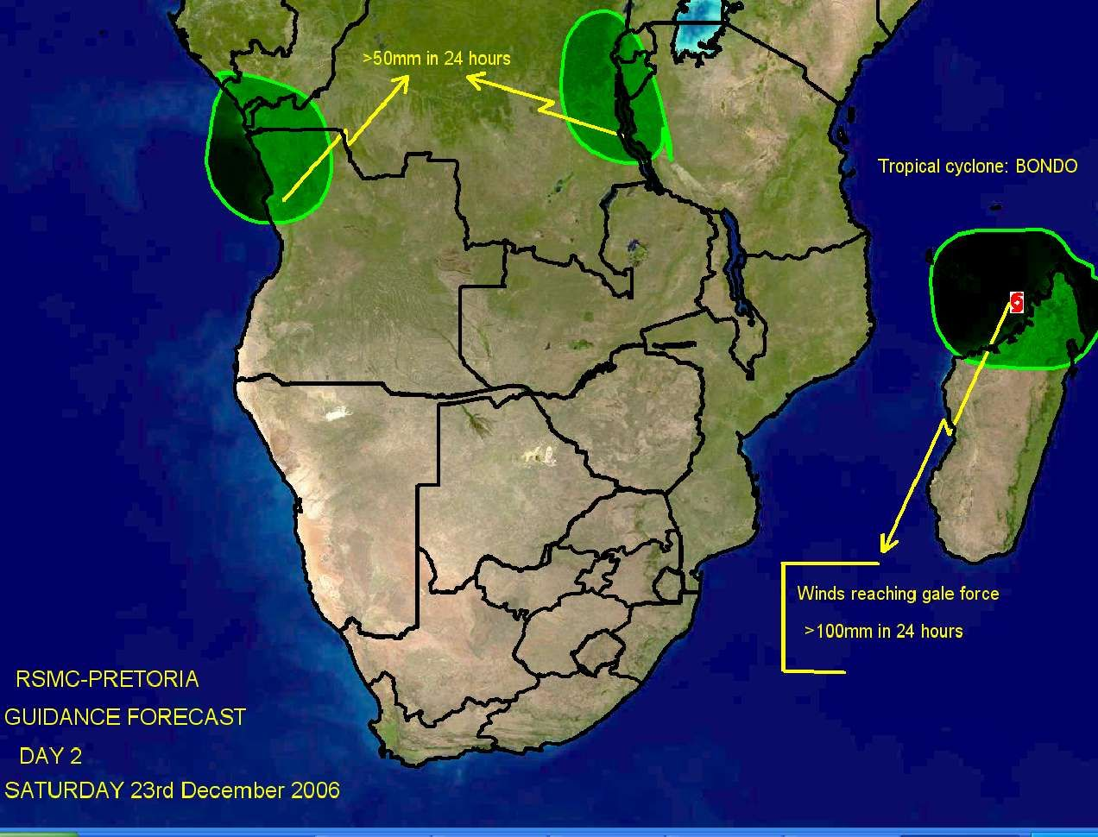
RSMC-PRETORIA
SWFDP GUIDANCE PRODUCTS

MEDIUM-RANGE (DAY 3, DAY 4 AND DAY 5)

Issue Date: 22nd December 2006
Valid for: 24th , 25th & 26th December 2006

- SYNOPSIS OF EXPECTED WEATHER PATTERNS
DAY 3 24th December 2006
According to ECMWF, GFS & NOAA NWS the tropical low will be situated on the north-west coast of Madagascar on day 3. with central pressure close to 1000hPa.
Degree of confidence (moderate to high)

DAY 4 25th December 2006
Tropical low (ex-BONDO) still on the north-west coast of Madagascar.
Degree of confidence (moderate to low – mainly uncertainty relating to speed / movement / positioning of tropical system)

DAY 5 26th December 2006
Tropical low (ex-BONDO) moving into to the central part of the Mozambique channel and intensifies with central pressure below 1000hPa. ( by day 6 ECMWF moves it towards Mozambique coast and making landfall near Xai-Xai on the south coast of Mozambique on day 7, 28th December.
Degree of confidence (low – mainly uncertainty relating to speed / movement / positioning of tropical system – with a 5 day lead-time there is extreme uncertainty in this regard)

- DISCUSSION OF GUIDANCE PRODUCTS FROM GLOBAL AND REGIONAL CENTRES
(Comments about the products that are used with reference to figures or charts included under bullet 3)

Forecaster: Evert Scholtz.

GRAPHICAL ADDITIONS

Fig 1. 1000 Hpa Relative humidity and streamlines DAY 3.

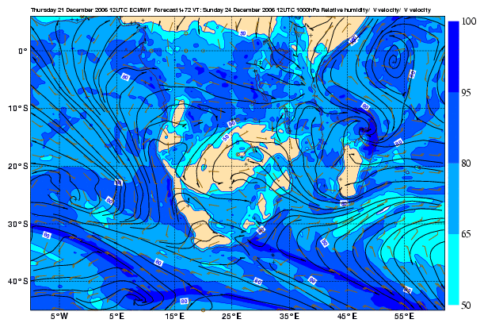

FIG 2. 1000 Hpa Relative humidity and streamlines DAY 4.

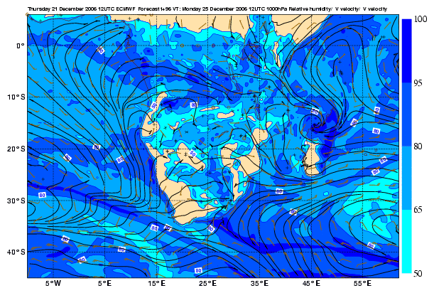
Fig3. 1000 Hpa Relative humidity and streamlines DAY 5.

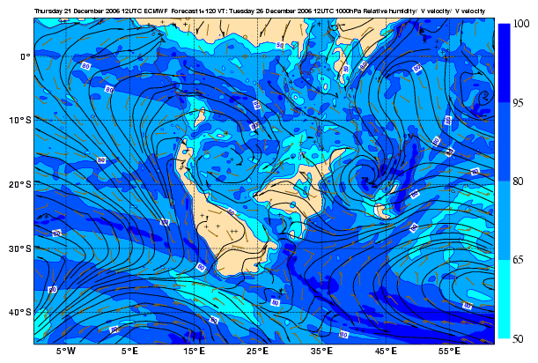

RSMC-PRETORIA
SWFDP GUIDANCE PRODUCTS
PROBABILITY TABLES

MEDIUM-RANGE (DAY 3, DAY 4 AND DAY 5)

Issue Date: 22nd January 2007

In order to provide more information about the geographical location of the severe event the following convention is adopted when filling in the cells: X for the whole country, N for the northern part, S for the southern part, W for the western part and E for the eastern part.

DAY 3: 24th January 2007
 | HEAVY PRECIPITATION  (exceeding threshold 50 mm/6 hrs) |  |  |  | STRONG WINDS  (exceeding threshold 20 kts)
Probability | <10% | 30% | 60% | >80% | <10% | 30% | 60% | >80%
Botswana | X |  |  |  | X
Madagascar |  | E coast |  |  | X
Mozambique | X |  |  |  | X
Tanzania | X |  |  |  | X
Zimbabwe | X |  |  |  | X

DAY 4: 25th January 2007
 | HEAVY PRECIPITATION  (exceeding threshold 50 mm/6 hrs) |  |  |  | STRONG WINDS  (exceeding threshold 20 kts)
Probability | <10% | 30% | 60% | >80% | <10% | 30% | 60% | >80%
Botswana | X |  |  |  | X
Madagascar |  |  | E coast |  | X
Mozambique |  | Cent coast |  |  | X
Tanzania | X |  |  |  | X
Zimbabwe | X |  |  |  | X

DAY 5: 26th January 2007
 | HEAVY PRECIPITATION  (exceeding threshold 50 mm/6 hrs) |  |  |  | STRONG WINDS  (exceeding threshold 20 kts)
Probability | <10% | 30% | 60% | >80% | <10% | 30% | 60% | >80%
Botswana | X |  |  |  | X
Madagascar |  |  | E coast |  | X
Mozambique | X |  |  |  | X
Tanzania | X |  |  |  | X
Zimbabwe | X |  |  |  | X

SEVERE WEATHER PROBABILITY MAP
FOR MEDIUM RANGE (DAY 3, DAY 4 AND DAY 5)

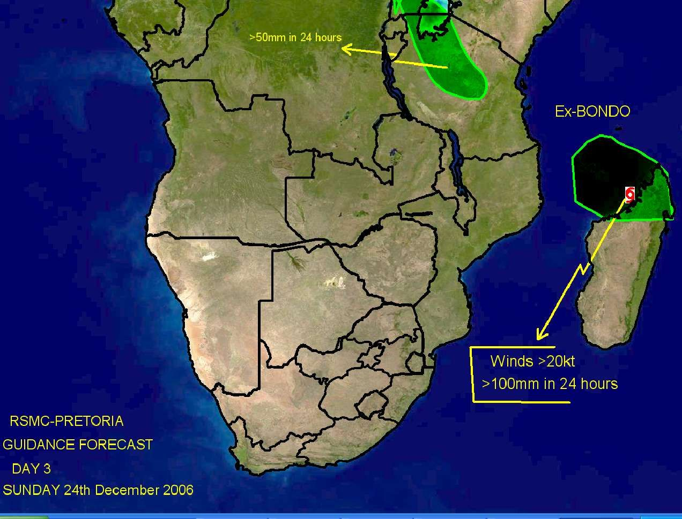

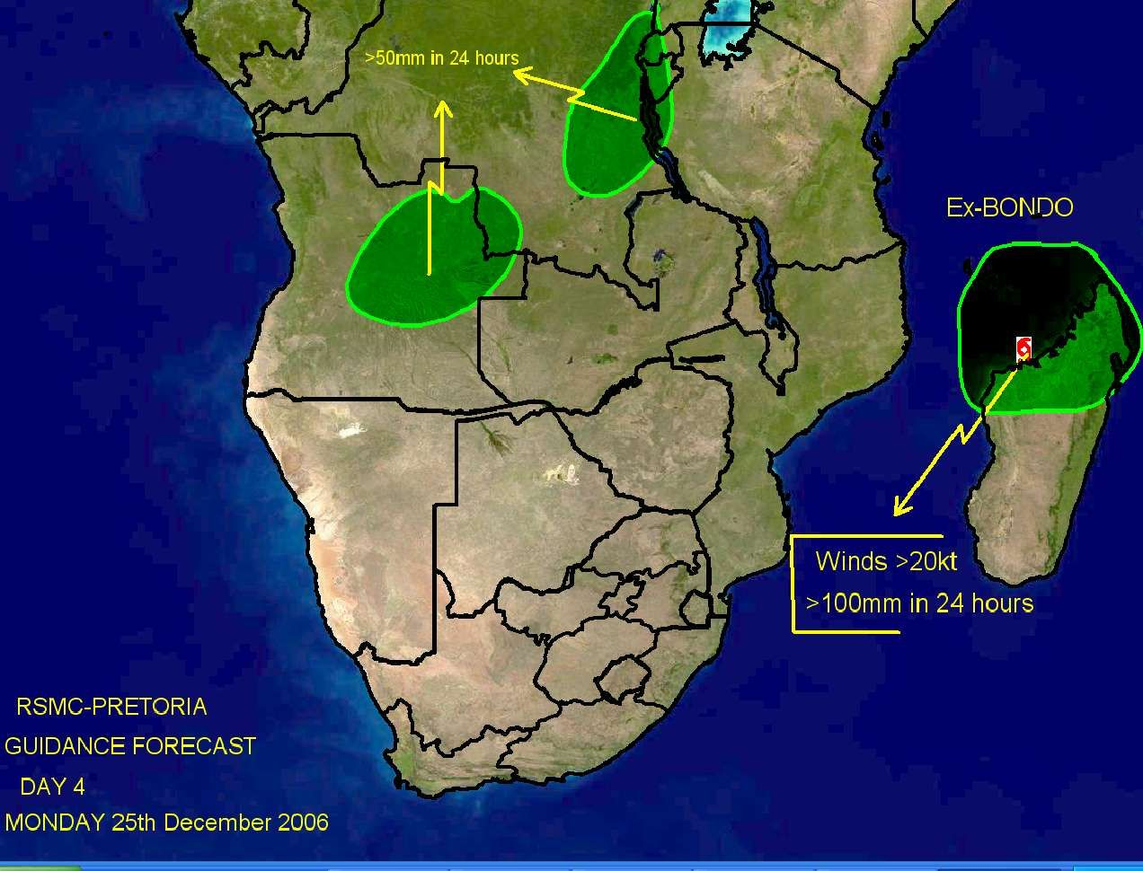

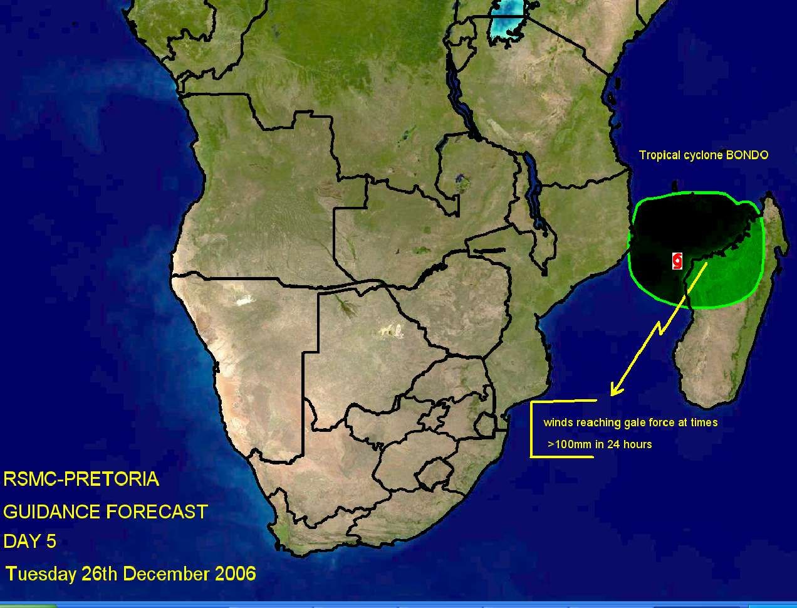

ANNEX C

EXAMPLE OF A SEVERE WEATHER EVENT EVALUATION FORM

The proposed evaluation form should allow to evaluate the performance of the RSMC Severe Weather Forecasting Guidance and as well as the efficiency of the NMHS warning system.

It must be completed by the NMHS in both of the following cases:
- a severe weather event has been observed; and
- a severe weather event has been forecast.

The evaluation form should document the characteristics of the severe weather event (whether observed or forecast) and allow to evaluate the efficiency of the forecasts given by the RSMC Severe Weather Forecasting Daily Guidance as well as the performance of the warnings issued by the NMHS. Therefore it should include the three following sections.

Section A – Identification of the severe weather event:
- NMHS concerned;
- number of the event;
- type of event;
- region affected.

Section B – Information about the observed weather event:
- start and end times of the severe weather event;
- maximum observed value of the characteristic parameter;
- assessment about the efficiency of the warning given the DMCPA;
- information from the end-users (number of interventions, casualties, damages, usefulness of the warning ).

Section C – Information about the forecast and warning issued from the NMHS:
- lead-time of the warning;
• start and end time of the severe weather event according to the forecaster’s assessment;
• level of risk as indicated in the RSMC Severe Weather Forecasting Daily Guidance;
- probabilities of medium-range in the RSMC Severe Weather ForecastingDaily Guidance;
- usefulness of the various products (RSMC Guidance, various models);
- comments including information on usefulness and applicability of used tools.

How to use this evaluation form to evaluate the performance of warnings ?

The common way to evaluate the performance of a warning system is based on the 2 x 2 contingency table matrix including the number of justified warnings (“hits”) “a”, the number of missed severe events “b” and the number of false alarms “c”. The POD index (Probability of Detection) is defined as the ratio of the number of hits by the total number of severe events, i.e., a/(a+b) ; the FAR (False Alarm Ratio) is defined as the ratio of the number of false alarms by the number warnings issued, i.e., c/(a+c).The information contained in the proposed evaluation form enables to computes the performance indicators of the warning issued by the NMHS as long as the assessment of the DMCPA (in section C) is correctly taken into consideration.

A template of an evaluation form is provided in the following pages. The evaluation form is to be filled by the NMHSs (preferably by a forecaster or manager of the forecasting unit) participating to the SWFDP regional subproject. This template can be modified with respect to the products selected for preparing the severe weather forecasts and warnings.

It is important that the design of the evaluation form be adapted to allow the data and information to be easily gathered and transformed into a tabular form. Avoid unnecessary and repetitive typing, and as much as possible to encourage and allow reliable creation and maintenance of the dataset that is needed to analyze and evaluate the performance indicators.

SEVERE WEATHER EVALUATION FORM
 | (Page 1)
INSTRUCTIONS: | :
1. This form must be filled in whenever: |  |  | (1) Severe weather is observed (Sections A and B)
 |  |  | (2) A warning has been issued to DM/CPA (Sections A and C)
2. Email the completed document to RSMC Pretoria, WMO and other agreed recipients
To standardize please put the title “SWFDP Evaluation Form” in the title list of the email
A. IDENTIFICATION OF THE SEVERE EVENT
NMHS: |  |  |  | Alphabetic
Region affected: |  |  |  | Alphabetic
Event Number: |  |  |  | Numeric
Type of event: |  |  |  | Numeric |  | (put the right number in the cell)
1: Heavy Precipitation | (indicate the most significant phenomenon,
2: Strong wind | either heavy precipitation or strong wind)
Severe convection |  |  |  | Numeric |  | (put 1 if extreme phenomena are  the consequence of severe  convection or 0 otherwise)
B. SEVERE WEATHER OBSERVED (to be completed even if no severe weather has been forecast)
 |  |  |  | JJ | MM | DD |  | HH | MM
 | Start of the event: |  |  |  |  |  | at |  |  | UTC
 | End of the event: |  |  |  |  |  | at |  |  | UTC
Max. observed value: |  |  |  | Unit
 | Numeric |  | Alphabetic
(According to the event: accumulated precipitation, gusts, other significant parameter)
Information from the end-users
short text explaining the consequences and possibly some figures
(number of interventions, casualties, damages, usefulness of the warning )

SEVERE WEATHER EVALUATION FORM
 |  | (Page 2)
C. SEVERE WEATHER FORECAST (to be completed even if severe weather did not occur)
 |  |  |  | JJ | MM | DD |  | HH | MM
Time of the warning | toward DMCPA |  |  |  |  |  | at |  |  | UTC
Start of the event; | forecaster assessment |  |  |  |  |  | at |  |  | UTC
End of the event; | forecaster assessment |  |  |  |  |  | at |  |  | UTC
Usefulness of the warning (feedback from the DMCPA)
check in the chosen cell |  |  | Lack of warning
 |  |  | False alarm warning
 |  |  | Late warning
 |  |  | Useful warning
Level of risk as appreciated by RSMC |  |  | (put 1 in the chosen cell)
 |  |  |  | No |  | Low |  | Med. |  | High
Level of risk | 1 day before:
Level of risk | 2 days before:
Probabilities of medium range outlooks as appreciated by RSMC
Probability | 3 days before: |  |  |  | %
Probability | 4 days before: |  |  |  | %
Probability | 5 days before: |  |  |  | %
Mark for usefulness of products (put 1 in the chosen cell)
 |  |  |  | Guidance
 |  |  | RSMC
KEY |  |  |  | NWP | EPS
A = Very useful (basis of the warning) |  |  | ECMWF
B = Useful (aided warning confidence) |  |  | NCEP
C = Neutral (not useful) |  |  | Met Office
D = Negative (misleading) |  |  | RSMC LAM
X = Not used
Comments including information on usefulness and applicability of used tools

SEVERE WEATHER EVALUATION FORM
(Page 3)
Quarterly Evaluation Table (to be fulfilled based on the Severe Weather Event Evaluation Form)

A row has to be filled in this table whenever a severe weather event is observed or a warning is issued toward DMCPA.
Starting date  of the event | SWFDP  Evaluation  Form  Event  Number | Type of event | Region affected | Highest observed value | RSMC Guidance |  | Which NWP/EPS forecast product(s) used by NMC |  | Local warnings issued? | Impact of the event | Impact of the warning
dd/mm/yy |  | Indicate if extreme phenomena are the consequence of severe convection | Indicate the region of the country hit by the severe weather | specify  units, according  to the phenomenon | Amount predicted  (same unit as in the preceding column) | Usefulness  from 1 to 4  1- Misleading  2 - Not useful  3 - Useful  4 - Very  useful | Indicate the model(s) used | Usefulness  from 1 to 4  1- Misleading  2 - Not useful  3 - Useful  4 - Very  useful | Yes  or  No | Damages, Casualties | According to the DMCPA assessment

ANNEX D

SWFDP Progress Report key elements and information

Important elements & information to be reported in the Quarterly Progress Report (to be submitted on-line through SWFDP database)

- Reporting Period (Start date to end date)
- Severe events (e.g. heavy rainfall, strong winds, high waves, flooding etc.)
- Reporting period highlights (e.g. duration and amount of rainfall, impact of rainfall and/or strong wind and high waves, affected areas, damages (if any), coordination with disaster management offices etc.)
- Clients (e.g. Disaster Management Offices, media, humanitarian organizations etc. New clients can also be added)
- Client feedback (e.g. adequacy and effectiveness of the warning and how it was used etc.)
- Desired products (e.g. NMHS may propose a demand for additional product(s) from global and/or regional centres if already not available etc.)
- Forecast Period and Area (to provide information about area of responsibility of an NMHS and the period for which NMHS issues forecast etc.)
- Dissemination channels (e.g. TV, radio, mobile SMS etc. New channel can also added)
- Observing Systems (e.g. basic synoptic network, AWS network, radar and satellite information receiving stations etc.)
- Workshop (to provide title, duration and summary outcome of the training workshops arranged for the forecasters, emergency managers, media, school officials, general public etc. during the reporting period)
- Product usage (to select various products which are available from participating global and regional centres and are used in making forecasts at national level etc.)
- Local forecasting tools (to provide information about the existing forecasting tools used at the NMHS and any new forecasting tool implemented at the NMHS etc.)
- Resources (to provide information about the budget of NMHS and the number of forecasters and observers working in NMHS etc.)
- Case Studies (to provide title and description of case studies related to the severe event(s) observed during the reporting period, key findings of the study etc.)
- Related projects (to provide information about the on-going and new related projects etc.)

- PROJECT EVALUATION AGAINST SWFDP GOALS

SWFDP GOAL | COMMENTS ON PROGRESS TOWARDS EACH GOAL | Questions to help you with an answer for each box
To improve the ability of NMHSs to forecast severe weather events |  | How did the products on the RSMC New Delhi help you make better severe weather forecasts and warnings?
To improve the lead time of alerting these events |  | How much earlier do you issue severe weather forecasts & warnings now compared to before?
To improve the interaction of NMHSs with Disaster Management and Civil Protection authorities (DMCPAs), the media, and the public, before, during and after severe weather events |  | Comment on any interactions with your disaster agency, media agencies and the public. Please indicate if there hasn't been any interaction since the last repor,.
To identify gaps and areas for improvements |  | What are the weaknesses in your forecast system?
To improve the skill of products from Global Centres through feedback from NMHSs |  | What weaknesses have you found in the products from RSMC, New Delhi, JMA, NCEP, UKMO, ECMWFetc.?

- EVALUATION OF PWS COMPONENT

Users | Question | Answer | Comments
Public | Any feedback from the public? | Yes or No | If Yes, please give details.
Public | Any public reaction when the warnings were heard or received? | Yes or No | If Yes, please give details.
Public | Were there any difficulties in obtaining feedback? | Yes or No | If Yes, please give details.
Disaster Management | Any feedback from disaster management authorities about the timeliness and/or usefulness of the warnings | Yes or No | If Yes, please give details.
Disaster Management | Were safety messages and/or call to action statements issued by the disaster management authority in agreement with your forecasts & warnings? | Yes or No | If Yes, please give details.
Media | Any feedback from the Media? | Yes or No | If Yes, please give details.
Media | How did your relationship with the Media work in getting warnings delivered? | Yes or No | If Yes, please give details.
Media | Were their difficulties in working with the Media? | Yes or No | If Yes, please give details.

- SUMMARY (general comments, challenges, etc)
- CASE STUDY (PowerPoint presentation to include guidance products (RSMC and NWP), satellite imagery, warnings issued, impact evidence etc.)

Case studies for each severe weather event DON'T need to be completed at the same time as the rest of this report.

Comment: Case studies don't need to be long. What's important is the learning experience that you gain from actually doing the case study.

- SEVERE EVENT EVALUATION
(See Severe Weather Event Evaluation Form)

ANNEX E : USER ASSESSMENT QUESTIONNAIRE

E.1: Evaluation Questionnaire for the Public

Q1. Do you get the warnings and forecasts issued by the National Meteorological Service?

Yes | No
□ | □

Q2. Do the warnings and forecasts arrive early enough for you to take any actions?

Yes | No
□ | □

Q3. How Do you get the forecasts and warnings? (Can choose more than one)

Radio | TV |  | Internet | Telephone | Local radio  network | Other(s)
□ | □ |  | □ | □ | □ | □

If other(s), please specify:

Q4. Do you understand the warnings and forecasts?

Yes | No
□ | □

Q5. Do you take any action in response to the warnings and forecasts?

Yes | No
□ | □

If yes, what did you do?

Q6. The warning was useful to protect your (Can choose more than one)

family | home | boat | farm | animals | other(s)
□ | □ | □ | □ | □ | □

If other(s), please specify:

Q7. Are warnings issued by the National Meteorological Service correct?

Yes | No | More or less
□ | □ | □

Q8. Are forecasts issued by the National Meteorological Service correct?

Yes | No | More or less
□ | □ | □

Name: Date:

E.2: Evaluation Questionnaire for Disaster Management

Q1. Did you get the warnings for the severe weather events in the period.…to….? (Specify)

Yes | No
□ | □

Q2. Did the warnings arrive early enough for you to take the necessary actions according to your specified responsibilities?

Yes | No
□ | □

Q3. How did you get the warnings? (Can choose more than one)

Radio | TV | Fax | Internet | Telephone | Local radio  network | Other(s)
□ | □ | □ | □ | □ | □ | □

If other(s), please specify:

Q4. Did you understand the warnings?

Yes | No
□ | □

Q5. Did you take any action in response to the warnings?

Yes | No
□ | □

If yes, what did you do?

Q6. In your opinion were the warnings correct?

Yes | No | More or less
□ | □ | □

Q7. Do you have any suggestions on how to improve the warning process, including dissemination methods, format, language etc.

Post and name: Date:

E.3: Evaluation Questionnaire for Media

Q1. Do you get the warnings for the severe weather events and forecasts from the National Meteorological Service?

Yes | No
□ | □

Q2. Do the warnings and forecasts arrive early enough for you to take the necessary actions according to your specified responsibilities?

Yes | No
□ | □

Q3. How do you get the warnings and forecasts? (Can choose more than one)

Radio | TV | Fax | Internet | Telephone | Local radio  network | Other(s)
□ | □ | □ | □ | □ | □ | □

If other(s), please specify:

Q4. Do you understand the warnings and forecasts?

Yes | No
□ | □

Q5. Are the language and format clear enough for you?

Yes | No
□ | □

Q6. Do you take any action in response to the warnings and forecast you receive?

Yes | No
□ | □

If yes, what do you do?

Q7. In your opinion are the warnings and forecasts accurate?

Yes | No | More or less
□ | □ | □

Q8. Do you have any suggestions on how to improve the warning and forecast process, including dissemination methods, format, language etc.

Post and name: Date:

