WMO Severe Weather Forecasting Demonstration Project (SWFDP)
SWFDP Regional Subproject for Southeast Asia (SWFDP-SeA)
Regional Training Workshop on Severe Weather and Impact based Forecasting and Warning Services
(Vientiane, Lao PDR, 19 February - 1 March 2019)

INFORMATION NOTE FOR PARTICIPANTS

1. MEETING VENUE
The SWFDP-SeA Regional Training Workshop on Severe Weather and Impact based Forecasting and Warning Services will be held at the Headquarters Office of the Department of Meteorology and Hydrology (DMH), Avenue, Ban Akad, Sikhottabong District, Vientiane, Lao PDR, from 19th February to 1st March 2019. More details about the meeting venue and location map are provided in Appendix A.

The participants are requested to bring their laptops to the workshop.
2. LOCAL ORGANIZATION COMMITTEE (LOC)
- Mr. Bounteum Sysouphanthavong
Weather Forecasting and Warning Division,
Department of Meteorology and Hydrology (DMH), Souphanouvong Avenue, Ban Akad, Sikhottabong District, Vientiane, Lao PDR
Tel: +856-20-56505997
E-mail address: s.bounteum@hotmail.com

- Mr. Viengxai Manivong
Administration Division
Department of Meteorology and Hydrology (DMH), Souphanouvong Avenue, Ban Akad, Sikhottabong District, Vientiane, Lao PDR
Tel: +84 856-21-215010
E-mail address: vxmanivong.dmh@gmail.com

3. VISA/ENTRY REQUIREMENTS
A valid passport is necessary for all persons entering Lao PDR. Some countries may need visa. Participants can apply the visa from the nearest Lao diplomatic and consular mission. There are 14 types of visas (with different conditions) for foreigners to enter Lao PDR. For more information about visas, their types and condition, and visa exemptions, please visit following website: http://www.immigration.gov.la/visas.html
For further information, please visit the website of the Ministry of Foreign Affair (MOFA) of Lao PDR: http://www.mofa.gov.la/index.php/
Please contact the local organizer if you require any assistance. Please see Appendix B.

4. REGISTRATION
Participants are requested to complete the Registration Form (Appendix B) and send to the LOC email address as above-mentioned.
5. ACCOMMODATION
There are many hotels located in downtown and near to the meeting venue as per convenience to the participants including for food, drinks & shopping etc. Participant can book the hotel directly through internet. If so require, LOC can also be requested for help. Detail of room rates, web links and locations of hotels are provided in the table below:
Hotel Names | Appox. Price (LAK) | Websites | Distance From DMH | Location
Landmark Mekong Riverside Hotel | 1,300,000 | https://landmarkmekongriversidehotel.com/en/redefining-luxury/ | 6.9 km | Don chan Rd., Buengkayorng village
Dhavara Boutique Hotel | 1,080,000 | https://www.dhavarahotel.com/ | 4.1 km | Rue Mantharourath, Ban Haysoke
Crowne Plaza Vientiane | 1,000,500 | https://www.ihg.com/crowneplaza/hotels/us/en/vientiane/vtecp/hoteldetail | 3.1 km | Rue Setthathilath, Nong Duang Village
Salana Boutique Hotel | 1,000,500 | http://www.salanaboutique.com/ | 3.7 km | Chao Anou Rd., Ban Haysoke
Lao Plaza | 850,000 | http://www.laoplazahotel.com/ | 4.8 km | Rue Samsenthai, Next to Lao National Museum
Green Park boutique Hotel | 780,000 | https://greenparkboutiquehotel.tophotelsnearme.net/ | 7 km | Khouvieng Road, Next to World Trade center Laos
Rashmi's The Plaza Vientiane | 680,000 | https://www.rashmishotel.com/ | 7.6 km | Thadeua Road, Buengkayorng village
Sumerset Vientiane | 650,000 | https://www.somerset.com/ | 3 km | Souphanouvong Ave. next to Fa Ngum Statue
Don chan Palace Hotel & Convention | 620,000 | https://www.donchanpalacelaopdr.com/ | 5.6 km | Fa ngum Rd., Si muang Village
Vansana Riverside | 600,000 | http://www.vansanahotel-group.com/ | 2.9 km | Fa ngum Rd., Hua muang Village, Near Mekong river
Mercure Vientiane | 560,000 | http://mercure.hotelinvientiane.com/ | 2.7 km | Rue Samsenthai, Near Fa Ngum Statue
Ibis Vientiane Boutique | 490,000 | http://ibis-nam-phu.hotelinvientiane.com/en/ | 4.3 km | Rue Samsenthai, Near Namphu park
Seasons Riverside | 420,000 | http://www.seasonsriverside.com/ | 2.8 km | Fa ngum Rd., Hua muang Village, Near Mekong river
Capitol Residence | 400,000 | http://capitol-residence.hotelinvientiane.com/en/ | 3.7 km | Rue Samsenthai, Ban Si hom
Family Boutique Hotel | 370,000 | http://www.familyboutique-hotel.com/ | 4.8 km | Rue Pangkham, Ban Anou
New Rose Boutique | 360,000 | http://www.newroseboutiquehotel.com/ | 4.5 km | Rue Pangkham, Ban Anou
Lane Xang Hotel | 350,000 | http://lane-xang.hotelinvientiane.com/en/ | 5.8 km | Fa Ngum Rd., Near World bank and Chao Anouvong Park
Sengtawan Riverside | 300,000 | http://www.sengtawan.com/ | 2.8 km | Fa ngum Rd., Hua muang Village, Near Mekong river
Mekong Hotel | 250,000 | http://www.mekong-hotel.com/ | 2.8 km | Souphanouvong Ave. near Fa Ngum Statue

6. INTERNET FACILITIES
Complimentary wireless internet connection will be available in the meeting rooms for all participants.

7. WORKING LANGUAGE AND WORKSHOP WEBSITE
The workshop will be conducted in English and all documentation will also be in English only. No interpretation service will be provided. The provisional training program and information note for the participants are made available on WMO website at the following link: http://www.wmo.int/pages/prog/www/BAS/CBS-meetings.html

8. WORKING LUNCH DURING THE WORKSHOP
LOC will help participants to look for a reasonable restaurant near the meeting venue.

9. LOCAL TRANSPORTATION
DMH will provide transportation for all participants from Wattay International Airport to Hotels. Participants will be met on arrival at the airport and will be transferred from the airport to the hotel. Participants are requested to carefully check their itineraries and send their flight schedules to LOC for providing transportation. DMH will also arrange transportation of participants between Hotels to the Meeting venue (DMH Headquarters) during the workshop.

Taxi service is also available from Wattay International Airport to Vientiane city centre including the hotels as indicated in the above table (≈10 km distance or less). It may take about 10 - 20 minutes to reach the city centre and cost around 40,000-80,000 LAK (~ USD5-USD10) for one-way trip.

10. FOOD
The main food in Lao PDR includes rice, beans, beef, chicken, vegetables, fish, noodle and other sea foods. There are a lot of delicious fruits such as sweet bananas, mangoes, pineapples, guavas and oranges.

11. CURRENCY
Lao currency is the Lao Kip (LAK). There are currency exchange offices in Wattay International Airport. The exchange rates for 1 USD ≈ 8,542 LAK (as on 10 January 2019, the rates are subject to change). Information on the day-to-day exchange rates at Wattay International Airport can be found at https://www.vientianeairport.com/

The Bank notes of 500 1000 2000 10000 20000 50000 and 100000 are in circulation. Credit cards are also accepted in some shops for major purchases. Most shops accept VISA and MasterCard, and some shops also accept American Express. ATM machines are also available.
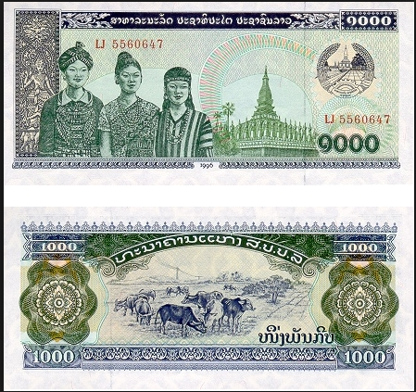
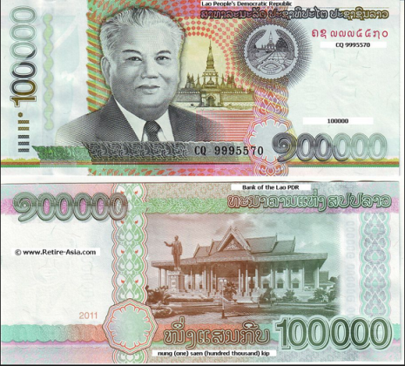
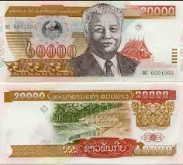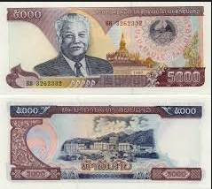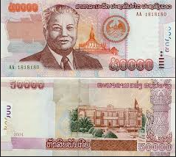

12. ELECTRICITY
The voltage in Lao PDR is 220V, 50Hz using the 2P AC Male flat plug type and multi-standard sockets. The majority of electrical outlets in Lao PDR are shown below:

13. CLIMATE OF VIENTIANE CAPITAL DURING FEBRUARY AND MARCH

 | February | March
Mean Maximum Temperature (ºC) | 30.8 | 33.1
Mean Minimum Temperature (ºC) | 19.6 | 22.1
Absolute Maximum Temperature (ºC) | 35.3 | 37.5
Absolute Minimum Temperature (ºC) | 15.3 | 17.5
Average Monthly Rainfall (mm) | 14.9 | 40.8
Maximum Rainfall in 24 hours (mm) | 9.7 | 19.9
Number of Rainy days | 5 | 8
Mean Maximum Humidity (%) | 88 | 86
Mean Minimum Humidity (%) | 43 | 43
Mean Sea Level Pressure (hPa) | 1012.4 | 1010.1

Appendix A
MEETING VENUE  Headquarters Office of Department of Meteorology and Hydrology (DMH)  Address: Souphanouvong Avenue. Ban Akad, Sikhottabong District, P.O. Box 2903, Vientiane Capital, Lao PDR  Tel: +856-21-215010  E-mail: dmhvte@gmail.com | 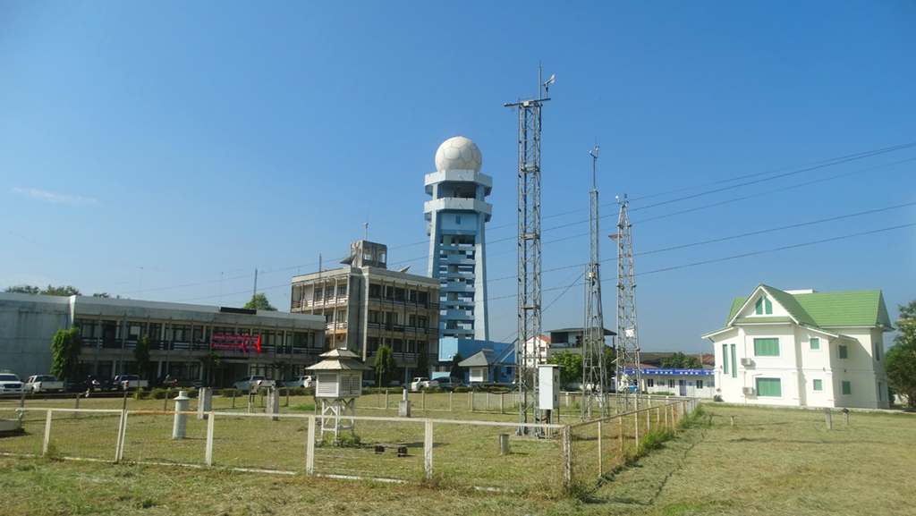
LOCATION MAP
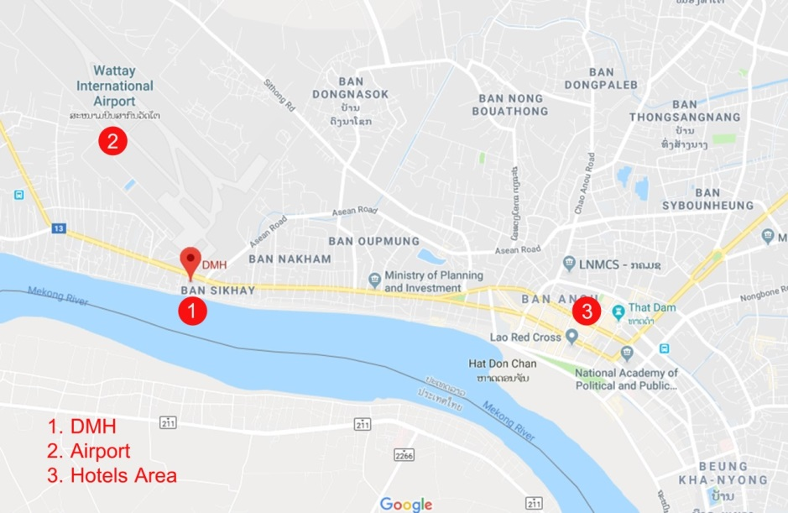
The route map from Airport and Hotel to Meeting Venue

Appendix B
REGISTRATION FORM FOR VISA SUPPORT
1. Dr./ Mr./ Mrs./ Ms. | ________ _________ ___________  First Name Middle Name Last Name
2. Present Official Position | ______________________________________
3. Country: | ______________________________________
4. Agency / Organization: | ______________________________________
5. Tel: | ______________________________________
6. Email address: | ______________________________________
7. Others: Lecturer ___ Participant___
8. In order to facilitate the application of Visa-on-Arrival or to issue the invitation letter for visa application purpose, please check the option below and provide the passport information as requested and return the Registration Form along with scanned copy of passport to the Local Organizing Committee (LOC) in Vientiane, Lao PDR via email before 1st February 2019. The same information is also required for the accompanying person, if any.
Full name as shown on Passport: |  | _______________________________
Date of birth:___________________ |  | Place of birth:____________________
Nationality:_____________________ |  | Gender:__________________________
Passport number:________________ |  | Profession:_______________________
Place of issue:__________________ |  | Date of issue:____________________
Place to apply for visa:________________ |  | Expiry Date:______________________

