WMO’s Severe Weather Forecasting Demonstration Project (SWFDP)
SWFDP Regional Subproject for Southeast Asia (SWFDP-SeA)
Regional Training Workshop on Severe Weather Forecasting and Delivery of Warning Services
(18-30 March 2018, Ha Noi, Viet Nam)

Venue: Headquarter of National Hydro-Meteorological Service (NHMS),
No. 08, Phao Dai Lang street, Ha Noi City, Viet Nam

INFORMATION NOTE FOR PARTICIPANTS

1. MEETING VENUE
The SWFDP-SeA Regional Training Workshop on Severe Weather Forecasting and Delivery of Warning Services will be held at the Headquarter of National Hydro-Meteorological Service (NHMS) of Viet Nam from 19-30 March 2018. More details of the meeting venue and location map are provided in Appendix A.
2. LOCAL ORGANIZATION COMMITTEE (LOC)
Ms. Do Quynh Hoa
Deputy Director,
Science, Technology and International Cooperation Department, NHMS of Viet Nam.

Office address: No 08, Phao Dai Lang street, Dong Da district, Ha Noi, Viet Nam
Tel: +84 2432673199 (ext 224)/ +84 912753507
E-mail address: hoahtqt@gmail.com

Mr. Hoang Trong Thang
Official, Science, Technology and International Cooperation Department, NHMS of Viet Nam.

Office address: No 08, Phao Dai Lang street, Dong Da district, Ha Noi, Viet Nam.
Tel: +84 2432673199 (ext 289)/ +84 983596123
E mail address: htthang.ht@gmail.com

3. REGISTRATION
Participants are requested to complete Registration Form (Appendix B) and send to the LOC email address as above-mentioned.
A registration and Information Desk will be set up in front of the Meeting Venue, and will be operated during 19-30 March 2018 (08.00 hours - 17.00 hours)
4. WORKING LANGUAGE AND WORKSHOP WEBSITE
The workshop will be conducted in English and all documentation will be in English only. No interpretation service will be provided. The provisional training programme

and information note for the participants will be made available on WMO website at the following link:
http://www.wmo.int/pages/prog/www/DPFS/Meetings/RAII-SeA-SWFDP-WK_Hanoi2018/DocPlan_001.html
5. INTERNET FACILITIES
Complimentary wireless internet connection will be available in the meeting rooms for all participants.

6. VISA/ENTRY REQUIREMENTS
Visitors entering the Viet Nam are generally required to have a valid passport and visa. All participants are recommended to contact the nearest Viet Nam Embassy in their respective countries and/or obtain information from https://lanhsuvietnam.gov.vn/default.aspx/ https://visa.mofa.gov.vn/Homepage.aspx for visa requirements. An official invitation letter issued by the LOC will be needed for the purpose of visa application. Please contact the LOC for further assistance.

In order to facilitate the application of Visa-on-Arrival arrangements, please kindly fill and send your Registration Form accompany with passport copy to us via LOC email preferably before 15 February 2018.

7. ACCOMMODATION
Accommodation will be arranged at Ha Noi Daewoo Hotel located close to the Meeting Venue Please complete and return the RESERVATION FORM FOR ACCOMMODATION (please see attached file) by Email or Fax before 28 February 2018 to: Ha Noi Daewoo Reservation: tthien@daewoohotel.com ; copy to LOC email address.

Ha Noi Daewoo Hotel
Mailing address: 360 Kim Ma str., Ba Dinh dist., Ha Noi, Viet Nam
Tel: +84 24 38315000 - Fax: +84 24 38315588
Website: http://www.daewoohotel.com/en
Please, kindly note that ALL PARTICIPANTS will stay at the Ha Noi Daewoo Hotel as special arrangements have been made.

8. WORKING LUNCH DURING THE WORKSHOP
LOC will help participants to look for a reasonable restaurant near the Venue.

9. LOCAL TRANSFERS BETWEEN AIRPORT AND HOTEL

Noi Bai International Airport to Center of Ha Noi

Taxi service: Taxi service is available from Noi Bai Airport to Ha Noi Daewoo Hotel (≈30 km distance). It takes about 50 minutes and costs around 400.000-500.000 VNĐ (around USD20-USD25 for one-way trip. Some popular taxi operators are Dai Nam, Viet Thanh, Noi Bai airport, Mai Linh, etc.

10. FOOD
The main food in Viet Nam includes rice, beans, beef, chicken, vegetables, fish and other sea foods. There are a lot of delicious fruits such as sweet bananas, mangoes, pineapples, guavas and oranges.

11. CURRENCY
Viet Nam currency is the Viet Nam Dong (VNĐ). There are currency exchange offices in Noi Bai International Airport. The exchange rates for 1 USD ≈ 22,765 VNĐ (exchange rate at time of January 31st, 2018, exchange rates difference up or down). Information on the day-to-day exchange rates at Noi Bai International Airport can be found at http://noibaiairport.vn. There are also banks and foreign currency exchange offices near by Meeting Venue. Money exchange is also available at the Ha Noi Daewoo Hotel.

12. ELECTRICITY
The voltage in Viet Nam is 220V, 50Hz using the 2P AC Male flat plug type and multi-standard sockets. The majority of electrical outlets in Viet Nam are shown below:

13. CLIMATE OF HA NOI, VIET NAM DURING 19-30 MARCH

Normal Minimum Temperature = 17-19 degree C
Normal Maximum Temperature = 21-23 degree C
Monthly normal rainfall = 30-50 mm
Minimum Humidity = 40-50%

Appendix A

Meeting Venue  Headquarter, National Hydro-Meteorological Service of Viet Nam  Address: No 08, Phao Dai Lang street, Dong Da district, Ha Noi, Viet Nam  Information: Science, Technology and International Cooperation Department  TEL: +84-4 0232673199 (ext 224 or ext 289)  E-mail: hoahtqt@gmail.com | 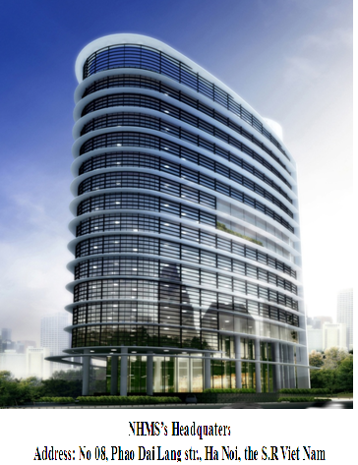
LOCATION MAP
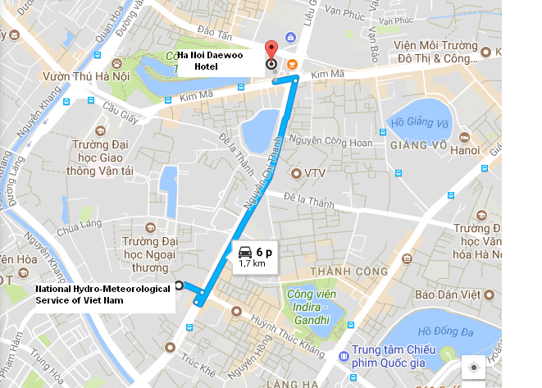
The route map from Ha Noi Daewoo Hotel to Meeting Venue

Appendix B
REGISTRATION FORM FOR VISA SUPPORT
1. Dr./ Mr./ Mrs./ Ms. | ________ _________ ___________  First Name Middle Name Last Name
2. Present Official Position | ______________________________________
3. Country: | ______________________________________
4. Agency / Organization: | ______________________________________
5. Tel: | ______________________________________
6. Email address: | ______________________________________
7. Others: Lecturer ___ Participant___
8. In order to facilitate the application of Visa-on-Arrival or to issue the invitation letter for visa application purpose, please check the option below and provide the passport information as requested and return the Registration Form accompany with passport copy to us via LOC email before 15 February 2018. The same information is required from the accompanying person, if any.
Full name as shown on Passport: |  | _______________________________
Date of birth:___________________ |  | Place of birth:____________________
Nationality:_____________________ |  | Gender:__________________________
Passport number:________________ |  | Profession:_______________________
Place of issue:__________________ |  | Date of issue:____________________
Place to apply for visa:________________ |  | Expiry Date:______________________

