WMO’s Severe Weather Forecasting Demonstration Project (SWFDP)
SWFDP Regional Subproject for Southeast Asia (SWFDP-SeA)
Training Desk on Severe Weather Forecasting
(7- 18 May 2018, Ha Noi, Viet Nam)

Venue: Headquarter of Viet Nam Meteorology and Hydrology Administration (VMHA),
No. 08, Phao Dai Lang street, Ha Noi City, Viet Nam

INFORMATION NOTE FOR PARTICIPANTS

1. MEETING VENUE
The SWFDP-SeA Training Desk on Severe Weather Forecasting will be held at the Headquarter of Viet Nam Meteorology and Hydrology Administration (VMHA) from 7-18 May 2018. More details of the meeting venue and location map are provided in Appendix A.
2. LOCAL ORGANIZATION COMMITTEE (LOC)
- Mr. Du Duc Tien
Numerical weather prediction and remote sensing division
National Center of Hydro-Meteorological Forecasting (NCHMF), VMHA

Office address: No 08, Phao Dai Lang street, Dong Da district, Ha Noi, Viet Nam
Tel: +84 2432673199 (ext 705)/ +84 936067015
E-mail address: duductien@gmail.com; ddtien@monre.gov.vn

- Mr. Nguyen Dang Quang
Numerical weather prediction and remote sensing division
National Center of Hydro-Meteorological Forecasting (NCHMF), VMHA

Office address: No 08, Phao Dai Lang street, Dong Da district, Ha Noi, Viet Nam
Tel: +84 2432673199 (ext 705)/ +84 919032309
E-mail address: quangvnes@gmail.com; ndquang@monre.gov.vn

3. REGISTRATION
Participants are requested to complete Registration Form (Appendix B) and send to the LOC email address as above-mentioned.
4. WORKING LANGUAGE AND WORKSHOP WEBSITE
The workshop will be conducted in English and all documentation will be in English only. No interpretation service will be provided. The provisional training programme and information note for the participants will be made available on WMO website at the following link: http://www.wmo.int/pages/prog/www/DPFS/Meetings/RAII-SeA-SWFDP-Training-Desk_HaNoi2018/DocPlan.html

5. INTERNET FACILITIES
Complimentary wireless internet connection will be available in the meeting rooms for all participants.

6. VISA/ENTRY REQUIREMENTS
Visitors entering the Viet Nam are generally required to have a valid passport and visa. All participants are recommended to contact the nearest Viet Nam Embassy in their respective countries and/or obtain information for visa requirements from the following: https://lanhsuvietnam.gov.vn/default.aspx/ https://visa.mofa.gov.vn/Homepage.aspx.

An official invitation letter issued by the LOC will be needed for the purpose of visa application. Please contact the LOC for further assistance. In order to facilitate the application of Visa-on-Arrival arrangements, please kindly fill and send your Registration Form accompany with passport copy to us via LOC email preferably before 25 April 2018.

7. ACCOMMODATION
A. Participant can book the hotel via https://www.booking.com/ with address: 62 Nguyen Chi Thanh, Dong Da, Ha Noi, Viet Nam
B. Email to LOC for finding the suitable accommodation (some recommended hotels near Headquarter of VMHA):

No. | Hotel name | Approx. Price for Deluxe Double Room | Address
1 | Hanoi Daewoo Hotel | US$111.43 | 360 Kim Ma Street, Ba Dinh, Ha Noi, Việt Nam
2 | Sunny Hotel 1 | US$56 | 2A/31 Nguyen Chi Thanh Street, Ba Dinh, Ha Noi, Việt Nam
3 | Sakura Hotel 3 | US$75,08 | 609 Kim Ma, Ba Dinh, Quận Ba Đình, Hà Nội, Việt Nam
4 | Danly Hotel | US$63,50 | 22-24 Dao Tan - Cau Giay, Quận Ba Đình, Hà Nội, Việt Nam
5 | Milan Hotel | US$23 | 30 Alley 157 Chua Lang, Quận Đống Đa, Hà Nội, Việt Nam
6 | Apec 2 Hotel | US$22 | 67 Linh Lang - Ba Dinh, Quận Ba Đình, Hà Nội, Việt Nam
7 | Regal Hotel | US$30 | 90 Pham Huy Thong, Quận Ba Đình, Hà Nội, Việt Nam
8 | Tea Hotel | US$25 | 3/31 Nguyen Chi Thanh, Ngoc Khanh, Ba Dinh, Quận Ba Đình, Hà Nội, Việt Nam
9 | New Hotel 3 | US$32 | 5, 81 Linh Lang, Ba Dinh, Quận Ba Đình, Hà Nội, Việt Nam
10 | Inter Hotel | US$39 | 2 Alley 24 Nguyen Van Ngoc Street, Cong Vi Ward, Ba Dinh District, Quận Ba Đình, Hà Nội, Việt Nam

8. WORKING LUNCH DURING THE WORKSHOP
LOC will help participants to look for a reasonable restaurant near the meeting venue.

9. LOCAL TRANSFERS BETWEEN AIRPORT AND HOTEL

Noi Bai International Airport to Centre of Ha Noi
Taxi service is available from Noi Bai Airport to Ha Noi city centre including Ha Noi Daewoo Hotel (≈30 km distance). It may take about 50 minutes to reach the city centre and cost around 400.000-500.000 VNĐ (~ USD20-USD25) for one-way trip. Some popular taxi operators are Dai Nam, Viet Thanh, Noi Bai airport, Mai Linh, etc.

10. FOOD
The main food in Viet Nam includes rice, beans, beef, chicken, vegetables, fish and other sea foods. There are a lot of delicious fruits such as sweet bananas, mangoes, pineapples, guavas and oranges.

11. CURRENCY
Viet Nam currency is the Viet Nam Dong (VNĐ). There are currency exchange offices in Noi Bai International Airport. The exchange rates for 1 USD ≈ 22,765 VNĐ (exchange rate at time of January 31st, 2018, exchange rates difference up or down). Information on the day-to-day exchange rates at Noi Bai International Airport can be found at http://noibaiairport.vn.

There are also banks and foreign currency exchange offices near by Meeting Venue. Money exchange is also available at some hotels including the Ha Noi Daewoo Hotel.

12. ELECTRICITY
The voltage in Viet Nam is 220V, 50Hz using the 2P AC Male flat plug type and multi-standard sockets. The majority of electrical outlets in Viet Nam are shown below:

13. CLIMATE OF HA NOI, VIET NAM DURING MAY
Normal Minimum Temperature = 22-24 degree C
Normal Maximum Temperature = 28-32 degree C
Monthly normal rainfall = 100-150 mm
Minimum Humidity = 70-80%

Appendix A
MEETING VENUE  Headquarters Office of Viet Nam Meteorology and Hydrology Administration (VMHA),  Address: No 08, Phao Dai Lang street, Dong Da district, Ha Noi, Viet Nam  Information: National Center of Hydro-Meteorological Forecasting (NCHMF)  Tel: +84-4 0232673199 (ext 705)  E-mail: duductien@gmail.com  quangvnes@gmail.com | 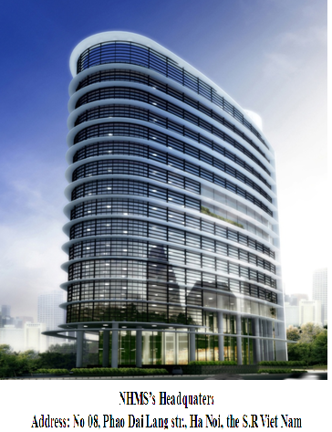
LOCATION MAP
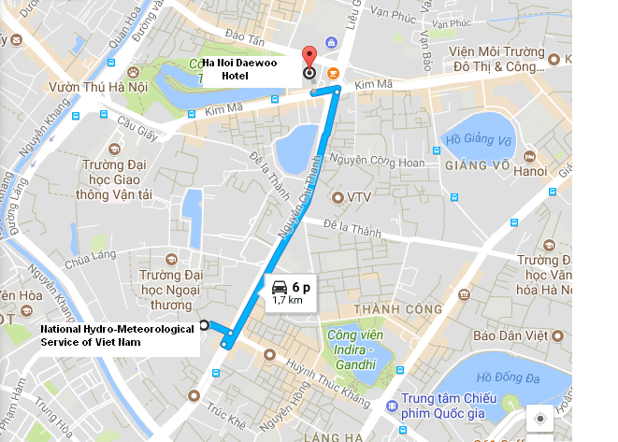
The route map from Ha Noi Daewoo Hotel to Meeting Venue

Appendix B
REGISTRATION FORM FOR VISA SUPPORT
1. Dr./ Mr./ Mrs./ Ms. | ________ _________ ___________  First Name Middle Name Last Name
2. Present Official Position | ______________________________________
3. Country: | ______________________________________
4. Agency / Organization: | ______________________________________
5. Tel: | ______________________________________
6. Email address: | ______________________________________
7. Others: Lecturer ___ Participant___
8. In order to facilitate the application of Visa-on-Arrival or to issue the invitation letter for visa application purpose, please check the option below and provide the passport information as requested and return the Registration Form accompany with passport copy to us via LOC email before 25 April 2018. The same information is required from the accompanying person, if any.
Full name as shown on Passport: |  | _______________________________
Date of birth:___________________ |  | Place of birth:____________________
Nationality:_____________________ |  | Gender:__________________________
Passport number:________________ |  | Profession:_______________________
Place of issue:__________________ |  | Date of issue:____________________
Place to apply for visa:________________ |  | Expiry Date:______________________

