The Severe Weather Forecasting Demonstration Project (RAII-SeA-SWFPD) Regional Sub-project Management Team (RSMT) Meeting;

The Southeast Asia Flash Flood Guidance (SEAFFG) System Initial Planning Meeting; and

The First Southeast Asia Steering Committee (SEA-SC) Meeting of the project “Building Resilience to High-Impact Hydro-Meteorological Events through Strengthening MHEWS in SIDS and SEA”

Venue: Headquarter of National Hydro-Meteorological Service (NHMS),
No. 08, Phao Dai Lang street, Ha Noi City, Viet Nam.
Duration: 20-23 November 2017

INFORMATION NOTE FOR PARTICIPANTS

1. MEETING VENUE
The RSMT, SEAFFG, and SEA-SC Meetings will be held at the Headquarter of National Hydro-Meteorological Service (NHMS) of Viet Nam from 20 to 23 November 2017. More details of the meeting venue and location map are provided in Appendix A.

2. LOCAL ORGANIZATION COMMITTEE (LOC)

Ms. Do Quynh Hoa
Deputy Director,
Science, Technology and International Cooperation Department, NHMS of Viet Nam.

Office address: No 08, Phao Dai Lang street, Dong Da district, Ha Noi, Viet Nam
Tel: +84 2432673199 (ext 224)/ +84 912753507
E-mail address: hoahtqt@gmail.com

Mr. Hoang Trong Thang
Official, Science, Technology and International Cooperation Department, NHMS of Viet Nam.

Office address: No 08, Phao Dai Lang street, Dong Da district, Ha Noi, Viet Nam.
Tel: +84 2432673199 (ext 289)/ +84 983596123
E mail address: htthang.ht@gmail.com

3. REGISTRATION
Participants are requested to complete the Registration Form (Appendix B) and send to the LOC through email as mentioned above. A registration and Information Desk will be set up in front of the Meeting Venue, and will be operated during 20-23 November 2017 (08.00---17.00).

4. WORKING LANGUAGE
The meeting will be conducted in English and all documentation will be in English only. No interpretation service will be provided.

5. INTERNET FACILITIES
Complimentary wireless internet connection will be available in the meeting rooms for all participants.

6. VISA/ENTRY REQUIREMENTS
Visitors entering the Viet Nam are generally required to have a valid passport and visa. All participants are recommended to contact the nearest Viet Nam Embassy in their respective countries and/or obtain information for visa requirements from the following websites:
https://lanhsuvietnam.gov.vn/default.aspx/
https://visa.mofa.gov.vn/Homepage.aspx.

An official invitation letter issued by the LOC will be needed for the purpose of visa application. Please contact the LOC for further assistance.

In order to facilitate the application of Visa-on-Arrival arrangements, please kindly fill and send your Registration Form accompany with passport copy to us via LOC email preferably before 30 October 2017.

7. ACCOMMODATION
Accommodation will be arranged at Ha Noi Daewoo Hotel located close to the Meeting Venue. Please complete and return the RESERVATION FORM FOR ACCOMMODATION (Appendix C) by Email or Fax before 30 October 2017 to Ha Noi Daewoo Reservation at the following Email Address: reservation@daewoohotel.com; ptthoa@daewoohotel.com; with copy to LOC email address as mentioned above.

Ha Noi Daewoo Hotel
Mailing address: 360 Kim Ma str., Ba Dinh dist., Ha Noi, Viet Nam
Tel: +84 24 38315000 - Fax: +84 24 38315588
Website: http://www.daewoohotel.com/en

Kindly note that ALL PARTICIPANTS will stay at the Ha Noi Daewoo Hotel as special arrangements have been made. The transportation for all participants between the Ha Noi Daewoo Hotel and meeting venue will be arranged. If participants choose to stay at a different hotel they will be responsible for arranging their own transportation to and from the meeting venue.

8. WORKING LUNCH DURING THE WORKSHOP
Working lunch will be arranged at very reasonable price at the restaurant near by Meeting Venue.

9. MEETING WEBSITE
The provisional agenda, tentative work programme and information note for the participants can be downloaded from the WMO website at the following link:
http://www.wmo.int/pages/prog/www/DPFS/Meetings/RAII-SeA-SWFDP-RSMT_Hanoi2017/DocPlan_001.html

10. LOCAL TRANSFERS BETWEEN AIRPORT AND HOTEL

Noi Bai International Airport to Hotel
Transportation will be arranged for participants from the airport to the hotel and back. Local organizers will meet all participants at the airport with the title: “RSMT, SEAFFG, SEA-PC MEETING IN VIET NAM 2017” board. Participants are requested to provide their flight details to the LOC at least a week before arrival date.

Noi Bai International Airport to Center of Ha Noi
If you can not find/meet the Local organizers please take a Taxi to the Hotel or a Bus to the Center of Ha Noi then take a Taxi to the Hotel:

Taxi service: Taxi service is available from Noi Bai Airport to Ha Noi Daewoo Hotel (≈30 km distance). It takes about 50 minutes and costs around 400.000-500.000 VNĐ (around USD20-USD25 for one-way trip. Some popular taxi operators are Dai Nam, Viet Thanh, Noi Bai airport, Mai Linh, etc.

11. FOOD
The main food in Viet Nam includes rice, beans, beef, chicken, vegetables, fish and other sea foods. There are a lot of delicious fruits such as sweet bananas, mangoes, pineapples, guavas and oranges.

12. CURRENCY
Viet Nam currency is the Viet Nam Dong (VNĐ). There are currency exchange offices in Noi Bai International Airport. The exchange rates for 1 USD ≅ 22,790 VNĐ. Information on the day-to-day exchange rates at Noi Bai International Airport can be found at http://noibaiairport.vn. There are also banks and foreign currency exchange offices near by Meeting Venue. Money exchange is also available at the Ha Noi Daewoo Hotel.

13. ELECTRICITY
The voltage in Viet Nam is 220V, 50Hz using the 2P AC Male flat plug type and multi-standard sockets. The majority of electrical outlets in Viet Nam are shown below:

14. CLIMATE OF HA NOI, VIET NAM IN 19-25 NOVEMBER
Mean Minimum temperature: 18.0-19.0 degree C
Mean Maximum temperature: 24.5-25.5 degree C
Mean Humidity: 80-85%
Monthly total precipitation amount: 60-80mm, but weekly total rainfall from 19 to 25 November is about 10-15 mm

Appendix A
Meeting Venue  Headquarter, National Hydro-Meteorological Service of Viet Nam  Address: No 08, Phao Dai Lang street, Dong Da district, Ha Noi, Viet Nam  Information: Science, Technology and International Cooperation Department  TEL: +84-4 0232673199 (ext 224 or ext 289)  E-mail: hoahtqt@gmail.com | 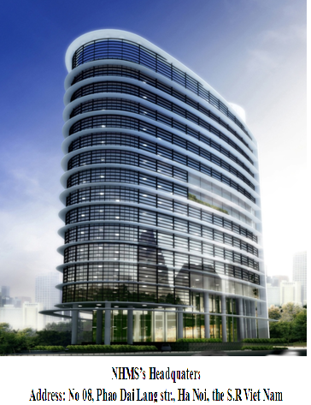
LOCATION MAP
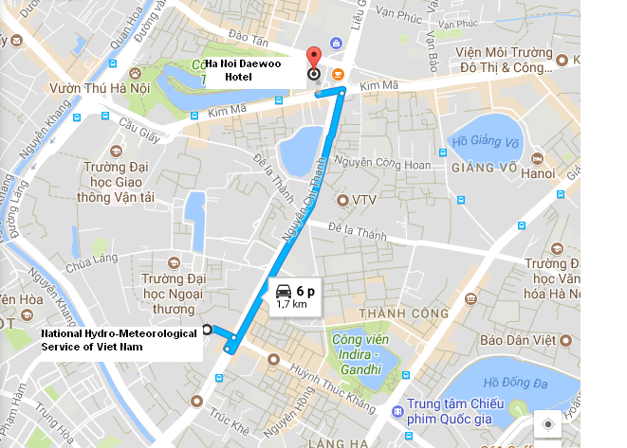

The route map from Ha Noi Daewoo Hotel to Meeting Venue

Appendix B

REGISTRATION FORM

1. Dr./ Mr./ Mrs./ Ms. | ________ _________ ___________  First Name Middle Name Last Name
2. Present Official Position | ______________________________________
3. Country: | ______________________________________
4. Agency / Organization: | ______________________________________
5. Tel: | ______________________________________
6. Email address: | ______________________________________
7. Participation in: RSMT ___ SEAFFG___ SEA-SC___
8. In order to facilitate the application of Visa-on-Arrival or to issue the invitation letter for visa application purpose, please check the option below and provide the passport information as requested and return the Registration Form accompany with passport copy to us via LOC email before 30 October 2017. The same information is required from the accompanying person, if any.
Full name as shown on Passport: |  | _______________________________
Date of birth:___________________ |  | Place of birth:____________________
Nationality:_____________________ |  | Gender:__________________________
Passport number:________________ |  | Profession:_______________________
Place of issue:__________________ |  | Date of issue:____________________
Place to apply for visa:________________ |  | Expiry Date:______________________

