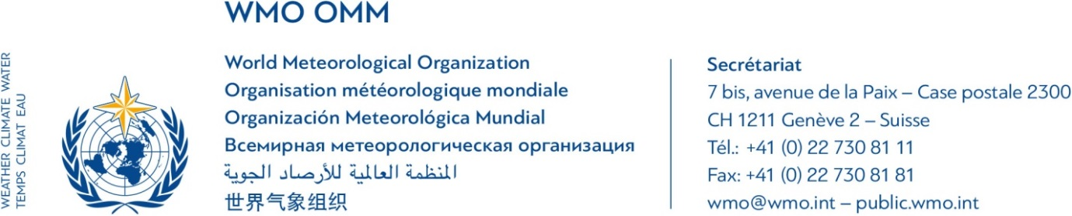
First Southeast Asia Project Steering Committee (SEA-PSC-1) Meeting for the project entitled:
“Building Resilience to High-Impact Hydrometeorological Events through Strengthening Multi-Hazard Early Warning Systems (MHEWS) in
Small Island Developing States (SIDS) and Southeast Asia (SEA)”
23 November 2017
Headquarter of National Hydro-Meteorological Service (NHMS)
No. 08, Phao Dai Lang street, Ha Noi City, Viet Nam

AGENDA (Doc 1)
(as of 8 November 2017)
Start | End | Thursday, 23 November 2017
14:00 | 14:30 | Session 1: Opening and Introduction  - Welcome remarks on behalf of the host country –representative from Ministry of Natural Resources and Environment.  - Welcome remarks on behalf of the Association of Southeast Asian Nations (ASEAN) Sub-Committee on Meteorology and Geophysics (SCMG) – Landrico Dalida, Deputy Administrator for Operations and Services, Philippine Atmospheric Geophysical and Astronomical Services Administration (PAGASA) on behalf of Dr Vicente B. Malano, Permanent Representative of the Philippines with WMO  - Welcome remarks on behalf of the Secretary-General of WMO –  Mr Abdoulaye Harou, Chief, Data Processing and Forecasting Systems Division, WMO Secretariat  - Roundtable introduction of participants  - Objectives, structure, document list and working arrangements of the meeting – Mr Jochen Luther, Project Manager, Development and Regional Activities Department, WMO Secretariat  - Election of a Chairperson (suggested: PR of Viet Nam) and adoption of the agenda
14:30 | 14:50 | Session 2: Current WMO capacity development activities in Southeast Asia and alignment with third-party activities  - Overview presentation – Jochen Luther  - Discussion, questions and answers
14:50 | 15:30 | Session 3: The project “Building Resilience to High-Impact Hydrometeorological Events through Strengthening MHEWS in SIDS and SEA”  - Overview presentation – Jochen Luther  - Review of the draft Terms of Reference (ToR) for the Southeast Asia Project Steering Committee (SEA-PSC) – Chairperson  - Discussion, questions and answers
15:30 | 15:50 | **** COFFEE/TEA BREAK ****
15:50 | 16:40 | Session 4: Discussion on the project implementation plan, including the annual work plan for 2017-2018 and an outlook to 2018-2019  - Overview presentation – Jochen Luther  - Discussion, questions and answers
16:40 | 17:00 | Session 5: Way forward and decisions  - Review of decisions and next steps – Chairperson  - Closure of the meeting - Mr Nguyen Linh Ngoc
17:00 |  | **** Closure of meeting ****

Document List

- Agenda – First Southeast Asia Project Steering Committee (SEA-PSC-1)
- Participant List – First Southeast Asia Project Steering Committee (SEA-PSC-1)
- Terms of Reference (ToR) – Southeast Asia Project Steering Committee (SEA-PSC)
- Project Overview
- Project Implementation Plan

