WORLD METEOROLOGICAL ORGANIZATION  COMMISSION FOR BASIC SYSTEMS  OPAG on DPFS  MEETING THE REGIONAL SUBPROJECT MANAGEMENT TEAM (RSMT) OF THE SEVERE WEATHER FORECASTING DEMONSTRATION PROJECT (SWFDP) IN SOUTHEAST ASIA  Ha Noi, Viet Nam, 20-23 November 2017 |  | WDS-DPFS/RAII/SeA-SWFDP-RSMT /Doc. XX  (XX.XI.2017)  _______  Agenda item : XX  ENGLISH ONLY

Contributions of the DWD, Germany to SWFDP in Southeast Asia

(Submitted by Detlev Majewski, DWD, Germany)

Summary and purpose of document

This document describes the current and planned activities of DWD, Germany and its contribution to Severe Weather Forecasting Demonstration Project in Southeast Asia (SWFDP-SeA).

Action Proposed

The meeting is invited to review the current and planned activities of DWD and discuss its role in and synergies between these activities and SWFDP-SeA.

Contribution of DWD (Germany) to the SWFDP-SEA
DWD introduced its new nonhydrostatic global model ICON (ICOsahedral Nonhydrostatic) in January 2015 with a horizontal grid spacing of 13 km (6.5 km over a European nest domain) and 90 layers. ICON replaced the former operational hydrostatic global model GME (20 km, 60 layers). ICON outperforms GME, especially for tropical regions, due to the higher horizontal and vertical resolution, more advanced numerical schemes and state-of-the-art physical parameterizations. In January 2016 the operational introduction of a hybrid ensemble-based variational data assimilation (ICON-EDA) including a short-range ensemble prediction system (ICON-EPS) led to a significant further improvement of the quality and usefulness of ICON forecasts (see Fig. 1).
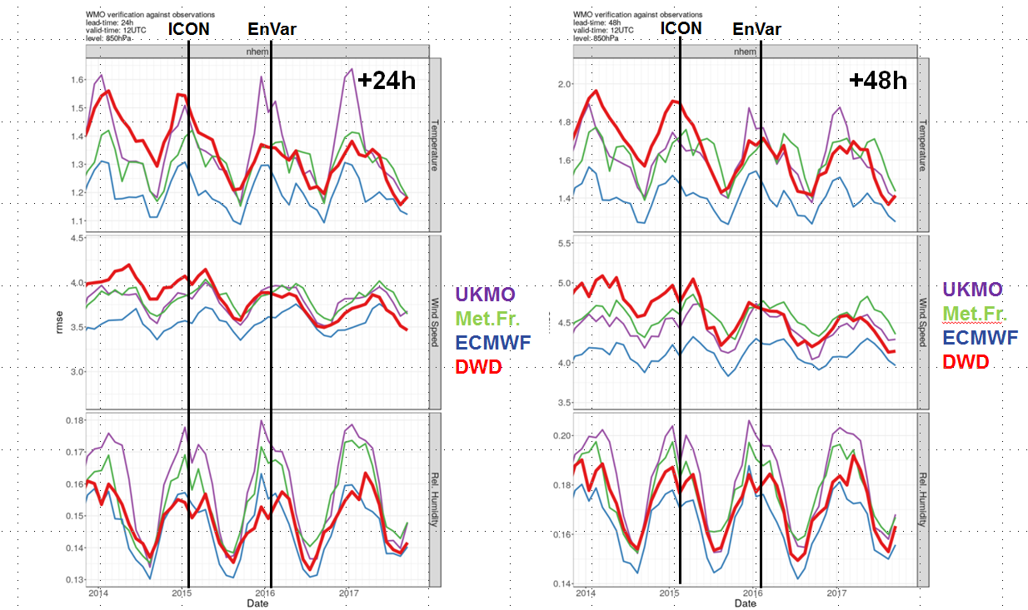.
Fig. 1 TEMP-Verification at 850 hPa for Europe 2014 to 2017. RMSE for temperature (top), wind speed (middle) and relative humidity (bottom); 24-h forecasts (left), 48-h forecasts (right).
Since July 2017 DWD provides all its NWP data on an open data server, see
https://opendata.dwd.de/weather/.
On this server DWD provides free and open access to analyses and forecasts of the global deterministic ICON model (13 km grid spacing, 6.5 km over Europe; based on 00, 06, 12 and 18 UTC analyses up to 120 hours, and based on 03, 09, 15 and 21 UTC up to 30 hours), see
https://www.dwd.de/DE/leistungen/opendata/help/inhalt_allgemein/opendata_content_de_en_pdf.pdf?__blob=publicationFile&v=13.
These data (on the icosahedral triangular model grid) can be easily re-gridded to a regular latitude/ longitude grid via the public domain software cdo (https://code.mpimet.mpg.de/projects/cdo/wiki), and visualized, e.g. with the public domain graphic package GrADS
(http://cola.gmu.edu/grads/gadoc/tutorial.html).
Via the internet DWD provides lateral boundary conditions based on ICON forecasts to more than 35 regional (hydro-) meteorological services worldwide which run the nonhydrostatic regional NWP system COSMO (Consortium for Small Scale Modelling, consisting of the weather services of Germany, Greece, Italy, Poland, Romania, Russia and Switzerland).
DWD collaborates with the National Hydro-Meteorological Service of Viet Nam (VHMS) in the field of regional NWP since October 2000 when VHMS, together with the National University of Vietnam (VNU) introduced DWD’s former regional NWP model HRM with a grid spacing of 28 km and 20 layers. In November 2008, VHMS hosted the 3rd International HRM Workshop, and in 2010 VHMS increased the resolution of its operational HRM to 14 km and began first tests of a 7-km high resolution version. Since 2012 VHMS runs the regional nonhydrostatic COSMO model operationally.
DWD offers a free annual “Regional NWP, Environmental and Climate Modelling Training Course” to all regional (hydro-) meteorological services, the next training is from 12 to 16 March 2018.

