WORLD METEOROLOGICAL ORGANIZATION  COMMISSION FOR BASIC SYSTEMS  OPAG on DPFS  MEETING THE REGIONAL SUBPROJECT MANAGEMENT TEAM (RSMT) OF THE SEVERE WEATHER FORECASTING DEMONSTRATION PROJECT (SWFDP) IN SOUTHEAST ASIA  Hanoi, Viet Nam, 11-14 August 2015 |  | DPFS/RAII/SeA-SWFDP-RSMT /Doc. 5.2  (Jul.29.2015)  _______  Agenda item : 5.2.1  ENGLISH ONLY

Contribution of Regional Forecasting Support Centre (RFSC) Hanoi to SWFDP in Southeast Asia

(Submitted by Du Duc Tien, Hanoi, Vietnam)

Summary and purpose of document

This document describes the contributions of RFSC Hanoi - Vietnam to Severe Weather Forecasting Demonstration Project in Southeast Asia (SWFDP-SeA).

Action Proposed

The meeting is invited to review this document and discuss the contributions of RFSC Hanoi - Vietnam to Severe Weather Forecasting Demonstration Project in Southeast Asia (SWFDP-SeA) and future plans for RFSC Hanoi

Annex - A: SWFDP-SeA portal login information and accessing products
Annex - B: List of station for EPSgram
Annex - C: Example of short range guidance for SWFDP-SEA
Annex - D: Example of medium range guidance for SWFDP-SEA

Reference(s):

- Manual on the GDPFS, Vol 1 – Global Aspects, WMO-485, updated 2010
http://www.wmo.int/pages/prog/www/DPFS/Manual_GDPFS.html
- SWFDP Overall Project Plan, updated 2010
http://www.wmo.int/pages/prog/www/DPFS/Meetings/SG-SWFDP_Geneva2010/documents/SWFDP_OverallPP_Updated_8jun2008.pdf
- SWFDP Guidebook on Planning Regional Subprojects, updated 2010
http://www.wmo.int/pages/prog/www/DPFS/Meetings/SG-SWFDP_Geneva2010/documents/SWFDP_Guidebook_Updated_24sept2008.pdf
- Severe Weather Forecasting Demonstration Project – Southeast Asia (SWFDP-SeA), Report of WMO mission to Hanoi, Viet Nam, 15-16 February 2011
- Annual Report on the activities of Regional Forecasting Support Centre (RFSC) - Hanoi, 2012
- SWFDP-SEA web portal: http://www.swfdp-sea.com.vn (username swfdp-sea password RA2)

1. Introduction to SWFDP-SeA and RFSC Hanoi

The Severe Weather Forecasting Demonstration Project (SWFDP) is a WMO Commission of Basic Systems (CBS) initiative, commenced in 2005, to demonstrate how warning services provided by NMHSs in developing countries can be enhanced and links with disaster management authorities improved through cooperative work among meteorological centers. The scope of the project is to test the usefulness of currently available and promising experimental products available from Numerical Weather Prediction (NWP) centers in improving severe weather forecasting services in countries where sophisticated model outputs are either not available, or not effectively used.
The SWFDP implements a cascading forecasting approach via the three-tier GDPFS network of global, regional and national meteorological centers. Global centers provide NWP products, including probabilistic forecasts, and other forecasting guidance, while Regional Centres interpret this information often from multiple sources, and produce regional-scale products to guide National Meteorological and Hydrological Services (NMHSs) in their forecasting functions for their respective countries. The NMHSs maintain their responsibilities and functions to issue alerts, advisories, severe weather warnings, and liaise with media and disaster management and civil protection authorities (DMCPAs) as part of national warning services.
The first meeting of the SWFDP-SeA Regional Subproject Management Team (RSMT) to develop an implementation strategy for the SWFDP-SeA was held in September 2010 in Tokyo. The meeting reviewed a draft SWFDP-SeA Implementation Plan which proposed three types of Regional Centers with the roles: regional forecasting support (Hanoi), training and technical support (Hong Kong Observatory, HKO), and tropical cyclone forecasting support (RSMCs Tokyo and New Delhi). Although the National Centre for Hydrological and Meteorological Forecasting (NCHMF) in Hanoi is not a designated RSMC within the WMO GDPFS, the SWFDP concept of operation requires an operational regional centre to support severe weather forecasting in the participating NMHSs. A follow-up WMO mission to Hanoi in February 2011 determined that the NCHMF Hanoi appeared to have an excellent development potential to undertake the role of the Regional Forecasting Support Centre (RFSC) in a SWFDP-SeA project. It is proposed that NCHMF Hanoi be designated the Regional Forecasting Support Centre to perform the function of the lead regional centre for the SWFDP-SeA.
The WMO GDPFS has been recognizing the role of a new class of Regional Forecasting Support Centre (RFSC) in the context of the SWFDP. The most suitable centre to fulfill the functions of a Regional Centre in an SWFDP subproject may not always be a WMO-designated RSMC. In this situation, an SWFDP RFSC may perform similar functions to an existing RSMC (with geographical specialization) within its Regional Association, but also provide regional severe weather forecasting guidance products for the SWFDP, for a group of meteorological services in the close vicinity of the RSFC, and for the short- to medium-range only (initially up to 5 days ahead).
Following the “SWFDP Guidebook for planning Regional Subprojects” a SWFDP-SeA Implementation Plan was developed for the anticipated meeting of the RSMT, wherein the responsibilities and functions of the Regional Forecasting Support Centre (RFSC) in Hanoi are described, as follows:
- to redirect toward the NMHSs relevant products issued from the global centre (if necessary);
- to provide NMHSs with its own interpretation of the medium-range guidance, including EPS products;
- to provides the NMHSs with the short-range NWP guidance (including products adapted to severe weather events), as frequently as possible;
- to indicate existing satellite/radar imagery and satellite/radar based products that could be used for nowcasting purposes;
- to issue Daily Severe Weather Forecasting Guidance products summarizing interpretation of NWP products with respect to severe weather over the responsibility area of the NMHSs;
- to provide the other centers with short-range NWP guidance and EPS output including probabilistic products specially adapted to the concerned severe weather events;
- to tailor products to the requirements of the National Centers including the provision of sub-domains and probabilistic products according to the lists given in Annex C;
- to evaluate its own interpretation of EPS products as well as its NWP guidance;
- to provide global canters with a feedback about the usefulness and efficiency of global products;
- to facilitate the flow of all forecasting guidance information to all participating Centers in the SWFDP through a dedicated password protected Web site and portal. Ideally this Web site would be maintained on a 24/7 basis and dedicated for the Regional Subproject;
- to coordinate real-time 24/7 communications among the participating centers in the region of the project (to maintain a list of 24/7 contact information; telephone, fax, e-mail).
The above additional functions of RFSC Hanoi in the context of the SWFDP regional subproject is not intended to affect the existing national responsibilities of National center of hydro-meteorological forecasting of Vietnam (NCHMF).
Currently, all the SWFDP-SeA activities over web portal (NWP products, guidances) are maintained by the numerical weather prediction and remote sensing division of NCHMF.

2. Status of SWFDP-SeA web portal
2.1. Technical specifications of SWFDP-SeA webpage
The Severe Weather Forecasting Demonstration Project (SWFDP) is an initiative to further explore and enhance the use of outputs of existing numerical weather prediction (NWP) systems, including ensemble prediction systems (EPS). The swfdp-sea website is aimed to provide National Meteorological and Hydrological Services (NHMSs), particularly in developing countries, with existing NWP products and forecast guidance. There are some techniques of configurations for the swfdp-sea website:
- Operating system of hosted server: Linux OpenSUSE 11.2.
- Main language used to develop website: Python with Django framework.
- Language used to design interface: HTML
- Web scripting language: JavaScript
There are two servers for the works of the website: data and web server. Data server is located at National Center for Hydro-Meteorology Forecasting (NCHMF) and the Web-server is located at Viettel’s Internet Data Center (Viettel IDC). Data server and Web server are connected directly via leased line. The website has been publiced via official address: www.swfdp-sea.com.vn
The following block diagram will show system structure details of swfdp-sea website:
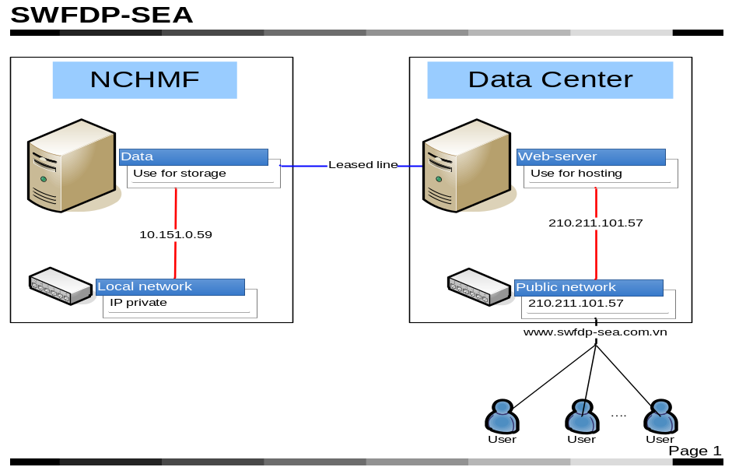
Fig 2.1: The swfdp-sea website structure
All the data including NWP products (Global and Regional NWP Products, EPS Products, satellite images) and forecast guidance will be stored on the data server. Image data are transferred to the web server via leased line so that all the products will be displayed on the website. Users can access the web site via internet and recommended Firefox browser (version 3.5 or higher).
Here are some main functions of the swfdp-sea web site:

Main products:
- Satellite-based 0-24 Hour Products
- Global and regional NWP Products
- Global EPS Products
- Regional EPS Products

Useful links:
- Training Website
- SeA-NWS webpage
- SWFDP-SeA & RMSC Webpages
2.2. Technical specifications of available products
2.2.1. Guidance products: see section 3.
2.2.2. Products related to satellite data:
2.2.2.1. Satellite Image
- infrared channel from MTSAT-2 satellite (after 7-Jul-2015, MTSAT is replaced by Himawari-8 satellite)
- the infrared horizontal resolution: 5kmx5km, 48 pictures per day, update every 30 minutes
2.2.2.2. Satellite-Based Rainfall
- Global Satellite Mapping of Precipitation (GSMAP) is global rainfall estimates by the retrieval algorithm for brightness temperatures (Tbs) from satellite-born microwave radiometers:
http://sharaku.eorc.jaxa.jp/GSMaP _crest/
- Horizontal resolution: 0.25x0.25 deg, 24 pictures per day, update every 1 hour.
2.2.2.3. Storm Tracks
- developed by NCHMF, this product is created for warning the direction and speed of the movements of deep convective systems of up to 3 hours. The algorithms are based on 3 steps: motion vector fields are derived two successive images using multi-scale variational method; deep convective clouds are simply recognized by multi-threshold method from MTSAT-2 data (infrared channels); and convective systems are separated by deep first searching (DFS) algorithm
- 24 pictures per day, update every 1 hour
2.2.2.4 Satellite-based rainfall from SCOPE-NWM project
- The new precipitation products have been developed and made available to SWFDP regional projects, under the framework of the Sustained, Co-Ordinated Processing of Environmental Satellite Data for Nowcasting (SCOPE-NWC): http://sigma.cptec.inpe.br/scope/. select the SeA region to sea the lastest satellite estimation for precipitation
2.2.3. Global and regional deterministic Numerical Weather Prediction (NWP)
2.2.3.1. GSM (JMA)
- The Global Spectral Model (GSM) for short- and medium-range forecasts up to 3 days ahead covering the entire globe:
http://www.jma.go.jp/jma/en/Activities/nwp.html
- Available Products:
- Surface variables: 6-hours accumulated precipitation
: 24-hours accumulated precipitation
: 48-hours accumulated precipitation
: 72-hours accumulated precipitation
: Pressure of mean sea level
: Temperature at 2 meters
: Wind at 10 meters
: 1000 – 500 mb thickness & pressure of mean sea level
- Level 850 mb: Wind and Geopotential Height
: Relative Humidity
: Vertical velocity
- Level 700 mb: Wind and Geopotential Height
: Relative Humidity
: Vertical velocity
- Level 500 mb: Wind and Geopotential Height
: Relative Vorticity
- Level 200 mb: Wind and Geopotential Height
: Divergence
- Resolution: 0.5 x 0.5 deg.; update every 6 hours (4 cycles per day at 00UTC, 06UTC, 12UTC and 18UTC).
2.2.3.2. GFS (NCEP)
- The Global Forecast System (GFS) of National Centers for Environmental Prediction (NCEP http://www.emc.ncep.noaa.gov/) for short- and medium-range forecasts up to 384 hours.
- Available Products:
- Surface variables: 6-hours accumulated precipitation
: 24-hours accumulated precipitation
: 48-hours accumulated precipitation
: 72-hours accumulated precipitation
: Pressure of mean sea level
: Temperature at 2 meters
: Wind at 10 meters
: 1000 – 500 mb thichness & pressure of mean sea level
- Level 850 mb: Wind and Geopotential Height
: Relative Humidity
: Vertical velocity
- Level 700 mb: Wind and Geopotential Height
: Relative Humidity
: Vertical velocity
- Level 500 mb: Wind and Geopotential Height
: Relative Vorticity
- Level 200 mb: Wind and Geopotential Height
: Divergence
- Resolution: 0.5 x 0.5 deg.; update every 6 hours (4 cycles per day at 00UTC, 06UTC, 12UTC and 18UTC).
2.2.3.3. NAVGEM (US Navy)
- The updated version of The Navy Operational Global Atmospheric Prediction System (NOGAPS - http://www.nrlmry.navy.mil/) for short- and medium-range forecasts up to 384 hours.
- Available Products:
- Surface variable: 6-hours accumulated precipitation
: 24-hours accumulated precipitation
: 48-hours accumulated precipitation
: 72-hours accumulated precipitation
: Pressure of mean sea level
: Temperature at 2 meters
: Wind at 10 meters
: 1000 – 500 mb thickness & pressure of mean sea level
- Level 850 mb: Wind and Geopotential Height
: Relative Humidity
: Vertical velocity
- Level 700 mb: Wind and Geopotential Height
: Relative Humidity
: Vertical velocity
- Level 500 mb: Wind and Geopotential Height
: Relative Vorticity
- Level 200 mb: Wind and Geopotential Height
: Divergence
- Resolution: 50km x 50km.; update every 6 hours (4 cycles per day at 00UTC, 06UTC, 12UTC and 18UTC).
2.2.3.4. GEM (CMC)
- The Global model of Canadian weather office (GEM - http://www.weatheroffice.gc.ca) for short- and medium-range forecasts up to 144 hours.
- Available Products:
- Surface variable: 6-hours accumulated precipitation
: 24-hours accumulated precipitation
: 48-hours accumulated precipitation
: 72-hours accumulated precipitation
: Pressure of mean sea level
: Temperature at 2 meters
: Wind at 10 meters
: 1000 – 500 mb thichness & pressure of mean sea level
- Level 850 mb: Wind and Geopotential Height
: Relative Humidity
: Vertical velocity
- Level 700 mb: Wind and Geopotential Height
: Relative Humidity
: Vertical velocity
- Level 500 mb: Wind and Geopotential Height
: Relative Vorticity
- Level 200 mb: Wind and Geopotential Height
: Divergence
- Resolution: 50km x 50km.; update every 6 hours (4 cycles per day at 00UTC, 06UTC, 12UTC and 18UTC).
2.2.3.5. GME/ICON (DWD)
- The Global model of Germany weather office (Deutscher Wetterdienst - DWD) (GME - http://www.dwd.de/) for short- and medium-range forecasts up to 5 days. The GME model has been replacing by the ICON system since 2015, see http://www.dwd.de and http://www.mpimet.mpg.de/en/science/models/icon.html for more information
- Available Products:
- Surface variable
: Pressure of mean sea level
: Temperature at 2 meters
: Wind at 10 meters
: 1000 – 500 mb thickness & pressure of mean sea level
- Level 850 mb: Wind and Geopotential Height
: Relative Humidity
: Vertical velocity
- Level 700 mb: Wind and Geopotential Height
: Relative Humidity
: Vertical velocity
- Level 500 mb: Wind and Geopotential Height
: Relative Vorticity
- Level 200 mb: Wind and Geopotential Height
: Divergence
- Resolution: 14km x 14km; update every 6 hours (4 cycles per day at 00UTC, 06UTC, 12UTC and 18UTC).
2.2.3.6. WRF (NCEP)
- The regional model WRF-ARW (NCEP), see http://www.wrf-model.org/index.php for more information, for short range forecasts up to 3 days.
- Available Products:
- Surface variable
: 6-hours accumulated precipitation
: 24-hours accumulated precipitation
: 48-hours accumulated precipitation
: 72-hours accumulated precipitation
: Pressure of mean sea level
: Temperature at 2 meters
: Wind at 10 meters
: 1000 – 500 mb thickness & pressure of mean sea level
- Level 850 mb: Wind and Geopotential Height
: Relative Humidity
: Vertical velocity
- Level 700 mb: Wind and Geopotential Height
: Relative Humidity
: Vertical velocity
- Level 500 mb: Wind and Geopotential Height
: Relative Vorticity
- Level 200 mb: Wind and Geopotential Height
: Divergence
- Resolution: 15km x 15km; update every 12 hours (2 cycles per day at 00UTC, and 12UTC).

2.2.3.7. COSMO (DWD)
- The regional model COSMO (DWD), see http://www.cosmo-model.org/ for more information, for short range forecasts up to 3 days.
- Available Products:
- Surface variable
: 6-hours accumulated precipitation
: 24-hours accumulated precipitation
: 48-hours accumulated precipitation
: 72-hours accumulated precipitation
: Pressure of mean sea level
: Temperature at 2 meters
: Wind at 10 meters
: 1000 – 500 mb thickness & pressure of mean sea level
- Level 850 mb: Wind and Geopotential Height
: Relative Humidity
: Vertical velocity
- Level 700 mb: Wind and Geopotential Height
: Relative Humidity
: Vertical velocity
- Level 500 mb: Wind and Geopotential Height
: Relative Vorticity
- Level 200 mb: Wind and Geopotential Height
: Divergence
- Resolution: 7km x 7km; update every day (1 cycle per day at 12UTC).

2.2.4. Global Ensemble Prediction Systems (EPS)
2.2.4.1. NAEFS
- The North American ensemble prediction system (NAEPS) from 21 ensemble member of GFS ensemble system.
- Available Products:
- Ensemble mean
: Pressure of mean sea level
: Geopotential height ensemble mean and spread at 500 mb
: 1000 – 500 mb thickness & pmsl
- Probabilistic:
: 24-hours precipitation quartile
: 24-hours precipitation probability
: 24-hours maximum windgust probability
- Specific points for EPSgram (see Annex-B for detail):
- Viet Nam: Quy Nhon, Nha Trang, Song Tu Tay, Phan Thiet, Huyen Tran, Truong Sa, Con Son, Ca Mau, Tho Chu, Phu Quoc, Ho Chi Minh, Pleiku, Da Nang, Hue, Dong Hoi, Vinh, Thanh Hoa, Bach Long Vi, Nam Dinh, Phu Lien, Hanoi, Son La, Lang Son, Cao Bang.
- Thailand: SuratThani, Trad, Nan, NakhonRatchasima, NakhonPhanan, ThongPhaphum, PhuketAirport, Songkhla, PrachuapKhirikhan, Aranyaprathet, Banglok, NakhonSawan, UbonRatchathani, UdonThani, Phitsanulok, ChiangMai.
- Laos PDR: Attapu, Pakxe, Xekong, Salavan, Savannakhet, Thakhek, Pakxan, Vientiane, Phonhong, Phonsavan, Viangxai, Xaignabonli, Louangphbang, Houayxay, Oudomxai, Louangnamtha, Phongxali, Attapu.
- Cambodia: Pailin, Mondulkiri, Takeo, SvayReing, StungTreng, SihanoukVille, Siemreap, Rattanakiri, Pursat, PreyVeng, PrehVihear, Pochentong, Krotie, Kompot, KompongThom, KompongSpen, KompongChhnang, Kompomgcham, Kohkong, Kandal, Battambang, BanteyMeanchey.
- Resolution: 1.0 x 1.0 deg.; update every 12 hours (2 cycles per day at 00UTC and 12UTC).
2.2.5. Regional Ensemble Prediction Systems
2.2.5.1. LEPS
- LEPS (Limited area Ensemble Prediction System) is the system using HRM (High resolution Regional Model of DWD) with forcing from 21 GFS ensemble members. Developed by NCHMF in order to provide ensemble products for forecasting 3-5 days ahead. The LEPS include 21 members.
- Available Products:
- Ensemble mean:
: 24-hours accumulated precipitation
: Pressure of mean sea level
: Wind and Geopotential Height at 850 mb
: Temperature at 850 mb
- Probabilistic:
: 24-hours precipitation quartile
: 24-hours precipitation probability
: 24-hours maximum windgust probability
: 24-hours maximum CAPE probability
: 24-hours minimum Showalter Index probability
: 24-hours maximum 2 meters temperature probability
: 24-hours minimum 2 meters temperature probability
- Specific points for EPSgram (see Annex-B for detail): same as NAEFS
- Resolution: 0.2 x 0.2 deg.; update every 12 hours (2 cycles per day at 00UTC and 12UTC).
2.2.5.2. SREPS
- SREPS (Short Range Ensemble Prediction System) is the system using HRM (High resolution Regional Model of DWD) and WRF (two dynamic core ARW and NMM) with forcing from multi global model GSM, GEM, GFS, GEM and NOGAPS. Developed by NCHMF in order to provide ensemble products for forecasting 1-3 days ahead. The SREPS include 15 members.
- Available Products:
- Ensemble mean: 6-hours accumulated precipitation
: Pressure of mean sea level
: Wind and Geopotential Height at 850 mb
: Temperature at 850 mb
- Probabilistic: 6-hours precipitation quartile
: 6-hours precipitation probability
: 10 meters strong wind probability
- Specific points for EPSgram (see Annex-B for detail): same as NAEFS
- Resolution: 0.15 x 0.15 deg.; update every 6 hours (4 cycles per day at 00UTC, 06UTC, 12UTC and 18UTC).

3. Daily guidance products

One of the main purposes of SWFPD-SeA is to provide the guidance from NWP up to 5 days (the short range from 1 to 2 days and the medium range from 3 to 5 days).

RFSC Guidance Products are based on a skillful evaluation of both Global and Regional model outputs for the domain area, satellite imagery at the hour of the issue and, expert interpretation that takes into consideration interactions with the local features.

For generating the guidance products, the following criteria are used:
- Heavy precipitation: > 50mm/24h & > 100mm/24h
- Strong Winds: > 30 Knots (over land and Sea) > 50 Knots (over Sea)

Assessment Scale for the Degree of Confidence of Forecast includes:
- Confidence Level >75% (High);
- Confidence Level 50-75% (Medium);
- and Confidence Level <50% (Low)

There are four main sections of the guidance:

- Current synoptic situations (for short range guidance 1-2 days) and longer expectations (for medium range guidance 3-5 days)
- The risk situations for strong wind and heavy rainfall with above criteria for each day.
- The comments about the degree of confidence for risk areas
- The risk maps and risk table for each day

Besides the above products, the surface analysis maps of NCHMF and latest satellite images are also included for more detail about the current synoptic situations in the short range guidance.

The synoptic situations are focused on the following items:
- The activities of sub tropical high system, the west heat low system, the Inter Tropical Convergence Zone (ICTZ) and South west monsoon
- Enhanced monsoon flow across the NE Sea.
- A band of organized convection can be seen on the IR and visible satellite imagery.
- Equatorial Rossby Wave.
- Observation Skew-T profiles across Thailand/Vietnam etc.
- Large precipitable water amounts.
- Strong low level flow, veering flow aloft with winds easing, high CAPE values, back building of storms which may give high rainfall totals.
- An extending upper trough enhancing the cold surge.

The degree of confidence is based on the agreement of the different global models and the agreement among the latest running cycle and other previous running cycles. Relating to the current weather situations, the high agreement is equal to the high confidence. The forecasters will draw the risk area for heavy rainfall and strong wind over the SeA domain (see Annex – A, section Accessing Short-range guidance products and Medium range guidance products).

An example of risk map:
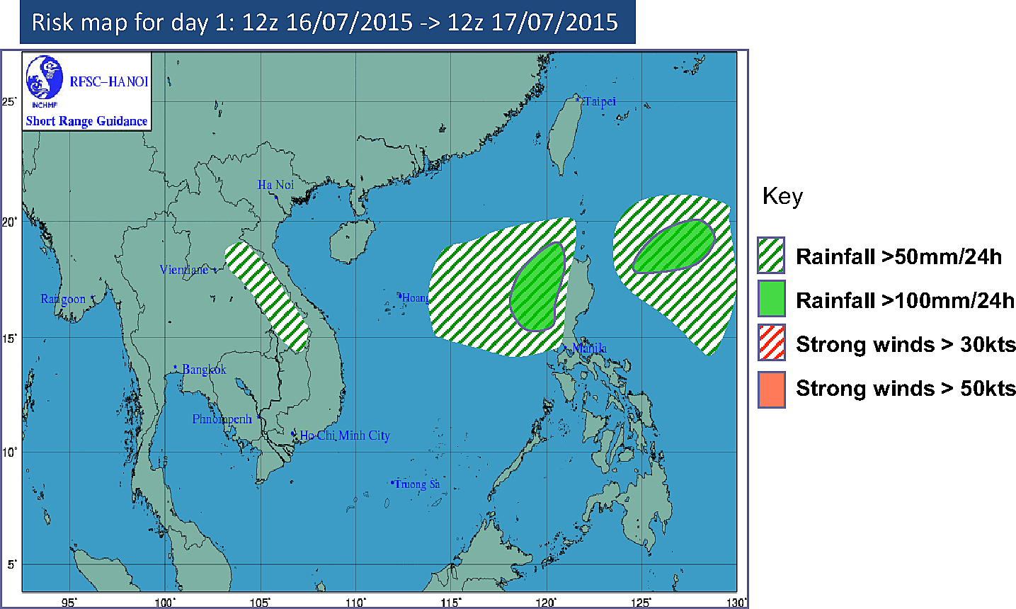

See Annex C for an example of short range guidance and Annex D for medium range guidance.
4. Future plans

- For guidance products: the short range and medium range guidance will be merged as the guidance up to 5 days (see Annex-C).
- Everyday verification for the guidance
- Updating Himawari-8 images every 10 minutes for satellite products
- Updating storm-tracking products based on new satellite products and testing the very short range warning capabilities of this product. Improving convective detection with JMA’s algorithms
- Extending regional model running domain covering the east sea of Phillippine
- Replacing the SREPS and LEPS systems by 5 days ensemble regional forecast with data assimilation (WRF/COSMO/NHM-JMA with LETKF method)
- Providing the ensemble products coming from all global forecasts and different cycle running for heavy rainfall
- Providing track and intensity tropical cyclone forecasting products based on RSMCs and NWP models
- The upgrading the swfdp-sea web portal is considered as a part of NCHMF website upgrading project near future.

Annex - A: SWFDP-SeA portal login information and accessing products

1. Login web page
Using Firefox browser to open swfdp-sea website:
At address bar, type www.swfdp-sea.com.vn => click [Enter]
The Fig. 1 below shows the initial Graphic User Interface of the website:
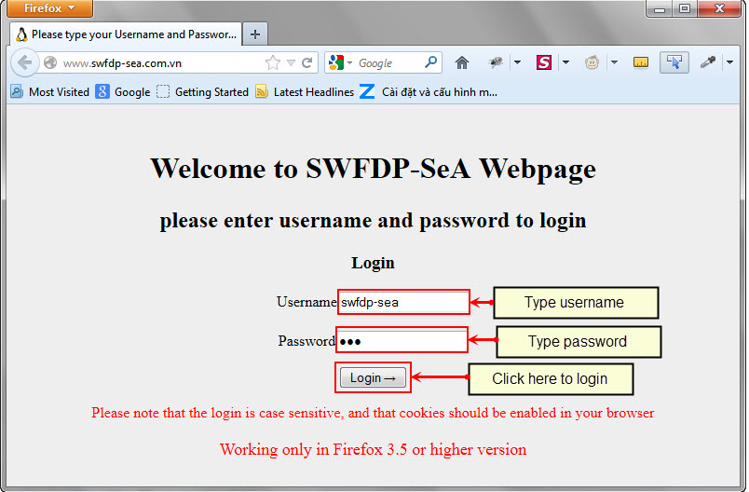
Fig. 1: Login page
- Type username: swfdp-sea
- Type password: RA2 (case sensitive)
- Click [Login] button to login.

2. Home page
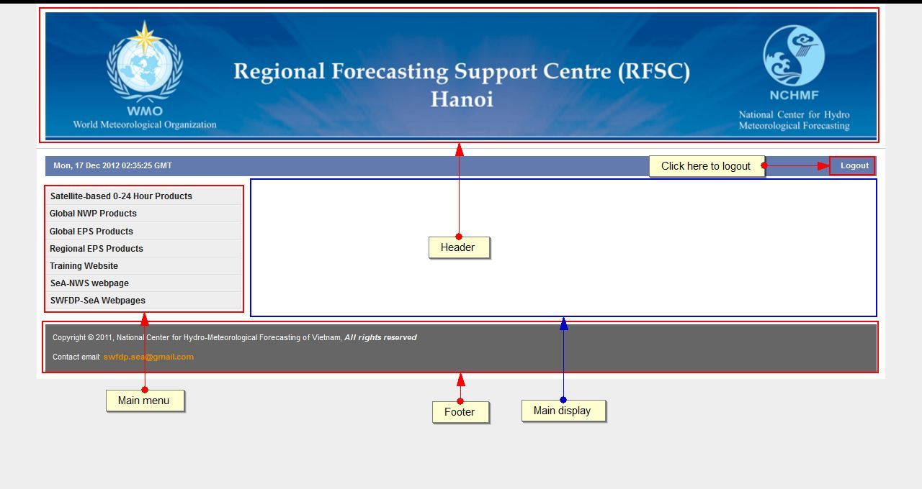
Fig. 2: Home page
After logging, we could see the main appearance of the website as in Fig. 2. There are two main parts of the website:
- The main menu is used to select the data group
- The main display is used for showing the forecast products

3. Accessing guidance products
3.1 The short-range guidance
For seeing short-range products, we need to follow these steps:
We firstly select [Guidance Products] and then select [Short-range (1-2 days)].
We can select [Issue date] from calendar and click [Reload]
Right click [Hanoi RFSC Guidance Product Short Range SWFDP Southeast Asia] to save the guidance including surface analysis maps, satellite image and risk maps for heavy rainfall and strong wind over SeA domain:

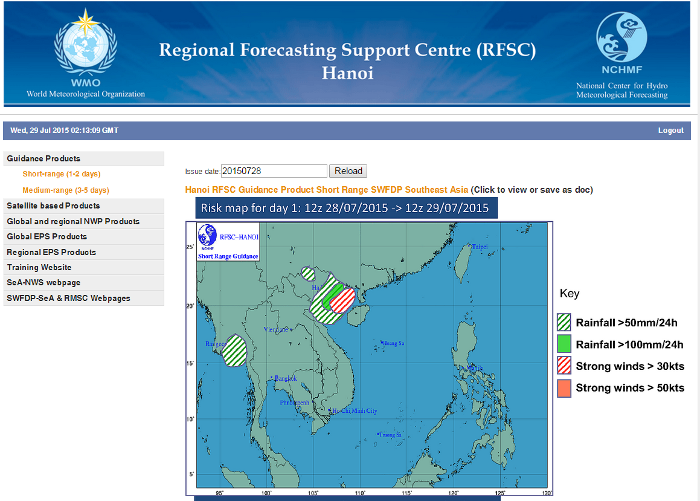

Examples of day 1 and day 2 guidance are showed in fig. 3 and fig. 4.
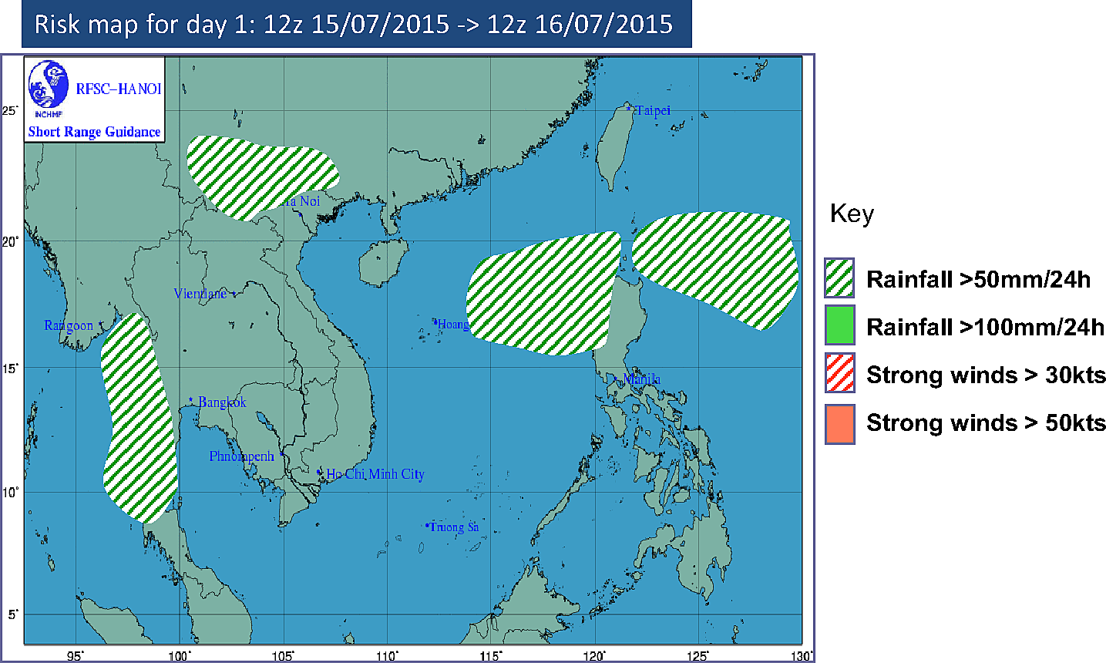
Fig. 3. Risk map for day 1 in short range guidance

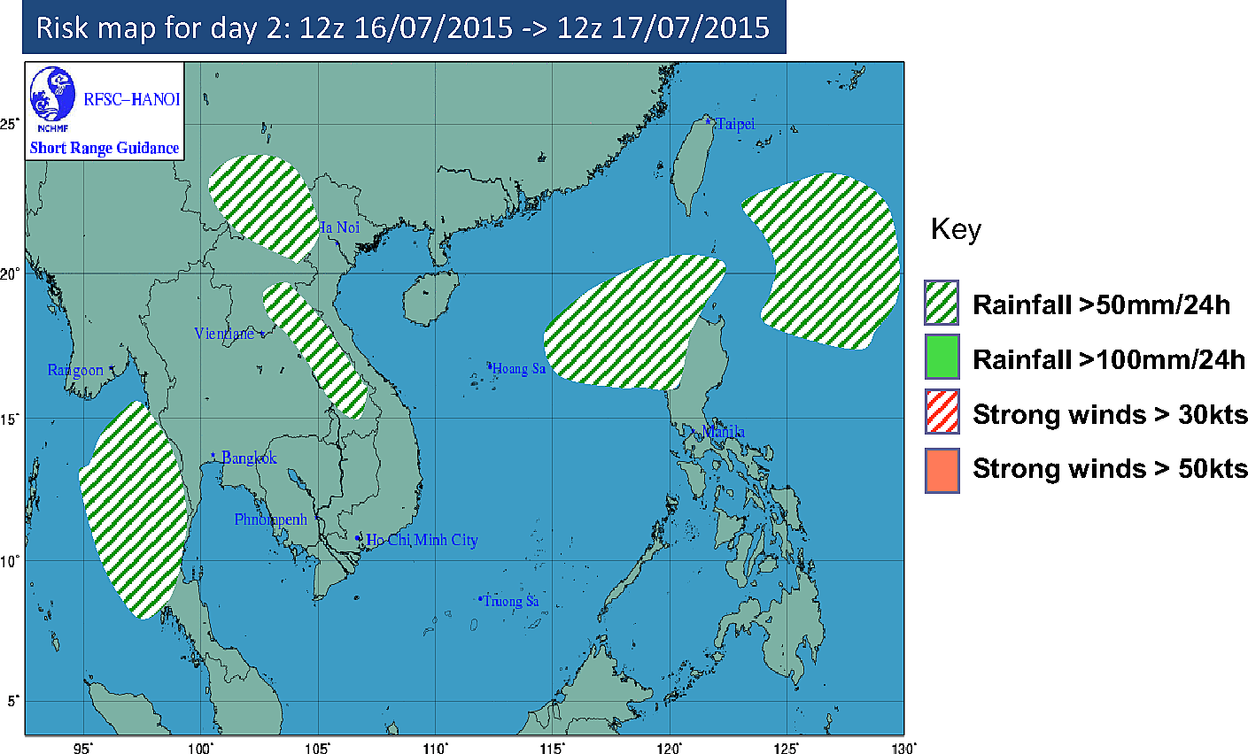
Fig. 4. Risk map for day 2 in short range guidance
3.2 The medium-range guidance
For seeing medium-range products, we need to follow these steps:
We firstly select [Guidance Products] and then select [Medium-range (3-5 days)].
We can select [Issue date] from calendar and click [Reload]
Right click [Hanoi RFSC Guidance Product Medium Range SWFDP Southeast Asia] to save the guidance including the expectation medium synoptic situation and risk maps for heavy rainfall and strong wind over SeA domain.

4. Accessing satellite products
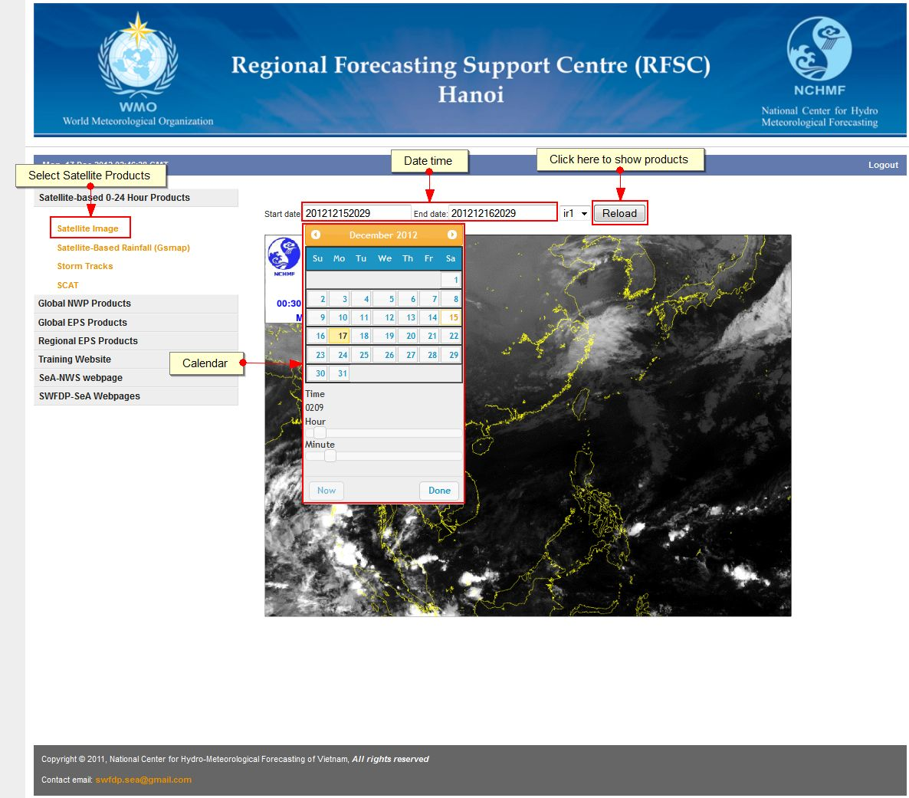
Fig. 5a. Satellite product

4.1. How to show Satellite Image
For seeing the infrared data of MTSAT-2 satellite, we firstly select [Satellite-based 0-24 Hour Products] and then select [Satellite image] to display. We can select the start time and end time of satellite data by the following steps:
- Click on the two boxes [Start date] and [End date] (Fig. 5)
- Click [Reload] button to show and loop image.
The time format is YYYYMMDDHHmm where: YYYY is year, MM is month, DD is day, HH is hour and mm is minute of satellite data. For example: 201211202135 means Year = 2012, Month = 11, Day = 20, Hour = 21 and Minute = 35

4.2. How to show Satellite Based Rainfall (Gsmap)
The same as in 4.1 but we select [Satellite Based Rainfall (Gsmap)]

4.3. How to show Storm Tracks
The same as in 4.1 but we select [Storm Tracks]

4.4. How to show SCAT
The same as in 4.1 but we select [SCAT]

4.5. How to show SCOPE-NWC for precipitation estimation from satellite
The same as in 4.1 but we select [SCOPE-NWC]
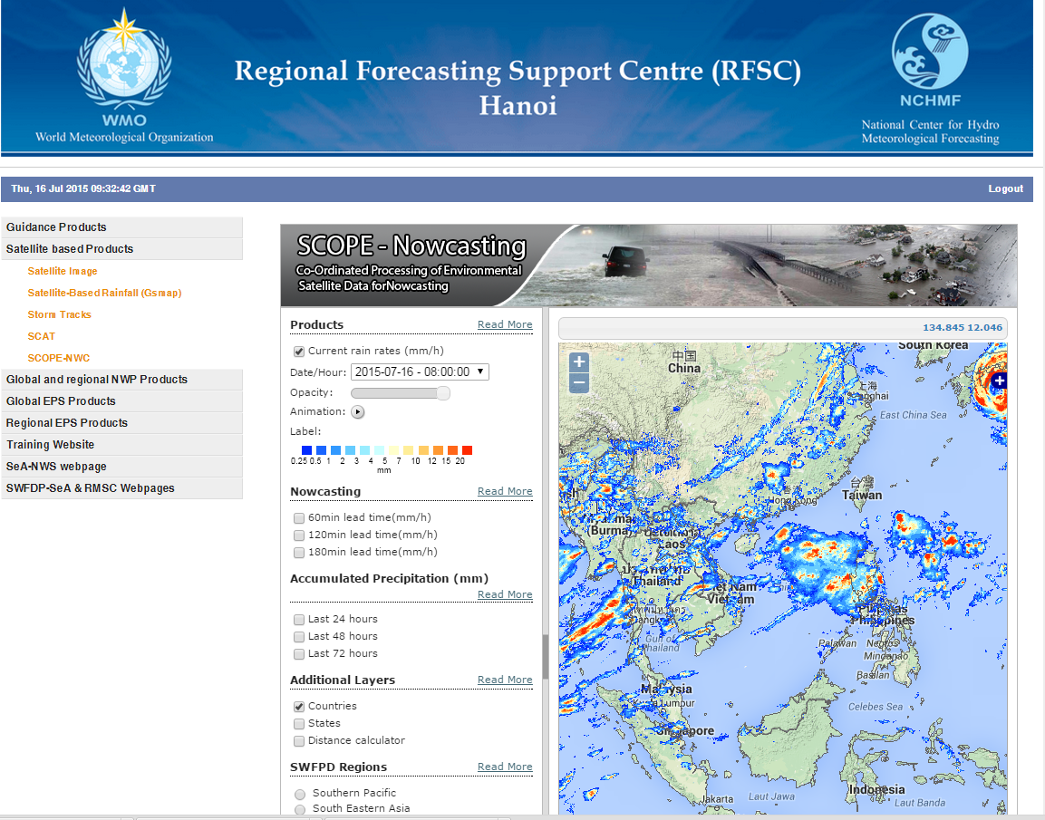
Fig. 5b. SCOPE-NWC for precipitation estimation from satellite

5. Global and regional NWP Products
For displaying global or regional nwp forecasts, firstly, we select [Global and regional NWP Products] and then chose what Global or regional product we would like to see, for example:
[GSM(JMA)_0.5x0.5]
- At the main display:
+ Selecting Initial Date from calendar (Eg: 2012112200)
+ Selecting product from product category (Eg: Surface)
+ Selecting weather chart (Eg: Pressure of mean sea level)
+ Click [OK] button
- Choose lead time, this picture will be displayed below as in Fig. 6.
- Click [Animation] to see animate pictures by lead time
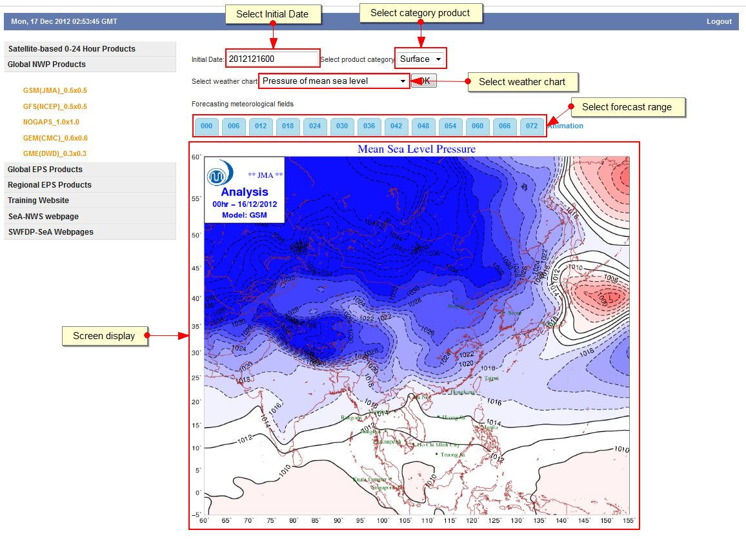
Fig. 6a: GSM Products

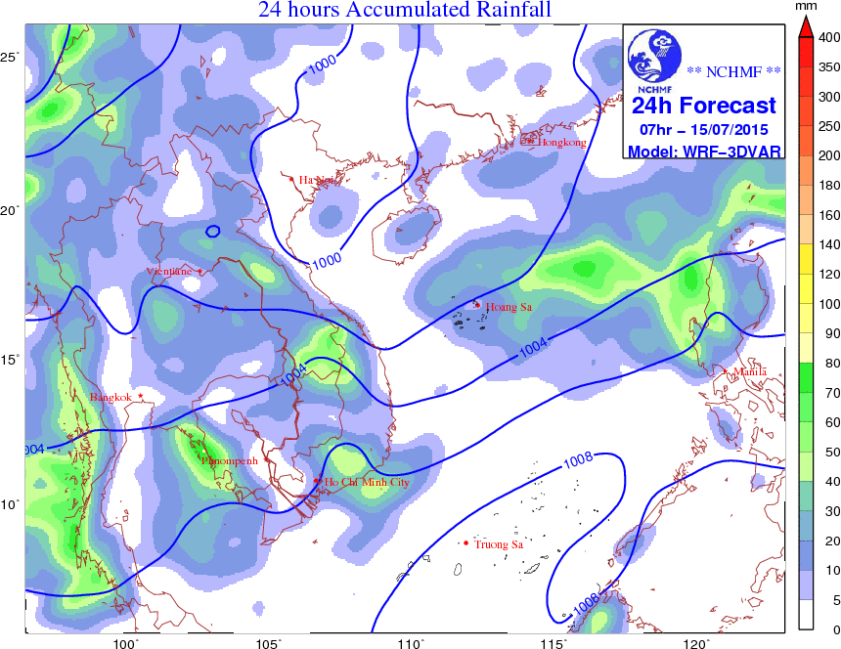 | 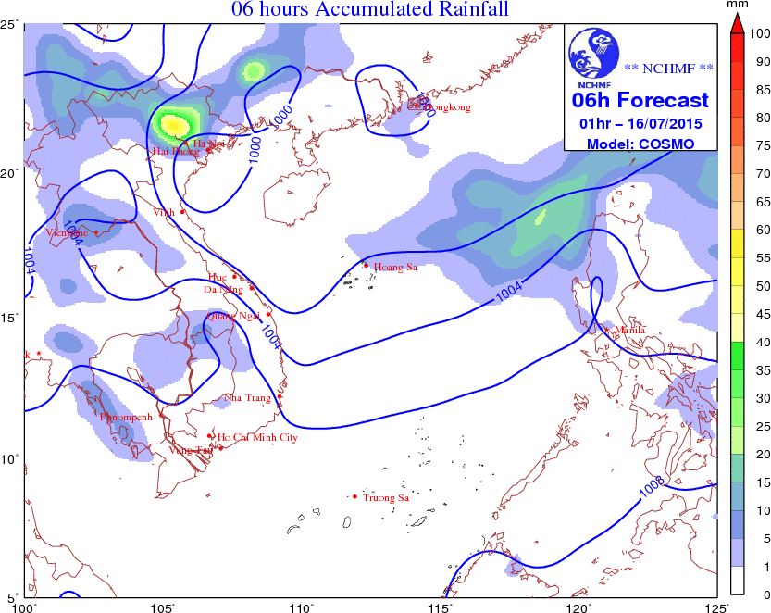
Fig. 6b: Regional forecast from WRF system (left) and COSMO system (right) for precipitation forecast over the SeA domain

6. Global EPS Products and Regional EPS Products
There are 3 ensemble forecast products including NAEFS, LEPS and SREPS products. The following steps will show you how to display global ensemble forecasts from NAEFS:
+ Select [Global EPS Products]
+ Select [NAEPS]
+ Select the initial data
+ If we want to see Pressure of mean sea level: select [Ensemble_mean] and then select [Pressure of mean sea level].
+ If user want to see the forecast for specific location, below the main image of Pressure of mean sea level we can select the nation, for example Vietnam and for Quynhon station. The fig. 7 shows the result of these selections.
For regional ensemble products from LEPS and SREPS, we could do the same selections as NAEPS product.
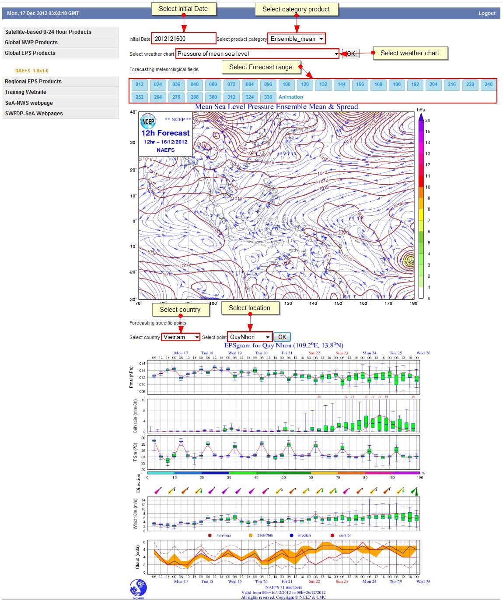
Fig. 7. NAEFS Products

7. Useful links
The last three menus include links to useful websites, for example:

Training Website
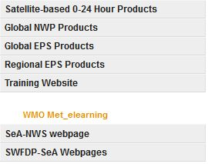
Fig. 8. Training Website

SeA-NWS webpage
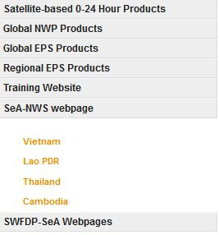
Fig. 9. SeA-NWS webpages

SWFDP-SeA & RMSC Webpages
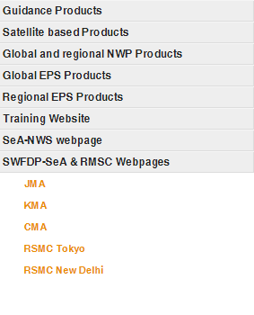
Fig. 10. SWFDP-SeA Webpages

Annex-B : List of station for EPSgram

1. Cambodia
ID | Station name | Latitude | Longitude | Height (m) | SREF | LEPS | NAEFS
48969 | Bantey Meanchey | 13º37' | 102º58' | 31m | x | x | x
48962 | Battambang | 13º06' | 103º12' | 13m | x | x | x
48990 | Kandal | 11º26' | 104º49' | 8m | x | x | x
48986 | Koh Kong | 11º38' | 102 59' | 13m | x | x | x
48995 | Kompomg Cham | 12º | 105º27' | 14m | x | x | x
48967 | Kompong Chhnang | 12º13' | 104º40' | 15m | x | x | x
48992 | Kompong Speu | 11º28' | 104º34 | 27m | x | x | x
48965 | Kompong Thom | 12º41' | 104º54' | 13m | x | x | x
48985 | Kompot | 10º36' | 104º11' | 4m | x | x | x
48970 | Krotie | 12º29' | 106º10' | 23m | x | x | x
48991 | Pochentong | 11º33' | 104º50' | 11m | x | x | x
48964 | Preh Vihear | 14º06' | 105º 09' | 62m | x | x | x
48997 | Prey Veng | 11º29' | 105º19' | 13m | x | x | x
48968 | Pursat | 12º33' | 103º51' | 18m | x | x | x
48973 | Rattanakiri | 13º44' | 106º59' | 330 | x | x | x
48966 | Siemreap | 13º22' | 103º51' | 15m | x | x | x
48983 | Sihanouk Ville | 10º37' | 103º29' | 13m | x | x | x
48972 | Stung Treng | 13º31' | 105º58' | 54m | x | x | x
48998 | Svay Reing | 11º50' | 105º48' | 6m | x | x | x
48993 | Takeo | 10º59' | 104º48' | 6m | x | x | x
48971 | Mondul Kiri | 12º27' | 107º11' | 690 | x | x | x
48963 | Pailin | 12º48' | 102º36' | 170 | x | x | x

2. Lao P.D.R.
ID | Station name | Latitude | Longitude | Height (m) | SREF | LEPS | NAEFS
48921 | Phongxali | 21.6763 | 102.0921 | 1300 | x | x | x
48924 | Louangnamtha | 20.9310 | 101.4165 | 600 | x | x | x
48925 | Oudomxai | 20.6967 | 101.9915 | 636 | x | x | x
48926 | Houayxay | 20.2619 | 100.4372 | 401 | x | x | x
48930 | Louangphbang | 19.8984 | 102.1652 | 305 | x | x | x
48938 | Xaignabouli | 19.2438 | 101.7103 | 326 | x | x | x
48927 | Viangxai | 20.4174 | 104.2309 | 913 | x | x | x
48935 | Phonsavan | 19.4438 | 103.1711 | 1094 | x | x | x
48941 | Phonhong | 18.4930 | 102.4488 | 179 | x | x | x
48940 | Vientiane | 17.9700 | 102.5704 | 171 | x | x | x
48945 | Pakxan | 18.3911 | 103.6657 | 157 | x | x | x
48946 | Thakhek | 17.4048 | 104.8084 | 151 | x | x | x
48947 | Savannakhet | 16.5523 | 104.7545 | 144 | x | x | x
48952 | Salavan | 15.7119 | 106.4127 | 168 | x | x | x
48953 | Xekong | 15.3424 | 106.7199 | 143 | x | x | x
48955 | Pakxe | 15.1201 | 105.8561 | 104 | x | x | x
48957 | Attapu | 14.8111 | 106.8302 | 105 | x | x | x

3. Thailand
ID | Station name | Latitude | Longitude | Height (m) | SREF | LEPS | NAEFS
48327 | Chiang Mai | 18.8 | 99 | 314 | x | x | x
48378 | Phitsanulok | 16.8 | 100.3 | 46 | x | x | x
48354 | Udon Thani | 17.4 | 102.8 | 178 | x | x | x
48407 | Ubon Ratchathani | 15.2 | 104.9 | 124 | x | x | x
48400 | Nakhon Sawan | 15.8 | 100.2 | 35 | x | x | x
48455 | Bangkok | 13.7 | 100.6 | 4 | x | x | x
48462 | Aranyaprathet | 13.7 | 102.6 | 49 | x | x | x
48500 | Prachuap Khirikhan | 11.8 | 99.8 | 5 | x | x | x
48568 | Songkhla | 7.2 | 100.6 | 7 | x | x | x
48565 | Phuket Airport | 8.2 | 98.3 | 9 | x | x | x
48331 | Nan | 18.78 | 100.78 | 200 | x | x | x
48421 | Thong Phaphum | 14.74 | 98.64 | 97.36 m | x | x | x
48357 | Nakhon Phanom | 17.42 | 104.78 | 145 | x | x | x
48431 | Nakhon Ratchasima | 14.96 | 102.07 | 186 | x | x | x
48501 | Trad | 11.77 | 102.88 | 2 m | x | x | x
48551 | Surat Thani | 9.14 | 99.15 | 5 m | x | x | x

4. Vietnam
ID | Station name | Latitude | Longitude | Height (m) | SREF | LEPS | NAEFS
48808 | Cao Bang | 22.67 | 106.25 | 243 | x | x | x
48803 | Lao Cai | 22.5 | 103.97 | 97 | x | x | x
48830 | Lang Son | 21.83 | 106.77 | 263 | x | x | x
48806 | Son La | 21.33 | 103.9 | 676 | x | x | x
48820 | Hanoi | 21 | 105.88 | 7 | x | x | x
48826 | Phu Lien | 20.8 | 106.63 | 116 | x | x | x
48823 | Nam Đinh | 20.43 | 106.15 | 3 | x | x | x
48839 | Bach Long Vi | 20.13 | 107.72 | 56 | x | x | x
48840 | Thanh Hoa | 19.75 | 105.78 | 5 | x | x | x
48845 | Vinh | 18.67 | 105.68 | 6 | x | x | x
48848 | Đong Hoi | 17.48 | 106.6 | 8 | x | x | x
48852 | Hue | 16.43 | 107.58 | 9 | x | x | x
48855 | Đa Nang | 16.03 | 108.2 | 7 | x | x | x
48866 | Pleiku | 13.98 | 108 | 779 | x | x | x
48870 | Quy Nhon | 13.77 | 109.22 | 6 | x | x | x
48877 | Nha Trang | 12.22 | 109.22 | 4 | x | x | x
48892 | Song Tu Tay | 11.42 | 114.33 | 5 | x | x | x
48887 | Phan Thiet | 10.93 | 108.1 | 5 | x | x | x
48900 | Ho Chi Minh | 10.82 | 106.67 | 10 | x | x | x
48917 | Phu Quoc | 10.22 | 103.97 | 4 | x | x | x
48916 | Tho Chu | 9.28 | 103.47 | 0 | x | x | x
48914 | Ca Mau | 9.18 | 105.15 | 3 | x | x | x
48918 | Con son | 8.68 | 106.6 | 9 | x | x | x
48920 | Truong Sa | 8.65 | 111.92 | 3 | x | x | x
48919 | Huyen Tran | 8.02 | 110.62 | 19 | x | x | x

Annex - C: Example of short range guidance for SWFDP-SEA


RFSC Guidance Product for SWFDP-Southeast Asia

SHORT-RANGE (DAY 1 and DAY 2)

Issue time: 0800Z Tue 28th July, 2015
Valid time: DAY1: 1200Z Tue 28th to 1200Z Wed 29th July 2015
DAY2: 1200Z Wed 29th to 1200Z Thu 30th July 2015

Preamble

RFSC Guidance Products are based on a skillful evaluation of both Global and Regional model outputs for the domain area, satellite imagery at the hour of the issue and, expert interpretation that takes into consideration interactions with the local features. For generating the guidance products, the following criteria are used:
- Heavy precipitation: > 50mm/24h & > 100mm/24h (the risk over 200mm/24 shall be described in discussion text)
- Strong Winds: > 30 Knots (over land and Sea) > 50 Knots (over Sea)
Assessment Scale for the Degree of Confidence of Forecast:

Confidence Level >75% (High); Confidence Level 50-75% (Medium); and Confidence Level <50% (Low)

Synoptic Situation BOTH DAYS:

Over the Southeast Asia domain:

- A trough having axis along 21^{O}N – 23^{O}N is across the north of Vietnam with a low pressure area during next 24 and 48 hours.
- The southwest monsoon prevails over the Andaman Sea and Thailand Gulf.

Risk over Southeast Asia domain next 24h and 48h
- The risk of heavy rain is expected over:
  - The northeast of Vietnam and Tonkin Gulf in DAY 1 and DAY 2.
- The risk of strong wind is expected over:
  - The Tonkin Gulf of Vietnam in DAY 1 and DAY2.

Degree of Confidence for DAY ONE:
- The northeast of Vietnam area and the Tonkin Gulf area are high haevy rain confidence coming from all the models with threshold 50 – 160mm/24h.
- The Tonkin Gulf area is medium strong wind confidence coming from 50% models with threshold >30kts.

Degree of Confidence for DAY TWO:
- The northeast of Vietnam area and the Tonkin Gulf area are high haevy rain confidence coming from all the models with threshold 50 – 160mm/24h.
- The Tonkin Gulf area is medium strong wind confidence coming from 50% models with threshold >30kts

Surface analysis maps:

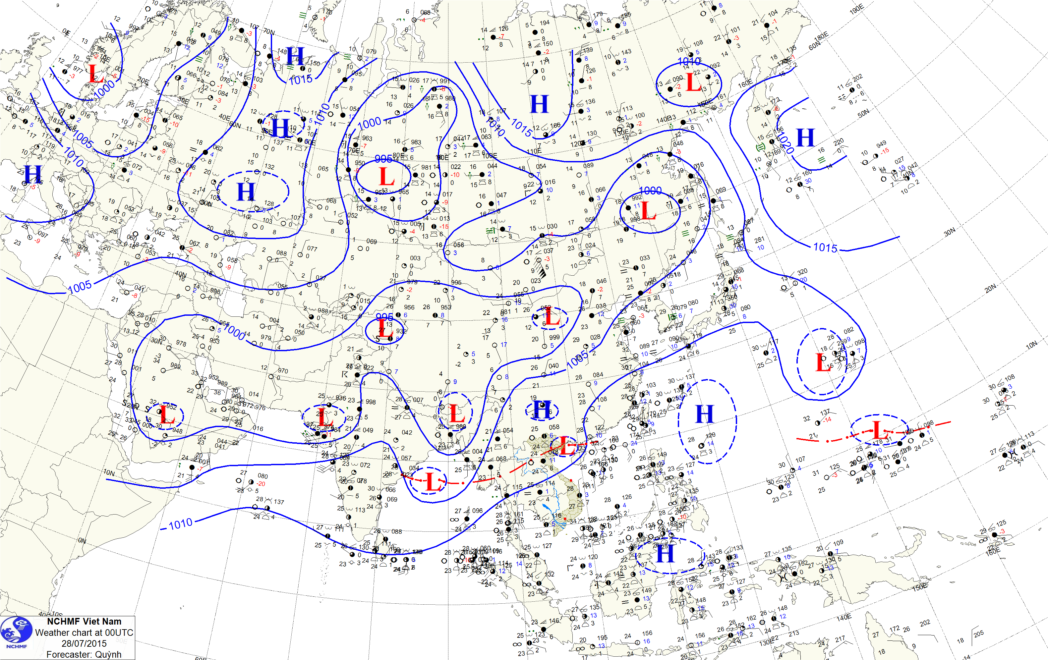

Risk maps
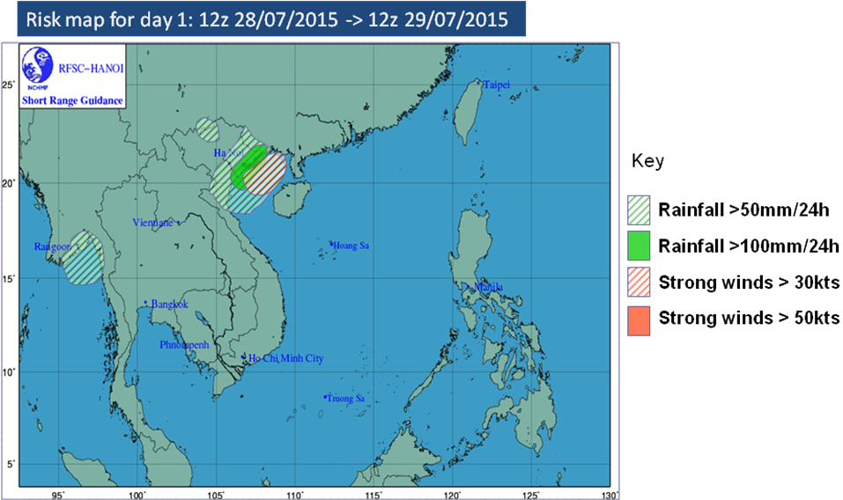

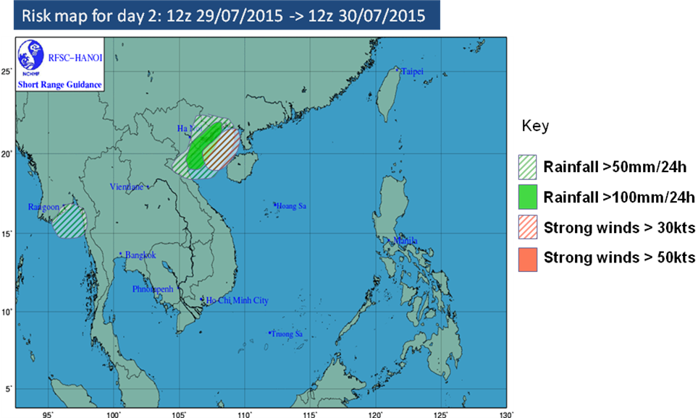

DAY 1: Risk Probability Table
Country | Rain > 50mm/24h  Risk |  |  |  | Rain > 100mm/24h  Risk |  |  |  | Wind > 15m/s (30kts)  Risk |  |  |  | Wind > 25m/s (50kts)  Risk
 | No | Low | Med | High | No | Low | Med | High | No | Low | Med | High | No | Low | Med | High
Cambodia | X |  |  |  | X |  |  |  | X |  |  |  | X
PDR Laos | X |  |  |  | X |  |  |  | X |  |  |  | X
Philippines | X |  |  |  | X |  |  |  | X |  |  |  | X
Vietnam |  |  |  | N |  |  |  | N | X |  |  |  | X
Thailand | X |  |  |  | X |  |  |  | X |  |  |  | X
DAY 2: Risk Probability Table
Country | Rain > 50mm/24h  Risk |  |  |  | Rain > 100mm/24h  Risk |  |  |  | Wind > 15m/s (30kts)  Risk |  |  |  | Wind > 25m/s (50kts)  Risk
 | No | Low | Med | High | No | Low | Med | High | No | Low | Med | High | No | Low | Med | High
Cambodia | X |  |  |  | X |  |  |  | X |  |  |  | X
PDR Laos | X |  |  |  | X |  |  |  | X |  |  |  | X
Philippines | X |  |  |  | X |  |  |  | X |  |  |  | X
Vietnam | X |  |  | N |  |  |  | N | X |  |  |  | X
Thailand | X |  |  |  | X |  |  |  | X |  |  |  | X

Key notes:
S: South
N: North
C: Center
E: East
W: West
Annex - D: Example of medium range guidance for SWFDP-SEA

RFSC Guidance Product for SWFDP-Southeast Asia

MEDIUM-RANGE (DAY 3, DAY 3 and DAY5)

Issue time: 0800Z Tue 28th July, 2015
Valid time: DAY3: 1200Z Thu 30th to 1200Z Fri 31st July 2015
DAY4: 1200Z Fri 31st to 1200Z Sat 01st Aug 2015
DAY5: 1200Z Sat 01st to 1200Z Sun 02rd Aug 2015

Preamble

RFSC Guidance Products are based on a skillful evaluation of both Global and Regional model outputs for the domain area, satellite imagery at the hour of the issue and, expert interpretation that takes into consideration interactions with the local features. For generating the guidance products, the following criteria are used:
- Heavy precipitation: > 50mm/24h & > 100mm/24h (the risk over 200mm/24 shall be described in discussion text)
- Strong Winds: > 30 Knots (over land and Sea) > 50 Knots (over Sea)
Assessment Scale for the Degree of Confidence of Forecast:

Confidence Level >75% (High); Confidence Level 50-75% (Medium); and Confidence Level <50% (Low)

Medium synoptic situation expectations:

Over the Southeast Asia domain:

- A trough having axis along 21^{O}N – 23^{O}N is across the north of Vietnam with a low pressure area. The activity of this trough is expected to be stronger next few days.
- The southwest monsoon prevails over the Andaman Sea and Thailand Gulf

Risk over Southeast Asia domain next 72h, 96h and 120h
  - The risk of heavy rain is expected over the northeast of Vietnam and Tonkin Gulf (northeast of Vietnam) in DAY 3, DAY 4 and DAY 5.

Degree of Confidence:
- The northeast of Vietnam and the Tonkin Gulf area are medium heavy rain confidence coming from 50% forecast models with threshold 50 – 120mm/24h in DAY 3.
- The north of Vietnam and the Tonkin Gulf area are medium heavy rain confidence coming from 50% forecast models with threshold 40 – 100mm/24h in DAY 4 and DAY 5.

Risk maps:

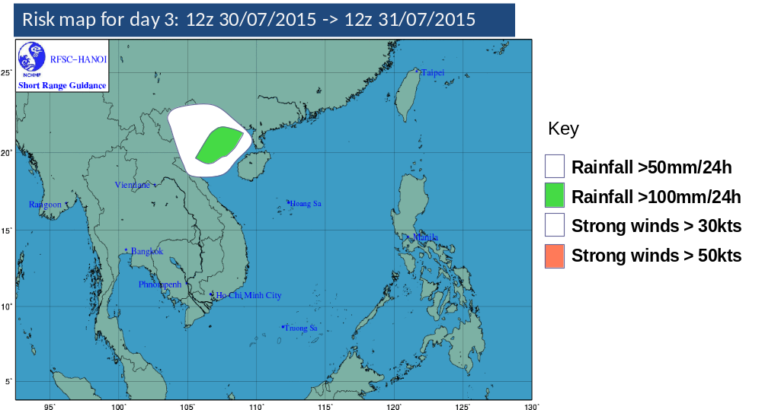
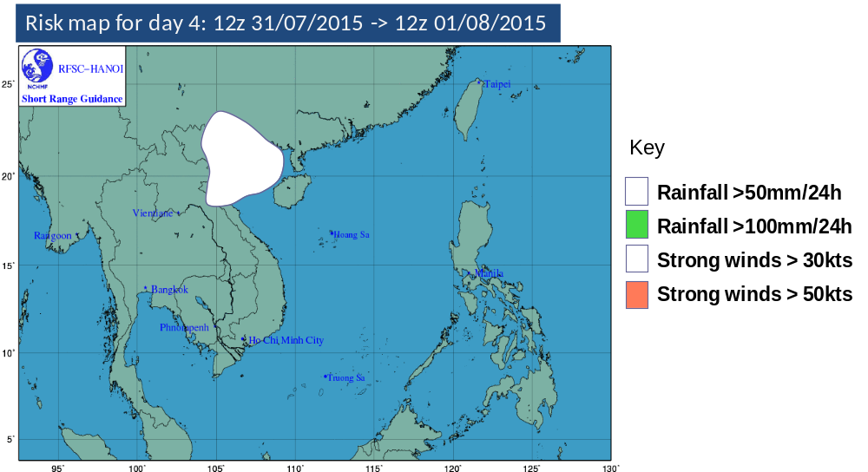
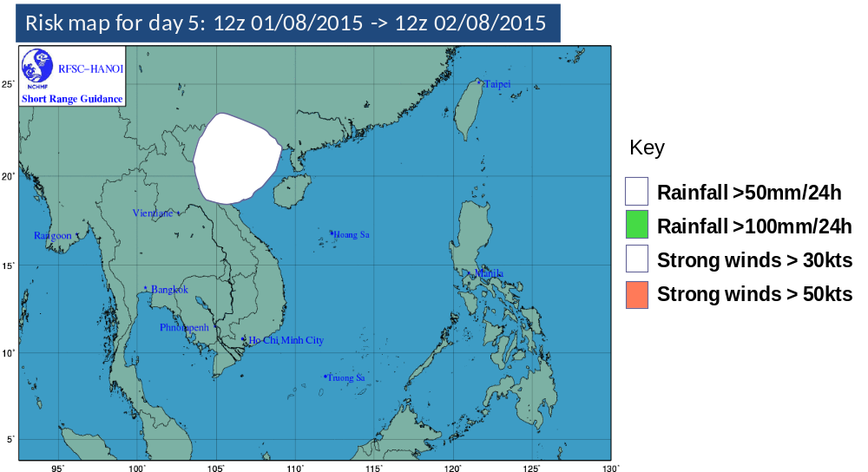

Risk Probability Table

DAY3
Country | Rain > 50mm/24h  Risk |  |  |  |  | Rain > 100mm/24h  Risk |  |  |  | Wind > 15m/s (30kts)  Risk |  |  |  | Wind > 25m/s (50kts)  Risk
 | No | Low | Med |  | High | No | Low | Med | High | No | Low | Med | High | No | Low | Med | High
Cambodia | X |  |  |  |  | X |  |  |  | X |  |  |  | X
PDR Laos | X |  |  |  |  | X |  |  |  | X |  |  |  | X
Philippines | X |  |  |  |  | X |  |  |  | X |  |  |  | X
Vietnam |  |  | N |  |  |  |  | NE |  | X |  |  |  | X
Thailand | X |  |  |  |  | X |  |  |  | X |  |  |  | X
DAY4
Country | Rain > 50mm/24h  Risk |  |  |  |  | Rain > 100mm/24h  Risk |  |  |  | Wind > 15m/s (30kts)  Risk |  |  |  | Wind > 25m/s (50kts)  Risk
 | No | Low |  | Med | High | No | Low | Med | High | No | Low | Med | High | No | Low | Med | High
Cambodia | X |  |  |  |  | X |  |  |  | X |  |  |  | X
PDR Laos | X |  |  |  |  | X |  |  |  | X |  |  |  | X
Philippines | X |  |  |  |  | X |  |  |  | X |  |  |  | X
Vietnam |  |  |  | N |  | X |  |  |  | X |  |  |  | X
Thailand | X |  |  |  |  | X |  |  |  | X |  |  |  | X
DAY5
Country | Rain > 50mm/24h  Risk |  |  |  |  | Rain > 100mm/24h  Risk |  |  |  | Wind > 15m/s (30kts)  Risk |  |  |  | Wind > 25m/s (50kts)  Risk
 | No | Low |  | Med | High | No | Low | Med | High | No | Low | Med | High | No | Low | Med | High
Cambodia | X |  |  |  |  | X |  |  |  | X |  |  |  | X
PDR Laos | X |  |  |  |  | X |  |  |  | X |  |  |  | X
Philippines | X |  |  |  |  | X |  |  |  | X |  |  |  | X
Vietnam |  |  |  | N |  | X |  |  |  | X |  |  |  | X
Thailand | X |  |  |  |  | X |  |  |  | X |  |  |  | X

Key notes:
S: South
N: North
C: Center
E: East
W: West
Med: Medium

