Severe Weather Forecasting Demonstration Project (SWFDP)
Workshop on TRAINING COURSE ON SERVICES OF ALERT AND EXTREME WEATHER CONDITIONS FORECAST IN WEST AFRICA AND CENTRAL AFRICA

(Dakar, Senegal, 02–06 november 2015)

INFORMATION NOTE
- VENUE
The workshop is scheduled to be held from 02 to 06 november 2015 at the meeting room of ASECNA Headquarters, Dakar Plateau.
ANACIM will provide necessary facilities to support the success of the workshop, including internet. Participants are encouraged to bring their own laptops.

- CONTACT PERSON
Contact Person for local arrangements

Name : Mami Thioro DIOUF
Direction de l’Exploitation de la Météorologie
Address : Aéroport Léopold Sédar Sanghor
Tel : +221 33 865 60 76
Telefax : +221 33 820 18 24
E-mail : mamithioro.diouf@anacim.sn

- WORKSHOP DOCUMENTS
The provisional training programme and information note for the participants can be downloaded from the WMO website at the following link:
http://www.wmo.int/pages/....
- VISA
Some visitors entering in Senegal are generally required to have a valid passport and visa. To obtain the visa, please complete and return the attached form (Annex I) and the copy of your passport to the following email address: Virginie DIOP (virginie.diop@anacim.sn) with a copy to Mami Thioro DIOUF (Mamithioro.diouf@anacim.sn) and Pascale Gomez (email: pgomez@wmo.int ).

The visa is not required for citizens of ECOWAS countries.

- LOCAL TRANSPORTATION BETWEEN AIRPORT AND HOTEL
Participants will arrive at the Leopold Sedar Senghor International Airport in Dakar. A pick for all the participants have been organized.
- ACOMMODATION
All participants will to stay at Ndiambour Hotel which are located on Carnot road, near ASECNA headquarter (training venue).

Le Ndiambour, 121 rue Carnot, Dakar, Senegal
Tel.: (+221) 33 889 42 89
Fax: (+221) 33 822 77 45
Email: ndiambour@orange.sn
http://www.lendiambour.com/
Participants will stay at Ndiambour hotel which is located on the rue Carnot downtown. All fees (nights + breakfast) will be covered by WMO. WMO will also cover lunch and two coffee breaks throughout the duration of the training course. Participants will be asked to settle extras and other meals at the hotel. A lumpsum will be provided for this purpose.
- LOCAL TRANSPORTATION BETWEEN HOTEL AND ASECNA
Participants will access to the place of the training course on foot.
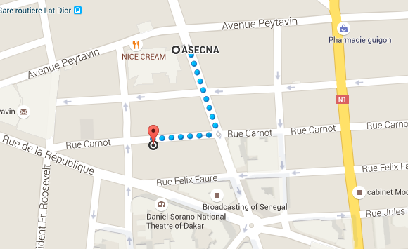

- FIELD TRIP/EXCURSION
Field trip/excursion will be organized for the participants by ANACIM on request of participants and on their costs. The necessary information will be provided during the workshop.
- CURRENCY EXCHANGE
The currency of Senegal is the CFA Franc. Daily information about the exchange rate can be found on http://www.xe.com/fr/currency/xof-cfa-franc. You can make changes at the airport and in local banks. The hotel and shops accept dollars and euros at reasonable rates.

- ELECTRICITY
The electric current is 220 volts Senegal. Participants should bring an adapter.
- CLIMAT
During the month of November, the weather in Dakar is marked by a morning and night freshness. There is opportunities haze reducing visibility at times.

Daily Minimum Temperature: 23.1 ° C
Daily Maximum Temperature: 29.7 ° C
Rain: 0.2 mm

For more information about the weather in Dakar, you can visit: www.anacim.sn

- CLOTHING
Casual and light attire will be appropriate while warm clothing for air-conditioned premises is suggested.

************************

Annex I
Severe Weather Forecasting Demonstration Project (SWFDP)
TRAINING COURSE ON SERVICES OF ALERT AND EXTREME WEATHER CONDITIONS FORECAST IN WEST AFRICA AND CENTRAL AFRICA
IN THE 02-06 November 2015

Information Sheet
Please complete and return to ANACIM
to email : virginie.diop@anacim.sn, mamithioro.diouf@anacim.sn, pgomez@wmo.int (or by fax : +221 33820 18 24) before …..2015
Contact Person: Mami Thioro DIOUF
JOIN A COPY OF YOUR PASSPORT

PERSONAL INFORMATION
Title : Prof. Dr. Mr. Ms. Others, please specify
Family / Last Name :
Given / First Name :
Organization :
Position Title:
Passport No.: | Issue Date : Expiry Date :
Tel:
Fax :
E-mail Address :
Special Dietary Requirements: |  |  | Vegetarian | Pork-free |  |  | Beef-free
 |  |  | Others, please specify :
ACCOMMODATION
Please indicate your information below.

Check-in Date
Check-out Date
Arrival Flight/Date/Time
Departure Flight/Date/Time

