WORLD METEOROLOGICAL ORGANIZATION  COMMISSION FOR BASIC SYSTEMS  OPAG DPFS  MEETING OF SEVERE WEATHER FORECASTING DEMONSTRATION PROJECT - REGIONAL SUBPROJECT RA I  PRETORIA, SOUTH AFRICA  31 JULY – 3 AUGUST 2006 |  | CBS-DPFS/RA I/SWFDP/Doc. 4.3(3)  (17.VII.2006)  _______  Item: 4  ENGLISH ONLY

A SUMMARY OF THE TECHNICAL FACILITIES PRESENTLY AVAILABLE AT THE NATIONAL INSTITUTE OF METEOROLOGY (INAM)

(Submitted by Mozambique)

Summary and purpose of document

This document provides a general overview of the technical facilities available at INAM presently and is an input to the SWFDP

Action Proposed

The meeting is invited to include this information in its discussions.
SEVERE WEATHER FORECASTING DEMONSTRATION PROJECT
(SWFDP) – MOZAMBIQUE

1. INTRODUCTION

Mozambique’s geographical position makes it prone to tropical cyclones that form and originate over the Indian Ocean every season from November to April. These tropical cyclones bring with them strong winds and heavy rains.

The tropical cyclones move into the southern Africa region and increase the flow of international rivers, nine of which drain into the sea through Mozambican territory. The combined effect of cyclones in Mozambique and of the swollen rivers is the devastation of infrastructures and property, often accompanied by a loss of life.

Besides the tropical cyclones the country is also affected by other severe weather events that are not related to the tropical cyclones, such as severe thunderstorms and lightning, strong winds brought by the frontal systems that reach the southern part of the country and sometimes hail although very rarely.

  - Country Climate

Mozambique is located in the eastern end of southern Africa between parallel 10° 27’ South and 26° 52’ South, and between 30° 12’ East and 40° 51’ East. It has an area of 799,380 square kilometers. It has a 2,515- kilometers coastline on the Indian Ocean to the east, and 4,330 kilometers of land borders with Tanzania to the north, Malawi, Zambia, Zimbabwe, and South Africa to the west, and Swaziland and South Africa to the southwest and south.

The meteorological conditions prevailing in Mozambique are mainly caused by the following factors:
- The Intertropical Convergence Zone (ITCZ);
- The thermal low over the middle of the southern Africa subregion (Namibia and Botswana);
- The two subtropical anticyclones in the southern hemisphere (St. Helena and the Mascarene high); and
- The extra-tropical cold fronts that reach the southern part of the country.

For this reason we can distinguish two distinct climate zones, one at the north of 15° south and the second one at the south of 21°south.

The influence of all these factors lead to two distinct seasons on the climate of the country: A dry winter season from April to September and a rainy summer season from October to April. Most of the rain that falls in the southern Africa region is brought by the Intertropical Convergence Zone (ITCZ), which occurs between a dry, warm air mass and a moist, cool air mass.
At times Mozambique is hit by tropical cyclones with genesis in the Indian Ocean between 5° south and 10° south and rarely by those with their genesis in the Mozambique channel. An average of three tropical cyclones per season (November–April) reach Mozambique with the peak being observed in January–February.

Because Mozambique is highly vulnerable to severe weather events the SWFDP can play a great role on preventing damages and loss of life in the country.

2. TECHNICAL FACILITIES PRESENTLY AVAILABLE AT INAM

- AMSS (Messir Comm) with the following capabilities:

  - 64 kbps connection to Pretoria;
  - Connection to RSMC La Reunion through email;
  - 64 kbps connection with Nampula (Regional Meteorological Centre for the northern Mozambique)
  - 128 kbps connection with Beira (Regional Meteorological Centre for central Mozambique) and Xai-Xai;
  - Email server that provides access to all
  - 512 kbps dedicated internet line to download NWP products

- MSG – 12 channel Satellite images, installed in March 2005

- Messir Vision (Maputo Headquarters, Maputo Airport and Beira) – for displaying the following products:
  - GRIB
  - Satellite
  - Text messages
  - BUFR
  - T4 charts

- Messir Aero (Maputo Airport and Beira) – WAFC data and products

- 29 synoptic stations (including 5 AWOS and 3 AWS)

- Two Doppler Weather Radars (Xai-Xai and Beira), integrated to the South Africa weather radar network since February 2006;

- 1 upper air station (Nampula)

- SUMO (Software for the Utilization of MSG in Outlook Activities, ver 1.00)

2.1 LIST OF NWP PRODUCTS AVAILABLE AT INAM

INAM receives NWP products from the following centers:
- ECMWF
- WAFC London (1250)
- WAFC London (2500)
- KWBC Washington
- PUM Mozambique (100)
- EGRR
- LFPW

It is very important to highlight that very recently INAM has installed a Weather Service Production System comprised of several MESSIR systems (MESSIR – NWP, MESSIR – PROD, MESSIR – MEDIA, and MESSIR – NET (see annex 1). This system provides capability to ingest all incoming observational and model data, and produce composite weather information and forecast products on 24/7 basis.
The MESSIR – NWP can be considered as the main feature of this system as it is based on the Ported Unified Model (PUM) which is the name given to the suite of atmospheric and oceanic numerical modeling software developed and used at the UKMet Office.

The MESSIR – NWP is suitable for high resolution forecasting;
- Provides higher resolution output than the global weather model, because of the focus on a limited area;
- Is a non-hydrostatic model designed to simulate or predict mesoscale and regional scale atmospheric circulation and phenomena such as atmospheric convection, mesoscale convective systems, orography, mesoscale instabilities, urban effects on weather, and air quality studies with a spatial scale from 1 to 1000 km.

The MESSIR – PROD Workstation can ingest and integrates a vast amount of information meteorological data and products, from a wide variety of sources into a single system. It allows the forecaster to create products based on the received data and disseminates them.

3. INVOLVEMENT OF THE DISASTER MANAGEMENT INSTITUTE (INGC)

The INGC is the Disaster Management Institute in Mozambique and works in a close collaboration with INAM. INAM is a member of the Technical Council of Emergency. Currently there are ongoing talks aiming at the possibility of having the two institutions connected online, so that all advisories and warnings issued by INAM can be accessed in real-time by INGC. Furthermore, the INGC is planning to have an “operations centre” where INAM will have its personnel working during the eventuality of a severe weather event.

3.1 Operation of the Warning System

The main purpose of a warning system is to avert or minimize loss of life and property damage. In this regard, before and during the occurrence of a severe weather event INAM performs a warning system based on the following steps:
- Preparation and dissemination of warnings through radio and television, email and through its web page. Warnings are also sent to the print media and radio community, to the Technical Council of Emergency and to the local authorities in the expected areas to be affected;
- Press conferences or interviews to explain the development of the phenomenon to the public.

3.2 Example of a Warning issued by INAM and sent to DMPCA


República de Moçambique
_________
Instituto Nacional de Meteorologia
Caixa Postal 256 – MAPUTO
Telefs.: 490064-490148-492530 - Fax: 491150 -Telex: SMMMP 6-259

NATIONAL CENTRE FOR WEATHER ANALYSIS AND FORECAST

TROPICAL DISTURBANCE SOUTH OF INHAMBANE

WARNING NR 03/06
Issued at 08:00hours (Local Time) 05th January 2006

At 08:00 local time the tropical disturbance was located south of Inhambane and moving southwards.

It is expected that within the next few hours the coastal zones of Gaza and Maputo provinces will be affected by strong winds with gusts up to 60Km/h.

There is a high chance of intermittent and moderate to heavy thunderstorms and rain in places.

The authorities of Inhambane, Gaza and Maputo provinces are advised to put in place prevention measures.
National Director
_____________________________

Filipe D. F. Lúcio

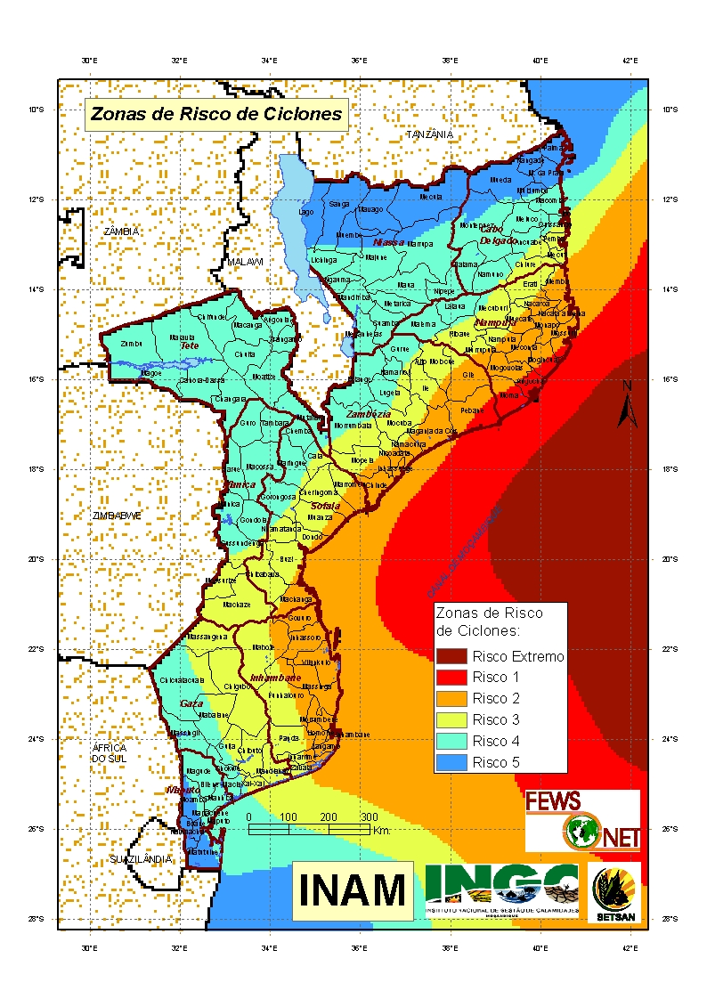

CYCLONE RISK ZONES

4. TRAINING OF THE FORECASTERS

Mozambique is still in lack of well-trained staff, mainly in the field of NWP and weather radar interpretation. Therefore, training on the EPS techniques, model verification and evaluation and radar image interpretation is of paramount importance.

5. FUTURE OPERATIONAL PLANS

- Continue to increase the national stations network mainly through the installation of classical and automatic synoptic stations;
- Effective establishment of two regional forecasting centers (Beira and Nampula);
- Improve the use of the Local Area Model;
- Introduction of nowcasting weather forecasting
- Training at different skills
- Installation of 1 weather Doppler radar in Nampula
- Installation of 2 upper air stations (Maputo and Beira)

