WORLD METEOROLOGICAL ORGANIZATION  COMMISSION FOR BASIC SYSTEMS  OPAG DPFS  SEVERE WEATHER FORECASTING DEMONSTRATION PROJECT (SWFDP)  RA I South-eastern Africa  Meeting of the Regional Subproject Management Team (RSMT)  MAPUTO, MOZAMBIQUE  27 February – 2 March 2007 |  | CBS-DPFS/RA I/RSMT-SWFDP/Doc. 4.2(2)  (08.II.2007)  _______  Item: 4  ENGLISH ONLY

RSMC-Pretoria First Progress Report

(Submitted by the South African Weather Service)

Summary and purpose of document

This document provides a progress report of the implementation and activities of the RSMC-Pretoria in support of the SWFDP RA1 in South-Eastern Africa.

Action Proposed

The meeting is invited to note the contents of the report and provide feedback to the RSMC-Pretoria on how it can improve the service delivered in support of the SWFDP

RSMC-PRETORIA
PROGRESS REPORT
December 2006
Mnikeli Ndabambi and Eugene Poolman

- INTRODUCTION
  - The South African Weather Service (SAWS) was designated by the WMO as a Regional Specialized Meteorological Centre (RSMC) with geographical responsibility for Southern and Central Africa. In this capacity the SAWS accepted the invitation by WMO to participate in the WMO CBS Severe Weather Forecast Demonstration Project (SWFDP) in Southern Africa.
  - The role of RSMC-Pretoria in the cascading process of the project is to “interpret information received from global NWP centres, run a limited area model to refine products, liaise with participating NMCs” (according to the Regional Subproject Implementation Plan). In this process RSMC-Pretoria is specifically tasked to issue guidance forecasts for days 1-5 to the NMCs advising them about potential heavy rain or strong winds according to the information received from the global NWP centres and its own limited-area model.

- LIMITED AREA MODELLING (LAM)
  - The SAWS is running the ETA LAM covering Southern Africa since 1993, and the resolution in 2006 was 32 km.
  - This system has been replaced operationally by the Unified Model of the Met Office running as a LAM with full data assimilation in 2007. The SAWS version is running at a 12 km resolution (called the UM SA12), and its domain includes Southern Africa up to the equator (see Addendum 1). A non-assimilation version was available to RSMC-Pretoria (and thus all participating NMCs and other centres) from 1 November 2006.
  - Products of the UM SA12 are available on either GRIB or in jpeg format on the RSMC website (see Addendum 1). At this stage none of the participating centres has requested the GRIB output yet. SAWS is investigating transmitting GRIB output of the UMSA12 via the EUMETCast/GEONETCast to participating NMCs as a means to overcome slow landlines.
  - Initial experiences with the new UM SA12 are very positive and its ability to capture the major events in Southern Africa is remarkable. A full verification process is ongoing and results of intercomparison with other models will be available later.
- GUIDANCE PRODUCTS
  - One of the important roles designated to RSMC-Pretoria is to issue daily guidance products for the next five days to the participating NMCs. Guidance are given for heavy rain exceeding the thresholds of 50 mm / 24 hours, 100 mm / 24 hours or 50 mm / 6 hours, and strong winds exceeding the threshold of 20 or 30 kts.
  - RSMC-Pretoria dedicated this task to a team of senior forecasters. These guidance products are the result of analysis of various global centre products and the UM SA12 available to the forecasters to assess the likelihood of heavy rain or strong winds.
  - Three sets of guidance products are prepared daily and consist of maps depicting the areas of likely heavy rain and/or strong wind, tables giving the probability of the event happening, and a document discussing the reasoning behind the guidance issued. A guidance package are issued in the morning for the short range (48 hours or days 1-2), and a similar package in the afternoon for the medium range (days 3-5). See Addendum 2 for an example.
  - Following an initial period of uncertainty and product fine tuning in the first weeks of November, the RSMC-Pretoria forecast team adapted and settled down to a working routine. The additional tasks did require modifications in the routines in the office, and the number of forecasters involved is not yet ideal. This will be improved as new forecasters become available later during the project period, and following changes in the structure and activities within the SAWS.
  - Forecasters find the various products from ECMWF, Met Office and NCEP very useful in identifying potential areas of severe weather. A number of cases exceeding the thresholds were identified.

- RSMC WEBSITE
  - To facilitate easier access to relevant NWP, ensemble prediction (EPS) products and guidance products RSMC-Pretoria developed a website available to all participating centres and NMCs. The web address is www.weathersa.co.za/RSMC and it is password protected (see Addendum 3).
  - Products from RSMC-Pretoria available on this website include the UM SA12 limited area model, post-processed fields of the NCEP EPS system as used by the SAWS, all the guidance products and some other relevant information.
  - The website also have links to the products of the global centres participating in the SWFDP, including NCEP EPS, ECMWF EPS, Met Office MOGREPs, UM African LAM from Met Office and NCEP medium range forecasts. There are also links to RSMC-Reunion and ACMAD, and the various NMCs in Southern and Central Africa. MOGREPS products became available only in January 2007 due to web development problems at SAWS.
  - Some countries unfortunately experience access speed problems to the RSMC website, however no complaints of no access at all due to the speed problem has been received. This should improve as upgrades to the SAWS internet lines are implemented by early February 2007.

- ARCHIVES
  - Archives of the products prepared by RSMC-Pretoria are kept at the SAWS for the period starting 6 Nov 2006. These products include the output of the UM SA12 and the guidance maps, tables and discussion documents.

ADDENDUM 1. PRODUCTS OF THE UNIFIED MODEL SA12

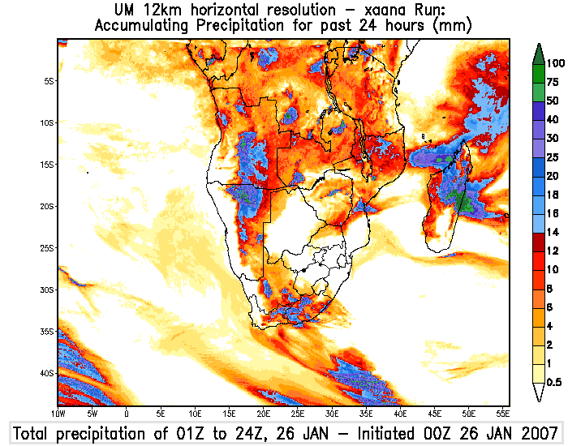
Figure 1. UM SA12 domain and example of a precipitation field

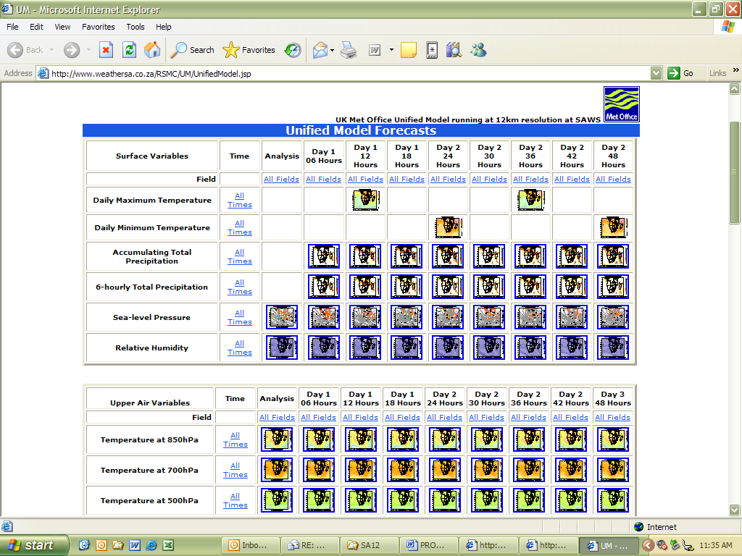
Figure 2. Example of the product page of the UM SA12 on the RSMC website. Forty different variables are available at six-hourly time steps from 00h till 48h.

ADDENDUM 2. GUIDANCE PRODUCTS FROM RSMC-PRETORIA
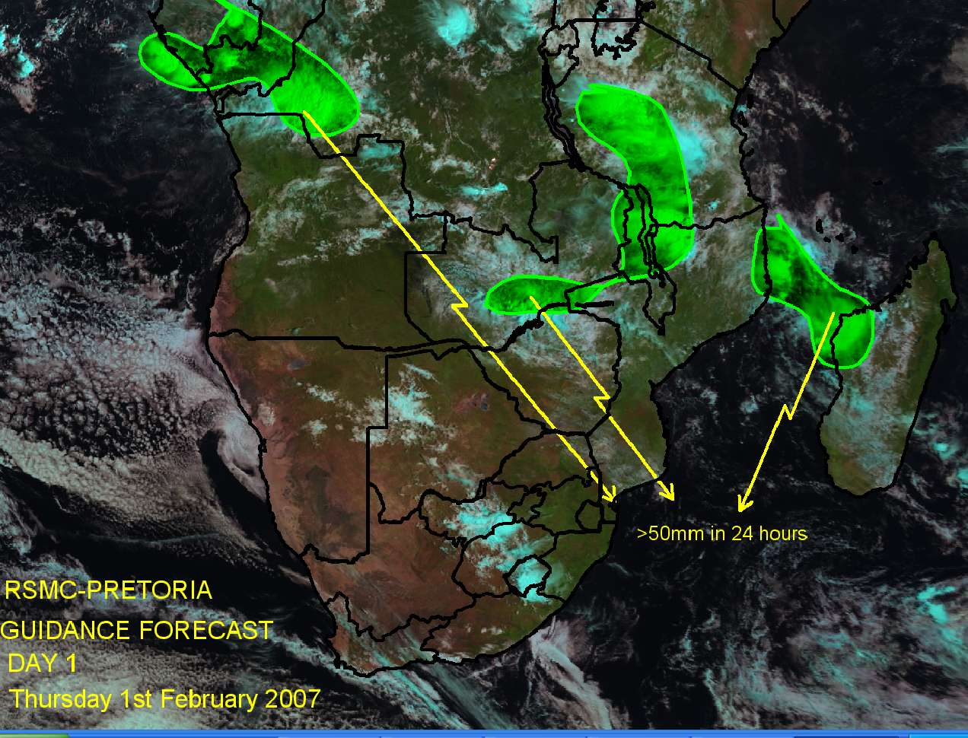
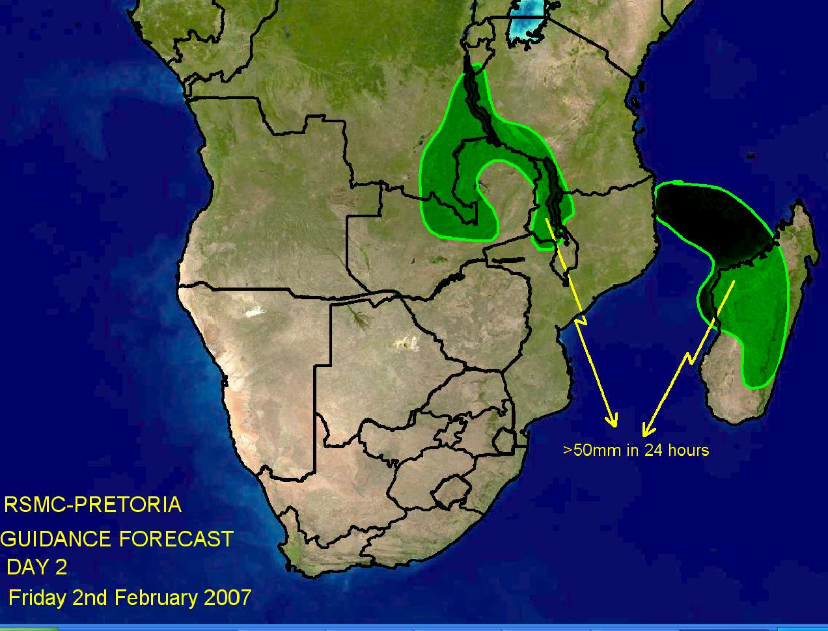
Figure 3. Examples of guidance maps for day 1 and day 2.

ADDENDUM 3. RSMC-PRETORIA WEBSITE

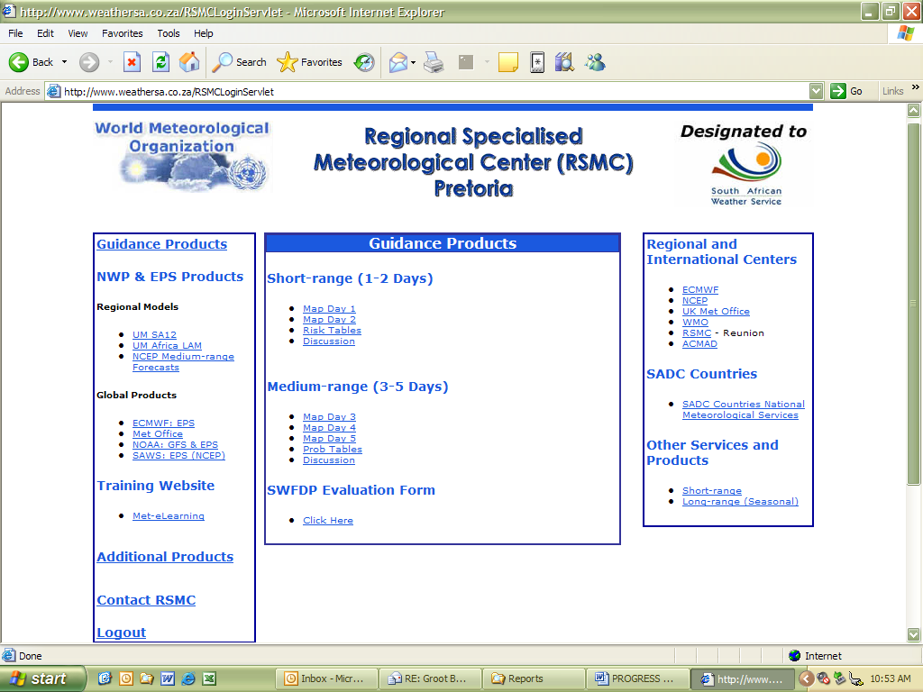
Figure 4. Example of the RSMC web page.

