WORLD METEOROLOGICAL ORGANIZATION  COMMISSION FOR BASIC SYSTEMS  OPAG DPFS  SEVERE WEATHER FORECASTING DEMONSTRATION PROJECT (SWFDP)  RA I South-eastern Africa  Meeting of the Regional Subproject Management Team (RSMT)  MAPUTO, MOZAMBIQUE  27 February – 2 March 2007 |  | CBS-DPFS/RA I/RSMT-SWFDP/Doc. 4.2(1)  (31.I.2007)  _______  Item: 4  ENGLISH ONLY

Report of RSMC La Réunion

(Submitted by RSMC La Réunion)

Summary and purpose of document

This document provides a summary of implementation activities for SWFDP at RSMC La Réunion, provided by Mr Yassine Kadri.

Action Proposed

The meeting is invited to review the contents and consider any necessary actions for the regional subproject.

1. Status of participation of RSMC La Réunion (Correspondence)

>>> "Yassine Kadri" <yassine.kadri@meteo.fr> 01/25/07 12:01 PM >>>
Bonjour Peter,

… … …

Pour ce qui concerne le CMRS de La Réunion, en l'état actuel des choses,
notre contribution se résume à la seule production classique assurée au
titre de la surveillance de l'activité cyclonique sur notre bassin de
responsabilité. Aucune production spécifique n'a été pour le moment mise en
place, dans le cadre du sous-projet, au profit du Service Météorologique
Sud-Africain.

Il convient cependant de noter que depuis le mois de novembre un nouveau
modèle de prévision numérique a meso-échelle est opérationnel sur le
Sud-Ouest de l’océan Indien. Ce modèle ALADIN couvre une bonne partie de la
zone de responsabilité du CMRS de La Réunion. Il est dote d'un propre cycle
d'assimilation (algorithme 3DVAR). Sa résolution horizontale est de 10 km
tant en analyse qu'en prévision. Le domaine couvert englobe, en particulier,
Madagascar. On pourrait, en tant que de besoin, mettre à la disposition du
service sud-africain les sorties de ce modèle.

Très cordialement,

Yassine KADRI
Meteo-France
Directeur Interregional adjoint
Direction Interregionale de La Reunion

(Unofficial translation)
………

Concerning RSMC La Réunion, given the present situation, our contribution is simply the routine production in accordance with the Tropical Cyclone Watch over our area of responsibility. For the time being no specific production has been put in place, under the sub-project, for the benefit of the South-African Weather Service.

However, one should note that since November a new meso-scale NWP model is operational on the South-West Indian Ocean. This ALADIN model covers a good portion of the area of responsibility of RSMC La Réunion. The model has its own assimilation cycle (3 D-VAR). Its horizontal resolution is 10km, for the analysis as well as for the forecast. The domain includes, in particular, Madagascar. We could, if expressed as a need, make available to the South-African Weather Service the output products of this model.
………

2. The Cyclone Season 2006-2007 in the South-West Indian Ocean: the situation on 25 January 2007 (Annex)
The cyclone season 2006-2007 in the South-West Indian Ocean :
the situation on 25 January 2007

While we’re heading towards mid-season (early February) only three named systems have developed so far, which is not abnormal but slightly below average though. Three other weak (and therefore unnamed) disturbances have elicited issuance of advisories. The table below indicate the period of activity of these different systems.

System | 01-20062007 | ANITA | BONDO | 04-20062007 | CLOVIS | 06-20062007
Period of activity | 15/10 – 23/10 2006 | 26/11 – 04/12 2006 | 15/12 – 28/12 2006 | 25/12 – 29/12 2006 | 29/12 – 04/01 2007 | 08-01-2007

As seen on the map below, all these 6 systems have formed and evolved west of the Chagos Archipelago (i.e. west of longitude 73 East). This is in big contrast with the previous season 2005-2006 which had seen the 6 first systems of the season to form east of the Chagos.
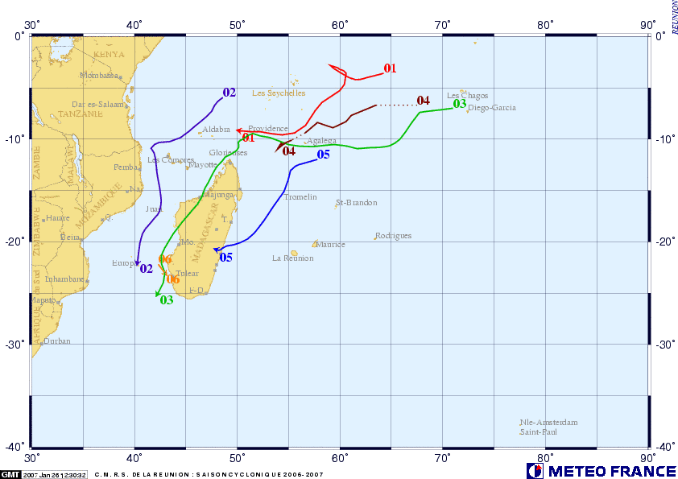

This shift of activity towards the central part of the Southwest Indian Ocean basin may be a consequence of the ongoing El Niño situation in the South Pacific. Although the influence of the ENSO is rather low in our basin (much lower than in other basins) it has been recognised following climatological studies that the state of the ENSO may influence the spatial location and distribution of cyclone activity in our region. In particular it has been shown that in El Niño situations the cyclone activity was reduced on the far eastern boundary of the basin and was oppositely enhanced in the central part of the basin (thus focusing west of the Chagos – between longitudes 55 and 73 East).
This observed westward shift of activity of course has consequences, since it increases the risk of cyclone impact for the inhabited lands of the region which are concentrated on the western side of the cyclone basin. Indeed the three named systems of the season all had consequences for the inhabited areas. Moderate tropical storm ANITA generated local heavy rains on the Comoros Archipelago, while the two main storms of the season so far (intense tropical cyclone BONDO and severe tropical storm CLOVIS) both hit Madagascar (BONDO on the northwest coast of the country – near the city of Mahajunga – and CLOVIS on the eastern coast with some negative impact (a few fatalities and significant damage reported –BONDO also affected the small Farquhar Archipelago with small outer islands belonging to Seychelles).
As shown on the two maps below, BONDO and CLOVIS greatly influenced the rain pattern on the region during the past month or so, since being the main contributors to the rain anomalies observed in the area and yielding significantly above normal rainfall amounts around Madagascar and slightly above normal rainfall over the northern half of Mozambique, Malawi and the far southern portion of Tanzania.

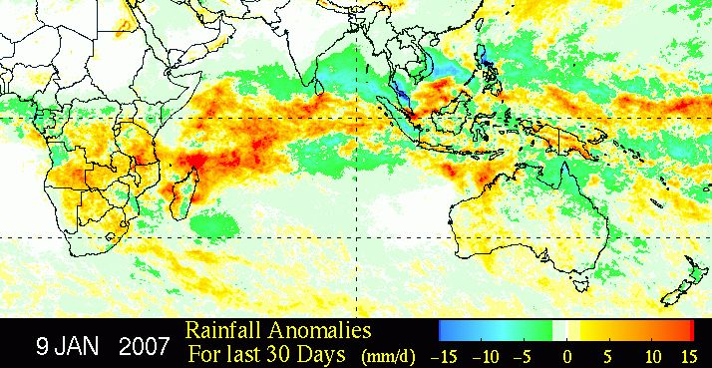

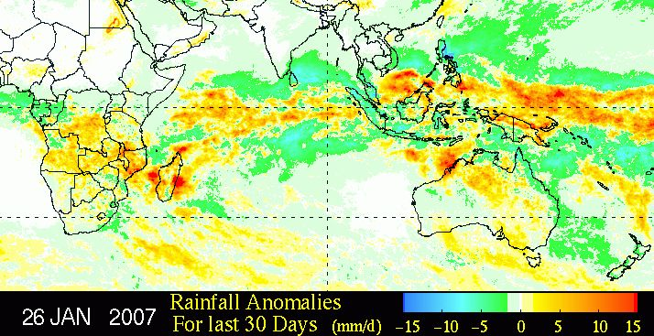
(N.B. the nucleus of large positive rain anomaly seen west of Madagascar is mostly linked to convective activity and not to the tropical cyclone activity of BONDO and CLOVIS).

