WORLD METEOROLOGICAL ORGANIZATION

COMMISSION FOR BASIC SYSTEMS

SEVERE WEATHER FORECASTING DEMONSTRATION PROJECT (SWFDP)

GUIDEBOOK ON PLANNING REGIONAL SUBPROJECTS

Revised 24 September 2008



CBS SEVERE WEATHER FORECASTING DEMONSTRATION PROJECT (SWFDP)

GUIDEBOOK ON PLANNING REGIONAL SUBPROJECTS

TABLE OF CONTENTS

1 - Purpose of the Guidebook

2 - General Introduction

2.1 - Objectives of the SWFDP
2.2 - The Cascading Forecasting Process
2.3 - Expected Benefits
2.4 - Responsibilities of the Centres in the Framework of the Cascading Forecasting Process

3 - Preparation of Regional Subproject

3.1 - Subproject Approval
3.2 - Setting up of a Management Structure
3.3 - Regional Subproject Implementation Plan
1 - Purpose of the Guidebook

The purpose of this SWFDP Guidebook is to provide participating centres in the Project with the basic information they need to guide in the planning and the organization of a SWFDP regional subproject. The Guidebook includes an introductory section then explains how to prepare the subproject and the expected milestones during its execution.

This Guidebook has been developed by the Secretariat under the guidance and review of the CBS Steering Group for the SWFDP, also known as the Project Steering Group (PSG),

2 - General Introduction

2.1 - Objectives of the SWFDP

2.1.1 - The scope of the Severe Weather Forecast Demonstration Project (SWFDP) is to test the usefulness of the products currently available from NWP centres, or products that could be made available from current NWP systems, with the goal to improve severe weather forecasting services in countries where sophisticated model outputs are not currently used. Such a demonstration project would use a cascading (forecasting) approach to provide greater lead-time for severe weather and would at the same time contribute to capacity building and improving links with disaster management or civil protection authorities.

2.1.2 - According to the recommendations of the CBS-XIII (2005) the goals of the SWFDP are defined as follows:
- to improve the ability of NMCs to forecast severe weather events;
- to improve the lead time of alerting of these events;
- to improve interaction of NMCs with DMCPA before and during events;
- to identify gaps and areas for improvements;
- to improve the skill of products from GDPFS centres through feedback from NMCs.

(DMCPA – disaster management and civil protection authorities)

2.1.3 – The CBS-Ext.(06) stressed the need to involve civil protection authorities to improve delivery of severe weather warning services. Regarding this aspect, collaboration with the Public Weather Services (PWS) and with the Disaster Risk Reduction, “DRR” programmes is encouraged.

2.2 - The Cascading Forecasting Process

2.2.1 - In the framework of the general organization of the Global Data-Processing and Forecasting System (GDPFS), the SWFDP implies a co-ordinated functioning among three types of GDPFS centres. Conceptually, it should involve one global centre, one regional centre and a small number of NMHSs located within the area of responsibility of the regional centre. In practice, a project could involve few additional centres, if beneficial and practical to do so.

2.2.2 - According to the conclusions of CBS-XIII, the proposed SWFDP is an excellent way to apply the cascading approach for forecasting severe weather in three levels, as follows:

- global NWP centres to provide available NWP products, including in the form of probabilities;
- regional centres to interpret information received from global NWP centres, run limited-area models to refine products, liaise with the participating NMCs;
- NMCs to issue alerts, advisories, severe weather warnings; to liaise and collaborate with Media, and disaster management and civil protection authorities; and to contribute to the evaluation of the project.

2.2.3 - Each centre will be required to adjust and tailor the list of products to the requirements of the particular regional subproject. A list of possible products to be exchanged between the centres is given as an example in Annex A of this Guidebook.

2.3 - Expected Benefits

2.3.1 - The SWFDP will provide the opportunity to encourage forecasters to use and experiment with standard products and recommended procedures, which have already been introduced in GDPFS centres and which could be relevant to a number of NMHSs that have not yet used them.

2.3.2 - The SWFDP aims to demonstrate the benefits of applying the cascading process for severe weather forecasting in the NMHSs, with the intention of not incurring research and development costs. It is viewed as way to explore how the concept could benefit several NMHSs in the same geographical region while facilitating a certain level of harmonization of forecasts and warnings to render them consistent across the region.

2.3.3 - It is also expected that the SWFDP would help strengthen the links between the NMHS and the DMCPA and then to increase the efficiency and effectiveness of the public warning services in case of severe weather events.

2.3.4 - In relation to the THORPEX (The Observing System Research and Predictability Experiment) research and development programme, it is hoped that implementation of SWFDP regional subprojects represents an opportunity for NMHSs and GDPFS centres to be better prepared to accommodate the implementation of the outcomes of this research and development programme (i.e. TIGGE/GIFS).

2.4 - Responsibilities of the Centres in the Framework of the Cascading Forecasting Process

Specific tasks are attributed to the three types of centres participating to the SWFDP in the cascading process.

2.4.1 - The Global Centre

- to provide the other centres with medium-range NWP guidance and EPS output including probabilistic products specially adapted to the concerned severe weather event;
- to suggest suitable existing satellite imagery and satellite based products that are helpful in assessing the current meteorological situation, and therefore also assess the quality of global NWP/EPS products;
- to evaluate the efficiency of products dedicated to medium-range severe weather forecasting through the feedback provided by the other centres.

2.4.2 - The Regional Centre

- to redirect toward the NMHSs relevant products issued from the global centre (if necessary);
- to provide NMHSs with its own interpretation of the medium-range guidance, including EPS products;
- to provides the NMHSs with the short-range NWP guidance (including products adapted to severe weather events), as frequently as possible;
- to indicate existing satellite/radar imagery and satellite/radar based products that could be used for nowcasting purposes;
- to issue a severe weather daily bulletin (called the RSMC Daily Severe Weather Forecasting Guidance) summarizing interpretation of NWP products with respect to severe weather over the responsibility area of the NMHSs;
- to evaluate its own interpretation of EPS products as well as its NWP guidance;
- to provide global centres with a feedback about the usefulness and efficiency of global products;
- to facilitate the flow of all forecasting guidance information to all participating Centres in the SWFDP through a dedicated password protected Web site and portal. Ideally this Web site would be maintained on a 24/7 basis and dedicated for the Regional Subproject.
- to coordinate real-time 24/7 communications among the participating centres in the region of the project (to maintain a list of 24/7 contact information; telephone, fax, e-mail)

2.4.3 - The National Meteorological Centre of the NHMS

- to interpret the guidance provided by the global centre and the regional centre;
- to issue special bulletins and warnings as required by the end users (hydrological services, DMCPA services, media…) when severe weather is expected;
- to use available nowcasting tools (satellite imagery or satellite based products, radar products) to update warnings;
- to exchange information on warnings between participating NMHS, and between NMHS and RSMC centre;
- to provide regional and global centres with a feedback on the efficiency of the global and regional products;
- to develop a communication strategy and plan to ensure effective response when warnings are issued;
- to establish contacts with DMCPA services and other end users prior and during severe weather events;
- to obtain feedback from users after the event (opportunity of warning, lead time, degree of impacts);
- to prepare a compiled report on the severe weather events that contains all the data needed to perform the evaluation of both RSMC Daily Severe Weather Guidance relevant to the country, and actual warnings issued by the NMC;
- to evaluate the warnings;
- to develop training to facilitate improved communication with the end users.

3 - Preparation of Regional Subproject

3.1 - Subproject Approval

The establishment of a regional subproject requires a formal agreement from the participating centres. The WMO Secretariat sends the invitation to participate:

- to the RA President, to seek his consent,
- to the Heads of the participating centres, to request their commitment.

3.2 - Setting up of a Management Structure

A regional subproject management team is to be set up with the aim of preparing the implementation of the project and managing and controlling its execution.

3.2.1 - Role of the Regional Subproject Management Team (RSMT)

The responsibilities of the regional subproject management team are defined as follows:

- to prepare the Regional Subproject Implementation Plan (RSIP);
- to manage the implementation of the regional subproject;
- to control the execution during the field phase;
- to evaluate the system.

3.2.2 - Members of the Regional Subproject Management Team

The Regional Subproject Management Team comprises the following members:

- a regional subproject Chairperson;
- a lead person in each of the participating centres;
- a Project Steering Group (PSG) contact person.

3.2.3 - Designation of the Regional Subproject Management Team Members

The designation of the members of the Regional Subproject Management Team is carried out through the following processes:

- The WMO Secretariat requests the RA President for designation of a subproject chairperson;
- The Project Steering Group (PSG) chairperson designates a contact person from PSG;
- The regional subproject chairperson requests each participating centres for designation of a lead person.

3.2.4 - Responsibilities of the Members of the Regional Subproject Management Team

The tasks of the members of the management team, during the preparation phase of the SWFDP are as follows:

The chairperson or the Management Team:

- to draft a detailed regional project development plan and to share between participating countries;
- to co-ordinate training requirements that support the demonstration project and to provide information to WMO Secretariat;
- to report on the project.

The lead person for each participating centre:

- to coordinate all aspects of project implementation and execution at their respective centres;
- to evaluate possible data-processing developments (e.g. work required to adjust or tailor NWP products);
- to arrange for forecasters in the centres to receive or have access to the agreed products;
- to define the information to be exchanged with their DMCPA and other end users;
- to define the information to be transmitted to the media;
- to identify training requirements;
- to prepare regular evaluation of the warnings during the field phase.

3.3 - Regional Subproject Implementation Plan (RSIP)

3.3.1 - Required Regional Subproject Milestones

The Regional Subproject Management Team is responsible for the elaboration of an implementation plan for the regional subproject.

The SWFDP, in its application of a cascading forecasting process, implies close cooperation and coordination between the centres. The start of the field phase should be defined by the Management Team to encompass the period when selected severe weather events are normally expected to occur. In order to be able to make a significant evaluation of the Regional Subproject the minimum duration of the filed phase should be one year. From a practical point of view, electronic correspondence using reliable e-mail accounts is the principal ongoing method for project management and control.

The regional subproject implementation plan should include the following milestones:

- submit a project implementation plan to the Project Steering Group (PSG);
- convene a kick-off meeting of the Management Team to clearly and precisely define the work to be carried out in each participating centre;
- completion of preparatory training for participants.
- start of the field phase;
- conduct mid-term project review;
- end of the field phase;
- complete the final report for submission to PSG.

During the field phase it is indispensable to regularly report about the efficiency of the cascading process and the pertinence of the warnings issued by the participating NMHSs. To this aim it is proposed that each participating NMHS prepares a quarterly report to be sent to the RSMC and to the chairperson of the Management Team (a proposed template of this quarterly report is given in the Annex D of this Guidebook). It is also strongly recommended to convene a RSMT meeting at mid-term to review the ongoing status of Regional Subproject implementation, to identify the current problems and to decide on immediate adjustments and solutions.

3.3.2 - Technical Preparation

In the technical preparation of the SWFDP regional subproject, the Management Team needs to finalize the list and the frequency of the products to be exchanged between the concerned GDPFS centres and to finalize the details of the evaluation procedures. It is also essential to verify that existing telecommunication and data-processing capability and capacity allow the transmission and display of the SWFDP requested information. If it is necessary to implement new tasks, the additional work must be carefully evaluated for consideration and decision by the Management Team.

3.3.2.1 - Products to be Exchanged

To assist participating centres in the demonstration project to define the products to be exchanged between the various participating centres, a sample list for consideration in the forecasting of severe weather is given in the Annex A of this Guidebook. An example of the content of the RSMC Severe Weather Daily Guidance issued from RSMC Pretoria during the SWFDP Regional Subproject in RA I (Southeaster Africa) is given int the Annex B of this Guidebook. The information to be transmitted by the NMHS toward the end-users when severe weather occurs remains under the responsibility and decision of the NMHS. Nevertheless, the implementation of a SWFDP Regional Subproject is a good opportunity to co-operate with DMCPA and other end-users to clearly define the content and the format of the warnings, the preferred lead-times and updates, the communication and the dissemination procedures.

3.3.2.2 – Routine Evaluation Procedure

Information for the purpose of evaluation will be required, and collected in a way that is relatively brief and straightforward in order to ensure that it is reliably completed on a regular basis. It is proposed that the information for the evaluation be collected by using an “event evaluation form” to ensure consistency and to allow rapid completion. This evaluation form has to be completed by the NMHS when a severe weather event has been observed and when a severe weather event has been forecast. The information that is contained in the evaluation form allows to calculate objective scores to assess the performances of both RSMC Severe Weather Daily Guidance and NMHS warning system. The way the evaluation is to be performed as well as a sample template of the evaluation form are given in Annex C to this Guidebook.

3.3.2.3 - Telecommunications

It is necessary to verify that the existing telecommunication means are capable to transmit the full amount of information in a timely manner as agreed between the centres participating to the demonstration project. This includes both the current GTS capabilities, broadband Internet access for displaying web pages or for file transmission using FTP. For several regions the possibilities to use satellite broadcast (Eumetcast, for example in Africa) should be also investigated. If the amount of data to be transmitted exceeds the capabilities of the existing telecommunication means it will be necessary to reduce the list of products to be exchanged. However, with regards to the duties of the NMHS, it is particularly important to ensure that the transmission of the weather warnings to the DMCPA services is carried out without delay.

3.3.2.4 - Data-processing Capabilities

The data-processing capabilities of each of the centres have to be able to produce and provide the forecasters with the products transmitted to it by the “upstream” centre. Depending on the kind of products, the exchange of new products may imply some additional workload in the regional centres and in the NMHSs. Storage capacity has also to be considered to allow the saving of the relevant products and information for project evaluation purposes.

3.3.2.5 – Training

Some training will probably be necessary to be sure that forecasters from regional centres and NMHSs are able to correctly interpret the various products exchanged during the field phase of the SWFDP and to prepare readable end user information especially towards DMCPAs, medias and other end-users. It is important to note that special training session devoted to a regional subproject could be planned in conjunction with existing training programmes, for example organized by WMO Secretariat or WMO Members.

3.3.3 - Evaluation of the Regional Subproject Costs

The cost evaluation of the SWFDP regional subproject will be carried out on the following way:

- the Regional Subproject Management Team provides costing for all aspects of the subproject, which would mainly be incurred for holding meetings and conducting the training;
- the Project Steering Group (PSG) reviews the costing.

ANNEX A

SAMPLE LIST OF PRODUCTS TO BE EXCHANGED IN A REGIONAL SUBPROJECT
FOR FORECASTING SEVERE WEATHER

1 - Data and Products issued from the Global Centre to the other Centres.

Products which are not routinely transmitted through the GTS should be provided in graphical form (Web pages) via Internet for rapid display and dissemination, and may also be made available by other methods (e.g. FTP).

1.1 - Current Deterministic NWP Fields up to 5 days – at 6-h Intervals up to 2 days, 12-h intervals after 2 days).

The recommended products include:

- charts to depict the large-scale flow (e.g. 500 hPa , 700 hPa, 850 hPa geopotential height, 850 hPa temperature, upper air winds, MSLP);
- surface weather elements (e.g. 6-hour accumulated precipitation, surface (10m) wind-speed).

In tropical regions other relevant products could also include:

- charts to depict the large-scale flow (e.g. surface streamlines, 850 hPa, 700 hPa, 500 hPa, 200 hPa wind flow and relative humidity, surface streamlines);
- charts to assist with forecasts of tropical cyclone formation, movement and intensification (e.g. 850 hPa, 200hPa relative vorticity and convergence, 850-400 hPa deep layer mean flow, 850-200 hPa vertical wind shear, vertical motion);

Frequency of products and minimum products set for daily distribution should be decided at the kick-off meeting.

1.2 - Probabilistic Forecast Products based on EPS

The recommended products include:

- probability of severe weather events such as precipitation and wind higher than given thresholds;
- “spaghetti” plots (e.g. 500 hPa geopotential height in extra-tropics, precipitation and wind higher than given thresholds);
- stamp maps (e.g. streamlines in the tropics, wind speed, accumulated precipitation);
- dispersion diagrams (plumes and EPSgrams) for weather elements at specific locations;
- representative members of a classification of weather pattern such as clustering or tubing (optional product depending on possibilities of Global Centre);
- severe weather risk index such as Extreme Forecast Index (where available).

If severe weather is associated with a Tropical Cyclone other relevant products could include:

- surface or 850hPa vortex track charts;
- tropical cyclone position fix and track forecast spread (strike probability);
- tropical cyclone formation probability.

2 - Data and Products issued from the Regional Centre to the NMHS

Products which are not routinely transmitted through the GTS should be provided in graphical form (Web pages) via Internet for rapid display and dissemination, and may also be made available by other methods (e.g. FTP).

2.1 To the NMHSs

2.1.1 - Current deterministic Limited Area Model fields up to 2 days at 6-hour intervals

Products could include, for example:

- charts to depict the large-scale flow (e.g. 500 hPa, 700 hPa, 850 hPa geopotential height, 850 hPa temperature, tropopause height, upper air winds, MSLP);
- surface weather elements (e.g. 6-hour accumulated precipitation, surface (10m) wind-speed and gusts (if available), 2m temperature, 850 hPa specific humidity);
- maps of vertical motion, potential vorticity or height of specified PV surface;
- maps of convective indices such as CAPE, Lifting Index, helicity…,
- relevant satellite images (where NMHSs do not have satellite receiving capability);
- special products derived from satellite images (e.g. derived precipitation or images annotated with guidance notes).

In tropical regions other relevant products could also include:

- charts to depict the large-scale flow (e.g. surface streamlines, 850 hPa, 700 hPa, 500 hPa, 200 hPa wind flow and relative humidity, surface streamlines);
- charts to assist with forecasts of tropical cyclone formation, movement and intensification (e.g. 850 hPa, 200hPa relative vorticity and convergence, 850-400 hPa deep layer mean flow, 850-200 hPa vertical wind shear, vertical motion);

Frequency of products and minimum products set for daily distribution should be decided at the kick-off meeting.

2.1.2 – The RSMC Severe Weather Forecasting Daily Guidance containing the interpretation of products from the Global Centres and Regional Centre with a commentary, containing (as required):

- interpretation of EPS and deterministic products;
- severe weather predictions (risk or probability estimates).
- tropical cyclone formation probability (if necessary)

A detailed content of the RSMC Severe Weather Forecasting Daily Guidance bulletin issued by RSMC Pretoria in the framework of the SWFDP Regional Subproject in RA I (Southeast Africa), is given in the Annex B of the Guidebook.

2.2 Toward the Global Centre

- Copy of quarterly report

3 - Data and products issued from the NMHS(s)
3.1 Toward the users (hydrological services, DMPCA services and other users).

Products should be agreed in the planning stage of the project according to the needs of the users, but might typically include:

- outlook bulletin for potential threats ahead;
- warning bulletin in case of severe weather, including information on probability;
- additional specific maps (if necessary);
- specific nowcasting products to update the warnings.

If severe weather is associated with a tropical cyclone:

- outlook bulletin for potential tropical cyclone formation, tropical cyclone alert or watch containing possible tropical cyclone movement or intensification scenarios;
- tropical cyclone warnings;
- additional specific maps (if necessary, e.g. forecast track maps, strike probability).

3.2 Toward the Regional Centre

- acknowledgement of the RSMC Severe Weather Forecasting Daily Guidance;
- near-real-time information on severe events (including false alarms and non-forecast events) via a Severe Weather Event Evaluation Form (sample template provided in Annex C of the Guidebook).
- the quarterly report (see Annex D of the Guidebook).

It is very important to prepare carefully the quarterly report and to fill the associated quarterly evaluation table to allow the RSMC to gather the information and to evaluate the pertinence of the RSMC Severe Weather Forecasting Daily Guidance.
ANNEX B

RSMC SEVERE WEATHER FORECASTING DAILY GUIDANCE

TO BE ISSUED BY THE RSMC TOWARD THE NMHSs
FOR SHORT-RANGE SEVERE WEATHER FORECASTING UP TO 48 H
AND MEDIUM-RANGE SEVERE WEATHER OUTLOOK FROM 72 H TO 120 H

The RSMC Severe Weather Forecasting Daily Guidance comprises the following parts:

- Part A: Text; depiction of the expected evolution of the weather for the concerned range and comments about the more representative products that are used with reference to figures included in the part B, to charts clearly identified (model, parameter, level, forecast range) or to graphics (EPS charts or meteograms).

- Part B: Figures; charts or graphics coming essentially from deterministic models (global or LAM) for short range forecasts and from Ensemble Prediction Systems (EPS) for medium range outlooks.

- Part C: The assessment of the degree of confidence of the forecast by the forecaster.

- Part D: Tables summarizing the risk of severe weather as assessed by the RSMC. (for short range forecasts) and the probabilities of the relevant parameter higher than a given threshold.

- Part E: Geographical maps (one map/forecast day including the boundaries of the countries with contours identifying the areas which are likely to be hit by the severe weather event (for short range forecasts) or probabilities areas for its occurrence.

The following pages of this Annex give an example of the RSMC Severe Weather Forecasting Daily Guidance issued from RSMC Pretoria in the framework of the SWFDP Regional Subproject in RA I (Southeast Africa) focused on heavy precipitation and strong wind forecasting.

RSMC-PRETORIA
SWFDP GUIDANCE PRODUCTS

SHORT-RANGE (DAY 1 AND DAY 2)

Issue Date: Friday 22nd December 2006
Valid for: 22nd, 23rd December 2006

- SYNOPSIS OF EXPECTED WEATHER PATTERNS
Day 1: 22nd December 2006
RSMC / TROPICAL CYCLONE CENTRE / LA REUNION
Tropical Cyclone warning (South-West Indian Ocean)
Position 2006/12/22 at 0600 UTC : within 20 NM radius of point 10.2S / 50.0E.Cntral pressure: 980 HPA
Max average win d speed (10 MN) : 55 KT
The system is rapidly weakening in a strongly southeasterly sheared environment.
It has slow down and is expected to curve.

Day 2: 23rd December 2006
TS BONDO near 11S 47E by midday tomorrow.

2. SATELLITE IMAGES AND SYNOPTIC DATA.
Tropical cyclone visible north of Madagascar.

2. DISCUSSION OF GUIDANCE PRODUCTS FROM GLOBAL AND REGIONAL CENTRES
Regional Models (UM SA 12, UM African LAM)

Forecaster: Evert Scholtz.

GRAPHICAL ADDITIONS
F ig 1. Quicksat surface winds DAY 1

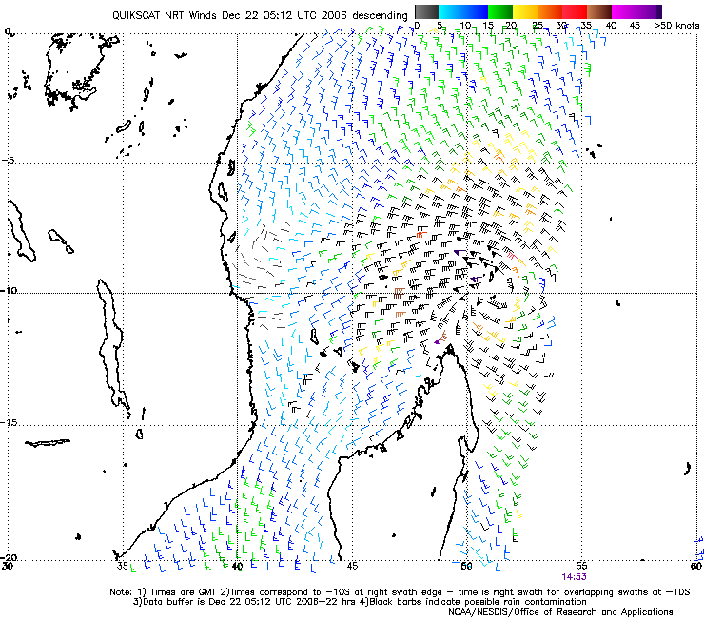

Fig 2. Satellite image and 150-300 Hpa divergence DAY 1

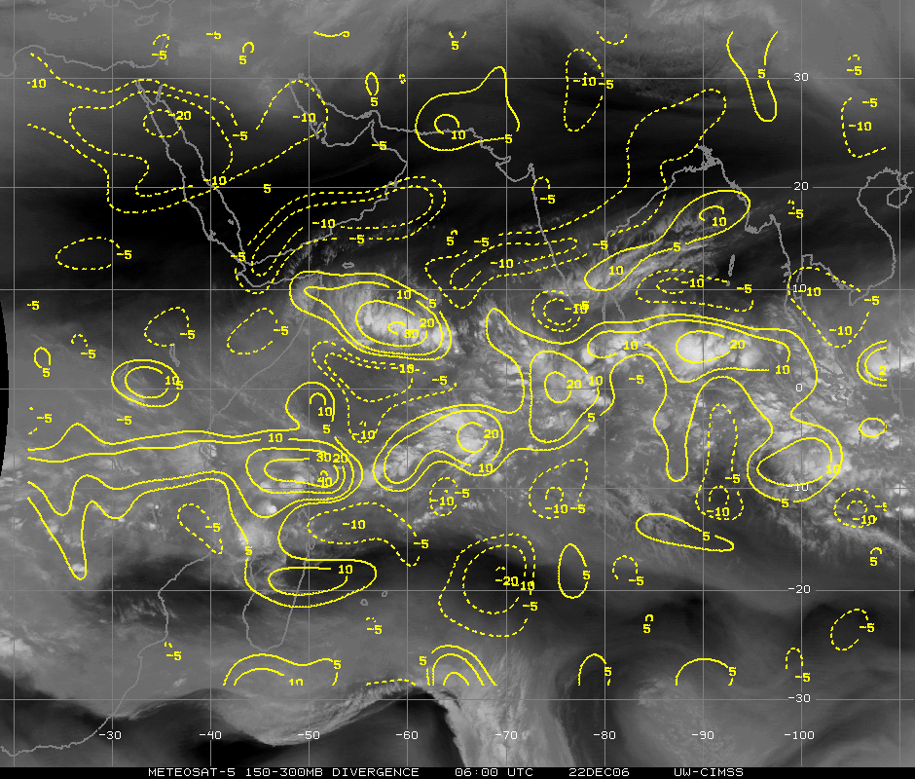
Fig 3. Shear tendency over past 24 h on DAY 1

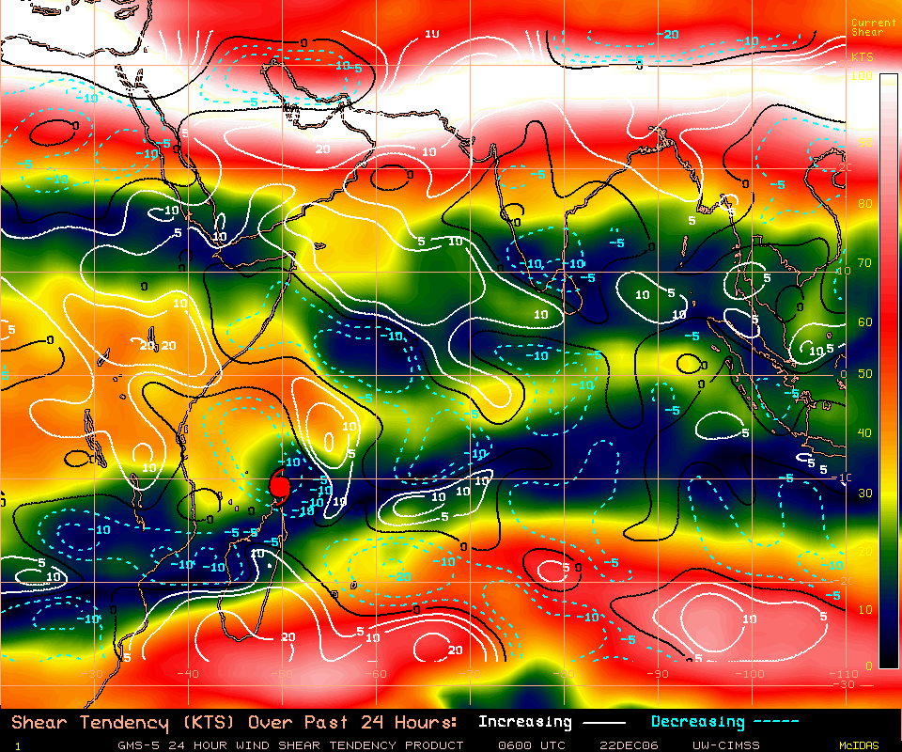

RSMC-PRETORIA
SWFDP GUIDANCE PRODUCTS
RISK TABLES

SHORT-RANGE (DAY 1 AND DAY 2)

Issue Date: 22nd December 2006
In order to provide more information about the geographical location of the severe event the following convention is adopted when filling in the cells: X for the whole country, N for the northern part, S for the southern part, W for the western part and E for the eastern part.

DAY 1: Friday 22nd ecember 2006
 | HEAVY PRECIPITATION |  |  |  | STRONG WINDS
RISK | No risk | Low risk | Medium risk | High risk | No risk | Low risk | Medium risk | High risk
Botswana | X |  |  |  | X
Madagascar |  |  |  | N |  |  |  | NE
Mozambique | X |  |  |  | X
Tanzania | X |  |  |  | X
Zimbabwe | X |  |  |  | X

DAY 2: Saturday 23rd December 2006
 | HEAVY PRECIPITATION |  |  |  | STRONG WINDS
RISK | No risk | Low risk | Medium risk | High risk | No risk | Low risk | Medium risk | High risk
Botswana | X |  |  |  | X
Madagascar |  |  |  | N |  |  |  | N
Mozambique | X |  |  |  | X
Tanzania | X |  |  |  | X
Zimbabwe | X |  |  |  | X

SEVERE WEATHER RISK MAP
FOR SHORT RANGE (DAY 1 AND DAY 2)

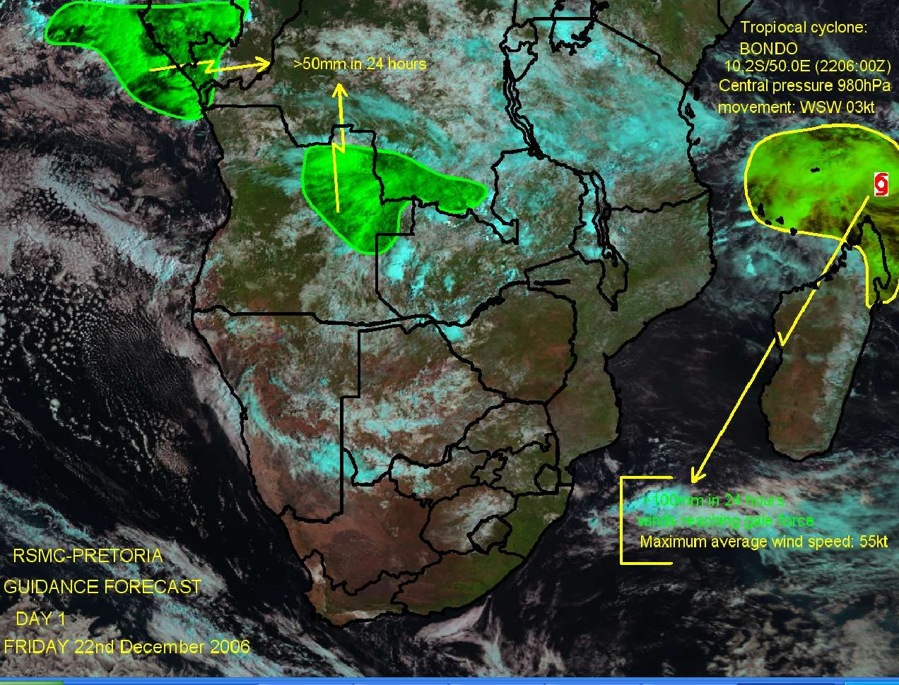

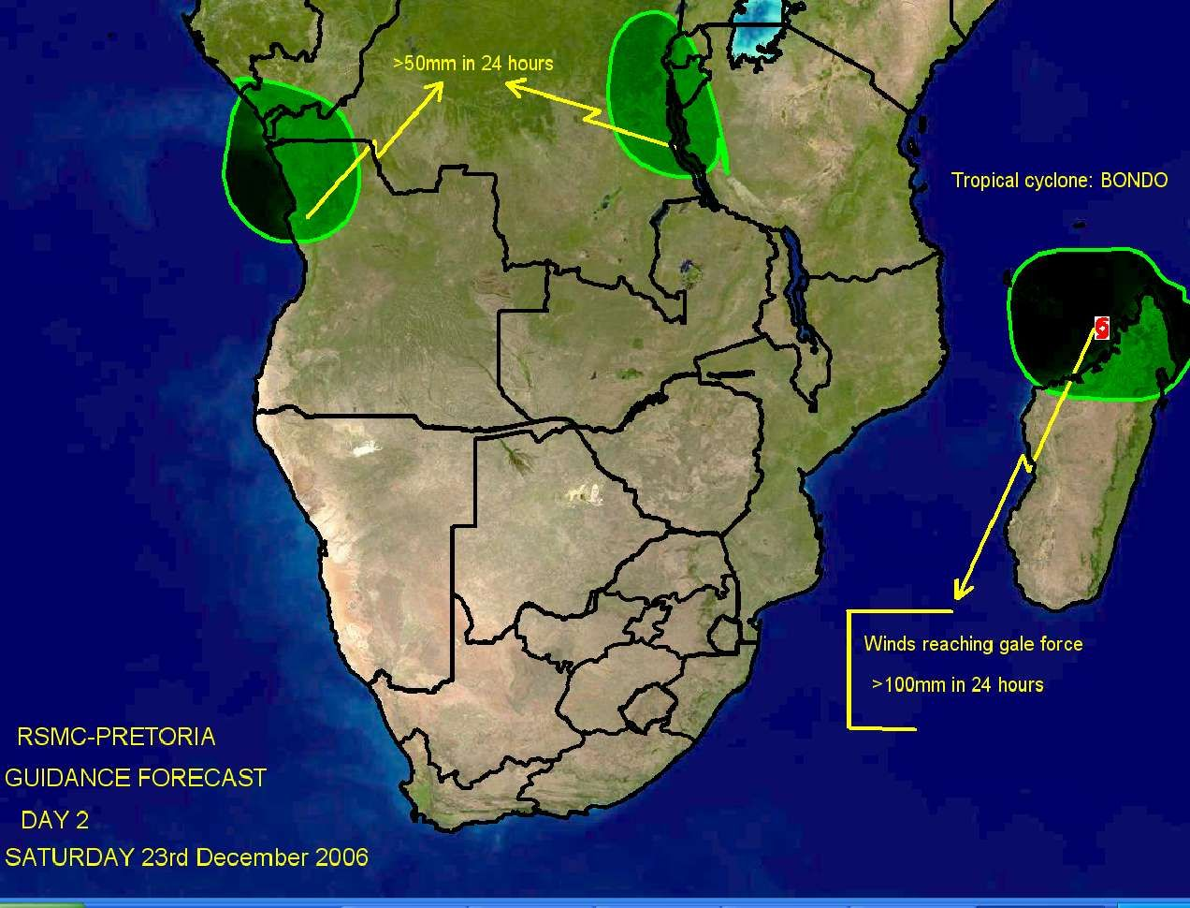
RSMC-PRETORIA
SWFDP GUIDANCE PRODUCTS

MEDIUM-RANGE (DAY 3, DAY 4 AND DAY 5)

Issue Date: 22nd December 2006
Valid for: 24th , 25th & 26th December 2006

- SYNOPSIS OF EXPECTED WEATHER PATTERNS
DAY 3 24th December 2006
According to ECMWF, GFS & NOAA NWS the tropical low will be situated on the north-west coast of Madagascar on day 3. with central pressure close to 1000hPa.
Degree of confidence (moderate to high)

DAY 4 25th December 2006
Tropical low (ex-BONDO) still on the north-west coast of Madagascar.
Degree of confidence (moderate to low – mainly uncertainty relating to speed / movement / positioning of tropical system)

DAY 5 26th December 2006
Tropical low (ex-BONDO) moving into to the central part of the Mozambique channel and intensifies with central pressure below 1000hPa. ( by day 6 ECMWF moves it towards Mozambique coast and making landfall near Xai-Xai on the south coast of Mozambique on day 7, 28th December.
Degree of confidence (low – mainly uncertainty relating to speed / movement / positioning of tropical system – with a 5 day lead-time there is extreme uncertainty in this regard)

- DISCUSSION OF GUIDANCE PRODUCTS FROM GLOBAL AND REGIONAL CENTRES
(Comments about the products that are used with reference to figures or charts included under bullet 3)

Forecaster: Evert Scholtz.

GRAPHICAL ADDITIONS

Fig 1. 1000 Hpa Relative humidity and streamlines DAY 3.

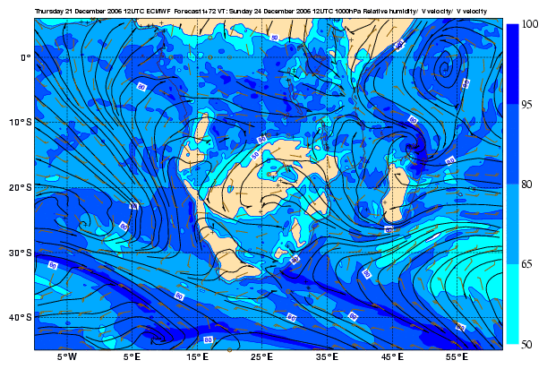

FIG 2. 1000 Hpa Relative humidity and streamlines DAY 4.

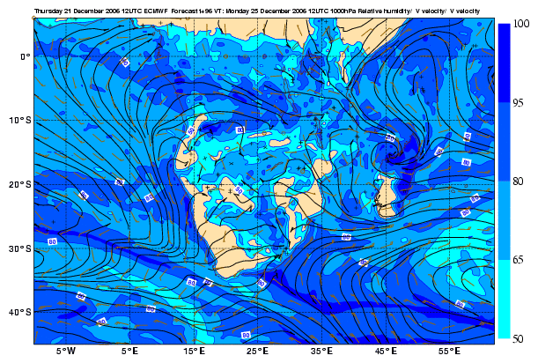
Fig3. 1000 Hpa Relative humidity and streamlines DAY 5.

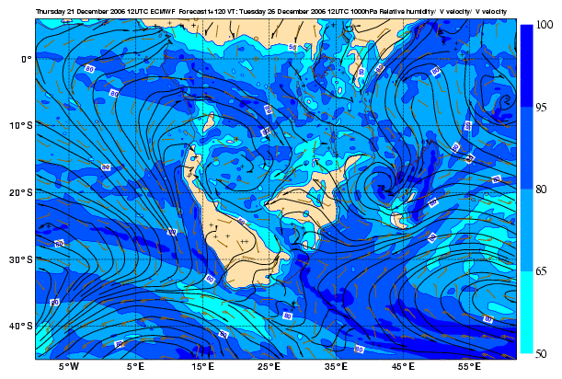

RSMC-PRETORIA
SWFDP GUIDANCE PRODUCTS
PROBABILITY TABLES

MEDIUM-RANGE (DAY 3, DAY 4 AND DAY 5)

Issue Date: 22nd January 2007

In order to provide more information about the geographical location of the severe event the following convention is adopted when filling in the cells: X for the whole country, N for the northern part, S for the southern part, W for the western part and E for the eastern part.

DAY 3: 24th January 2007
 | HEAVY PRECIPITATION  (exceeding threshold 50 mm/6 hrs) |  |  |  | STRONG WINDS  (exceeding threshold 20 kts)
Probability | <10% | 30% | 60% | >80% | <10% | 30% | 60% | >80%
Botswana | X |  |  |  | X
Madagascar |  | E coast |  |  | X
Mozambique | X |  |  |  | X
Tanzania | X |  |  |  | X
Zimbabwe | X |  |  |  | X

DAY 4: 25th January 2007
 | HEAVY PRECIPITATION  (exceeding threshold 50 mm/6 hrs) |  |  |  | STRONG WINDS  (exceeding threshold 20 kts)
Probability | <10% | 30% | 60% | >80% | <10% | 30% | 60% | >80%
Botswana | X |  |  |  | X
Madagascar |  |  | E coast |  | X
Mozambique |  | Cent coast |  |  | X
Tanzania | X |  |  |  | X
Zimbabwe | X |  |  |  | X

DAY 5: 26th January 2007
 | HEAVY PRECIPITATION  (exceeding threshold 50 mm/6 hrs) |  |  |  | STRONG WINDS  (exceeding threshold 20 kts)
Probability | <10% | 30% | 60% | >80% | <10% | 30% | 60% | >80%
Botswana | X |  |  |  | X
Madagascar |  |  | E coast |  | X
Mozambique | X |  |  |  | X
Tanzania | X |  |  |  | X
Zimbabwe | X |  |  |  | X

SEVERE WEATHER PROBABILITY MAP
FOR MEDIUM RANGE (DAY 3, DAY 4 AND DAY 5)

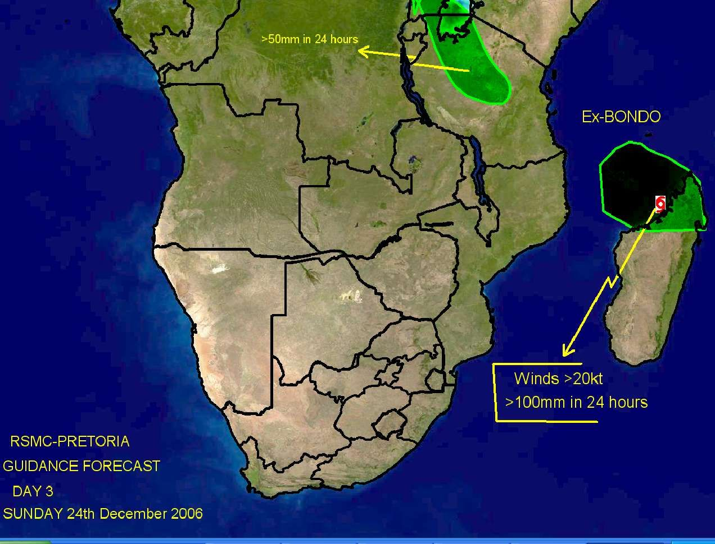

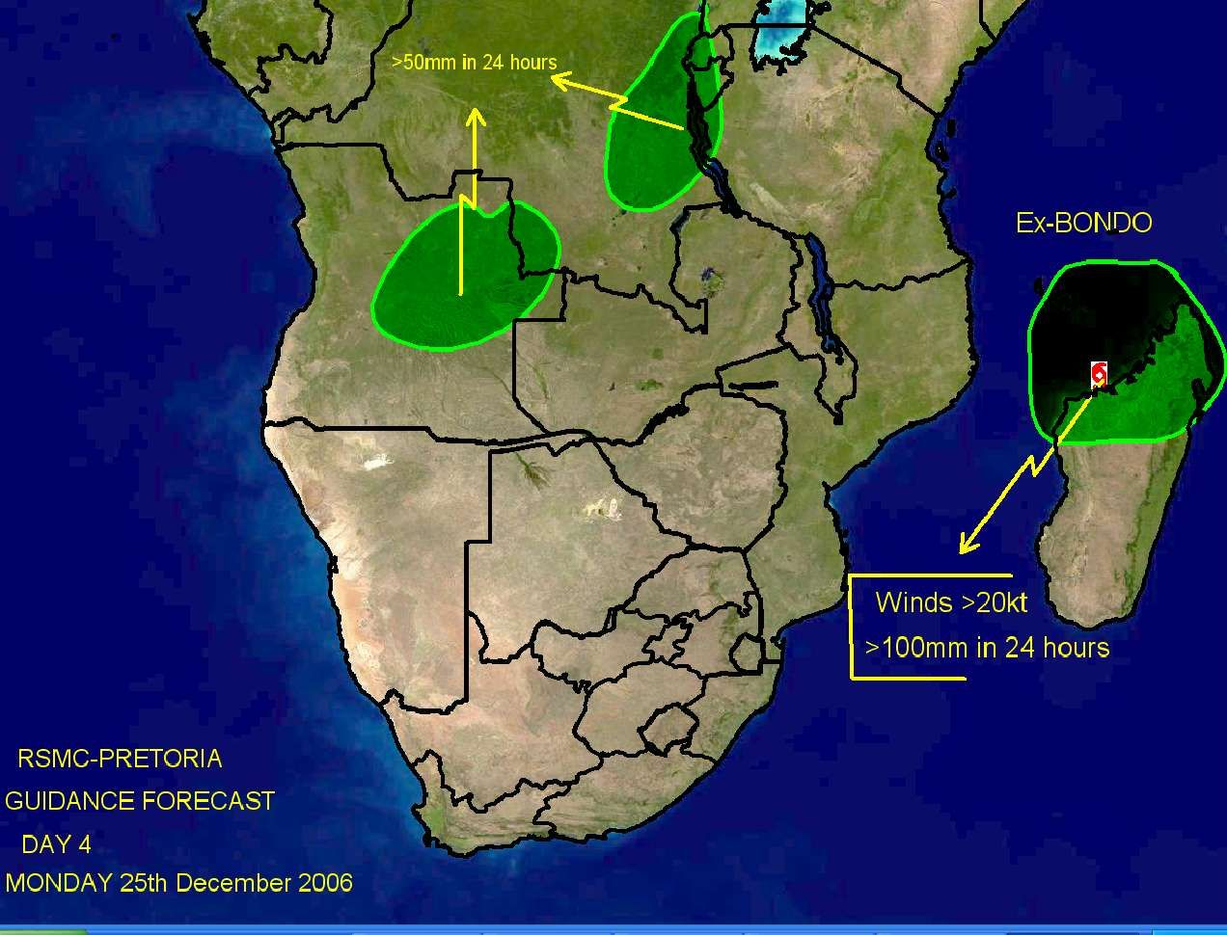

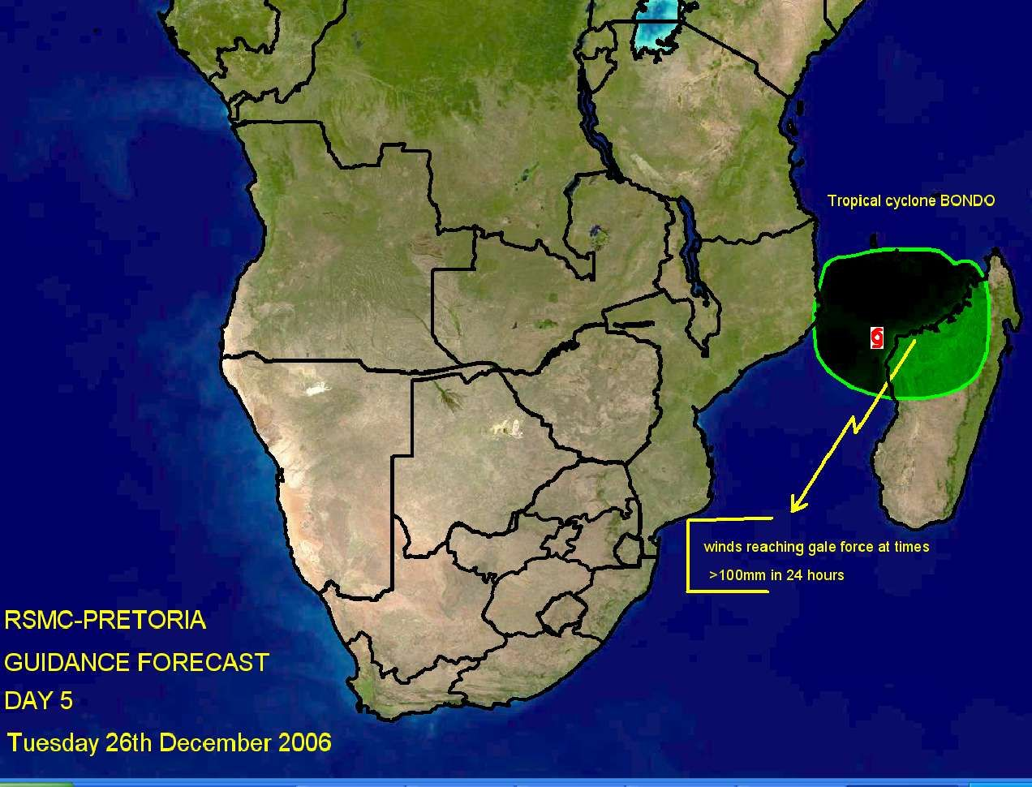

ANNEX C

EXAMPLE OF A SEVERE WEATHER EVENT EVALUATION FORM

The proposed evaluation form should allow to evaluate the performance of the RSMC Severe Weather Forecasting Guidance and as well as the efficiency of the NMHS warning system.

It must be completed by the NMHS in both of the following cases:
- a severe weather event has been observed; and
- a severe weather event has been forecast.

The evaluation form should document the characteristics of the severe weather event (whether observed or forecast) and allow to evaluate the efficiency of the forecasts given by the RSMC Severe Weather Forecasting Daily Guidance as well as the performance of the warnings issued by the NMHS. Therefore it should include the three following sections.

Section A – Identification of the severe weather event:
- NMHS concerned;
- number of the event;
- type of event;
- region affected.

Section B – Information about the observed weather event:
- start and end times of the severe weather event;
- maximum observed value of the characteristic parameter;
- assessment about the efficiency of the warning given the DMCPA;
- information from the end-users (number of interventions, casualties, damages, usefulness of the warning ).

Section C – Information about the forecast and warning issued from the NMHS:
- lead-time of the warning;
• start and end time of the severe weather event according to the forecaster’s assessment;
• level of risk as indicated in the RSMC Severe Weather Forecasting Daily Guidance;
- probabilities of medium-range in the RSMC Severe Weather ForecastingDaily Guidance;
- usefulness of the various products (RSMC Guidance, various models);
- comments including information on usefulness and applicability of used tools.

How to use this evaluation form to evaluate the performance of warnings ?

The common way to evaluate the performance of a warning system is based on the 2 x 2 contingency table matrix including the number of justified warnings (“hits”) “a”, the number of missed severe events “b” and the number of false alarms “c”. The POD index (Probability of Detection) is defined as the ratio of the number of hits by the total number of severe events, i.e., a/(a+b) ; the FAR (False Alarm Ratio) is defined as the ratio of the number of false alarms by the number warnings issued, i.e., c/(a+c).The information contained in the proposed evaluation form enables to computes the performance indicators of the warning issued by the NMHS as long as the assessment of the DMCPA (in section C) is correctly taken into consideration.

A template of an evaluation form is provided in the following pages. The evaluation form is to be filled by the NMHSs (preferably by a forecaster or manager of the forecasting unit) participating to the SWFDP regional subproject. This template can be modified with respect to the products selected for preparing the severe weather forecasts and warnings.

It is important that the design of the evaluation form be adapted to allow the data and information to be easily gathered and transformed into a tabular form. Avoid unnecessary and repetitive typing, and as much as possible to encourage and allow reliable creation and maintenance of the dataset that is needed to analyze and evaluate the performance indicators.

SEVERE WEATHER EVALUATION FORM
 | (Page 1)
INSTRUCTIONS: | :
1. This form must be filled in whenever: |  |  | (1) Severe weather is observed (Sections A and B)
 |  |  | (2) A warning has been issued to DM/CPA (Sections A and C)
2. Email the completed document to RSMC Pretoria, WMO and other agreed recipients
To standardize please put the title “SWFDP Evaluation Form” in the title list of the email
A. IDENTIFICATION OF THE SEVERE EVENT
NMHS: |  |  |  | Alphabetic
Region affected: |  |  |  | Alphabetic
Event Number: |  |  |  | Numeric
Type of event: |  |  |  | Numeric |  | (put the right number in the cell)
1: Heavy Precipitation | (indicate the most significant phenomenon,
2: Strong wind | either heavy precipitation or strong wind)
Severe convection |  |  |  | Numeric |  | (put 1 if extreme phenomena are  the consequence of severe  convection or 0 otherwise)
B. SEVERE WEATHER OBSERVED (to be completed even if no severe weather has been forecast)
 |  |  |  | JJ | MM | DD |  | HH | MM
 | Start of the event: |  |  |  |  |  | at |  |  | UTC
 | End of the event: |  |  |  |  |  | at |  |  | UTC
Max. observed value: |  |  |  | Unit
 | Numeric |  | Alphabetic
(According to the event: accumulated precipitation, gusts, other significant parameter)
Information from the end-users
short text explaining the consequences and possibly some figures
(number of interventions, casualties, damages, usefulness of the warning )

SEVERE WEATHER EVALUATION FORM
 |  | (Page 2)
C. SEVERE WEATHER FORECAST (to be completed even if severe weather did not occur)
 |  |  |  | JJ | MM | DD |  | HH | MM
Time of the warning | toward DMCPA |  |  |  |  |  | at |  |  | UTC
Start of the event; | forecaster assessment |  |  |  |  |  | at |  |  | UTC
End of the event; | forecaster assessment |  |  |  |  |  | at |  |  | UTC
Usefulness of the warning (feedback from the DMCPA)
check in the chosen cell |  |  | Lack of warning
 |  |  | False alarm warning
 |  |  | Late warning
 |  |  | Useful warning
Level of risk as appreciated by RSMC |  |  | (put 1 in the chosen cell)
 |  |  |  | No |  | Low |  | Med. |  | High
Level of risk | 1 day before:
Level of risk | 2 days before:
Probabilities of medium range outlooks as appreciated by RSMC
Probability | 3 days before: |  |  |  | %
Probability | 4 days before: |  |  |  | %
Probability | 5 days before: |  |  |  | %
Mark for usefulness of products (put 1 in the chosen cell)
 |  |  |  | Guidance
 |  |  | RSMC
KEY |  |  |  | NWP | EPS
A = Very useful (basis of the warning) |  |  | ECMWF
B = Useful (aided warning confidence) |  |  | NCEP
C = Neutral (not useful) |  |  | Met Office
D = Negative (misleading) |  |  | RSMC LAM
X = Not used
Comments including information on usefulness and applicability of used tools

ANNEX D

EXAMPLE OF THE INFORMATION TO BE INCLUDED IN THE
QUATERLY REPORT OF THE SEVERE WEATHER
REGIONAL SUBPROJECT

NMC : - - - - - - - -
PERIOD: (Start date to end date)

- HIGHLIGHTS OVER THE PERIOD

- OVERVIEW OF PRODUCTS

  - Usefulness of RSMC-Devere Weather Daily Guidance
  - Usefulness of SWFDP NWP/EPS Products received from each global centre and RSMC Limited Area Model (if available)

- PROJECT EVALUATION AGAINST SWFDP GOALS

SWFDP GOAL | PROGRESS AGAINST GOALS
To improve the ability of NMCs to forecast severe weather events
To improve the lead time of alerting these events
To improve the interaction of NMCs with Disaster Management and Civil Protection authorities before, during and after severe weather events
To identify gaps and areas for improvements
To improve the skill of products from Global Centres through feedback from NMCs

- EVALUATION OF WEATHER WARNINGS

- Feedback from the public
- Feedback from the DMCPA to include comments of the timeliness and usefulness of the warnings
- Feedback from the media
- Warning verification by the NMCs

- SUMMARY (general comments, challenges, etc)

- CASE STUDY (PowerPoint presentation to include guidance products (RSMC and NWP), satellite imagery, warnings issued, impact evidence etc)

Starting date  of the event | SWFDP  Evaluation  Form  Event  Number | Type of event | Region affected | Highest observed value | RSMC Guidance |  | Which NWP/EPS forecast product(s) used by NMC |  | Local warnings issued? | Impact of the event | Impact of the warning
dd/mm/yy |  | Indicate if extreme phenomena are the consequence of severe convection | Indicate the region of the country hit by the severe weather | specify  units, according  to the phenomenon | Amount predicted  (same unit as in the preceding column) | Usefulness  from 1 to 4  1- Misleading  2 - Not useful  3 - Useful  4 - Very  useful | Indicate the model(s) used | Usefulness  from 1 to 4  1- Misleading  2 - Not useful  3 - Useful  4 - Very  useful | Yes  or  No | Damages, Casualties | According to the DMCPA assessment
ANNEX E - Quarterly Evaluation Table (to be fulfilled based on the Severe Weather Event Evaluation Form)

An row has to be filled in this table whenever a severe weather event is observed or a warning is issued toward DMCPA.

