WORLD METEOROLOGICAL ORGANIZATION  COMMISSION FOR BASIC SYSTEMS  OPAG on DPFS  Severe Weather Forecasting Demonstration Project (SWFDP)  Regional Subproject Management Team  ARUSHA, TANZANIA  27 – 31 MAY 2013 |  | DPFS/RAI-SWFDP-EA-RSMT/Doc. 7.3(1)  (19.IV.2013)  _______  Agenda item : 7.3  ENGLISH ONLY

(CHALLENGES IN FORECASTING SEVERE WEATHER EVENTS IN UGANDA, ISSUANCE AND DELIVERY OF WARNINGS AND GENERAL DISSEMINATION OF WEATHER INFORMATION)

(Submitted by Mr John Eza, Meteorologist, National Meteorological Centre, Entebbe-Uganda)

Summary and purpose of document

This document presents the environment around the implementation of the Severe Weather Forecasting Demonstration Project in Uganda, the challenges and future prospects and seeks to find redress for some of these challenges.

Action Proposed

The meeting is invited to consider the following”

- Initiate the development of hazard indicators from the available high resolution model products. Forecasters already have access to Extreme Forecast Index (EFI) maps for precipitation, temperature and winds. Maps for all forecast fields could be availed. ECMWF already produces maps for all forecast fields but available to EU members only. Similar maps could be developed to cover weather phenomena like hail size, wind gusts, lightning, wind shear and direction, extreme rainfall to determine convection type and severity.

- Help improve observations over Lake Victoria. As of now we do not have in situ observations over the Lake. This renders verification of daily forecasts extremely difficult. Currently the UDoM relies on Satellite data to ascertain what happens over the lake. We neither have radar nor AWS observations over the lake.

- Avail continuous operational training of forecasters at UDoM by experts in the area of NWP modeling, in the interpretation of the various NWP products especially ensemble forecasts and high resolution model products for severe weather forecasting. Experts in the PUMA (SYNERGIE) system could also the forecasters at UDoM because this rich system is still grossly underutilized.

- Introduction

As one of the members of the SWFDP-Eastern Africa, Uganda has benefited tremendously from the collaborative pilot project ‘’ The Mobile Weather Alert’’ between Uganda Department of Meteorology, WMO, Ericsson, MTN and the National Lake Rescue Institute. The pilot to the fishing community of Kalangala Island in lake Victoria, ran from May 2011 to February, 2012 when the final survey of the project was carried out. In the same year 2012, a similar pilot project for farmers was inaugurated in Kasese district in Western Uganda. This is still on-going.

Right from the Inception of the Severe Weather Forecasting Demonstration Project for the Eastern Africa region, Uganda has participated in nearly all its programmes amongst which are the following;

- Technical Planning Workshop on Severe Weather Forecasting Demonstration Project Development for Eastern Africa held in Nairobi, Kenya, from 4 to 8 October , 2010.
- Preparatory training on severe weather forecasting and warning services in support of disaster risk reduction, and fishing and farming communities conducted in Dar-es-salaam, Tanzania, from 18 to 29 October, 2010.
- Training workshop on severe weather forecasting and warning services, held in Arusha, Tanzania, from 21 November, 2011 to 2 December, 2011.
- Meteorological training course on ECMWF Products: Use and Interpretation of ECMWF Products in WMO National Meteorological and Hydrological Sevices held at ECMWF’s headquarters in Reading, UK, from 10 to 14 October, 2011 and from 8 to 12 October, 2012.
- Training of Forecasters of the National Meteorological Centre, Entebbe-Uganda many a time, on forecasting movement of large storm systems (MCC) using NWP and real time observations by Paul Davies of UK Met.

The knowledge and skills acquired from the aforementioned training workshops, especially in the use and application of NWP/EPS products in forecasting severe weather, has impacted positively on the quality of our forecasts.

2. a). Severe weather events akin to Uganda and their causes

Uganda often suffers from the wrath of severe weather events some of which are;

- Severe local storms – small scale hazardous weather or hydrological events produced by thunderstorms, large hail, strong winds or flash floods.
- Other hazards – extreme heat or cold, dense fog, high waves, river flooding and lakeshore flooding.

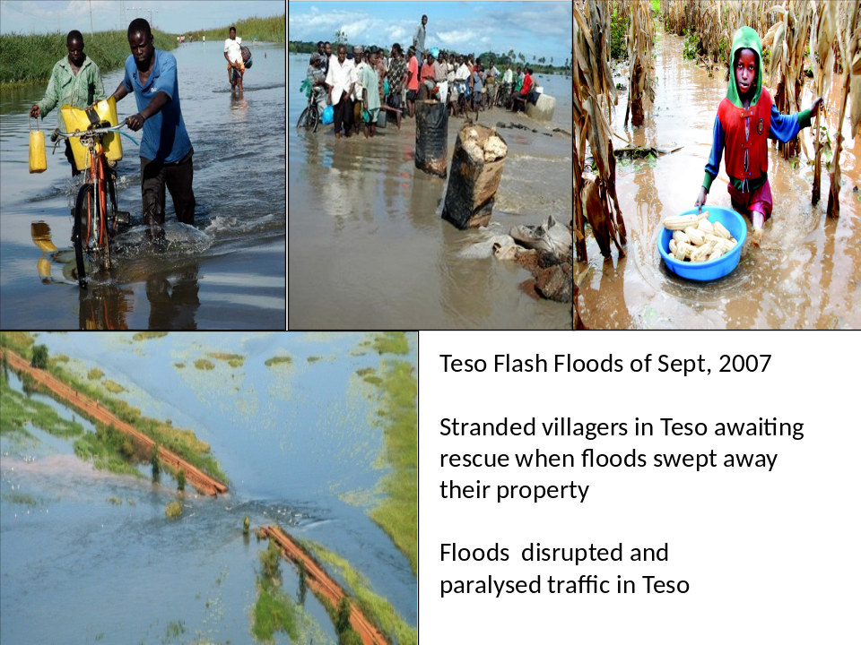

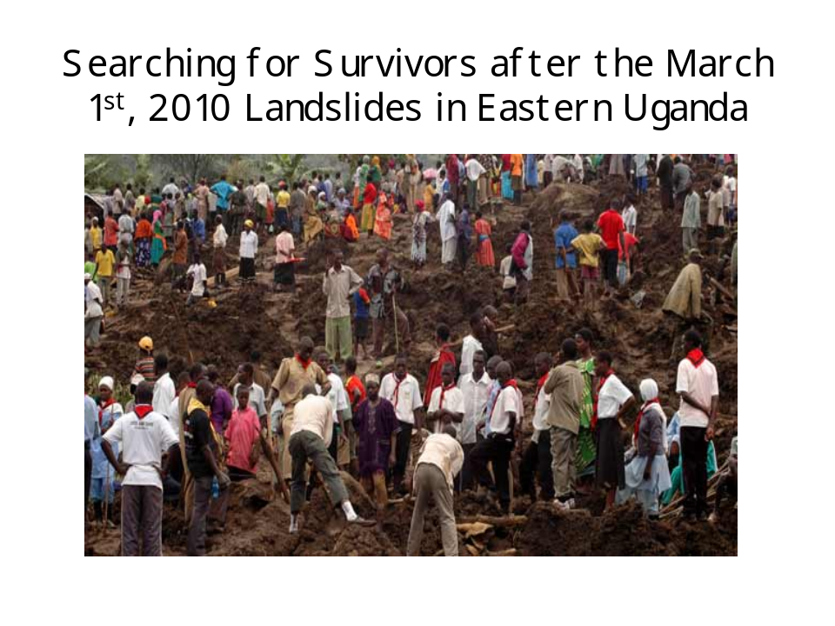

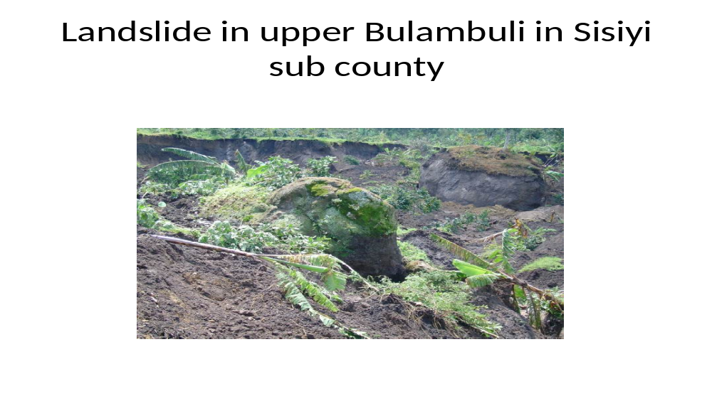

Effects
- Flash floods and drought
- Famine and disease
- Poverty and food insecurity
- Income loss
- Economic downturn
Among many others.

b). Severe weather thresholds

- Precipitation - >= 30mm/24hr
- Winds - >= 20knots
- Temperature - >= 32⁰C

3. Severe weather forecasting

This is carried out by use of the traditional surface weather chart analysis to determine the behaviour of the preasure systems that have a bearing on the position of the ITCZ and other controlling systems such as cyclones. Upper air charts at various levels are also analyzed to determine the vertical profile of the atmosphere in addition to various other charts.
In conjunction with the traditional method of forecasting, we make use of NWP/EPS products which are readily available from regional and global forecasting centres such as the underlisted.

- RSMC – Nairobi daily guidance
- NCEP (noaa)
- ECMWF and
- UK Met.

From these we make use of the following:

- Msl, winds at 850hpa and at 300hpa
- Moisture; - precipitable water, RH values and sources
- Lifting mechanisms: - lifting index, shear, orography and
- EFI and EPS
We also make use of satellite images (eg. Eumetsat ) in tracking the movement of storms.

The forecast is arrived at through concensus.

4. Warning criteria currently in use by UDoM

Hazard  e.g. heavy rain | Description  e.g. season, region | Warning Criteria  e.g. 100 mm/24h | Notes  e.g. general public
Thunderstorms and lightning | any time | Severe  30mm/24hr | Aviation and general public
Severe storms | seasonal | Severe | General public
Floods after heavy storms | seasonal | 50mm/24h | General public
Hailstorms | seasonal | severe | Aviation and general public
Strong waves over Lake Victoria | aynytime | severe | Fishing community
Occasional waterspouts over Lake Victoria | Seasonal | whenever observed | Aviation and fishing community
Severe haze | seasonal | horizontal visibility  < 6km | Aviation, fishing, water/road transport
Thick fog | seasonal | Horizontal visibility <1000m | Aviation, fishing, water/road transport
Mist | anytime | Horizontal visibility 1km to 5km | General transport, Aviation

Warning criteria for ” Mobile Weather Alert”

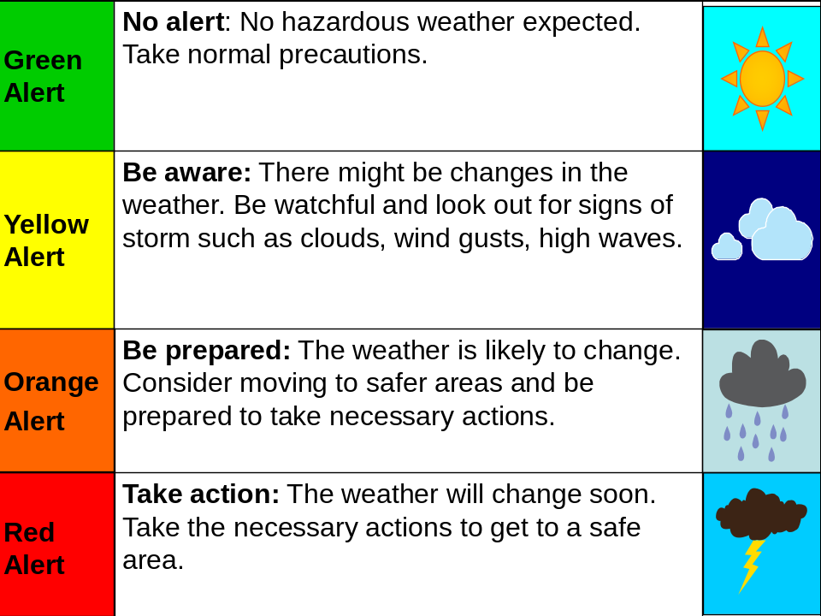

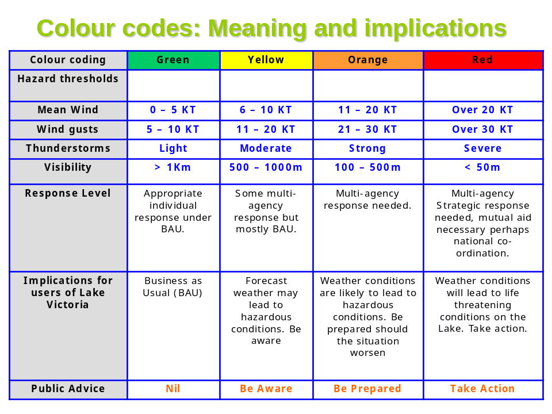

5. Issuance and dissemination of weather information and feedback

The users of weather information in Uganda include the general public, various government ministries such as Disaster Preparedness and Management; Agriculture, Animal Industry and Fisheries; Works and Transport; Water and Environment; Forestry; Health to mention but a few. We also have International Organizations like the WFP, WHO, FAO and the ICRC together with local organizations like the Uganda Red Cross Society and numerous NGO’s both local and international. Small scale farmers and fishermen are also part of the clientele of weather information.

The NMHS issues hourly, 2-hourly, 3-hourly and so on weather advisories and 6-hourly weather forecasts (TAFs) mainly for aviation and daily forecasts for the general public.
Currently the daily forecasts are disseminated through emails as the weather studio is malfunctional and needs revamping. Seasonal forecasts are issued and disseminated by the data processing unit of the Uganda Department of Meteorology (UDoM), at its headquarters. Mobile weather alerts are issued daily for daytime and disseminated through mobile phones with lead times of atleast 3 hours.
So far two surveys have been carried out to obtain feedback for mobile weather alerts with encouraging results. Feedback from farmers is obtained through surveys and field visits by Agricultural Extension Workers (AEWs) and Community Knowledge Workers (CKWs).

Uganda Department of Meteorology usually participates in the seasonal climate outlook for the Greater Horn of Africa (GHACOF) where seasonal forecasts and rainfall anomalies for the region are debated. Climate outlook is crucial for many sectors of the economy for planning and management of their activities.

6. Challenges

The Ugandan society and the government have never comprehended the vital linkage between weather, climate and socio-economic development. This has resulted into the relegation of the weather and climate sector to the bottom of the budget priorities of the government. Other challenges include;
- Lack of equipment and tools such as weather radar for tracking storms.
- Inadequate data (very narrow data collection base).
- NWP models shortcomings such as underestimation of precipitation, showing no precipitation signals, early prediction and switching off of convective processes, model simulations and
- Insufficient or no feedback from users of weather data information.
A major setback is in the area of weather information dissemination due to non-vailability of an operational weather studio which would enable accessibility of weather information by a large proportion of the population.

7. Conclusion

The Uganda Department of Meteorology (UDoM) is currently transforming into a semi-autonomous body, the Uganda National Meteorological Authority (UNMA). The current budget constraints that have drastically affected all facets of weather service delivery in the country are expected to be addressed by the new entity. This is expected to lead to improvement in severe weather forecasting capabilities (quality and timeliness of forecasts) and dissemination of forecasts and early warning systems and hence improvement of disaster prevention and mitigation in the country.

