WORLD METEOROLOGICAL ORGANIZATION  COMMISSION FOR BASIC SYSTEMS  OPAG on DPFS  Severe Weather Forecasting Demonstration Project (SWFDP)  Regional Subproject Management Team  ARUSHA, TANZANIA  27 – 31 MAY 2013 |  | DPFS/RAI-SWFDP-EA-RSMT/Doc. 7.2  (24.V.2013)  _______  Agenda item : 7.2  ENGLISH ONLY

CASCADING FORECASTING PROCESSES: THE ROLES OF RFSC DAR ES SALAAM FOR SWFDP-EA LAKE VICTORIA BASIN

(Submitted by RFSC DAR ES SALAAM – TANZANIA METEOROLOGICAL AGENCY)

Summary and purpose of document

This document explains capability and potential contribution of RFSC – DAR ES SALAAM to SWFDP-Eastern Africa and Lake Victoria Basin.

Action Proposed

The meeting is invited to consider and discussthe roles, contributions, future plans and challenges facing by the RFSC Dar es salaam for severe weather forecasting and verification of forecasts for the Lake Victoria basin.

INTRODUCTION

In the SWFDP – EA Tanzania Meteorological Agency (RFSC - Dar es salaam) has a responsibility of assisting RSMC – Nairobi in issuing severe weather forecasting guidance for the Lake Victoria basin and verification of the forecasts. The guidance forecasts are based on available NWP products provided byglobal centers ECMWF (deterministic products, Probabilistic forecasts, EPSGRAMS and EFI), UKMET models (UKGM, ALAM and 4km resolution Lake Victoria model), GFS and regional models COSMO (Nairobi) and 5km resolution WFR (Dar es salaam) together with observations and human forecaster’s knowledge (climatology). The RFSC – Dar es salaam under the Severe and Medium RangeWeather Forecasting (SEMERAWF) desk at Tanzania Meteorological Agency was established in October 2011 and together with other activities, it is responsible for issuing the guidance forecast to NMHSsover the lake Victoria basin.

The guidance forecasts issued give information about the possibility and risk of heavy precipitation (exceeding 50mm in 24hours), strong winds (20KT or more) and large waves (exceeding 2m) in the lake Victoria basin. The guidance forecast products are available in the password protected web resource www.meteo.go.tz/severe and it is made available for NMHSs for countries surrounding the lake Victoria i.e. Kenya, Uganda, Tanzania, Rwanda and Burundi.

GUIDANCE FORECASTING PROCESS

As stated above the guidance forecasts look at the potential possibilities and their associated risks of heavy precipitation, strong winds and large waves over the lake Victoria basin at agreed thresholds of 50mm in 24hrs, 20KT and 2m respectively. The forecasts are based on real time observation (both station and satellite) and NWP forecasts from the Global centers well as Regional centers. The products issued by the RFSC Dar es salaam are forecasts charts for day1 and day2, verification charts for the last forecasted day2, risk table as well as a discussion document. Also the RFSC Dar make available a 5km WRF forecasts through its password protected web resource at www.meteo.go.tz/severe.

From late September 2012 towards February, 2013 (Phase I of the Global Guidance services) the RFSC – Dar es salaam together with RSMC – Nairobi were receiving guidance forecasts and additional model fields from the UKMET office. These guidanceforecasts and additional model fields (particularly from the UKGM which we previously didn’t have access to) were very useful in the RFSC’s activities and improved the skills of the forecasts issued.
Since March 2013 to current the project has moved to the next phase (phase II of the Global Guidance service) where the audio-visual conference is held daily between the experts at the RFSC – Dar es salaam, RSMC – Nairobi and the Global Guidance Unit (GGU) of the UKMET office of which the model forecasts are discussed and the consensus forecast for the region is reached. This process is very useful as it involves experts from different regions, knowledge and we are now able to use other models that we didn’t have access to before and also ensures consistency in the guidance forecasts issued by the RFSC – Dar es salaam and RSMC – Nairobi for the Lake Victoria region.


Fig 1: Mr. Elias Lipiki, forecaster at RFSC – Dar es salaam participating in audio-visual conference with fellow forecasters from UKMET office and RSMC – Nairobi.

GUIDANCE FORECAST AND VERIFICATION CHARTS
i. Forecast chart for day1 | 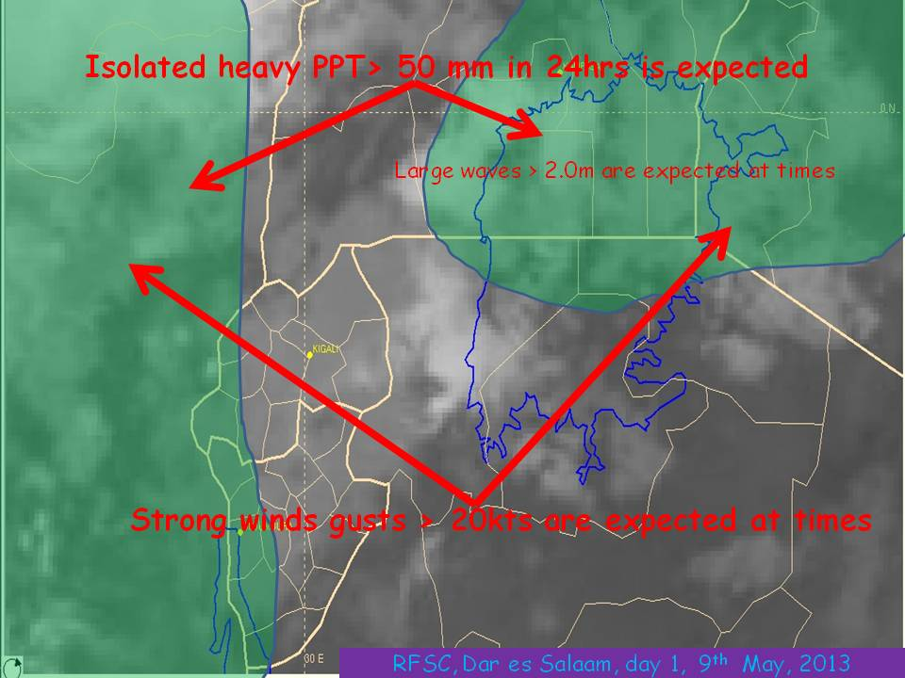
This chart indicates the areas where heavy precipitation, strong wind or large waves are expected for day1. The area where heavy precipitation is expected is indicated green in the map and a sentence explaining the expected phenomena. For the case of strong winds and large waves in the lake, a sentence and an arrow indicate it.
 | Fig 2: Guidance forecast chart for day1
ii. Forecast chart for day2 | 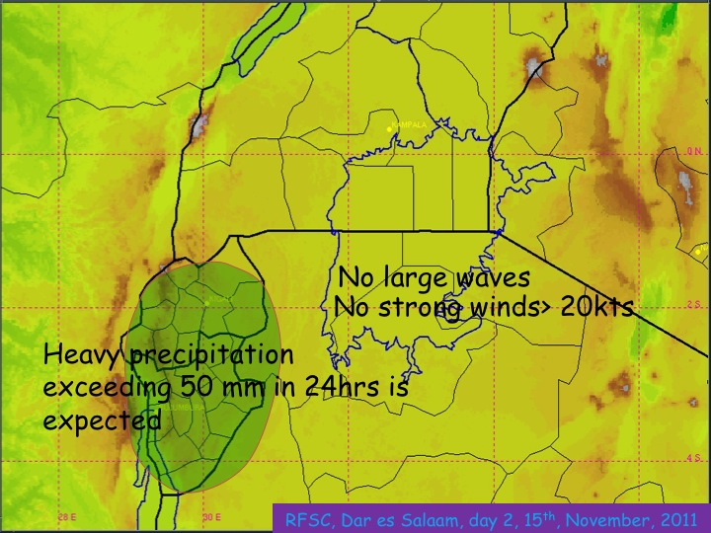
This chart indicates the areas where heavy precipitation, strong winds or large waves are expected for the next day (day2) of the forecast. Here the area where heavy precipitation is expected is indicated green in a map and a sentence explaining the expected phenomena. For the case of strong winds and large waves in the lake, a sentence and an arrow indicate it.
 | Fig 3: Guidance forecast chart for day2
iii. Verification chart | 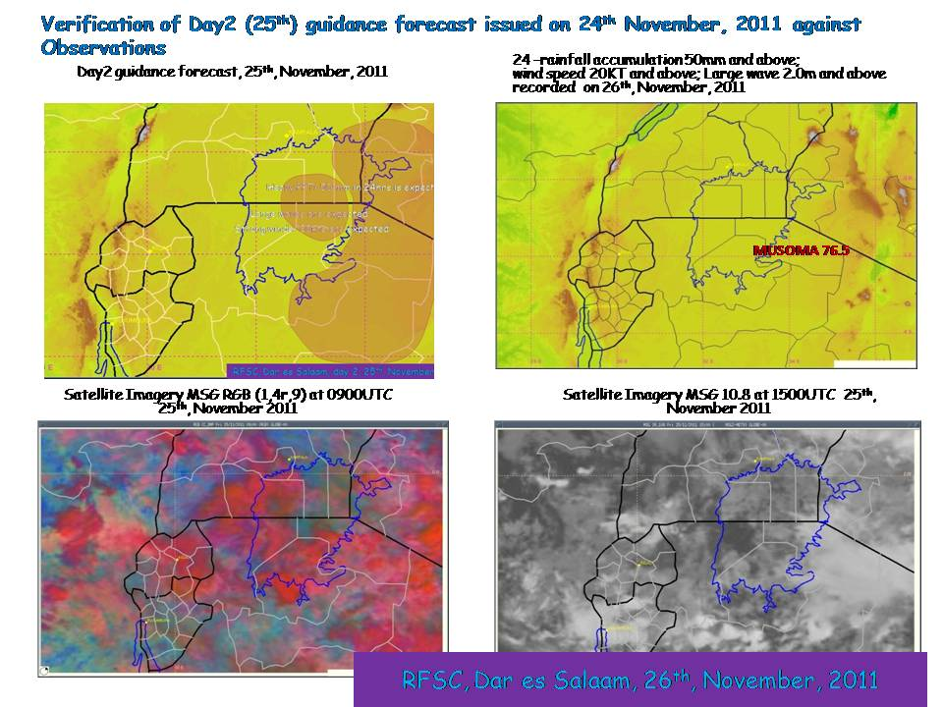
This chart includes the verification of the previous day2 forecast against observation both station observation and satellite observation. On the web portal there is a link to Tropical Rainfall Measuring Mission (TRMM) image for that day. This also will add value for verification of the forecast in places where there were no station observations. For the station observation only significant observation (30mm precipitation) is indicated.
 | Fig 4: Verification of guidance forecast for the previous for day2

RISK TABLES AND DISCUSSIONS

Together with the guidance forecast charts discussed above, the RFSC – Dar es salaam also issues the risk tables and discussion.

The risk tables indicate the risks for the severe weather phenomena expected at a particular day for a given region. The risks have been categorized as no risk, low risk, medium risk and high risk based on the forecaster(s) judgment. Please see annex I of this document for an example of the risk table.

The discussion documentscontain the discussion of synoptic scale evolutions of winds, moisture, instability, etc.and model forecasts. Here what brought about the issued forecast is being discussed. Please see annex II of this document for an example of the discussion document.

FUTURE PLANS OF THE RFSC – DAR ES SALAAM TO THE SWFDP-EA
Improvement of National Observing network.
On its five years plan, the Tanzania Meteorological Agency is planning to increase the surface observation network by installing new automatic weather station for the entire country including the lake Victoria basin.

Also Tanzania Meteorological Agency is in the process of installation of a Meteorological S-band Doppler Radar at Mwanza, south of the Lake Victoria and expected to be operational by September 2013. On its operational stage the Mwanza Radar will be expected to play a significant role in raising skills of the forecast in the Lake Victoria basin especially in nowcasting of the severe weather by expanding observational capability and resolution.
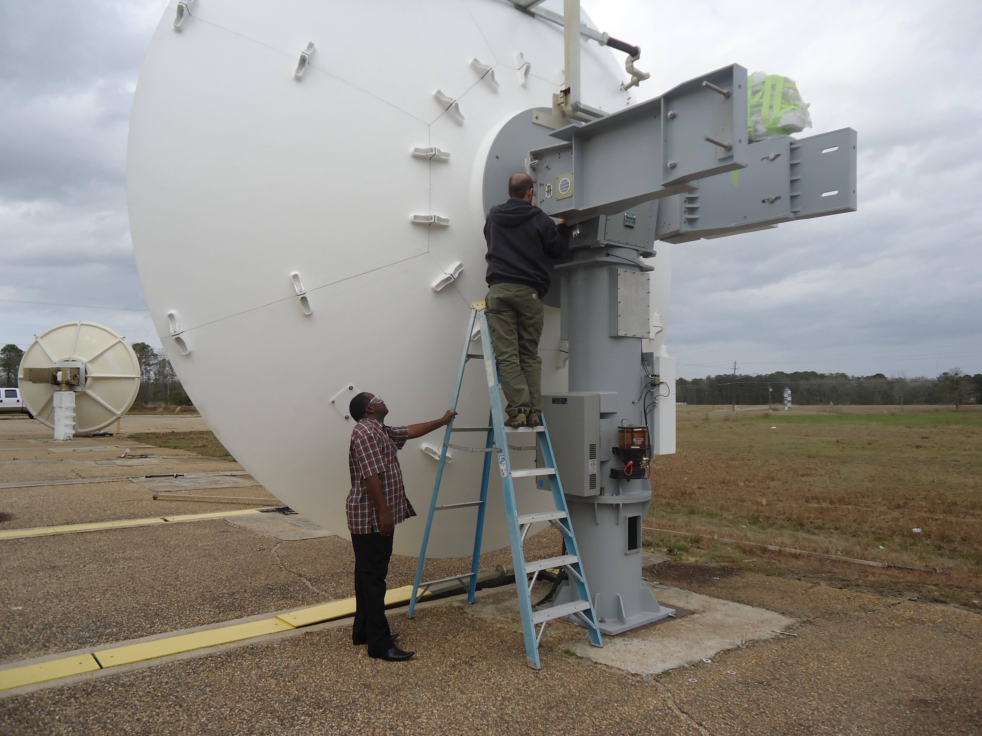 | 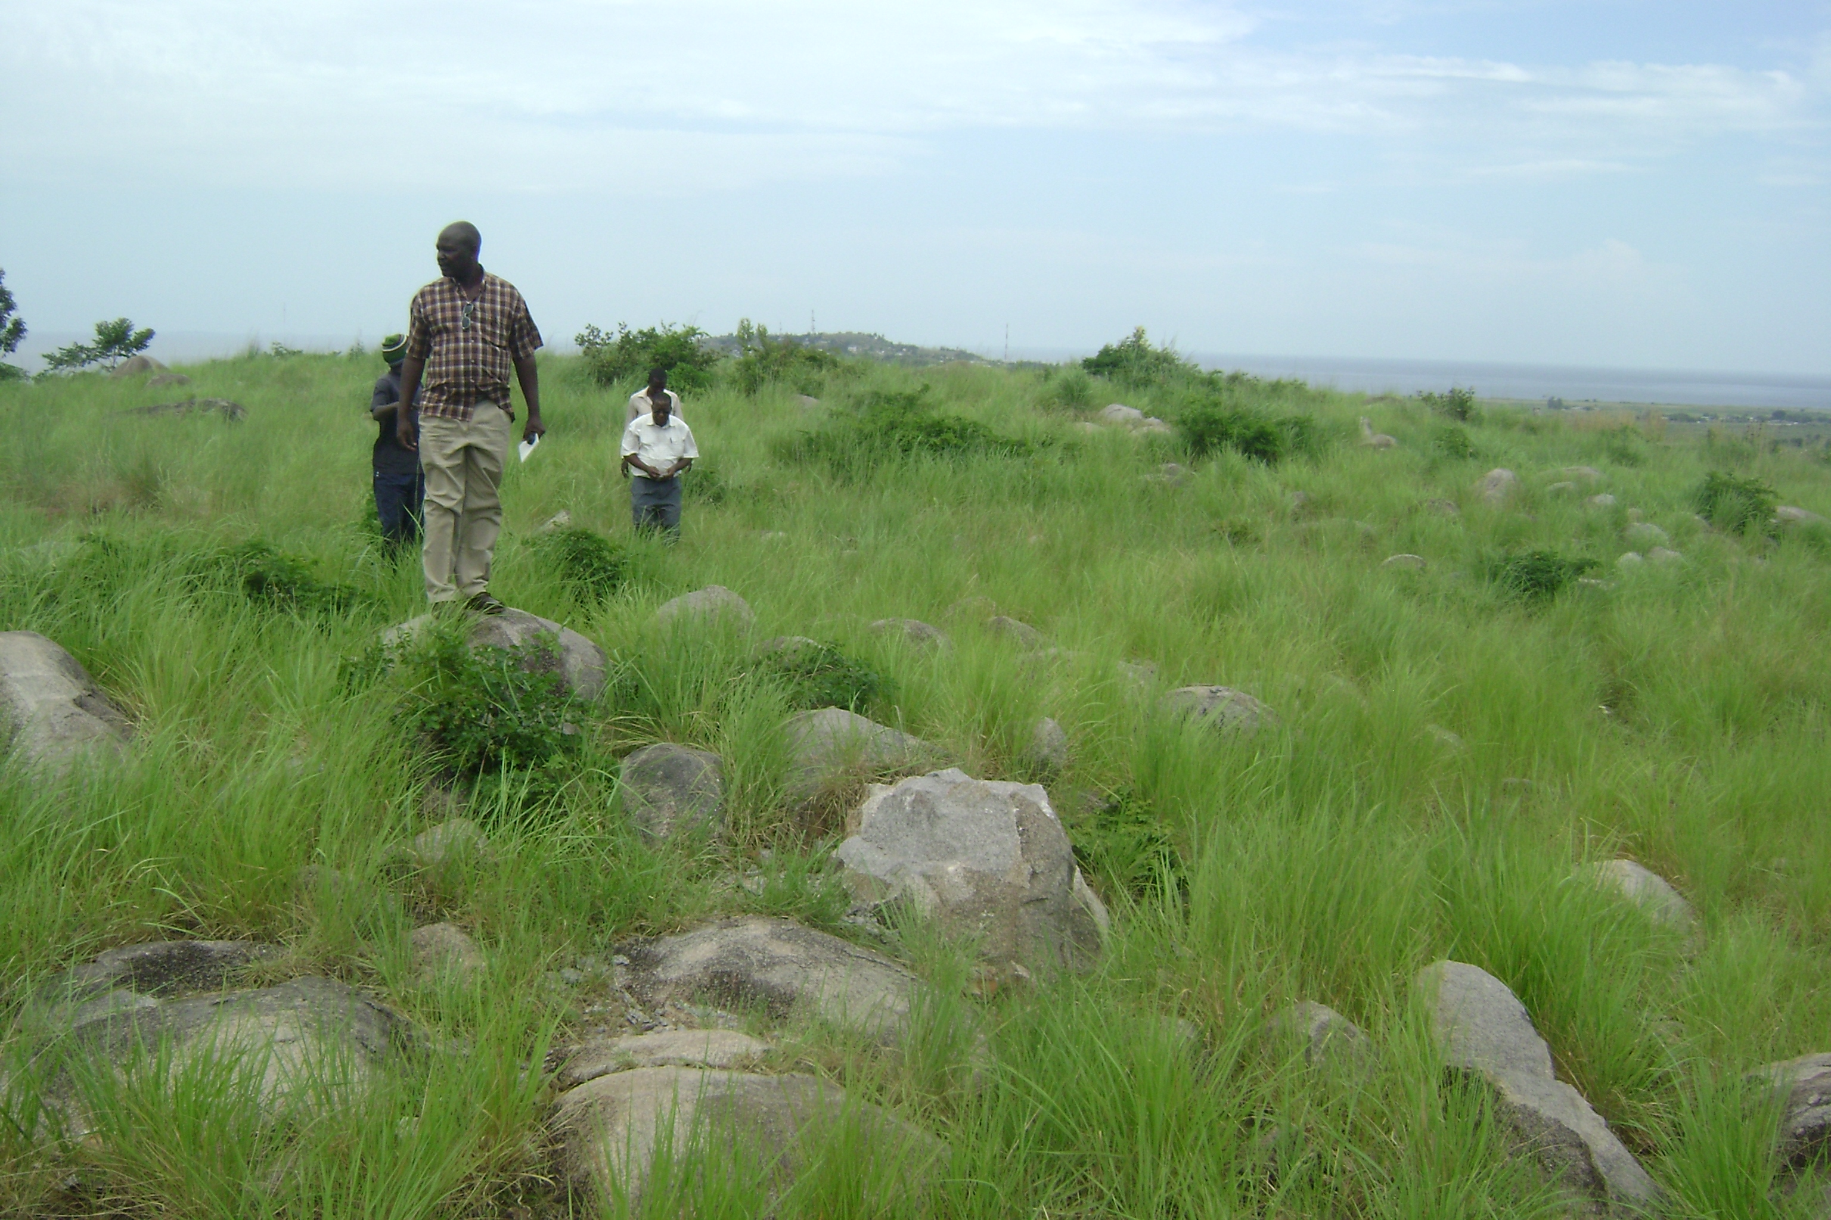
Fig 5: A Mwanza radar when it was Factory Acceptance Test (FAT) in Alabama, USA March 2013 | Fig 6: Radarinstallation site in Kiseke hill, Mwanza

CHALLENGES
The RFSC – Dar esSalaam faces a number of challenges in its daily activities. These include: -
- The Internet connection is not always stable. It varies in connection speed in day to day thereby sometimes reduction of the quality of audio-visual conference and other operational activities. The Tanzania Meteorological Agency has taken this challenge and it is in the plan of upgrading its Internet services by joining the national optical fiber network direct from its offices.

- Observational meteorological data availability from the NMHSs of the member states for verification of forecasts. The observational meteorological data are not readily available for verification of our forecasts from the member states within the lake Victoria basin. The only data available are those from the synoptic stations that are in the GTS network. These stations are very few for example we can access not more that five stations from Uganda and only four stations from Rwanda.

- Available NWP products in webportal at RSMC-Nairobi and RFSC-Dar es salaam from the Global centers in the graphic format covering very big area which sometimes make it very difficult to make detailed forecast for a small region like Lake Victoria basin especially if a forecaster wants to identify the strength of the wind i.e. from the wind barbs. Here it is advised that the Global centers to considerthe possibilities of providing the model fieldsmanipulative format (NetCDF, GRIBe.t.c.).
Annex 1
9
RFSC, Dar es Salaam, 23rd May, 2013

RFSC-TANZANIA
LAKE VICTORIA FORECAST GUIDANCE PRODUCTS
RISK TABLES

SHORT-RANGE (DAY 1 AND DAY 2)

Issue Date: Thursday 23rd May, 2013.
This risk table is for the regions along the lake Victoria Basin. The following key has been adopted for presentation of the geographical location of the severe weather events.

B ─ Burundi
K ─ Lake Victoria Basin part of Kenya (Nyanza.)
R ─ Rwanda
T E ─ Eastern side of Lake Victoria Basin part of Tanzania (Mara region)
T W ─ Western side of Lake Victoria Basin part of Tanzania (Kagera region)
T S ─ Southern side of Lake Victoria Basin part of Tanzania (Mwanza region)
UW ─ Western side of Lake Victoria Basin part of Uganda (Sese islands, Rakai, Masaka, Mbarara Provinces etc)
UN ─ Northern side of Lake Victoria Basin part of Uganda (Iganga, Jinja, Mpigi Provinces etc)

Day 1, Thursday 23rd May, 2013.
COUNTRY | HEAVY RAIN |  |  |  | STRONG WINDS |  |  |  | LARGE WAVES
COUNTRY | RISK |  |  |  | RISK |  |  |  | RISK
COUNTRY | No | Low | Medium | High | No | Low | Medium | High | No | Low | Medium | High
BURUNDI | X |  |  |  | X |  |  |  | X
KENYA | X |  |  |  | X |  |  |  | X
RWANDA | X |  |  |  | X |  |  |  | X
TANZANIA | X |  |  |  | X |  |  |  | X
UGANDA | X |  |  |  | X |  |  |  | X

Day 2, Friday 24th May, 2013
COUNTRY | HEAVY RAIN |  |  |  | STRONG WINDS |  |  |  | LARGE WAVES
COUNTRY | RISK |  |  |  | RISK |  |  |  | RISK
COUNTRY | No | Low | Medium | High | No | Low | Medium | High | No | Low | Medium | High
BURUNDI | X |  |  |  | X |  |  |  | X
KENYA | X |  |  |  | X |  |  |  | X
RWANDA | X |  |  |  | X |  |  |  | X
TANZANIA | X |  |  |  | X |  |  |  | X
UGANDA | X |  |  |  | X |  |  |  | X

Annex 2
RFSC, Dar es Salaam, 23rd May, 2013

RFSC-DAR ES SALAAM
LAKE VICTORIA FORECAST GUIDANCE PRODUCTS

SHORT-RANGE (DAY 1 AND DAY 2)

Issue Date: Thursday 23rd May, 2013.

Valid for: 23rd and 24th 2013.

Day 1, Thursday 23rd May, 2013.
There is a trough at 850hPa level over the Lake Victoria basin coupled with another trough at 700hPa over the eastern lake basin extending westwards. With very little moisture at low levels; only dry convergence and weak convection are expected over the lake basin (mainly eastern and western lake basin).
No strong winds or large waves are expected.

Degree of confidence: High.

Day 2, Friday 24th May, 2013
There is a continue persistence of the trough at 850hPa level over the lake Victoria basin accompanied by with another trough at 700hPa with confluent flow over the eastern lake basin extending westwards. With very little moisture at low levels; only dry convergence and weak convection are expected over the lake basin (mainly eastern and western lake basin).
No strong winds or large waves are expected over the region.

Degree of confidence: High.

DISCUSSION OF GUIDANCE PRODUCTS FROM GLOBAL AND REGIONAL CENTRES.

Regional and Global models are in good agreement for weak signals of precipitation for today and further reduction for tomorrow.

Forecaster: Mafuru K.B.

