WORLD METEOROLOGICAL ORGANIZATION  COMMISSION FOR BASIC SYSTEMS  OPAG on DPFS  Severe Weather Forecasting Demonstration Project (SWFDP)  Regional Subproject Management Team  ARUSHA, TANZANIA  27 – 31 MAY 2013 |  | DPFS/RAI-SWFDP-EA-RSMT/Doc. 4  (24.V.2013)  _______  Agenda item : 4  ENGLISH ONLY

Summaries East Africa October-December 2012

(Submitted by A. Garcia Mendez)

Summary and purpose of document

This document contains a summary and comments on the East Africa Quarterly Reports for the period October to December 2012.

Action Proposed

The meeting is invited to note the information provided in this document.

1. Overview

Five countries from Eastern Africa sent Quarterly reports for the period October to December 2012. Rwanda is missing as well as South Sudan.

Summary of Quarterly Reports - Eastern Africa

 | Burundi | Ethiopia | Kenya | Rwanda | South Sudan | Uganda | Tanzania (United Rep.)
Oct-Dec 2011 | yes | no | yes | yes | / | yes | yes
Jan-Mar 2012 | yes | no | yes | yes | / | yes | yes
Apr-Jun 2012 | yes | no | yes | yes | / | yes | yes
Jul-Sep 2012 | no | no | yes | yes | / | yes | yes
Oct-Dec 2012 | yes | yes | yes | no | / | yes | yes

All the reports mention the benefits of using the SWFDP cascading process. Case studies were provided by Burundi, Ethiopia, Kenya, Uganda and Tanzania.

2. Usage of NWP models by NMS and Supporting Centers

All reports mention explicitly the usage of global models from ECMWF, UKMO and NCEP. The products from Global models include deterministic and EPS forecasts as well as derived products as the Extreme Forecast Index (EFI) and probabilities of weather parameters for different thresholds. The criteria used for the guidance products in order to issue warnings are:
- Heavy rain for precipitations exceeding 50 mm/24 hours.
- Strong winds exceeding 25 Kts.
- Ocean/lake waves exceeding 2 meters.

The RSMC from Nairobi mentions the assessment of the EPS spread as a tool to check out the forecasts reliability. The EPS consistency is also checked out through the use of EPSgrams.

Following the cascading process, high resolution Limited Area Models as COSMO or WRF are used for the short range.
There is a general agreement regarding how useful the products received and used from different Centers are. There are in the reports a few comments related to model failures to detect significant events.
- Burundi report mentions that local meso-scale events are not well forecast by Global and higher resolution Limited Area Models.
- Uganda report mentions that ECMWF EFI and EPS probabilities show a lack of details over Lake Victoria. After discussing this issue with ECMWF MetOps colleagues it seems there is a jump in the model climate between the D+1 forecasts and the forecasts beyond that range. I could provide more details during the meeting.
- Ethiopia ask for verifications over different topographic areas of the country.

The reports mention also an improvement in their lead time to issue warnings.

3. Case studies

The revision of case studies provided by the countries involved in SWDP is very important since they show the kind of products used in the operational forecasting process, how the products have been used and the logical sequence followed when warnings for severe weather events are issued.
Some kind of normalization in the presentation of case studies is needed though, so the Global and Local forecasting Centers as well as the forecasters involved in the SWFDP receive feedback regarding the usefulness and strategic approach to the whole forecasting process. A good starting point could be to look at the Guidelines for a SWFDP case study by Richard Jones (Regional Training Workshop on Severe Weather SEA, Macau 8-13 April 2013). In the Annex at the end of this document you can find a template on how to build and present a case study. The proposed methodology is composed of:

- Abstract
- Introduction
- Weather situation
- Forecasts and warnings issued
- Weather products used
- Observation and impacts
- Evaluation of the forecasts
- Conclusion, recommendations
A similar strategy is used in the ECMWF WMO training courses taking place once a year in Reading.
The case studies presented by Tanzania and Kenya covers the period 1st to 2nd of November 2012. On Nov 1st 2012 the convection on and around lake Victoria organized in a long strip of convective cells from Tanzania into Kenya.

The case study of Uganda is from December 31st 2012. Deep convection developing on the northeastern side of lake Victoria then to lake itself and finally reaching Uganda.

Ethiopia presents a case study from May 21st 2012 showing floods on the southeastern side of Ethiopia (Gode zone, Somali region). The RSMC-Nairobi guidance missed the event.

4. Summaries from the Quarterly Reports

Burundi

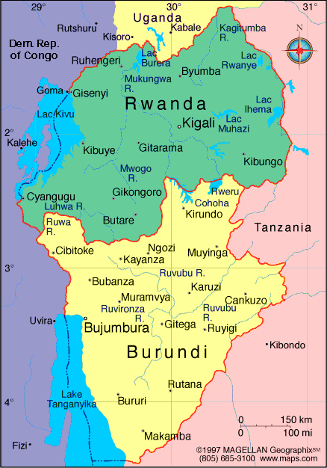

- The OND 2012 rainy period was characterized by above normal rainfall over much of the country, particularly over the southern and western parts of the country, which could achieve up to 150% of the normal rainfall. Bujumbura station, which is located in the western region, received 434.0 mm, which represents 156 % of the 280 mm normal rainfall during the OND season.
- The Burundi NMHS used the daily severe weather forecasting guidance from the RSMC-Nairobi.
- NWP and EPS products received from regional and global centers including ECMWF, NOAA, UK METOFFICE and RSMC- Nairobi were used. The ECMWF rainfall and extreme temperature model products were extensively used for their accuracy.
- The Burundi NMHS issued alerts and warnings on extreme weather events with a reasonable lead-time, generally 48 hours earlier, which is an improvement compared to before.
- Means of information dissemination are still weak.
- Some local severe weather events such as local heavy rains, strong winds and hailstones sometimes result from small-scale storms, which do not appear on these global, and regional forecasts models.
- Lack of Memorandum of Understanding between the NMHS and media, and inadequate feedback from some users.
- Case studies: None

Tanzania

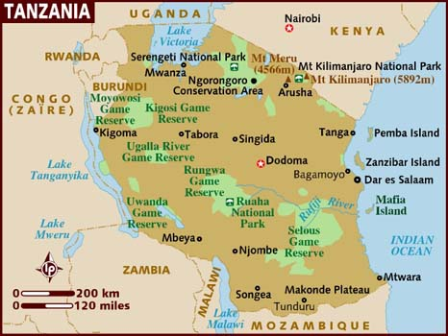

- Tanzania experienced the rain season over parts of the country. These rains have caused deadly floods over some parts during this period. Some of the areas where there were heavy precipitation events are Southwestern highlands, Lake Victoria basin, Northeastern highlands and the Northern coast.
- Guidance products from RSMC - Nairobi and RFSC - Dar es Salaam together with products from other centers were very useful.
- The SWFDP products received from the global centers continued to be very useful especially in precipitation forecasts and strong wind forecasts as important tool in early warning activities by providing a significant lead-time of severe weather event occurrences.
- The Deterministic, probabilistic and EPS from MOGREPS, ECMWF, RSMC-PRETORIA UM-SA12, RSMC-Nairobi COSMO, RFSC-Dar es Salaam WRF, UK-MET and NCEP have continued to assist forecasters in their daily weather forecasting including severe weather events.
- Guidance products from RSMC Nairobi (day 1 to day 5) and RFSC Dar es Salaam (for day 1 and day 2 for the lake Victoria basin) and NWP products from ECMWF, UKMET and NCEP.
- The interaction between Tanzania Meteorological Agency and Prime Minister’s Office Department of Disaster Management (PMO-DMD) continued to improve.
- Need to establish common communication protocols between Agencies involved in Early Warning and Disaster Management.
- TMA continued to participate in the social networks such as Facebook, Twitter and social forums.
- Case study: heavy rains associated to a MJO phase over Tanzania 1st November 2012.

Uganda

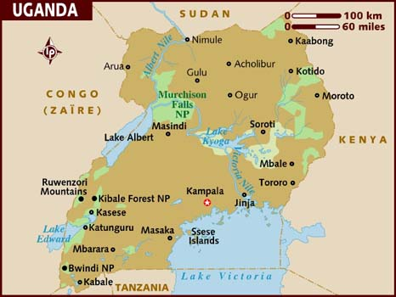

- This period is within the second major rain season of the region (September – December rain season). Many areas in the Northern part of the country in particular received heavy rains in the month of October (>35mm/24hr) compared to the rest of the country. In the months of November and December, Northern, Eastern and the Lake Victoria region of the country experienced relatively more severe thunderstorms (with rainfall amounts of >35mm/24hr) in relation to the Western and Central parts of the country. These rains caused flash floods leading to inundation of crop fields, flooding of homesteads particularly those in low lying areas and in some instances drowning of people and animals.
- The products from UK Met office, NOAA/NCEP and ECMWF are very crucial in forecast formulation and interpretation. The products which among others include, 6-hourly accumulated rainfall maps, Extreme Forecast Index (EFI), Epsgrams and various stability/instability index maps (CAPE, PWAT, LIFTED-INDEX, K-INDEX etc) in conjunction with Satellite Imageries from EUMETSAT, CONGO SAT24, SYNERGIE SYSTEM etc, are very useful in ensemble forecasting.
- RSMC-Daily Guidance has been available for quite a while now. These products are employed in conjunction with NWP/EPS products from global centres (Met office, ECMWF and NCEP-CPC etc.)
- Our lead times have improved by at least 3 hours, since available products have enhanced our nowcasting capabilities.
- Limited capacity in forecast verification due to lack of know how of new or modern verification techniques and also majorly due to shortages in ground observations.
- With UKMO products, the colour scheme does not give clear visual impression between areas of say heavy and extreme PPT.
- ECMWF EFI for winds, wind gusts and PPT provide no details over Lake Victoria. It just runs circles around the Lake.
- Work closely with Disaster Management under the National Disaster Risk Reduction Platform (NDRRP). A major issue of concern with the media is that at times they misreport and sensationalize serious weather situations.
- Case study: Storms over Lake Victoria 31st December 2012

Guidance Nairobi (Kenya)

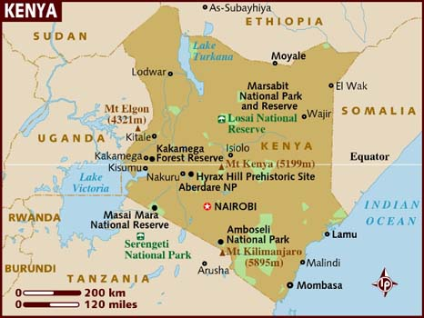

- The guidance Products during the period were based on a skilful evaluation of both Regional and Global model outputs for the domain area, Satellite imagery at the hour of issue and, expert interpretation that takes into consideration interactions with the local features. The criteria for generating the guidance products included:
  - Heavy rain: ≥ 50 mm/24hr;
  - Strong winds: ≥ 25 Kts;
  - Ocean/lake large waves: ≥ 2m
- The daily RSMC guidance helped NMHSs forecasters to increase their skills and confidence in the preparation of forecast products.
- The ECMWF, NCEP, GFS and daily UKMO ensemble and deterministic products were extensively utilized thus enabling detections of the severe weather events in advance.
- High-resolution refinements and details in the model fields given by the limited area models and the chronological evolution of the model parameters through the EPSgrams in longer lead-times improved efficiency of the production and issuance of forecasts/warnings. These enabled evaluation of the extent of the spread of the predicted events objectively using ensemble-forecasting technique.
- Interactive site improved the interaction with Disaster Management and Civil Protection authorities (DMCPAs), the media, and other sector users, before, during and after severe weather events. The major weakness which needed improvement during the period was unstable and slow Internet connectivity and frequent power interruptions. These delayed the production and timely dissemination of the products.
- UKMET office issued daily guidance products at 0400Z, which in addition to the other forecasting tools facilitated effective productions of forecasts products. The feedback and archiving mechanism on the web portal facilitated the interaction with other NMHSs, Disaster Management and Civil Protection authorities, media and other users.
- Forecasts and warnings issued during the period concerning heavy rains over the Nairobi and central province on 2nd November and 26th December 2012 over Kenya saved life and destructions of property.
- The major challenges:
  - Frequent power interruptions and slow Internet connectivity.
  - Inactive websites of RSMC member countries such as Burundi while others still maintained obsolete materials.
  - Irregular interactions with the users during the period and misinterpretation of the forecasts/warnings issued led to under utilization of the information to reduce fatalities.
- Case studies: 2nd November 2012. Precip exceeding 90 mm on Nairobi county

Ethiopia

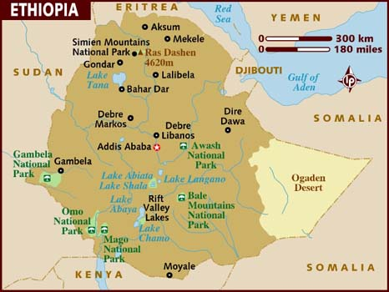

- October to January is the period of dry season for most portions of Ethiopia. Hence, December to January can be classified as Ethiopia's dry season, when the overall climate is a little cooler than the rest of the season. Most of the highland of Ethiopia is sunny during the day and cold during the night and morning, which includes frost in December and January.
- The SWFDP products have contributed to increase our confidence and improve severe weather forecasting/warning to the region. Especially, the NCEP/NOAA (GFS, WRF) and ECMWF, UK Met Office in conjunction with Satellite product are very useful to give prediction and warning.

By observing the RSMC, EPS, weather systems products we issued weather forecasts for the short range day one to two) and medium range (up to day five), Warnings are given depending on the probable event that may be stipulated to happen.
- Areas of improvement
  - Lack of model interpretation capacity.
  - Time lag in dissemination of the information to the end users.
- Most models don’t capture weather conditions and local effects on the Ethiopian highlands. We have noticed problems in the accuracy of the models and inconsistencies.
- Case study: Floods in Gode (Somali region). Precip exceeding 50 mm. RSMC-Nairobi Guidance did not capture the event across southeastern parts of the country.

Annex

Template for developing a significant event case study for the SWFDP

The following is a template for a significant event case study with suggested sections. Such a case study is one of the requirements of the regular project reports to be provided by participating countries in the SWFDP.
Based on a suggested template for RA V

Abstract:
You should summarize the main facts of the case and your main conclusions. The reader should be drawn to read further.

Introduction
Why are you considering this case study? What leads up to this? What is the importance of this study? Have there been any others like this one? Is there a scientific body of knowledge that supports this type of case - this type of phenomenon?
As in any good narrative tell your readers why they should be reading your report. You should also give them an indication of what they are about to read- the “story” line.
You should repeat that story in the conclusion.
Links should be referenced as: (example)
World Data Center for Meteorology (Beijing, China; Russian Federation; Ashville, USA) provides access to weather observations.

Overview of the weather situation
Draw on facts and images that describe the overall weather situation. In many cases this would be a surface map with important features outlined. What was the upper flow like? What were the forcing features, the precursors to the phenomena that you will describe? eg. Tropical cyclones start from tropical depressions – what was the track? ; large extra-tropical lows start from rapidly developing lows.
For Meso-scale phenomena: for large convective storms describe: the weather situation; atmospheric stability; vertical profiles; low level humidity; shear; triggers;
Local effects – the weather situation in the local area should be described as well as the forcing involved eg. Sea breeze (water and land temperatures, predominant winds; stability) ; valley or gap winds (topographic features, predominant winds, pressure gradient, stability) .
Coastal flooding: High tide and storm surge –consider moon and sun tides; wind induced storm surge; wind waves and swell;
River flooding: describe precondition of the river, lake; catchment basin, weather description and precipitation amounts;.
Atmospheric phenomena: eg. Rainbows; parhelic circles; condensation trails; describe weather situations and atmospheric conditions that are precursors for the phenomena

Figures should be labelled (indicate the product, source and time and the features that should be noted by the reader) eg see Fig. 1 (example) below:

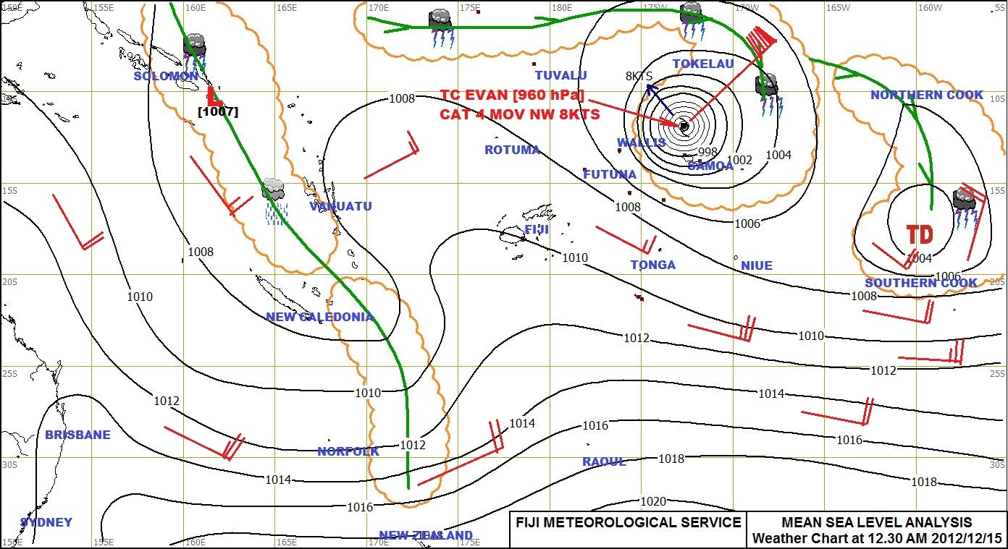

Figure 1: Fiji Meterological Service Mean sea level pressure analysis as at 12:30 am (Fiji local time) 12 Dec 2012. Note the position of TC Evan to the NW of Samoa and moving NWward. TC Evan subsequently turned toward the southwest. Note also the tropical depression in the Cook Islands.

Forecasts and warnings issued
In a case study of a significant event; provide a list of the forecasts and warnings issued; the more detailed ones should be annexed. Carefully differentiate the issue time, validity time, the area affected and the intensity of the phenomena being forecast against the observations to arrive at your conclusion. When was the warning issued to the DMCPA? Where there any interactions with the DMCPA?

Weather products used
Products from supporting RSMC’s including graphical and worded advisories could be included. Details should be annexed but referred to in the body of the text. Consider products from global centres. Each product and service type should be described with details about the product content, technical foundation (i.e. what kind of model?, spatial and temporal scales (if necessary eg. 4km WRF model), availability (eg. from ECMWF 12UTC run). Each should be labelled as a Figure in the text with the appropriate legend. . More specific technical details should be annexed. Local models could also be included however the details should be annexed.

Observations and impacts
Present observations that support the severity of the phenomenon being considered e.g. max sustained wind and gusts for how long; precipitation how much and over what period – how widespread was this phenomenon; satellite imagery and radar could be used for the observations;
Impacts
Present facts about the extent and severity of the flooding; wind damage e.g. trees blown down houses destroyed; injuries and deaths; gathered from news reports, or better still, authoritative information obtained from national disaster management or civil protection authorities . If the reports are long they could be summarized, quoted, or annexed.

Evaluation of the forecasts
How good were the local forecasts? Make sure to respect the valid times of the forecasts. Evaluate the quality of the forecast with respect to the intensity of the phenomenon being forecast, the affected area with the supporting observations.
How good were the RSMC advisories and supporting forecasts?
How good was the numerical model support? Consider both global and local models.

Conclusion, recommendations

What are the main conclusions to be drawn for the evidence provided? For the evaluation of an event how well was it forecast? Could something have been done better? Should this procedure be followed in the future? Why? How could this case study be of help in a future event?
If the case is reporting on an event that is not well handled or well forecast – what could or should be done to make it better in the future? What could have been done differently?

Scientific article should be referenced using standard reference notation: eg:
References :
Carr, L.E., III, and R.L. Elsberry, 1997: Models of tropical cyclone wind distribution
and beta-effect propagation for application to tropical cyclone track forecasting. Mon.Wea. Rev., 125, 3190-3209

http://www.wmo.int/pages/prog/www/CBS-Reports/documents/CASESTUDY_template_v12May2011.doc
http://cdc.cma.gov.cn/
http://meteo.ru/english/
http://www.ncdc.noaa.gov/oa/wdc/index.php

