WORLD METEOROLOGICAL ORGANIZATION  COMMISSION FOR BASIC SYSTEMS  OPAG on DPFS  TECHNICAL-PLANNING WORKSHOP ON SEVERE  WEATHER FORECASTING DEMONSTRATION PROJECT (SWFDP) DEVELOPMENT  FOR EASTERN AFRICA (RAI)  Nairobi, Kenya, 4-8 October 2010 |  | CBS-DPFS/RAI/EA-TPW-SWFDP/Doc. 4.1(1)  (24.09.2010)  _______  Agenda item : 4.1  ENGLISH ONLY

SEVERE WEATHER FORECASTING AND WARNING SERVICES, INCLUDING DELIVERY AND COMMUNICATION TO THE USERS

(Submitted by Vincent N. Sakwa / Julius Kabubi)

Summary and purpose of document

This document provides information on the severe weather forecasting and warning system and services at the National Meteorological Service of Kenya

Action Proposed

The meeting is invited to review and consider this information to help formulate a possible implementation of a SWFDP regional subproject for Eastern Africa.

Discussion

Kenya Meteorological Department (KMD) uses the High Resolution Regional Model (HRM) and Weather Research and Forecasting (WRF) for severe weather forecasting.
The HRM is a flexible tool for Numerical Weather Prediction (NWP). The Deutscher Wetterdienst (DWD) provides this comprehensive package to National Meteorological and Hydrological Services (NMHSs), universities, and research institutions world-wide. Operational HRM-Kenya is based on GME data at 30 km horizontal resolution and 60 vertical levels. Model domain (Mesh size: 0.125° ~ 14 km) extends from latitudes (12⁰ S, 12⁰N) and longitudes (26⁰E, 51⁰E).
Weather Research and Forecasting (WRF) Environmental Modeling System (EMS) is a complete, full-physics, Numerical Weather Prediction (NWP) package that incorporates dynamical cores from both the National Center for Atmospheric Research (NCAR) Advanced Research WRF (ARW) and the National Center for Environmental Predictions' (NCEP) Non-hydrostatic Mesoscale Model (NMM-WRF) releases into a single end-to-end forecasting system.

The global climate models e.g ECMWF, UK, etc and Statistical models are used for forecasting the climate in Kenya.

Severe Weather and extreme Climate Events in Kenya

Recent observations of weather and climate events in Kenya have shown that the country is increasingly becoming predisposed to both natural and manmade disasters such as floods, droughts, landslides and fires. This has continued to threaten both sustainable development and poverty-reduction initiatives. According to the WMO, over 90% of all natural disasters in Africa are Hydro meteorological, that is, weather and water related. These are referred to as the hydro-climatic disasters.

Hydro-meteorological disasters are responsible for the serious disruption of the functioning of a society or community and widespread human, material or environmental losses. These disasters, and the communities exposed to them, may be expected to climb with increased climate variability as a result of climate change. Tragically, the span of attention given to hydro-meteorological disasters is often short, probably because the disaster events continue only for a short while, and as the memory of disaster events fades, so does the urgency for Disaster Risk Reduction (DRR) strategies.

With increased frequency and intensity of extreme climate and severe weather events, the Government of Kenya (GK), through its institutional set-up, has started to recognize the need to understand and prepare for these disasters. Several institutions of higher learning are now running undergraduate and postgraduate degree courses in disaster management. The Government has also started to institute various legal and institutions mechanisms for disaster preparedness, response and mitigation including the “National Climate Change Response Strategy”. Despite all these efforts, the knowledge on disaster risk reduction by the general public and local communities is still low, thus making it difficult to plan, prepare, prevent and reduce severe consequences of disasters to the public.
The following are some of the severe weather in Kenya:-

- Hailstorms in some parts of the country, especially Kericho-Nandi Hills area.
- Strong gusty winds
- Thunderstorms over the lake Victoria basin
- Lightning; particularly over the Lake Basin and Mt. Elgon area
- Floods; over Nyando River catchment, Nzoia catchment in Budalangi, Lower Tana, Perkerra River, Athi/Galana, etc.
- Drought particularly over the North, Northeastern, Northwest and Southeastern part of the country
- Sandstorm over the Northern part of Kenya
- Heat waves
- Frost over the highlands (Mau, Arberdares and Mt Kenya region)
- Forest fire

Early Warning System in Kenya

The National Weather Service in Kenya has initiated elaborate measures to communicate and educate the communities on the impacts and mitigation measures required to avoid socio-economic losses emanating from weather related disasters. Being a Disaster Risk Reduction (DRR) initiative, the Department liaises with many stakeholders in disaster risk management, training and awareness programmes on hydro-climatic disasters, advocacy and outreach programmes to reach the communities and other users.
National Meteorological Service in Kenya provides different types of forecasts. These are:
- Now-casts (0-6h)
- Short- range forecasts (24h-5days)
- Medium-range forecasts (7-14days)
- Longe range forecasts (30-90days)

All the forecasts are communicated to the users through the Provincial Directors of Meteorology (PDMs), RANET FM, Radio Station; including Electronic and Print Media.

Annex

Some of the most common severe weather disasters in Kenya include;

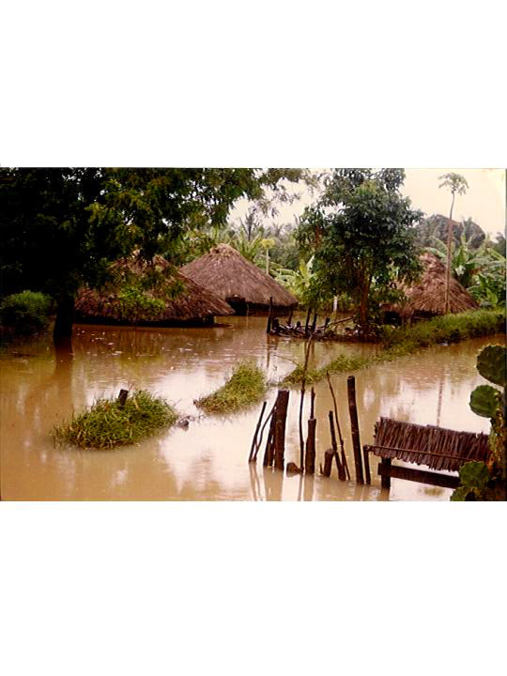

- Floods

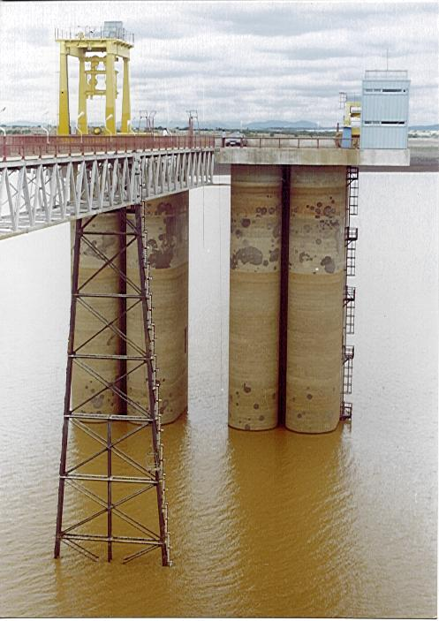

2a. Hydrological Drought

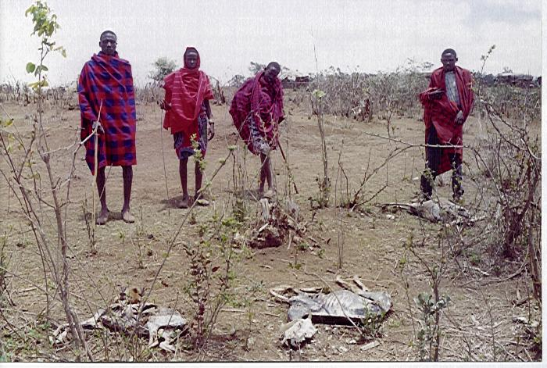

2b. Agricultural Drought

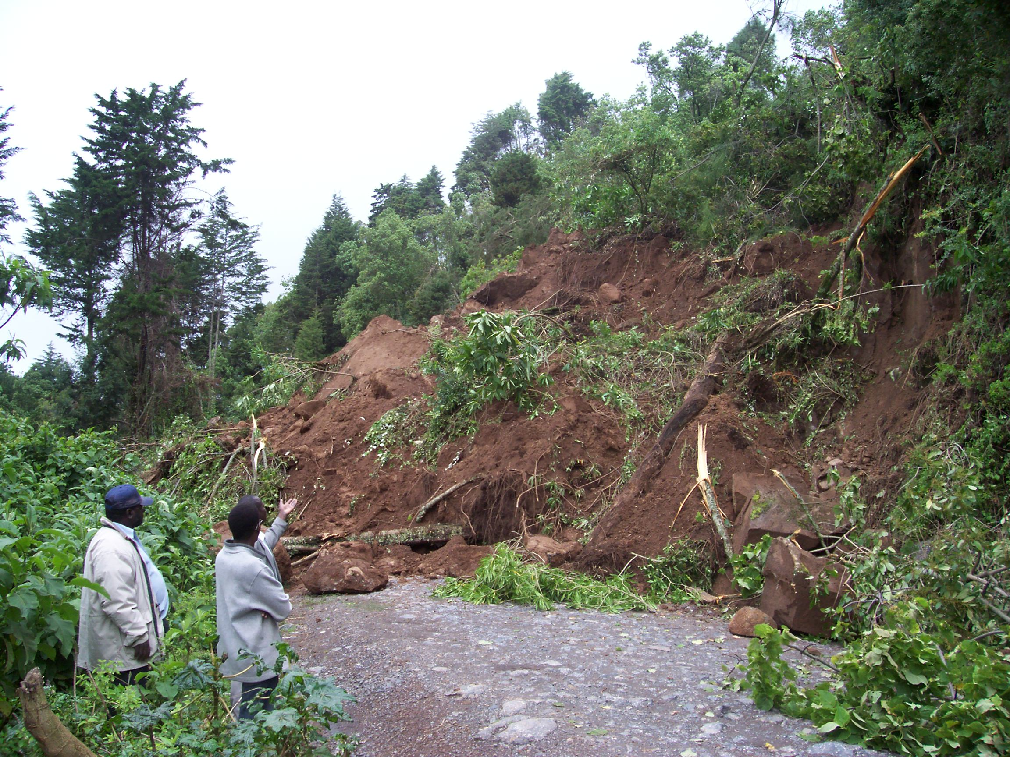

- Landslides

The challenges that are hampering the country’s ability to deal with severe weather disasters are;

- Knowledge gaps in identification, assessment and awareness of disaster risks;
- Weak disaster management policies and institutions ;
- Lack of mainstreaming DRR in development plans;
- Low funding of the National Disaster Operation Centre (NDOC) for DRR propagation;
- Low human capacity and poor coordination
- Public education and Awareness on DRR is lacking
- No budgetary provision for DRR
- Climate variability and change

Reference

Burridge, D. M., 1975: A split semi-implicit reformulation of the Bushby-Timpson 10-Level model.Quart. J. Roy. Meteor. Soc. 101, 430, 777-792.

Davies, H. C., 1976: A lateral boundary formulation for multi-level prediction models.
Quart. J. Roy. Meteor. Soc. 102, 432, 405-418.

Doms, G. and U. Schättler, 2003: The nonhydrostatic limited-area model LM of DWD. Part 1: Scientific documentation. Deutscher Wetterdienst, Offenbach, Germany.

Zhang, Z. and Krishnamurti;1997: Ensemble foreacting of hurricane tracks. Bull.Amer. Metor. Soc. 78, 2785-95

Zoltan Toth and Eugenia Kalnay;1993: Ensemble forecasting at NMC: The generation of perturbations. Bull.Amer. Metor. Soc. 74(12), 2317-30

Herzog, H., 1995: Testing a radiative upper boundary condition in a nonlinear model with hybrid Vertical coordinate. Meteorology and atmospheric physics, 55, 185-204.

Mesinger, F., 1997: Dynamics of limited-area models: formulation and numerical methods. Meteorol. Atmos. Phys. 50, 47-60.

Mukabana, J.R., 1993: Review of the existing limited-area modeling activities in East Africa. WMO Tropical Meteorology Research Programs (TMRP), report series No.5 pp. 13-38, WMO/TD – 695.

Mukabana, J.R. and Pielke, R.A., 1996:Investigating the influence of Synoptic-scale Monsoonal winds and mesoscale circulations on Diurnal Weather Patterns over Kenya using a mesoscale numerical model. Mon. Wea. Rev.,AMS, 124, 225 – 239.

Pielke, R.A., 1974: A three-dimensional numerical model of the land and sea breezes over Southern Florida. Mon. Wea. Rev., 102, 115 – 139.

Temperton, C. and M. Roch, 1991: Implicit normal mode initialization for an operational regional model. Mon. Wea. Rev., 119, 667-677.

Tiedtke, M., 1989: A comprehensive mass flux scheme for cumulus parameterization in large scale models. Mon. Wea. Rev., 117, 1779-1800.

