WORLD METEOROLOGICAL ORGANIZATION  COMMISSION FOR BASIC SYSTEMS  OPAG on DPFS  Regional Subproject Management Team (RSMT)  of the SWFDP – Eastern Africa  Nairobi, Kenya, 21-24 June 2011 |  | DPFS/RAI-EA-SWFDP-RSMT/Doc. 4.1(4)  (15.VI.2011)  _______  Agenda item: 4.1  ENGLISH ONLY

ECMWF contribution to SWFDP for Eastern Africa

(Submitted by David Richardson)

Summary and purpose of document

This document summarises the planned contribution of ECMWF to the SWFDP in Eastern Africa (RA ). A draft guide to the use of ECMWF ensemble-based products is attached as an annex

Action Proposed

The meeting is invited to review the contents of this document. A number of products, including EPSgrams for each participating country are already available on the ECMWF web site; the meeting is requested to provide feedback on these products

Annex(es): - On the operational use of products from the ECMWF Ensemble Prediction System (EPS), Draft version

1. Introduction
The European Centre for Medium-Range Weather Forecasts (ECMWF) is an independent international organisation supported by 34 States. ECMWF’s main goal is to provide medium-range global numerical weather forecasts for the National Meteorological Services of its Member States.

ECMWF has a co-operation agreement with WMO and actively supports the work of WMO. ECMWF provides a range of services for WMO Members including real-time forecasts. A number of products have been specifically developed in support of severe weather forecasting, including predictions of tropical cyclone tracks.

Recent enhancements to the service provided to WMO Members include:
- Increase in spatial resolution of forecast data available to download from 2.5° to 0.5° (2009) latitude-longitude grid. The 2.5 degree data is available in GRIB edition 1, whereas the 0.5 degree data is available in GRIB edition 2. The plans are to discontinue the 2.5 degree data set following a transition period when both data sets are available in parallel.
- Addition of ensemble mean and spread (standard deviation) to available products

More information on the range of services and how to access them is available on the ECMWF web site

http://www.ecmwf.int/about/wmo_nmhs_access/index.html

2. ECMWF support to SWFDP
ECMWF supports the WMO Severe Weather Forecast Demonstration Projects (SWFDP). ECMWF is participating in the first SWFDP in southern Africa (RA I) and in the SWFDDP in the south-western Pacific (RA V) as a global data provider (“global centre”). ECMWF provides a range of products from both the deterministic forecasts and the Ensemble Prediction System (EPS), focusing on early warning for severe weather. These are provided as graphical products, mainly as charts focused on the region of interest for the SWFDP. The products are accessible via the ECMWF web site, on a password-protected page.

3. Proposed ECMWF contribution to SWFDP in Eastern Africa

ECMWF will participate in the SWFDP as a Global Centre.

ECMWF will provide a range of products from its high-resolution deterministic forecast and its ensemble prediction system (EPS). Products will be aimed at providing indication about the risk of severe weather. Initially these will be based on the existing product range, plotted on the geographical area of interest for the SWFDP, and will include

- probabilities of precipitation and winds exceeding given thresholds
- extreme forecast index (EFI); identifies locations where the ensemble is substantially far from the model climate, indicating potential severe event
- tropical cyclone tracks and strike probability maps
- site-specific forecasts for surface weather parameters (EPSgrams) for specified locations (up to 10 stations for each participating country)

All products will be updated twice a day with forecasts from 00 and 12 UTC; an archive of the previous 7 days will also be provided to assist in evaluation.

All products will be provided in graphical format on the ECMWF web site (password-protected). ECMWF will issue each participating NHMS with a login to access these pages. Centres that already have ECMWF accounts will be able to use these. Any participating NHMS that has not yet received its login information should contact ECMWF to arrange this access.

A number of products are already available on the ECMWF web site as part of the normal service provided for WMO members (using your ECMWF web accounts).

http://www.ecmwf.int/products/forecasts/d/charts/medium/

These include the extreme forecast index, probabilities for precipitation and wind, and tropical cyclone products. They are provided on a map covering the whole of Africa. Although larger than the specific area proposed for the SWFDP, these are still expected to provide useful information and participants are encouraged to look at and provide feedback on these standard products. Following the Technical Planing Workshop in October 2010, ECMWF has implemented EPSgrams for 10 sites for each country participating in this SWFDP (sites provided by the countries). Again feedback of the usefulness of these EPSgrams is welcome.

http://www.ecmwf.int/products/forecasts/d/charts/medium/epsgramswmo/

The ECMWF contact person for the SWFDP is David Richardson (david.richardson@ecmwf.int).

ECMWF will consider requests for additional products to support the SWFDP, but the resources required to undertake the work will need to be taken into account.

ECMWF will encourage and support evaluation of the SWFDP and requests participants to provide feedback on the application and usefulness of ECMWF products during the project.

4. Training

ECMWF has prepared a guide to the use of its EPS products for WMO Members. The guide also includes the additional products that are available to the participants of the SWFDPs. A draft copy of the guide is attached. It is currently being update; the revised guide will be made available on the ECMWF website.

ECMWF runs an annual training course on the Use and Interpretation of ECMWF Forecast Products for forecasters from WMO Member States. The purpose of the course is to train forecasters in the use and understanding of ECMWF products, especially those that may not be familiar, such as the probabilities from the Ensemble Prediction System (EPS), the EPSgrams, Extreme Forecast Index, and tropical cyclone strike probabilities.

Applicants from WMO Member Countries are not charged course fees for this course. In addition, a limited amount of funding is available (provided by WMO) to support travel and subsistence. In recent years a number of participants from the SWFDPs in southern Africa and SW Pacific have benefited from participating in this course.

The next course will be held at ECMWF in October 2011. Several participants from SWFDP participating countries, including the E Africa SWFDP, will attend this course. However, due to large demand it has not been possible to provide financial assistance to all applicants. Further information is provided on the ECMWF web site:

http://www.ecmwf.int/newsevents/training/

On the operational use of products from the ECMWF Ensemble Prediction System (EPS)

Anders Persson, October 2010
DRAFT

1. Introduction

The ECMWF Ensemble Prediction System (EPS) offers a wide range of forecast products, many of which are displayed on the ECMWF WMO web site. These are presented in this brief manual.
In the 1st section the EPS is explained, in the 2nd the EPS products available on the ECMWF WMO site are presented and finally in the 3rd section the use of EPS together with deterministic forecast information briefly discussed. A more detailed documentation is to be found in the “User Guide of the ECMWF forecast products” on the same web site.

2. The EPS system

The EPS has been developed as an extension to the traditional Numerical Weather Prediction (NWP) categorical products. Whereas the latter provides one single deterministic forecast, which is not necessarily the most likely and does not provide any confidence measure; the EPS in contrast aims at providing the most likely forecast value, together with a confidence measure and probabilities of alternative developments, in particular related to extreme or high-impact weather.

2.1 Why do weather forecasts go wrong?

Computer based weather predictions are based on mathematical equations of the atmospheric dynamics and physics. They are integrated forward in time from a 3-dimensional analysis of the atmosphere. These forecasts are never 100% perfect because of necessary mathematical simplifications and unavoidable errors in the initial conditions. The calculations have for practical reasons, for example, to disregard, or treat in a simplified manner, weather systems and geographic features beneath a certain horizontal or vertical scale. The initial conditions, the 3-dimensional analysis of the atmosphere, will contain errors due to lack of observations, erroneous observation and difficulties to accurately analyse complex weather systems..

2.2 The rational behind the EPS

Parallel to the work of improving the realism of the atmospheric model, increasing the number and quality of observations, improving the quality controls and developing more advanced ways to analyse them, a rather opposite approach has been taken. By slightly changing the analysis within the margins of analysis uncertainty, an ensemble of alternative, “perturbed”, initial states is constructed.

If forecasts starting from these perturbed analyses more or less agree with the forecast from the non-perturbed analysis (the Control forecast) then the atmosphere can be considered to be in a predictable state and any unknown errors would not have a significant impact. If, on the other hand, the forecast spread is large and the perturbed forecasts deviates significantly from the Control forecast, and from each other, the conclusions could be drawn that the atmosphere is in a rather unpredictable state. Mostly the spread of the forecasts does not cover the whole climatological range so it is normally possible to infer which weather patterns could possibly develop and, not least important, might not develop.

2.3 The ECMWF ensemble system

The current ensemble system at ECMWF is run on a global model (T639L62) with a horizontal resolution of about 31 km and with 62 levels up to 80 km, 40-50 of which are in the troposphere. The basic atmospheric analysis is a downscaled version from the one used for the forecasts for the higher resolution operational deterministic (T1279L91) model. The down scaled, so called Control analysis, is modified to create 50 alternative or perturbed, analyses in three ways:

- By a so called “singular vector” technique which mainly perturbs dry parameters such as wind, temperature and geopotential. They are calculated to maximize the impact during the first 48 hours either intensifying or weakening baroclinic features. These perturbations are applied outside the tropics.
- To account for the uncertainties due to small scale turbulent or convective processes a stochastic perturbation technique (“stochastic physics”) is added globally. Recently this stochastic technique has been further developed (“kinetic energy back-scattering”).
- To specifically address uncertainties in the moisture analysis, typical of low latitudes, in particular of tropical cyclones, a special version of the singular vectors are applied an in the tropics.

The ensemble technique has recently (22 June 2010) been introduced also in the ECMWF analysis system. Information from this system is then on a daily basis been incorporated back into the EPS perturbation technique further improving the realism of alternative analyses.

Since the 50 ensemble forecasts start from analyses which have resulted from perturbing a (Control) analysis with optimal accuracy, most of them and their subsequent forecasts are unavoidably on average slightly less accurate. However, whatever the perturbed forecasts may lack in individual skill, they compensate by being many! Thanks to this they cannot only provide reliable and skilful probabilities, but their average generally provides a more accurate forecast than the unperturbed Control forecast together with a spread estimation and probabilities of alternative, high-impact developments.

2.4 The ensemble mean

The Ensemble Mean (EM) is obtained by averaging the forecasts from all the ensemble members. This has the effect of filtering out small scale atmospheric features which differ between the members and therefore are to be regarded as less predictable. On the other hand the averaging retains those larger scale features which show agreement among the members and therefore can be considered more predictable. The EM therefore displays a higher degree of accuracy (for most measures) and less “jumpiness”, i.e. a higher degree of day-to-day consistency, than the deterministic forecasts. Maps depicting the EM of MSLP might sometimes appear physically unrealistic – at least to an educated meteorologist! However, in each geographical location the forecast value is likely to be closer to the truth than the forecast value from a single deterministic forecast. In spite of their smooth appearances these ensemble averages give indications of the general weather type: zonal, blocked, NW-cyclonic, NE-anticyclonic etc which a forecaster with local experience easily can interpret into prevailing weather.

What has been filtered away, although considered less predictable, might in the end very well verify. This information is therefore retained and will resurface in the form of spread indicators or probabilities.

2.5 The ensemble spread

The ensemble spread is a measure of the difference between the members of the ensemble forecast and is simply represented by the standard deviation. The spread refers strictly to the accuracy of the EM. Generally, small spread indicates high forecast accuracy; large spread low forecast accuracy both with respect to the ensemble mean. This inference does in principle not apply to the corresponding Control (currently T639) or deterministic (currently T1279) runs, unless they happen to provide a solution that lies mid-range within the ensemble.

The forecast spread often varies considerably between one parameter and another. During a high-pressure blocking event there may be small spread in the weather elements such as precipitation and wind, but large spread in clouds and temperature. Conversely, in a zonal regime the opposite might be true with large spread in the precipitation forecast and a small spread in the temperature.

The forecast uncertainty, as indicated by the EPS spread, commonly increases with the forecast step although there might be cases when it is larger at shorter ranges than at longer. The weather might be more disturbed and active in the beginning of the ten day period than later.

2.6 The probabilities

Since all ensemble members are on average equally likely, the probability of a weather event is simply defined as the proportion of EPS members forecasting this event. The probabilities are computed for a specific location (grid point) but depending on the parameter it refers to different thresholds and time intervals.

Note that if none of the 50 members has the event, the computed risk should not be considered to be strictly 0%, as it should not be strictly be considered 100% just because all of the 50 members have the event. A simplistic way to correct for this is to apply an algorithm suggested by the French mathematician Laplace (“Laplace Rule of Succession”) which in our case would read

Modified probability = (number of members having the event +1)/52

This makes 2% the lowest possible probability, 98% the highest. An intermediate value, say 7% becomes 8% and 80% becomes 79%. Probabilities between 37% and 63% will not be noticeably affected.

3. ECMWF products available to WMO member states

3.1. Ensemble mean and spread charts

Maps of EM and ensemble spread help the forecaster to judge how far into the forecast the ensemble mean forecast can carry informative value. On the left panels the contours represent the EM, the right panels the single higher T1279 resolution deterministic forecast.

The four parameters that can be selected for display here are listed below. Contouring in blue and red shows absolute values of these parameters (the meaning of the coloured shading is explained further down):

* Pressure reduced to mean sea level (labelled in hPa, 5hPa interval)
* Wind speed at 850-hPa isobaric surface
* Temperature on the 850hPa isobaric surface
* Height of the 500-hPa isobaric surface

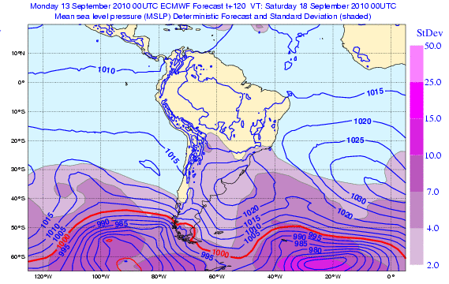

Fig. 1a: An example of the right panel chart, the MSLP forecast from the last operational T1239 run with overlaid field of the standard deviation of the MSLP from the last EPS run.

As mentioned above the spread relate to the accuracy of the EM. Their relation to the deterministic forecast is weaker and only applies when the deterministic forecast is similar to the EM. In principle the closer the deterministic forecast resembles the EM the more likely it is.

There is not necessarily a clear relation between spread and what is commonly regarded as “synoptic spread”. Two similarly looking forecast maps might display large variance differences if they contain systems with strong gradients that are slightly out of phase. On the other hand, two synoptically rather different forecast maps with weak gradients will display small differences.

The spread within the ensemble is represented on each panel, on the right simply represented as the Standard deviation (Std), on the left shown as the Normalised standard deviation (Nstd) defined as Nstd = Std/Mstd where Mstd is a Mean standard deviation, a pre-computed field which represents the mean of the standard deviations of the 30 most recent 00 UTC ECMWF ensemble forecasts. It is a function of lead time and of geographical location.

As an example, if the spread (the Std) at day 5 seems to be large, but has of late also tended to be equally large at day 5 in the same area, then the Nstd will denote a value that is close to 1. Conversely if the spread in a particular area at day 5 exceeds the spread that had recently been seen there at day 5, then the Nstd will indicate a value > 1.

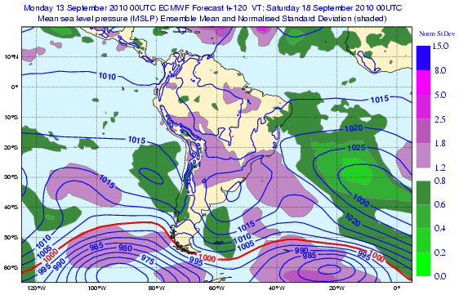

Fig. 1b: An example of the left panel with the EM of the MSLP from the last EPS run, together with the normalized standard deviation taken from the same EPS run. The purple shading indicates where the ensemble spread is larger than the average during the last 30 days, the green shading where it is less.

While relatively large spread indicates relatively high uncertainty the Nstd aims to put this spread into the context of the general ensemble behaviour, in that area, over the last 30 days.

So although the forecast for, say, MSLP on day 8 will ordinarily be a low confidence forecast, there will nonetheless be some occasions when one can be a bit more confident than 'usual', and the Nstd will tend to show this by having a value rather <1.

3.2 EPSgrams

The EPSgrams show the time evolution of the forecast distribution of several weather parameters at specific grid points. For each 6-hourly step, the forecast distributions are created using each of the 50 members of the ECMWF EPS; these are complemented by the single forecasts from the unperturbed EPS Control and the high-resolution deterministic run. The deterministic is currently run on a 16 km grid, whilst the EPS (including the control run) is currently on a 31 km grid. The data is represented in a box-and whiskers plot showing the median (short horizontal line), the 25th and 75th percentiles (wide vertical box), 10th and 90th percentiles (narrower boxes) and the minimum and maximum values (vertical lines).

When an EPSgram is created for a specific location the four surrounding EPS grid points are considered. If there is at least one land point within those four, then the nearest of those land points will be chosen; otherwise, if only sea points are available, the nearest sea point will be chosen. This situation will be noted in the EPSgram title section; if the words “EPS sea point” appear it is a sea point, if this does not appear it is a land point.

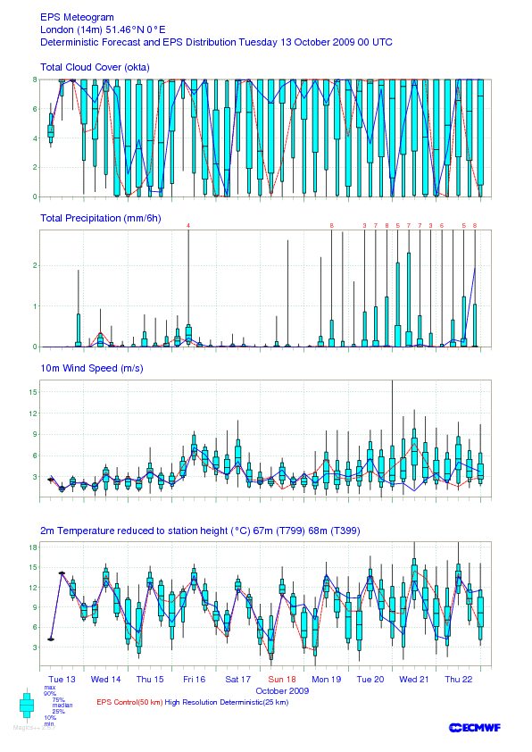
Fig 2. An EPSgram for London, UK. Note that the degree of “blueness” is not related to the most likely cloud amounts (top row).

The red dotted line represents the T639 Control forecast, the blue full line the T1279 deterministic forecast. This value is an interpolation from the four nearest grid points in this model to the location of the selected EPS grid point. In case of strong gradients along coasts or in mountainous regions the two values can differ substantially. In such circumstances it may be appropriate to give more weight to the deterministic solution.

At the top instantaneous forecasts of total cloud cover values in oktas (eighths of the sky covered by clouds). When all 50 members have either 0/8 cloudiness (clear skies) or 8/8 cloudiness (overcast) there will be no line or box at all. Note that when the forecast is very uncertain and all cloud amounts are more or less equally likely the blue columns cover the whole range, something which might give a visual impression of “overcast”..

It is followed beneath by 6-hourly accumulated precipitation (sum of convective and large scale) in millimetres, over previous six hours (0-6UTC, 6-12UTC, etc) is shown. The y-axis range is chosen separately for each meteogram, so that at least 90% of the values are covered. The y-axis range therefore commonly varies from one location to the next and, for the same location, from one forecast to the next. When the top of the distribution is beyond the scale maximum the largest 6-hourly totals are shown at the top as red numbers.

Note that probabilities for intervals longer than 6h cannot be deduced from the EPS gram (except in dry weather when all members repeatedly show no rain). Note also that because of its higher resolution the deterministic run is generally more able to generate higher precipitation amounts than the EPS/Control runs.

10m wind speed is given as instantaneous forecast mean wind speed in m/s. The peaks of the whiskers should not be interpreted as wind gusts. Again, because of its higher resolution the deterministic run is generally more able to generate stronger winds than the EPS/Control runs.

At the bottom 2m temperature instantaneous forecast values in degrees Celsius. The model orography height (shown above the temperature graph), generally different for the deterministic and EPS/control, can differ significantly from the station height (shown in the title at the top). A temperature correction is therefore applied assuming a constant lapse rate of -6.5 Celsius per 1000 m. No account is thereby taken of the fact that at night time low level sites may be colder than sites higher up.

3.3 Wave EPSgrams (currently only available for the South Pacific SWFDP)

The data are based on the resolution of both the EPS wave model (currently about 110 km) and the high resolution deterministic wave model (currently about 40 km).

10 m wind directions (“wind rose”) are divided into eight main directions or octants each covering 45° (N, NE, E, SE etc) e.g. the N-ly octant between 335.5° and 22.5°. From 50 members and four 6-hour forecast steps each day yields altogether 200 forecasts of the directions. The radius of an octant is proportional to the probability of that wind direction (i.e. to the proportion of forecasts falling in that octant). The exact probability of each octant is indicated by shading, obtained using a continuous colour scale from light to dark blue. To aid visualization the radius of each wind rose is re-scaled to match the size of the most populated octant.
.
10m wind speed (m/s) is given as the mean of the instantaneous forecast wind speed in m/s. Again, the peaks of the whiskers should not be interpreted as likely wind gusts.

The significant wave height is given by instantaneous forecast value in metres. The significant wave height is estimated from the zero-moment of the wave frequency (4 times the square root of the wave frequency). Hence it is an estimate of the mean of the highest 1/3 of the waves, corresponding with international conventions.

The mean wave direction is the mean direction of propagation of the waves, based on a weighted average of the wave spectrum. The directions shown accord with oceanographic convention, meaning that they show the direction towards which waves are propagating: e.g. zero means propagating towards the north. Note that this is opposite to the way in which the wind direction is displayed. The instantaneous distribution is shown for the 12 hour forecast, and every 24 hours after that. The distribution rose for the wave direction is created similarly to the wind direction, see a) above. Furthermore, each octant is coloured based on the distribution of significant wave height associated with each mean wave direction (see colour scale in the upper right corner).

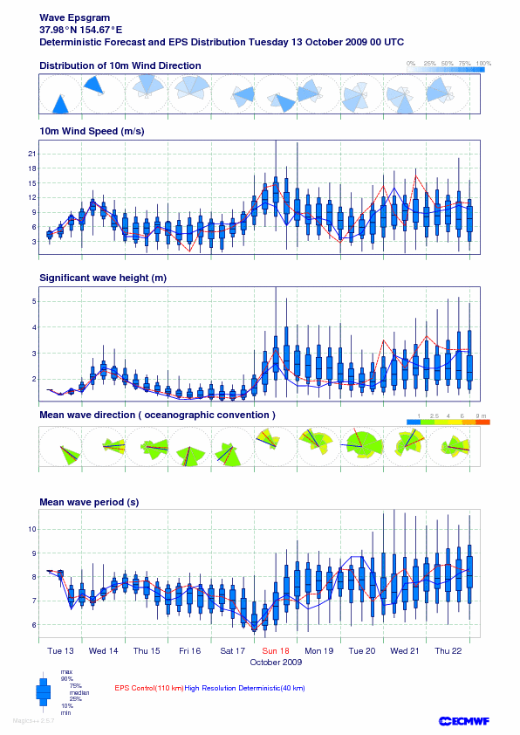
Fig 3. A wave EPSgram for a location in the NW Pacific, east of Japan. Increasing winds and waves were forecast for Sunday 19 October, due to the approach of a weakening tropical cyclone (Nepartak).

The coloured areas in each octant correspond to the fractional number of ensemble members with significant heights in each range specified by the coloured ruler. The radius segment is proportional to this number. The straight red and blue lines are the mean direction for the control and deterministic forecasts.

Mean wave period: Instantaneous forecasts in seconds. The mean period presented here corresponds to the mean period derived from the minus-one moment of the frequency wave spectrum; it is also known as the ‘energy period’. The key point for the user is that more weight is given here to the low frequency waves containing swell than to the high frequency waves.

3.4 Probability maps

Probability maps are available for precipitation exceeding certain thresholds per 24h, and for wind gusts exceeding certain thresholds at some time within 24 h periods, and for instantaneous mean winds exceeding certain thresholds at specific time.

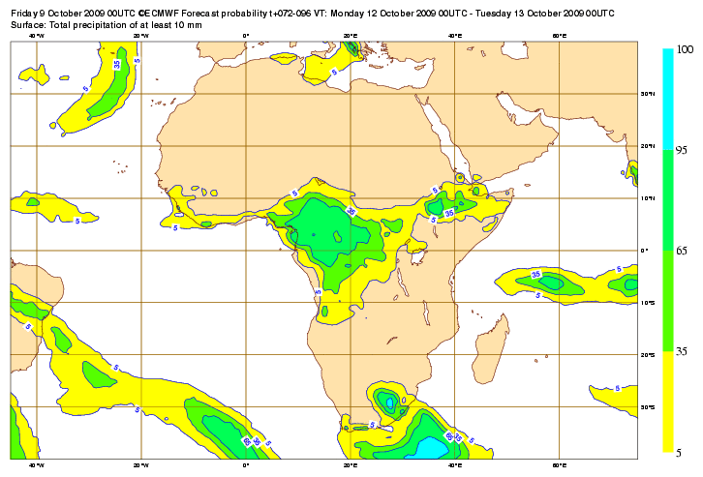
Fig. 4: Probability of precipitation of 10 mm/24h or more during Monday 12 October according to the EPS forecast from DT 00UTC Friday 9 October.

Precipitation probabilities refer to time intervals partly because the values themselves are originally computed as accumulated values over some shorter time interval. The reason why probabilities for extreme wind gusts have been computed as probabilities over 24 hours is because it is seen to be more important to know that an extreme wind gust might occur than to know exactly when.

3.5 The Extreme Forecast Index

The Extreme Forecast Index (EFI) aims to condense probability information, in particular the degree to which the forecast EPS distribution is anomalous or “unusual” compared to the model climate (M-climate) distribution - for the chosen location, for the chosen time of year and for the chosen lead time. The EFI aims to reflect that a 30% probability of >20 mm in 24 hours would be “unusual” in Egypt, but not in Ireland. The choice of reference climate (M-Climate) has been made to take proper account of the limitations of using an imperfect model. The EFI index is particularly useful in areas where the ECMWF model climate is less realistic, such as in the tropics. Note also that as the M-climate is function of lead time, model drift is also correctly accounted for.

The EFI is mathematically derived from a cumulative distribution function (CDFs). Using the rank on the y-axis, it is easy to see the median (rank=50%) and any other percentiles. The EFI relates to the area between two CDF curves, one for the M-Climate, the other for the current EPS distribution (see Figure 5).

Fig. 5: A schematic explanation of the principle behind the Extreme Forecast Index, measured by the area between the Cumulative Distribution Functions (CDFs) of the M-Climate and the 50 EPS members. In this case EFI > 0 (probabilities higher than normal for warmer anomalies). Had the red line been predominantly to the left of the blue line, the EFI would have taken a negative value (probabilities higher than normal for cold anomalies).

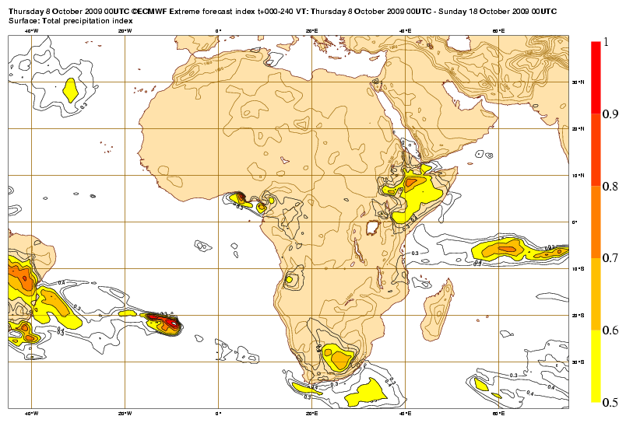
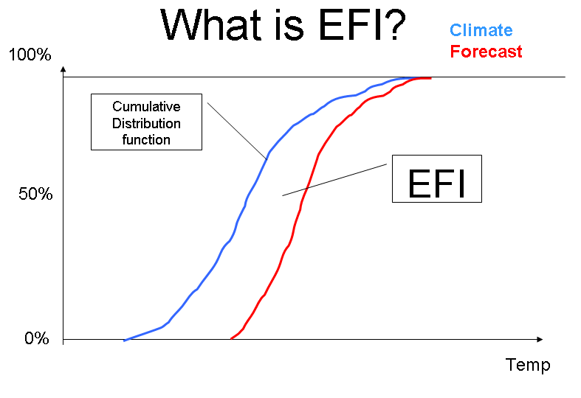
The EFI can in principal take values between -1, when all EPS members forecast values that are below the minimum seen in the M-climate, and +1, when all forecasts are above the maximum seen in the M-climate. The EFI values do not represent probabilities as such (although higher EFI values do of course indicate that an extreme event is more likely than usual).

Fig.6 The Extreme Forecast Index for precipitation calculated for the ten-day period 8-18 October 2009. Areas that might experience abnormally high precipitation amounts during this period are evidently east Brazil, parts of south and equatorial Africa. To be able to find out more precisely when anomalous precipitation event(s) are likely to take place the forecaster must consult EFI maps for the shorter 1 or 5 day periods.

Absence of rain or complete calm may be regarded as “unusual” at some locations, but no account is taken of that in the EFI, i.e. EFI is only shown for the wet and windy extremes for these parameters. However, since low temperatures are of equal interest to high temperatures both these are covered by the EFI.

Although giving concrete guidelines regarding the interpretation of specific EFI values is very difficult, experience suggests that 0.5-0.9 can generally be regarded as signifying that “unusual” weather is likely, and values above 0.9 as generally signifying that “very unusual” or extreme weather is likely.
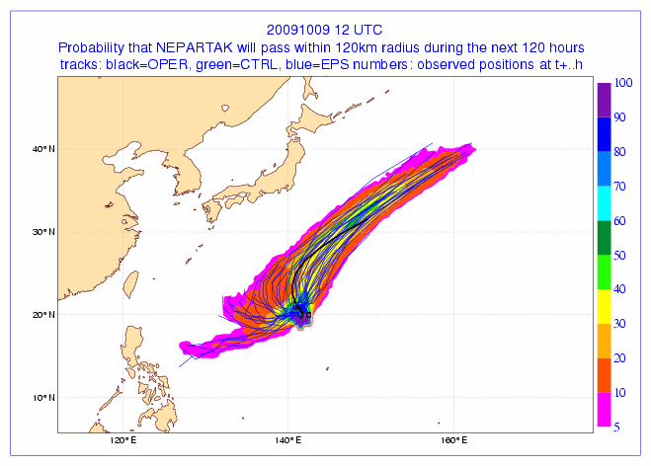
3.6 Tropical Cyclone tracks

a) Cyclone position: Once official reports signify the existence of a tropical cyclone it is automatically tracked, both in the deterministic and the EPS forecasts by searching for MSLP and 850 hPa vorticity extremes around the first guess position. In some circumstances the thickness maximum, the central mean sea level pressure and the orography are also considered in the evaluation.

b) Strike probability chart: The strike probability is defined as the proportion of EPS members that predicts the tropical cyclone will pass within a 120 km radius of a given location at any time during the next 120 hours. In other words, the time dimension is eliminated. A 40% probability means that within a circular area of 120 km there are cyclone centres from 20 members, not necessarily for the same verifying time.

Figure 7: The strike probability chart for tropical cyclone Nepartak from the DT 12 UTC 9 October 2009 forecast. Tracks from individual members are shown as blue lines, from the control run in green and from the deterministic model in black. In previous runs around 50% of the ensemble indicated that Nepartak would approach the Philippines; in this run evidently only a handful of members were predicting this outcome.

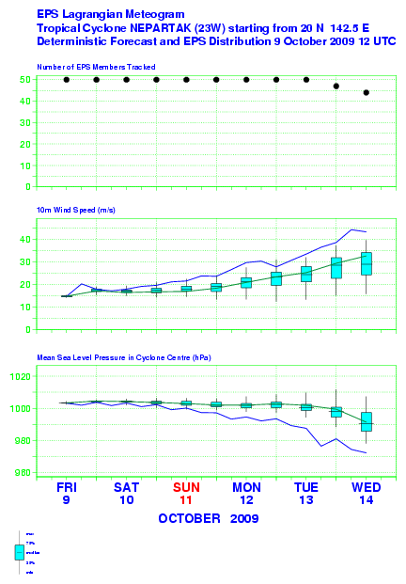
The Lagrangian meteogram contains time series of central pressure, and of the 10m wind speed maximum predicted within a 7x7 degree lat-long box centred on the cyclone and following its motion in each forecast member. Symbols used are similar to those used on the EPSgrams. In a special display the number of EPS members which contain the tropical cyclone is also presented at the top; the other parameters need to be interpreted with this number in mind. Work is under way to extend the system also to include potential tropical cyclones, i.e. cyclones whose genesis has been forecast but which have not yet come into existence.

Figure 8: Lagrangian meteogram for tropical cyclone Nepartak form the same EPS forecast as in Fig 7. Only by days 5 and 6 are there any members in which the tropical cyclone was no longer detectable (top panel). Due to its higher horizontal resolution the operational forecast (blue line) has higher wind speeds and a lower central pressure than the EPS system.

4. The use of the EPS in combination with deterministic forecasts

The problem of combining deterministic numerical forecasts with ensemble forecasts has attracted attention over the years. Here we provide some guidelines on how the forecaster might address the task of ‘combination’. Since the spread of the ensemble is linked not only to the possible errors, but also forecast “jumpiness” a natural approach would be to compare the latest EPS not only with the last deterministic forecast, but also the 2-3, perhaps 4, proceeding deterministic runs. The EPS probabilities should then be modified towards the deterministic “mini-ensemble” forecast information.

In case the deterministic and ensemble information agree, with the latter having small spread, this is the “ideal” but rare situation, but the forecaster must still be careful to not over-interpret details in the deterministic forecasts which might still not be predictable.

A more common situation is that the last 2-3 deterministic forecasts are “jumpy” and the ensemble has large spread, but they broadly agree: The last deterministic forecast might not be as accurate as normal and the forecaster is advised to follow either one of the previous deterministic forecasts leaving non-predictable details to be formulated as probabilities, or preferably the EM.

It may happen that the last 2-3 deterministic forecasts are consistent, but the ensemble system shows large spread: If the EM agrees with the deterministic forecasts, a rather confident deterministic forecast can be issued, although with less due consideration not to over interpret details.

In the rare situation that the deterministic forecasts are not in line with the ensemble information, the forecaster is in a precarious situation and it is difficult to define any clear rules. If the divergence is due to the representation of complex terrain (topography or coasts) the deterministic should be more relied on.

In case the last 2-3 deterministic forecasts are very inconsistent (“jumpy”) whereas the ensemble has small spread: Clearly the ensemble system in this case has underestimated the high sensitivity of the atmospheric flow to initial conditions. The last deterministic forecasts should be regarded as extra members, given a weight equivalent to (for example) 50-60 extra members.

The EPS is a relatively new system. There are still unresolved issues and challenges to meet: the perturbation techniques can be further developed, the resolution can be improved, the effects of physical processes involving moisture might demand new approaches etc. For the foreseeable future the forecaster will need to incorporate information from other sources, from observations, from the deterministic models and from their own experience when formulating their forecast.

Appendix: The advantage of probability forecasting

Imagine a location where it rains 3 days out of 10. The local forecast offices issues forecasts with the same frequency, 30% for rain, 70% for dry conditions. Assume their overall performance is reflected in this contingency table:

 | Obs rain | Obs dry
Fcst  rain | 2 | 1
Fcst dry | 1 | 6

Two users, A and B, of these forecasts both suffer 100 units (in their currency) if rain occurs and they have not taken action to protect themselves (their crops or their goods). But whereas A only have to pay 15 units to protect himself, B has to pay 60 units. Thanks to his low protection cost A protects every day which costs him 150 units over a 10-day period. B on the other hand has chosen never to protect due to the high cost and suffers a loss of 300 units over the same period.

However, taking advice from the local forecast office over a typical 10-day period A lowers his loss to 145 units and B to 280 units, both protecting 3 times and being caught out unprotected only 1 time.
The local forecast office now offers A and B a surprising special service to lower their cost: it will only issue rain or no-rain forecast when the forecast is absolute certain. If it is not a “50-50-forecast” will be issued. Assume this happens about 4 times during a typical ten-day period.

 | Obs rain | Obs dry
Fcst rain | 1 | 0
?? | 2 | 2
Fcst dry | 0 | 5

This does not look very impressive, rather the opposite, but paradoxically both A and B benefit highly from this special service. User A drastically lowers his cost to 75 units, and B to 260 units.

The reason is that A and B are now free to interpret the 50-50-forecast in their own ways. Since A has low protection cost, he can afford to interpret the 50-50-forecast as if it could rain and take protective action. B on the other hand, having expensive protection, prefers to interpret the 50-50-forecast as if there will be no rain.

But the forecasters can go further. They might on half of the 50-50% occasions be slightly more certain, on half less certain. The former can be labelled 70%-occasions, the latter 30%-occasions. Doing so, they have introduced proper probabilities as a measure of their confidence.

The forecast office can further refine its service. On some of the 70% occasions they might be more certain; then these can be labelled 80%-occasions, in case they feel less certain can be labelled 60% occasions. In the same way the 30%-occasions can be divided into 20% and 40% occasions.

Over a 100-day period the hit and miss table might look like this where the cases of uncertain forecasts have been grouped after the degree of uncertainty (or certainty). :

 | Obs rain | Obs dry
100% | 10 | 0
80% | 8 | 2
60% | 6 | 4
40% | 4 | 6
20% | 2 | 8
0% | 0 | 20

This will allow other users, with other protection costs to benefit from the forecast service. As a general rule protective action should be taken if the forecast probability exceeds someone’s cost/loss ration. So someone with a cost of 30 units should take action when > 30% is forecast, someone with cost 75 units, when >75% is forecast.

So what might appear as a less “brave” categorical forecast might indeed prove to be a more valuable for the users!

Probability density functions, or “pdf’s”, are the derivative of the CDF with respect to the parameter.

