WORLD METEOROLOGICAL ORGANIZATION  COMMISSION FOR BASIC SYSTEMS  OPAG on DPFS  RAI-SWFDP – Eastern Africa  NWP/Web Developers Workshop  Nairobi, Kenya, 14 – 16 March 2012 |  | DPFS/RAI-EA-SWFDP-NWP/WEB/Doc. 3.2  (12.III.2012)  _______  Agenda item : 3.2  ENGLISH ONLY

(REVIEW THE PROJECT WEB SITES AND PORTAL)

(Submitted by Tanzania Meteorological Agency, TMA)

Summary and purpose of document

This document explains the progress in developing the project WebPortal for Lake Victoria Basin forecasting Guidance (http://www.meteo.go.tz/severe) at Regional Forecasting Support Centre (RFSC-Dar es Salaam) which is linked to RSMC-Nairobi. This information will be considered as an input on preparation strategy for further development of the SWFDP – Eastern Africa WebPortal.

Action Proposed

The meeting is invited to consider the review of project web portal and discuss the following proposal concerning the content, management and IT aspects for Lake Victoria Basin.

Annex(es): Appendix 1. Discussion of the Global and regional systems.
Appendix 2 Risk Table generated from the day one and day two forecast guidance. …….

Reference(s): -N/A

1 Introduction

In the Severe Weather Forecasting Demonstration Project for Eastern Africa, TMA has been assisting RSMC Nairobi severe weather forecasting guidance for the Lake Victoria Basin. The project is focusing on a specific component addressing severe weather forecasting and warning services over the Lake Victoria, marine meteorological aspects for the safety and protection of fishers through the password protected webportal below with Username: swfdp and password: swfdp1 for SWFDP-EA for NMHs over the region.

2 Webportal Homepage (http://www.meteo.go.tz/severe)

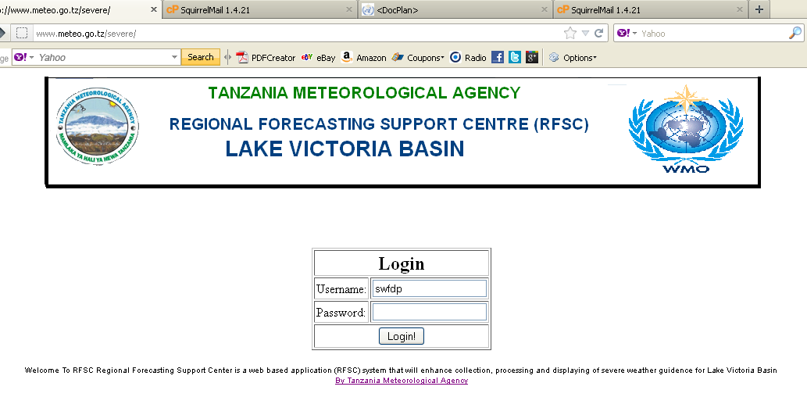
The interface after login is as shown below where map for NWP products from UKMET office and TMA, forecast guidance for day 1 and day2, verification for day 2 and Tropical Rainfall Measuring Mission (TRMM); risk table, discussion and real time satellite imagery. Current no RADAR data and agrometeorological information are available.
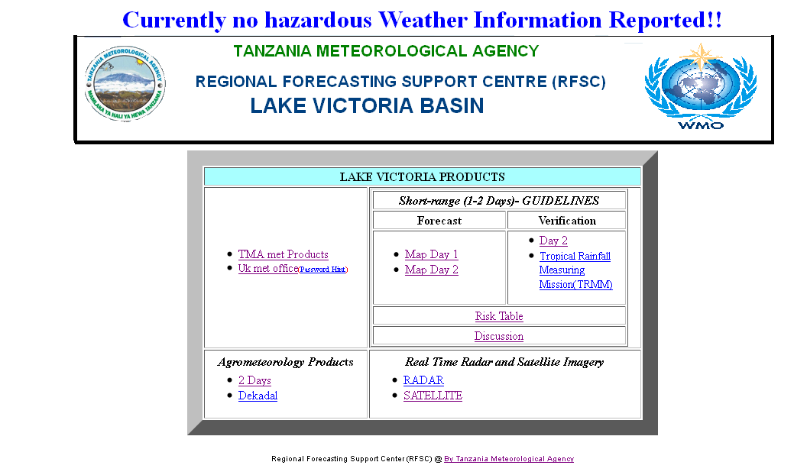

3 Discussion
Physical conditions supporting the severe weather forecasting for day one and day two are discussed incorporating the confidence as guidance for forecasters to develop warning for their respective countries (See Appendix 1).

4 Forecast Guidance

Currently, the forecast guidance are issued for heavy rain (50mm/day), strong surface wind (20kts or above) and large waves (2m or above).
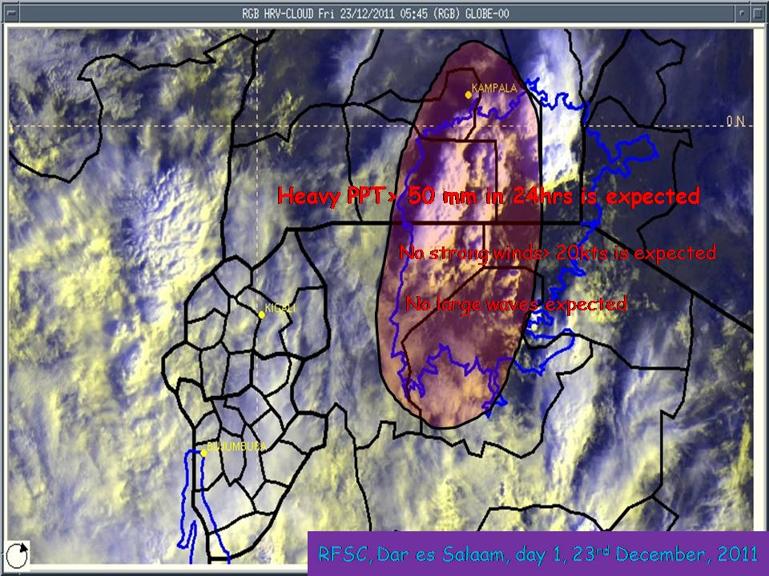 | 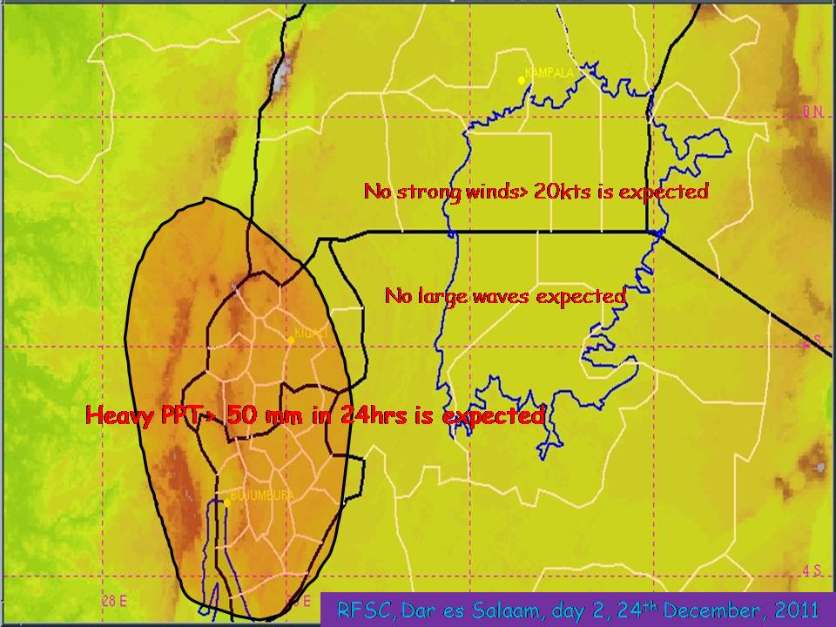
RFSC, Dar es Salaam, Day 1, 23rd December 2011 | RFSC, Dar es Salaam, Day 2, 24th December 2011

4 Risk Table
Risk Table is for the regions along the Lake Victoria Basin with detailed information of the geographical location (Appendix 2) of the severe weather events for Lake Victoria Basin, B ─ Burundi, K ─ Lake Victoria Basin part of Kenya (Nyanza.), R ─ Rwanda, T E ─ Eastern side of Lake Victoria Basin part of Tanzania (Mara region), T W ─ Western side of Lake Victoria Basin part of Tanzania (Kagera region), T S ─ Southern side of Lake Victoria Basin part of Tanzania (Mwanza region), UW ─ Western side of Lake Victoria Basin part of Uganda (Sese islands, Rakai, Masaka, Mbarara Provinces etc) and UN ─ Northern side of Lake Victoria Basin part of Uganda (Iganga, Jinja, Mpigi Provinces etc).

5 Verification
On the webportal products, verification against observations of day 2 forecast guidance is displayed. However, there is a challenge of severe weather event observations exchange between the member states within the Lake Victoria Basin. Unfortunately, there is no verification against observations for large waves for the lake Victoria Basin.
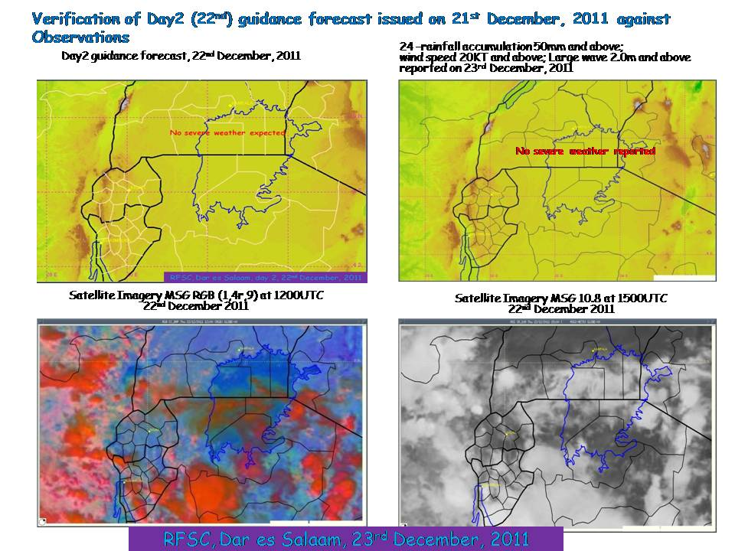

Annex(es): Appendix 1: Discussion of the Global and regional systems.

RFSC-TANZANIA
LAKE VICTORIA FORECAST GUIDANCE PRODUCTS

SHORT-RANGE (DAY 1 AND DAY 2)

Issue Date: Friday 23rd December, 2011

Valid for: 23rd and 24th December, 2011

Day 1, Friday 23rd December, 2011

Global and regional models show low level south-westerly flow converging with south-easterly flow over the southern part of the Lake Victoria towards the centre and to the northern parts where they converge with northerly to north-easterly flow. Levels of moisture as well as instability indices show possibility of heavy precipitation over the area. But no strong winds or large waves expected over the region.

Degree of confidence: High.

Day 2, Saturday 24th December, 2011

Convergence zone shifts towards Burundi and Rwanda areas where there is south-easterly flow converge with south-westerly. So, heavy precipitation exceeding 50mm in 24 hours is likely in this region. Again no strong winds and large lake waves are expected over the Lake Victoria basin.

Degree of confidence: Moderate.

DISCUSSION OF GUIDANCE PRODUCTS FROM GLOBAL AND REGIONAL CENTRES.

Regional and Global models are in agreement.

Forecaster: Abubakar Lungo

Appendix 2: Risk Table generated from the day one and day two forecast guidance

RFSC-TANZANIA
LAKE VICTORIA FORECAST GUIDANCE PRODUCTS
RISK TABLES

SHORT-RANGE (DAY 1 AND DAY 2)

Issue Date: Friday 23rd December, 2011

This risk table is for the regions along the lake Victoria Basin. The following key has been adopted for presentation of the geographical location of the severe weather events.

B ─ Burundi
K ─ Lake Victoria Basin part of Kenya (Nyanza.)
R ─ Rwanda
T E ─ Eastern side of Lake Victoria Basin part of Tanzania (Mara region)
T W ─ Western side of Lake Victoria Basin part of Tanzania (Kagera region)
T S ─ Southern side of Lake Victoria Basin part of Tanzania (Mwanza region)
UW ─ Western side of Lake Victoria Basin part of Uganda (Sese islands, Rakai, Masaka, Mbarara Provinces etc)
UN ─ Northern side of Lake Victoria Basin part of Uganda (Iganga, Jinja, Mpigi Provinces etc)

Day 1: Friday 23rd December, 2011

COUNTRY | HEAVY RAIN |  |  |  | STRONG WINDS |  |  |  | LARGE WAVES
COUNTRY | RISK |  |  |  | RISK |  |  |  | RISK
COUNTRY | No | Low | Medium | High | No | Low | Medium | High | No | Low | Medium | High
BURUNDI | X |  |  |  | X |  |  |  | X
KENYA | X |  |  |  | X |  |  |  | X
RWANDA | X |  |  |  | X |  |  |  | X
TANZANIA |  | TS, TW |  |  | X |  |  |  | X
UGANDA |  |  | UN, UW |  | X |  |  |  | X

Day 2: Saturday 24th December, 2011

COUNTRY | HEAVY RAIN |  |  |  | STRONG WINDS |  |  |  | LARGE WAVES
COUNTRY | RISK |  |  |  | RISK |  |  |  | RISK
COUNTRY | No | Low | Medium | High | No | Low | Medium | High | No | Low | Medium | High
BURUNDI |  |  | B |  | X |  |  |  | X
KENYA | X |  |  |  | X |  |  |  | X
RWANDA |  |  | R |  | X |  |  |  | X
TANZANIA | X |  |  |  | X |  |  |  | X
UGANDA | X |  |  |  | X |  |  |  | X

