WORLD METEOROLOGICAL ORGANIZATION  COMMISSION FOR BASIC SYSTEMS  OPAG on DPFS  RAI-SWFDP – Eastern Africa  NWP/Web Developers’ Workshop  Nairobi, Kenya, 9-11 May 2011 |  | DPFS/RAI-EA-SWFDP-NWP/WEB/Doc. 5.1(2)  (28.IV.2011)  _______  ENGLISH ONLY

Review of the SWFDP South Pacific Islands’ Web site and Portal

(Submitted by the Secretariat)

Summary and purpose of document

This document provides an overview of content and management of the SWFDP South Pacific Islands’ Web site and Portal, including the South Pacific Guidance Charts.

Action Proposed

The meeting is invited to consider this information when preparing a strategy for developing an SWFDP – Eastern Africa Web site and Portal.

MetConnect Pacific – the SWFDP for South Pacific Islands Web site (http://swfddp.metservice.com/)

Each participating country was assigned its own username/password for accessing the website.

MetConnect Pacific is pivotal to the Cascading Forecasting Process whereby information is passed along a two-way chain from the Global Centres to RSMCs to NMHSs and eventually to emergency management authorities and the mass media.

The landing page on MetConnect Pacific is the RSMC Wellington page containing the manually generated South Pacific Guidance charts which interpreted the vast array of Ensemble/NWP guidance for the benefit of the NMHS forecasters.

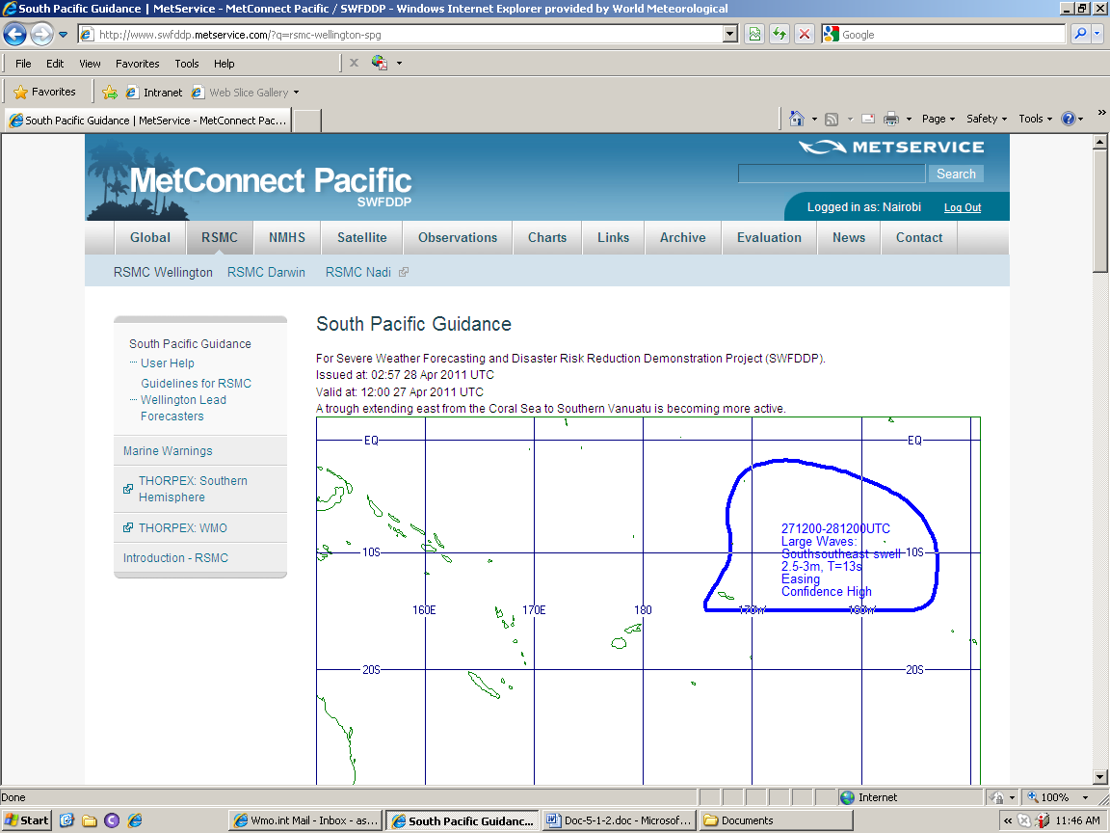

The Project website is remotely hosted on Amazon Cloud (multi-location server in the USA) with a secure link between the MetService ICE database (store for the Project data) and Amazon Cloud. Project data is received via ordinary links or special Ensemble or NWP images FTPed as PNG files e.g. UKMO and RSMC Darwin.

The layout of the live buttons on the website banner has endeavoured to reflect the Cascading Forecasting Process – “Global”, “RSMC” and “NMHS” running from left to right. The UKMO has provided a set of EPS meteograms, MOGREPS/MOGREPS-15 wind/precipitation probability charts out to 6 days and TC ensemble images. ECMWF have setup a special area on their website for SWFDP-South Pacific Islands tailor-made data. RSMC Darwin also provides a set of images from its regional area model.

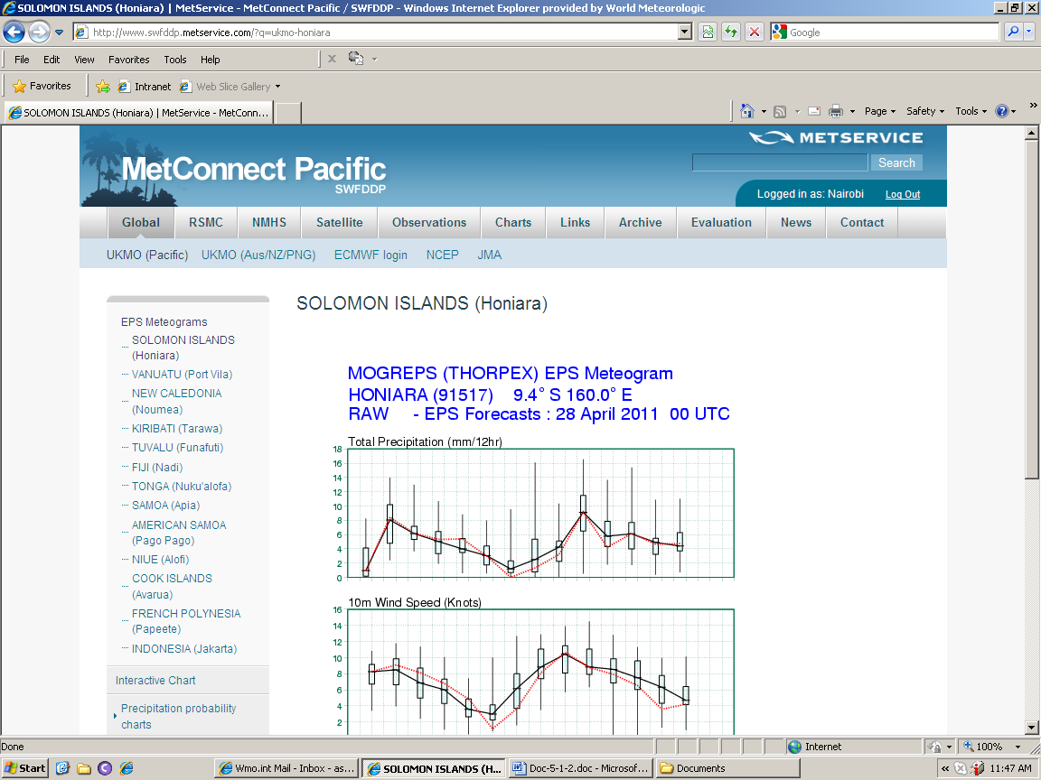

The “Satellite” button opens up the access to satellite imagery (water vapour, IR, and visible)

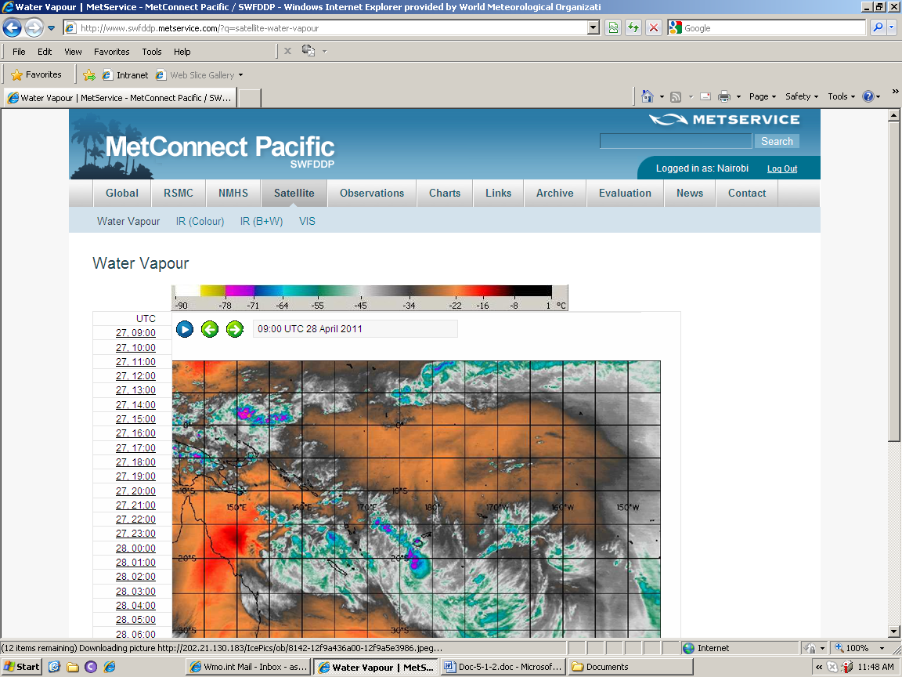

The “Observations” button is under development. It will include “Metars”, “Synops”, and “Upper Air” messages at the stations within the project footprint.
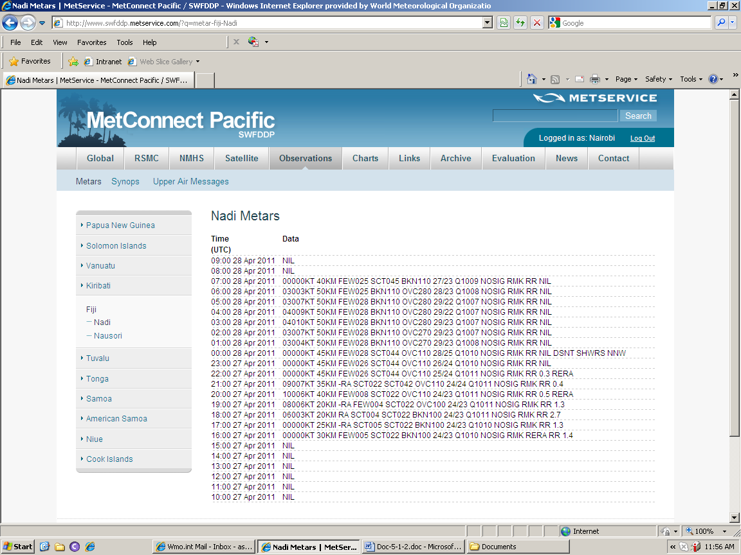

The “Charts” button provides access to synoptic charts covering the project footprint.

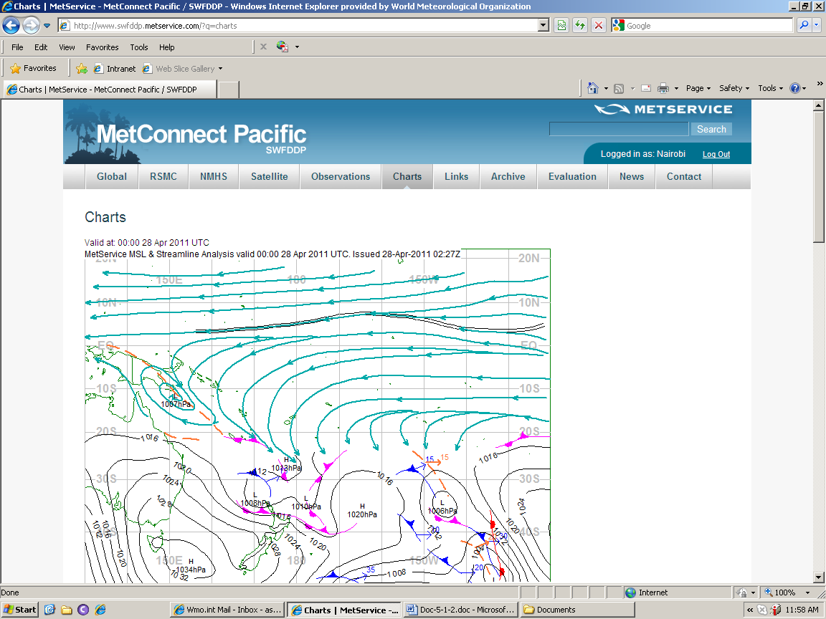

The “Links” button provides access to relevant Web links to Tropical Cyclones, rainfall estimation, and satellite related matters, and miscellaneous.

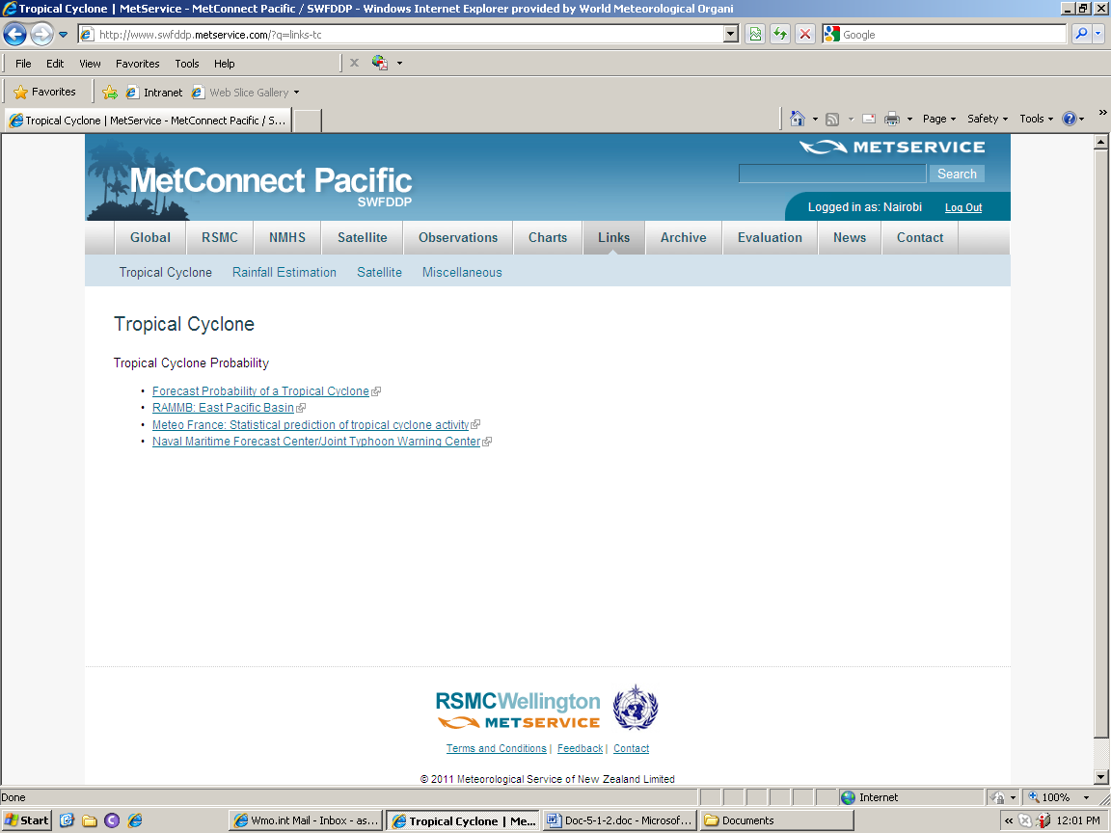

The “Archive” button opens up a page of instructions of what data is archived and how it might be requested.

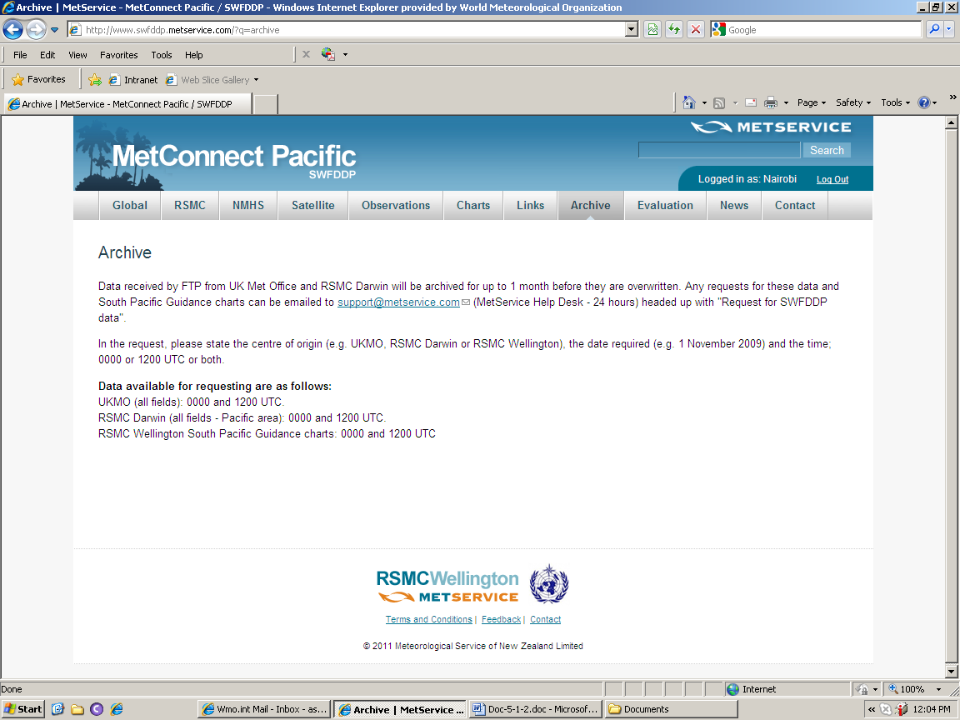

The “Evaluation” button allows users to download the document “Annex H” (Evaluation Form) and Annex I (Format for the regular Progress Reports to be submitted by participating NMHSs at four-monthly intervals) of the Regional Subproject Implementation Plan.

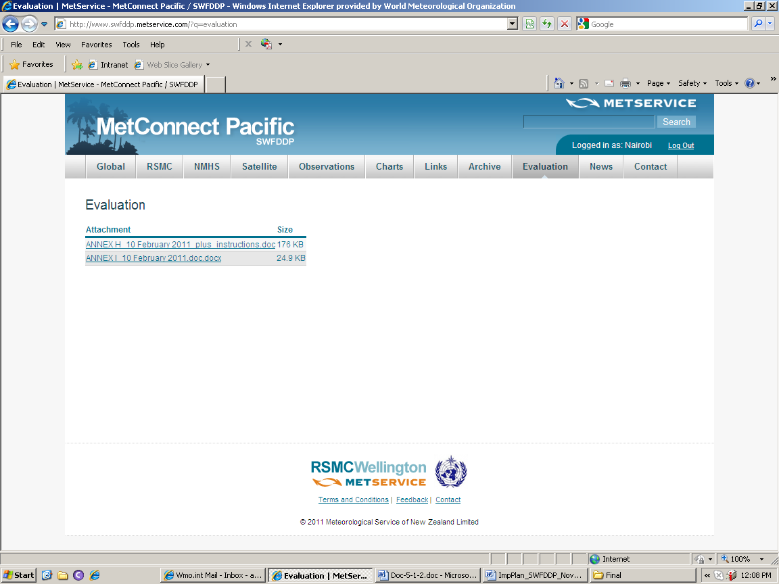

The ‘News’ page posts messages from time to time whenever there are any changes to MetConnect Pacific or to do with the SWFDP-South Pacific Islands that might be of interest to users.

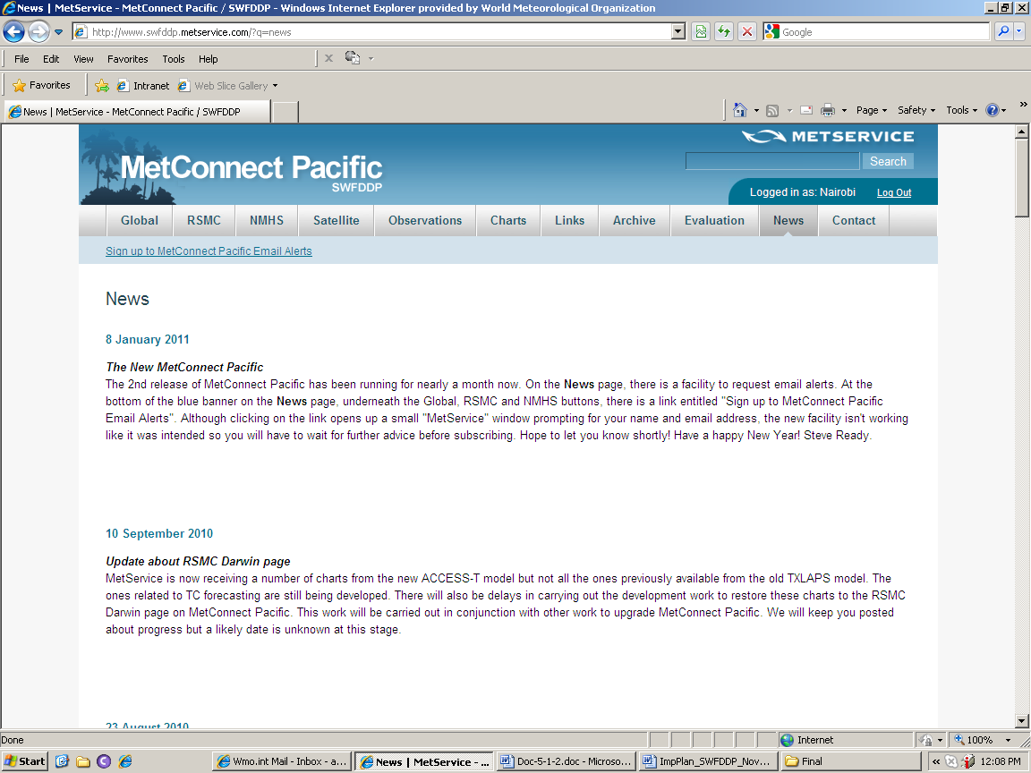

The ‘Contact’ button reveals a whole set of contacts.

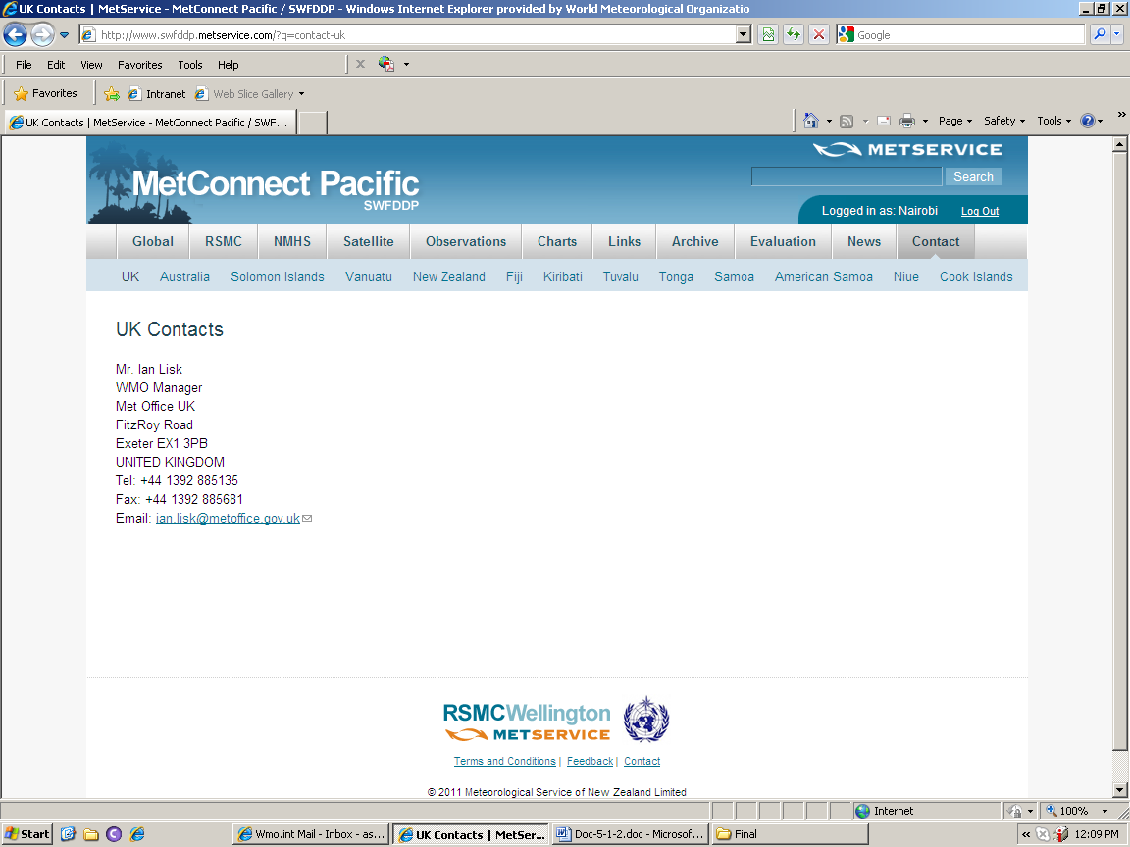

South Pacific Guidance Charts

RSMC Wellington forecasters generate five South Pacific Guidance (SPG) charts around 03:00 and 15:00 UTC every day containing an interpretation of the global and regional guidance out to 5 days. Information is included on the charts whenever the following criteria are met - rain ≥ 100mm/24hrs; winds ≥ 30 knots; and waves ≥ 2.5m north of 15S and ≥ 3.5m at and south of 15S; and Tropical Cyclone (whether one exists or is expected to form). If none of the criteria are satisfied for any of the phenomena, the chart would display ‘NilSig’. By and large, the criteria used for the RA I SWFDP – Southern Africa have been followed. However, waves were an addition and the threshold was negotiated amongst NMHSs participating in the Pilot Phase. For all phenomena expect tropical cyclones, a forecasters’ expression of confidence is given by one of these words: Low (1 chance in 5), moderate (2 chances in 5) and high (3 chances in 5).

The chart example given below was produced for the 24 hours from 1200 UTC on 11 February to 1200 UTC on 12 February 2010. It represents the full range of phenomena that could be depicted on a chart at one time.

RSMC Wellington forecasters can take up to an hour to produce a set of five charts. There is such a huge amount of information to wade through so they have become very discerning about what is essential to scrutinise and what can be considered if time permits. With additional data waiting in the pipeline, a way needs to be found to assimilate the increasing amounts of data without being swamped.



