WORLD METEOROLOGICAL ORGANIZATION  COMMISSION FOR BASIC SYSTEMS  OPAG on DPFS  RAI-SWFDP – Eastern Africa  NWP/Web Developers’ Workshop  Nairobi, Kenya, 9-11 May 2011 |  | DPFS/RAI-EA-SWFDP-NWP/WEB/Doc. 5.1(1)  (3.V.2011)  _______  ENGLISH ONLY

Review of the SWFDP Southern Africa Web site and Portal

(Submitted by Ezekiel K. Sebego, SA Weather Service)

Summary and purpose of document

This document provides an overview of content and management of the SWFDP Southern Africa Web site and Portal.

Action Proposed

The meeting is invited to consider this information when preparing a strategy for developing an SWFDP – Eastern Africa Web site and Portal.

(http://www.weathersa.co.za/RSMC) – the SWFDP for Southern Africa Web site)

Username= SWFDP
Password= RA1

All countries in the region are using the same login details for accessing the SWFDP Southern Africa website.

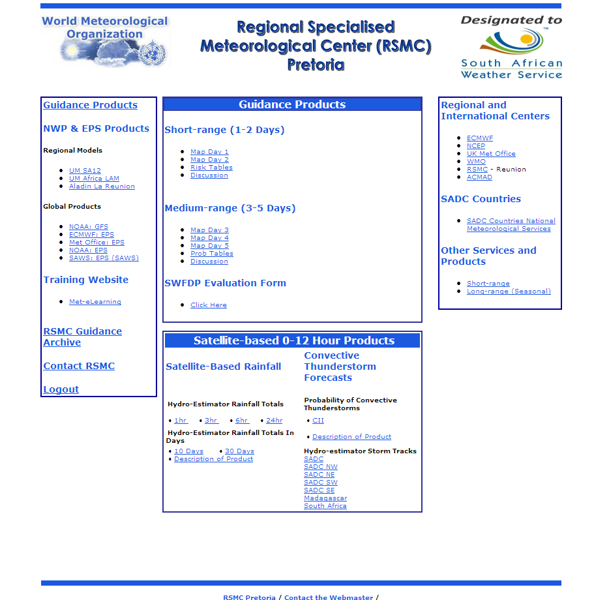
Homepage of the SWFDP Southern Africa

The Project website is hosted at the South African Weather Service (SAWS) headquarters in Pretoria.

The homepage of the SWFDP Southern Africa contains links to

1. NWP and EPS products from global as well as regional centres
2. manually-generated guidance maps for the region
3. Satellite-based observational products for the region
4. Archive of all the guidance products issued, dating back to more than 12 months
5. Contact details for the international centers, regional centers (eg, RSMC La Reunion) as well as the NMHS in the region

The functioning of the SWFDP takes a cascading approach, one in which

- the global NWP centers provide the available NWP/EPS products
- regional centres then interpret the information received from global centers, run limited area models to fine the products
- Issue guidance forecasts products daily to the local NMHS’s
- NMHS’s issue advisories, watches and warnings to the Disaster Management Authorities
- Feedback from NMHS’s to regional and global centers also forms an important part of the project.

List of NWP/EPS products available to this project

- From regional Centers

- UM SA 12 by SAWS (RSMC Pretoria)

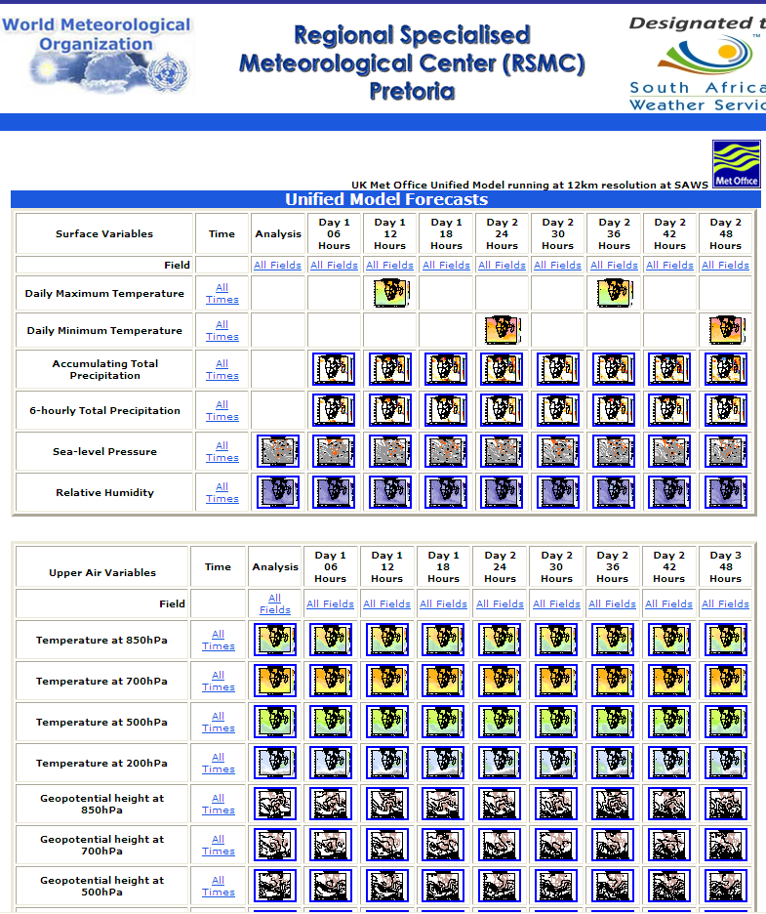
2. Aladin by RSMC La Reunion

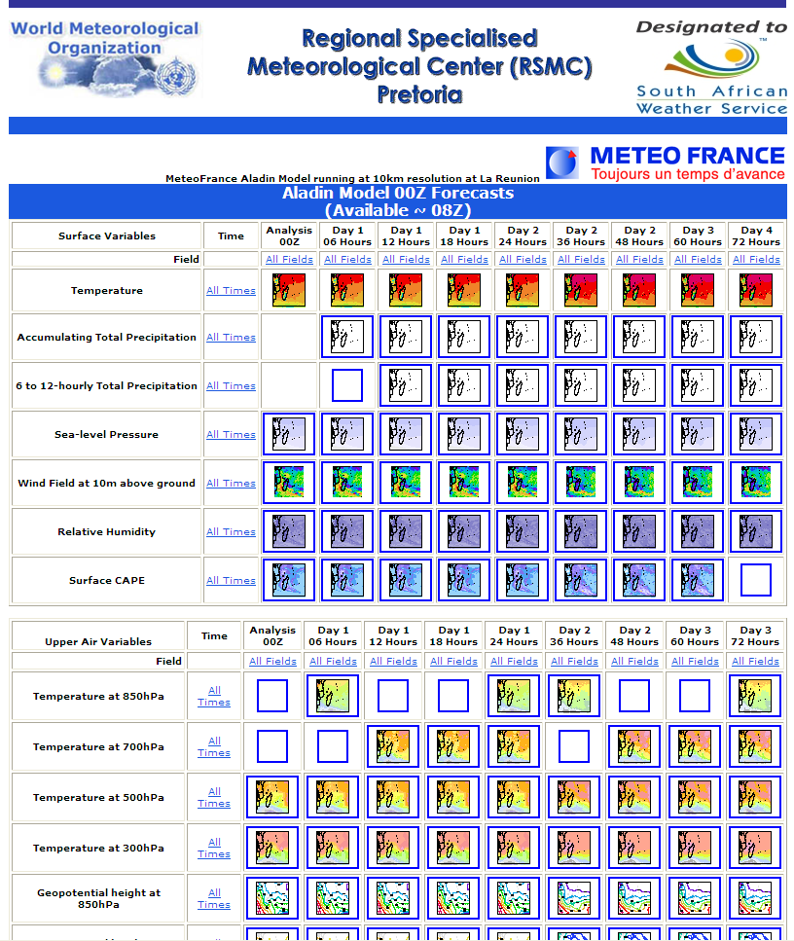

  - SAWS EPS

SAWS EPS uses information from NCEP (USA)

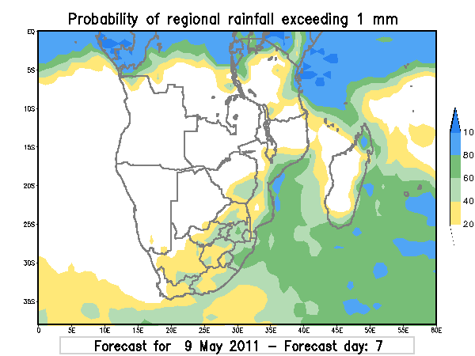
Example of EPS products produced at RSMC Pretoria (SAWS)

- From Global Centers

- NOAA GFS+EPS

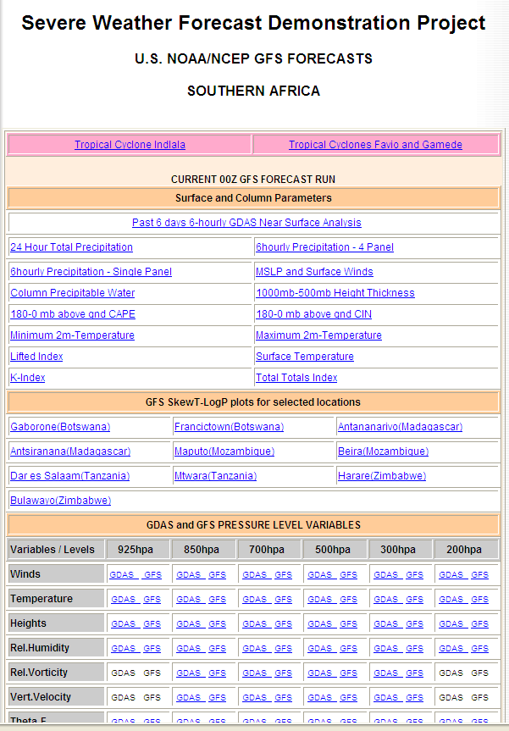

- UKMO Africa LAM + EPS

Note: UKMO Africa LAM’s domain has recently been changed to 15S and northwards (now out of SA SWFDP) and operates at a higher resolution. SADC region will receive UM grib files from RSMC Pretoria.
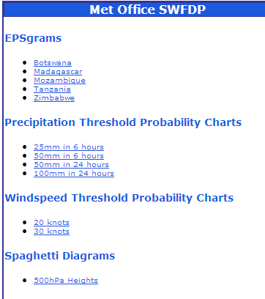
EPS products available from UKMO for the SWFDP Southern Africa

3. ECMWF NWP+EPS

Both deterministic and probabilistic products from ECMWF are available on a ‘micro-site’ (http://www.ecmwf.int/products/forecasts/d/charts/medium/special/swdfp/)
dedicated to the SWFDP Southern Africa within the ECMWF website. This ‘micro-site’ is password-protected and all countries in the regions have access to it. Further products from ECMWF are available through a channel arranged with WMO. Products from ECMWF include new ones like Extreme Forecast Index (EFI), EPSgrams as well as wave products.

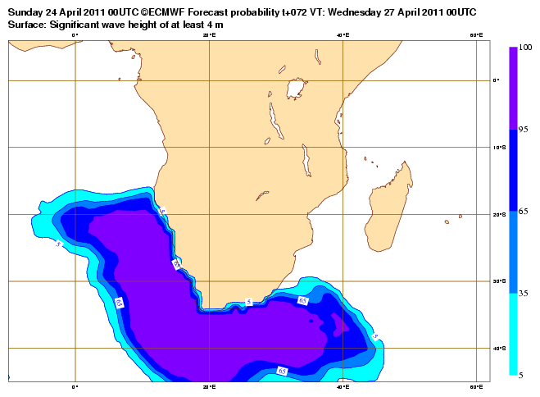
ECMWF Wave probability forecast produt
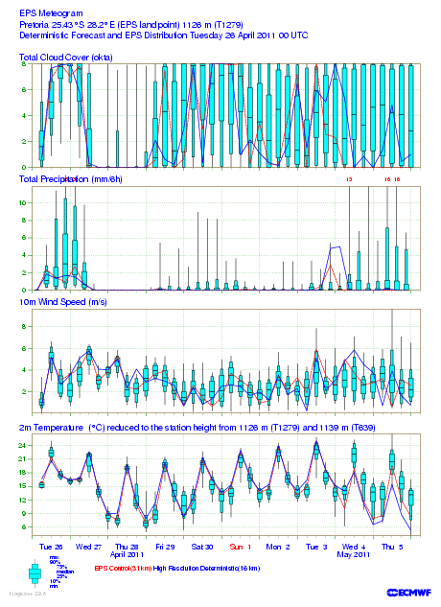

List of Guidance products issued on this project

The main elements being forecasted in SWFDP Southern Africa are precipitation, wind and waves. The thresholds which are being used for this project are outlined in annexure 1. These thresholds were adopted from the pre-existing ones being used at the South African Weather Service and the participating NMHs’s could still stick to their own local thresholds.

Guidance products are prepared daily for the next five days for the entire Southern Africa region as follows:

- Five maps (one for each of the next five days) are produced indicating areas where a weather hazard is expected to exceed the agreed threshold.

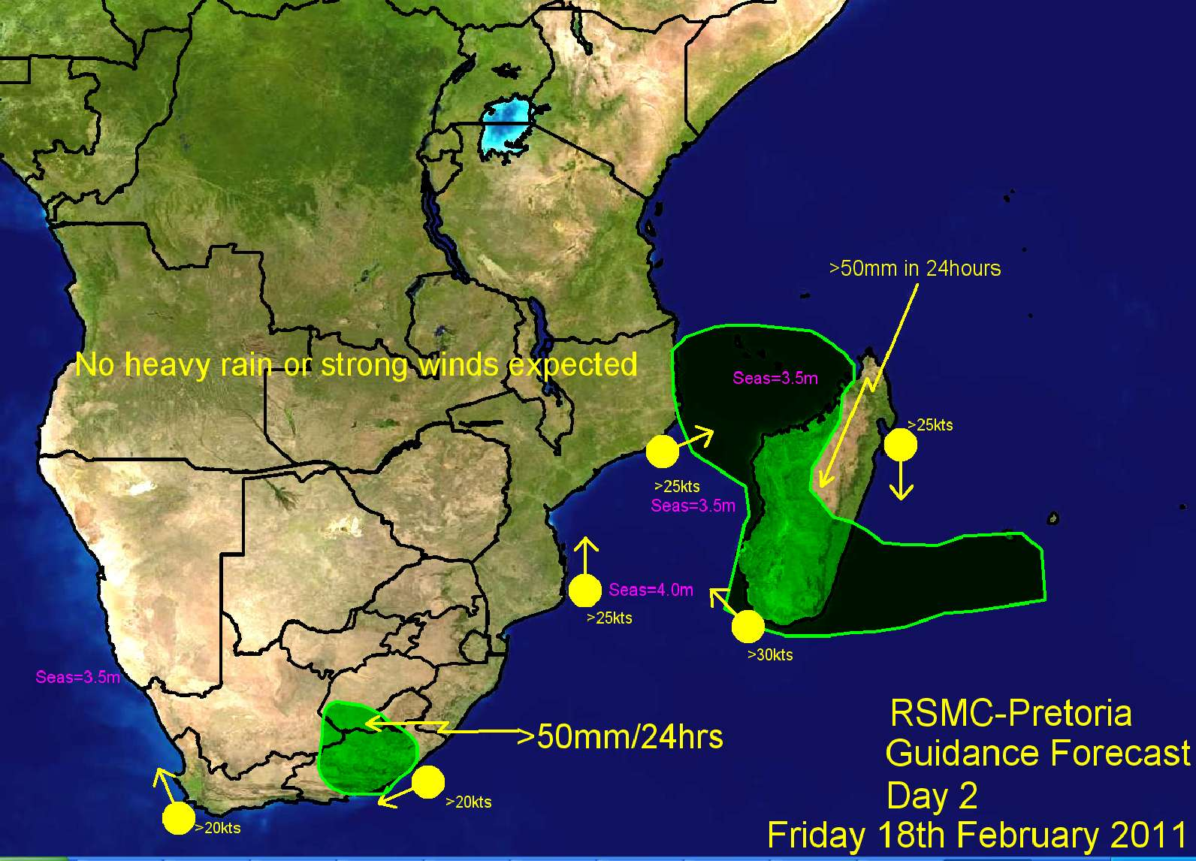
An example of a guidance map as issued by RSMC

- A text weather discussion is produced daily for the short-term (days 1 and 2) and another one for the medium-term (days 3 to 5) describing the most prominent expected weather patterns and arguments for the proposed threat areas.

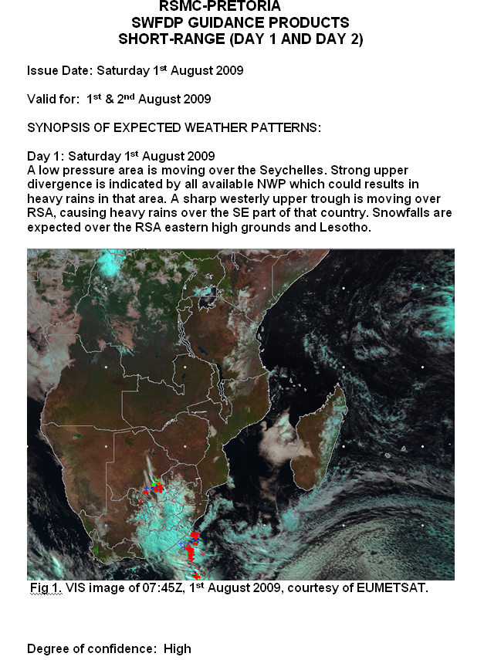
An example of a text weather discussion. It can include extra things like satellite image and figures from NWP/EPS products.

3. A Short-range Risk Table (days 1 and 2) and Medium term Probability Table (days 3 to 5) are also produced to indicate the risk (or probability on the medium term) of the threat in particular countries as it is assessed by the guidance forecaster at the RSMC.

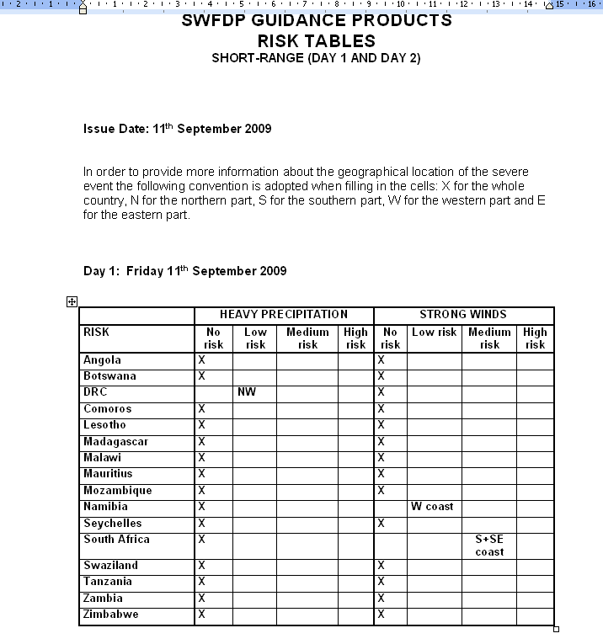
An example of a risk table to indicate the risk of the threat as assessed by the forecaster at RSMC

Feedback

Feedback from NMHS’s (and RSMC) to regional and global centres is very important and is encouraged.

The evaluation form used for SWFDP Southern Africa is available as annexure 2.

Satellite-based 0-12hour products

Satellite-based observational products are available for the region at different time intervals.

Hydo-Estimator

The Hydro-estimator is a satellite rainfall algorithm developed by NOAA and adapted for the Meteosat Second Generation (MSG) by EUMETSAT. It estimates precipitation from the IR10.8_m (i.e. cloud top) temperatures measured by the MSG satellite. The algorithm identifies areas on the satellite image that are colder than their surroundings as well as areas that are warmer than their surroundings. Through this method, convectively active and inactive regions are recognized. The Hydro-estimator takes input from Numerical Weather Prediction (NWP) model fields such as precipitable water, relative humidity, level of neutral buoyancy and 700hPa winds into account. This product is best suited for convective events and tends to underestimate or “miss” stratiform rainfall.

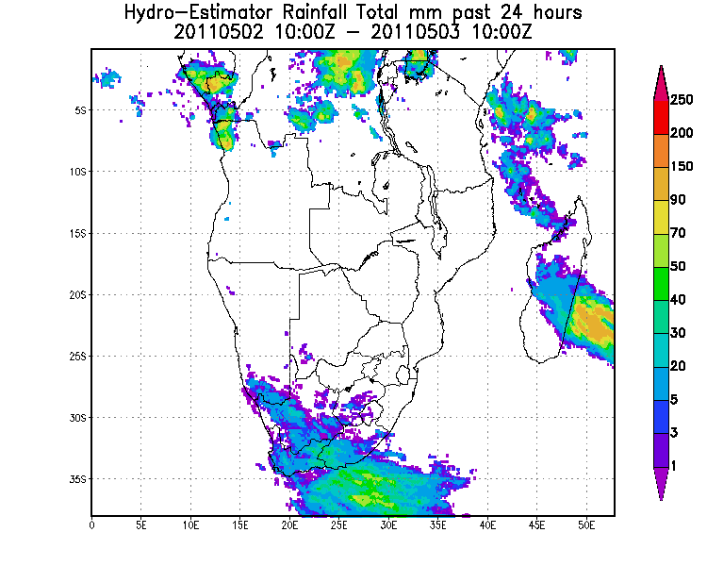
An example of a 24 hour hydro-estimator

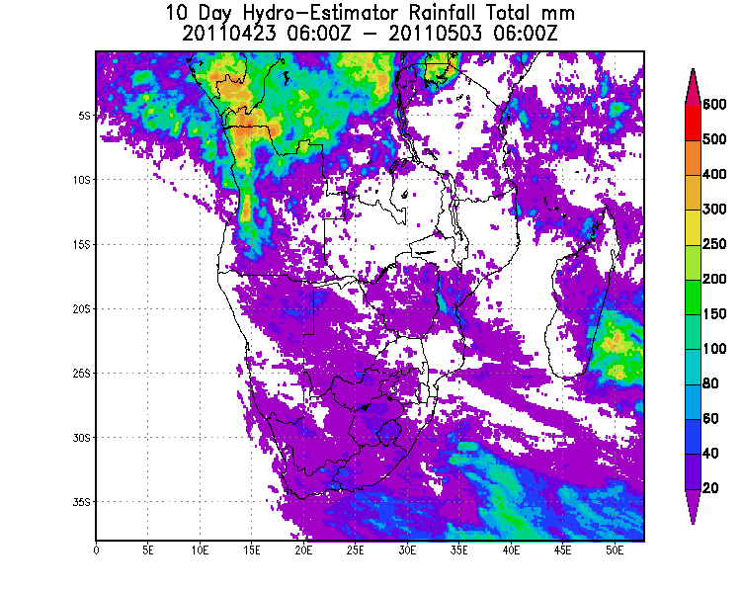
An example of a 10 days hour hydro-estimator

ANNEXES

Annex 1

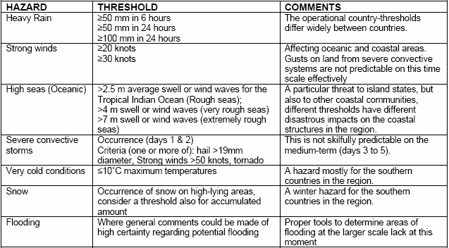

Annex 2

 | EVALUATION FORM (Page 1)
 | SEVERE WEATHER EVALUATION FORM
INSTRUCTIONS: | :
1. This form must be filled in whenever: |  | (1) Severe weather is observed (Sections A and B)
 |  | (2) A warning has been issued to DM/CPA (Sections A and C)
2. Email the completed document to RSMC Pretoria, WMO and other agreed recipients
To standardize please put the title “SWFDP Evaluation Form” in the title list of the email
A. IDENTIFICATION OF THE SEVERE EVENT
NMHS: |  |  | Alphabetic
Region affected: |  |  | Alphabetic
Event Number: |  |  | Numeric
Type of event: |  |  | Numeric |  | (put the right number in the cell)
1: Heavy Precipitation | (indicate the most significant phenomenon,
2: Strong wind | either heavy precipitation or strong wind)
Severe convection |  |  | Numeric |  | (put 1 if extreme phenomena are  the consequence of severe  convection or 0 otherwise)
B. SEVERE WEATHER OBSERVED (to be completed even if no severe weather has been forecast)
 |  |  | JJ | MM | DD |  | HH | MM
 | Start of the event: |  |  |  |  | at |  |  | UTC
 | End of the event: |  |  |  |  | at |  |  | UTC
Max. observed value: |  |  | Unit
 | Numeric | Alphabetic
(According to the event: accumulated precipitation or gusts)
Information from the end-users
short text explaining the consequences and possibly some figures
(number of interventions, casualties, damages, usefulness of the warning )
 | EVALUATION FORM (Page 2)
C. SEVERE WEATHER FORECAST (to be completed even if severe weather did not occur)
 |  |  | JJ | MM | DD |  | HH | MM
Time of the warning | toward DMCPA |  |  |  |  | at |  |  | UTC
Start of the event; | forecaster assessment |  |  |  |  | at |  |  | UTC
End of the event; | forecaster assessment |  |  |  |  | at |  |  | UTC
Level of risk as appreciated by RSMC |  | (put 1 in the chosen cell)
 |  |  | No |  | Low |  | Med. |  | High
Level of risk | 1 day before:
Level of risk | 2 days before:
Probabilities of medium range outlooks as appreciated by RSMC
Probability | 3 days before: |  |  | %
Probability | 4 days before: |  |  | %
Probability | 5 days before: |  |  | %
Mark for usefulness of products (put 1 in the chosen cell)
 |  |  | Guidance
 |  | RSMC Pretoria
KEY |  |  | NWP | EPS
A = Very useful (basis of the warning) |  | ECMWF
B =Useful (aided warning confidence) |  | NCEP
C = Neutral (not useful) |  | Met Office
D = Negative (misleading)
X = Not used
Comments including information on usefulness and applicability of used tools

