WORLD METEOROLOGICAL ORGANIZATION  COMMISSION FOR BASIC SYSTEMS  OPAG on DPFS  RAI-SWFDP – Eastern Africa  NWP/Web Developers’ Workshop  Nairobi, Kenya, 9-11 May 2011 |  | DPFS/RAI-EA-SWFDP-NWP/WEB/Doc. 4(4)  (6.V.2011)  _______  Agenda item : 4.4  ENGLISH ONLY

ROLES OF AND CONTRIBUTIONS BY CENTRES FOR LIMITED AREA MODELLING (LAM) OVER THE PROJECT FOOTPRINT AND LAKE VICTORIA REGION

(Submitted by Kenya Meteorological Department, KMD)

Summary and purpose of document

This document explains the capability and potential contribution of KMD for Limited Area Modelling (LAM) both over the project footprint and Lake Victoria region and SWFDP – Eastern Africa.

Action Proposed

The meeting is invited to consider this contribution and discuss the following proposal concerning the role of the Kenya Meteorological Department KMD within the new SWFDP-Eastern Africa in RAI and Lake Victoria Basin.

1.0 Introduction

The Kenya Meteorological Department (KMD) uses the High Resolution Regional Model (HRM) from Deutscher Wetterdienst (DWD), Germany and Weather Research and Forecasting (WRF) from USA for severe weather forecasting.
This document considers the capability and potential contribution of KMD for Limited Area Modelling (LAM) both over the project footprint and Lake Victoria region and SWFDP – Eastern Africa.

2.0 Limited Area Models

The HRM is a flexible tool for Numerical Weather Prediction (NWP). The Deutscher Wetterdienst (DWD) provides this comprehensive package to National Meteorological and Hydrological Services (NMHSs), universities, and research institutions world-wide. Operational HRM-Kenya is based on GME data at 30 km horizontal resolution and 60 vertical levels. Model domain (Mesh size: 0.125° ~ 14 km) extends from latitudes (12⁰ S, 12⁰N) and longitudes (26⁰E, 51⁰E).

The Weather Research and Forecasting (WRF) Environmental Modeling System (EMS) is a complete, full-physics, Numerical Weather Prediction (NWP) package. It incorporates dynamical cores from both the National Center for Atmospheric Research (NCAR) Advanced Research WRF (ARW) and the National Center for Environmental Predictions' (NCEP) Non-hydrostatic Mesoscale Model (NMM-WRF). The model releases into a single end-to-end forecasting system.

3.0 Observation System
3.1 Current Observational Network
Kenya Meteorological Department has a reasonable observational network composed of :
- 36 synoptic and agrometeorological stations distributed all over the country (Automatic Weather Stations (AWSs) have been installed in 24 of these stations and another 12 have been acquired and will be installed soon);
- Three upper air observing stations (radiosondes) one of which is currently operational (There are plans to revive the other two upper level observation stations) ;
- KMD has installed three tidal gauges along the Kenyan coast and hopes to even add more marine equipment along the Kenya’s continental shelf; The impacts of tides and strong waves on the erosion of the coastline and shoreline change need to be studied closely using high-scale numerical coastal models;
- 17 Hydro-Meteorological AWSs;

3.2 Planned activities to improve the network
- Procurement process for the acquisition of three radar systems has started. The data obtained would be used in the data assimilation system and
- The department is in the process of setting up a network of equipment along the Kenyan coast including the expensive Acoustic Doppler Current Profilers (ADCP) in order to accumulate critical data that would be used in generating Wave Models for the region.

4.0 Verification
Verification of the two models is ongoing. The model output products being considered in the verification exercise are the temperature, wind fields and moisture. So far the two models are doing quite well over this region. Verification exercise will contribute positively to the success of SWFDP program.

Annex(es):

Some of the most common severe weather disasters in Kenya include;

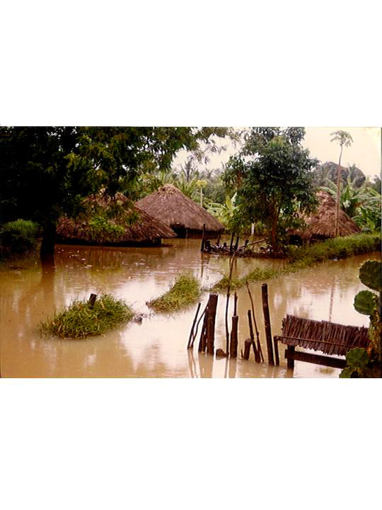

- Floods

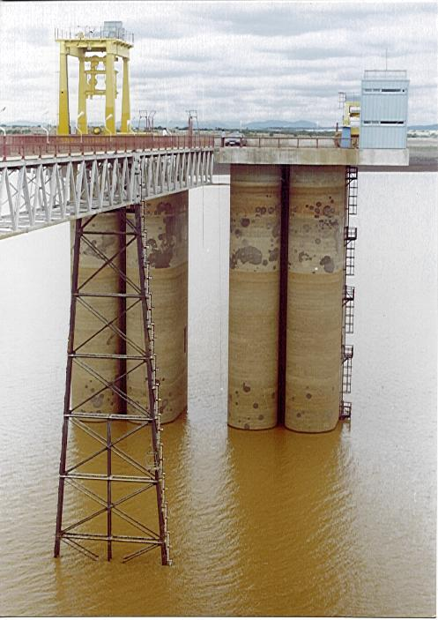

2a. Hydrological Drought

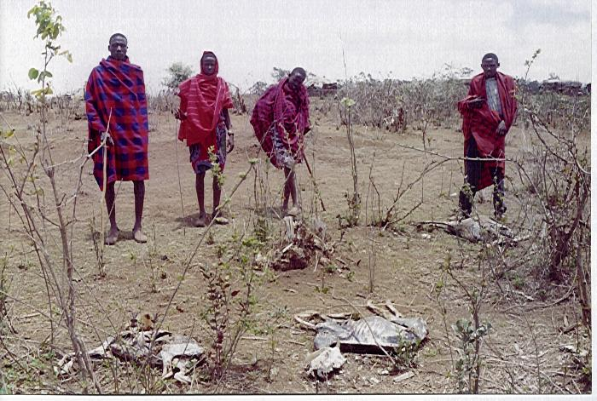

2b. Agricultural Drought

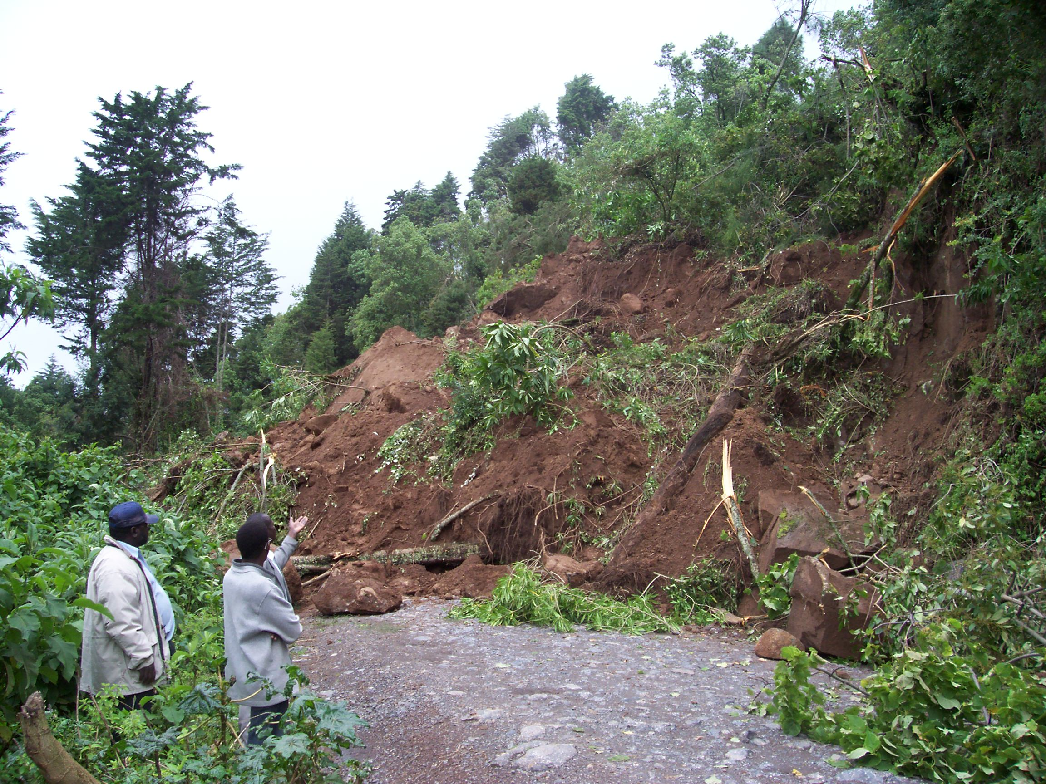

- Landslides

The challenges that are hampering the country’s ability to deal with severe weather disasters are;

- Knowledge gaps in identification, assessment and awareness of disaster risks;
- Weak disaster management and preparedness policies and institutions ;
- Lack of mainstreaming DRR in development plans;
- Low funding of the National Disaster Operation Centre (NDOC) for DRR propagation;
- Low human capacity and poor coordination
- Public education and Awareness on DRR is lacking
- No budgetary provision for DRR
- Climate variability and change

Reference

Burridge, D. M., 1975: A split semi-implicit reformulation of the Bushby-Timpson 10-Level model.Quart. J. Roy. Meteor. Soc. 101, 430, 777-792.

Davies, H. C., 1976: A lateral boundary formulation for multi-level prediction models.
Quart. J. Roy. Meteor. Soc. 102, 432, 405-418.

Doms, G. and U. Schättler, 2003: The nonhydrostatic limited-area model LM of DWD. Part 1: Scientific documentation. Deutscher Wetterdienst, Offenbach, Germany.

Zhang, Z. and Krishnamurti;1997: Ensemble foreacting of hurricane tracks. Bull.Amer. Metor. Soc. 78, 2785-95

Zoltan Toth and Eugenia Kalnay;1993: Ensemble forecasting at NMC: The generation of perturbations. Bull.Amer. Metor. Soc. 74(12), 2317-30

