WORLD METEOROLOGICAL ORGANIZATION  COMMISSION FOR BASIC SYSTEMS  OPAG on DPFS  RAI-SWFDP – Eastern Africa  NWP/Web Developers’ Workshop  Nairobi, Kenya, 9-11 May 2011 |  | DPFS/RAI-EA-SWFDP-NWP/WEB/Doc. 4(2)  (5.V.2011)  _______  Agenda item : 4.2  ENGLISH ONLY

ROLE OF AND CONTRIBUTION BY THE GERMAN WEATHER SERVICE REGARDING LIMITED AREA MODELLING (LAM) OVER THE PROJECT FOOTPRINT AND LAKE VICTORIA REGION

(Ulrich Blahak and Alexander Smalla, DWD)

Summary and purpose of document

This document briefly describes the planned contribution of the German Weather Service (DWD) with regards to supporting the LAM activities at the Kenya Meteorological Department (KMD) within the framework of the SWFDP in RA I.
It is outlined that DWD already has a longstanding tradition in supporting several (also African) countries (e.g., Kenya since 2001) with its regional model HRM (High resolution Regional Model), at the same time enabling KMD to continuously run the model through provision of initial and boundary data from the global model GME and staff training concerning the HRM. At the last SWFDP workshop in Nairobi, it has been decided that this should basically be the role of the DWD in the project. The necessary resources for support and custom-tailored data provision are already available at DWD, as such tasks have been and will be continuously fulfilled in the future also for several other countries.
Because very soon the resolution of GME will be increased from 30 to 20 km globally, it is however emphasized that the LAM for SWFDP should plan for a considerably smaller grid spacing in the range of ~7 km (“large” domain over Eastern Africa) and (maybe) a very high resolution domain (< 3 km) over the Lake Victoria region.
HRM, due to its hydrostatic nature, is not designed for such a high resolution. Here, DWD offers to provide its currently operational non-hydrostatic COSMO-model (Consortium for Small Scale Modelling) in replacement for the HRM.

Action Proposed

The meeting is invited to consider and discuss the following proposal concerning the role of the DWD within the new SWFDP in RA 1.

Introduction

DWD has a longstanding tradition in providing its regional model HRM to developing countries to enable them to run their own numerical weather prediction system. DWD provides the model, support, the external data (i.e., orography, soil and vegetation data), and the necessary initial and boundary data from the global model GME in a custom tailored and efficient way, i.e., the countries get the necessary fields in the original GME resolution (approx. 30 km grid spacing, 60 vertical model levels from 10 m to 36 km above the ground), cut to exactly the required HRM domains to reduce the amount of GME data transferred via the Internet, and with a very short cutoff time of 2:50 h based on 00, 06, 12 and 18 UTC. GME-data are provided up to a forecast lead time of +5 days at 3-hourly intervals.

Based on this approach, it is proposed that DWD shall provide and extend the necessary models, data and training of NWP staff to enable the RSMC to continuously run a LAM (nested into GME) to provide short term numerical weather predictions up to a lead time of +5 days or so for the entire project region (grid spacing ~7 km). Nested herein, more detailed simulations over the Lake Victoria region using grid spacing < 3 km are envisioned, out to a lead time of +1 day or so, depending on available computing resources. In these fine-scale simulations, the parameterization for deep convection will be switched off to explicitly allow for tropical convection. With this system, targeted severe weather elements would be, e.g., strong precipitation events, wind storms, or extreme temperatures. The details of this commitment and connections to other centers would of course be subject to discussions at the workshop.

Because the hydrostatic HRM cannot be applied at such high resolutions, DWD has an interest to move current HRM users to its currently operational non-hydrostatic high resolution limited area model (COSMO-model) until Q1 2013. Recently, the Consortium for Small Scale Modelling (COSMO) decided to provide an “older” version (~1 year old) of this model to developing countries for free, including initial and boundary data and training as is already provided today for the HRM. DWD has established an additional staff position (Mr. A. Smalla), initially for two years (2011-2012), for the support of model users in the transition from HRM to the COSMO-model.

Since KMD is about to receive soon a new powerful Linux cluster (delivered by Meteo-France International, MFI), the additional computational costs of running a non-hydrostatic model (~ factor 2 - 4) should not be critical. The HRM and COSMO-model will be pre-installed on this machine as part of the delivery agreement with MFI.

Therefore it is proposed that from the beginning of the SWFDP on, the COSMO-model should be run in the proposed nested configuration, maybe in addition to the HRM in a 11 km configuration only. On the one hand, this constitutes a small multi-model ensemble, and on the other hand extends KMD-personnel’s skills towards small-scale non-hydrostatic modelling.

The necessary training for the NWP staff can be realized by the annual HRM / COSMO training course in Germany, provided the travel expenses of the trainees are covered by the SWFDP.

New supercomputer (LINUX cluster) at KMD

Totally independent from the SWFDP, KMD is about to receive a new quite powerful Linux cluster and database system from Meteo-France International (MFI). If all things go according to plan, the timeline is to have the system installed and running at KMD approximately before the End of 2011. However, the exact status of delivery is not known to us at the moment, but hopefully becomes clear during the time of the workshop.

Planned system configuration:

- Database system for observations and model output (~6 TB for mod_db)
- 10 - 12 compute nodes a 2x12 CPUs = 240 – 256 CPUs
- 2 Master / front-end nodes (login, scheduling, pre- und post-processing)

Pre-installed software on the Linux cluster will be the scheduler SMS from ECMWF, WRF-model, HRM and COSMO-model (with the help of DWD staff members M. Gertz and A. Smalla).
DWD and MFI have established contacts about this matter. Concerning the scheduler, the HRM and COSMO-model might also be run under the simpler scheduler of M. Gertz, which is applied at the moment by KMD for their HRM runs on their current system.

Concerning the SWFDP, this new system (assuming it will be installed timely) would provide the necessary computational resources to run NWP models (HRM and/or COSMO) for the abovementioned high resolution nested grid configuration (COSMO 7km and < 3 km). Otherwise, the simulation domains have to be chosen considerably smaller and the resolution has to be coarser.

During the installation phase, MFI provides some training for the involved KMD staff (~8 weeks, details to be determined). At the moment, we don’t know if there will be further technical support after successful system installation and acceptance.

HRM vs. COSMO-model

This section briefly describes the main differences between HRM and COSMO.

The HRM is a hydrostatic limited area NWP model and was derived from the predecessor DM (“Deutschland Modell”) of the COSMO-model at DWD. The DM was operational until 1998, using grid spacings of >= 11 km and parameterized convection.

The COSMO-model is non-hydrostatic and uses the fully compressible set of basic equations, so that in principle it can be run at much higher resolution. Weather services from 7 European countries use and jointly further develop the COSMO-model within the Consortium for Small Scale Modelling.

The current operational configuration at DWD uses a 7 km grid with parameterized convection on a large domain over Europe and the eastern North Atlantic (COSMO-EU), as well as a nested domain with 2.8 km grid spacing over central Europe (COSMO-DE). Parameterized deep convection is switched off in this inner domain (shallow convection however is still parameterized). DWD applies a nudging data assimilation system, including latent heat nudging based on radar data for the COSMO-DE. The forecast lead time is +78 h for the COSMO-EU (4 runs per day) and +21 h for the COSMO-DE (8 runs per day). The goal of the 2.8 km rapid update cycle configuration is to improve especially the forecast of summertime convection and wintertime orographic precipitation. Because of the inherent quasi-stochastic behaviour of small-scale convection and its limited deterministic predictability, DWD currently implements and tests a 2.8 km resolution ensemble prediction system based on the COSMO-DE configuration with 20 - 40 members.

Many national weather services, also from developing countries (e.g. KMD), currently run the HRM, using initial and boundary data from the GME (provided by DWD). It has already been mentioned in the introduction, that DWD is interested to move current HRM users to the COSMO-model; and has established a staff position for support in this matter. Developing countries will get the model and initial- and boundary data for free, whereas other countries may obtain a license for a moderate fee.

The computational costs of running the non-hydrostatic COSMO-model are higher than with HRM. Figure 1 shows results of a certain comparison benchmark experiment run by INMET Brazil. The wall clock time is higher for the COSMO-model by a factor of 4 at low processor numbers, but decreases considerably when using more processors (green line, right ordinate). This means that the scalability of the COSMO-model on parallel computers is better and the additional costs on machines like the upcoming KMD-cluster are not all too high.

On the technical side, running HRM and the COSMO-model is quite similar, because both models are namelist driven and can use the same initial and boundary data from GME. Also, the same scheduler of M. Gertz can be applied to organize an operational job chain.

More informations and the COSMO-model documentation can be found on the COSMO web page:

http://www.cosmo-model.org

First simulation experiments with the COSMO-model over Eastern Africa and the Lake Victoria Region

As preparation for the workshop, we conducted first test simulations with the COSMO-model in a nested grid configuration, using grid spacings of 7 and 2.8 km. The necessary external parameters (orography, roughness length, soil type, vegetation, etc.) have been generated for both grid spacings and nearly for the whole of Africa. We tentatively defined the two domains depicted in Figure 2 (7 km) and figure 3 (nested 2.8 km), generated input- and boundary data for the 7 km domain from the GME and started a 7 km free forecast run for March, 19, 2011, 00 UTC out to +48 h.
From the results, we generated initial- and boundary data for the 2.8 km domain and started a free forecast run again from 00 UTC out to +48 h.

As a specialty, the surface temperature of Lake Victoria has been initialized with its climatological value for this time of year and treated prognostically using the lake model FLake, which is part of the COSMO-model. This lake surface temperature should be important for the formation of convection near to and over the lake.

A few results of these runs are shown in figures 4, and 5 (3h-accumulated precipitation for 7 km respectively 2.8 km from 15 – 18 UTC on day 1), and 6 and 7 (2 m temperature and 10 m wind barbs at 14 UTC on day 1). It can be seen that the total precipitation during the afternoon of day 1 (mainly convective cells) is considerably less in the 7 km run (parameterized convection) compared to the 2.8 km run (grid scale deep convection), where a convection-typical “spotty” pattern of 3h-accumulated rain, locally more than 60 mm, can be seen. The 2 m temperature is lower for the coarse-grid run, maybe due to the action of the convective parameterization. The typical afternoon sea breeze over Lake Victoria is visible in the 10 m wind for both runs, but is more pronounced at 2.8 km.

More results will be presented at the workshop.

The model runs have been performed on the NEC SX9 vector parallel machine at DWD headquarters in Offenbach, Germany. For the 7 km run, 12 vector nodes have been used, whereas for the 2.8 km run 8 nodes have been used. The 7 km run with its 397 x 444 grid points, 50 vertical levels and 40 s timestep took about 25 min for 2 days of simulation, and the 2 km run with 560 x 400 grid points, 60 vertical levels and 25 s timestep took 90 min for 2 days. Therefore, the simulation time per grid point per day for 1 processor and 1 s timestep is 0.0408 s (7 km) respectively 0.0401 s (2.8 km).

To estimate the time on a state-of-the-art 200 processor scalar machine (such as the new Linux cluster expected for KMD), a rule of thumb is that, for the COSMO-model, one SX9 vector node is as performant as 50 scalar processors. Based on that, our 7 km run would have taken roughly 40 min per day, and the 2.8 km run roughly 90 min. Of course this depends on the exact model configuration as well as on the hardware of the cluster and might actually deviate somewhat.

These numbers should help the workshop participants to take meaningful decisions about the domain size(s) for the LAM model(s) in the SWFDP in light of the available computational resources.

Support for migrating from HRM to the COSMO-model

HRM / COSMO workshop in Langen, Juli 2011:

- Participants from KMD: I. Mulama, V. Sakwa, J.G. Gathura

Mr. Alexander Smalla, DWD:

- 2 years fulltime position to support users to migrate from HRM to COSMO-model.
- Responsible for the above HRM / COSMO workshop in Langen.
- Under consideration with MFI: 1+ week(s) visit at KMD after installation of the new Linux cluster to help in setting up the HRM- and/or COSMO-simulations and in creating plots of the modeling results, paid by MFI.
- He can also be “booked” from KMD or WMO SWFDP for further on-site support, e.g., for visits of 1 or 2 weeks (costs: flight, lodging, daily allowance).

Mr. Michael Gertz, DWD:

- Proven support for running his scheduler for HRM, now also for the COSMO-model.
- Arrangement with MFI: 1+ week(s) visit at MFI in Toulouse for installation of HRM, COSMO-model and scheduler(?) on the KMD Linux Cluster, paid by MFI.

Technical and other Issues

The workshop should clarify the following issues (and maybe more):

Will the new Linux cluster be installed on time at KMD?

Is there enough staff at KMD for running the LINUX cluster and for running the models?

What is the internet Bandwidth for KMD? We got the information that KMD has 4 MBits line, but the actual speed might be slower. The COSMO-model preprocessor “int2lm” in principle can handle GME frame data (instead of whole 3D data sets for the boundary data), which makes for considerable reduction of data transfer from DWD to KMD, but this needs some minor modifications for it to work.

How reliable is the electrical power? Is there a UPS for the computers?

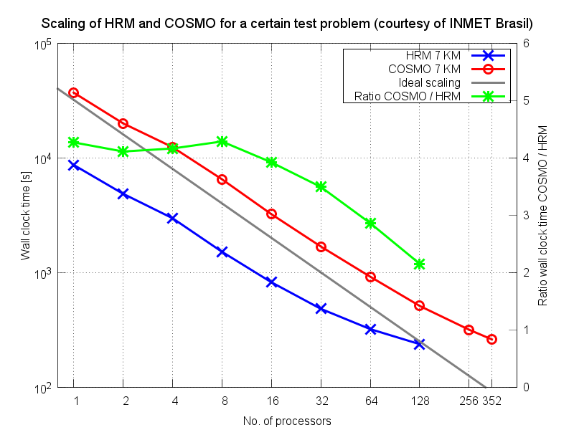
Figure 1: Performance and scaling comparison of HRM (blue) and COSMO-model (red). Shown is the wall clock time as function of processor number on a Linux cluster from INMET Brazil for a certain benchmark setup. Green: wall clock time ratio COSMO / HRM. Grey: line of ideal scaling.
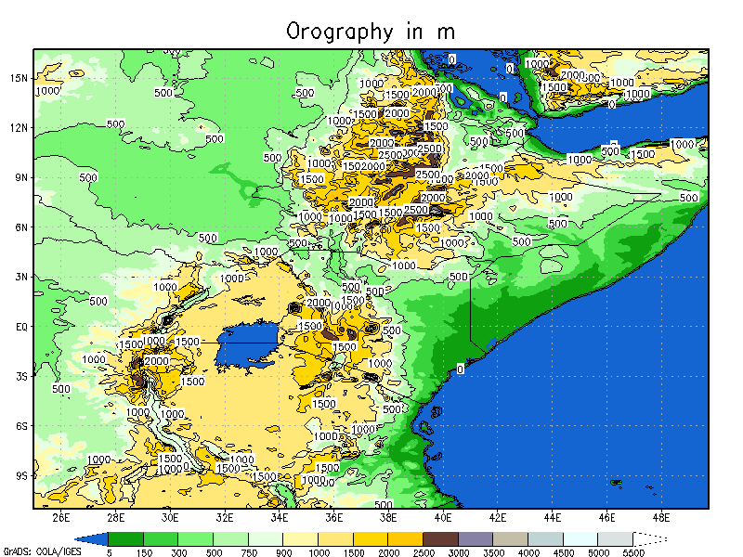
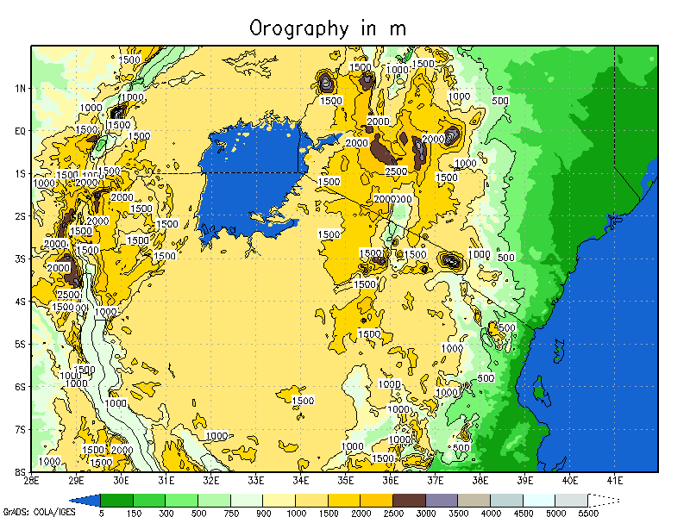
Figure 2: Simulation domain chosen for our COSMO 7 km experiment. 397 x 444 GPs.
Figure 3: Simulation domain chosen for our COSMO 2.8 km experiment. 560 x 400 GPs.
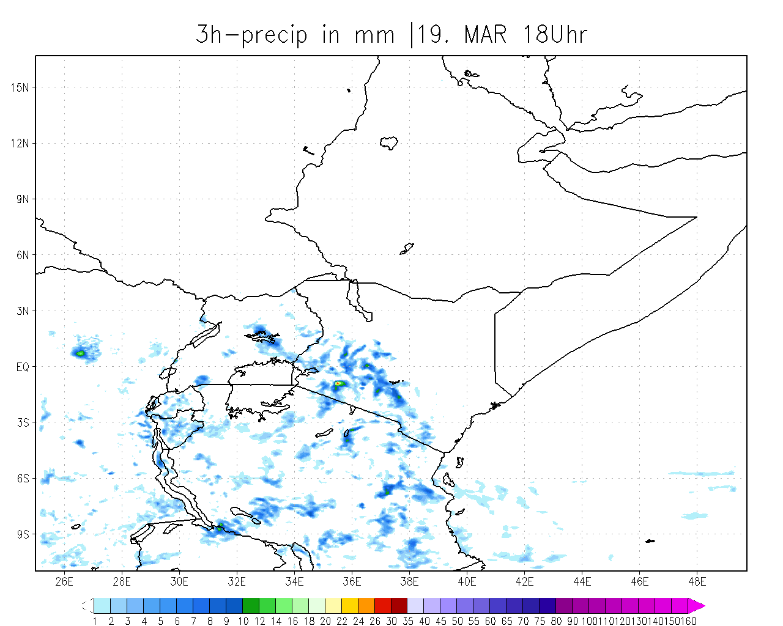
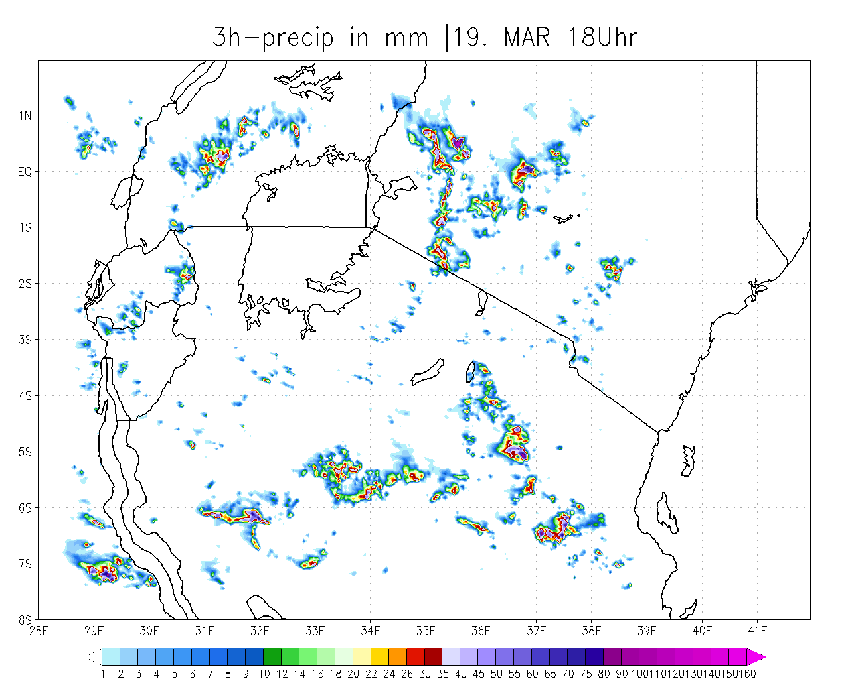
Figure 4: COSMO 7 km, total 3h-precipitation in mm, 15 – 18 UTC.
Figure 5: COSMO 2.8 km, total 3h-precipitation in mm, 15 – 18 UTC.
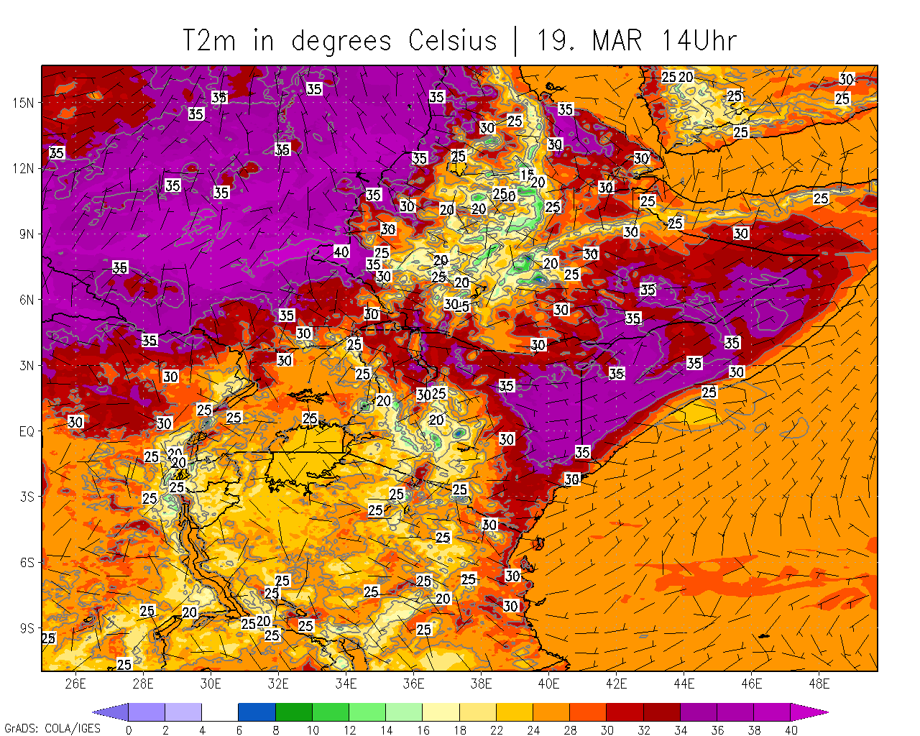
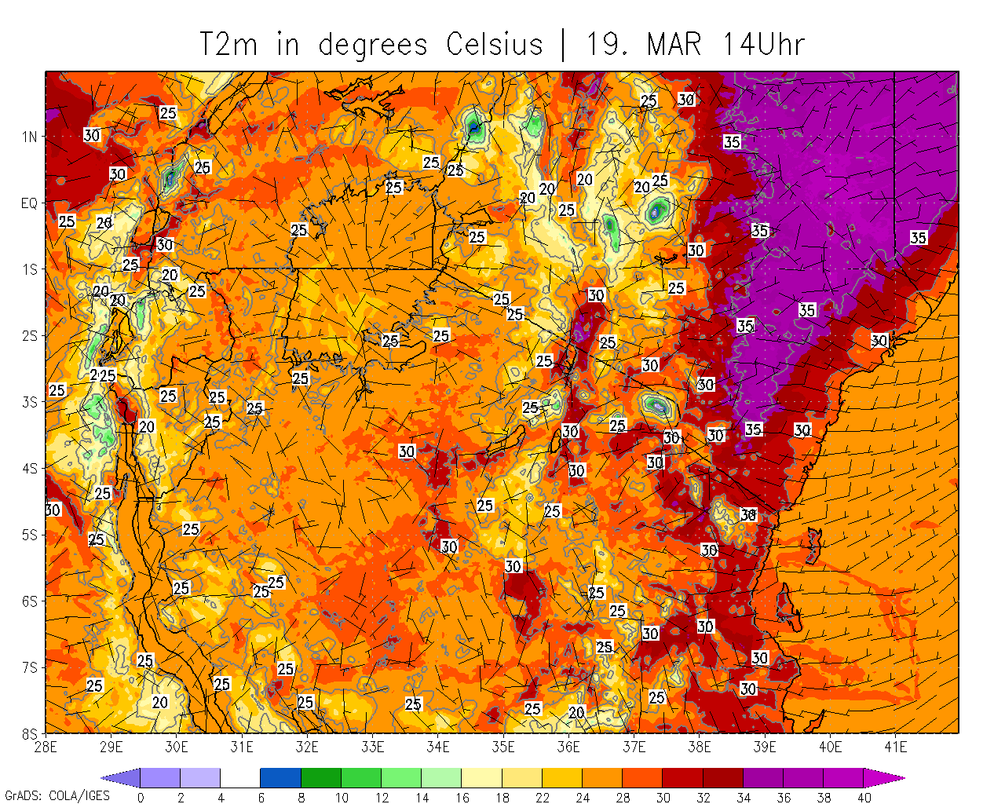
Figure 6: COSMO 7 km, T 2 m and wind 10 m, 14 UTC.
Figure 7: COSMO 2.8 km, T 2 m and wind 10 m, 14 UTC.

