WORLD METEOROLOGICAL ORGANIZATION  ________  COMMISSION FOR BASIC SYSTEMS  OPAG on DPFS  IMPLEMENTATION COORDINATION TEAM  ON DATA-PROCESSSING AND  FORECASTING SYSTEM  TOULOUSE, FRANCE, 29 MAY – 2 JUNE 2006 |  | CBS/ICT-DPFS/Doc. 10(1)  (16.V.2006)  ______  ITEM : 10  Original: ENGLISH

DPFS and Nowcasting

(Submitted by the Rapporteur of the OPAG on DPFS on the application of NWP to Severe Weather Forecasting)

Summary and purpose of document

This document presents a very brief overview of nowcasting activities in member States and a proposal for the creation of an expert team on nowcasting and very short range forecasting.

Action Proposed

The meeting is invited to consider the information in this document and provide comments as appropriate on the opportunity of creating an expert team and its proposed terms of reference.
- BRIEF OVERVIEW OF NOWCASTING ACTIVITIES IN MEMBER STATES

  - The information provided in this document comes essentially from the recent WWRP international symposium on Nowcasting and Very Short Range Forecasting (WSN05) held in Toulouse, France, from 5 to 9 September 2005. All the information about this symposium, including the programme, abstracts, presentations and posters, is available on line at the following Internet address: http://www.meteo.fr/cic/wsn05/.

1.2. Different examples of nowcasting products, some of them experimental, either presented at WSN05 or coming from other sources, are shown in the Annex to this document.

1.3.

The timeframe of nowcasting is typically the 0-6 hour period where it is used to improve forecasts.

1.4. Nowcasting relies on observation systems, high resolution NWP and such techniques as image processing, data fusion, data analysis, extrapolation,…

1.5. Nowcasting can improve high impact weather forecasting, e.g. convective hazards (heavy rain, hail, lightning, wind gusts,…), winter weather events (snowstorm, blizzards,…) or other hazardous conditions (fog,…).

1.6. Nowcasting can be used to help addressing the needs of such end users as transportation industry, emergency services, hydrology, agriculture, construction industry, recreation, power and energy industry, air quality monitoring, homeland security.

1.7. Nowcasting can be implemented on a wide variety of means, going from local treatment on a PC to dedicated centres (eg the SAF Nowcasting)

- NOWCASTING AND DPFS

2.1. The CBS Management Group, Sixth Session, April 2006, proposed the creation of an expert team on nowcasting and very short-range forecasting.

  - The following Terms of Reference are proposed for such an expert team :
- Establish a list of the main existing nowcasting methods or products.
- Classify them as regards the type of phenomena covered, their potential use and its limitation, the pre-requisite (eg have access to weather radars, satellite data acquisition, mesoscale models, workstations, etc.),…
- Analyse what nowcasting systems are used in meteorological operations and propose recommendations in this respect.
- Watch R&D on Nowcasting.
- Address specifically the issues of the use of very high-resolution NWP models in nowcasting and the provision of nested data sets for LAM ran at NHMSs.

  - As a complement, in the frame of the Severe Weather Forecasting Demonstration Project (SWFDP), nowcasting products can be added to the list of products used in regional SWFDP subprojects by NHMSs to help following and nowcasting severe weather events.

ANNEX
Examples of nowcasting products

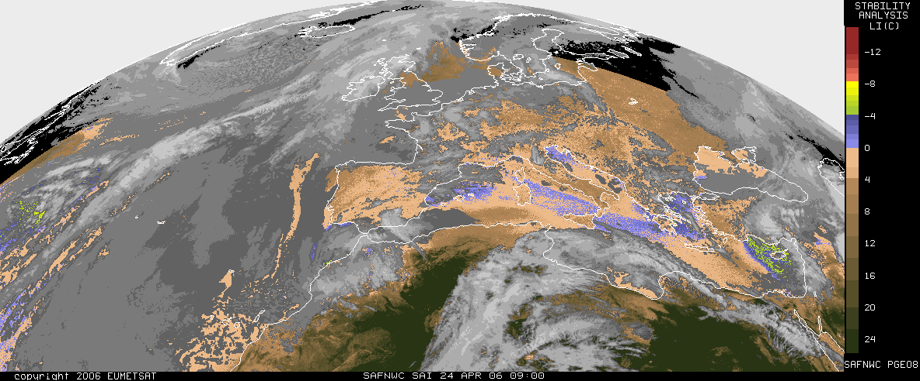

Stability analysis using the SEVIRI radiances (MSG)
SAF Nowcasting, http://nwcsaf.inm.es/

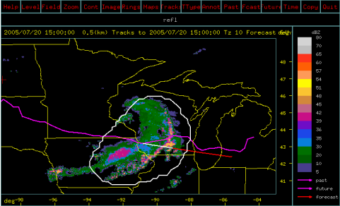

Extrapolated precipitation zone, National Convective Weather Forecast AutoNowcaster

Ahijevych et alii, NCAR, WSN05

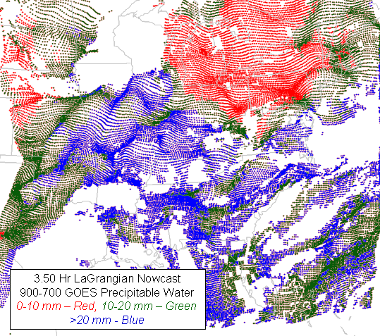

GOES precipitable water

Petersen et Aune, NOAA, WSN05

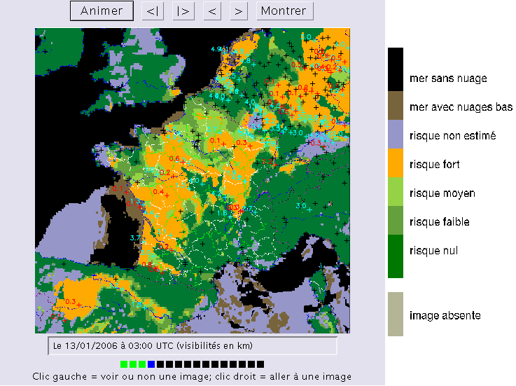

Fog risk analysis

Tzanos, Météo-France

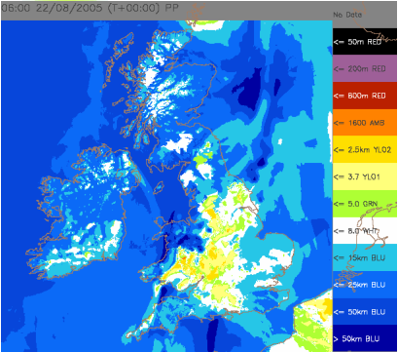

Visibility analysis

Golding, UK Met Office, WSN05

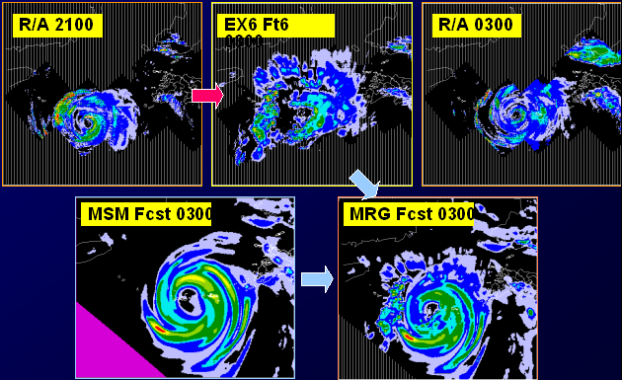

Very short range forecast of precipitation

Sugiura, Japan Meteorological Agency, WSN05

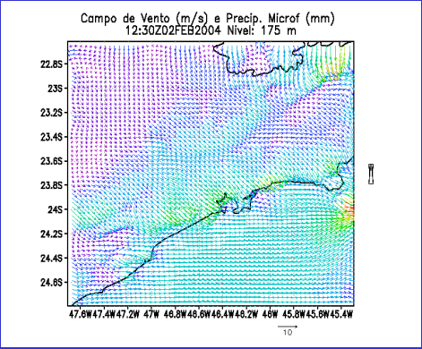

Wind and rainfall 2 km forecast over São Paulo

Pereira Filho et alii, University of São Paulo, WSN05

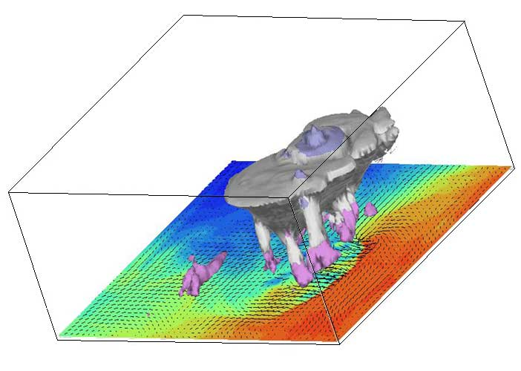

Squall line over Paris simulated with the new AROME model of Météo-France (ground wind and potential temperature + 3D hydrometeors)

Météo-France

