WORLD METEOROLOGICAL ORGANIZATION  COMMISSION FOR BASIC SYSTEMS  OPAG on DPFS  IMPLEMENTATION COORDINATION TEAM  Tokyo, Japan, 13 – 17 September 2010 |  | CBS-DPFS/ICT /Doc. 6(1)  (30.VIII.2010)  _______  Agenda item: 6  ENGLISH ONLY

EXTENDED AND LONG-RANGE FORECASTING

Report of the chairperson of the Expert Team on Extended and Long-range Forecasting (ET-ELRF)

(Submitted by Richard Graham)

Summary and purpose of document

This document reports on the activities of the ET-ELRF, developments in the GPC network and associated Lead Centres and their products and on use of the products. It expands on the conclusions and recommendations of the recent ET-ELRF meeting (June/July 2010).

Action Proposed
The meeting is invited to review the information provided and make recommendations for issues to be raised or proposals to be made at the forthcoming CBS meeting.

Annexes:
Annex 1: Training, guidance material and basic requirements
Annex 2: Proposed revised ToRs for the ET-ELRF

Reference: Final report of the ET-ELRF meeting, 28 June – 02 July, 2010, Exeter, UK.
Report of the chairperson of the Expert Team on Extended and Long-range forecasting (ET-ELRF)

1. Conclusions and recommendations of the meeting of the ET-ELRF, Exeter, UK, June/July 2010

The conclusions and recommendations paragraphs of the ET-ELRF meeting held at Exeter, 28 June – 2 July, 2010 (ET-ELRF2010) are copied as the first paragraphs of sections 1.1 to 1.10 below. Further details have been added to expand on key points. The full report of the ET-ELRF2010 meeting is available at http://www.wmo.int/pages/prog/www/CBS-Reports/DPFS-index.html.

Key areas addressed at the meeting included the evolving role of Global Producing Centres of long-range forecasts (GPCs) and their associated lead centres (LCs) for Long-range Forecast Multi-model Ensembles (LC-LRFMME) and Standardized Verification System for Long-range Forecasts (LC-SVSLRF) and integration with the developing network of Regional Climate Centres (RCCs) and Regional Climate Outlook Forums (RCOFs). These issues were discussed within the new overarching background of the developing Global Framework for Climate Services (GFCS) and also with regard to the proposed development of WMO Global Seasonal Climate Updates (GSCU).

The team concluded and recommended that:

1.1 Overall progress

Significant progress had been made in developing the GPC network and services since the previous ET-ELRF meeting (Beijing 2008, hereafter ET-ELRF2008), including: designation of 2 additional GPCs bringing the total to 12; designation of the LC-LRFMME (at CBS 2009); development of new LC products, including user selectable multi-model forecast combinations; active engagement of some GPCs with RCCs and RCOFs in promoting and assisting use of GPC products (examples include activities at the Beijing and Tokyo Climate Centres, and at the GHACOF and PRESAO RCOFs). The Team also concluded that a number of GPCs had made and were making significant enhancements to their prediction systems.

Further details:

GPCs:
At the previous meeting of the ICT (Montreal, 2008), GPC designation for Rosshydromet (Moscow) was pending, and applications for GPC status had been made by the South African Weather Service (SAWS – Pretoria) and the Centre for Weather Forecasts and Climate Studies (CPTEC). Designation for all 3 centres has now been approved by CBS and WMO Executive Council. The 12 GPCs are listed in Table 1, together with brief details of the forecast system configurations. Forecasts from all GPCs are available on their websites. In addition, forecasts from 10 GPCs are available from the LC-LRFMME website (forecasts from Pretoria and CPTEC are in process of being made available from the LC-LRFMME website).

LC-LRFMME:
On recommendation of CBS-XIV, the LC-LRFMME was officially designated by EC-LX1 (2009). The LC-LRFMME (http://www.wmolc.org) is jointly operated by GPC Seoul and GPC Washington. A key aim is to provide a ‘one stop shop’ for GPC information, in this regard its functions are designed around the following central themes:
- collect long-range forecast data from all GPCs each month;
- maintain a central portal from which forecast users (e.g. Regional Climate Centres, National Meteorological and Hydrological Services, Regional Climate Outlook Forums) can access the GPC output in standard digital and graphical formats;
- to exploit the skill benefits from multi-model forecast methods by developing and providing multi-model forecast products and to promote research into techniques for combining predictions from different models.

Additions to the functionality of the LC-LRFMME website have been made and include a facility that allows multi-model products to be generated with any combination of individual models. This facility may be of use when, because of rapidly developing ENSO conditions for example, separate consideration of signals from coupled and uncoupled systems may be desirable. Plans for further development of the LC-LRFMME were also discussed at the meeting. More details are provided in sections 1.4 and 1.5.

Use of LC-LRFMME products:
The LC-LRFMME has been operating smoothly for more than 2 years. Its products are being used increasingly by NMHSs and Regional Climate Outlook Forums - to date there are 123 registered users of the LC-LRFMME website, representing NMHSs and other centres from 49 countries. A number of GPCs have provided training on the use of GPC and LC-LRFMME products, examples include training given at the pre-forum workshops of the GHACOF (Greater Horn of Africa) and PRESAO (West Africa) RCOFs.

LC-SVSLRF and use of products:
The LC-SVSLRF has continued to run without reported problems. As of June 2010, a total of 11 GPCs have submitted SVS scores, though not all are fully compliant with requirements. Statistics have been compiled on the use of the LC-SVSLRF website over recent months as a guide to its value to GPCs, RCCs and others (see section 1.6).

1.2 Compliance against designation criteria

The Team welcomed GPC cooperation in the review of GPC compliance with designation criteria. It concluded that all GPCs were providing forecast products such as temperature and precipitation and appropriate verification to make prudent use of these forecasts. However it acknowledged that some GPCs were not fully compliant with the designation criteria. Recognising that temporary periods of non-compliance are acceptable in light of the competing need for forecast system development, the Team nevertheless encouraged all GPCs to reach or regain full compliance.

Further details:

The potential for centralising the calculation of verification scores was discussed (section 1.5), this would assist in maintaining compliance levels and also in the standardisation of verification.

1.3 Global Framework for Climate Services

The Team noted and welcomed the decision at WCC-3 to develop a Global Framework for Climate Services (GFCS), and concluded that the above progress, together with developments in establishing RCCs, represented significant contributions to secure the foundation of the GFCS.

Further details:

The GPCs and associated Lead Centres are key components of the Global Climate Centre capability at the ‘base’ of the Climate Services Information System (CSIS) component of the GFCS (Fig. 1).

The ET-ELRF has contributed to the definition of the mandatory and highly recommended functions of RCCs led by CCl (and discussed at the ICT meeting (Montreal 2008). These were approved for inclusion in the manual on the GDPFS and two RCCs: Beijing Climate Centre (BCC) and Tokyo Climate Centre (TCC) (both RA II) have now been designated. It was noted that while only two RCCs are currently designated, good progress had now been made towards establishing RCCs or RCC-Networks in other WMO regions.

The Team noted the formation of a joint CCl/CBS ET on RCCs as approved by the CCl-XV Management Group. It reviewed the terms of reference and proposed a slight adjustment to reflect the CBS aspects more clearly. The Team proposed that CBS may be represented on this ET by Dr David Jones (Australia) and Dr Caio Coelho (Brazil) (both members of the ET-ELRFF), and requested the President of CBS to consider communicating these names to the President of CCl at an appropriate time.

The Team noted the important role played by RCOFs in preparing regional consensus forecasts (RCOFs are established in Africa, Asia, South Eastern Europe, South America, and South Pacific Islands). It noted that a number of GPCs were actively supporting RCOFs and encouraged this to continue. It noted that GPC products developed by the LC-LRFMME had been shared and used by RCOFs (e.g. at PRESAO, GHACOF, FOCRAII for Asia, SASCOF for the summer monsoon forecast of South Asia).

The Team acknowledged the discussions in progress on implementing RCOFs and RCCs for certain climate-sensitive areas spanning more than one WMO Region, such as the Greater Mediterranean Basin (RAs I and VI), the Polar Regions (all RAs), Southeast Asia (RAs II and V).

The Team agreed on the need to ensure that the role of GPCs, as a key building block of the CSIS component, is adequately highlighted in the WMO draft Position Paper on the GFCS:
(http://www.wmo.int/pages/gfcs/documents/GFCS_Position_Paper_DRAFT_REV_1_en_1.pdf). To this end, the Team agreed to review the description of GPCs and their roles within the Position Paper, and that the chairperson should bring consolidated views to the attention of the CBS, through the ICT-DPFS meeting (September 2010) (see separate document).

1.4 Provision of hindcast data

The Team acknowledged that, particularly in the context of the GFCS, EC-LXII had urged GPCs to make their hindcasts available to users. It noted that 9 GPCs were providing their hindcasts to the LC-LRFMME and that others were making hindcasts available on a case-by-case basis through active engagement at RCOFs. It was noted that since its previous meeting (ET-ELRF2008) one additional GPC had decided to make its hindcasts available to the LC-LRFMME.

Further details:

Partly because of data policy issues, some GPCs are unable to provide hindcast information to the LC-LRFMME. For this reason, ‘core’ LC-LRFMME products were defined (at ET-ELRF 2008) that do not require provision of hindcasts. Specifically, core products are based on anomalies for each ensemble member (and the ensemble mean) pre-calculated ‘in-house’ by GPCs (using their hindcasts) and provided to the LC-LRFMME. This level of data provision was implemented as ‘phase 1’ of the data exchange and is the basis of all current LC-LRFMME products. Although useful, such provision limits the potential to develop e.g. probability forecasts and ‘skill-weighted’ multi-model combinations. In this regard, ET-ELRF2008 also defined ‘additional’ LC-LRFMME products to be generated using data from those GPCs able to provide hindcasts. Such products (that include probability products) were scheduled as a ‘phase 2’ activity. It is important that such products are now generated to provide appropriate support for the GFCS, and at ET-ELRF2010 the LC-LRFMME was urged to proceed with phase 2, even though some centres continue to be unable to provide hindcasts.

  - Global Seasonal Climate Update (GSCU)

The Team welcomed the initiative to develop a Global Seasonal Climate Update (GSCU) and concluded that a number of developments to GPC and LC products would help to assist the preparation of GSCUs including: development of new LC-LRFMME probability products, verification of LC-LRFMME multi-model products and possible centralized calculation of verification scores for individual GPC products. It therefore urged the GPCs and LCs to review the feasibility and make progress on these issues and to participate in the scoping workshop for GSCUs.

Further details:

The proposed WMO GSCU will summarise the current status (monitoring) and the expected future behaviour (prediction) of major general circulation features and large-scale oceanic anomalies around the globe (e.g., ENSO, North Atlantic Oscillation, Indian Ocean Dipole, etc.) and discuss briefly likely impacts on continental-scale temperature and precipitation patterns. The GSCU will represent an expansion of the existing WMO El Niño/La Niña Updates and will be generated using similar consensus methods. A scoping meeting for GSCUs (under joint auspices of CCl and CBS), and a meeting of the GSCU Task Team will be held 12-15 October 2010.

The conduit for GPC information provided by the LC-LRFMME, and associated skill information from the Lead Centre for Standardized Verification of Long-range Forecasts (LC-SVSLRF) will be key tools for developing the prediction component of the GSCU, but to optimize their effectiveness, some developments are needed, specifically:
- Probability products, and products relating to the above circulation features, need to be developed by the LC-LRFMME, based on individual GPC data and multi-model combinations (see also section 1.4);
- Verification information for the LC-LRFMME multi-model products needs to be developed, so that the input to the GFCS can be informed by understanding of the skill ‘track record’. Verification of multi-model products has not yet been achieved because of the incomplete provision of hindcast information;
- Sustained compliance and greater standardization in the verification products currently provided by the GPCs and displayed on the LC-SVSLRF website is needed. These latter would be most readily achieved by centralization of the verification process, i.e. one GPC (or the LC-LRFMME) takes on the task of accessing hindcast data and performing the verification for all GPCs who provide hindcasts. GPCs were asked to consider their position in taking on this role.

  - The SVSLRF and proposed amendments to Attachment II-8 (Standardized Verification System for LRF)

The Team noted that RCCs were being encouraged to make use of the set of verification scores embodied and documented in the SVSLRF. In this context Attachment II.8 required some revision since it currently addresses only requirements on GPCs. In addition it was concluded that Level 3 verification scores should no longer be mandatory for GPCs as such scores are more meaningful when generated at regional level. The LC-SVSLRF was tasked with leading preparation of the necessary amendments to the Attachment II.8.

Further details:

Amendments to Attachment II-8 are proposed for 3 issues:

Level-3 scores: Level-3 verification involves production of contingency tables at each model grid point enabling deterministic and probabilistic diagnostics (e.g. Gerrity Scores, ROC and reliability) to be calculated at each grid point, or over all grid points in a region. It was agreed that level-3 diagnostics were useful, but impractical to generate and exchange on the global scale, because of the very large amounts of data involved. It was agreed that it would be more practical for RCCs to request from GPCs, as required, the level-3 information for their specific regions. For this reason it was agreed to amend Attachment II-8 to the effect that Level-3 scores should no longer be mandatory for GPCs.

Broadening the audience for the SVSLRF document: The document is currently aimed at GPCs. However, it was noted that RCCs (as part of the mandatory functions) are encouraged to make use of the SVSLRF diagnostics. It was therefore agreed to adjust the document to make it more relevant to RCCs as well as GPCs.

‘Raw’ and post-processed forecasts: The SVS currently requires verification on ‘raw’ (or simply calibrated) model products. However, the Team concluded that it was preferable for users to have access to verification of the forecast products provided. The Team therefore agreed that GPCs should perform SVSLRF verification on their final products (as made available to the LC-LRFMME, RCCs and NMHSs), regardless of the level of post-processing applied.

The LC-SVSLRF was tasked with proposing the necessary amendment to Attachment II-8, covering the three above topics.

In addition to the above, the report from the LC-SVSLRF also drew attention (amongst other things) to: compliance issues related to verification (as part of the compliance discussion in section 1.2), the low rate of web access, by users, to some products (particularly the MSSS scores) and the use of different observational datasets for verification (making scores from the GPCs difficult to compare). In this regard the Team encouraged GPCs (using coupled systems) to maintain compliance with providing Niño3.4 verification. The LC-SVSLRF was encouraged to continue the monitoring of user access to the scores, as this would be useful to inform a later review of verification requirements and possible amendments to the SVS. On the issue of consistency of verification datasets, the LC-SVSLRF was asked to review new dataset availability, and to revise its recommendations on the datasets to be used by GPCs, if necessary in consultation with the other Team members. On confirmation of the recommended datasets, all GPCs were urged to use these datasets for calculating verification scores.

It was agreed that the main priority area for development of the SVS should be the production of confidence intervals on the scores. The Team noted that GPC Montreal had recently (March 2010) provided programmes and examples on the SVSLRF Web site to calculate the confidence levels (following input from Dr Mason of IRI). The Team therefore requested GPCs to make use of this software and asked the LC-SVSLRF to advise on ways to carry out the exchange and display the information.

1.7 Survey on use of GPC products

The Team took note of the recent survey on use of GPC products and recommended that a number of activities be undertaken to improve accessibility and use of the products, including; development of a ‘flyer’ describing GPC services, development of clearer navigation to and identification of GPC websites, development of training material, a review of the completeness of GPC products for RCC use, and active engagement of GPCs in the process of developing regional forecasts at RCCs and RCOFs.

Further details:

An outline syllabus covering topics to be included was prepared by a subgroup (Annex 1). The Team also recognized the need for information on technical requirements (e.g. hardware specification, communications bandwidth) for efficient access to and application of GPC products for regional and national applications and services. It therefore encouraged projects delivering institutional strengthening (e.g. the KOICA project for Greater Horn of Africa) to consult with the GPCs already engaged with the institutions concerned to help establish the technical requirements.

  - Wiki pages

The Team also recommended that wiki pages be created to facilitate discussion between GPCs, RCCs and LCs on the development of LC services, and also to facilitate discussion between GPCs, RCCs and NMHSs during the process of preparing and assessing regional forecasts. Progress has been made in establishing these wiki pages (see http://www.wmo.int/pages/prog/www/WIS/wiswiki/tiki-index.php?page=ET-ELRF)

  - Extended-range prediction

The Team concluded that a number of GPCs were making significant developments to their extended-range prediction systems, and noted the potential high value of predictions at this range. It recommended that advances in evaluation and use of these forecasts would be best addressed, at this time, through GPCs conducting pilot studies with users, and encouraged GPCs to do so.

Further details:

The Team agreed that a demonstration project would be appropriate to promote the development and use of extended forecasts and products. It also recommended that the CLIVAR Asian-Australian Monsoon Panel and Variability of African Climate System Panel consider initiating projects on assessing predictions of intra-seasonal variability.

1.10 Multi-annual and decadal prediction

The Team concluded that it should respond to the GFCS requirement for development of predictions on longer than seasonal timescales. It welcomed the offer from GPC Exeter to contribute in coordinating international collaboration in research on decadal prediction and, through the ET-ELRF, to report back to CBS on the potential for multi-annual prediction and to CCl OPACE-3 on potential for predictions of greater-than-two-year range.

Further details:

The current capabilities for multi-annual to decadal prediction were discussed. The work of Smith et al (2007) was noted which, using the Met Office decadal prediction system (DePreSys), demonstrated that initialisation improves skill in decadal-range prediction of global-mean temperature, relative to uninitialized (IPCC-type) predictions. Further work providing evidence that initialisation improves skill at regional scales, at least for multi-annual prediction range, was also discussed. Largest skill gains are found for temperature predictions (a case study is provided in Fig. 2), but improvements are also evident for precipitation, as may be appreciated from Fig. 3 which compares correlation skill assessments for DePreSys ensemble-mean predictions of annual precipitation with corresponding uninitialised (NoAssim) predictions.

- Further remarks

The Team reviewed and amended its terms of reference. Changes made were largely in response to the developing role of GPCs within the GFCS. The amended terms of reference are provided as Annex 2.

A number of the topics addressed at ET-ELRF2010 were aired in a presentation by the chair of the ET-ELRF at the CCl Technical Conference on Changing Climate and Demands for Climate Services for Sustainable Development, held in Antalya, Turkey, 16-18 February 2010. The presentation has now been written up with contributions from all GPCs and other authors, and accepted for publication (Graham et al. 2010).

References:
Smith DM, Cusack S, Colman AW, Folland CK, Harris GR, Murphy JM (2007) Improved surface temperature prediction for the coming decade from a global climate
model. Science 317: 796-799.

Graham RJ, Yun W-T, Kim J, Kumar A, Jones D, Bettio L, Gagnon N, Kolli RK, Smith D (2010) New perspectives for GPCs, their role in the GFCS and a proposed contribution to a ‘World Climate Watch’. Climate Research (accepted)

Table 1
WMO GPCs at time of writing, with summary information of the forecast system configurations

GPC name | Centre | System Configuration (ensemble size of forecast) | Resolution (atmosphere) | Hindcast period used
Beijing | Beijing Climate Centre | Coupled (48) | T63/L16 | 1983-2004
CPTEC | Centre for Weather Forecasts and Climate Studies | 2-tier (15) | T62/L28 | 1979-2001
ECMWF | European Centre for Medium Range Weather Forecasts | Coupled (41) | T159/L62 | 1981-2005
Exeter | Met Office Hadley Centre | Coupled (42) | 1.25°x1.85°/L38 | 1989-2002
Melbourne | Australian Bureau of Meteorology | Coupled (30) | T47/L17 | 1980-2006
Montreal | Meteorological Service of Canada | 2-tier (40) | T32/T63/T95/2.0°x2.0° (4- model combination) | 1969-2004
Seoul | Korean Meteorological Agency | 2-tier (20) | T106/L21 | 1979-2007
Tokyo | Japan Meteorological Agency | Coupled (51) | T95/L40 | 1979-2008
Toulouse | Météo-France | Coupled (41) | T63/L91 | 1979-2007
Washington | National Centres for Environmental Prediction | Coupled (40) | T62/L64 | 1981-2004
Moscow | Hydromet Centre of Russia | 2-tier (10) | 1.1°x1.4°/L28 | 1979-2003
Pretoria | South African Weather Service | 2-tier (6) | T42/L19 | 1983-2001

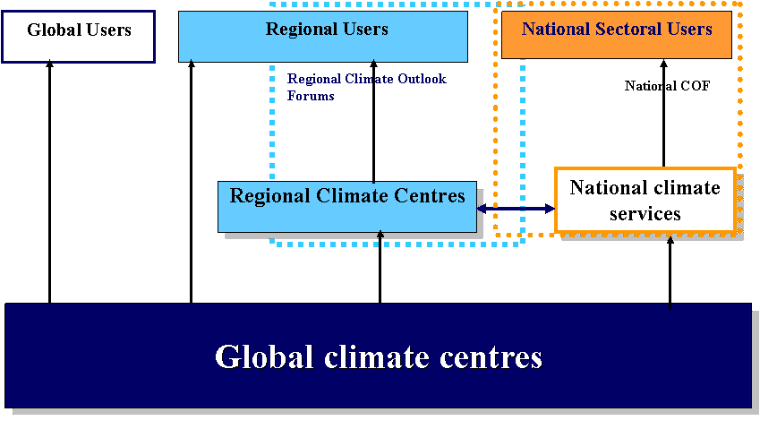
Fig. 1: The WMO Climate Service Information System illustrating the flow of climate information from global centres to regional and national centres and users. The Global Climate Centres include prediction centres, such as the GPCs, their associated lead centres, and global climate monitoring centres. (from draft ‘Position Paper on Global Framework for Climate Services’ at http://www.wmo.int/pages/gfcs/index_en.html)

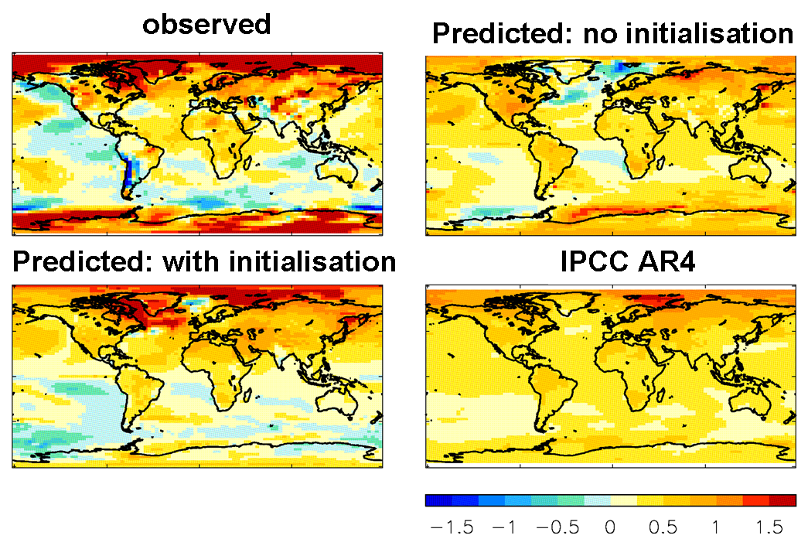
Fig. 2: Case study prediction of multi-annual temperature anomalies for the period June 2005 to Nov 2008. Top left: observed anomalies (NCEP reanalysis); bottom left: prediction from June 2005 initialisation using the Met Office decadal prediction system (DePreSys), top right: prediction from an equivalent system, but with no data assimilation, bottom right: prediction from an ensemble of uninitialized systems from the IPCC AR4. Note improved regional prediction from the initialised system.

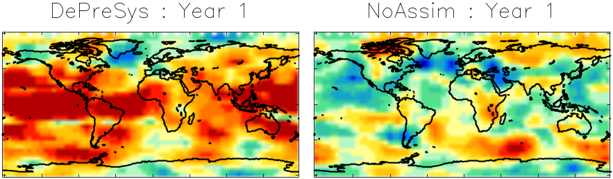
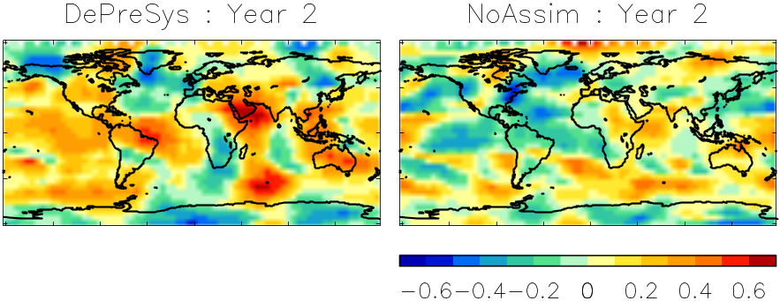
Fig. 3: Correlation between observed (GPCP) and predicted ensemble-mean annual precipitation anomalies. Each pixel shows the correlation of regional averages (over a 35°x35° latitude/longitude box) centred on that pixel and calculated over a set of hindcasts starting each November from 1979 to 2005. Left-hand column: correlations from the Met Office decadal prediction system (DePreSys). Right-hand column: correlations achieved with a corresponding system with no assimilation of the initial state (NoAssim). Both DePreSys and NoAssim predictions are the ensemble mean of a 9-member ensemble. The top and bottom rows show respectively correlations for the first and second year of the hindcasts. Note the higher correlations obtained when the initial state is assimilated (left column).

Annex 1

TRAINING, GUIDANCE MATERIAL AND BASIC REQUIREMENTS

Group composition:
Dr C.A. SANTOS COELHO
Mr T. TOKUHIRO
Mr V.N. SAKWA
Dr K. KOLLI
Mr J.P. CERON

Main objectives:
Understanding Climate and its drivers
Understanding Climate Models
Understanding GPCs products and services
Understanding Verification
Understanding communication (to convey the forecast in an efficient way to the user)

The objectives to be covered in 5 packages, expanded below:

Climate knowledge: focus on Global and regional aspects, primarily about inter-annual variability (e.g. ENSO, DMI, NAO), General Circulation for both Ocean and Atmosphere, Ocean/Atmosphere and Land Surface interactions, Teleconnection Patterns, regional climate variability and impact of large scale forcings, Climate system

Climate models (CM): basic principle of CM (including parameterizations), operational deployment of CM for SIP, Coupled versus non coupled models, Ensemble forecast/Uncertainty sources, Regional Climate Models, Post-Processing (Diagnostic vs prognostic variables), Validation

GPC products: Calibrations (bias correction, ensemble mean, spread, probabilities, …), practical access (including e.g. format, data analysis codes), visualisation (e.g. Grads), Products sub-setting, Potential additional products, hindcasts vs forecasts, Lead-Time, MME, LC-MME products and access

Verification: reference datasets, terminology, SVS and specific methods (CCl guide), Interpretation and use, LC-SVSLRF products and access, User oriented evaluations

Tailoring for users/communication: downscaling and tailoring (empirical and dynamical), Methods and software, expert assessment, Communication (including multidisciplinary work)

Other
Training at basic and advanced levels to be drawn from the same syllabus (experience suggests e.g. 1 week for basic, 2 weeks for advanced)

A list of experts available for training will need to be maintained

Annex 2

REVISED TERMS OF REFERENCE OF THE ET-ELRF

(a) On the basis of requirements from Regional Climate Centres (RCCs), Regional Climate Outlook Forums (RCOFs) and NMHSs, and in the context of the Global Framework for Climate Services (GFCS), guide future development, outputs and coordination of components in the production of LRF. The components include Global Producing Centres (GPCs), Lead Centres for Long-range Forecast Multi-model Ensembles (LC-LRFMME), and the Lead Centre for the Standardized Verification System for Long-range Forecasts (LC-SVSLRF);

(b) In coordination with CCl, promote the use of GPC and LC forecast and verification products by RCCs, RCOFs and NMHSs, develop interpretation guidance to facilitate their use, and encourage feedback on usefulness and application;

(c) Report on production, access, dissemination and exchange of LRF products and provide recommendations for future consideration and adoption by CAS, CCl, CBS and other appropriate bodies;

(d) In consultation with relevant experts in CAS and CCl and with the Coordination Group on Forecast Verification, review developments in verification scores and practices with a view to updating the Standardized Verification System for Long-range Forecasts (SVSLRF);

(e) Assess applications for GPC status against the designation criteria and make recommendations on designation to CBS;

(f) Review the rules regarding user access to GPC and LC-LRFMME forecasts products;

(g) Review the status of extended-range forecasting activities and promote the exchange of extended-range forecasts and verification products;

(h) Promote international cooperation and research on initialized predictions for timescales longer than seasonal and report on potential for operational predictions to CBS and CCl;

(i) Review the Manual on the GDPFS (WMO-No. 485) and propose updates as necessary concerning extended and long-range forecasts.

