WORLD METEOROLOGICAL ORGANIZATION  COMMISSION FOR BASIC SYSTEMS  OPAG on DPFS  IMPLEMENTATION COORDINATION TEAM  Tokyo, Japan, 13 – 17 September 2010 |  | CBS-DPFS/ICT /Doc. 11.5  (08. IX.2010)  _______  Agenda item: 11  ENGLISH ONLY

REGIONAL PERSPECTIVE ON NWP/EPS SYSTEMS, PRODUCTS AND INFRASTRUCTURE

REGIONAL ASSOCIATION V (SOUTH-WEST PACIFIC)

(Submitted by Terry Hart and Joan Fernon, Australia)

Summary and purpose of document

This document provides a summary of the Global Data Processing and Forecasting System (GDPFS) of WMO, including the Emergency Response Activities (ERA), in Regional Association V.

Action Proposed

The meeting is invited to note the report on the status of the GDPFS in RA V and the issues raised when it considers plans for the development of NWP/EPS systems and the exchange of outputs from those systems in support of Public Weather and Disaster Risk Reduction Services.

Annex: Status of the GDPFS in RA V (as at July 2010)

Introduction
There have been significant developments in DPFS in RA V over the last few years. Indonesia, Malaysia and the Philippines have commenced operating limited area models and, in the case of Malaysia, this includes wave and storm surge models. Additionally, WMC Melbourne has been designated as a Global Producing Centre (GPC) for seasonal to inter-annual forecasts based on ensemble predictions from a coupled ocean-atmosphere model.

A major initiative is the Severe Weather Forecasting and Disaster Risk Reduction Demonstration Project (SWFDDP) which commenced in a pilot phase in November 2009 and will move to a demonstration phase at the end of 2010. This project aims to demonstrate the application of leading edge NWP output to public weather and disaster risk reduction services in developing countries. It will also demonstrate the continuing value of the GDPFS through which advanced regional centers provide synthesized guidance products to support services in small developing NMHSs. This latter aspect is particularly necessary in the Pacific region of RA V.

The GDPFS in RA V
Based on the latest updated information provided by Members on the status of the implementation of the GDPFS: WMC Melbourne and the ASEAN Specialized Meteorological Centre (ASMC) Singapore are running global models; six countries (out of 18) are reporting running Limited Area Models using boundary conditions obtained either from their own GM or from GM of other Centres like Offenbach (GME) (used by 1 Centre) or Washington (GFS) (used by 4 Centres) or Tokyo (GMS) (used by 1 Centre); three countries have reported running non-hydrostatic models; four countries have reported running wave models; one country has reported running a dust-sand model; and one Centre runs a global model for LRF. Two countries report running ocean circulation models. In support to long-range forecasting (LRF), GPC Melbourne is producing seasonal to inter-annual forecasts based on ensemble predictions from a coupled ocean-atmosphere model. A listing of NWP systems operated in RA V is provided in Annex A, including details of Australia’s new ACCESS systems.

RSMCs with geographical specialization (Darwin, Melbourne and Wellington) provide regional products to assist NMCs in the forecasting of small-, meso- and large-scale weather systems.

RSMC Melbourne (with activity specialization in atmospheric transport modelling (ATM)) maintained its readiness to support environmental emergency response for RA V and on 1 September 2008 was designated in the arrangements for the Joint ATM-backtracking response system for the Comprehensive Nuclear-Test-Ban Treaty Organization (CTBTO). RSMC Darwin is a Volcanic Ash Advisory Centre and provides ash clouds trajectories and dispersion forecasts for aviation.

The NWP systems operated by Australia were replaced in August 2010 by “ACCESS” (Australian Community Climate and Earth-System Simulator) Numerical Weather Prediction (NWP) systems. ACCESS systems are based on the UK Meteorological Office’s Unified Model/Variational Assimilation (UM/VAR) system. A new range of analysis and prognosis charts generated by the ACCESS systems have been made freely available at http://www.bom.gov.au/australia/charts/viewer/.

The dynamics of the UM are non-hydrostatic. The grid points at which the equations are solved are staggered vertically and horizontally, thus minimizing errors in the numerical solution to the dynamics. The UM runs on “hybrid height” levels”, which approximate constant heights above terrain in the low levels and constant heights above MSL above about 30km, with a smooth blend in between. ACCESS systems employ a 4-dimensional variational data assimilation (4DVAR) scheme. This scheme is much improved over the three-dimensional variational data assimilation used in the older systems; since time differences between various observations; and between observations and the nominal analysis time are resolved in a dynamically consistent way. Secondly considerably more observations and observation types are assimilated into the ACCESS systems compared with the older systems. In particular satellite observations such as AIRS data with its detailed temperature and moisture profiles. Additionally synoptic surface winds and temperatures are assimilated into ACCESS systems.

The new ACCESS systems have almost identical domains to those of the older Australian systems. ACCESS-TC, the new tropical cyclone forecasting system, is not yet operational, but is expected to be so soon. Figure 1 below displays the domains and grid spacing of the ACCESS systems.

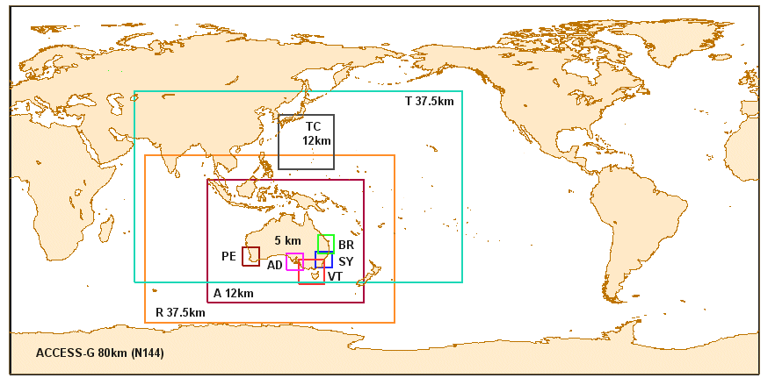
Figure 1: Domains and grid spacing of ACCESS systems.

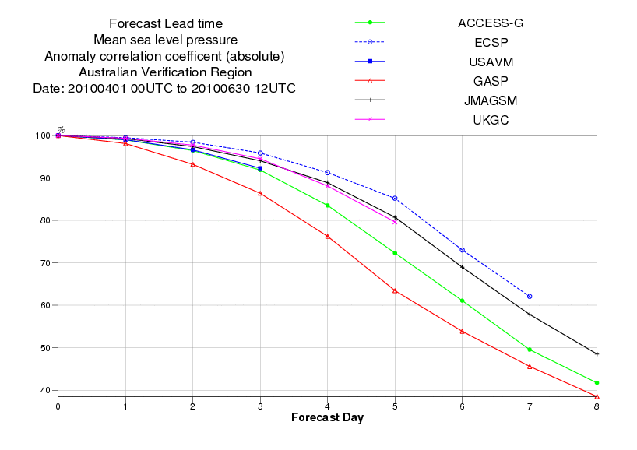
Figure 2: MSLP anomaly correlations over the Australian region for ACCESS-G(green), GASP(red) European Centre ECSP, United States USAVM, UK Met Office UKGC and Japanese Met Agency JMAGSM. Higher correlations indicate a better performance.

The new ACCESS systems show significant improvements in NWP forecast performance skill relative to Australia’s previous suite of NWP. MSLP objective performance statistics for the new global and regional models (ACCESS-G and ACCESS-R) all show improved performance, particularly at longer forecast times compared with the respective predecessors GASP and LAPS375. See Figure 2 for MSLP anomaly correlations, over the Australian region, for ACCESS-G verses GASP and a number of other global models. ACCESS-G shows clear improvement over GASP.

Figure 3 compares MSLP S1 skill score, root mean square error and forecast bias, over the Australian region, for ACCESS-R and LAPS375. All verification scores indicate an improvement in ACCESS-R over LAPS375, with the increased relative improvement at longer forecast times.
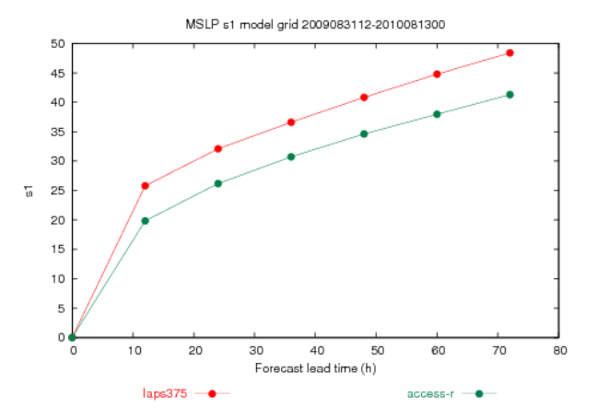  a) | 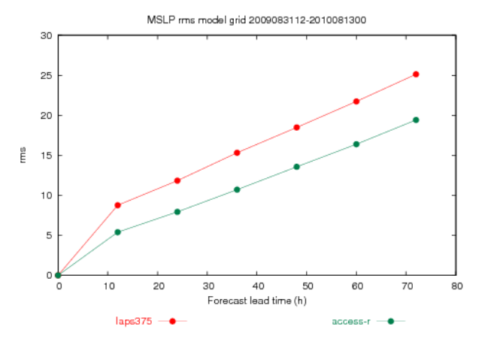  b)
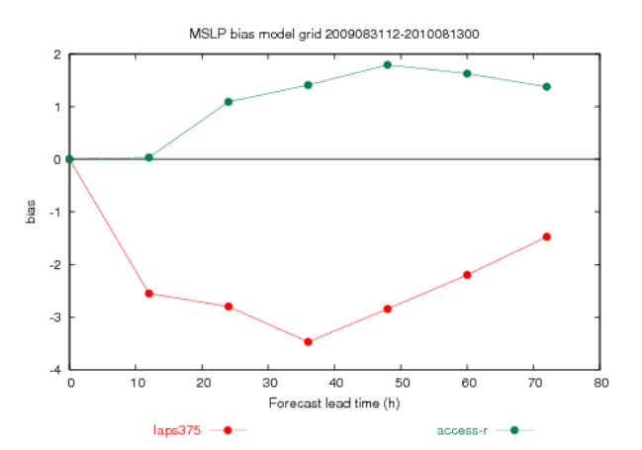
c)
Figure 3: MSLP a) S1 Skill Score, b) RMS error, c) bias over the Australain region for ACCESS-R(green), LAPS(Red). Lower values of S1 skill score, RMS error, and absolute values for bias indicate a better performance.

A subjective synoptic-based assessment of the ACCESS systems has been undertaken over the last year. It has been found that ACCESS-G compares favourably with the ECMWF model in depicting the broad-scale circulation out to 5 days. However, the larger horizontal grid spacing of ACCESS-G compared to the UKMO and ECMWF global models is evident in forecasting the movement and intensity of smaller scale synoptic systems such as cut-off lows in the Tasman Sea and easterly propagating sharp upper troughs. This issue will be addressed in 2011 when ACCESS-G will be upgraded to half the horizontal grid spacing. ACCESS-R’s depiction of synoptic systems and their evolution with time is superior to LAPS375. In mid-latitudinal westerly regimes 72 hour forecasts ACCESS-G forecasts are superior to those of ACCESS-R. This is due to errors propagating eastward from ACCESS-R’s western boundary. ACCESS-T, which replaces TXLAPS, appears to be performing well, capturing and maintaining relatively weak low-level tropical circulations well. However, tropical cyclones in the NW Pacific have not been well represented. This is because the synthetic vortex “bogussing” of tropical cyclones circulations, which had previously been used in the TXLAPS assimilation, has not yet been implemented in the ACCESS systems. Synthetic vortex “bogussing” is due to implemented in ACCESS-T prior to the 2010/2011 southern hemisphere tropical cyclone season.

As noted above, the ACCESS suite will be upgraded in 2011. As a result, significant forecast performance improvements are expected. ACCESS-G and ACCESS-R will double their current horizontal resolution. ACCESS-T and ACCESS-A will be superseded by the new higher resolution ACCESS-G and ACCESS-R respectively. The upgraded systems will run on 70 model levels compared to the current 50 levels. Additional satellite observations will be assimilated including 1-hourly local Atmospheric Motion Vectors (AMVs), IASI hyper-spectral infrared data, GPS-radio occultation data, and WINDSAT scatterometer data. An ACCESS ensemble prediction system is also planned, but is not expected to be operational until 2012.

Severe Weather Forecasting Demonstration Project
Following the success of the Severe Weather Forecasting Demonstration Project (SWFDP) regional sub-project in southern Africa (RA I), the Pacific region of RA V was endorsed as the site of the next sub-project. The sub-project in RA V is known as the Severe Weather Forecasting and Disaster Risk Reduction Demonstration Project (SWFDDP) to emphasise that public weather services and disaster risk reduction are part of the project from the start.

The SWFDDP provides a valuable opportunity to develop services to local communities through translating the potential of advanced NWP products, including EPS products, into operational use within NMHS and their partner organisations such as media and natural disaster management offices (NDMOs). A major focus is extending the lead time for warning of severe weather events. Another goal in RA V is to strengthen the role of the various RSMCs in their services to countries in the Region including RSMC Nadi–TCC in its provision of tropical cyclone warning services.

The Implementation Plan for the SWFDDP was completed in April 2009 and involves:
- the NMHSs of Solomon Islands, Vanuatu, Samoa, Fiji;
- RSMC Wellington as the main regional centre for the project,
- RSMC Nadi with specialization in TC forecasting
- RSMC Darwin
- Global Producing Centres Met Office (UK) and the ECMWF who are contributing products for the SWFDDP, with potential participation from NCEP (USA) and MeteoFrance.

The pilot phase commenced on 1 November 2009 focusing on Fiji, Samoa, Vanuatu and Solomon Islands in a complete end-to-end cascading process. In-country training (provided by Australia, UK and New Zealand) was delivered during June, September and October 2009.

The SWFDDP Web portal developed by RSMC Wellington (called MetConnect Pacific) is now operational as a single point of access for global and regional products. RSMCs Wellington and Nadi are producing extended range guidance products for the participating countries, with RSMC Nadi providing guidance for tropical cyclones and RSMC Wellington, guidance on other severe weather and marine phenomena. RSMC Wellington produces graphical guidance out to five days, synthesising the additional NWP products being provided as part of SWFDDP. NWP products on MetConnect Pacific currently come from global centres (UK Met Office and ECMWF) and RSMC Darwin with possible contributions later in the project from NOAA/NCEP (USA) and Météo-France. Some samples from the MetConnect Pacific site are shown in the figures below.

The SWFDDP was originally intended to focus on tropical cyclones, but after consultation was broadened to cover other severe weather events – heavy rainfall, strong winds and large waves, especially long period swell that can inundate low-lying areas.

The pilot phase was successful and a progress report has been prepared. It is planned to move into a full demonstration phase starting from November 2010. Four additional NMHS will participate in this phase - Kiribati, Tuvalu, Tonga, Niue & Cook Islands.

After evaluation of the project, future options proposed are to extend the operational guidance area to a new “western window” and to set up a similar guidance area north of the equator.

GDPFS – Long-Range Forecasts
There has been significant progress by designated Global Producing Centres (GPC) of Long-Range Forecasts, including GPC Melbourne, which is designated as the Lead Centre for LRF Verification in collaboration with GPC Montreal. GPC Melbourne has been contributing to the Multi-Model Ensembles (MME) efforts at the Lead Centre for Multi-Model Ensembles, jointly operated by GPC Washington and GPC Seoul

Tropical Cyclone Forecasting
NWP and EPS products are now the key tool for forecasting the genesis and tracks of tropical cyclones. Strong links have been established in RA V between the Tropical Cyclone Committee and the Working Group covering GDPFS. Such links are being strengthened through the SWFDDP.

While NWP systems have achieved a high level of accuracy in tropical cyclone track forecasting, NWP systems have much lower skill in forecasting intensity. There is also an increasing need for including uncertainty information in the forecasts for more effective disaster risk assessment. The Regional Association has encouraged RSMCs and NMHSs to further exploit the use of ensemble techniques in tropical cyclone forecasting and probabilistic forecasts. In the mean time, methods for calibration of TC intensity, utilization of consensus track forecast or an ensemble of EPS, interpretation techniques of probabilistic forecasts for decision-makers and downscaling techniques need to be developed.

The Association also noted the increased accuracy in the prediction of the genesis and intensity of tropical cyclones that can result from improvements in model resolution. The Association urged the research community to quantify these benefits in deterministic models and to investigate the use of high resolution ensemble systems, such as proposed by the developing TIGGE LAM (Limited Area Modelling) project. It requested Members and the Secretary-General to continue to explore the potential for a research and development project over this Region to investigate this approach to improved prediction and to quantify the potential societal benefits.

Research and Development: Transition from Research to Operations and Next Generation Systems for Weather Forecasting
The recent meeting of RA V noted the benefits to its Members from participation in Forecast Demonstration Projects (FDPs, e.g., Sydney 2000) and concurred with the recommendation of the Executive Council Research Task Team (EC-RTT) that two-way interactions between research, users and operations should begin early in the FDP planning process to help focus basic and applied research on user needs and ensure a more rapid transfer of research to operations and end-users. In particular, user interaction was urged in the eventual incorporation of the Global Interactive Forecast System/THORPEX Interactive Grand Global Ensemble (GIFS-TIGGE) products for tropical cyclones and possible heavy rainfall into the SWFDDP.

Other Issues
Marine Meteorological Forecasting
Given the large area of ocean in RA V, marine forecasting is very important. The full potential of NWP systems to provide very valuable guidance is probably not yet being realised in support of warnings for high impact and extreme sea state events.. A particular problem that has been identified through JCOMM is the problem of coastal damage or inundation from remotely generated long period swell. Wave models now have considerable skill in these predictions that can be translated into warning and alerting services. This work is being pursued in RA V by the Storm Surge Watch Scheme (SSWS) Action Team which is a task team under the RA V Tropical Cyclone Committee.

Nowcasting
Many NMHS in RA V do not have access to radar data, or even local lightning detection networks. The recent meeting of the Regional Association noted that nowcasting can integrate a variety of observational platforms (e.g., radars, satellite, lightning detection systems and in-situ observations) and noted the potential benefits of non-radar based systems to Members with limited radar capability. The ICT may be able to assist RA V Members to improve nowcasting capabilities using non-radar based and integrated nowcasting systems.

Ensemble prediction systems (EPS)
The meeting of RA V in May 2010 encouraged Members to increasingly integrate outputs from ensemble prediction systems (EPS) into the process of forecasting to enhance the production of forecasts and warnings, and noted that continuing support for capacity building in the use of EPS products was needed, especially in developing countries. It agreed that the inclusion of EPS outputs in the SWFDDP is central to demonstrating methods for extending the lead-time for alerting of severe weather.

Capacity of NMHS in RA V
Many of the NMHS in the Pacific region are very small with few trained meteorologists. Consequently, it is a great challenge for them to access and analyse the vast array of NWP products available from DPFS centres and translate those products into enhanced services. There is a valuable role for an RSMC to synthesise the products into summary guidance products. This role is being demonstrated in SWFDDP, but the MetConnect Portal also greatly improves the accessibility of the raw NWP products by the NMHS through a convenient and accessible web display.

Communications
A major factor affecting the ability of many NMHS in RA V (especially the small island states) to fully benefit from the increasing availability and skill of NWP systems is the limited or unreliable Internet access. Good Internet bandwidth is necessary for satisfactory access to the wealth of products available such as through MetConnect Pacific. RA V would benefit from initiatives of the ICT to improve the efficiency of access to NWP products.

Societal and Economic Research Applications (SERA)
Improvements in communicating predictions and their uncertainty could greatly benefit society, ecosystems and the economy and open new areas of application for NHMSs. The Regional Association noted that investments in SERA are usually a small fraction of the funds spent on observational and modelling hardware for weather prediction. The Association strongly urged its Members to consider the societal and economic impacts that flow from systems such as the GDPFS.

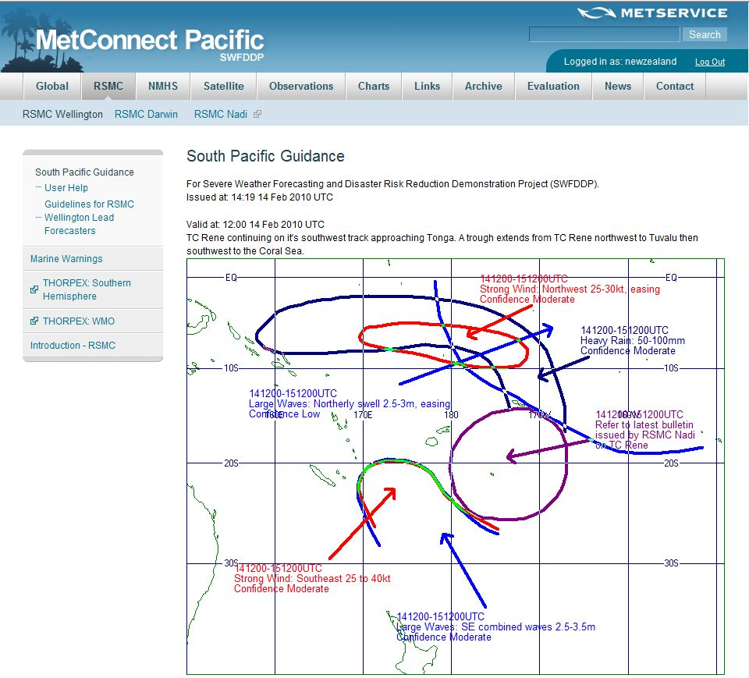

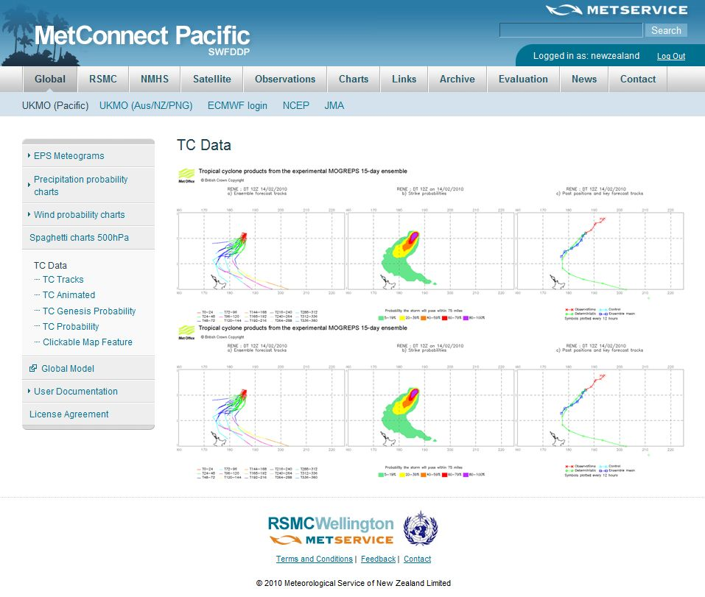

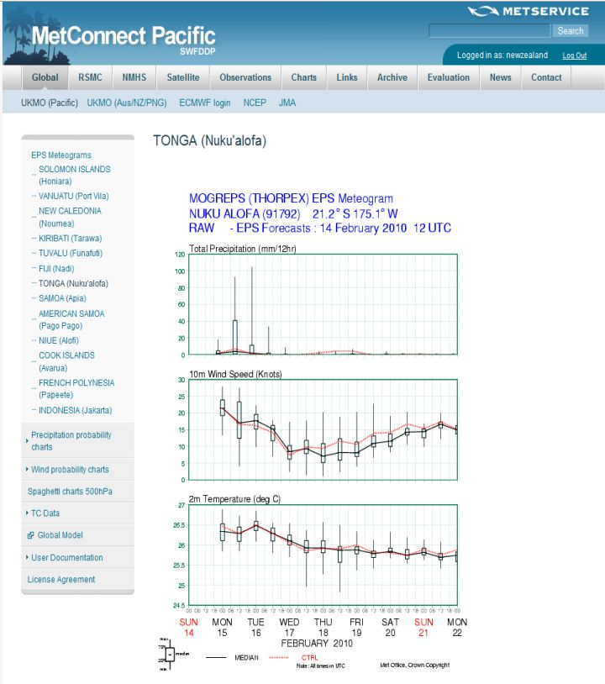

Annex A: Status of the GDPFS in RA V (for 2010)
(not including USA, UK and MeteoFrance who are also RA V Members)

GM = Global Model
LAM = Limited Area Model
Perturbation technique for ensemble prediction systems: SV = Singular Vectors, BGM = Breeding of Growing Modes, LAF = Lagged Average Forecasts, StoP = Stochastic Physics, OP = Observation Perturbations, ETKF = Ensemble Transform Kalman Filter
NMC= National Meteorological Centre
RMC= Regional Meteorological Centre (also called Geographical RSMC = Geographical Regional Specialized Meteorological Centre)
RTCC= Regional Tropical Cyclone Centre (also called RSMC for Tropical Cyclone)
RCATM= Regional Centre for Atmospheric Transport Model (also called RSMC for Transport Model)
WMC= World Meteorological Centre
GMC= Global Model Centre (one is also called RSMC for Medium-Range Forecast)
GPC= Global Producing Centre for Long-range Forecasts (LRF)

CENTRE | STATUS | MODELS | RESOL. | LEV. | RANGE | Boundary | Domain | Products on:
JAKARTA (2009) | NMC | Access to GM and LAM  LAM-ARPEGE, non-hydrost  TXLAPS, non-hydrostatic | 0.5°  0.375° | 15  16 | 72 h  48 h |  | Indonesia Region (40S-15N; 90-170E)
JAKARTA (2009) | NMC | LAM (MM5) non-hydrostatic | 50km, 30km ,  5-10 km | 23 | 72 h | GFS (NCEP) | ?
JAKARTA (2009) | NMC | CCAM | 27 km | 18 | 96 h
JAKARTA (2009) | NMC | CCAM | 9 km | 18 | 96 h
JAKARTA (2009) | NMC | Wave Model |  |  | 168 h | GFS (NCEP)
KUALA-LUMPUR (2009) | NMC | LAM (MM5) 3 D-VAR /  LAM (WRF) nested | 36 km | 23/30 | 72 h | GFS (NCEP), GSM (JMA) | 20S-30N; 85-135E
KUALA-LUMPUR (2009) | NMC | LAM (MM5) 3 D-VAR /  LAM (WRF) nested | 12 km | 23/30 | 72 h | GFS (NCEP), GSM (JMA) | 1.2S-12N; 98-121.5E
KUALA-LUMPUR (2009) | NMC | LAM (MM5) 3 D-VAR /  LAM (WRF) nested | 4 km | 27/30 | 72 h | GFS (NCEP), GSM (JMA) | 1-8N; 99-105.5E
KUALA-LUMPUR (2009) | NMC | LAM (MM5) 3 D-VAR /  LAM (WRF) nested | 4 km | 27/30 | 72 h | GFS (NCEP), GSM (JMA) | 0.5-8.5N; 109-120.5E
KUALA-LUMPUR (2009) | NMC | BOGUS (TC track) | 36 km |  |  |  | 0-20N; 90-130E
KUALA-LUMPUR (2009) | NMC | MMD-EPS Ens. 10 members | 12 km |  | 120 h | GFS (NCEP), GSM (JMA) | 1.2S-12N; 98-121.5E
KUALA-LUMPUR (2009) | NMC | Wave Model | 0.5° |  | 72 h | MM5 | Straight of Malacca and South China Sea
MANILA (2006) | NMC | LAM (MM5) | 20 km | 36 | 72 h | GFS (NCEP) | ?
MANILA (2006) | NMC | LAM(HRM) | ? | ? | ? | GME(DWD) | ?
SINGAPORE (2008) | NMC and ASEAN Specialised Meteorological Centre (ASMC) | GSM | 1.875° | 16 | 240 h |  | Gl
SINGAPORE (2008) | NMC and ASEAN Specialised Meteorological Centre (ASMC) | WRF | 25km | ? | 72 h | GFS (NCEP) | 15S-30N, 90E-145E
SINGAPORE (2008) | NMC and ASEAN Specialised Meteorological Centre (ASMC) | WRF (nested) | 5km | ? | 72 h |  | 0.5S-5N,100.5-106.5E
SINGAPORE (2008) | NMC and ASEAN Specialised Meteorological Centre (ASMC) | WaveWatch 3 | 1 deg |  | ? |  | 20S-40N, 60E-160E
SINGAPORE (2008) | NMC and ASEAN Specialised Meteorological Centre (ASMC) | WAM | 1 deg |  | ? |  | 50S-50N, 40E-160E
SINGAPORE (2008) | NMC and ASEAN Specialised Meteorological Centre (ASMC) | WAM (nest) | 0.25 deg |  | ? |  | 10S-12N, 90E-112E
SINGAPORE (2008) | NMC and ASEAN Specialised Meteorological Centre (ASMC) | Princeton Ocean Model (POM) | 1/12 deg | ? | ? |  | 9S-24N, 99E-121E
SINGAPORE (2008) | NMC and ASEAN Specialised Meteorological Centre (ASMC) | PRECIS | 50 km |  | Months? | UKMO | 13S-26N, 85E-143E
DARWIN (2010) | RMC | full access to GM and LAM
DARWIN (2010) | RMC | full access to LAM-(ACCESS-TC, from start TC season) | 0.10° | 50 | 72 h |  | See domains | GTS | SAT
NADI (2009) | RTCC | Access to GM |  |  |  |  |  | GTS
WELLINGTON ? | RMC | LAM | ? | ? | ? | ? | ?

MELBOURNE (2010) | WMC, RMC, RCATM and GPC | GM (ACCESS-G)  4D-VAR | N144 | 50 | 240 h |  | Global | GTS  Radio Fax:  VMC  VMV | SAT: DIFACS and MCIDAS
MELBOURNE (2010) | WMC, RMC, RCATM and GPC | LAM (ACCESS-R) 4D-VAR | 0.375° | 50 | 72 h | ACCESS-G | 65S-17N, 65E-185E | GTS  Radio Fax:  VMC  VMV | SAT: DIFACS and MCIDAS
MELBOURNE (2010) | WMC, RMC, RCATM and GPC | LAM (ACCESS-T) 4D-VAR | 0.375° | 50 | 72 h | ACCESS-G | 45S-56N, 60E-143W “ | GTS  Radio Fax:  VMC  VMV | SAT: DIFACS and MCIDAS
MELBOURNE (2010) | WMC, RMC, RCATM and GPC | LAM (ACCESS-A) 4D-VAR | 0.11° | 50 | 48h | ACCESS-R | 55S- 5N, 95E-170E
MELBOURNE (2010) | WMC, RMC, RCATM and GPC | LAM (ACCESS-C) | 0.05° | 50 | 36 h | ACCESS-R | 5 domains centred Brisbane,Sydney,Melbourne, Adelaide,Perth
MELBOURNE (2010) | WMC, RMC, RCATM and GPC | LAM (ACCESS-TC)  (to be implemented soon) | 0.10° | 50 | 72 h | ACCESS-T | Up to 3 30x30deg domains centred on TC
MELBOURNE (2010) | WMC, RMC, RCATM and GPC | Ens. 30 members, GM (POAMA) coupled with Ocean model ACOM2 | T47  0.5°-1.5° | 17  25 | 9 months |  | Global
MELBOURNE (2010) | WMC, RMC, RCATM and GPC | Microscale dispersion system: ADMS3 (Atmospheric Dispersion Model Version 3) | dependent on ACCESS model |  |  | ACCESS-A, ACCESS-C
MELBOURNE (2010) | WMC, RMC, RCATM and GPC | Hysplit Atmospheric Transport Model | dependent on ACCESS model |  |  | Any of the ACCESS models
MELBOURNE (2010) | WMC, RMC, RCATM and GPC | Wave Models (WaveWatch3) | 1° |  | 96 h | ACCESS-G (10m) | 78S-78N, 0-360E
MELBOURNE (2010) | WMC, RMC, RCATM and GPC |  | 0.5° |  | 48 h | ACCESS-R (10m) | 60S-12N, 69E-180E “
MELBOURNE (2010) | WMC, RMC, RCATM and GPC |  | 0.125° |  | 48 h | ACCESS-A (10m) | 50S-0,100E-165E “

