WORLD METEOROLOGICAL ORGANIZATION  COMMISSION FOR BASIC SYSTEMS  OPAG on DPFS  IMPLEMENTATION COORDINATION TEAM  Paris, France, 21 – 25 May 2012 |  | CBS-DPFS/ICT /Doc. 7  (11.V.2012)  _______  Agenda item : 7  ENGLISH ONLY

Report of the chairperson of the ET-EPS

Submitted by Ken Mylne

Summary and purpose of document

This document reports on the activities of the ET-EPS and progress made with respect to EPS-based products, probabilistic forecasting methods, and applications, coordination with THORPEX/GIFS-TIGGE and with the SWDFP.

Action Proposed

The meeting is invited to review the actions and recommendations of the ET-EPS and make recommendations for issues to be raised or proposals to be made at the forthcoming CBS meeting.

Annex(es):
- Annex I –Guidelines on EPS and Forecasting
- Annex II – ET-EPS Terms of Reference

Reference(s): - See links provided in text.

1 ET-EPS Meeting, 14-18 Nov 2011, WMO HQ, Geneva.
A summary of the meeting is provided here, and this paper is based heavily on the report from that meeting, updated where appropriate. The full report of the meeting can be found at
http://www.wmo.int/pages/prog/www/CBS-Reports/documents/Final-Report-ET-EPS-Geneva2011.pdf



(Back Row) Jean Nicolau, Ken Mylne, Pierre Eckert, Peter Chen, Masayuki Kyouda, Gerhard Wotawa

(Front Row) Young-Youn Park, Alice Soares, André Méthot, Jing Chen, David Richardson, Yuejian Zhu
EXECUTIVE SUMMARY

The meeting of the CBS Expert Team on Ensemble Prediction Systems (ET-EPS) took place at the WMO Headquarters, in Geneva, Switzerland, from 14 to 18 November 2011, under the chairmanship of Mr Ken Mylne (UK).

The meeting reviewed recent progress in implementing global EPS, regional EPS, convective-scale EPS and specialized EPS (e.g. Typhoon EPS). Significant advances have been made by several WMO Members in EPS, whose outputs provide the most important basis for a probabilistic approach to weather forecasting, in all time scales, including short-range forecasting. These products, used in conjunction with high-resolution deterministic NWP outputs, represent an enhanced forecasting strategy, especially for predicting severe weather events.

While a limited number of GDPFS centres run EPS operationally, many NMHSs are exploring various applications, and others are seeking to build capacity for their forecasters to access and effectively use EPS products in their forecasting process as well as to deliver services that are based on probabilistic forecasting methods. In particular, EPS application to support early warning of severe weather is of the highest priority, in contributing to disaster risk reduction. In this context, the meeting reviewed recent progress of EPS applications and integration into operational weather forecasting, post-processing and calibration, and the propagation of weather forecast uncertainty into specialized applications (e.g. EPS in atmospheric transport and dispersion, etc.), . Collaboration with Public Weather Services (PWS) on communicating forecast uncertainty to users, with emphasis on disaster risk reduction and to ensure effective pull-through of the benefits to societal impact, was discussed.

The meeting was briefed on key research activities of THORPEX-TIGGE, achieved and anticipated, and their implications and benefits for operational EPS production, access and use. It developed the EPS operational requirements for further research and studies.

The application of EPS to predict severe or high-impact weather events is among the most important topics, including in particular the propagation of the weather forecasts into impact models. Operational flood forecasting systems, including coastal flood forecasting due to waves and storm surges, are increasingly moving towards the adoption of EPS to drive their predictions. The availability of several global ensemble weather prediction systems has been providing an opportunity to explore new dimensions in flood forecasting and the potential to provide early warnings. The Team reviewed recent progress, on flash floods and coastal flood forecasting and other specialized applications such as Atmospheric Transport and Pollution.

Many NMHSs have difficulties in making use of ensemble fields made available in real-time by the producing centres for downloading. In particular, many NMHSs, especially those of developing countries and LCDs, do not have the computing facilities or capability to generate products from ensemble fields. Therefore, EPS continues to be a critical component of the guidance data provided to SWFDP subprojects from the global centres. The subprojects in Southern Africa, the South-west Pacific and in Eastern Africa have been supplied with EPS data by ECMWF, the Met Office UK and NCEP. The subproject in Southeast Asia, planned to commence in April 2012, will be supplied with EPS data by CMA, JMA, KMA and ECMWF (products available for all WMO Members). The use of EPS data is also included in plans for the SWFDP subproject being initiated in the Bay of Bengal. The meeting agreed that the training workshops carried out as part of the SWFDP subprojects have proven one of the most effective ways of providing training on the use of EPS, as the training has been provided in conjunction with ongoing access to operational EPS data.

The meeting reviewed and updated the Guidelines on EPS and Forecasting, which are provided in Annex I to this report. The meeting also reviewed the status of implementation of the Lead-Centre for EPS Verification.

Noting that a first version of the new Manual on the GDPFS (WMO-No. 485) will be presented to CBS-XV, in 2012, for consideration, the meeting agreed that any proposed amendments to the Manual on the GDPFS should be reflected in the new version. The meeting requested the chairperson, in coordination with the Expert Team members and in liaison with the chairperson of the CBS Coordination Group on Forecast Verification, to review the draft text for the new Manual, and submit to the Secretariat a revised version by mid-March 2012.

The meeting reviewed the team’s Terms of Reference (ToR) as adopted at CBS-Ext.(10), and proposed revised ToR as given in Annex II.

2. PROGRESS OF EPS IMPLEMENTATIONS

2.1 Global EPS

2.1.1 Global Ensemble Prediction Systems (GEPS) have improved during the last couple of years (since its previous meeting, in 2009), in terms of resolution, ensemble size, length of integration and frequency of forecast cycles. The horizontal resolution has increased to 32-70km for most of the EPS Global Producing Centres, while Météo-France has implemented a system with variable horizontal resolution (15km over France to 90 km at the antipodes (e.g. over New Zealand)). The number of vertical levels has also increased to between 28 and 70 levels. Most of the centres increased ensemble size and most systems have more than 20 members. The length of integration is 10-15 days at most centres. At most of the centres, the frequency of the outputs is 6 hours, however for short-range forecasting, some centres provide outputs every 3 hours.

2.1.2 While singular vectors and Breeding Vector (BV) methods are still used in generating initial perturbations, an increasing number of centres are now implementing variations on the Ensemble Kalman filter (EnKF) including the Ensemble Transform Kalman Filter (ETKF) and Ensemble Transform and Rescaling (ETR) methods. Several centres are now integrating their ensemble generation and data assimilation systems using Ensemble Data Assimilation (EDA) systems or hybrid data assimilation systems in which the ensemble is used to provide background error statistics for data assimilation.

2.1.3 Model error uncertainties are simulated by a range of stochastic physics perturbations, including Stochastic Kinetic Energy Backscatter (SKEB), Random Parameters (RP) and Stochastic Total Tendency Perturbations (STTP). Some systems use a Multi-Model or Multi-Physics approach and Perturbations of Physics Tendencies (PPT).

2.1.4 A summary of the main characteristics of the Global Ensemble Prediction Systems implemented at the participating centres at this meeting (as of November 2011) is provided in Table 2.1.

Table 2.1 – Summary of main characteristics of the Global Ensemble Prediction Systems implemented at the participating centres at this meeting (as of November 2011)
 | ECMWF, Europe | Meteo-France | UK Met Office | KMA, Korea | CMA, China | JMA, Japan | NCEP, USA | CMC, Canada
Name |  | PEARP | MOGREPS-G /15 |  | GEPS | One-week EPS | GEFS | GEPS
Model  Name |  | ARPEGE | UM | UM |  | GSM | GFS | GEM
Assimilation  Method | 4D-Var | 4D-Var | Hybrid  4D-Var | 4D-Var | SSI | 4D-Var | GSI | 196 members  EnKF
Horizontal  Resolution | T639/T319 (32/64 km) | Variable TL538 with a stretched coeff of 2.4 (15km→90km) | N216 (60km) | N320 (40km) | T213 (60km) | T319 (60km) | T190  (70km) | 66km
Vertical  Resolution (levels) | 62 | 65 | 70 | 70 | 31 | 60 | 28 | 40
Initial  Times | 00,12 | 06, 18 | 00, 12  (From 2012  M-G also 06, 18) ²⁾ | 00,12 | 00,12 | 12 | 00, 06, 12, 18 | 00, 12
Lead  Time | 15 days | 72h (06), 108h (18) | M-G 3d  M-15 15d | 10 days | 10days | 9 days | 16 days | 16 days
Output  Frequency | 3h to 144, then 6h | 3h to 54h then 6h | M-G 3h  M-15 6h | 6h | 6h to 120h,12h to 240 | 3,6,12-hour | 6 hours | 6 hour
No. of  Members (+control) | 50+1 | 34+1 | 23+1  (From 2012 M-G 11+1) ²⁾ | 23+1 | 14+1 | 50+1 | 20+1 | 20+1
Coupled  Ocean | From D10 | No | No | No | No | No | No | No
Multi-Model | No | No | No | No | No | No | No | Yes
Initial  Perturbations | SV+EDA | SV+EDA | Localized ETKF | Localized ETKF | BGM | SV | ETR | EnKF
Model  Perturbations | SKEB+ SPPT | Multi Physics | RP, SKEB | RP, SKEB | No | SPPT | STTP | SKEB  & PPT
Surface  Perturbations | No | No | SST | No | No | No | No | No
Notes: 1) Only systems represented at the meeting are included.
2) From 2012 MOGREPS-G will change from 24 members twice per day to 12 members 4 times per day; products will be generated from 24 members by time-lagging of the last 2 cycles.

2.2 LAM-EPS

2.2.1 Operational Regional Ensemble Prediction Systems (REPS) is playing a rapidly increasing and important role in a number of NMHSs and Consortia (e.g. COSMO, Aladin, UM). Currently, the horizontal resolution ranges typically from 7km to 33km, with up to 70 levels. The ensemble size ranges from 15 to 24 members and the length of integration ranges from 2 to 5.5 days. At most of the centres, the frequency of the outputs is 3 hours. In addition one centre is now running a convection-permitting EPS with a horizontal grid-length of 2.8km and hourly outputs for a 1 day forecast – this is included here for completeness, but is discussed in more detail in section 2.3 below.

2.2.2 A variety of methods is used in generating initial perturbations in REPS, including global localized Ensemble Transform Kalman Filter (ETKF), Breeding Growth Method (BGM) and extended Breeding Vector (BV) method with Ensemble Transform and Rescaling (ETR). It should be noted that a number of these use downscaling techniques where the regional perturbations are downscaled from the global EPS providing the boundary conditions; in some cases the initial analysis is also downscaled. Models errors are addressed by a range of stochastic physics perturbations, including Stochastic Kinetic Energy Backscatter (SKEB) and Random Parameters (RP). Some REPS use a Multi-Model or Multi-Physics approach and Perturbations of Physics Tendencies (PPT). Most of the centres are implementing perturbations of surface fields (e.g. SST).

2.2.3 A summary of the main characteristics of the Regional Ensemble Prediction Systems implemented at the participating centres at this meeting (as of November 2011) is provided in Table 2.2.

Table 2.2 – Summary of main characteristics of the Regional Ensemble Prediction Systems implemented at the participating centres at this meeting (as of November 2011)
 | UK Met Office | COSMO | COSMO | CMA, China | NCEP, USA | CMC, Canada
Name | MOGREPS-R | LEPS | DE-EPS | REPS | SREF | REPS
Forecast Model | UM | COSMO (param. Conv) | COSMO (expl. Conv) | WRF | NAMB/WRF | GEM
Assimilation  Method | 4D-Var | No | Nudging | 3D-Var | GSI | No
Initial  Analysis | Regional 4D-Var | Global | High resolution | Regional 3D-Var | Various | Global EnKF
Domain | Europe & N Atlantic | Europe | Germany | China | North American | North America
Horizontal  Resolution | 18km | 7km | 2.8km | 15km | 30km | 33km
Vertical  Resolution (levels) | 70 | 40 | 60 | 31 | 40-60 | 40 (plus lid nesting – top boundary)
Initial  Times | 06, 18  (From 2012, 03, 09, 15, 21Z)²⁾ | 12 | 0, 3, 6, 9, 12, 15, 18, 21 | 00,12 | 03, 09, 15, 18 | 00, 12
Lead  Time | 54h | 132h | 24h | 60h | 87h | 3 days
Output  Frequency | 3h | 6h | 1h | 3h | 3h | 6 hour
LBC Source | MOGREPS-G | ECMWF EPS | SREPS | CMA GEPS | various | Canadian GEPS
No. of  Members | 23+1  (From 2012 11+1) ²⁾ | 16 | 20 | 14+1 | 21 | 20+1
Multi-Model | No | No | No | No | Yes | No
Initial  Perturbations | Global Localized ETKF | No (ECMWF EPS) | From 4 Global models | BGM | BV and ETR | Glob EnKF
Model  Perturbations | RP, SKEB | No | No | Multi Physi. | Yes | SKEB  & PPT
Surface  Perturbations | SST | No | No | Yes | Soil moisture | No
Notes: 1) Only systems represented at the meeting are included.
2) From 2012 MOGREPS-R will change from 24 members twice per day to 12 members 4 times per day; products will be generated from 24 members by time-lagging of the last 2 cycles.

2.3 Convective-scale EPS

2.3.1 At many advanced centres and consortia, NWP development to support high-impact weather prediction is now focused on high-resolution global models and convection-permitting (or convective-scale) models (grid spacing: 1-3 km). EPS is highly relevant to convective-scale NWP because convective instability adds a new scale of forecast uncertainty not resolved by the lower resolution models, and with much shorter timescales. In addition to convection itself, models on this resolution have greatly enhanced capability for forecasting other aspects of local weather, such as low cloud and visibility of interest to aviation. Many of these phenomena are significantly affected by topographic forcing which may give enhanced predictability when that forcing can be resolved by the models (e.g. convective initiation or valley fog). Convective scale EPS has the potential to provide information on the predictability of all these weather elements.

2.3.2 Physical processes leading to convection are highly non-linear, so that the explicit modelling of convective cells over one or a few hours should already be seen as medium-range forecasting, with very limited deterministic predictability for the individual cells. Thus, convection-permitting ensembles already focus on the shortest-range (0-24 hours), as opposed to the short-range (0-3 days).

2.3.3 A few centres (e.g. Météo-France, UKMO, and COSMO) have been experimenting with convection-allowing ensembles with horizontal resolutions of around 2.5km. None of these are operational at the current time, except the COSMO-DE-EPS. The emphasis has been put on the prediction of heavy precipitation events.

2.3.4 Uncertainty on the convective scale has a very large dimensionality, and a very large ensemble would be required to fully sample this. Therefore, these systems have been addressing uncertainty in the location of convective precipitation by neighbourhood techniques whereby the probability of heavy precipitation at a location can be estimated by considering whether the (deterministic) model has precipitation within a neighbourhood around that location.

3. PROGRESS OF EPS APPLICATIONS AND OPERATIONAL INTEGRATION

3.1 Integration of EPS in core operational forecasting

3.1.1 While noting that the majority of operational forecast production in many NMHSs has continued to be based on deterministic models, with the ensembles providing peripheral and supplementary information, work is now underway by a number of centres to further integrate EPS in core operational forecasting.

3.1.2 The North American Ensemble Forecast System (NAEFS) established in 2004 by the Meteorological Service of Canada (MSC), the National Meteorological Service of Mexico (NMSM), and the US National Weather Service (NWS) is used in all three countries for operational forecasting. The participating centres collaborate in the development of post-processing algorithms and software and share a common procedure to generate the basic products of bias-corrected forecasts, the corresponding weights and climatological percentile values. The products for probabilistic forecast (10%, 90%, 50%, mean, mode and spread) have been generated after statistical bias correction for all ensemble members. These products are freely available in digital form through the NOMADS Web site (http://nomads.ncdc.noaa.gov/), including easy selection of regional cut-outs. Downscaling probabilistic products have been generated in NDGD (National Digital Guidance Database) grid by using Real Time Mesoscale Analysis (RTMA) as proxy truth. Some of the end products are developed jointly (such as the North American week-2 temperature and precipitation anomaly forecast), while others are provided by individual participating centres.

3.1.3 The meeting was informed that in order to integrate EPS more fully in the operational production, UKMO has been working to post-process deterministic and EPS forecasts in a more integrated fashion. The two post-processing techniques are being used:

(a) Site-specific forecasts
The UKMO uses a database system to store forecast data for specific locations (sites) both in the UK and around the globe. Site-specific extraction from model grids is carried out by a routine named SSPS (site-specific processing system) which selects the most appropriate model grid-point and corrects for differences between model orography and station height. Exactly the same SSPS routines are used to extract data from EPS grids (both MOGREPS and ECMWF EPS) and the deterministic models. Where site observations are available, a Kalman filter (KF) is applied to correct site-specific model biases in forecasts, which further reduces the impact of the difference in resolution between EPS and deterministic models. Creation of the deterministic “best-data” value is now based on a Best Data Blending technique, which is a lagged blending updating technique, and incorporates a lot of EPS data. This is accompanied by probabilistic tables which store percentile values, Ensemble Mean and Spread. Probabilities for any threshold required by a user can be interpolated from these percentile points. If necessary, the ensemble spread is adjusted to ensure that the distribution is consistent with the deterministic value. This combination of deterministic and probabilistic best-data allows all automated products to use consistent data, including uncertainty as either error bars, a full distribution or probabilities of specific events.

(b) Gridded data
Gridded NWP data for the UK are stored on a 2km UKPP (UK post-processing) grid (outside the UK a 5km EuroPP grid is used for Europe and a 10km GlobalPP grid is under development). Forecasts from both short-range high resolution models and longer-range lower-resolution global models are downscaled to the same 2km grid. Ensemble data are now being experimentally downscaled to the same 2km grid, using high-resolution topographical information to make simple temperature and wind-speed adjustments.

3.1.4 The meeting discussed the portability of such systems and techniques, focusing especially on developing countries. It noted that high-resolution gridded fields will not be appropriate for all countries due to the high computing demands. It recommended sharing knowledge and experience to evaluate the applicability of such systems and techniques to other countries/regions.

3.2 New developments in post-processing and calibration

3.2.1 To provide better predictions, some centres conduct statistical post-processing to their EPS products for bias correction and calibration of the pdf (probability density function). Bias correction is the most widely applied procedure, and an adaptive Kalman Filter approach is commonly used. The use of reforecast data can allow more complete training of statistical post-processing and make it more effective, especially for extreme events. At some centres, combination of an EPS with the corresponding high resolution deterministic prediction is operationally implemented, and statistical downscaling technique, with high resolution analysis as the reference, is used to provide forecast guidance at local scale. Some more sophisticated techniques for calibrating the first and second moments of the pdf are also being implemented. Further explanation and advice on these post-processing techniques is provided in the Guidelines on EPS and Forecasting updated by the ET-EPS at their meeting.

3.3 Communication of forecast uncertainty to users (PWS)

3.3.1 A Public Weather Services (PWS) representative was invited to attend the ET-EPS meeting to discuss collaboration with the PWS programme on communicating forecast uncertainty to users to ensure effective pull-through of the benefits to societal impact. However, no PWS representative was available to participate in the meeting.

3.3.2 The meeting noted that a major block to the publication and use of probabilistic forecasts has been the belief among many scientists and managers that people do not understand probabilistic information. There is now a considerable body of academic research which shows that a large majority of people do understand this information, and make better decisions when presented with it.

3.3.3 Two separate experiments conducted at Exeter University in the UK, using samples of several hundred undergraduate students studying a wide range of academic disciplines, have shown that candidates presented with temperature forecasts including uncertainty information in different formats make significantly better decisions than those presented with simple deterministic forecasts. People presented with the uncertainty information in graphical form were able to assimilate it and make their decisions more quickly than those presented with the same information in tabular form.

3.3.4 A mass-participation experiment conducted by the UK Met Office in collaboration with the Universities of Bristol and Cambridge through an on-line game has also shown that people presented with probabilistic information in a variety of formats make better decisions than those given simple deterministic forecasts. The game format, in which participants were asked to make decisions to help an ice-cream seller maximise his sales on the basis of temperature and rainfall forecasts, was used to attract over 8000 separate people to participate. The majority of these were in the UK and spanned a wide range of ages and academic attainment. Participants were randomly assigned different types of forecast presentation, and each candidate asked the same questions based on the forecasts. Early results show not only that people make better decisions with probabilistic forecasts, but that they make the best decisions with the most complex presentations. For rainfall forecasts they made better decisions, and showed greater understanding of their confidence in their decisions, when the probability of precipitation was presented numerically (e.g. 20%) than when a simpler Low/Medium/High scale was used. For temperature forecasts they performed best when presented with a fan chart showing 5 percentile points, the most complex presentation used. Importantly, in simple situations where the decision was easy even with a deterministic forecast, participants did not make worse decisions when presented with probabilistic presentations, so they were not confused by the information.

3.3.5 The meeting also noted that experiments conducted by psychologist Susan Joslyn in the USA have also shown that people make better decisions when presented with uncertainty information in weather forecasts. For general public or non-experts, people understand that forecasts involve uncertainty. They are able to estimate the uncertainty on their own when no uncertainty estimate is provided. This study concludes that people realize there is uncertainty in weather forecasts, and are reluctant to act when they have no information on the confidence of the forecast. People make better decisions when forecasts include uncertainty estimates. Uncertainty estimates increase trust in the forecast as they acknowledge the uncertainty.

3.3.6 The meeting agreed that the evidence shows that while not everyone may be able to make better decisions with uncertainty information, a very large number can. It would not make sense to withhold the useful extra information from those who can benefit from it because of a minority who are less able to exploit it.

3.3.7 There is evidence that many people want a simple headline weather forecast which they can assimilate quickly; one option is to provide the uncertainty information to those who choose to look beyond the headline for more detail. Nevertheless, for example, for precipitation the headline may be best presented as a Probability of Precipitation figure, with or without an accompanying graphical symbol.

3.3.8 The latest research also provides useful guidance on the relative effectiveness of different presentations of uncertainty information in helping people make better decisions. It is ecommended that the PWS programme review and update the guidelines on the presentation of probabilistic forecasts in the light of this new research.

3.3.9 Given the above results, it is strongly recommended that PWS should consider wider provision of uncertainty information to both civil responder services and the general public. The use of probabilistic information in severe weather warnings is discussed in item 3.4. In addition to aiding better decision-making, providing this uncertainty information has the following advantages:

- Scientific integrity through more honest representation of the capability and limitations of prediction systems;
- Allows public users of forecasts to decide their responses according to their personal sensitivities and vulnerabilities;
- Defensible position for the NMHS where accusations of wrong forecasts are made, since all available information is shared publicly.

3.3.10 It should be noted that the studies of public understanding have been conducted in developed countries. Even the widest study using an on-line game, which included candidates with a wide range of academic achievement, was nevertheless a selective sample of those who chose to play the game and complete it to the end. It can therefore be argued that the results are not applicable to all countries or to the entire population. Despite this, there is now very strong evidence that very many people can benefit from having well-presented uncertainty information, and it does not make sense to withhold that information because some others may not be able to fully exploit it.

3.4 Customer-focused applications

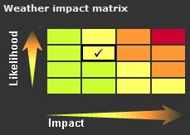

3.4.1 Some NMHSs are increasingly attempting to predict the impact of weather and the associated risk for customers, including civil protection authorities and Governments. Both the UK Met Office and Meteo-France now use warning systems employing a “traffic light” colour from the range Green, Yellow, Amber or Red (as widely used in the European MeteoAlarm system), although the assessment of likelihood and impact differs in the two countries. The illustration in the matrix above is used in the UK: a Yellow warning may result from either a higher probability (likelihood) of a moderate impact, or a low probability of a high impact event. Amber warnings result from similar but higher combinations, while a Red is limited to a high probability of a high impact event. EPS can be a valuable tool in helping assess the likelihood component of risk.

3.4.2 The assessment of the level of impact of an expected event is to a large degree subjective, but initial guidelines on impact levels for different types of weather event (strong winds, heavy rain, etc) can be defined based on forecaster experience in analysing the meteorological situation and discussions with civil responder groups who are the primary users of the severe weather warnings. Climatology provides a useful reference for impact thresholds, but relevant thresholds for impact-based warnings may vary according to the season and also due to antecedent conditions – for example, thresholds for strong wind impact may be lower in summer when there are leaves on the trees, or if the soil is saturated so trees are more likely to fall. Given an appropriate set of impact-related thresholds, EPS can be used to estimate the probabilities of exceeding these thresholds to complete the risk matrix shown in 5.4.2. The UK Met Office showed promising early results with a first-guess warning system exploiting the risk matrix with a regional EPS.

3.5 EPS in Atmospheric Transport and Dispersion

3.5.1 EPS is also now applied in atmospheric transport modelling (ATM) and the modelling of oil spill drift. Regarding ATM, the meeting noted that recent events (European volcano crisis in 2010, and the nuclear accident in Japan, in 2011) triggered significant attention for this technology. Some centres have started experimenting with ATM models coupled with weather forecasts from EPS systems, and this is strongly encouraged.

3.5.2 Ensemble ATM applications require substantially more and different input data (model-level data) from EPS systems than the other applications. The centres operating EPS systems need to be aware of that additional user requirement, and are encouraged to work with the ATM community.

4. GIFS-TIGGE DEVELOPMENTS AND PLANS

4.1 GIFS-TIGGE

4.1.1 Recent TIGGE developments focus on calibration of EPSs, combination of multi-models and research related to the development of probabilistic forecasts. Results on multi-model benefits vary and depend on the application and on the methods employed. Multi-model combinations for operational use should be made after bias correction of the individual models, and further research studies on these aspects are recommended, with an emphasis on surface variables. There is a need for research studies on the trade-off between numbers of EPS members versus resolution, and consequential benefits of multi-ensemble combinations.

4.1.2 GEOWOW (GEOSS interoperability for Weather, Ocean and Water) is an EU-funded FP7 3-year project beginning in September 2011. GEOWOW will make a significant European contribution to the Global Earth Observation System of Systems (GEOSS) by improving the overall quality of the current GEOSS Common Infrastructure (GCI), addressing access to data, usability and interoperability. The project will enhance the accessibility of the TIGGE archive at ECMWF for the wider user community, in particular the ability to efficiently access long time series of forecast data at user-specified locations, and will support the development of TIGGE-LAM facilities at ECMWF. GEOWOW will demonstrate the potential use of new ensemble products, with a focus on severe weather, in close liaison with the SWFDP.

4.1.3 MRI/JMA has developed a Web site (http://tparc.mri-jma.go.jp/TIGGE/tigge_SWFDP.html) which displays risks of high-impact weather (e.g. heavy rainfall, extremely high/low temperature, and strong wind) using the TIGGE data from four global NWP centres (ECMWF, JMA, NCEP and UKMO) and a brief description about these products and effective guidelines on how to use them. The genesis potential of high-impact weather is calculated by comparing ensemble members with climatological PDFs calculated from each of the four TIGGE models. The Web site is automatically updated every day and includes forecast up to 15 days ahead, but due to TIGGE research restrictions these forecasts are currently updated two days behind real-time. SWFDP RSMCs have been invited to evaluate prototype products available on the Web site and assess requirements for near-real-time products. To facilitate this, some centres are investigating how to make such products available in real-time.

4.1.4 The GIFS-TIGGE Working Group has recommended that training on new GIFS products should be integrated in any training conducted by the ET-EPS. EPS training is now covered through the SWFDP, and therefore training on the interpretation of the new products developed under GIFS should also be integrated in SWFDP training events.

4.1.5 Future developments planned by the GIFS-TIGGE Working Group include links to a new sub-seasonal to seasonal prediction project to maximize compatibility between this new project archive and the existing TIGGE archive.

4.2 TIGGE-LAM

4.2.1 TIGGE-LAM is intended to provide an equivalent to the TIGGE archive for LAM-EPS. Scope for this is much less globally because of limited overlap of ensemble domains, but the TIGGE archive centres agreed several years ago to archive a limited set of High Priority Parameters for ensembles in their own regions of the globe. The area with greatest overlap was Europe where the TIGGE archive centre is ECMWF.

4.2.2 Progress on implementing TIGGE-LAM has been very slow for two reasons: (a) lack of devoted resources; and (b) technical problems due to GRIB2 coding. The meeting learned that CMA is now archiving high priority parameters from the CMA Regional EPS System and ECMWF will archive European products as part of GEOWOW.

4.2.3 With the focus of LAM ensemble development moving rapidly to convection-permitting ensembles, TIGGE-LAM implementation should now accommodate these developments, and this has already been considered within GEOWOW.

5. EPS IN SEVERE WEATHER FORECASTING, INCLUDING THE SWFDP

5.1 Probabilistic forecasts of important meteorological and other weather-related parameters into impact models (e.g. flash floods and coastal flood forecasting)

5.1.1 The ECMWF Extreme Forecast Index (EFI) is widely used to provide alerts for potential severe weather events and is now provided for use of WMO members. Following feedback from users, the current EFI products are being extended to include more parameters (e.g. snowfall and ocean waves) and later forecast ranges (currently only provided to day 5; new products will include information up to day 15). KMA has been working on the development of an EFI of daily minimum and maximum temperature, wind gust, and daily accumulated rainfall amounts to support one-week forecast.

5.1.2 Products for tropical cyclone genesis have been implemented on the ECMWF Web site. A new TC tracker is under pre-operational testing, which extends the predicted tracks from 5 days up to 10 days ahead.

5.1.3 EPS is increasingly applied to predict severe or high-impact weather events and in the propagation of the weather forecasts into impact models. The uncertainty in the weather forecast can be propagated through to uncertainty in impact by coupling ensemble members to impact models and generating a distribution of impact predictions. Examples of applications include:

- risk-based first-guess severe weather warnings, which provides guidance to forecasters related to the impact of severe weather (e.g. Met Office UK);
- risk models combining hazard probability from EPS with models of societal impact (e.g. strong wind impact on transport networks implemented at Met Office UK);
- hydrology (e.g. MAP D-Phase for small catchments; and EFAS for large catchments. NWS of US for all time and space scales. Experimental hydrological EPS is implemented at Météo-France);
- Storm surge (e.g. Met Office UK and Netherlands have implemented; Météo-France will do it next year);
- Waves (e.g. implemented at the ECMWF; and a multi-model jointly implemented by NCEP and US Navy);
- Marine Pollution (e.g. implemented in Météo-France);
- Atmospheric Transport (e.g. implemented experimentally at Met Office UK, and with a multi-analysis ensemble for backtracking in Austria);
- Energy (wind, solar, etc.) and Trading;
- Forest fire (e.g. implemented in Canada);
- Aviation (i.e. icing, CAT, low visibility; routing; runway management).

5.1.4 This approach is strongly endorsed, particularly where the primary source of uncertainty is from the weather forecasts. For ATM, further work is required to understand the complete picture, particularly understanding the uncertainty in the source term.

5.2 Practical application of EPS in existing projects (e.g. SWFDP)

5.2.1 Many NMHSs have difficulties in making use of ensemble fields made available in real-time by the producing centres for downloading. In particular, many NMHSs, especially those of developing countries and LDCs, do not have the computing facilities or capability to generate products from ensemble fields. A critical component of the guidance data provided to SWFDP subprojects from the global centres is therefore prepared EPS products in the form of charts and graphics. The subprojects in Southern Africa, the South-west Pacific and in Eastern Africa have been supplied with EPS data by ECMWF, the Met Office UK and NCEP. The subproject in Southeast Asia, planned to commence in April 2012, will be supplied with EPS data by CMA, JMA, KMA and ECMWF (products available for all WMO Members). The use of EPS data is also included in plans for the SWFDP subproject being initiated in the Bay of Bengal.

5.2.2 Products from multiple ensemble systems (PEARP/MF, EPS/ECMWF, MOGREPS/UKMO, EPS/CMC, GEPS/NCEP) and also combined products, produced from the TIGGE database are made available via the RSMC La Réunion Website. Access to these products is provided to members of the Tropical Cyclone Committee (RA I) and to participating NMHSs in the SWFDP – Southern Africa, under password access and a usage agreement.

5.2.3 Training workshops carried out as part of the SWFDP subprojects have proven one of the most effective ways of providing training on the use of EPS, as the training has been provided in conjunction with ongoing access to operational EPS data.

5.2.4 Through the SWFDP SG, the Chair of ET-EPS has been influential in trying to secure greater resources and a long-term sustainability strategy for training in the SWFDP.

6. DEVELOPING GUIDANCE FOR FORECASTERS

6.1 At its previous meeting the ET-EPS started to create some Guidelines on EPS and Forecasting, but was subsequently unable to secure the resources to complete these. During the meeting of 2011 some further progress was made, and following the meeting the Chairman was able to complete an initial edit of the guidelines - the updated Guidelines on EPS and Forecasting are provided in Annex I.

6.2 The meeting requested the chairperson of the ET-EPS to work with the WMO Secretariat to investigate the possibilities for arranging for editing of the Guidelines on EPS and Forecasting and then to publish them as a WMO publication and to distribute it to all WMO Members.

6.3 Other sources of guidance that may be of use to WMO Members are also available, notably: the ECMWF User Guide which provides comprehensive guidance on the use of ECMWF systems and COMET on-line training materials.

7. VERIFICATION

7.1 JMA, as the Lead Centre for EPS Verification, has been operating two Internet sites since 2004: (a) an FTP site for the EPS producing centres to upload the statistical data for their EPS verification reports; and (b) a Web site (http://epsv.kishou.go.jp/EPSv/) that shows the original verification statistics, their update and contents information, and their visualized figures, indicating that it is possible to diagnose the skill of EPS of each EPS producing centre through comparison with those of other EPS.

7.2 As of October 2011, eight EPS producing centres are registered in the FTP site, and seven are uploading their verification statistics to the FTP site. However, exchanged parameters are still quite limited. The exchange of CRPS, which is defined as a new score in the latest amendment of the Manual on GDPFS, has started up quickly.

7.3 The meeting recalled that the verification grid spacing used in calculation of the statistics has been 2.5°x2.5° (lat/lon). Noting that for deterministic NWP verification, Cg-XVI approved for inclusion in the Manual on the GDPFS (WMO-No. 485) that all parameters shall be verified against the centre’s own analysis on a regular 1.5° x 1.5° grid, it s recommended that the same principle should be applied to the EPS verification.

7.4 To ensure consistency between results from different centres, it is proposed that a common climatology shall be used for those scores requiring a climatology. All centres shall use the climatology provided via the lead centre, which is the same as the one used for deterministic NWP verification.

7.5 Following the request by the 2006 extraordinary session of the Commission for Basic Systems (CBS-Ext.(06)), the Web site ceased to be password protected in December 2009, in order to make the EPS verification results available to all WMO Members. At the same time, a new page (http://epsv.kishou.go.jp/EPSv/Exchange/reportstatus.html) was established in order to show the reported verification parameters and their available periods for each centre. In July 2011, following the approval of the amendments to the Manual on the GDPFS by Cg-XVI, the Web site and its operating system was updated to include: (a) a scheme to decode and publish CRPS tables; (b) links to lead to published CRPS-related data; and (c) a Note to show the details of each center’s report. Recently, the CRPS tables, which include statistics of both ensemble and control, and its published data became available on the Web site. The CRPS-base skill score are also visualized as a part of the published data in order to clearly show not only ensemble skill but also impact of ensemble use on single use.

8. REVIEW OF EPS ASPECTS IN THE MANUAL ON THE GDPFS

8.1 Noting that a first version of the new Manual will be presented to CBS-XV, in 2012, for consideration, the ET-EPS meeting agreed that any proposed amendments to the Manual on the GDPFS should be reflected in the new version. The ET-EPS meeting requested the chairperson, in coordination with the Expert Team members and in liaison with the chairperson of the CBS Coordination Group on Forecast Verification, to review the draft text for the new Manual, and submit to the Secretariat a revised version by mid-March 2012. However it is noted in May 2012 that, due to limited resources, this review has not yet been completed.

9. REVIEW THE TERMS OF REFERENCE OF THE ET-EPS

9.1 The ET-EPS reviewed the team’s Terms of Reference (ToR) as adopted at CBS-Ext.(10), and proposed revised ToR as given in Annex II.
ANNEX I

UPDATED GUIDELINES ON EPS AND FORECASTING

1. Introduction
Ensemble Prediction Systems (EPS) are Numerical Weather Prediction (NWP) systems which allow us to estimate the uncertainty in a weather forecast as well as the most likely outcome. Instead of running the NWP model once (a deterministic forecast), the model is run many times from very slightly different initial conditions. Often the model physics is also slightly perturbed, and some ensembles use more than one model within the ensemble (multi-model EPS) or the same model but with different combinations of physical parameterization schemes (multi-physics EPS). Due to the cost of running an NWP model many times, the EPS is normally run at around half the horizontal resolution of the equivalent deterministic NWP model. The EPS normally includes a control forecast which uses the ensemble resolution model but without any perturbations to the analysis or model. The individual NWP solutions which make up the ensemble are often referred to as the ensemble members. The range of different solutions in the forecast allows us to assess the uncertainty in the forecast, and how confident we should be in a deterministic forecast. The uncertainty in a weather forecast can vary a lot from day to day according to the synoptic situation, and the EPS approach provides an estimate of this day-to-day uncertainty. The EPS is designed to sample the probability distribution function (pdf) of the forecast, and they are often used to produce probability forecasts – to assess the probability that certain outcomes will occur.
These guidelines are intended to provide some general advice to forecasters and forecast providers on the effective use of EPS, and on what EPS can and cannot be expected to provide. A general working knowledge of the principles and use of NWP is assumed. For those requiring more detailed information, the ECMWF User Guide (http://www.ecmwf.int/products/forecasts/guide/ ) provides comprehensive guidance on the use of ECMWF systems including detailed advice on the use of EPS; the COMET training materials (http://deved.meted.ucar.edu/nwp/pcu1/ensemble/) also provide training on the use of EPS.
In general, it is strongly recommended that uncertainty should be communicated as part of every forecast. Guidance on the communication of uncertainty is given in the PWS Guidance (WMO TD-1422).

Examples shown in these guidelines are mostly taken from the UK Met Office’s MOGREPS EPS systems, or the ECMWF EPS, but the principles described apply to any EPS.

2. Why should we use EPS?
NWP systems using the latest numerical models of the atmosphere are very powerful systems to aid the forecaster in producing weather forecasts. Many models now provide a good enough representation of the weather that they can also be used to provide basic automated weather forecasts from Direct Model Output (DMO), although in general it is recommended that some post-processing should be used to calibrate automated forecasts. DMO provides a better representation of some weather elements than others, for example surface temperature is often quite well-resolved (at least away from steep surface orography) whereas precipitation is often much less well resolved.
However, despite these advances, it is well-known that forecasts from even the very best models can often go badly wrong. This is most obvious in forecasts several days ahead and is due to the chaotic nature of the atmosphere. We forecast the weather by starting the model from an analysis of the state of the atmosphere based on the latest observations which are taken all around the world. The model then calculates how the atmosphere will change and evolve from this initial analysis state over the coming days. Chaos theory means that the way the atmosphere evolves is very sensitive to small errors in that initial analysis, so that a tiny error (often too small for the forecaster to even notice) can grow into a large error in the forecast. Even with the best observations we can never make a perfect analysis, so we cannot make perfect forecasts. This is why we run EPS (ensembles).
In an ensemble forecast we make very small changes (perturbations) to the analysis, and then re-run the model from these slightly perturbed starting conditions. If the different forecasts in the ensemble are all very similar to each other then we can be confident of our forecast, but if they all develop differently, and for example some develop a major storm while others develop a much weaker depression, then we will be much less confident. However, by looking at the proportion of the ensemble members which predict a storm, we can make an estimate of how likely the storm is.
When we look at shorter-range forecasts of 1 or 2 days ahead, the general pattern of the weather is usually much more predictable, but we can still find important differences between ensemble members when we look at the local detail of the weather which may be important to many forecast users. Also, occasionally the larger-scale evolution can be uncertain even at short-range – this is most likely to happen during the development of major storms, so it is important to take account of the EPS even in short-range forecasts.
3. Types of EPS
Ensemble Prediction Systems for use in weather forecasting come in three main types, global, regional and convective-scale, and as with deterministic NWP models, they address different time-scales in the forecast. These will be outlined briefly below. Within each of these categories there are many variations, such as the way in which perturbations are created and the variations in the models used within the models – however the principles of how the ensembles are used remains the same, and these details are not covered here. (It may be noted that ensembles are also used for long-range forecasting and climate prediction. The principles are very similar, but these will not be considered in these guidelines which focus on forecasts of up to 15 days, which is the period over which it is often possible to forecast daily weather.)
3.1 Global EPS
Global EPSs are normally designed and used for medium-range forecasting of 3-15 days ahead. They use global NWP models and are run at relatively low resolutions with typical grid-lengths of between 30 and 70km. Although they are primarily designed for use in the medium-range, their global coverage means that they can also be used to provide short-range EPS forecasts in regions of the globe where no other EPS are available, and may be the only available option for many WMO members. In this context they are used extensively to provide products to support the WMO SWFDP (Severe Weather Forecasting Demonstration Project) projects.
Forecasters using global EPS should always remember that the relatively low grid resolutions will limit the detail they can expect in the forecasts. Global EPS will often not be able to resolve details such as the full strength of wind speed in a storm.
3.2 Regional EPS
Regional, or LAM (Limited Area Model) EPSs use regional models over smaller areas and are focussed more on the short-range forecast of 1-3 days ahead. They use higher grid length resolution than the global EPS, typically between 7 and 30km, which allows them to forecast more local detail in the weather and also to better resolve intense weather systems. Nevertheless the forecaster should still remember the limitations of resolution, so for example a regional EPS should not be expected to predict details of small-scale systems like thunderstorms.
A regional EPS has to take its lateral boundary conditions (the weather systems moving into the area from outside the domain) from a global EPS. Some regional EPS systems use a high-resolution regional analysis and calculate corresponding high-resolution perturbations, but others simply take the initial conditions and perturbations from the same global EPS which provides the boundary conditions – this is normally referred to as downscaling. In a downscaling EPS the forecast needs to run for a number of hours before the model can “spin up” the higher resolution detail.
3.3 Convective-scale EPS
Convective-scale NWP, with model grid-lengths of 1-4km run over relatively small domains, is now available in a number of more advanced NWP centres. These models, sometimes referred to as convection-permitting are able to resolve some of the detail of large convective systems, and thus can attempt to predict details such as the location and intensity of thunderstorms. While this offers great potential for improved forecasts, convective systems evolve very rapidly and have short predictability timescales, so the forecasts can rapidly be affected by chaos. EPS is therefore highly relevant to convective-scale NWP because convective instability adds a new scale of forecast uncertainty not resolved by the lower resolution models, and with much shorter timescales.

In addition to convection itself, models on this resolution have greatly enhanced capability for forecasting other aspects of local weather, such as low cloud and visibility of interest to aviation. Many of these phenomena are significantly affected by topographic forcing which may give enhanced predictability when that forcing (slopes, coastlines, vegetation, albedo, .) can be resolved by the models (e.g. convective initiation or valley fog). Convective scale EPS has the potential to provide information on the predictability of all these weather elements.
At the time of writing in 2011 convective scale EPSs are under development at various centres. DWD runs the COSMO-DE-EPS with a resolution of 2.8 km in preoperational mode since December 2010. The UK Met Office and Météo-France have plans to introduce such systems in the near future, and research is being conducted in other countries.
Due to the very high cost of running convective-scale EPS they are unlikely to be available outside the producing nations for many years, and experience of them is still very limited. They are discussed only briefly in these guidelines.
The much higher resolution of convective-scale EPS is expected to allow better resolution of many weather phenomena than is possible with global and regional EPS, for example local winds forced by topography and possibly elements like low cloud and visibility, especially where such phenomena are forced by local details of the topography or land surface.
For precipitation the models are likely to better resolve the intensity and spatial scales of local precipitation, especially in convective precipitation. However to sample the full range of uncertainty in convective precipitation would require very large ensembles with hundreds or thousands of members, which will not be affordable in the foreseeable future. It is therefore strongly recommended that convective-scale EPS is post-processed using techniques such as neighbourhood processing (where it is assumed that a feature such as a convective shower may be realistic but may be misplaced and occur anywhere around the neighbourhood within, say, 10 grid-lengths of where it appears in the model) to provide a more realistic spatial distribution of probabilities. Similar techniques may also be appropriate for other variables, to take account of the small size of the ensembles.
4. Standard EPS Products
This section describes some of the standard EPS products which are generated from most EPS systems, and briefly how they may be used.

4.1. Basic Direct Model Output Product Generation
A range of basic products are produced from most EPS systems directly from model output fields. These typically include:
4.1.1 Ensemble Mean
This is a simple mean of the parameter value between all ensemble members. The ensemble mean normally verifies better than the control forecast by most standard verification scores (RMSE, MAE, ACC, etc) because it smoothes out unpredictable detail and simply presents the more predictable elements of the forecast. It can provide a good guide to the element of the forecast which can be predicted with confidence, but must not be relied on its own as it will rarely capture the risk of extreme events.

4.1.2 Ensemble Spread
This is calculated as the (non-biased) standard deviation of a model output variable, and provides a measure of the level of uncertainty in a parameter in the forecast. It is often plotted on charts overlaid with the ensemble mean. The example below shows both ensemble mean PMSL as black contours and spread of PMSL as colour shading. The areas of strong colours indicate larger spread and therefore lower predictability.

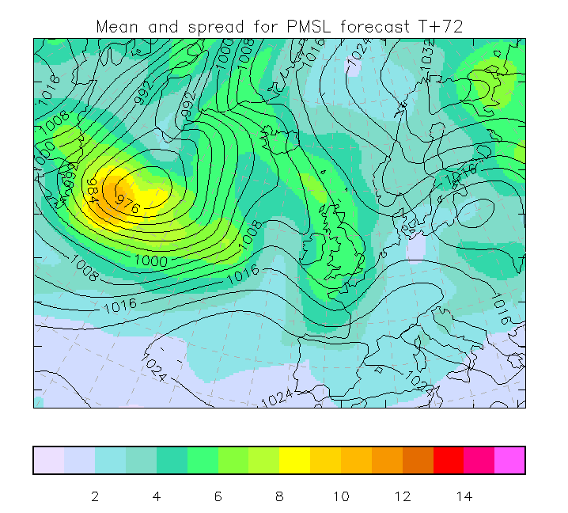

4.1.3 Basic Probability
Probability is frequently estimated as a simple proportion of the ensemble members which predict an event to occur at a particular location or grid-point (e.g. 2m Temperature less than 0 Celsius, or more than one standard deviation below normal). The example shown below shows the contoured probability of wind gusts exceeding 40kt. The ensemble mean pressure at mean sea-level (PMSL) is also included as grey contours.

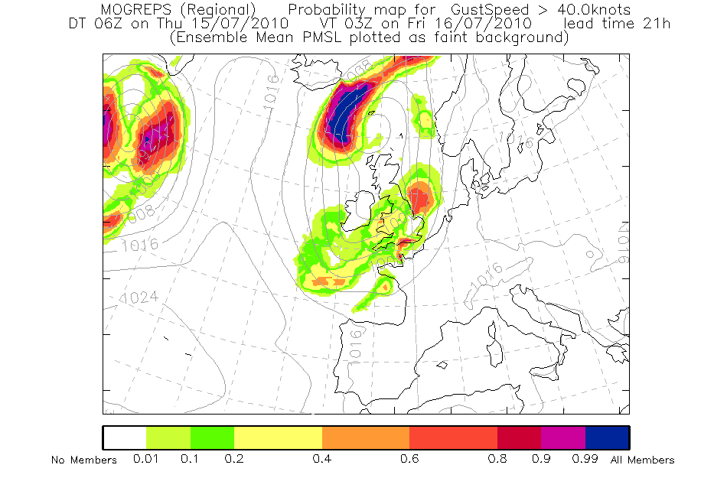

It should be noted that this definition of probability is not a true Bayesian probability as would be defined by a statistician, but provides a useful estimate for practical purposes. It makes an assumption that the model accurately reflects the climate distribution of occurrence of an event. Probability forecasts produced in this way should always be verified over large samples of cases to determine the extent to which forecast probabilities relate to observed frequencies.

The second example shown below is one of those produced for the SWFDP project in the South Pacific.

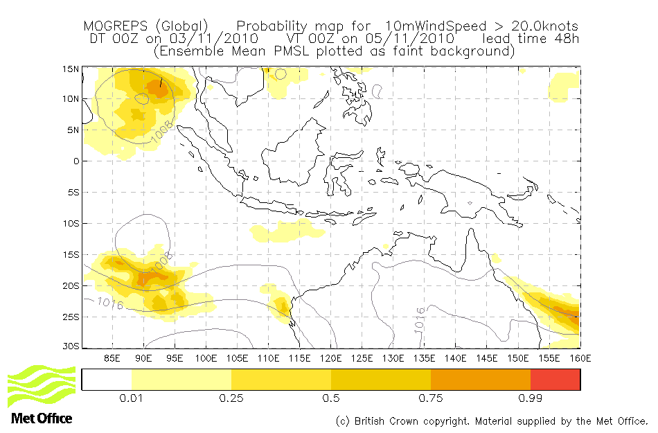

4.1.4 Quantiles
A set of quantiles of the ensemble distribution can provide a short summary of the uncertainty. Commonly used quantiles are the Maximum and Minimum of the ensemble distribution, and the 25th, 50th (median) and 75th percentiles. Others often used include the 5th, 10th, 90th and 95th percentiles.

4.1.5 Spaghetti Maps
Charts showing a few selected contours of variables (e.g. 528, 546 and 564Dm contours of 500hPa geopotential height) from all ensemble members can provide a useful image of the predictability of the field. Where all ensemble member contours lie close together the predictability is higher; where they look lie spaghetti on a plate, there is less predictability.

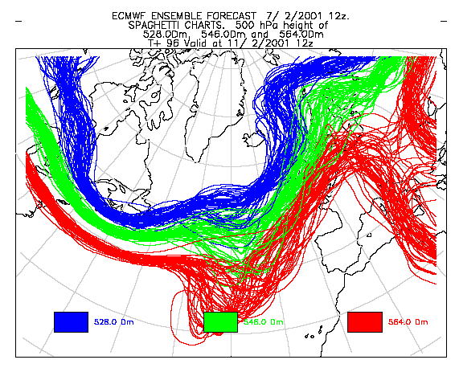

4.1.6 Postage Stamp Maps
A set of small maps showing contoured plots of each ensemble individual member allows the forecaster to view the scenarios in each member forecast, and assess the possible risks of extreme events. However this presents a lot of information which can be difficult to assimilate.

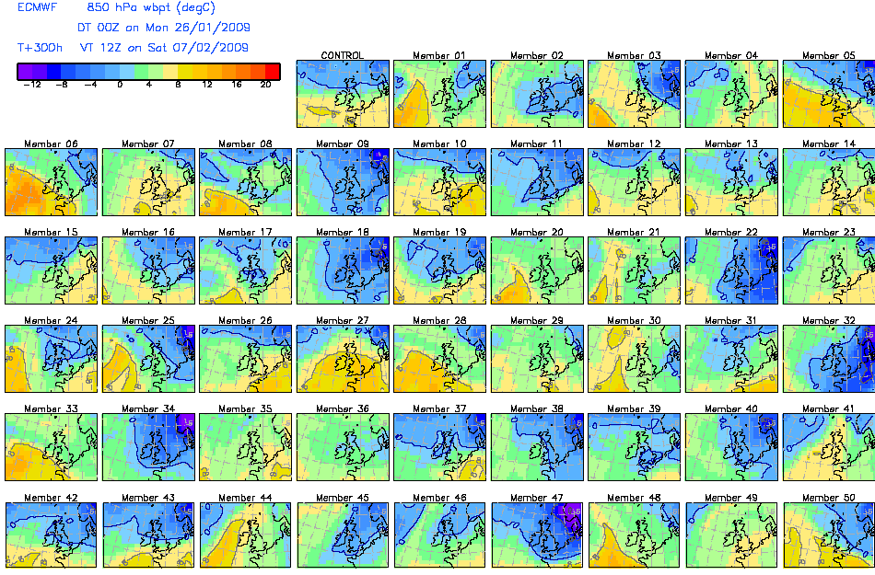

4.1.7 Site-specific Meteograms
Model output variables can be extracted from the grid for specific locations. There are many presentations which can be used to represent the forecast at locations, such as plume charts, Probability of Precipitation etc. One of the most commonly used is the Ensemble Meteogram (or EPSgram) which uses a box and whisker plot to illustrate the main percentile points of the forecast distribution for one or more variables.
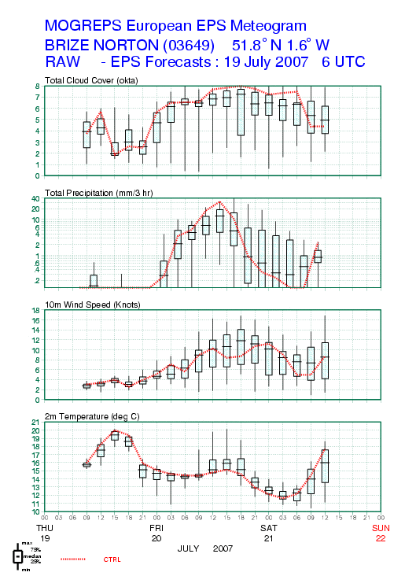
5. General Comments Applying to all use of EPS
This section presents a number of general principles which apply to all use of EPS. Following sections provide more detail on the specific use of EPS for particular types of forecast production.
- An EPS best represents the uncertainty in resolved variables
  - Upper-air usually more skilful than surface
    - Surface parameters are affected by sub-grid scale uncertainty not resolved by the model
  - As resolution and model performance increases, the ability to predict surface weather parameters is continually improving
- An EPS is only as good as the model(s) it uses.
  - If a model is unable to represent certain phenomena, the EPS will also be unable to represent it.
    - A good example is that most ensembles cannot resolve convective storms, which is one of the reasons why some centres are developing ensembles at convective scale.
  - An EPS will share any systematic biases of the model used.
- How to combine deterministic forecast with ensemble/probabilistic?
  - Relative capabilities of ensemble members compared to hi-res/control
  - See the “Guidelines on using information from EPS in combination with single higher resolution NWP forecasts (February 2006)”
- A common question is whether a forecaster can improve the distribution by re-weighting members (e.g. the high-resolution control forecast if included) or by rejecting some members?
  - Forecasters may think that some members are unrealistic
  - Can we eliminate some members on the basis of recent observations or pick a “best member”?
    - PERHAPS, for certain aspects of the forecast over very short-period forecasts and for local forecasts over a small area
      - Over a large area or the full model domain, the control forecast will always be the most skilful.
    - NOT for longer period forecasts
  - This type of approach is subjective and difficult.
  - It is strongly recommended that forecasters should use the whole EPS distribution in a probabilistic approach.

- Strengths and weaknesses of the models/ensembles available to the forecaster should be known. Documentation should be easily available to the forecaster.
  - Verification of multiple thresholds to be available
  - Summary doc of strengths and weaknesses by season
- Be careful with “end of chain” diagnostic parameters (e.g. precipitation, cloudiness,…). For instance look at distributions of indices in convective situations.
- Forecasters should not always rely on direct model output of weather variables, but should also consider analysis of better resolved diagnostics which may aid interpretation of the EPS forecast (e.g. synoptic features,, environment/precursors/potential for high-impact weather developments such as moisture convergence, low level jets, development regions, convective diagnostics etc).

The use of EPS (and other probabilistic tools) opens the possibility of issuing two different types of forecast, fully probabilistic, or deterministic with supplementary uncertainty information (for instance confidence). Which type we use affects who makes decisions from the forecast. In general the use of fully probabilistic forecasts allows each user to tailor their decision to their specific needs (e.g. using cost-loss estimation), and is therefore strongly encouraged.
6. Use of EPS in Deterministic Forecasting
In general it is strongly recommended that probabilistic forecasts provide the best and most complete weather forecast for customers, and should be encouraged, especially at longer lead-times. However it is recognised that many customers demand a simple deterministic forecast, and where a deterministic forecast is to be produced, the use of an EPS can often provide a more reliable forecast than a single deterministic NWP run. This is particularly true for forecasts more than 1-3 days ahead, and can help reduce jumpiness from run-to-run of the forecast system at any time range.

Several indicators from the EPS can be used to optimise the deterministic forecast. The ensemble mean will on average score the best by many standard verification scores, but it must be remembered that it will tend to smooth out the smaller scale unpredictable detail, and will rarely capture the intensity of important high-impact weather systems. The ensemble mean should not therefore be used on its own if the use of the forecast is concerned about potential severe weather impacts. Other useful guides to the most likely forecast can be the median (central point in the pdf) or mode (most likely value in the pdf) – these are easier to identify for single weather parameters than for the complete forecast picture.

If a deterministic forecast is to be issued, it may sometimes be augmented by a statement of the confidence of this forecast to take some advantage of the uncertainty information available. The confidence will not always be the same for all elements of the same forecast. Confidence indices, if used, are best provided separately for each variable. The confidence level should be based on the spread of the ensemble, but also considering the known forecast skill limitations.

The best approach to issuing a deterministic forecast will depend on the predictability as indicated by the ensemble spread. The spread could be analyzed using various products such as, spaghetti plots, and map depicting variance at the synoptic scale and then, at the lower scales, using meteograms, quantiles, cluster analysis, etc. :
- Small spread in the ensemble (good predictability)
  - In this case it may be reasonable to offer more detail in the forecast.
  - Take the control, the high resolution control, the ensemble mean or the median as a guide (with due regard for the need for calibration or bias correction).
  - Spread may often differ between model variables so small spread in one parameter does not guarantee confidence in all aspects of the forecast.
    - Good synoptic scale predictability does not always mean predictability in surface weather variables such as temperature or convective precipitation.
    - Forecaster should still take account of uncertainty in parameters not resolved by the model.
- Large spread in the ensemble (poor predictability)
  - Avoid giving too much detail in the forecast
  - Ensemble mean should be considered but if the ensemble covers a range of scenarios the ensemble mean will not provide a realistic scenario
  - So in that situation, take most representative member of the ensemble (e.g. most populated cluster or mode of pdf) as a guide to the most probable outcome
    - Note that the most representative ensemble member may not give the most probable value for each weather element (e.g. most probable temperature at a location may not be correlated with the most probable precipitation amount.)
  - The uncertainty assessment
    - Encourage users to follow forecast updates.
  - Take into account extremes of the EPS and of the high resolution control
    - Make a careful evaluation of the possible evolutions of the synoptic situation and their potential impacts.
    - Take into account the behavior of models.
      - The high-resolution control may be better able to represent certain high-impact events.
- In the short range (12 - 18 hours), it may be possible to take into account the latest observations (3-6 hours into the forecast) in order to choose a scenario or a member of the ensemble
  - For example, a rapidly evolving cyclone may be best predicted by the member with the best position after a few hours but ONLY in the very short-range!
  - Be aware that future evolution will be influenced by features coming from upstream. This makes member selection for forecasts beyond ~24h impossible.
  - Also the consistency of the latest runs with respect to the previous is a factor to take into account.
- In the longer range, while probabilistic forecast are best suited, if a deterministic forecast is to be produced, the use of the ensemble mean or median could yield more reliable forecasts, with less jumpiness between runs of the forecast.

6.1 Decision Making from deterministic forecasts
Weather forecasts are only useful when people make decisions from them. It is often argued that it is easier to make a decision from a deterministic forecast than a probabilistic one. However when the forecaster issues a deterministic forecast the underlying uncertainty is still there, and the forecaster has to make his/her best guess at the likely outcome. Unless they fully understand the decision that the user is going to make based on the forecast, and the impact of different outcomes, then the forecaster’s “best-guess” may not be well-tuned to the real needs of the user.
- The choice of making a deterministic forecast for a specific event to occur should not be taken without some knowledge of the needs of the end user. An optimal decision cannot be made without the cost-lost ratio of the user. This ratio can be assessed by a survey or a direct discussion with the end user.
- When appropriate the forecasters should convey the risks and impacts associated with worst-case scenarios alongside the most likely outcome

7. Scenarios
A useful way to summarise the uncertainty in a weather forecast can be to describe a small number of possible outcomes, or scenarios, rather than giving the full detail of a probabilistic forecast. For some customers used to receiving deterministic forecasts, this may be more acceptable. Ideally the EPS can be used to estimate the relative likelihood of the different scenarios presented. In most cases, to avoid confusion, the best approach may be to issue a most-likely scenario based on the advice above on issuing deterministic forecasts, plus a single alternative scenario – this may often be a worst-case scenario, perhaps reflecting a low probability but high-impact possibility suggested by the most extreme ensemble members. However care should be taken not to give the impression that either scenario will be correct – the truth could easily lie somewhere in between (or even be different again!)
Useful tools to aid in issues alternative scenarios are postage-stamp maps (4.1.6) which show the forecaster all the individual forecasts in the ensemble, or clustering (9.3) which automatically groups the ensemble members and provides the forecaster with an objective assessment of the possible scenarios.
8. Full Probabilistic Forecasts
Wherever possible, the use of a full probabilistic approach is recommended in issuing forecasts. This provides a full representation of the uncertainty information provided by an EPS, and also allows users to tune their decision-making to take account of their particular applications.
Probabilistic forecasts can be expressed in a number of ways, and need not always use the word probability:
- A forecast of a weather variable provided with error bars which vary according to the ensemble spread.
- A fuller representation of the ensemble distribution showing a number of percentile values, as used in the standard meteogram product.
- Probabilities of specific (well-defined) events occurring, expressed as numbers or as contoured shading on a map.
When a forecast is presented as a probability, it is very important to express very clearly what the probability is for, so that both the forecaster and the user is clear and understands. We often talk about the probability of an event occurring, and it is this event which must be defined. Often the event will be for a threshold value to be exceeded (e.g. more than 50mm of rain, or temperature below 0 Celsius). Ideally it will be something which has an important impact for which someone will have to take a decision (e.g. the probability that ice will form on roads so that road treatment will be required). It is also important to define when and where the event is forecast for:
- Exact time, or time period which the forecast refers to.
- Exact location or area which the forecast applies to.
  - If it is an area, does it mean a forecast that the threshold will ne exceeded somewhere in the area, or everywhere in the area?
A good test of whether an event is well-defined is to ask yourself whether you could easily measure whether the event does happen or not (in other words, could you verify the forecast). If you cannot easily say, then you may need to define the event better.
The following bullets provide a number of issues which should be considered when basing probabilistic forecasts on EPS outputs:
- Calibrated, bias corrected forecast can be directly issued to the end user (low cost).
  - This approach allows for the possibility of issuing automated forecasts for many locations and users.
  - Methods for bias correction and calibration are discussed in section 9.
- Direct model output (DMO) from ensembles should be used with care, as it may not provide reliable probabilistic forecasts, but will often nevertheless provide valuable information. In some cases use of DMO may be essential where there is no calibration system in place – calibration is difficult for certain variables such as precipitation, or where adequate observations are not available.
- To generate probabilistic forecasts of outcomes dependent on more than one weather element, it is important to calculate this outcome for each ensemble member and then combine members to create the probabilities. This retains consistent correlations between different weather variables and also different locations (e.g. the correlation in temperature between two locations). Calibration or post-processing may spoil this consistency.
  - This principal also applies when using the ensemble to drive downstream impact models (e.g. hydrological models) where the downstream model should be run for each ensemble member and then the probability of the downstream impact calculated.
- In “usual” situations, forecasters should not try to change the probabilistic forecasts issued by the EPS (DMO or post-processed). The forecasts can be issued directly to the public. Forecasters should target their attention to “unusual” situations.
- In “unusual” situations, probabilistic forecasts can be adapted by the forecasters using experience, analogues, conceptual models,…. Forecasters may be able to correct for some known system biases or model weaknesses. The corrections should be made by using the guidelines mentioned in section I.
- Studies have shown that the general public is able to make better decisions, when presented with uncertainty information in forecasts than with a deterministic forecast. When uncertainty information is not provided people make their own assumptions.
- Probabilities have to be presented in a comprehensive graphical form. Examples and guidelines are given in the PWS document PWS-18, WMO/TD No. 1422. (Homework for Alice: include a few beautiful graphics).
- Probabilities of events relevant to specific applications should be defined. This includes, for example, application in agriculture in which the occurrence of dry spells or rainy periods influences irrigation, seeding, harvest…
- Risk is a combination of impact and likelihood of a phenomenon which can be produced by the EPS. It gives an objective and valuable decision basis to the forecasters in order to assess different warning levels. Impact has to be agreed with the relevant authorities (PWS customers). Climatology usually provides a good reference to establish the thresholds of phenomena which produce impact. The thresholds can be adapted taking into account the recent evolution of the various environmental parameters (recent rainfall accumulations affect soil saturation, leaf-cover on vegetation, snow cover etc.).
- It is recommended that where probabilities are indicated for significant high-impact weather, a forecaster-written comment or warning should be added.
9. Post-Processing
The aim of this guidance is to provide explanation and advice for post-processing using statistical dynamical and other approaches to improve EPS outputs. There are numerous approaches and the paragraphs below capture some of the most common. Some methods are quite generic and may be best applied by EPS producers at source, while others are quite specific to applications and may be better applied specifically for individual users.

9.1 Statistical post-processing
Generally speaking statistical post-processing is needed in order to correct systematic errors in models and thereby add value to direct NWP model output. These errors are particularly important for surface parameters (e.g. 2m temperature, 2m humidity, 10m wind speed, precipitation, total cloudiness, …) and are linked to local conditions.
More precisely, statistical post-processing can be used to:
- Remove systematic biases
- Adjust ensemble spread
- Quantify uncertainty not represented directly by the EPS
- Predict what model does not represent explicitly (e.g. low visibility)

In general statistical methods are easier to apply to some types of model output variable than others. Temperature is often relatively easy, for example, as it is a continuous variable and varies relatively smoothly in model fields, and most importantly temperature errors are often approximately normally distributed. Precipitation, by contrast, is particularly difficult because precipitation fields often have much multi-scale structure which is poorly represented by models, especially on the small scales. Its climatological distribution, and hence the distribution of forecast errors is bounded at zero at one end and often highly skewed, making it much more difficult to represent statistically. The problem can sometimes be reduced by transforming the distribution to make it more quasi-normal, but in general post-processing methods for precipitation are much less effective than for other variables.

9.1.1 Bias correction of the First Moment of the PDF (Probability Density Function)
This post-processing is similar to MOS (Model Output Statistics) methods applied for single models, but with some important differences. For ensembles, it is well known that a traditional MOS which is trained specifically for each forecast lead-time will lead to a significant decrease of the ensemble spread at longer lead times. Instead, it is recommended to use a pseudo-perfect prognosis approach. This method is based on the use of MOS statistical models computed over the first 24h of the forecast and then applied to the corresponding steps during at all forecast lead-times

Adaptive methods such as the Kalman-filter are recommended to allow the corrections to be automatically updated to account for model changes (upgrades) and changes in the season.

In the case of single-model ensembles (i.e. the same model is used for all of the members, even where model perturbations are implemented) the same statistical model should be trained using the control forecast and applied to all members of the ensemble.

In the case of multi-model or multi-physics ensembles (i.e. where different models are used to build the pdf, or systematically different model versions are applied, e.g. different parameterization schemes) specific statistical models should be trained and applied for each model version.

In either case the development of these statistical models need a training set of model outputs (predictors) and observations (predictands). In the case of adaptive methods such as the Kalman filter this training set is updated continuously from the daily forecasts.

The “observations” can be either site-specific observations or may be the best available set of analyses. In the case of site observations the statistical post-processing will lead to local forecasts (i.e. at each site specific point where observations are available). When analyses are used the end product is a bias-corrected and downscaled gridded forecast.

It should be noted that when different weather variables are independently bias-corrected, some of the correlation between variables represented by the different ensemble members may be lost. For this reason forecasters may prefer to view direct model outputs.

9.1.2 Calibration of higher moments of the PDF

Bias removal for the second moment of the pdf is often known as “calibration”. It aims to improve the reliability of the probabilistic forecast. Therefore this kind of post-processing is specific to ensemble prediction systems and is particularly important to optimize probability forecasts. As for the first moment bias correction, calibration is based on local conditions and requires high quality observations or analyses as a reference.

A number of methods are under development which attempt to calibrate both the first and second moments of the pdf to optimize the complete distribution.
- A method developed at the University of Washington is now considered as one of the best to deal with this issue. This method, called “Bayesian Model Averaging” is based on specific statistical assumptions (e.g. normal distribution for temperature).
- EKDMOS (Ensemble Kernel Distribution Model Output Statistics) is another technique which has been implemented in the USA.

The above methods are commonly applied to variables such as temperature and wind-speed. Variables such as precipitation are more difficult to correct due to the nature of the pdf and the local variability of observations. Some specific approaches are under development, but post-processing methods are at present less successful and may not improve significantly over raw model outputs.

It must be noted that there are limitations to the potential of statistical post-processing especially in the case of severe events. Commonly calibration will improve the statistical reliability of probabilistic forecasts (the match of forecast probabilities to frequency of observations of the event) but reduce the resolution of the forecasts (the ability to discriminate whether an event will occur or not). Sometimes it is found that calibration will improve forecasts of common events, but degrade the probabilities of more extreme events. The main reason for this is that observations of these kinds of events are rare, and the statistical distributions are trained to the more common events. Therefore calibration cannot be expected to provide significant improvement over the raw forecasts in this case.
Some attempts have been made to develop post-processing explicitly for prediction of more extreme events, for example first-guess severe weather warning systems. In these cases the systems can be calibrated specifically to optimize the reliability for extreme thresholds. Nevertheless, human expert interpretation remains particularly important for assessment of the risk of extreme events.

9.2 Downscaling
A number of methods may be used to add some local detail to forecasts generated with lower resolution models, and these techniques may be applied to EPS forecasts just as with deterministic NWP.

9.2.1 Dynamical Downscaling
Dynamical downscaling may be defined as the use of a higher resolution limited-area NWP model to add detail forced by topographic detail and to resolve fine-scale processes such as convection. Ideally all ensemble members will be downscaled, but where cost constraints prevent this, a selected set of members may be downscaled. In dynamical downscaling, the initial conditions, boundary conditions and perturbations are taken directly from the lower resolution EPS members. Care must be taken to ensure that the downscaling is appropriate to ensure good performance of the high-resolution model, e.g. appropriate ratios of grid sizes, rate of updating of boundary conditions etc. The model performance should be carefully tested over the domain. Many LAM and convective-scale EPSs are dynamical downscaling systems from global ensembles.

9.2.2 Topographic downscaling using simple physical models
For some parameters such as 2m temperature and 10m wind speed a simple downscaling can be applied using a relationship to the surface topography. For example in surface temperature forecasts the lapse rate may be used to downscale the low resolution EPS field to a higher resolution grid using a gridded topography. The example below shows probabilities of strong wind downscaled from a regional EPS using a high-resolution orography field, and shows how probabilities of winds over the mountains in Scotland can be detected which were missed in the DMO version of the chart.

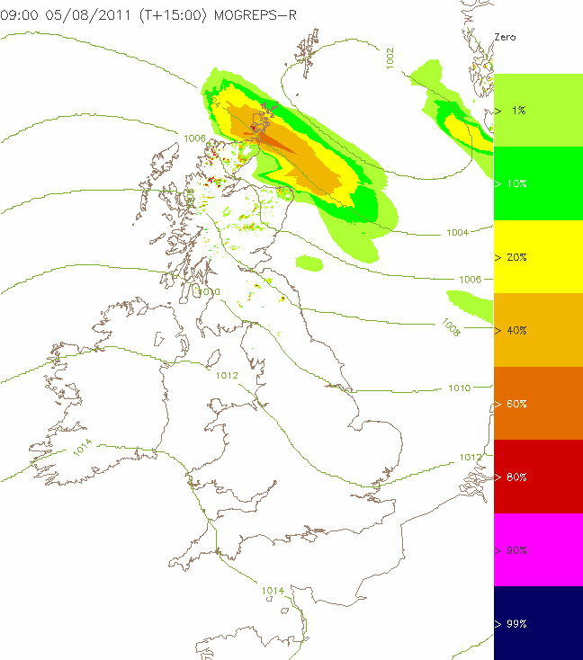

9.2.3 Site-specific extractions
Forecasts for specific locations may be generated by extracting data from model grids. In the simplest implementations data are simply taken from the nearest model grid-point, or are interpolated between the nearest grid-points by linear interpolation. Various methods are used to improve on these approaches, using similar techniques to the downscaling methods. In particular corrections to surface temperature and wind speed should be made to account for the difference between model orography and the true altitude of the site. An intelligent grid-point selection system which chooses the most representative grid-point can also be better than a simple interpolation, especially near coastlines where it may be better to choose the nearest land-point to represent a land-location, rather than for example the nearest grid-point which may be over the sea. This approach may also be beneficial near steep orography.

A one-dimensional model could also be used for specific forecast applications (e.g. 1D fog models for airports).

9.2.4 Statistical Downscaling
Downscaling of surface fields may also be done by building a statistical relationship between low-resolution model fields and high-resolution analyses. There are two approaches which may be followed:

9.2.4.1 Using Analysis Differences
The statistical relationship may be developed by comparing high-resolution gridded analyses with the corresponding analysis fields on the EPS model grid. This provides a downscaling vector which may then be applied to EPS forecast fields to provide bias-corrected and downscaled forecast fields on the high-resolution grid.

9.2.4.2 Kalman Filter
A Kalman filter approach may be applied at each grid-point of the high-resolution grid to build a statistical relationship with the lower-resolution EPS analysis fields. This Kalman filter may then be applied to the EPS forecast fields to provide bias-corrected and downscaled forecast fields on the high-resolution grid.

9.2.5 High Impact Weather Diagnostics
A number of methods are available to diagnose specific high-impact weather phenomena from NWP models, and these can be applied equally to EPS. A good example is Severe Convection diagnostics. These often use a number of model multi-level model outputs to diagnose the instability and potential for severe convection, and provide probabilities for phenomena such as large hail, tornadoes and convective wind gusts.

9.2.6 Downscaling by combination of low-resolution EPS and high-resolution control forecast
Low resolution ensemble perturbation fields (difference between the perturbed member forecast and the control forecast) can be added to a high resolution control forecast fields to provide a high-resolution probabilistic forecast.

9.3 Clustering techniques
Classification processes can be used to synthesize the huge amount of information contained in ensembles. Different kinds of classifications can be implemented :
- Clustering attempts to group together members which are most similar in their evolution over a defined geographical region of interest. Several standard clustering algorithms are available and may produce different groupings under. The clustering outcome also depends on the variables chosen.
- The “tubing” classification identifies a central cluster of the members closest to the ensemble mean and those members most significantly different from the ensemble mean (tube extremes). Tubing is useful to identify the most likely outcome and also the possible scenarios most different from that solution.
- Classification of forecasts by matching ensemble members to a defined set of flow regimes, for example the Grosswetterlagen types defined for central Europe. This method may provide the clustering which best matches a synoptic forecaster’s expectations.

9.4 Use of Reforecasts
Research has shown that calibration of ensemble forecasts using historical sets of “reforecasts” – forecasts run with the same model or EPS from sets of historical cases, initiated from reanalyses – can be very effective in improving the quality and reliability of probabilistic forecasts. Such reforecasts provide a better dataset for training of statistical post-processing methods compared to using recent forecasts, as they provide a better sampling of different weather regimes and types. This can be particularly useful for optimizing the calibration of forecasts for rare or extreme events. However the running of reforecasts adds substantially to the computing cost of running an EPS, and depends also on the availability of a suitable reanalysis dataset to provide the initial conditions. As a result very few EPSs currently have reforecast datasets available, but their use is recommended where possible. Where a full reforecast dataset is not available, an alternative may be to use a recent archive of EPS forecasts from the same system, although is likely to provide a less reliable sampling of the full model climate.

9.4.1 Extreme Forecast Index (EFI)
One application of reforecasts is the computation of an Extreme Forecast Index.
NWP models and EPS systems do not represent accurately the climate of the real atmosphere, and identification of extreme events may be best done in relation to model climatology. The Extreme Forecast Index developed by ECMWF allows identification of forecasts which are extreme relative to the model climate, providing an alert to a risk of severe weather. The EFI does not provide explicit probabilities of severe events.

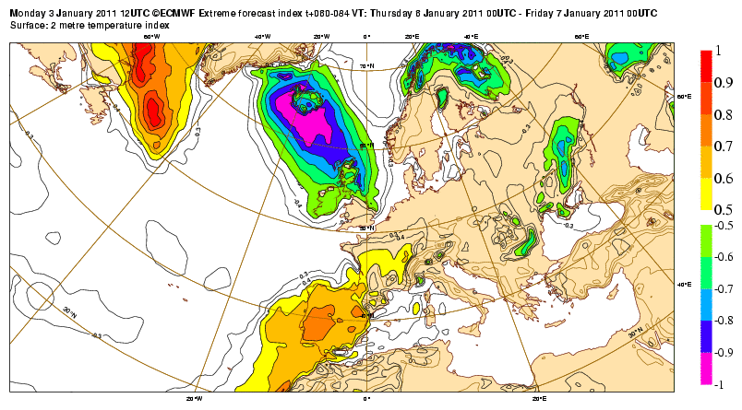

Reforecasts can also be used to assess forecast severity in relation to climatological return periods, which can be a useful way to communicate the severity of an event.

9.4.2 Quantile-Quantile Matching
Another approach to forecast calibration which can be used where an estimate of the model climate is available is Quantile Matching. For example the value corresponding to the 90th percentile of the model climate may be interpreted to represent the 90th percentile of the real observed climate distribution for a particular location. In general this method requires the use of a reforecast dataset to provide the model climate.
9.5 Feature Tracking
A useful technique for lower resolution EPS such as global EPS is to track meteorological features in each member of the ensemble. A good example is Tropical Cyclones (TC) which are not well-resolved in the model, but the global models can nevertheless predict the movement of the storms quite well. A global EPS could not be expected to predict the intensity of strong winds or heavy rain in a TC but could track its position. The forecaster can interpret the probabilities of severe weather by knowing the characteristics of tropical cyclones, combined with the ensemble information on where it is likely to go. The example below shows tracks of Hurricane Tomas in the members of the ensemble, probabilities that the storm will pass close to locations on the map, and summary tracks such as the ensemble mean track. These types of charts are often made available to the Tropical Cyclone RSMCs.

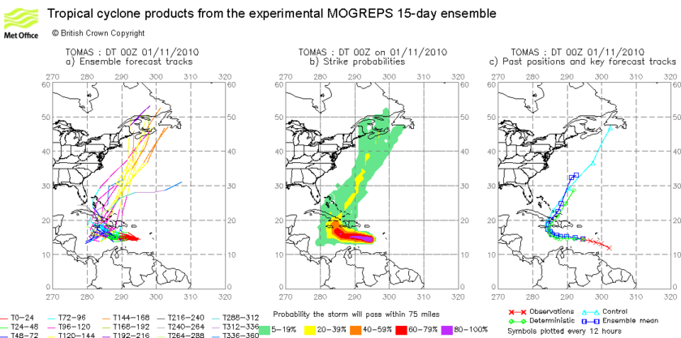
10. Use of EPS in Prediction of Severe Weather and issue of Warnings
Severe or high-impact weather events occur on a wide range of scales in space and time, from Tropical cyclone, extra-tropical cyclone, monsoon, winter storms and other large scale systems, to smaller scale systems such as local severe storms, orographic precipitation, thunderstorms and tornados. Forecasters must take account of the different predictabilities of different types of events (e.g. do not try to predict a thunderstorm 3 days in advance).

A well structured NMHS severe weather warning system should have appropriate thresholds, lead-times and level of service agreed with users. Thresholds should normally reflect the level of impact the weather is expected to have on society, including danger to life and property, and disruption to everyday life. Features which should be considered in a warning system include:
- Types of warnings; regions; thresholds (severity/impact and probability)
  - Risk = Probability x Impact
- A good warning system is one that will be easily understood by users, with standard thresholds adhered to by forecasters.
  - Many countries now use a 4-colour traffic light system (Green, Yellow, Amber and Red) indicating different levels of risk and corresponding levels of action which users should take.
- A good warning system will require feedback from users to NMHSs. The NMHSs in turn should give feedback to producers enabling them to design appropriate products.

EPS are a powerful tool in predicting severe weather events. For impact-based warnings systems the EPS may be used to help estimate the probability of weather hazards for use in the estimate of Risk = Probability x Impact. However, EPS can only predict severe weather which the model(s) can resolve:
- Numerical Weather Prediction has limitations in explicitly resolving smaller scale phenomena, which leads to under-estimation of extreme events likelihood within EPS.
- Sometimes can identify pre-cursor conditions for severe developments or favorable large scale environment such as convective indices
- Lower resolution EPS (Global) is less likely to be able to resolve details of an extreme event
- Regional EPS, which usually has higher resolution, should provide more detailed uncertainty estimates at the smaller scales.
Hazard thresholds used in the EPS may need to be calibrated to take account of the above limitations.

Early indications of some extreme events will be predicted in the tail of the ensemble distribution.
- Therefore forecasters and users should not ignore low probability events, especially when those events are very rare.
  - For example, ignoring probabilities below 20% or even 10% could result in missing the most important events signaled by the EPS.
  - To be able to use low probabilities, forecasters need verification information
  - “false alarms” are actually correct features of low probabilities. However low probabilities may be required in potential high-impact situations
  - It is expected that the probability will increase closer to the event – usually but not always
An extreme event may also be forecast essentially correctly, but with errors or uncertainties in location or timing.

Synoptic interpretation (e.g. weather feature tracking, use of analogues) or statistical downscaling tools are ways to add skill to the basic EPS.
- Note that some statistical methods require large data samples for training, and may not be well-suited to rare or extreme events.
- Cyclone tracking products (for both tropical and extra-tropical cyclones) can provide a useful summary of the development of high-impact storms.
- There is potential for development of more feature-based diagnostics for poorly resolved severe weather systems.

The Extreme Forecast Index (EFI) can be a useful tool in alerting forecasters to a potential severe event.
- EFI does not provide explicit probabilities of specific events, and should be interpreted in conjunction with other tools.
- Currently only a small number of systems can provide an EFI due to the need for a model climatology.

Consideration of input from multiple forecasting systems (EPS and deterministic) may give additional information on the probability of extreme events
- Production of verification highlighting the skill and limitations of EPS is important.
  - Users of EPS should be aware of those limitations and strengths.
  - However, due to the rarity of most extreme events it is often impossible to provide reliable (or statistically valid) verification of probabilistic performance. It may be possible to gain some estimate of skill for extreme events by extrapolating from the verification of less-severe events.
- Given the diminishing of the EPS skill with increasing lead time, latest available products are generally given higher credibility. However, previous runs of an EPS may still provide useful information about a rare event because of the lack of spread (limitation in the sample size).
11. Severe Weather Impact Modeling
The uncertainty in the weather forecast can be propagated through to uncertainty in impact by coupling ensemble members to impact models and generating a distribution of impact predictions. Examples include hydrological models for probabilistic flood forecasting, coastal storm surge models, heat health models etc. This is an advanced application which is being increasingly applied in the more advanced centres. The example below shows an ensemble forecast of storm surge at a coastal port, where the weather forecasting EPS has been used to force an ensemble with a storm surge model. The red lines at the top of the graph show the flood danger level oscillating up and down with the tide, and a flood risk is indicated where the ensemble forecast surge lines cross above the red lines. This is an interesting example as one member of the ensemble produces an extreme surge at day 7, indicating a low probability of severe coastal flooding. In this situation the user needs to be able to take some early preparedness action but without over-reacting because the probability of the flooding occurring is low:
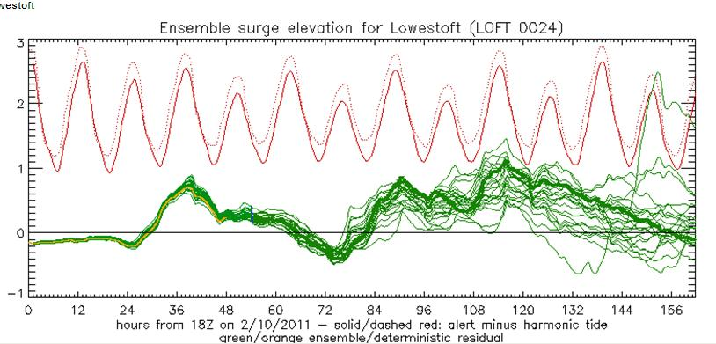

12. Verification
Verification is a very important part of everything we do in forecasting. If we do not verify our forecasts – measure how good they are by looking back afterwards and seeing how well the forecast matched what actually happened – then we have no way of learning and improving our forecasts in the future. This is just as true with probabilistic forecasts. You will often find people say that a probability forecast can never be wrong (unless we say 0% or 100%). Some people will also say that it is just a way for the forecaster to avoid making a decision. The way to challenge these views is to demonstrate that we do verify the forecasts, and that they have useful skill.

We do not provide here a detailed guide on verification of forecasts, but we describe a few important points:
- A single probability forecast cannot be right or wrong.
  - If we predict something with a high probability and it happens, it is often tempting to say “Look, we got it right!” We should avoid doing this, because when we forecast something with a low probability and it happens we will want to say to the user “We did say it was a possibility even though it was a low probability”.
- If we say there is a 30% probability that we will get more than 10mm of rain, and the observation shows that we get only 1mm, the forecast is not right or wrong. We have to measure the actual observed amount for many occasions when we make such a forecast – out of every 100 times that we say this, we should get over 10mm on 30 occasions. This is what the forecast means. Out of 100 times that we predict 80% probability, we should get it 80 times.
- The simplest way to present verification is using a reliability diagram, which plots a graph of the observed frequency against the forecast frequencies – so it plots exactly the test described above. Below are three examples of reliability diagrams for probabilities of wind speeds exceeding Beaufort Force 8, 9 and 10. The ideal is that the line should lie up the main diagonal, from (0,0) to (1,1). The first diagram on the left for Force 8 is quite good and shows that forecasts of high probability do mean the event is much more likely – the slope of the graph is slightly less than ideal, but good. The second is similar but not quite so good for the highest probabilities at the top right of the graph. The third on the right, for Force 10, shows useful skill for probabilities up to 30%, but at probabilities above that there is no useful information. In fact this is a rare event and there are not enough samples in the dataset to measure whether there is useful skill – this is a common problem with verifying extreme events, we do not have enough data to measure probabilistic skill.
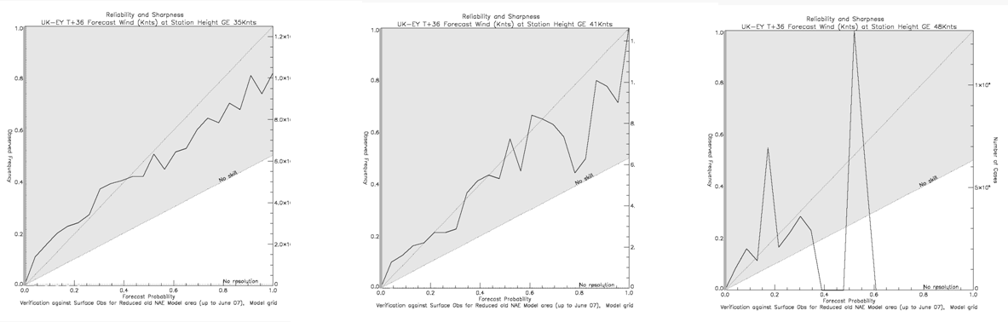
- There are many other measure of probabilistic forecast. We list some other common ones here – much more information is easily available from an internet search for these terms, or from standard guides to forecast verification:
  - Brier Score – a root mean square error for probability forecasts of a particular event threshold.
  - Brier Skill Score – compares the Brier Score of the forecasts with the Brier Score of some reference forecast system.
  - Reliability – measures how well forecast probabilities match observed frequencies.
  - Resolution – measures how good the system is at predicting probabilities which are different from “normal”.
  - ROC (Relative Operating Characteristic) – measure how good the forecasts are for decision-making – similar to resolution.
  - CRPS and RPS – (Continuous) Ranked Probability Score – like a Brier Score for multiple thresholds of the weather variable.

WMO CBS has defined a standard set of verification scores for comparison of EPSs, and these are displayed for a number of global EPSs at the Lead Centre website at http://epsv.kishou.go.jp/EPSv/ .

13. Forecaster Training
In general, forecaster training should include components on predictability and ensemble forecasting:
- Motivation for probabilistic forecasts – chaos theory and its impact.
- Statistical background theory and approaches.
- Aims of initial condition and model perturbations.
- Standard ensemble verification tools and their meaning.
- Explanation of basic meaning of products (e.g. lines on chart).
- Methods of post-processing and their impacts.

Learning Through Doing – The training of forecasters in the use of EPS guidance should be a practical experience using tools which are as close as possible to those used in operations. The optimal benefit from practical training on EPS is only obtained when an NMHS has access to operational EPS data, the operational time to use it and the products and tools to make direct use of it.
  - Benefits of training which is not reinforced by operational practice are rapidly lost.
  - Provision of training in conjunction with a demonstration project such as the SWFDP can help to ensure that the training is reinforced and consolidated by the provision of relevant operational EPS data.

  - During training, case studies should be worked through showing the appropriate use of EPS guidance, both in routine and severe weather scenarios.
  - Web based tools can be valuable in training, as they can be used on any workstation system through a standard browser to ensure continued access afterwards.

- In the relatively new area of EPS, periodic training is expected to generate the best benefit. Forecasters require time to build experience in using this guidance followed by further training to reinforce key concepts. It would also be of benefit if various NMHSs could share their experience with EPS.
- Training resources
  - ECMWF Users’ guide http://www.ecmwf.int/products/forecasts/guide/
  - COMET ensemble modules: http://deved.meted.ucar.edu/nwp/pcu1/ensemble/

ANNEX II

TERMS OF REFERENCE OF THE ET-EPS

Expert Team on Ensemble Prediction Systems

- Provide advice on EPS in relation to probabilistic forecasts in the context of short- and medium-range EPS products, focusing on applications concerned with all aspects of the EPS systems which forecast the weather on a daily basis;
- Propose guidance for the generation of EPS products for the communication of uncertainty in prediction of the weather and its impact;
- Liaise with the PWS programme to promote and support the use and communication of probabilistic information available from the GDPFS centres;
- Promote and support the education and training of forecasters, including rationale of concepts and strategies of EPS, and on the nature, interpretation and application of EPS products;
- In consultation with the Coordination Group on verification, review verification system for EPS products and provide guidance on the interpretation of verification;
- Support the further development of the Lead Centre on Verification of EPS by reporting on verification measures and determining the best way of presenting skill of ensemble forecasting systems;
- To review the Manual on the GDPFS (WMO-No. 485) and propose updates as necessary concerning EPS;
- Develop specifications for the introduction of probabilistic information into products from RSMCs and Regional Centres of the SWFDP;
- Liaise with THORPEX GIFS-TIGGE WG to trial new products and advise on their suitability for operational application.

