WORLD METEOROLOGICAL ORGANIZATION  COMMISSION FOR BASIC SYSTEMS  OPAG DPFS  IMPLEMENTATION COORDINATION TEAM ON DATA PROCESSING AND FORECASTING SYSTEM (DPFS)  MONTREAL, CANADA, 29 Sept. – 3 Oct. 2008 |  | CBS-DPFS/ICT-DPFS/Doc. 8(2)  (29. IX.2008)  _______  Agenda item : 8  ENGLISH ONLY

Non-NUCLEAR EMERGENCY RESPONSE ACTIVITIES
Report of the Chair of the ET non-Nuclear ERA

(Submitted by Jim Fraser & Chris Ryan (Australia))

Summary and purpose of document

The Chair of the CBS DPFS Expert Team on Atmospheric Transport Modelling for non-Nuclear Emergency Response Activities (ET-nNERA) reports on progress, and proposes plans for future work.

Action Proposed

The meeting is invited to note the activities of the ET-nNERA, its proposed Work Plan, and proposed amendments to the Expert Team’s Terms of Reference, and to make appropriate recommendations to CBS.

- BACKGROUND

1.1 The goal of the Emergency Response Activities (ERA) programme is to assist NMHSs, with other relevant agencies of Member countries and in cooperation with relevant international organisations, to respond effectively to environmental emergencies. Until 2005 the programme mainly focused on emergencies caused by nuclear accidents and radiological incidents. Eight designated RSMCs (Beijing, Exeter, Melbourne, Montréal, Obninsk, Tokyo, Toulouse and Washington) are prepared to provide atmospheric dispersion model products on request, and RTH Offenbach provides the communications link for notification by the International Atomic Energy Agency (IAEA) Incident and Emergency Centre (IEC) to the RSMCs.

1.2 It being widely recognised that the tools used to model the dispersion of nuclear contaminants in the atmosphere can also be applied to other hazardous materials, the ERA programme was directed to expand its activities into non-nuclear environmental emergencies. A WMO survey of NMHSs carried out in mid-2004 helped in developing an understanding of their requirements and capabilities in the programme. The results of the survey were considered at a WMO Workshop on Development of Scope and Capabilities of the ERA in December 2004. The workshop recommended that priority should be given to expanding the programme to atmospheric transport and dispersion modelling to support response to chemical accidents and smoke from large wild-land fires.

1.3 At CBS-XIII (2005) a new Expert Team on Modelling of Atmospheric Transport for non-Nuclear Emergency Response Activities (ET-nNERA) was established. The team membership and Terms of Reference (Annex 1) were adopted by the CBS Management Group in April 2005. The ET complements the nuclear ERA Coordination Group (nERA-CG) and shares many of its members. The Expert Team met in September 2005 at Melbourne and in June 2007 at Montreal. Reports of those meetings can be found at
http://www.wmo.int/pages/prog/www/CBS-Reports/DPFSERA-index.html

1.4 CBS-Ext.(06, November 2006) adopted all the key results of the Expert
Team, which were reported through the Implementation Coordination Team for the
OPAG on DPFS, including:
• Chemical incidents are predominantly of the localized and short-lived
nature where very rapid emergency response is essential; therefore
concentrate efforts on developing the necessary capabilities at the
NMHSs;

• A higher priority would be the trans-boundary transport of airborne
hazards such as in the case of smoke from large fires where a
regionalized approach would be appropriate, i.e., through a
designated RSMC(s) to provide emergency support to and build
capacity at NMHSs; and similarly, for large trans-boundary dust or
sand storms;

• Cooperation with International Organizations is important, e.g. with the
IAEA on nuclear aspects, with ICAO on the airborne volcanic ash
advisory service, with the UNEP/UN Office for the Coordination of
Humanitarian Affairs (UNEP/UN-OCHA) Joint Unit, and with World
Health Organization’s (WHO) International Programme on Chemical
Safety (IPCS), in particular operational components that could be
linked to the developing operational framework;

• Expanding the official services provided by the RSMCs on
Atmospheric Transport Modelling to include backtracking, and that a
backtracking experiment is to be planned and undertaken in 2007.

1.5 Congress (Cg-XV, May 2007) continued to support the extension of the ERA
programme to include non-nuclear aspects, including airborne and waterborne
hazards.

- PROPOSED CHANGES TO THE TERMS OF REFERENCE

2.1 At its meeting in June 2007 at Montreal the Expert Team reviewed its Terms of Reference. Considering the progress made since CBS-XIII (Feb. 2005), and recognising that the team’s work had moved from the initialising and exploration stage to ongoing activities, some modifications were proposed to the Terms of Reference for consideration at the next Session of CBS. The new Terms are given in Annex 1.

- SCIENTIFIC AND TECHNICAL DEVELOPMENTS FOR ERA

Backtracking Demonstration Experiment
3.1 A major outcome of the Expert Team’s 2007 meeting at Montreal was planning for a demonstration experiment with the goals of:
- demonstrating to WMO Members and relevant international organizations the new operational backtracking capabilities and products that the RSMCs can provide; and
- exploring the concept of operations for the requesting and the provision of backtracking products and services.

3.2 The experiment was carried out over 29 February to 3 March 2008, with the participation of RSMCs Beijing, Exeter, Melbourne and Washington. RSMC Exeter provided the basis for the experiment by simulating a chemical release to the atmosphere from a tanker ship off the coast of France in the English Channel. Using the UK Met Office dispersion model NAME III nested in the forecast wind field, simulated observations of chemical concentration at a number of receptor sites in Europe were generated.

3.3 The participating RSMCs were then requested to perform backtracking simulations to identify the source location. Back dispersion plumes, back trajectory plots and Source Receptor Sensitivity (SRS) calculations were generated by each of the RSMCs for each simulated observation. The results were encouraging, with the SRS results showing particular promise. Annex 2 provides more detail on this aspect of the experiment.

3.4 For this initial experiment the results were not calculated in real-time so operational procedures were not exercised. A second more comprehensive experiment is planned for 2009.

ATM Ensemble Techniques
3.5 Collaboration with the European Commission Joint Research Centre (EC-JRC, Ispra) in its ENSEMBLE project could assist the WMO ERA programme in exploring and developing ensemble approaches for atmospheric transport modelling. The Expert Team has requested the Secretariat to contact the manager of the ENSEMBLE project with the goal of developing a suitable cooperative framework for this work. In addition, arrangements are being made between RSMCs to establish a routine exchange of atmospheric transport model products in GRIB format, so as to allow investigation of ensemble methods.

Biological Hazards
3.6 Present understanding of the behaviour and spreading of animal diseases other than Foot and Mouth Disease (FMD) by the atmospheric pathway remains poor, Interactions between the meteorological and animal health communities are encouraged. This subject should continue to be monitored by the Expert Team.

Chemical Hazards
3.7 US NOAA is developing a new chemical interface to the CAMEO chemicals database for the Web-based HYSPLIT dispersion model, used for emergency response applications that will permit the speciafication of the emission source characteristics from simple pull-down menus. When completed, the interface will be available to other countries using HYSPLIT.

Sand and dust storms
3.8 A Sand and Dust Storm Warning System has been proposed as an initiative of the World Weather Research Programme (WWRP), within the WMO Commission on Atmospheric Sciences, where three regional centres for sand and dust storm modelling and forecasting are being organized for eastern Asia, Europe and North Africa, and North America. The Expert Team noted that coordination between CAS and CBS would be highly desirable to ensure operational issues and requirements are considered and addressed.

Formats for exchange of ATM products
3.9 In order to ensure rapid and effective communication of time-critical information, data and product formats have to permit efficient exchange and usage, for example for immediate visualization, input and layering of fields within specialized decision support or mapping systems.

3.10 The Expert Team has sought, through the Secretariat, clarification regarding WMO data and product format standards and related policy with respect to exchange of GIS-like products among WMO Members as well as with external users, recognizing that new electronic formats are in wide use and are desired by some users for product exchange.

4 COOPERATION WITH OTHER INTERNATIONAL ORGANIZATIONS
4.1 While the potential areas of collaboration with agencies such as UN-OCHA and WHO have been well recognised, it has proven difficult to establish practical arrangements or plans. The Expert Team has proposed that reciprocal attendance of programme experts from the respective Organizations at technical meetings may be a useful pathway to collaboration arrangements. The World Organization for Animal Health has been identified as another potential partner.

ICAO
4.2 In the context of air navigation and air traffic control operations, significant benefits continue to be realized from the specialized atmospheric and transport modelling of airborne volcanic ash. This major threat to aviation is considerably reduced with the use of modelling and specialized forecast products and services provided by the 9 Volcanic Ash Advisory Centres designated to support ICAO's International Airways Volcano Watch programme.

5 DESIGNATION OF RSMCs FOR ATMOSPHERIC TRANSPORT MODELLING
5.1 In the event of a request to WMO for designation of a centre as an RSMC in the specialization of Atmospheric Transport Modelling, that centre must demonstrate to CBS its capabilities against the requirements stated in the Manual on the GDPFS for nuclear emergency response and for CTBTO backtracking.

- FUTURE WORK
6.1 The Expert Team, at its meeting in 2007, reviewed and updated its Work Plan, including activities to be undertaken up to its next meeting, likely to take place in the second
quarter of 2009. The new Work Plan is found in Annex 3.
ANNEX 1: TERMS OF REFERENCE OF THE ET-nNERA

Current Terms Of Reference

The Terms of Reference for the CBS Expert Team on Modelling of Atmospheric Transport for Emergency Response Activities, as recommended by CBS-XIII (2005) and adopted by the CBS Management Group (CBS-MG-V, 2005) are as follows:

- Identify the needs of the NMHSs for atmospheric transport modelling;

- Examine the atmospheric transport modelling capabilities of RSMCs and other centres for support to non-nuclear emergencies, for example in volcanic eruptions, dust storms, wild-land fires, chemical and biological incidents and other hazards;

- Identify the potential role of international organizations (e.g. WHO, UNEP, UN-OCHA, others);

- Review the status and develop an action plan.

The name of this Expert Team is referred in short as the “Expert Team on non-Nuclear Emergency Response Activities (ET-nNERA)”.

This Expert Team is established under the CBS-XIII (2005) Open Programme Area Group (OPAG) on Data-Processing and Forecasting Systems (DPFS).

Proposed Revised Terms Of Reference

Revised Terms of Reference recommended by the Expert Team at its meeting in Montréal, Canada, 4–8 June 2007) are as follows:

a) Monitor the needs of the NMHSs for atmospheric transport modelling and
identify those areas in which RSMCs can be of assistance;

b) Identify and promote technical resources which can assist NMHSs in
developing their atmospheric transport modelling capabilities, particularly
for limited area non-nuclear emergencies such as chemical releases to
the atmosphere;

c) Monitor the atmospheric transport modelling capabilities of RSMCs and
other centres for support to transboundary non-nuclear emergencies,
such as volcanic eruptions, dust storms, large fires, and biological
incidents, with the goal of improving operational arrangements;

d) Develop strategies to strengthen operational links with international
organizations relevant to non-nuclear ERA, and between NMHSs and relevant national authorities.
ANNEX 2: SRS Results from the March 2008 Backtracking Experiment

Results and text prepared by Roland Draxler from NOAA

An SRS (Source Receptor Sensitivity) calculation consists of a single backtracking simulation to correspond with each measurement by releasing a tracer at the sampling location over the duration of the measurement. The atmospheric transport model is integrated in the upwind direction with a 6-hour average output of the measurement mass divided by the upwind source area, the value which represents the relative contribution that each source area could have made to that particular measurement (the SRS function).

All integrations were terminated at the same time (0000 UTC 29 February). Each RSMC contributed 28 SRS files, each representing a different sample at different locations and starting times.

Each of these files was post-processed into a binary file compatible with the NOAA display software and time-standardized so that regardless of the start time of the calculation, all SRS fields consisted of 12 six-hour duration time periods over the duration of the experiment. SRS fields after the measurement period to the end of the sampling period were set to zero. These 28 simulations were then combined into an ensemble SRS mean or the 95th percentile SRS. The 95th percentile SRS shows a map of the highest SRS values at each grid cell location. The graphics were computed independently for each RSMC, for each six hour sampling period and for all 12 sampling periods combined. The combined results for the ensemble means and 95th percentiles are shown below.

These preliminary results show that the upper percentile SRS appears to provide a more focused representation of the potential source regions than the ensemble mean. Further, the individual RSMC products are very similar to each other when comparing the 95th percentiles. The ensemble means tend to show too much structure associated with the individual measurement locations. There are substantial differences between the RSMC SRS values, suggesting that not the same release rate was used by all centres. In a more realistic simulation, the release rate should be scaled to the actual measurement value, resulting in higher SRS fields from locations that are nearer to the actual source location. In this exercise, the simulated measurement data were not used to scale the SRS calculations. For instance, upwind calculations from the zero measurements at the other sampling locations could have been used to reduce the potential source area.

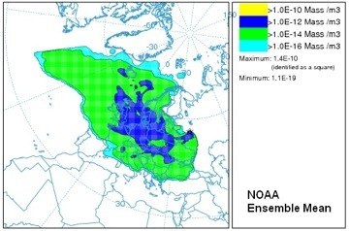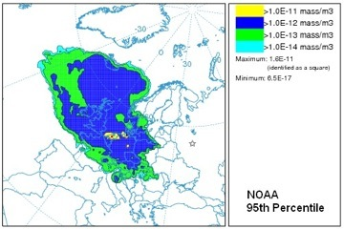
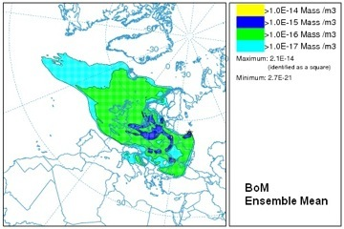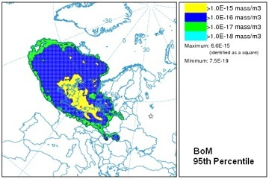
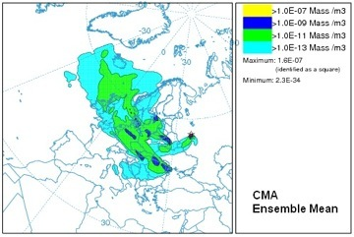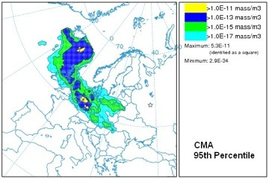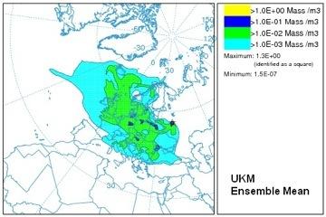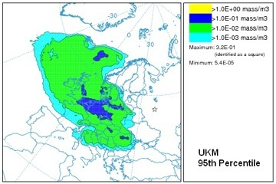
ANNEX 3: PROPOSED WORK PLAN FOR THE NON-NUCLEAR ERA PROGRAM (as proposed in June 2007)

General

Area of Requirement | Component Action | Priority / Timing / Milestone | Responsibility
Observational data (chemical sniffers, etc) | Explore availability of real-time and post-incident measurement data.  Define the use of such data from local and national monitoring in real time operations and post event validation and incorporate as a statement of guidance in operational framework document. | Chair to contact Shershakov for update. | Chair, Shershakov
Role of International Organizations (including linkage between NMHS with their national civil protection authority) | Develop interface (program coordination, etc including operations) between WMO and WHO, and with UNEP/OCHA  Acquire contacts from WHO and UNEP/OCHA and provide to NHMS. Future consideration to exercises to involve NMHS’s and National Authorities.  Engage with these organizations to promote the usefulness of ERA products.  Explore areas of mutual interest with OIE | Ongoing, although it is noted there are limited resources available at these organizations.  On going  December 2007 | Chair, Secretariat  Secretariat  Sorensen, Wortley
Promote ERA programme to NMHS via Regional Associations | Role for DPFS Rapporteurs in RAs | On going at future ICT meetings | Secretariat
Articles and updates to WMO Tech. Note 778 | Review and update to articles and annexes | Review of annexes to carry on. New printed version of TD 778 not thought to be needed | ET
Format and Range of Products | Summary of range and format of products which are currently being demanded to be catalogued | In time for next ET meeting (2009) | ET
Glossary of terms relating to ATM | Glossary of terms relating to ATM to be compiled for inclusion on ERA web pages. | End October 2007 | Perron
Ensemble | Request to be made to “ENSEMBLE” for dedicated space to be made available for use by ET for NN ERA for research purposes.  Arrangements to be made in order for ATM Products to be produced and sent to “ENSEMBLE” WMO area in order to research usefulness of ensemble techniques/products. | End of December 2007  End of June 2008 | Secretariat  ET, Chair (whip)
Backtracking | Conduct Backtracking demonstration/experiment to prove current capability.  Report to be prepared on Backtracking Demonstration/experiment | End of October 2007  End of February 2008 | All RSMC’s, plus invite to DWD and Austrian Weather Service (ZAMG).  Chair, Perron, Wortley, Draxler
Chemical Release to the Atmosphere

Area of Requirement | Component Action | Priority / Timing / Milestone | Responsibility
Capacity Building | SG letter to willing provider states regarding what they are prepared to do to support capacity building – request national technical contact point | Not Done but will be considered | Secretariat
 | SG letter to all Members to promote PR-to-PR arrangements for capacity building, and basic principles of ERA | Not Done but will be considered | Secretariat
NMHS’s to have access to available Mesoscale meteorological models (Aladin, MM5, WRF, GEM LAM, HRM, HIRLAM etc) | WMO secretariat to put relevant point of contact information on web page | Models noted on web page - points of contact will be considered for inclusion. | Chair, Secretariat
Dispersion Model (Air) | Preparation of a document that describes the stratification from basic minimum tools to sophisticated ATMs | End of December 2007 | Chair, Wortley to draft
Chemical Release to the Atmosphere (Cont)

Area of Requirement | Component Action | Priority / Timing / Milestone | Responsibility
Develop Operational Capabilities at NMHS’s | Preparation of a document describing the proposed operational framework which would contain local response information, including the Melbourne submitted paper, Wortley paper on stratification, and tech 778 doc  The following also has to be included in the document:  - Training and exercising  - Preparedness considerations  - How to transit from preparedness to an operational outfit?  - Quality assurance guidelines, use of test data should be normal procedure within NMHSs to validate the correctness of their approach; Develop guidelines for procedures, standards for outputs, benchmarking, exercises, etc.  Reviewing the usage of ERA web pages by NMHS’s to guide further developments | First draft End of August 2008  Final version End of December 2008  Report for next ET meeting (2009) | Chair,  Wortley, Ryan, Perron  Secretariat
Chemical Release to the Atmosphere (Cont)

Area of Requirement | Component Actions | Priority / Timing / Milestone | Responsibility
Training (Implementation and Maintenance) | COMET collaboration:  - Case studies  - Translation of modules  - Additional modules  Explore web addresses and further discussions with Tim Spangler  Identify On-line training  Publish Suitable Internet Links  WMO co-sponsored Training Seminars (planning, who is capable of carrying or participating as experts)  Identify and take advantage of WMO co-sponsored training events of opportunity (few places offered to WMO participants) | Continue to monitor COMET developments.  On going  Funds not currently available ongoing  Ongoing | Secretariat  ET to Chair  Secretariat  Secretariat

Smoke from large fires (wild-land, oil, chemical)

Area of Requirement | Component Actions |  | Priority / Timing / Milestone |  | Responsibility
Observational data, monitoring, database | Explore the role of the Global Fire Monitoring Centre (Freiburg), and other international organizations, GMES (Global Monitoring of Environmental Security), etc, and feedback to ET. e.g. is this real-time, etc  Identify relevant remote sensing of large fires and smoke from large fires, in real time to assist in Operations for RSMC’s and NMHS’s. (NESDIS, etc) To include image based and quantitative. |  | Not done. Although nice to know it is not considered critical. Some exploration done, current understanding is that they are not real time.  Not Done. Further investigation and catelogueing required.  End of December 2007 |  | Jean/Servranckx
Interim operational arrangements |  | Investigate the role and operational arrangements at Singapore Centre for ASEAN regional smoke and haze prediction.  Produce a paper to review current state of the science in particular relating to  - Definition of source term (including satellite measurement techniques), species to consider (e.g. PM2.5)  - Type of products available |  | End of December 2007  Next NN ERA ET meeting (2009) |  | Chair  ET members who have the capability

Smoke from large fires (wild-land, oil, chemical) (Cont)

Area of Requirement | Component Actions | Priority / Timing / Milestone | Responsibility
Smoke and pollutants transport and dispersion modeling, Ensemble approach | Evaluate tools or standards to facilitate display of different ensemble members | End of December 2007 | Perron, Draxler

Sand and Dust Storms

Area of Requirement | Component Action | Priority / Timing / Milestone | Responsibility
Operational arrangements | Determine whether there is a need for Regional/Global arrangements, including international organizations  Explore possibility of co-ordination with the organizers of the expert meeting who are investigating a proposed WMO/GEO sand and dust storm warning system  Develop a web-based information page on the subject | Awaiting results of WMO/GEO Expert Meeting (Nov. 2007)  End of September 2007  Not done. It would be good to add to the general web page. Links relating to JMA and CMA services could be added. | Chair, Secretariat  Chair  Chair, Song and Fujita
Modeling | Members to share what they are doing/experience in terms of relevant activities | On going | ET
Specialized Centres | Future consideration, dependant on result of co-ordination with WMO/GEO expert meeting above |  | Chair, Secretariat

There are a number of areas that could be considered (e.g. chemical releases in the water, biological events, etc) and that have been raised by other international organizations (e.g. UNEP OCHA), but this expert team will give priority to work related to chemical releases in the atmosphere.
Events might cover all the horizontal scales. Therefore different arrangements might be required. This expert team will focus on local scale chemical emergencies. In the context of this expert team, local scales cover the range up to hundreds of kilometers.
The availability of training in languages other than English is rather limited. The group is invited to think about practical solutions to alleviate this problem.
The group felt that large fire in this context correspond to events that can be detected through space based platform
Eventually, fire propagation model will become available. In this case, local meteorological monitoring will become extremely important.
There is a need to understand if this capability is required…. Can the survey help the group have a better grasp on this issue.

