WORLD METEOROLOGICAL ORGANIZATION  COMMISSION FOR BASIC SYSTEMS  OPAG on DPFS  MEETING OF THE CBS (DPFS) TASK TEAM ON SURFACE VERIFICATION  Montreal, canada  9-13 may 2016 |  | CBS-DPFS/ ET-OWFPS /Doc. 4.2(1)  (6.V.2016)  _______  Agenda item : 4.2  ENGLISH ONLY

4.2 Upper Air Verification

(Submitted by Tom Robinson)

Summary and purpose of document

This document provides background information on the exchange of upper air verification data amongst participating NWP producing Centres

Action Proposed

The meeting is invited to consider the information and recommendations in this report.

Reference:
- Appendix A.II.2.3.2 of the new CBS Manual WMO-No.485

Annex: 4.2_EPSverification.doc

Introduction
NWP producing centres have been exchanging monthly upper air verification data for over two decades. The standards for this exchange, described in the Manual of the Global Data-Processing Forecasting System, were first developed in 1998 and were updated in 2012 to account for the evolution of NWP since the original standards. Most but not all of the participating centres have adopted the new standards. A Lead Centre for Deterministic NWP Verification (LC-DNV) was established (ECMWF) where centres can upload or download data, view graphed data and obtain information related to the verification data exchange.

Status report on Lead Centre for Deterministic NWP Verification (LC-DNV) activities

All components of the Lead Centre have been fully operational. No major changes have been implemented in the LCDNV operations since the last ET-OWFPS report.

Regular verification reports have been received, processed and provided to participating centres for download. As requested by ET-OWFPS, an automatic log of received or updated reports is available on the LCDNV wiki at https://software.ecmwf.int/wiki/display/WLD/Availability+log.

Two centres, KMA and DWD, have implemented the updated CBS guidelines since the last ET-OWFPS meeting. Currently 8 centres produce full or partial set of scores compliant to the new CBS guidelines; 5 of these centres also send scores in the old format. Two centres produce only scores following previous CBS guidelines. For more detail refer to table 1 below (also available at (https://software.ecmwf.int/wiki/display/WLD/Recent+guidelines%3A+implementation+status.

The components of LCDNV are
- the ftp site (ftp://wmolcdnv@ftp.ecmwf.int/) for reception of new verification reports, sharing reports of participating centres and access to auxiliary data (climatology fields);
- the processing system to check and process incoming verification reports;
- the interactive display system for plotting and comparison of verification scores (http://apps.ecmwf.int/wmolcdnv/);
- the wiki system for sharing LCDNV-related information (https://software.ecmwf.int/wiki/display/WLD/WMO+Lead+Centre+for+Deterministic+NWP+Verification).

From a user perspective, notwithstanding suggested changes documented below, the information on the Lead Centre web-site appears to be fairly complete and well laid out, including description of the procedures and access to relevant data (climatology, radiosonde lists, etc.).

Current status of participating NWP centres:

Centre | Implementation of updated computing procedures at centres | Availability of new scores in new file format via the LC-DNV ftp server
BoM (Australia) | implemented in 2013 | since January 2013 (monthly means)
CMC (Canada) | In progress
NCMRWF (India) | in progress
ECMWF | implemented in 2010 | since January 2012 (daily scores and monthly means)
DWD (Germany) | implemented in March 2016 (scores against observations) | since April 2016 (scores against observations, daily scores and monthly means)
UK MetOffice (United Kingdom) | implemented in 2014 | since summer 2014 (daily scores and monthly means computed by LCDNV)
NCEP (USA) | in progress
Meteo-France (France) | implemented in 2013 | since September 2013 (daily scores and monthly means)
JMA (Japan) | implemented in 2012 | since December 2012 (daily scores and monthly means)
KMA (South Korea) | implemented in 2015 | since June 2015 (daily scores and monthly means)
RuMS (Russia) | implemented in 2012 | Since August 2012 (daily scores and monthly means)
Table 1: Progress toward implementation of the updated verification exchange procedures

Actions from previous meeting (ET-OWFPS, Oct. 2014) related to u/a verification

4.2.3 ET-OWFPS requested that relevant studies (including those from CG-FV actions) be added to LC-DNV wiki
- a link exists for the addition of relevant studies on the LC-DNV web-site, but no new studies have been added since the previous meeting.

4.2.5 Communicate requests (re proposed additions to the LC-DNV site) to LC-DNV and to liaise with LC-DNV as required
a. Links to model description pages on producing centre web sites
- there is a link to the WMO GDPFS web-site, but information on recent model changes is lacking;
b. Info on corrected data on ftp server / historical log of received data
- completed. There is a link to a data availability log on the web-site (as mentioned above), which includes information on whether data has been updated from the original upload;
c. Version of radiosonde list, interpolation method, bias-corrected observations
- the current operational radiosonde list is available on the LC-DNV site, but no indication as to which radiosonde list each centre is using, nor which interpolation method is used and whether or not the centre uses bias corrected observations;
d. Confidence intervals
- this is in the LC-DNV work plans, to be implemented for those centres sending daily files, but not likely to be implemented this year.
e. Text download of data from plots
- Also in the LC-DNV workplans, likely to be implemented at the same time as the confidence intervals.

4.2.6 Follow up initial contact with non-compliant centres to establish progress.
- LC-DNV has reported on this (above). Report on progress received from NCEP (May 4)

4.2.9 ET-OWFPS recommended that centres should report what their verification procedures do to use position and time of radiosonde observation, and requested LC-DNV to add this information on the LC-DNV site
- no followup as yet. At the previous meeting, it was decided that the difference in scores in the troposphere was not large enough to merit pursuing this at that time. To some extent the issue is tied to the distribution of radiosondes in BUFR format, which allows for coding of time and position information. There remains a relatively small percentage, estimated at 15-30%, of radiosondes being sent in BUFR world-wide, with the range in the estimate due to possible incorrect BUFR implementation by some countries, with corresponding impacts on the utility of the reports. It is recommended that this be reviewed again at the next meeting.

4.2.11 The optimal solution for verification against observations is to follow the proposal for surface verification and exchange scores for individual stations. ET-OWFPS requested LC-DNV to report on the technical implication for this proposal.
- LC-DNV expects to have a final format for the surface data exchange by end of June and this can be used as a model for upper air data. There is no technical impediment to implementing such a scheme.

4.2.12 ET-OWFPS noted the report from the LC-DNV that the procedure used to extrapolate below orography has a significant impact on Anomaly Correlation Coefficient over Himalayas, and requested LC-DNV and Tom Robinson to make proposal to address this in verification (mask out areas below orography?).
- This is not just a problem over the Himalayas, but anywhere that extrapolation below orography is necessary. The simple solution is to mask such areas so as not to be included in the calculations of the verification statistics. A verification system used in Research Branch at CMC currently uses this approach, using analysed surface pressure to determine values below the level being verified. So, for example, in figure 1, all areas where analysed surface pressures fall below 850 hPa are denoted in grey. Figure 2 consists of an image showing these areas masked out in the verification of 850 hPa geopotential heights.

It is recommended that data be masked prior to calculating verification scores where the analysed field falls below model orography.

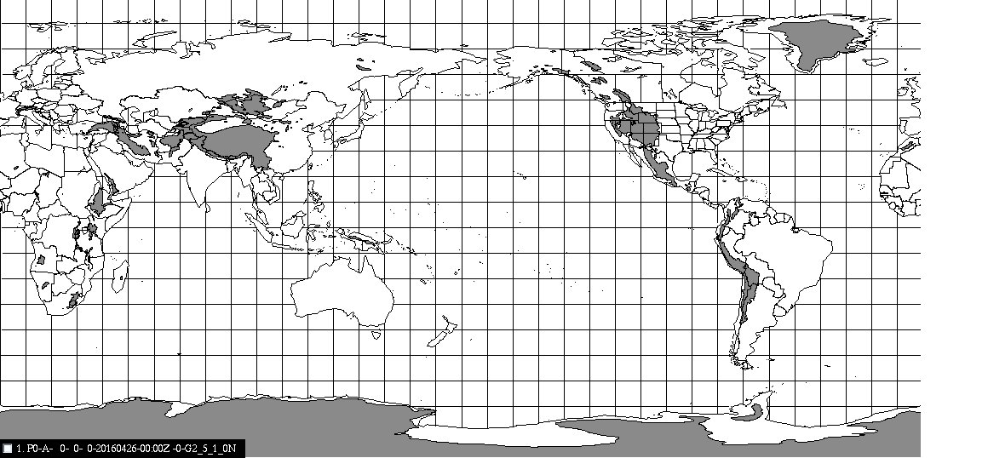
Figure 1: CMC analysed surface pressures below 850 hPa, valid April 16, 00 UTC

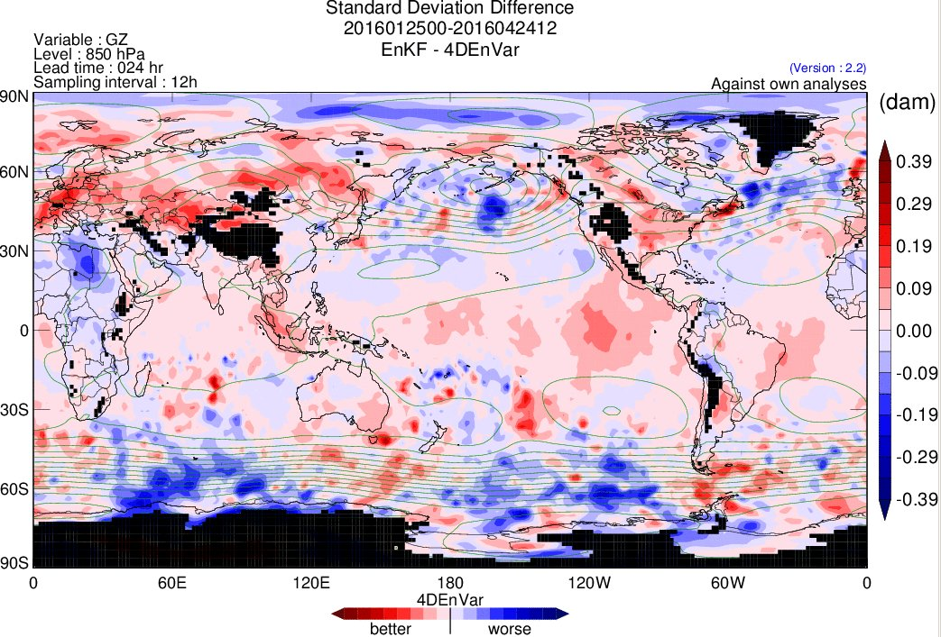
Figure 2: Standard deviation difference between two experiments of 24-hour 850 hPa geopotential height foreacasts, with all analysed surface pressue values below 850 hPa masked.

