WORLD METEOROLOGICAL ORGANIZATION  COMMISSION FOR BASIC SYSTEMS  OPAG on DPFS  MEETING OF THE CBS (DPFS) EXPERT TEAM ON OPERATIONAL WEATHER AND FORECASTING PROCESS AND SUPPORT (OWFPS)  Beijing, china 12-16 march 2018 |  | DPFS/ET-OWFPS/Doc. 4.4 (2)  (1.III.2018)  _______  Agenda item : 4.4  ENGLISH ONLY

WGNE Intercomparison of Tropical Cyclone Forecasts

(Submitted by Hitoshi Sato, JMA)

Summary and purpose of document

This document provides a summary of WGNE tropical cyclone forecast verification, including recent verification activities and related results.

Action Proposed

The meeting is invited to note the information in the document.

Reference(s):
- Appendix 2.2.38 of the Manual on the Global Data-processing and Forecasting System, 2017 Edition, WMO-No.485

1. Background
The Working Group on Numerical Experimentation (WGNE) was established by the World Climate Research Programme (WCRP) Joint Scientific Committee (JSC) and the WMO Commission for Atmospheric Sciences (CAS). The group works to foster the advancement of atmospheric circulation models. As part of its contribution to WGNE, the Japan Meteorological Agency (JMA) has conducted intercomparison of tropical cyclone (TC) forecasts based on global numerical weather prediction (NWP) model output since 1991.
At the beginning of the project, ECMWF, UKMO and JMA were the participating NWP centres, and the target region was limited to the western North Pacific. JMA enlarged the verification region to include the North Atlantic in 1999 and the eastern North Pacific in 2000, and has conducted TC verification for the whole tropical and mid-latitude region encompassing Central to South Pacific and Indian Ocean areas since 2002.
A total of 11 NWP centres are now involved in the project. Participating NWP centres are as follows:
BoM (Australia)
CMA (China)
CMC (Canada)
DWD (Germany)
ECMWF
FRN (France)
JMA (Japan)
KMA (South Korea)
NCEP (USA)
NRL (USA)
UKMO (United Kingdom).
The verification methods and scores are consistent with those described in the new Manual on the GDPFS (WMO-No.485).

2. Verification
2.1 Target TCs
TC best-track data provided by individual RSMCs are used in verification, with focus on cyclones reaching tropical storm (TS) intensity with maximum sustained winds of 34 knots or stronger. The tropical depression (TD) stage of targeted TCs is also included in this verification, and TCs remaining at TD level throughout their lifespan are excluded.
2.2 Tracking method
TCs are tracked using mean sea level pressure data provided by participating NWP centres. Under this method, the minimum value in the predicted mean sea level pressure field is used to determine the TC centre. For accurate identification, a surface fitting technique is employed. First, an initial TC centre (T (= Forecast lead time) + 0 hrs) within a 500 km radius of an analysis centre point based on best-track data is identified. Then, the TC centre for the first prediction time (T + 6 hrs) within a 500 km radius of the initial TC centre is identified. Subsequently, a TC centre within a 500 km radius of a reference point determined from linear extrapolation of these two predicted centre points is identified. In each step, the minimum pressure point nearest to each reference point is identified as the initial or predicted TC centre. Tracking ends when no appropriate minimum pressure point is found.
2.3 Forecast times
Scores are computed for forecasts initialized at 1200 UTC. Annual scores are computed for a year from 1 January to 31 December in the northern hemisphere and for a year from 1 September to 31 August in the southern hemisphere.
Forecast steps are every 6 hours to 192 hours of the forecast range.
2.4 Scores
The following scores are calculated against the best-track dataset:
(a) Detection rate;
(b) Storm track verification:
- Position error: Distance between predicted and analysed TC centres;
- Along-track/cross-track (ATCT) bias:
AT bias: bias in the direction of TC movement;
CT bias: bias in the direction perpendicular to TC movement;
(c) Bias of central pressure.
2.5 Verification areas
Verification is conducted for each of the six regions in which TCs are analyzed under the WMO Tropical Cyclone Programme (Fig. 1).
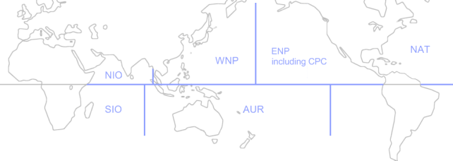
Fig. 1. The six target regions used for verification.

2.6 Verification tool
JMA has developed a tracking tool that can handle global forecast data in GRIB format on a regular latitude-longitude grid at any resolution and enables tracking of predicted TC centres based on the method outlined in 2.2. The tool outputs tracking results in text format. Verification tools for calculation and visualization of detection rates, position errors, ATCT-bias, and bias of central pressure against best-track data are also available.
2.7 Exchange of forecast field data
JMA coordinates the exchange of forecast field data produced by participating NWP centres. Data are received via the Internet or on HDDs.
2.8 Exchange of score data and visualization
JMA operates a web server to support the provision of various verification results. The following scores in the pictorial form are available on the WGNE intercomparison of Tropical Cyclone Forecasts website (http://nwp-verif.kishou.go.jp/wgne_tc/index.html):
- Detection rate: The score is drawn every 12 hours until 120 hours;
- Storm track verification: Position error is shown every 12 hours until 120 hours; position error is also shown as a map every 24 hours until 192 hours; ATCT bias is shown in scatter-diagram form every 24 hours until 192 hours;
- Bias of central pressure: A scatter diagram of analysed and predicted central pressure is shown every 24 hours until 192 hours.

3. Recent verification results
This section outlines some recent verification results for 2015 that were reported at the 32nd WGNE meeting in Exeter, UK, in October 2017.
Figure 2 shows detection rates and position errors in the western North Pacific for every 12 hours from T + 0 to T + 120. The detection rates for most centres were over 0.9 on average.
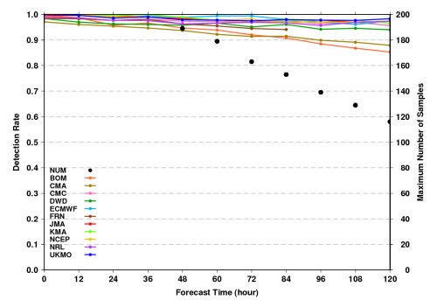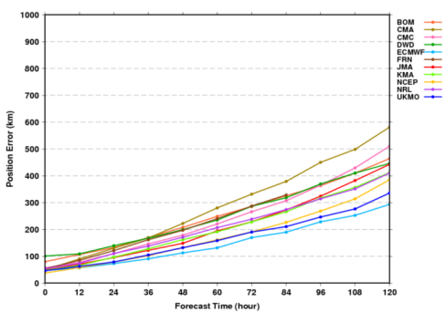
Fig. 2. Detection rates (left) and position errors (right) in the western North Pacific for 2015.

The scatter diagram of position errors (Fig. 3) represents CT-bias (x-axis) and AT-bias (y-axis) for each stage of recurvature. Two significant systematic errors are observed from numerous NWP centres. One is positive CT direction error in the before stage. Since TCs move westward in this stage, such errors indicate northward bias of the TC prediction against the verifying analysis. The other is negative AT direction error in the after stage, which results from slow bias in TC prediction.
Figure 4 shows intensity biases in the western North Pacific. The x-axis represents analysis central pressure, and the y-axis represents forecast central pressure. All the NWP models tend to underestimate the intensity of deep TCs. Meanwhile, forecast cases where the forecast intensity is stronger than the best-track analysis are frequently seen in some models.
The time series of T + 72 position errors (Fig. 5) show that TC track forecasts have improved in each region, although there is large interannual variability in the NIO.

4. Preparation for the designation as LC-TCFV
JMA will improve the following verification activities when it is designated as LC-TCFV:
- Although calculated scores in the text or binary form are not available on the said WGNE intercomparison website, they will be available on the JMA’s Lead Centre for TCFV website.
- The verification will be conducted for region by region using available data even before global TC best-track data from individual RSMCs are collected. The verification results will be uploaded onto the JMA’s LC-TCFV website soon after the verification is completed.

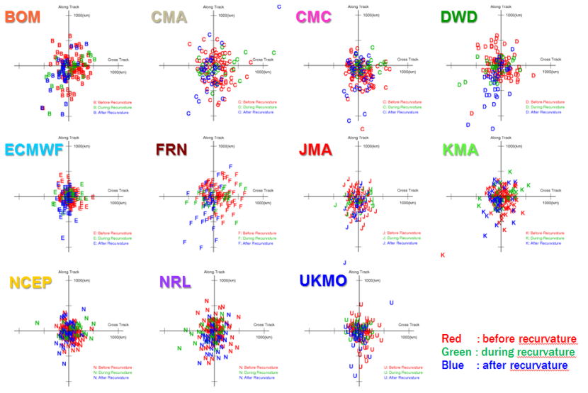
Fig. 3. ATCT bias scatter diagram in the western North Pacific at T + 72 for 2015.

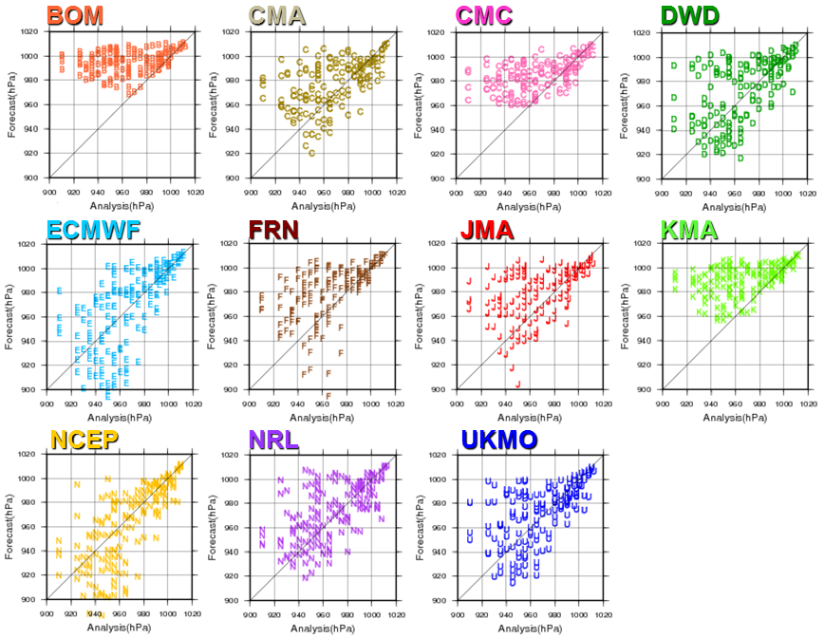
Fig. 4. Central pressure scatter diagram in the western North Pacific at T + 72 for 2015.

(a) WNP (b) NAT
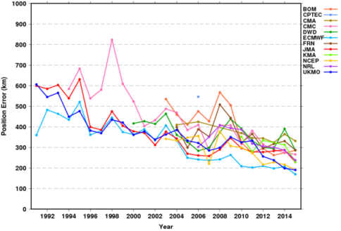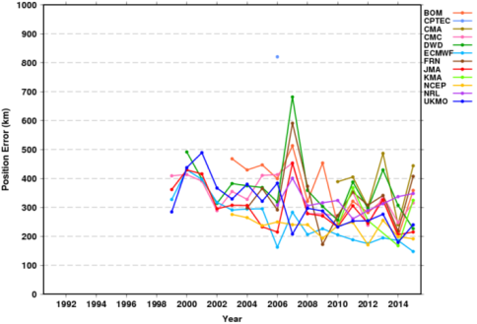
(c) ENP (d) NIO
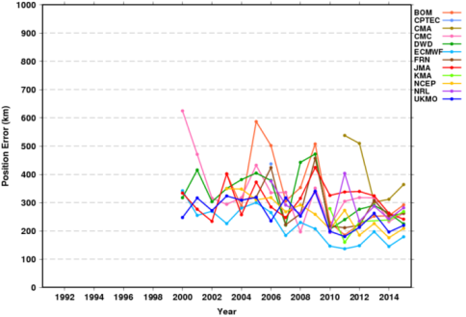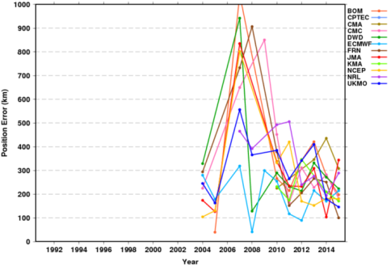
(e) SIO (f) AUR
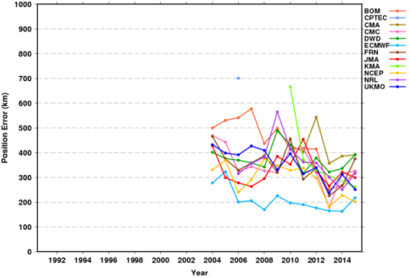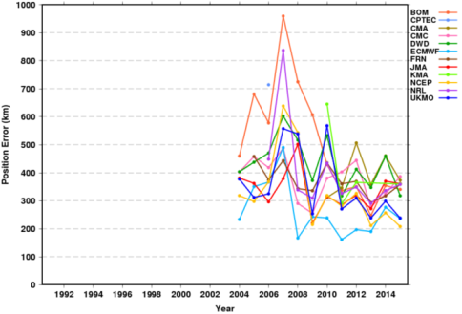
Fig. 5. Time-series of T + 72 position errors at each region.

