WORLD METEOROLOGICAL ORGANIZATION  COMMISSION FOR BASIC SYSTEMS  OPAG on DPFS  EXPERT TEAM ON OPERATIONAL PREDICTIONS FROM SUB-SEASONAL TO LONG TIME-SCALES  Exeter, UK, 10 – 14 March 2014 |  | CBS-DPFS/ET-OPSLS /Doc.7.4(1)  (06.III.2014)  _______  Agenda item : 7.4  ENGLISH ONLY

Recommendations on operational provision of interannual-to-decadal (near-term climate) predictions

(Submitted by Richard Graham)

Summary and purpose of document

This document reports on an informal international exchange of real-time multi-annual to decadal forecasts hosted by the Met Office Hadley Centre. It recommends that steps should now be taken to make these forecasts available to WMO members, in line with GFCS plans to extend the current provision on seasonal timescales to multi-annual and decadal timescales and beyond. New WMO-designated centres and a coordinating Lead Centre are proposed to realize and regulate this provision. Minimum requirements on participating centres and the Lead Centre are also proposed.

Action Proposed

The meeting is invited to review the contents, consider the recommended minimum requirements and functions of the proposed centres for multi-annual to decadal prediction and the associated lead centre and make recommendations to CBS and CCl.

Recommendations on operational provision of interannual-to-decadal (near-term climate) predictions

- The informal exchange hosted by the Met Office Hadley Centre (MOHC)

Many civil and other sectors have planning timescales covering 1-10 years ahead and it is important that the Global Framework for Climate Services (GFCS) develops capabilities and services for prediction on this decadal timescale - though capability at this range is currently less developed than for seasonal forecasting. The growing need for decadal climate predictions has also been recognized by the inclusion of a protocol for historical tests in the latest model inter-comparison project (CMIP5) which has informed the IPCC fifth assessment report.

The focus of the CMIP5 decadal experiments is historical and aims to assess the expected skill of decadal predictions. However, many of the contributing centres are also making actual decadal climate predictions in near real-time. The MOHC is coordinating an informal exchange of these real-time forecasts with the aim of assessing and understanding differences and similarities between forecasts, identifying a consensus (multi-model ensemble) view in order to prevent over-confidence in a single model, and establishing current collective capacity. In addition, the informal exchange is a necessary step in developing infra-structure and protocols such that multiannual to decadal predictions can be incorporated into the Climate Service Information System (CSIS) of the GFCS. Three exchanges have taken place so far: specifically for forecasts starting nominally on 1st January 2011, 1st January 2012 and 1st January 2013; and a further exchange of forecasts starting 1st January 2014 is underway. For details of the first two exchanges, including a description of forecasts and verification, the reader is referred to Smith et al. 2012. Each exchange consists of up to 9 dynamical climate models and 3 empirical techniques (see Table 1). Both initialized and uninitialized predictions are exchanged so that the impacts of initialization can be assessed. Analysis so far has focused on generating, for each individual model and the multi-model, global maps of forecast near-surface temperature averaged over the first year and subsequent 5 year periods, together with indications of ensemble spread. Forecasts of other variables have also been generated including for Atlantic Multi-decadal Variability (AMV), Pacific Decadal Variability (PDV) and Nino3. The list of variables exchanged has recently been expanded to include precipitation and mean sea level pressure, and will be further expanded this year to include the Atlantic Meridional Overturning Circulation. A website to display all individual contributor forecasts and multi-model products in a standard format is being developed and will be released in March 2014.

Verification of the real-time forecasts of year-1 near-surface temperature (the only verifiable period so far in the real-time exchange) shows promising skill that substantially exceeds that of the uninitialized predictions. The 2011 year-1 predictions and verification are provided in Fig.1. The observed temperature anomalies are dominated by La Niña conditions in the Pacific (with a tongue of cool temperatures in the tropics and a horseshoe pattern of warm temperatures to the north, west and south), a cool Australia, warm high latitudes and USA and a warm north Atlantic sub-polar gyre and tropical Atlantic. Most of the individual models capture these features well with typical pattern correlations of 0.5, which increases to 0.62 for the multi-model mean. In contrast the multi-model mean of the uninitialized predictions has spatial correlation skill of 0.31, showing a substantial benefit from initialization. Some impact from initialization is retained out to 4 years ahead (not shown) and there are also signs of prediction skill present for the frequency of societally important climate extremes such as daily temperatures and hurricane numbers (Eade et al 2012, Smith et al 2010).

These results, together with assessments of long-term individual model skill using retrospective forecasts (Smith et al 2007,2010, Pohlmann et al 2009, 2013, Chikamoto et al 2012; Hazeleger et al 2013, Doblas-Reyes et al 2013, Knight et al 2014, Meehl et al 2014), represent good evidence that the forecasts, accompanied by information on track-record performance, can be of benefit to WMO members. Figure 2 from Smith et al. (2010) shows widespread long-term skill for the 1-5 year period calculated from retrospective forecasts. We therefore recommend that the forecasts are made widely and routinely available through WMO CBS procedures and protocol. This would include WMO designation of centres willing to commit to a continued exchange defined by a minimum set of products and service criteria. We also recommend that a Lead Centre for coordinating the exchange and displaying individual and multi-model forecasts is designated. The Met Office has developed the capacity for this Lead Centre role and offers to continue coordination of the existing decadal exchange under these more formalized arrangements. Establishment of an operational multi-annual to decadal prediction capability will be a significant contribution to the CSIS of the GFCS. In the next section we propose minimum requirements for the designated centres and Lead Centre.

- Proposed minimum requirements for near-term climate prediction centres and associated lead centre

It is evident from Table 1 that only one of the contributing centres (Met Office, Exeter) is also a WMO-designated Global Producing Centre for long-range forecasts (GPC). Thus an optional extension of the GPC minimum requirements to include near-term climate prediction does not seem the best way forward. A possible alternative approach is to define GPC areas of specialization, for example GPC(subseasonal); GPC(seasonal); GPC(near-term climate). A centre may then apply for GPC designation in one or more of these areas of responsibility. In the following sections we propose designation criteria and minimum product requirements for GPCs with specialization in near-term climate prediction. We also propose similar criteria for an associated Lead Centre. A staged implementation is envisaged beginning with ensemble mean real-time forecasts and verification and developing within 2 years of designation to include full hindcast exchange, probabilistic forecast products and hindcast verification. Designated centres would need to be prepared to participate in Stage 1 and Stage 2. The second stage of the implementation could also consider additional products such as forecasts of indices, particularly where these show good skill (e.g. Atlantic Multi-decadal Variability).

It is a question of discussion for the ET-OPSLS whether centres using empirical methodology would be eligible apply for GPC status. They may not be able to supply all the global fields listed below. However, there are precedents for making exceptions if the input increases the value of the proposed annual consensus statement (see section 2.2). For example in the seasonal forecast exchange GPCs operating 2-tier systems are exempt from supplying SST forecasts.

  - GPCs with specialization in near-term climate prediction (NTCP)

Stage 2 activities are marked with an asterisk.

Designation criteria
Global Producing Centres (GPCs) specialising in near-term climate prediction shall:
- Prepare, with at least annual frequency, global forecast fields of parameters relevant to multi-annual to decadal prediction
- Make available on the WMO Information System (WIS) a range of these products. The proposed minimum list to be made available is below.
- Provide an agreed set of forecast and hindcast* variables to the associated Lead Centre
- Prepare verification statistics as defined below.
- Make available on a website up-to-date information on the characteristics of its global decadal prediction system.

Minimum forecast products
1. Global maps of ensemble mean anomalies with indications of ensemble spread for the following variables averaged over at least year 1 and years 1-5 of the forecast:
- near-surface air temperature;
- precipitation;
- sea level pressure.

- *Global maps of probability for tercile categories (or other events) for the following variables for the following variables averaged over at least year 1 and years 1-5 of the forecast:
- near-surface air temperature;
- precipitation;
- sea level pressure

- Ensemble mean annual global mean near-surface temperature and indications of ensemble spread, for every year of the forecast.

Verification
Hindcast*:
Scores should be calculated on at least 15 retrospective forecasts. The verification products that should be made available for near-surface temperature, precipitation and sea level pressure are:

- global maps of grid-point temporal correlation of the ensemble mean
- global maps of Relative Operating Characteristic (ROC) scores for specified categories
- Reliability and sharpness diagrams for specified categories for the agreed geographical regions.

Real-time:
- Side-by-side global maps of ensemble mean predicted and observed anomalies for temperature, precipitation and sea level pressure for at least year 1 and years 1-5. Regions where the observations lie outside the 5-95% model range will be highlighted with stippling;
- Spatial pattern correlation coefficients between observations and ensemble mean forecasts for global fields of temperature, precipitation and sea level pressure
- Observed annual mean global temperature over plotted on previous forecasts.

2.2 Lead Centre for Near-Term CLimate Prediction (LC-NTCP)

Centres designated as Lead Centre for Near-Term Climate Prediction (NTCP) shall:
- Collect an agreed set of hindcast* and forecast data from Global Producing Centres specializing in NTCP;
- Make available on a web site agreed lead centre (LC) products in standard format, including multi-model products
- Generate verification (as above*) for individual GPC forecasts and the multi-model and display in standard format;
- Redistribute digital hindcast* and forecast data for those GPCs that allow it;
- Maintain an archive of the real-time GPC and MME forecasts;
- Promote research and experience in NTCP techniques and provide guidance and support on NTCP to GPCs, RCCs and NMHSs;
- Based on comparison among different models, provide feedback to GPCs about model performance;
- coordinate an annual consensus prediction product giving global prospects for the next 1-5 years.

References

Chikamoto Y, Kimoto M, Ishii M, Mochizuki T, Sakamoto TT, Tatebe H, Komuro Y, Watanabe M, Nozawa T, Shiogama H, Mori M, Yasunaka S, Imada Y (2012) An overview of decadal climate predictability in a multi-model ensemble by climate model MIROC. Clim Dyn. doi:10.1007/s00382-012-1351-y
Doblas-Reyes F.J., I. Andreu-Burillo, Y. Chikamoto, J. García-Serrano, V. Guemas, M. Kimoto, T. Mochizuki, L.R.L. Rodrigues and G.J. van Oldenborgh (2013), Initialized near-term regional climate change prediction, Nature Communications, 4, 1715, doi:10.1038/ncomms2704
Hazeleger, W., B. Wouters, G.J. van Oldenborgh, S. Corti, T. Palmer, D. Smith, N. Dunstone, J. Kroger, H. Pohlmann and J.-S. von Storch (2013) Predicting multi-year North Atlantic Ocean variability, J. Geophys. Res., 118, 1087-1098, doi:10.1002/jgrc.20117
Meehl, G. A. et al (2014) Decadal Climate Prediction: An Update from the Trenches, Bull. Amer. Met. Soc., doi: http://dx.doi.org/10.1175/BAMS-D-12-00241.1
Pohlmann H, Jungclaus J, Kohl A, Stammer D, Marotzke J (2009) Initializing decadal climate predictions with the GECCO oceanic synthesis: effects on the North Atlantic, J Clim, 22, 3926-3938
Pohlmann, H., D. M. Smith, M. A. Balmaseda, N. S. Keenlyside, S. Masina, D. Matei, W. A. Muller and P. Rogel, Predictability of the mid-latitude Atlantic meridional overturning circulation in a multi-model system, 2013, Climate Dynamics, 41, 775-785, DOI 10.1007/s00382-013-1663-6
Smith D.M. and collaborators, 2012: Real-time multi-model decadal predictions. Clim Dyn. DOI 10.1007/s00382-012-1600-0
Smith, D. M. and Murphy, J. M. (2007), An objective ocean temperature and salinity analysis using covariances from a global climate model J. Geophys. Res., 112 ,C02022, 10.1029/2005JC003172
Smith, D. M. and R. Eade and N. J. Dunstone and D. Fereday and J. M. Murphy and H. Pohlmann and A. A. Scaife (2010), Skilful climate model predictions of multi-year north atlantic hurricane frequency Nature Geosci.,3 ,846—849, 10.1038/ngeo1004
Wouters, B., W. Hazeleger, S. Drijfhout,G. J. van Oldenborgh, V. Guemas (2013), Multiyear predictability of the North Atlantic subpolar gyre, Geophsy. Res. Lett., 40, 12, 3080–3084, 10.1002/grl.50585
Table 1: Summary of participating centres, prediction system resolution and forecasts exchanged. (from Smith et al. 2012)
Name | Institute | Method  D: Dynamical  E: Empirical | References | Start month | Resolution ª  Atmosphere (A) Ocean(O) | Ensemble size
 |  |  |  |  |  | 2011^{b} | 2012^{b} | Uninitialized
CCCMA | Canadian Centre For Climate Modelling and Analysis | D: Full field initialization | Merryfield et al 2012, Fyfe et al 2012, Boer et al 2012 | Jan | A: 2.8x2.8 L35  O: 0.94x1.4 L40 | 10 | 10 | 10
GFDL | Geophysical Fluid Dynamics Laboratory, USA | D: Full field initialization | Zhang and Rosati 2012, Zhang et al 2007 | Jan | A: 2.5x2.0 L24  O:1.0x1.0^{c} L50 |  | 10^{d} | 10^{d}
IC3/KNMI | Institut Català de Ciències del Clima, Spain and Royal Netherlands Meteorological Institute | D: Full field initialization | Hazeleger et al 2010, 2012, Du et al 2012 | Nov | A: T159 L 62  O: 1x1 ^{c} L 42 | 10 | 10 | 3
MIROC5 | University of Tokyo, National Institute for Environmental Studies, and Japan Agency for Marine-Earth Science and Technology, Japan | D: Anomaly initialization | Tatebe et al. 2012, Chikamoto et al 2012 | July, Oct, Jan | A:1.41x1.41 L40  O:1.41x0.80 L50 | 9 | 9 | 12e
MOHC | Met Office Hadley Centre, UK | D: Anomaly initialization | Smith et al 2007, 2010 | Sep | A: 3.75x2.5 L19  O: 1.25x1.25 L20 | 10 | 10 | 10
MPI | Max Planck Institute, Germany | D: Anomaly initialization | Matei et al. 2012, Müller et al. 2012 | Jan | A: T63 L47  O: 1.5x1.5 L40 | 10 | 10 | 3
MRI | Meteorological Research Institute, Japan | D: Anomaly initialization | Yukimoto et al. 2012 | July, Oct, Jan | A:1.125x1.125 L48  O: 1.0x0.46 L51 | 9 | 9 | 4e
RSMAS | Rosenstiel School of Marine and Atmospheric Science, University of Miami, USA | D: Full field initialization | Kirtman and Min 2009, Collins et al 2006 | Jan | A: 2.5x2.5  O: 1x1 | 3 | 3
SMHI | Swedish Meteorological and Hydrological Institute | D: Anomaly initialization | Hazeleger et al 2010, 2012 | Sep | A: T159 L 62  O: 1x1 ^{c} L 42 | 3 | 7 | 3
NRL | Naval Research Laboratory, USA | E: Multiple linear regression | Lean and Rind 2008, 2009, Kopp and Lean 2011 | Jan | A: 5x5 |  | 1
Reading (AR1) | University of Reading, UK | E: Trend plus auto-regression | Ho et al 2012 | Jan | O: 1x1 | 1 | 1
Reading (CA) | University of Reading, UK | E:Trend plus constructed analogue | Ho et al 2012 | Jan | O: 1.0x1.0 (Atlantic only) | 1 | 1
ªDegrees longitude x latitude, or spectral (T159≈1.125º), L vertical levels ^{b}The first calendar year of the forecast ^{c}Reducing to 1/3º latitude at the Equator ^{d}Only ensemble mean data were provided ^{e}Ensemble consists of simulations with RCP2.6, RCP4.5, RCP6.0 and RCP8.5

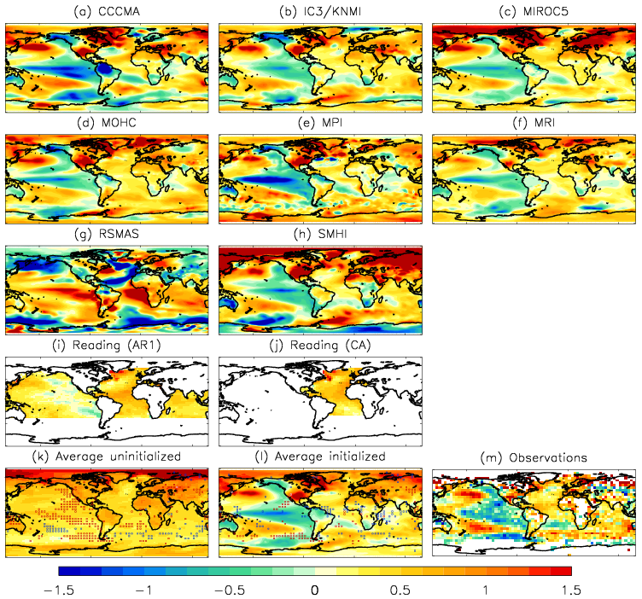
Figure 1: Forecast and observed temperature anomalies for 2011. (a)-(j) Ensemble mean forecast from each prediction system, showing the first calendar year of forecasts starting between 1st September 2010 and 1st January 2011. Average forecasts ((k) and (l)) are for those systems for which uninitialized projections are available (see Table 1 for further details). The stippling in these indicates where the 5-95% forecast confidence range (diagnosed from the spread of the individual ensemble members) is warmer (red/white) or cooler (blue/black) than the observations. Observations (m) are taken from HadCRUT3 (Brohan et al. 2006). All anomalies are degrees centigrade relative to the average of the period 1971 to 2000.
From Smith et al. 2012

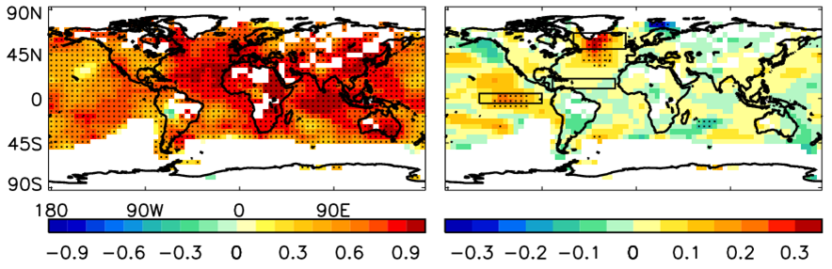

Figure 2: a) Temporal correlation skill for forecasts of 1-5 year average (June to November) near-surface temperature from the Met Office decadal prediction system. Skill is calculated from hindcasts started annually over the period 1960 to 2005. Hindcasts are initialised in the November preceding the 1-5 year period start. Stippling is plotted where skill is significant at the 95% level. b) Difference between (a) and corresponding predictions made without initialisation of the ocean-atmosphere state. Stippling is plotted in regions where the difference in correlation skill is significant at the 95% level.
From Smith et al. 2010

