WORLD METEOROLOGICAL ORGANIZATION

Commission for Climatology

(TRIAL PHASE)

Issued: February 2016 Target Season: March-April-May 2016

Supplementary Information

APPENDIX 1 - Monitoring

1.1 Large-scale circulation indices

APPENDIX 2 - Prediction

This appendix contains supporting material for the probabilistic forecast maps and SST indices described in the main part of this Update. The same sequence of global maps is shown for each of the five variables in the following order:

- Surface air temperature;
- Precipitation;
- Sea Surface Temperature (except for 6, 8, 9 and 10 below);
- 500 hPa Geoptential Height; and
- Mean sea-level pressure

For each variable the following sequence of maps/charts is shown:

- Ensemble mean anomalies for individual GPCs relative to the common baseline of 1983-2001;
- Ensemble mean anomalies for those GPCs for which forecast anomalies relative to 1983-2001 are not available;
- Forecast consistency map showing the number of GPCs (out of 9) with positive/negative ensemble mean anomalies (relative to their own baseline period);
- Deterministic Multi-Model Ensemble (DMME) forecast constructed using 5 GPCs and the common baseline (1983-2001). The same 5 GPCs used for the Probabilistic Multi-Model Ensemble (PMME) forecasts (those supplying hindcast data for 1983-2001) are used for consistency;
- DMME forecast constructed using 9 GPCs and each model’s own baseline;
- PMME forecast constructed using 5 GPCs (see 4 above) and the 1983-2001 common baseline;
- Anomaly Correlation Coefficient (ACC) verification for the 5 GPC DMME (top left) and each GPC (as available) over the period 1983-2001; or over the GPCs own hindcast period if hindcasts are provided and do not encompass the 1983-2001 period.
- ROC map verification for the 5 GPC PMME (top left) and each GPC (as available) over the period 1983-2001; or over the GPCs own hindcast period if hindcasts are provided and do not encompass the 1983-2001 period.
- ROC Curve and Score verification for the 5 GPC PMME (top left) and each GPC (as available) over the period 1983-2001; or over the GPCs own hindcast period if hindcasts are provided and do not encompass the 1983-2001 period.
- Reliability Diagram verification for the 5 GPC PMME (top left) and each GPC (as available) over the period 1983-2001; or over the GPCs own hindcast period if hindcasts are provided and do not encompass the 1983-2001 period.

In addition, predictions of the following derived parameters are also provided:

- Global seasonal mean temperature
- SST indices
  - Nino1.2
  - Nino3
  - Nino4
  - Nino3.4
  - Indian Ocean Dipole (IOD)
  - North Tropical Atlantic (NTA)
  - South Tropical Atlantic (STA)

Finally, some information is also included on the forecast and hindcast data provided by the GPCs.
2.1 Surface Temperature

2.1.1 Individual GPC ensemble mean forecasts of 2m temperature anomalies relative to 1983-2001

CPTEC  Baseline : 1983-2001  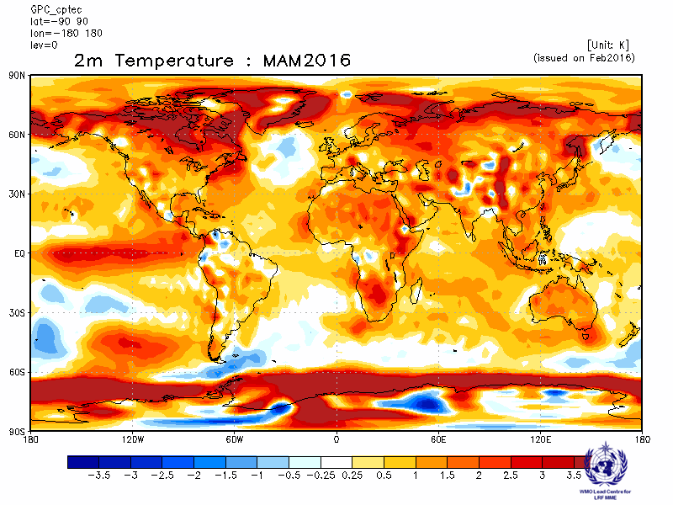 | Melbourne  Baseline : 1983-2001  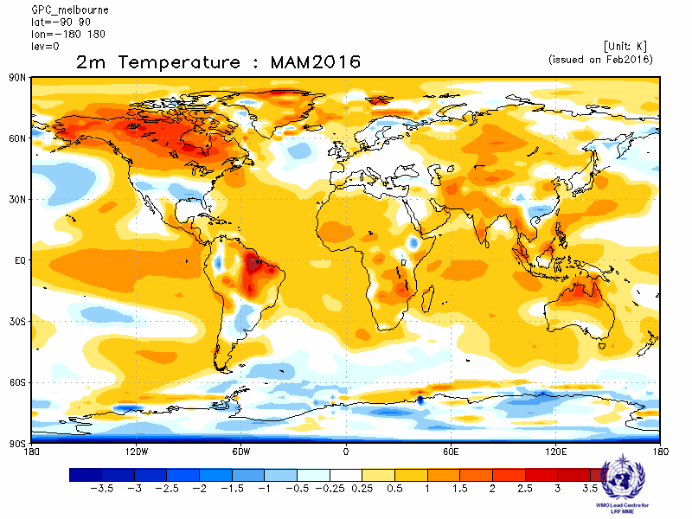
Montreal  Baseline : 1983-2001  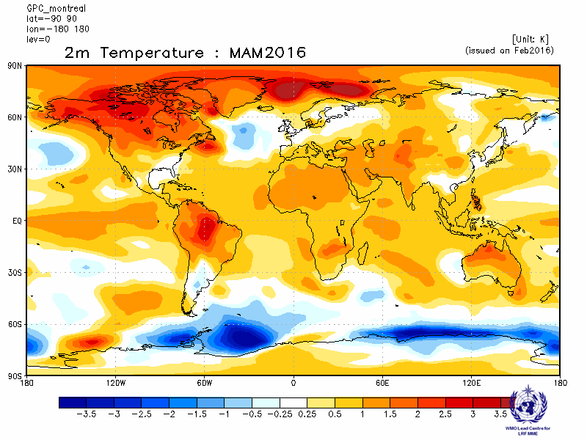 | Moscow  Baseline : 1983-2001  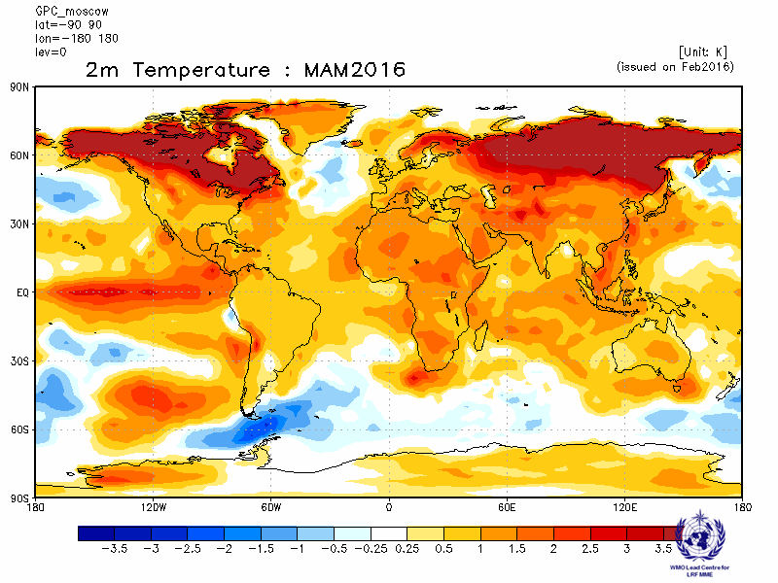
Washington
Baseline : 1983-2001
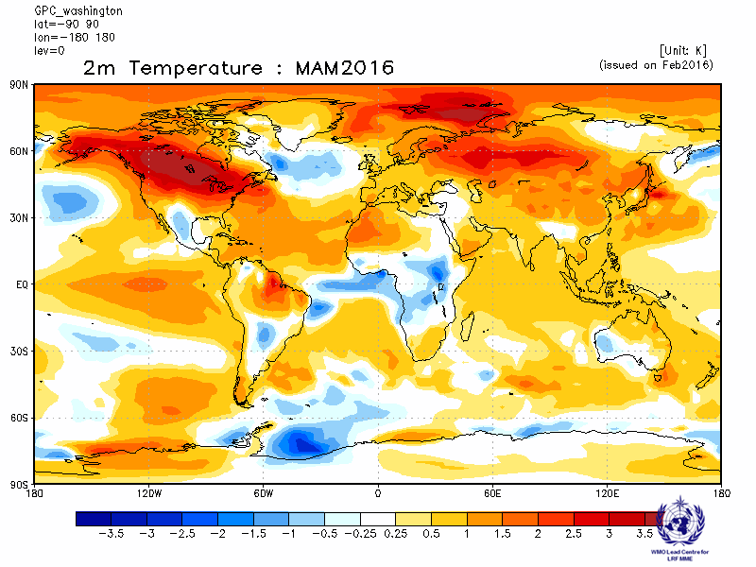

2.1.2 Individual GPC ensemble mean forecasts of 2m temperature anomalies from other GPCs for which forecast anomalies relative to 1983-2001 are not available.

ECMWF  Baseline: 1981-2010  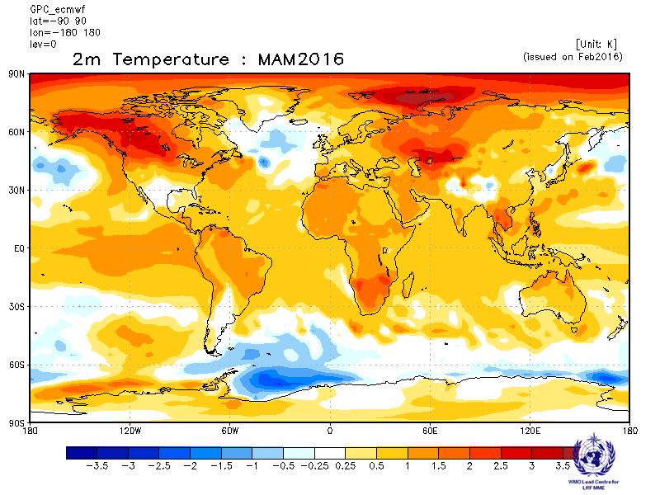 | Exeter  Baseline: 1996-2009  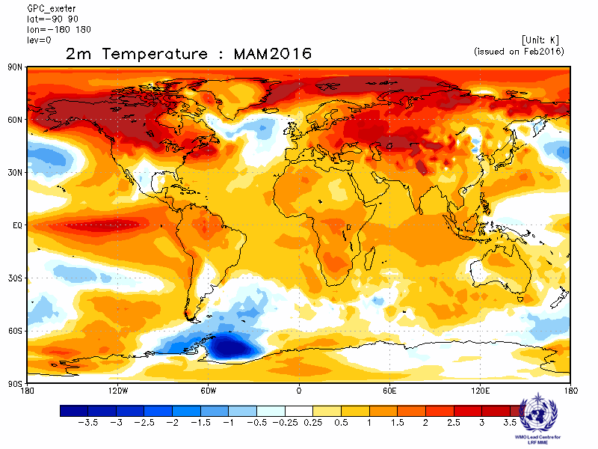
Seoul  Baseline: 1996-2009  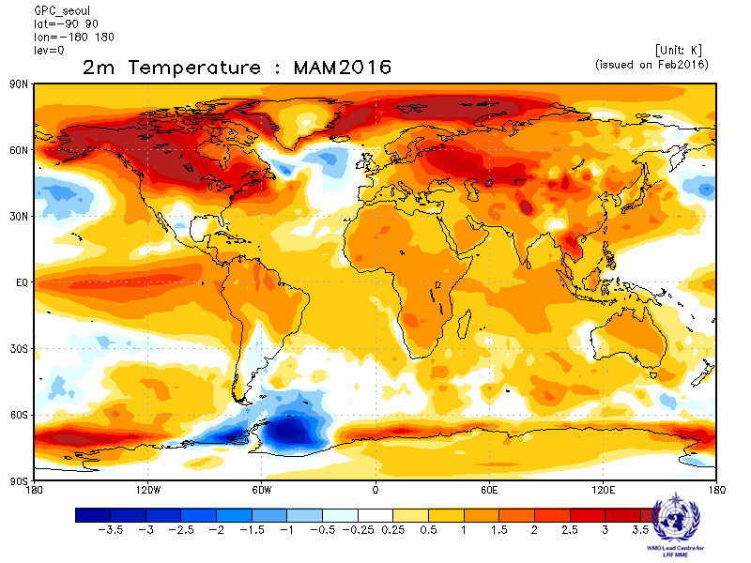 | Toulouse  Baseline: 1979-2007  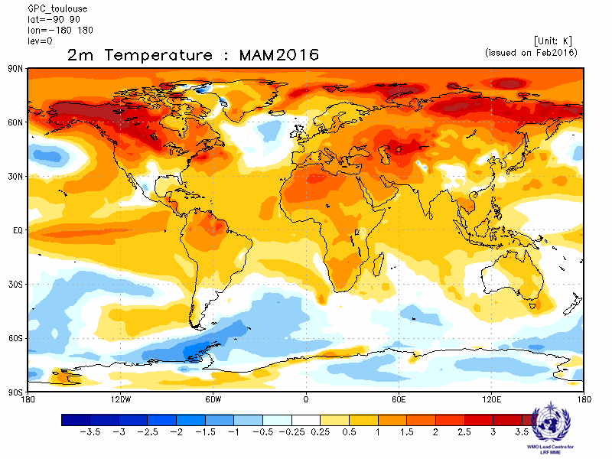

2.1.3 Forecast consistency map (9 GPCs): 2m Temperature
(number of GPCs with positive/negative ensemble mean anomalies – relative to own baseline)
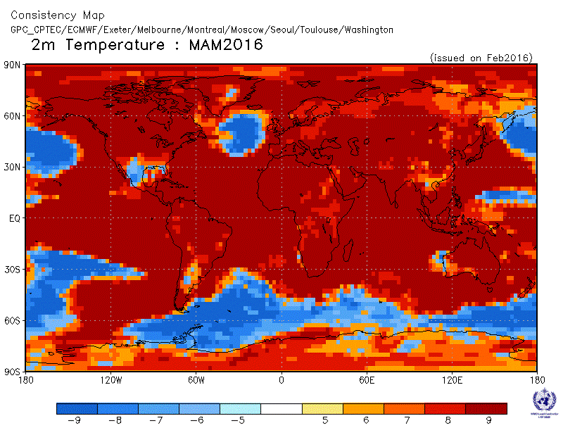

2.1.4 DMME (5 GPCs), using the same baseline for all models (1983-2001): 2m temperature

Ensemble mean anomaly
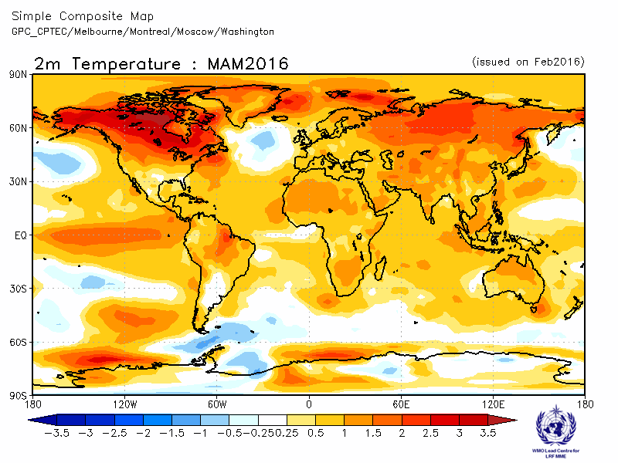
2.1.5 DMME (9 GPCs), for each model using its own baseline: 2m temperature

Ensemble mean anomaly
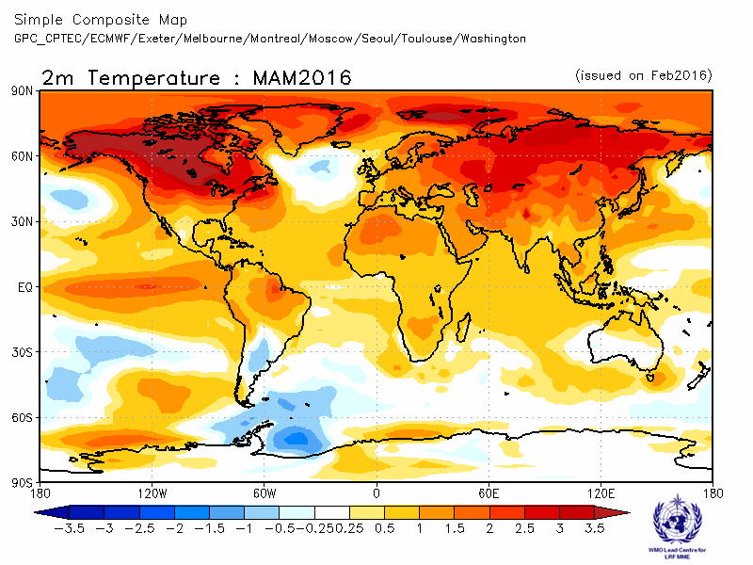

2.1.6 PMME (5 GPCs), using the same baseline for all models (1983-2001): 2m temperature
Probability of most likely tercile category

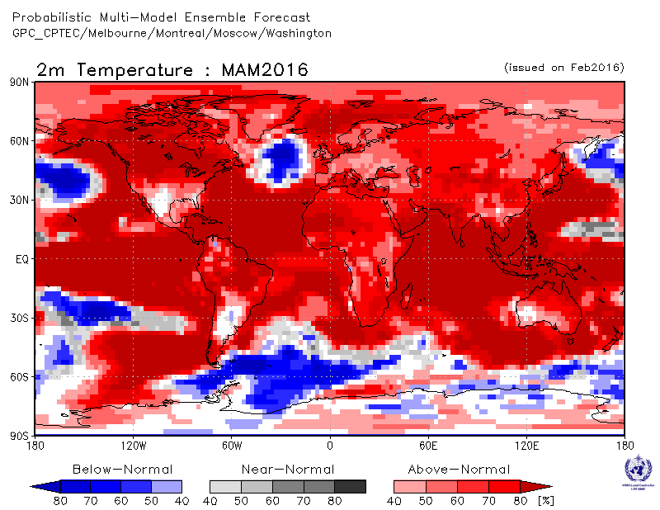

2.1.7 Verification of GPC ensemble mean 2m temperature anomaly forecasts, 1983-2001
Verification measure: Anomaly Correlation Coefficient (ACC)
Verification dataset: ERA-interim

DMME  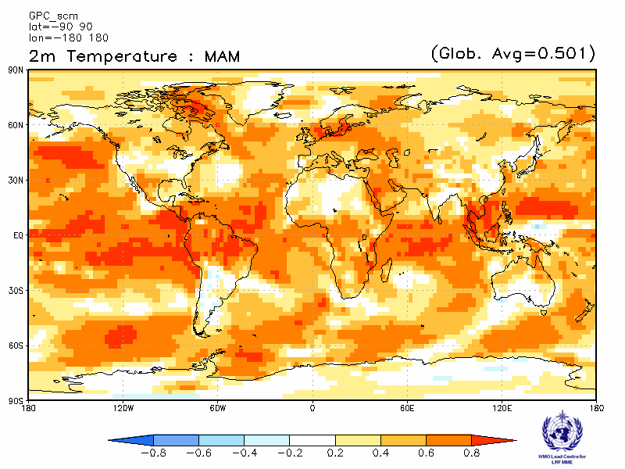 | CPTEC  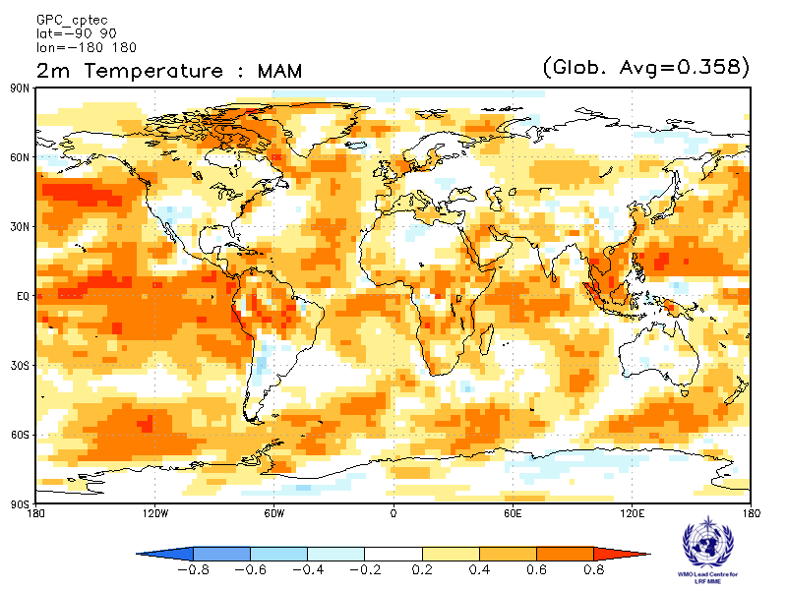
Melbourne  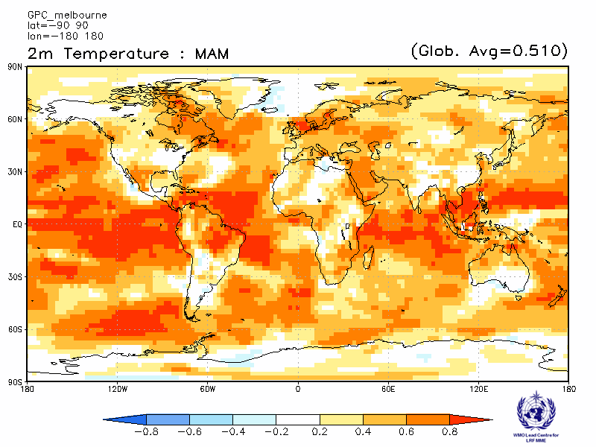 | Montreal  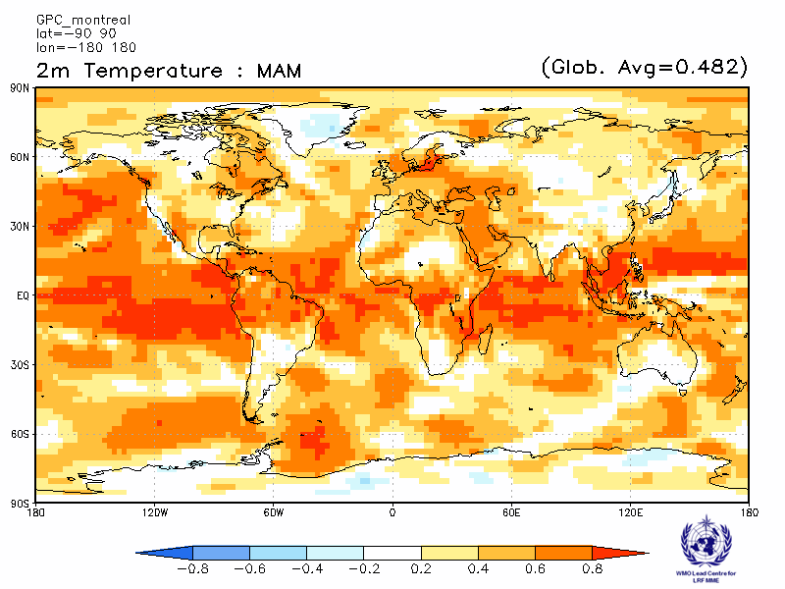
Moscow  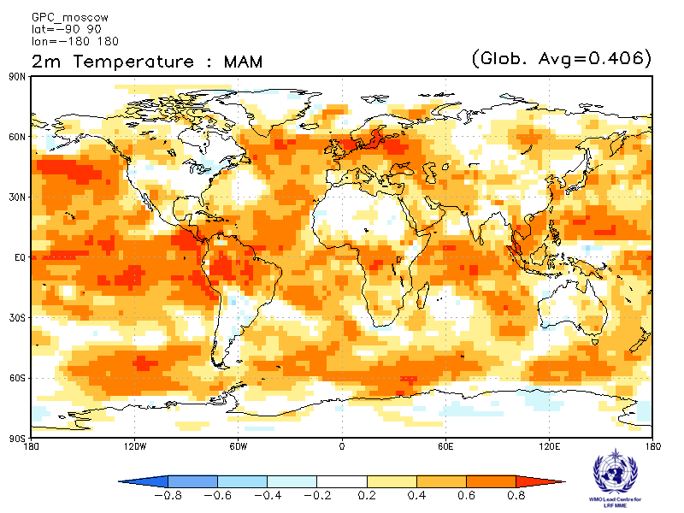 | Washington  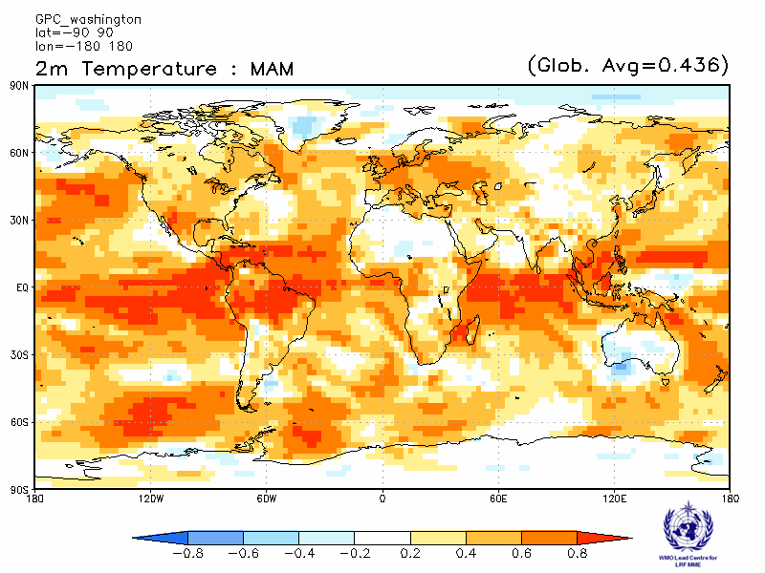

ACC verification of 2m temperature anomaly forecasts from other GPCs

Exeter  Verification period: 1996-2009  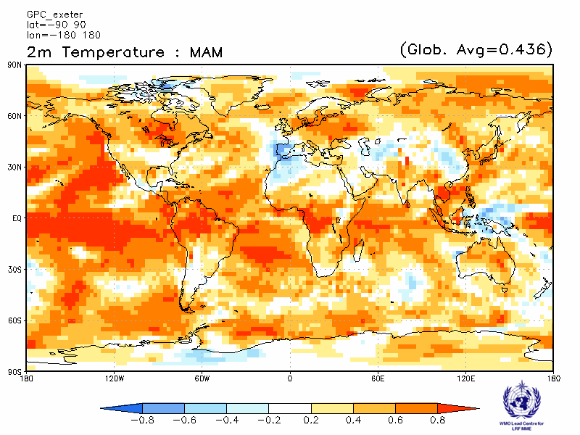 | Seoul  Verification period: 1996-2009  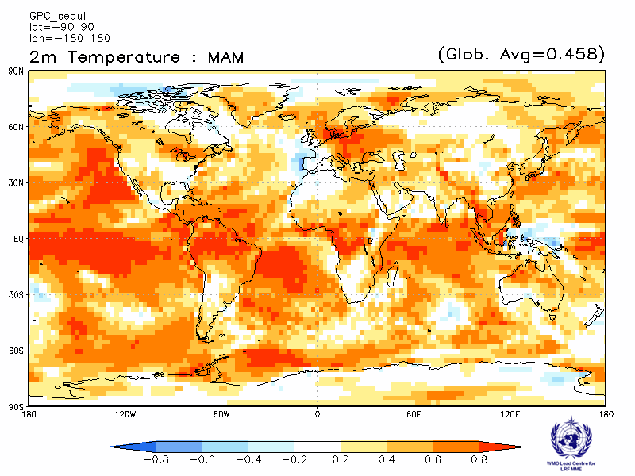

2.1.8 Verification of GPC 2m temperature probabilistic forecasts, 1983-2001
Verification measure: Relative Operating Characteristics (ROC) score for tercile forecast
Verification dataset: ERA-interim

PMME  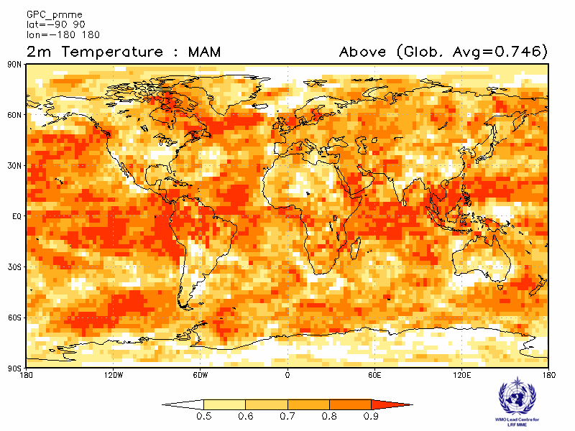 | CPTEC  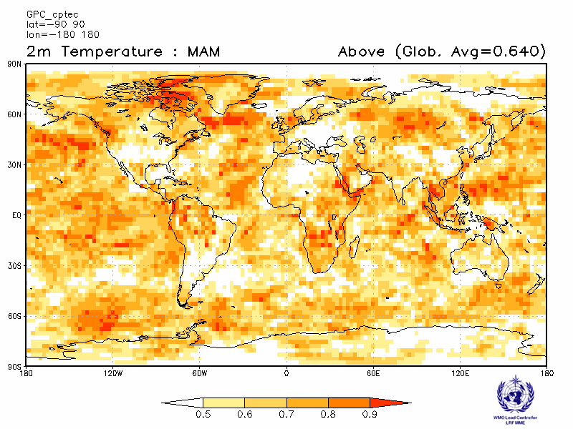
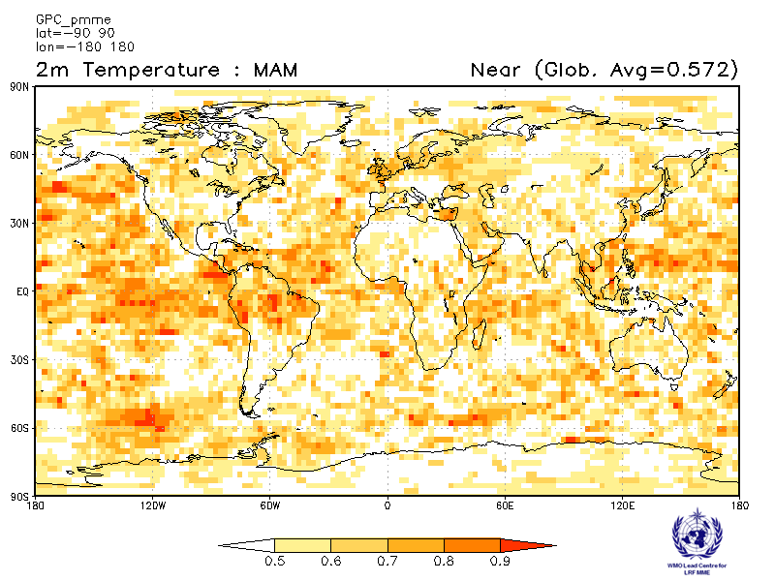 | 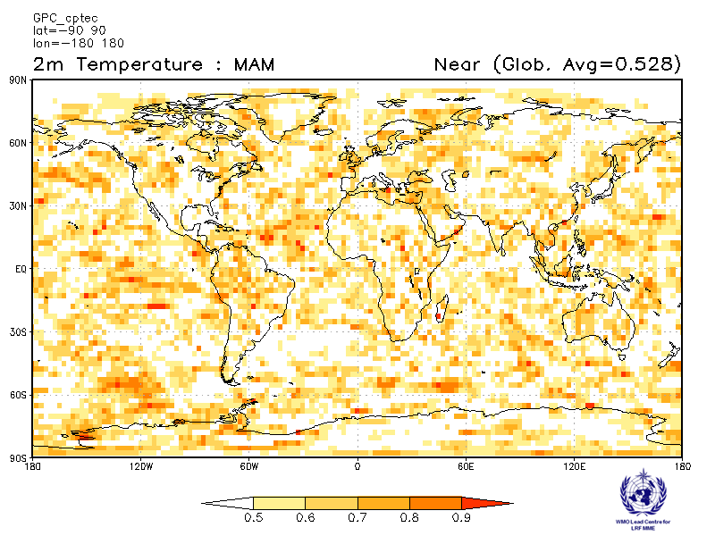
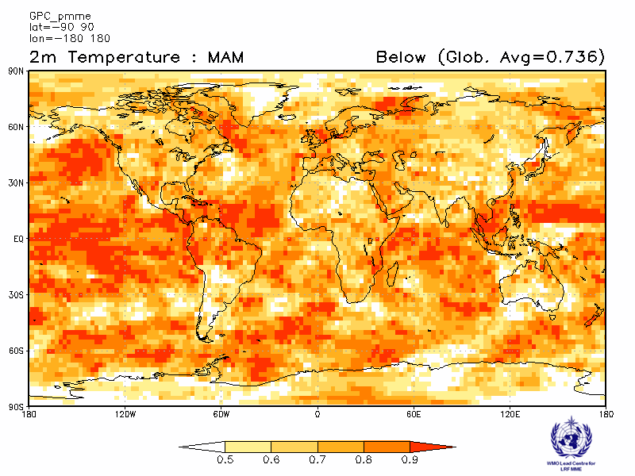 | 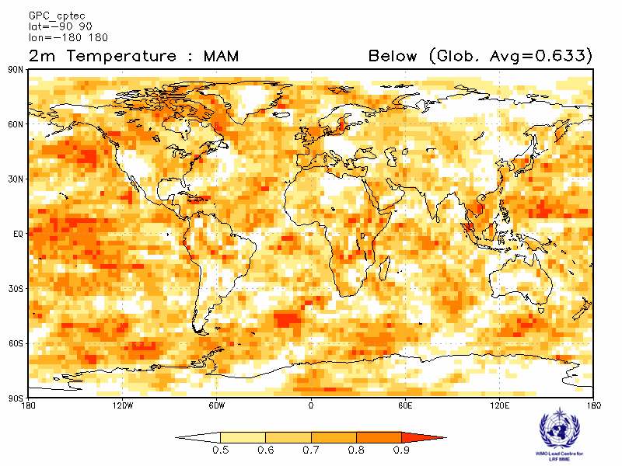

Melbourne  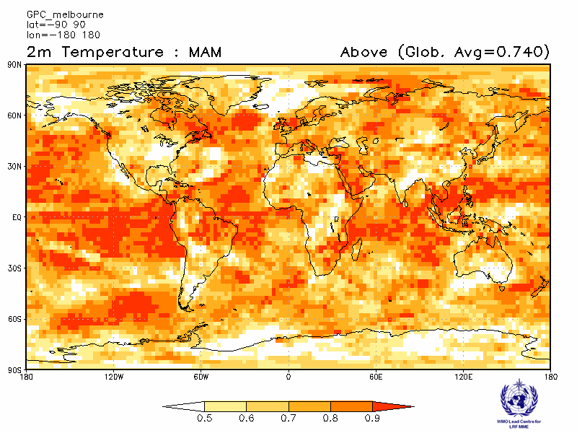 | Montreal  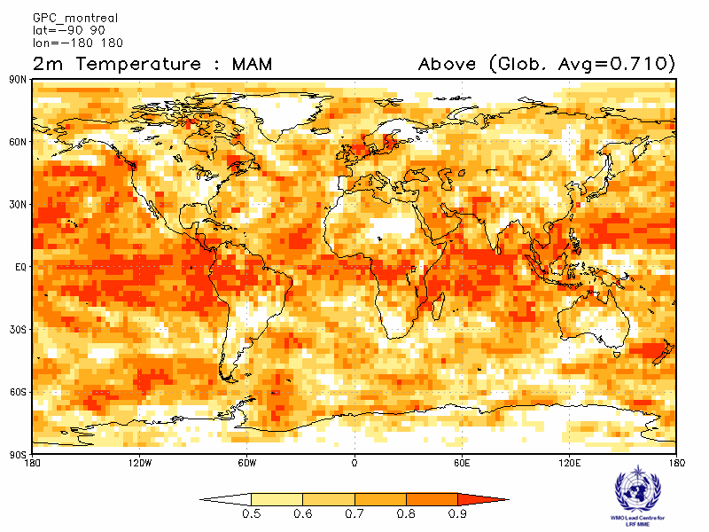
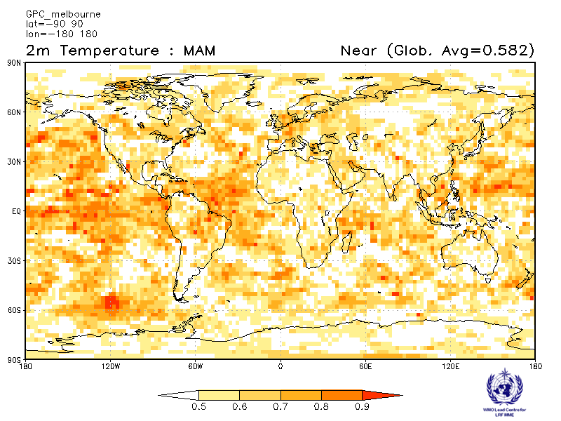 | 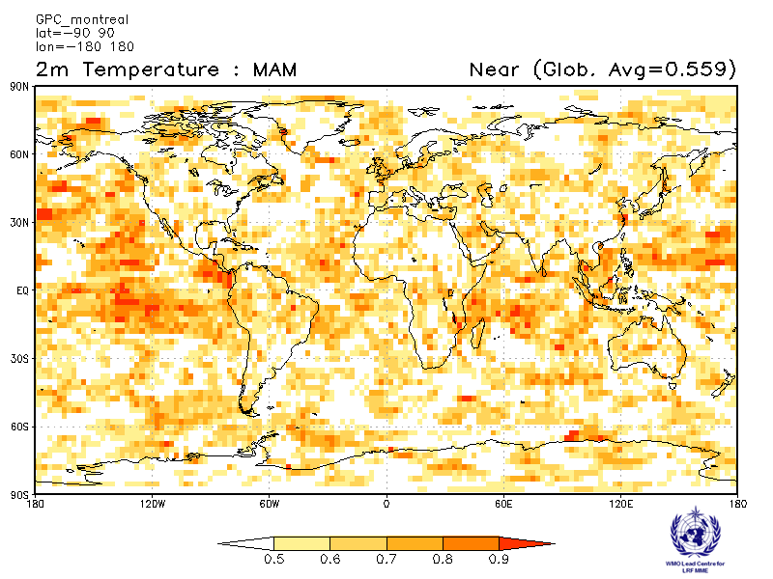
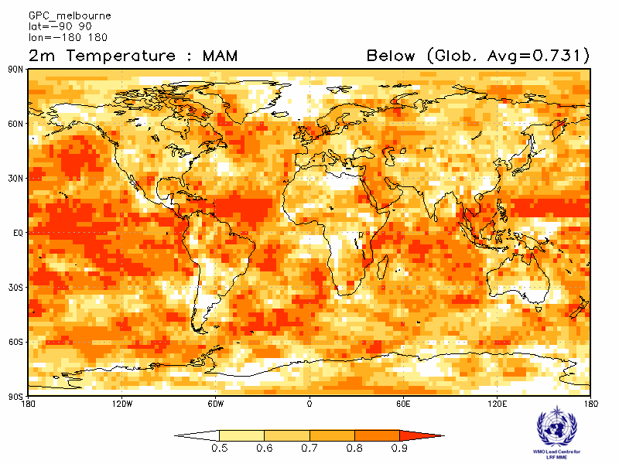 | 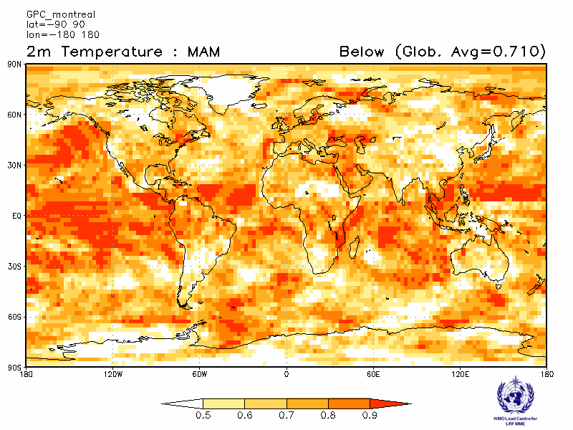

Moscow  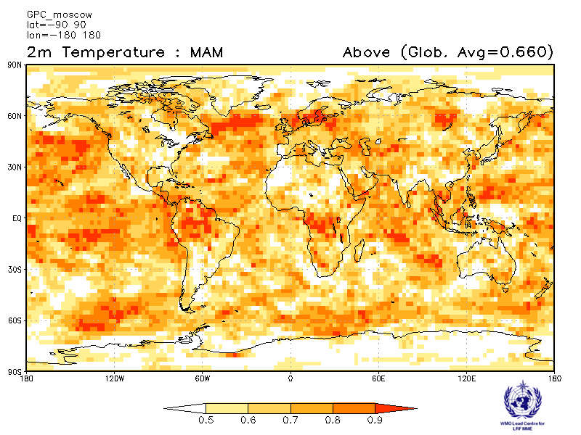 | Washington  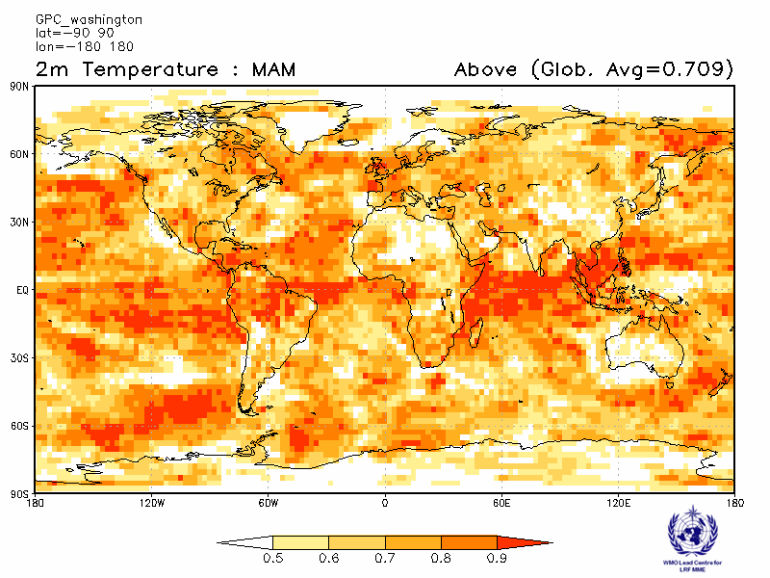
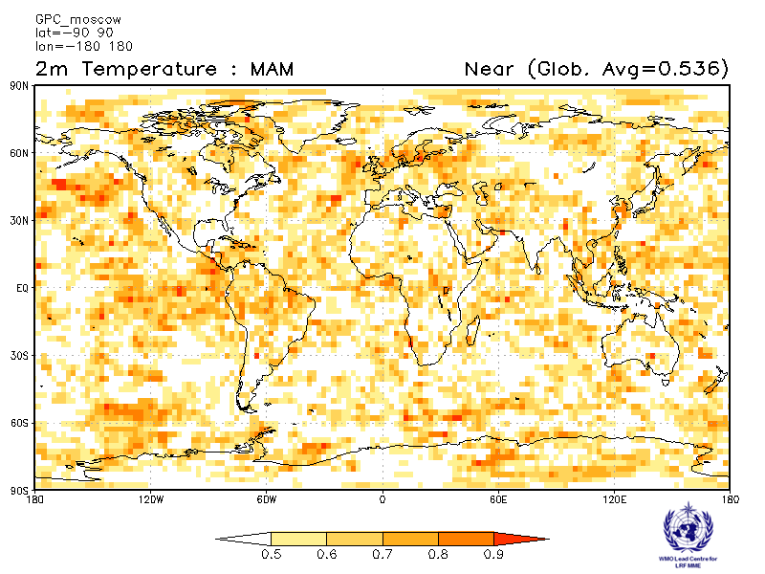 | 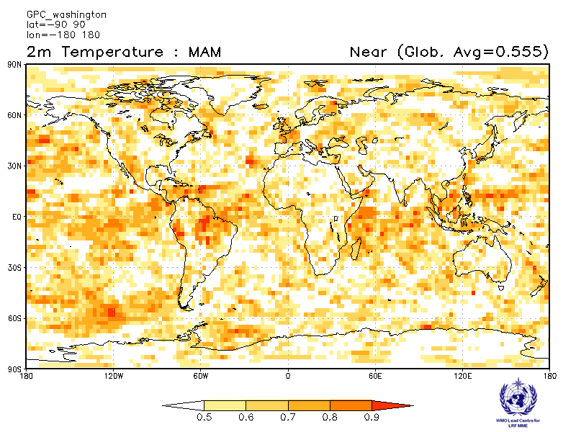
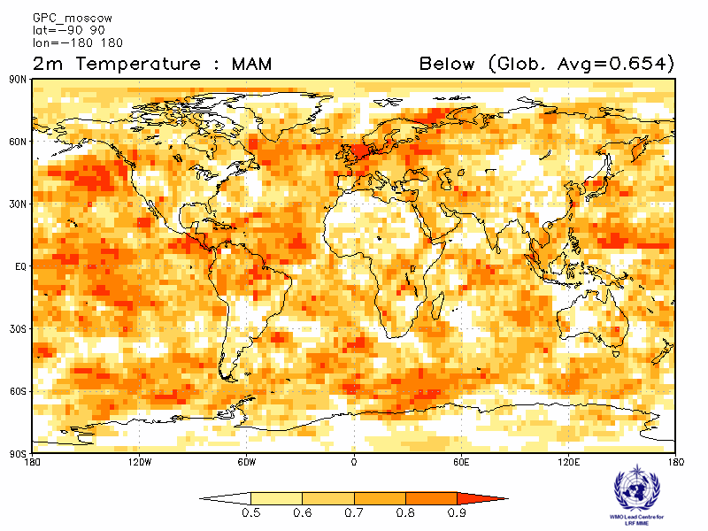 | 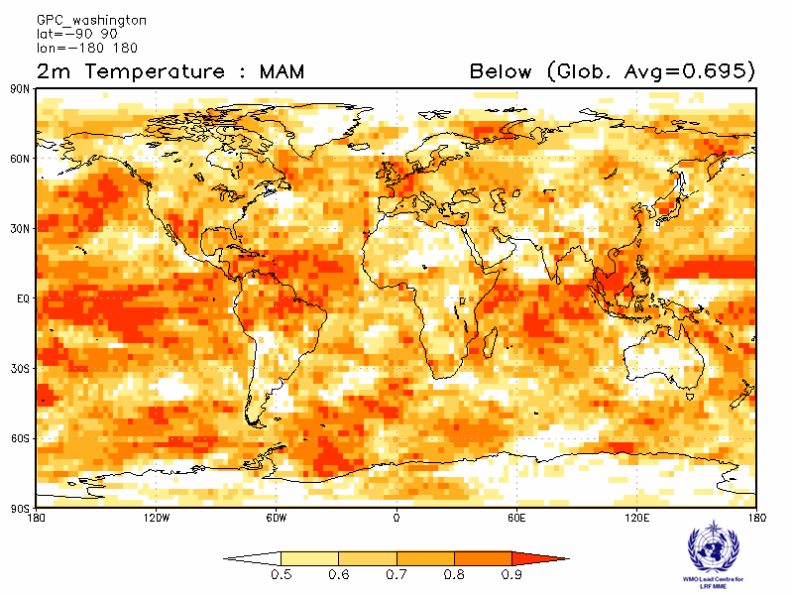

ROC score verification of 2m temperature probabilistic forecasts from other GPCs

Exeter  Verification period : 1996-2009  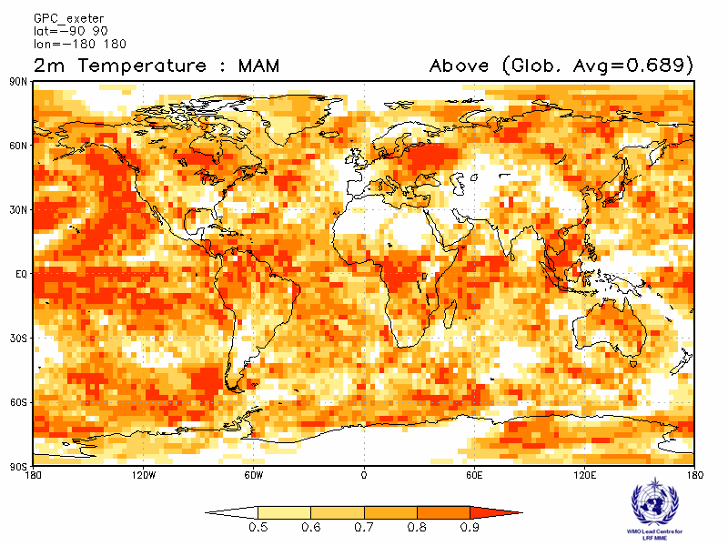 | Seoul  Verification period : 1996-2009  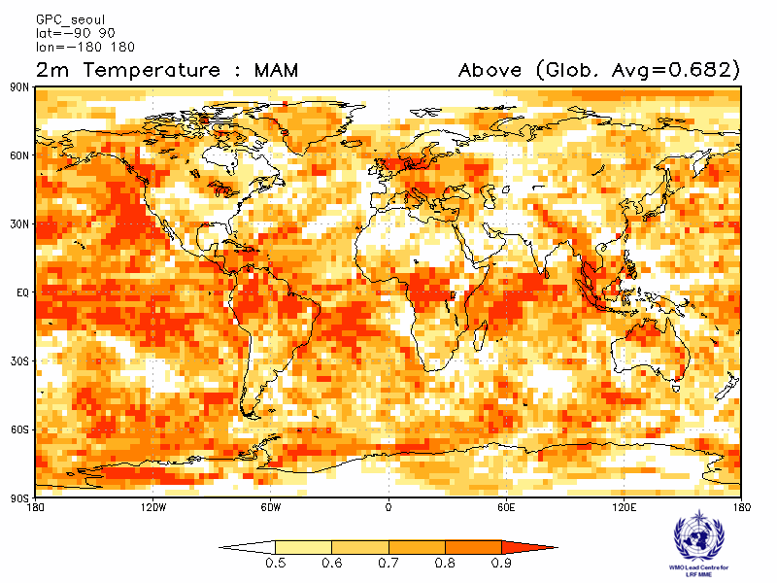
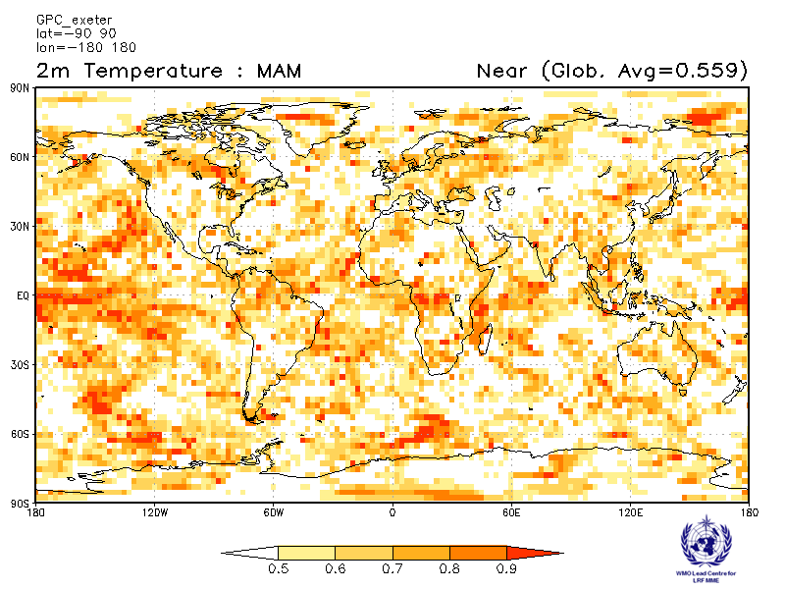 | 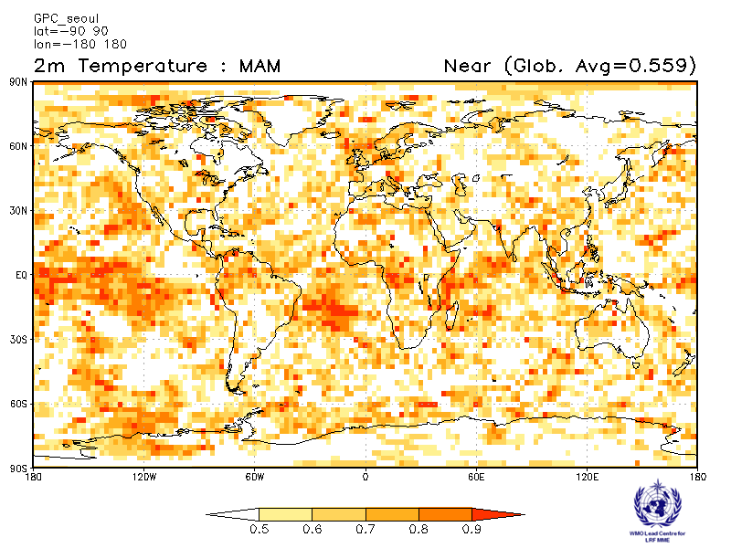
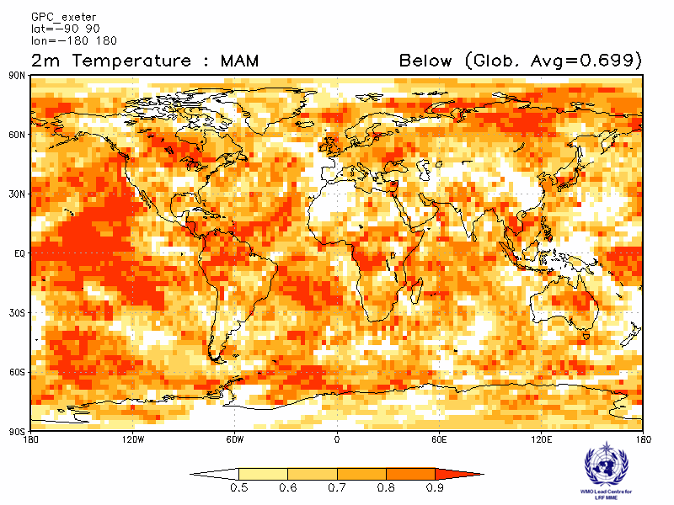 | 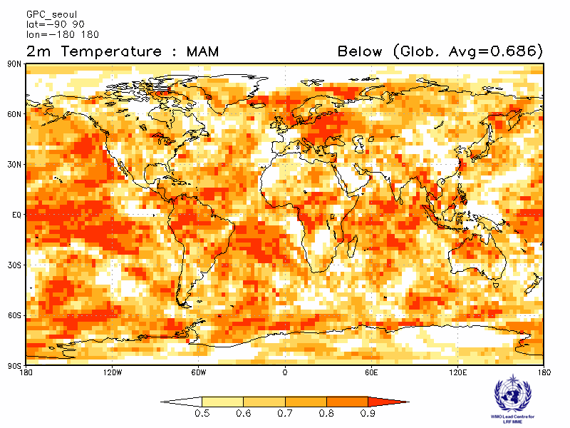

2.1.9 Verification of GPC 2m temperature probabilistic forecasts, 1983-2001
Verification measure: Relative Operating Characteristics (ROC) Curve and Score over globe
Verification dataset: ERA-interim

PMME  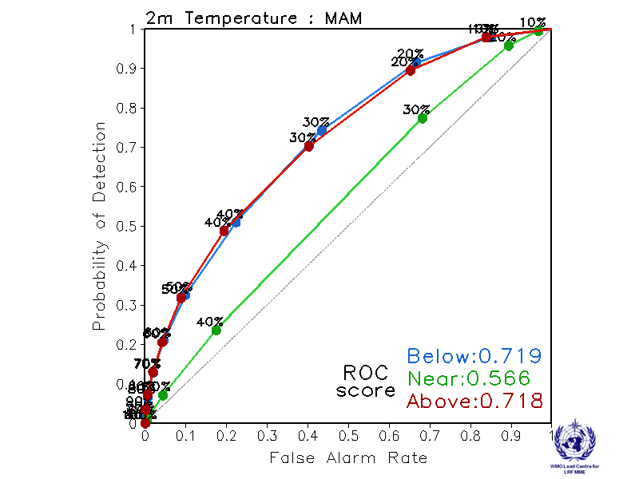 | CPTEC  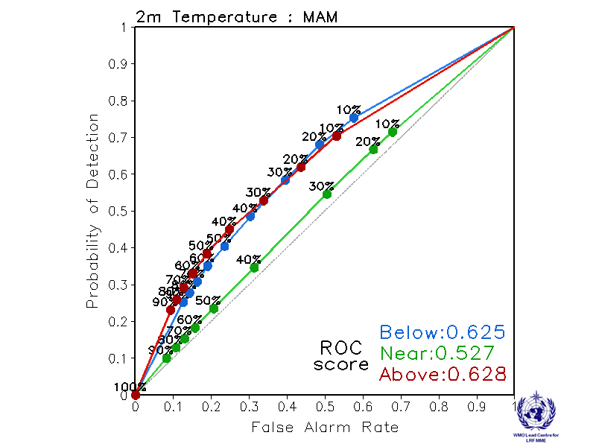
Melbourne  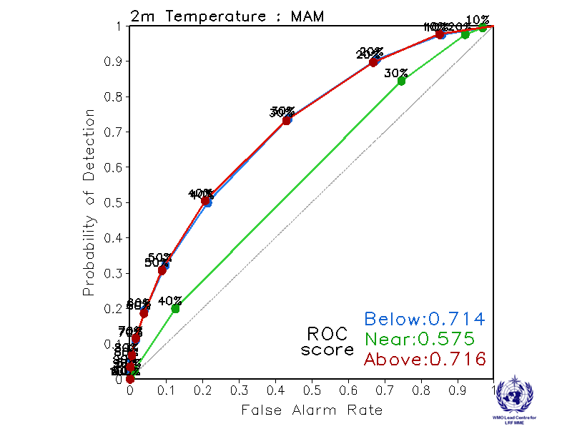 | Montreal  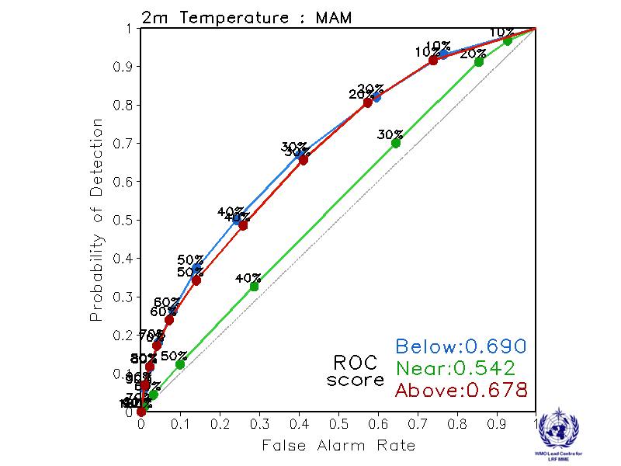
Moscow  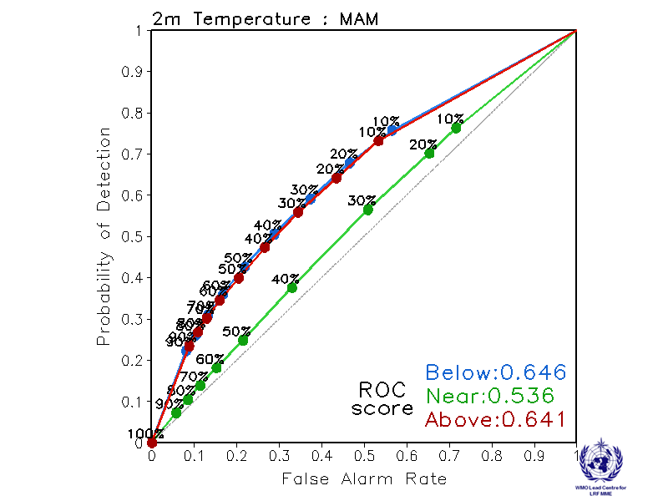 | Washington  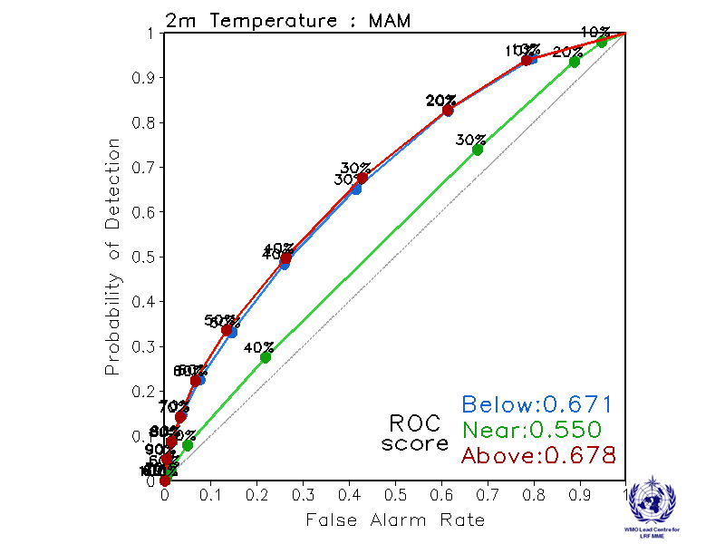

ROC curve and Score verification of 2m temperature probabilistic forecasts from other GPCs

Exeter  Verification period: 1996-2009  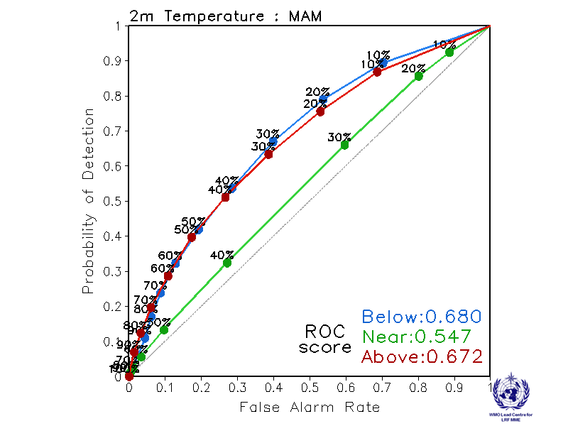 | Seoul  Verification period: 1996-2009  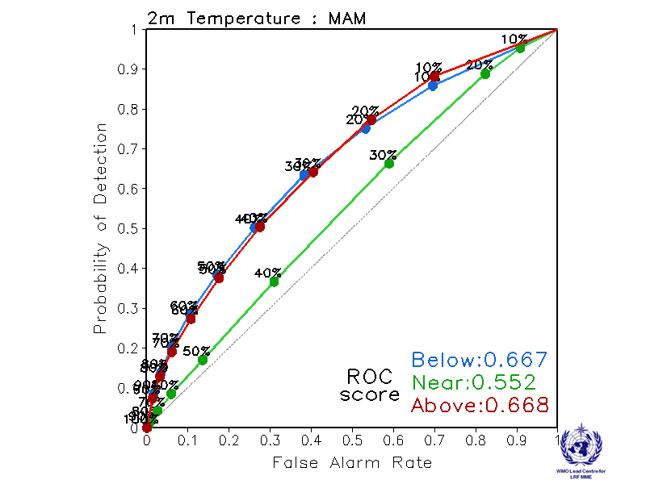

2.1.10 Verification of GPC 2m temperature probabilistic forecasts, 1983-2001
Verification measure: Reliability Diagram over globe
Verification dataset: ERA-interim

PMME  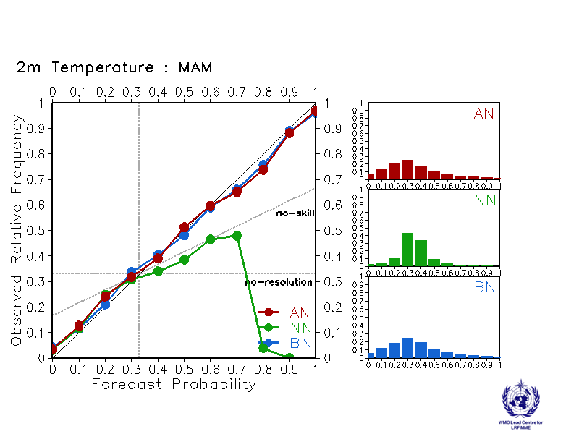 | CPTEC  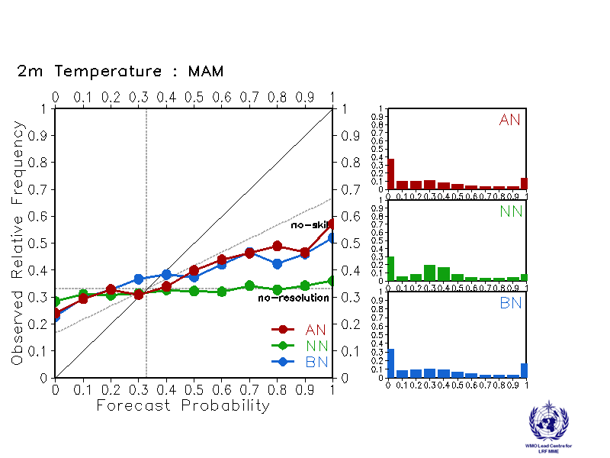
Melbourne  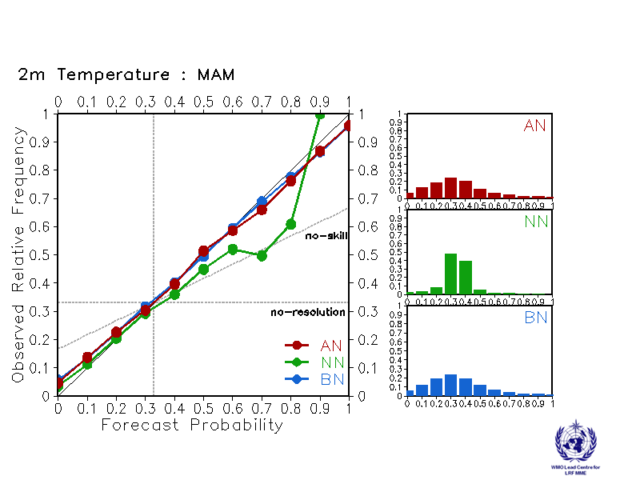 | Montreal  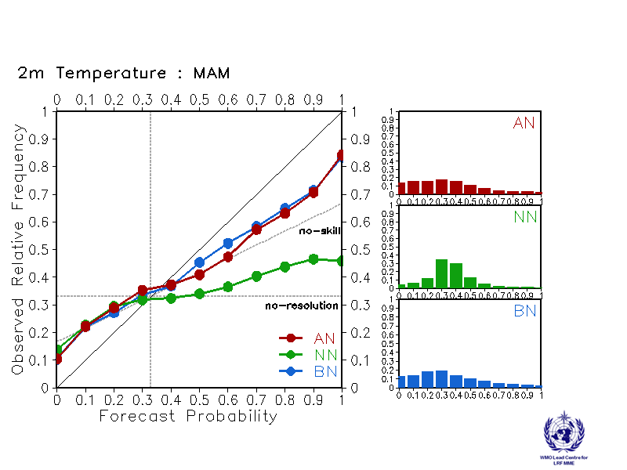
Moscow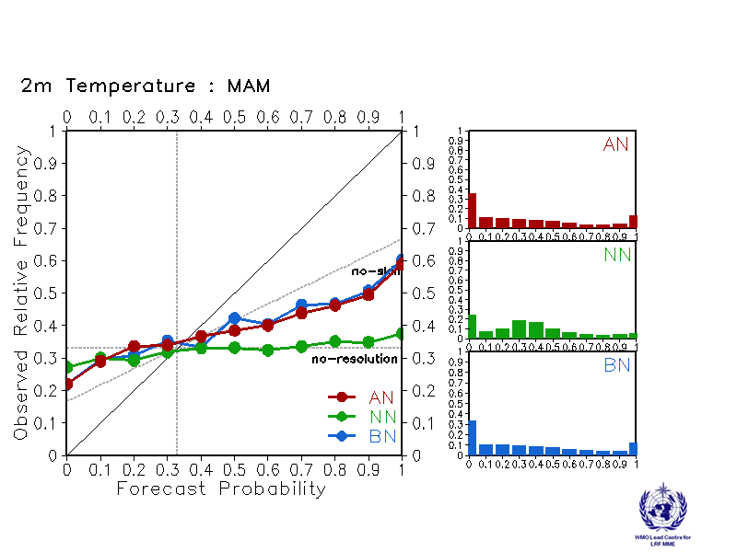 | Washington  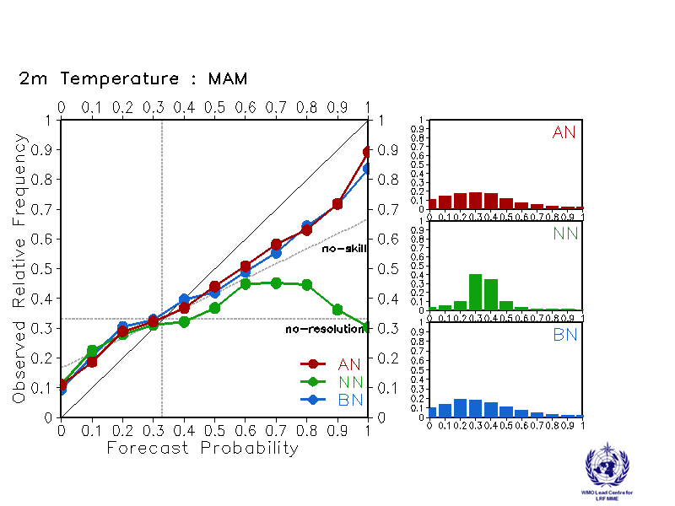

Reliability Diagram verification of 2m temperature probabilistic forecasts from other GPCs

Exeter  Verification period: 1996-2009  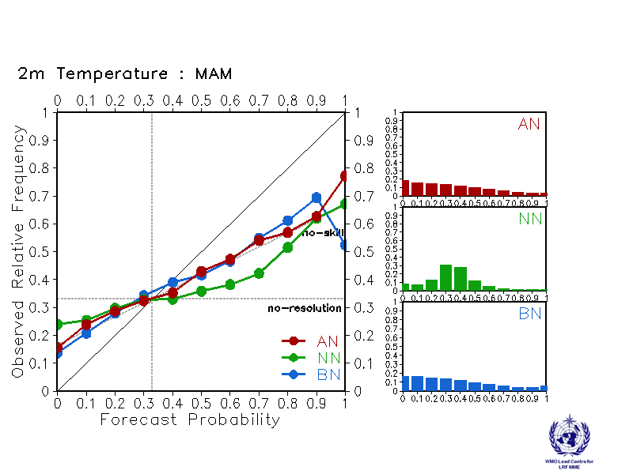 | Seoul  Verification period: 1996-2009  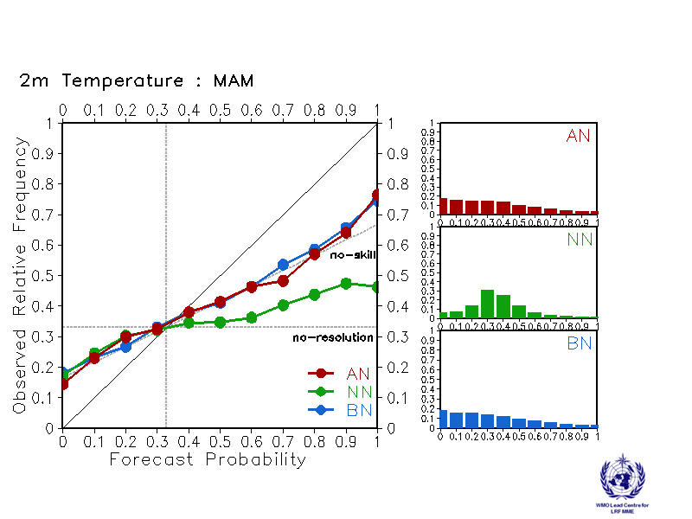

2.2 Precipitation

2.2.1 Individual GPC ensemble mean forecasts of precipitation anomalies relative to 1983-2001

CPTEC  Baseline : 1983-2001  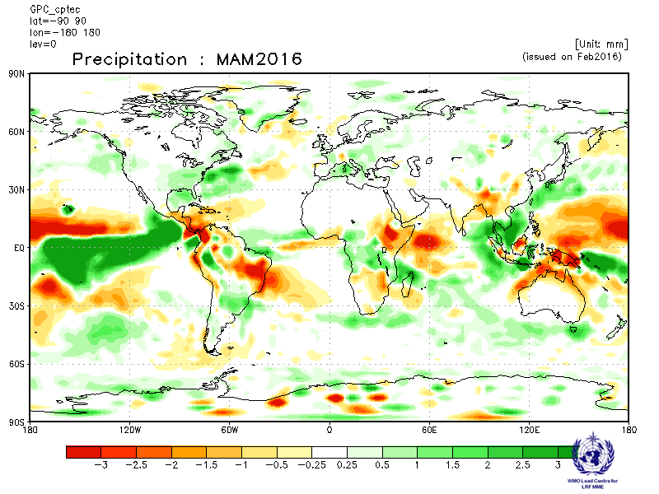 | Melbourne  Baseline : 1983-2001  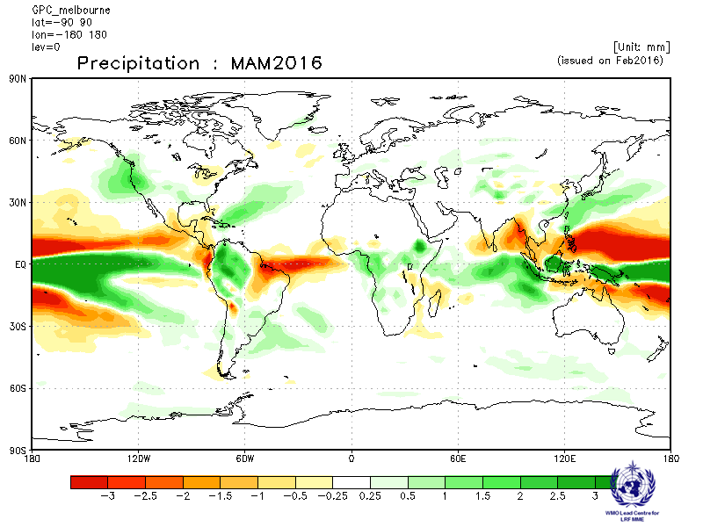
Montreal  Baseline : 1983-2001  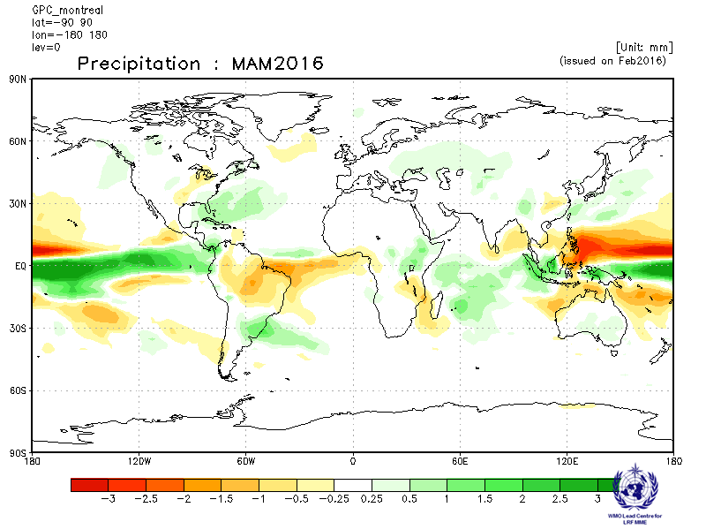 | Moscow  Baseline : 1983-2001  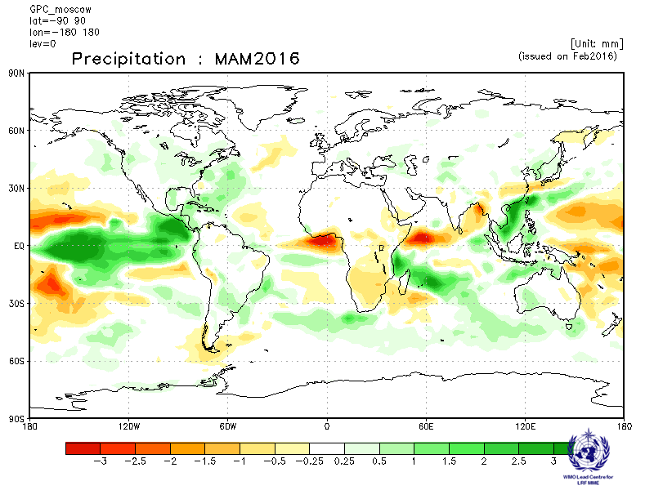
Washington
Baseline : 1983-2001
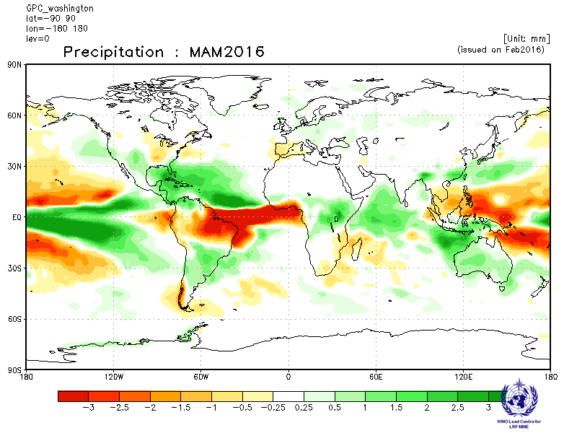

2.2.2 Individual GPC ensemble mean forecasts of precipitation anomalies from other GPCs for which forecast anomalies relative to 1983-2001 are not available.

ECMWF  Baseline: 1981-2010  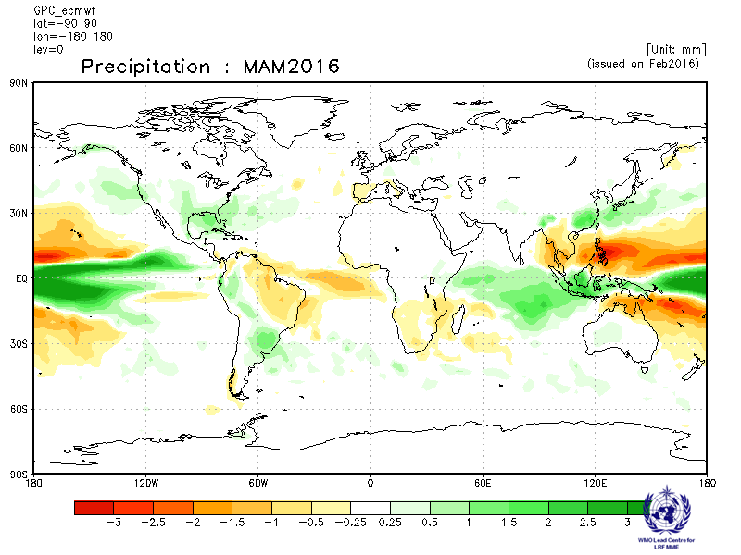 | Exeter  Baseline: 1996-2009  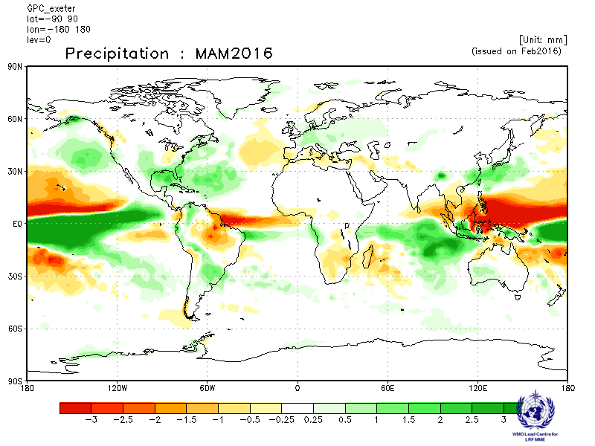
Seoul  Baseline: 1996-2009  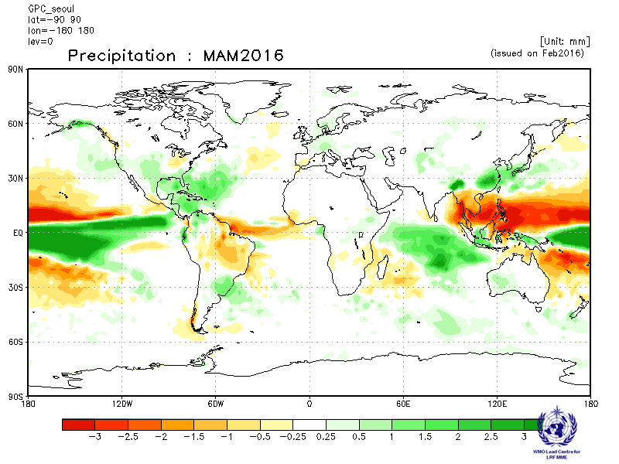 | Toulouse  Baseline: 1979-2007  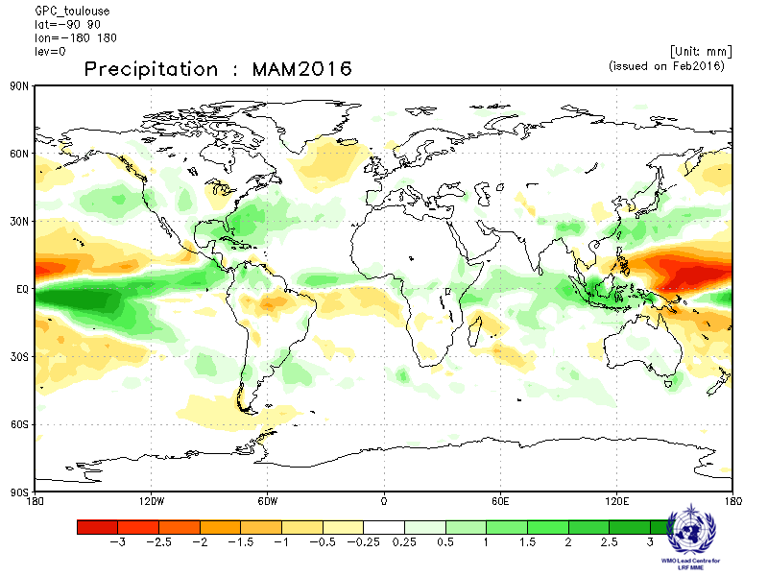

2.2.3 Forecast consistency map (9 GPCs): precipitation
(number of GPCs with positive/negative ensemble mean anomalies – relative to own baseline)
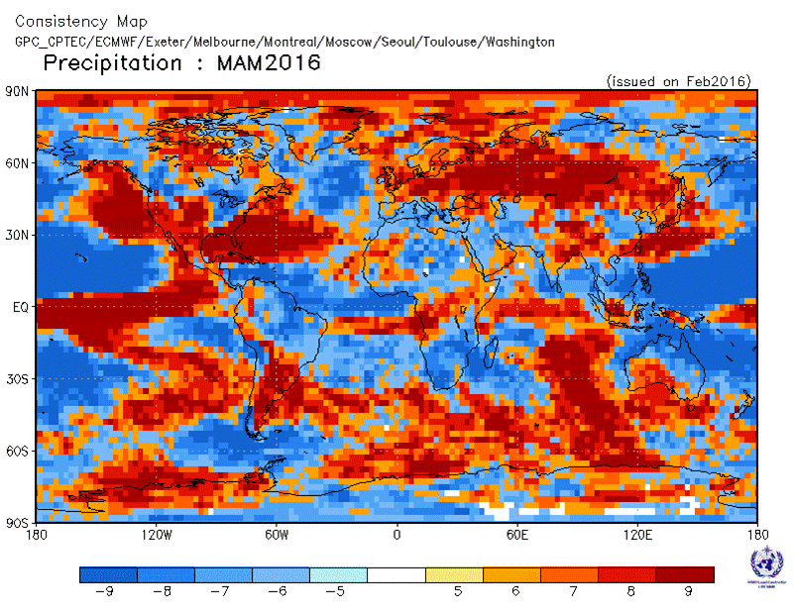
2.2.4 DMME (5 GPCs), using the same baseline for all models (1983-2001): precipitation

Ensemble mean anomaly
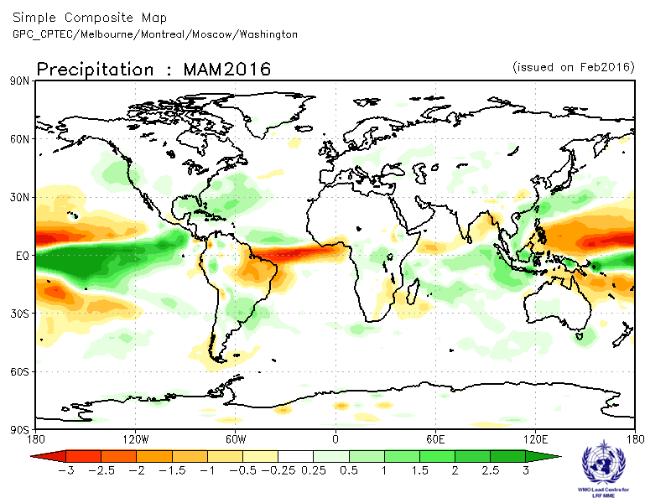

2.2.5 DMME (9 GPCs), for each model using its own baseline: precipitation
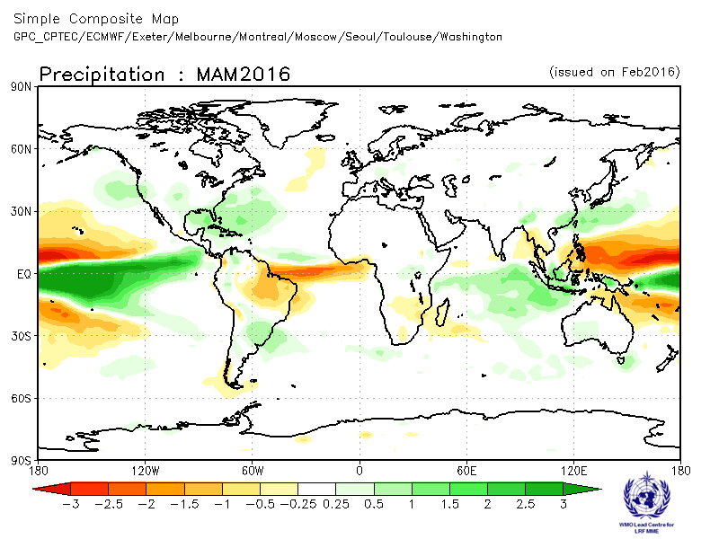
Ensemble mean anomaly

2.2.6 PMME (5 GPCs), using the same baseline for all models (1983-2001): precipitation

Probability of most likely tercile category
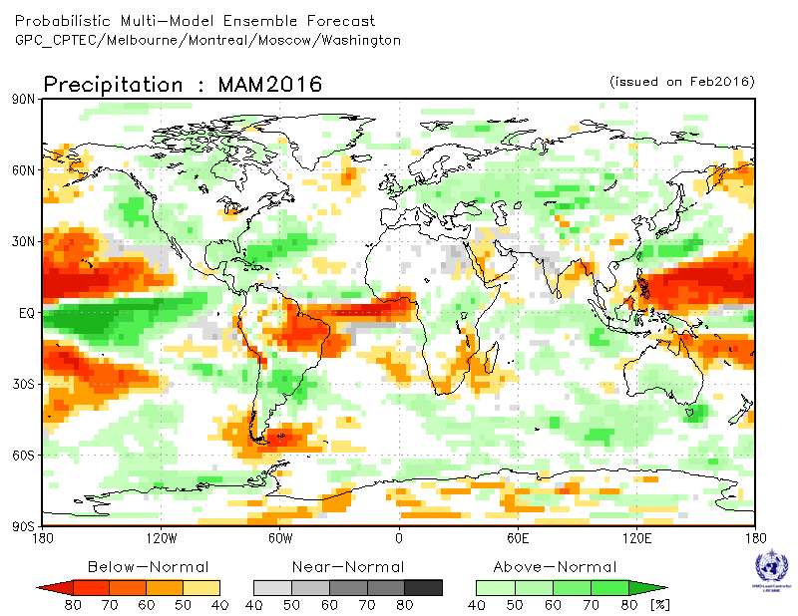
2.2.7 Verification of GPC ensemble mean precipitation anomaly forecasts, 1983-2001
Verification measure: Anomaly Correlation Coefficient (ACC)
Verification dataset: GPCP
DMME  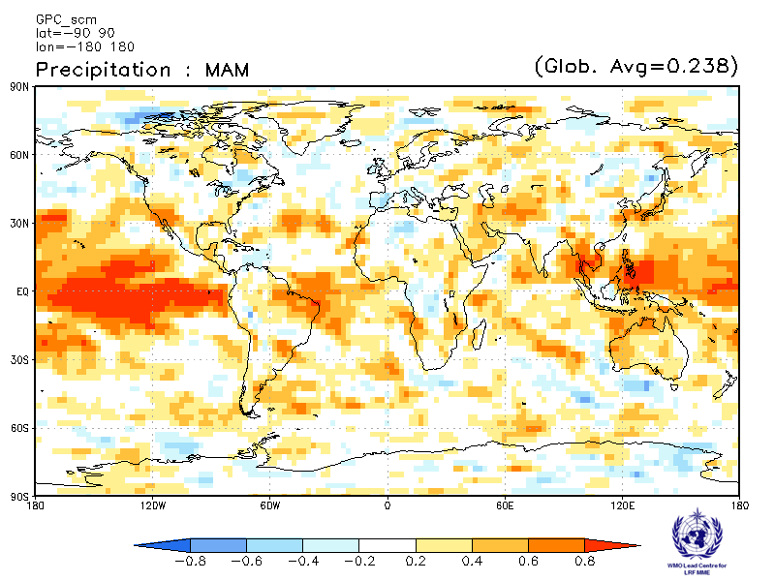 | CPTEC  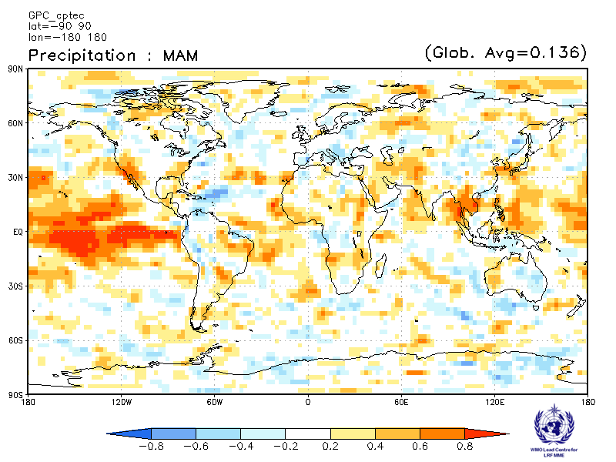
Melbourne  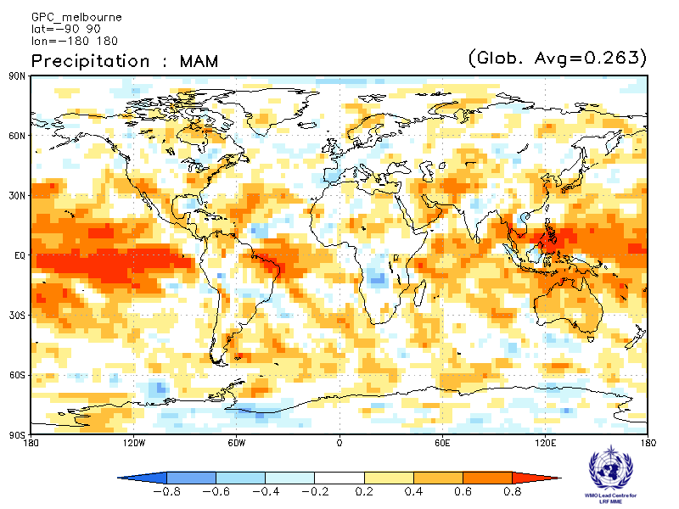 | Montreal  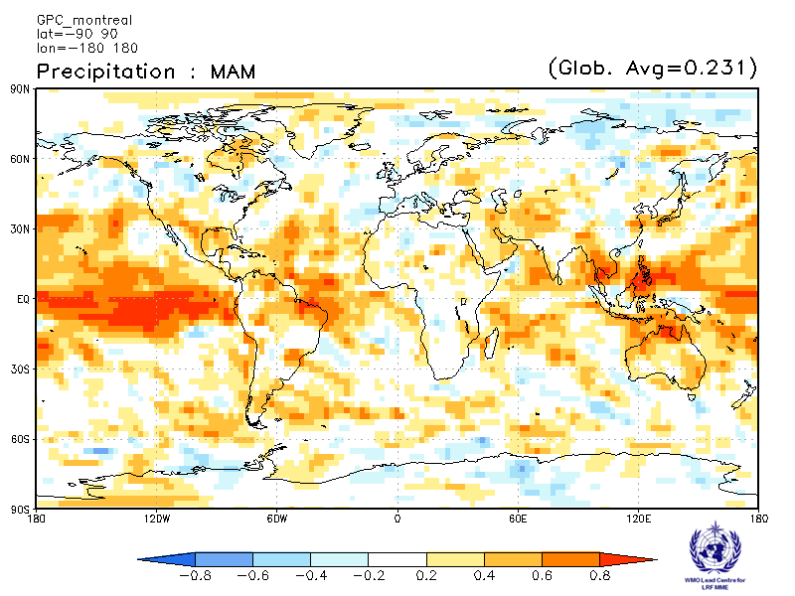
Moscow  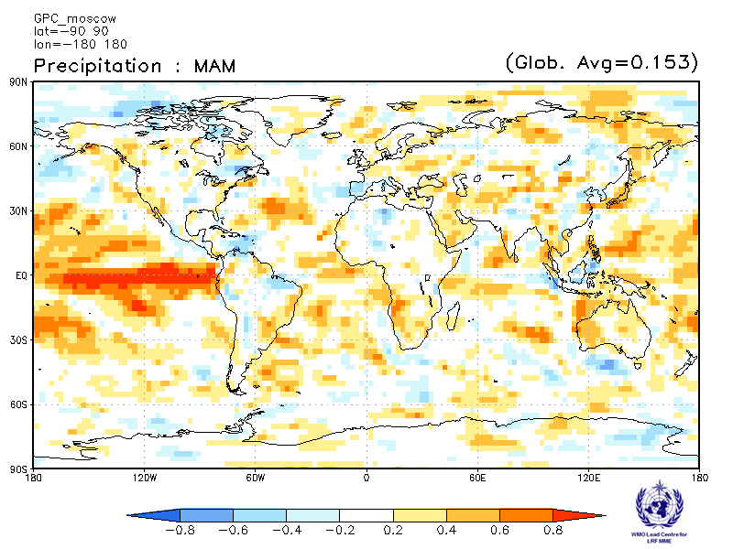 | Washington  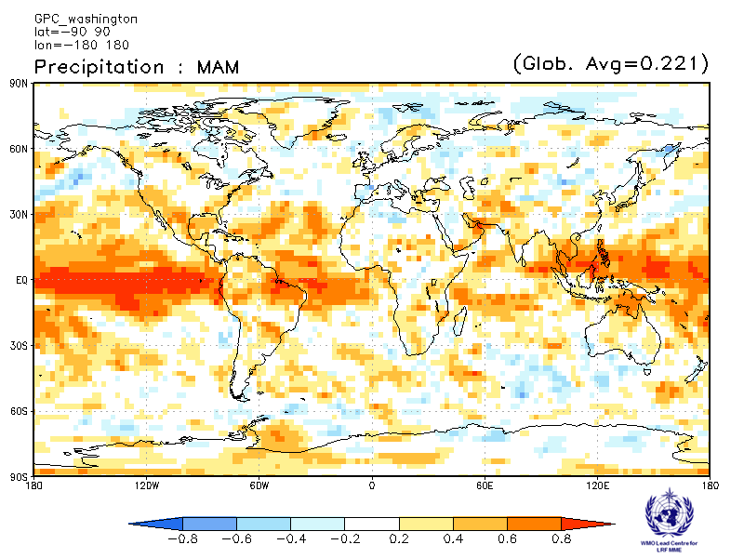

ACC verification of precipitation anomaly forecasts from other GPCs

Exeter  Verification period: 1996-2009  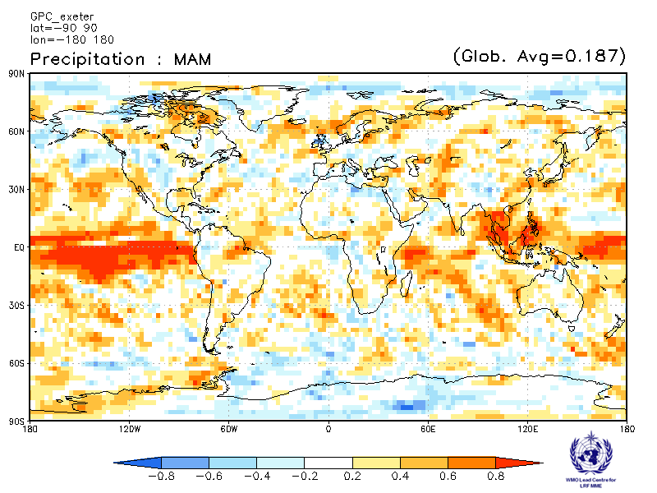 | Seoul  Verification period: 1996-2009  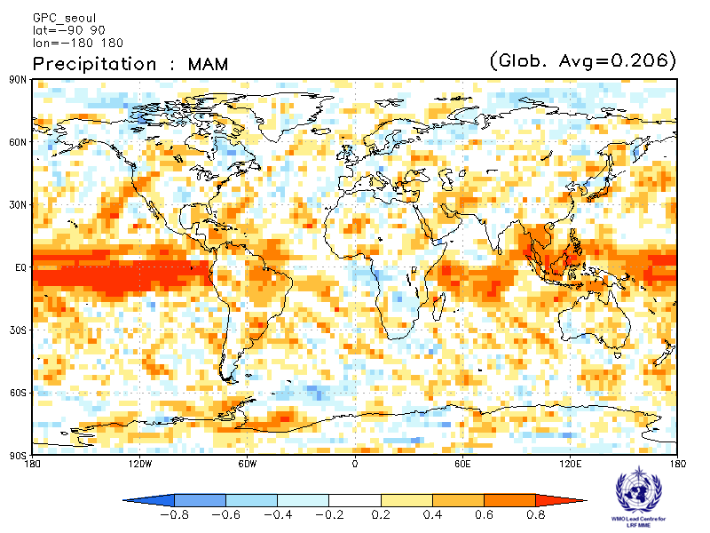

2.2.8 Verification of GPC precipitation probabilistic forecasts, 1983-2001
Verification measure: Relative Operating Characteristics (ROC) score for tercile forecast
Verification dataset: GPCP

PMME  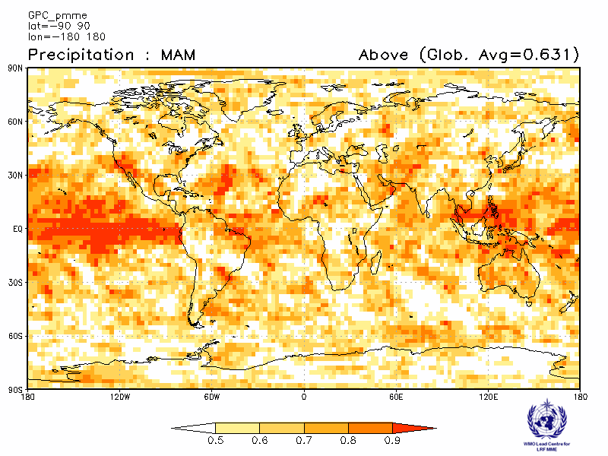 | CPTEC  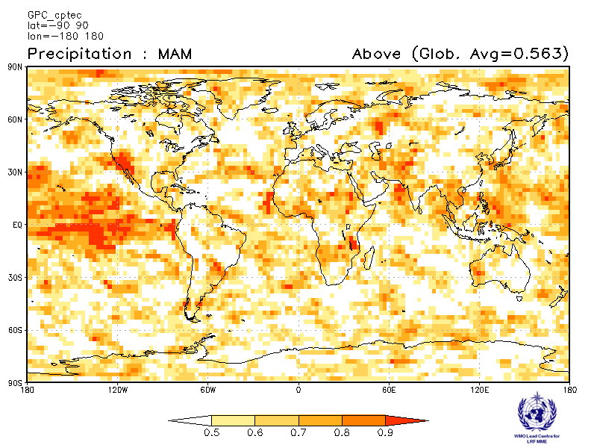
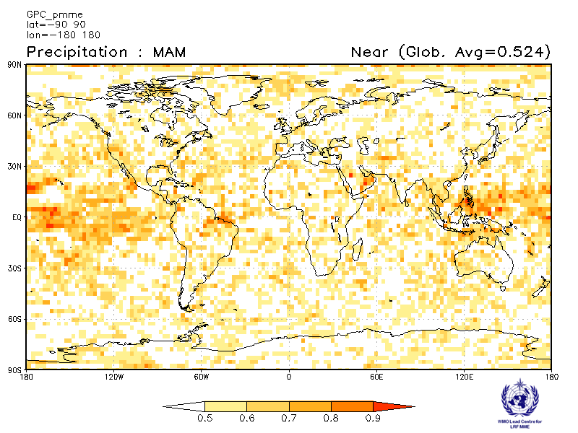 | 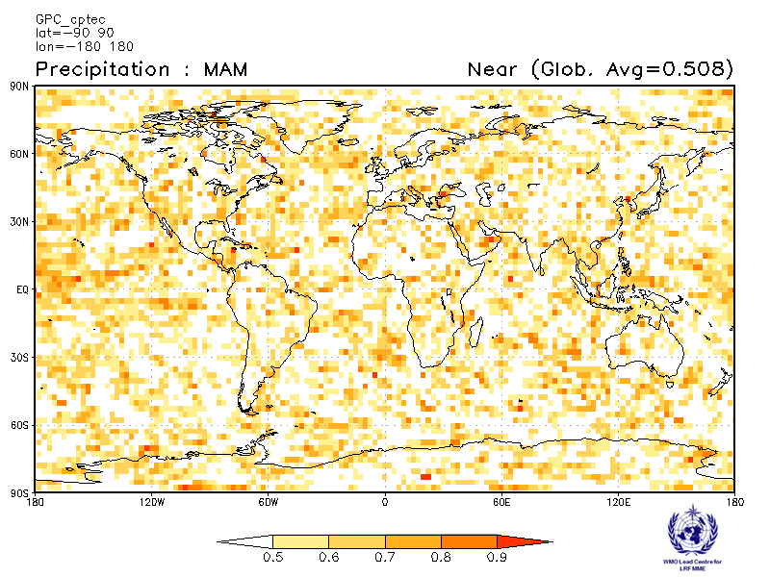
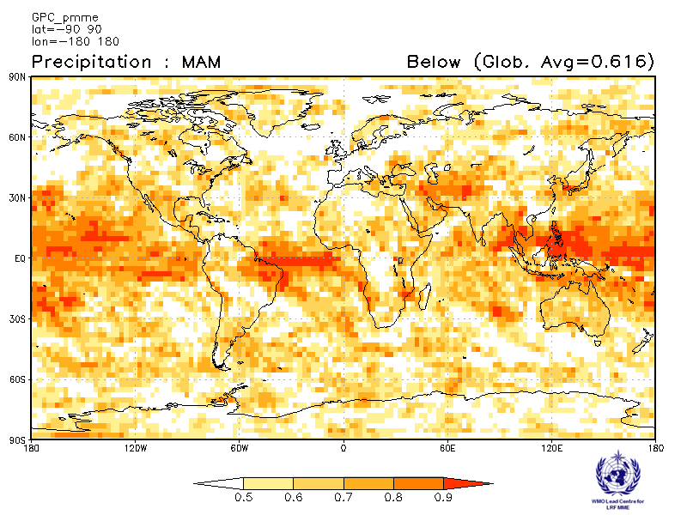 | 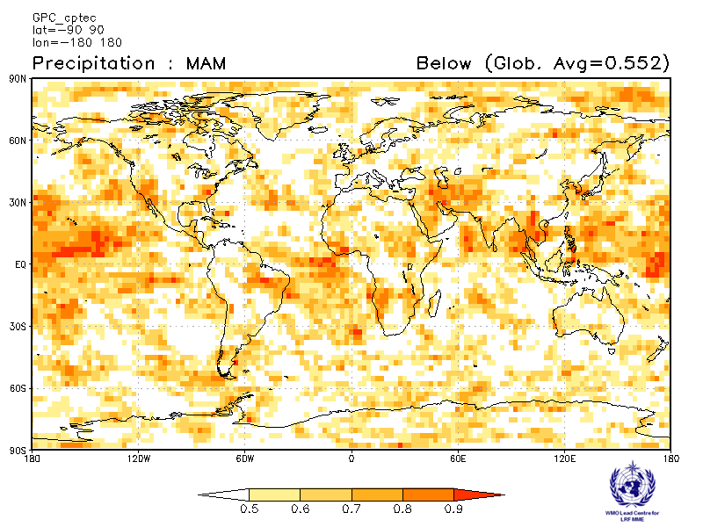

Melbourne  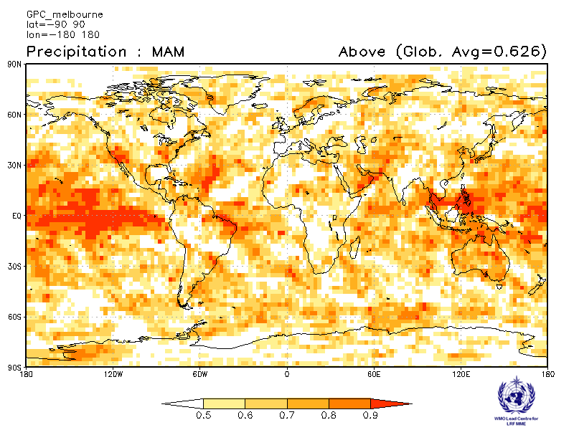 | Montreal  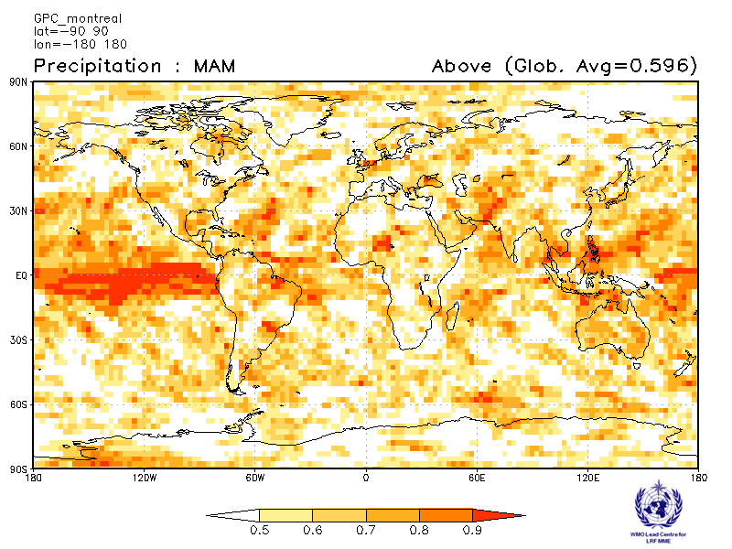
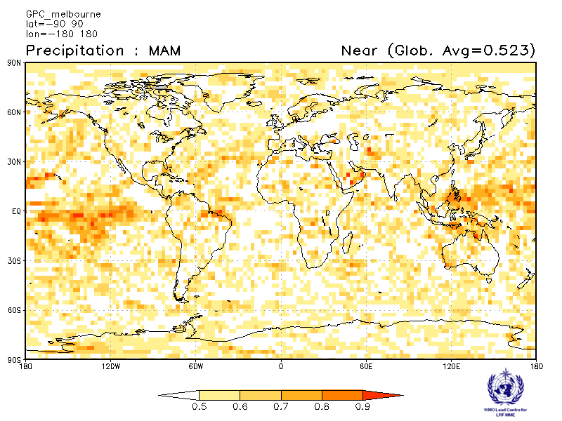 | 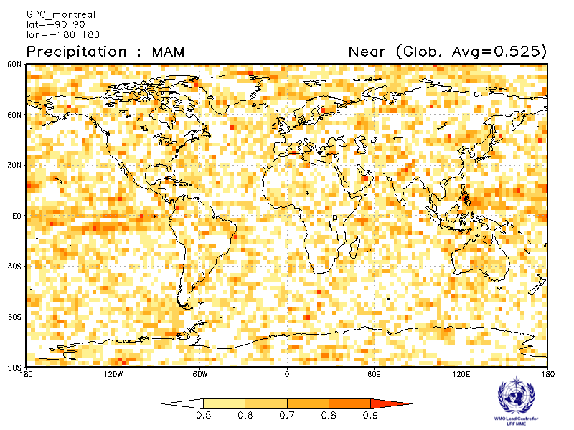
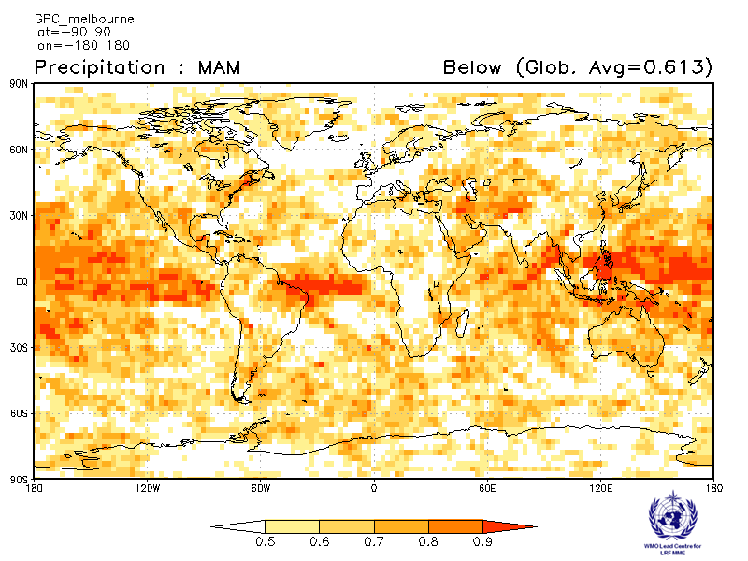 | 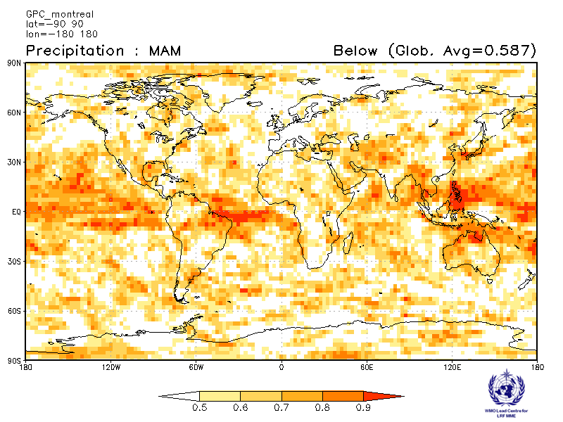

Moscow  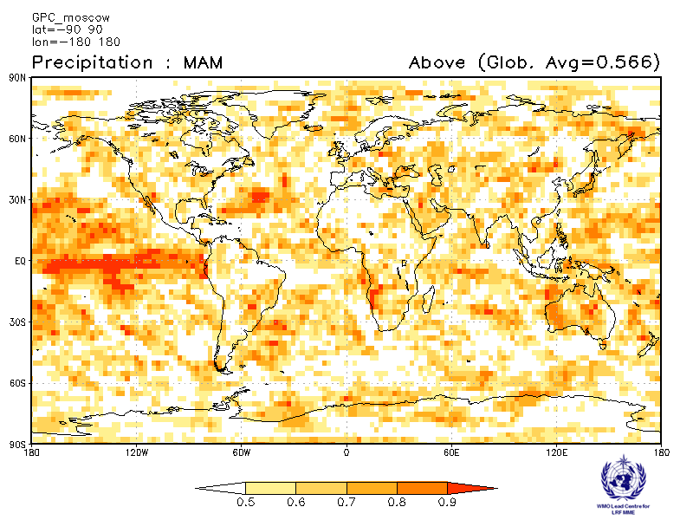 | Washington  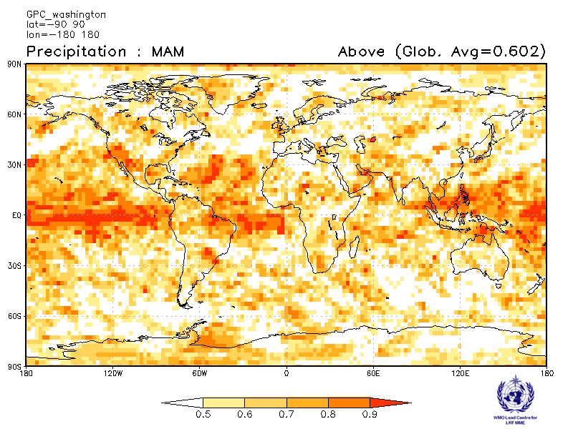
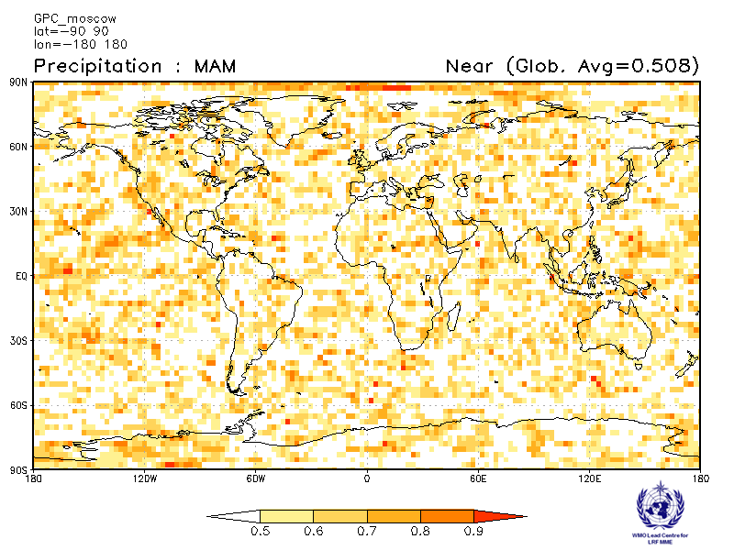 | 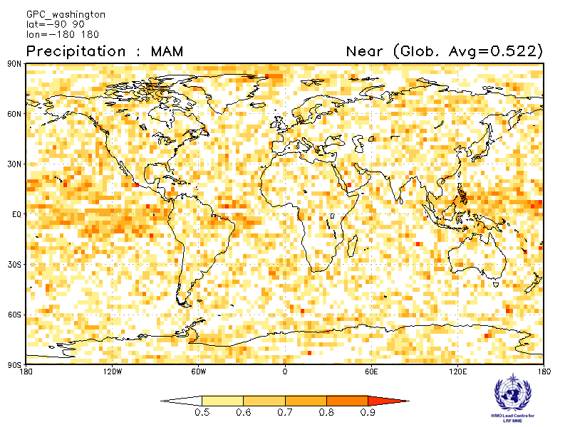
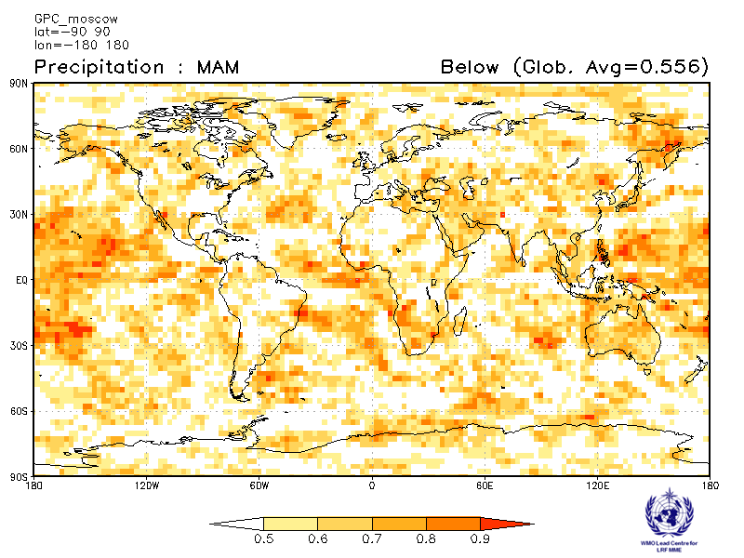 | 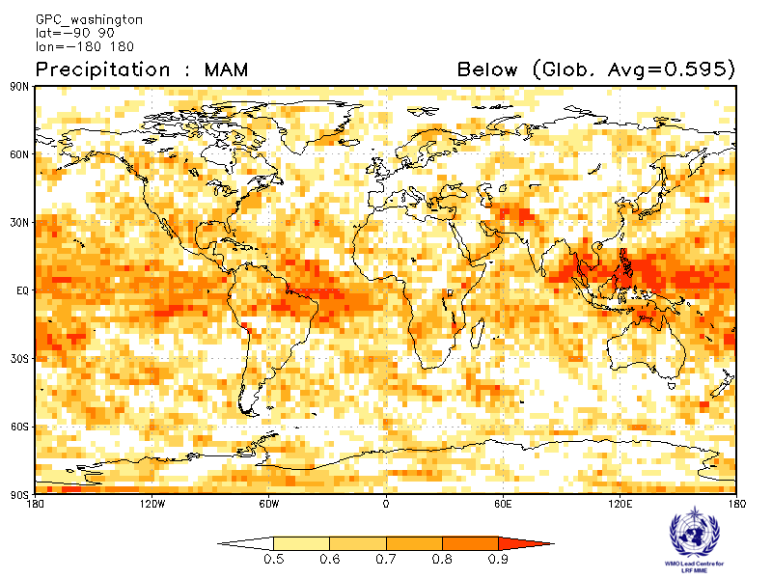

ROC score verification of precipitation probabilistic forecasts from other GPCs

Exeter  Verification period : 1996-2009  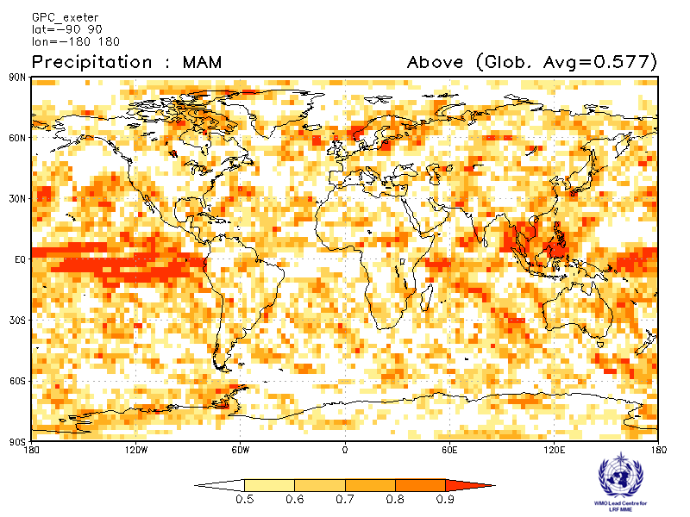 | Seoul  Verification period : 1996-2009  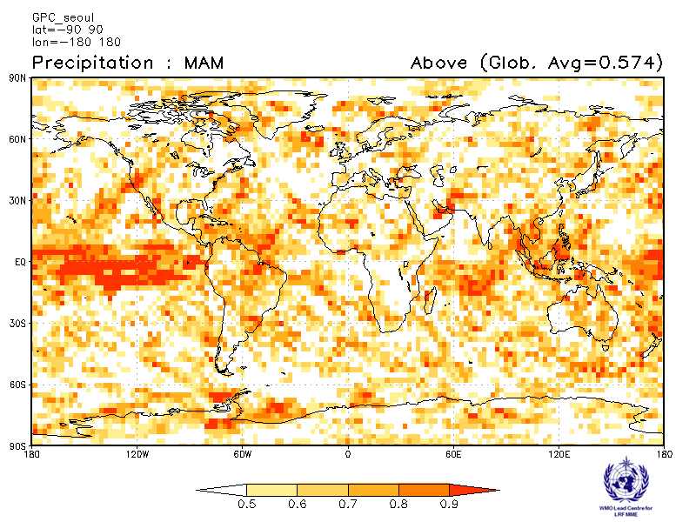
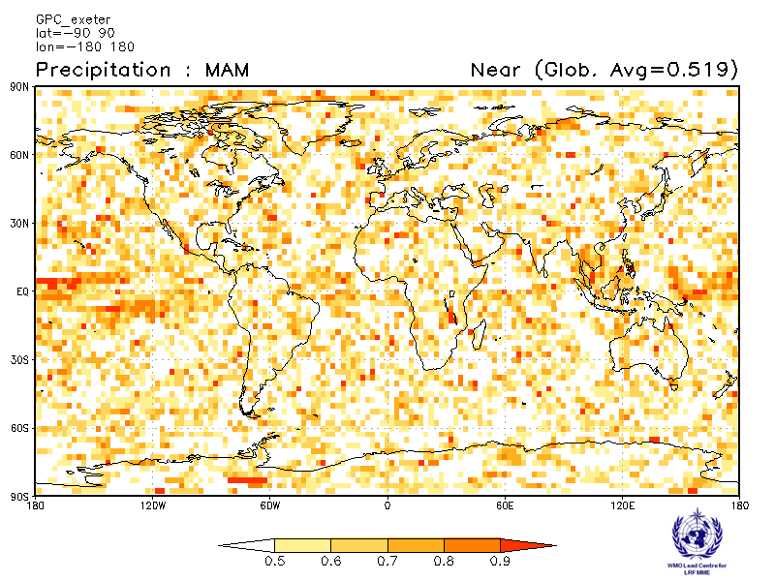 | 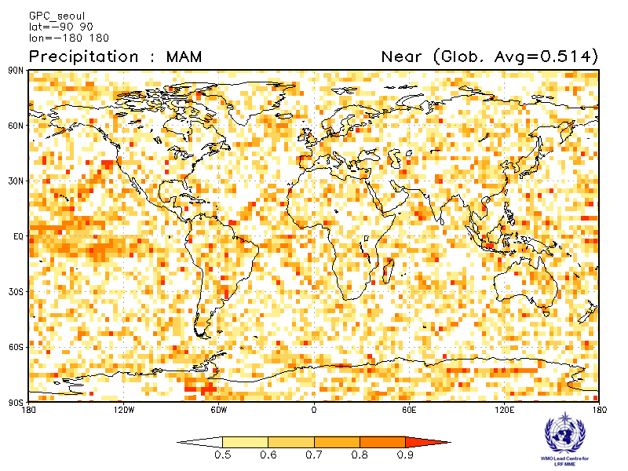
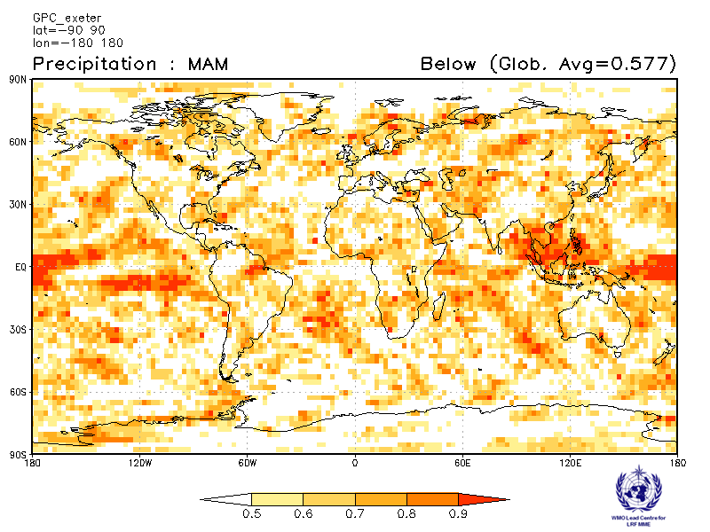 | 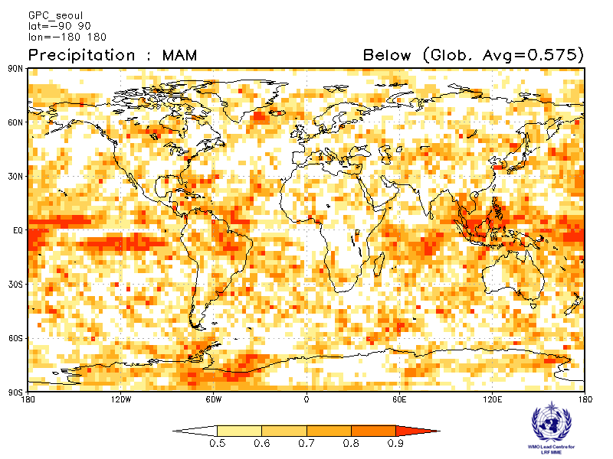

2.2.9 Verification of GPC precipitation probabilistic forecasts, 1983-2001
Verification measure: Relative Operating Characteristics (ROC) Curve and Score over globe
Verification dataset: GPCP

PMME  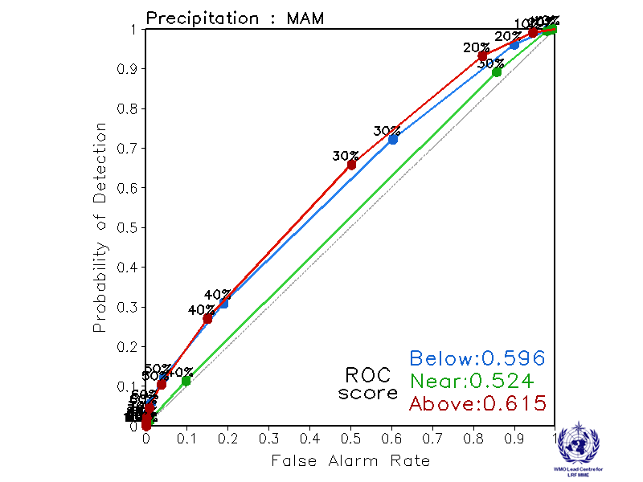 | CPTEC  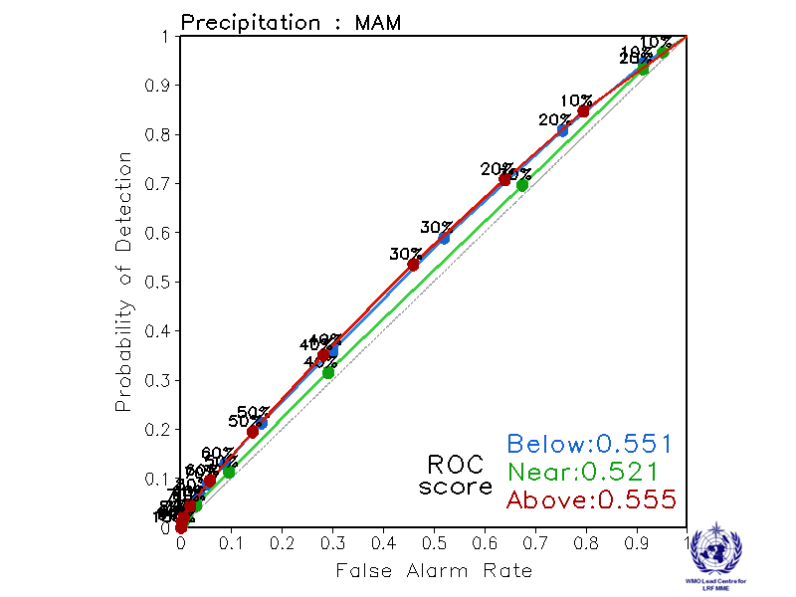
Melbourne  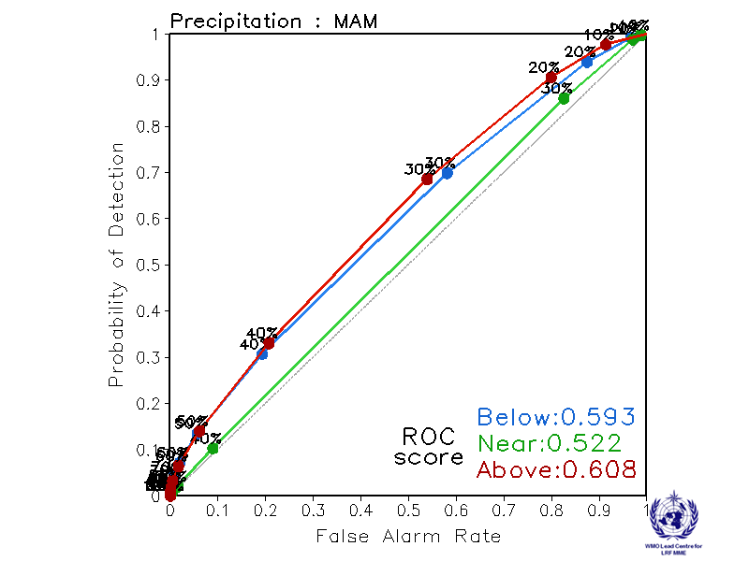 | Montreal  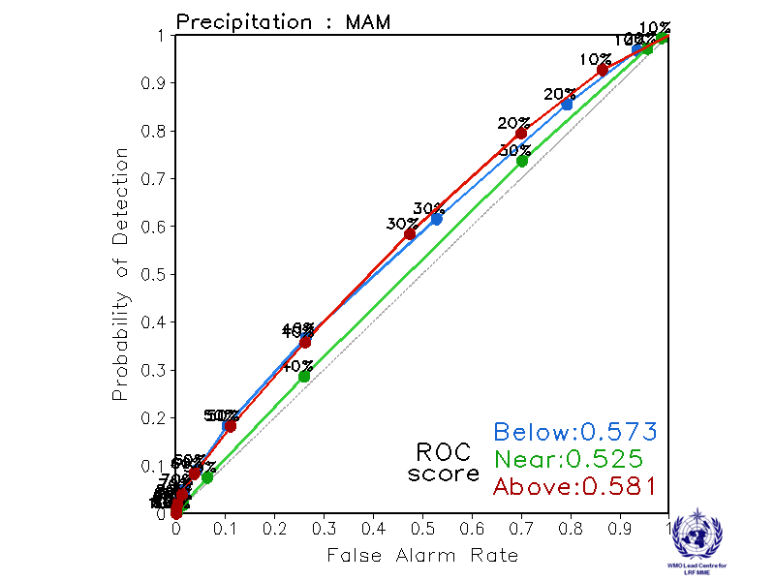
Moscow  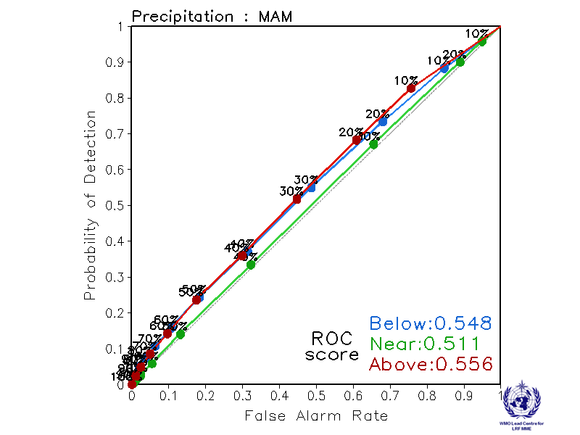 | Washington  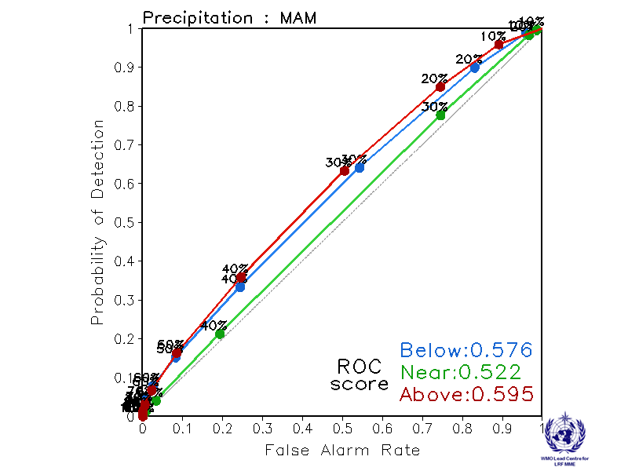

ROC curve and Score verification of precipitation probabilistic forecasts from other GPCs

Exeter  Verification period: 1996-2009  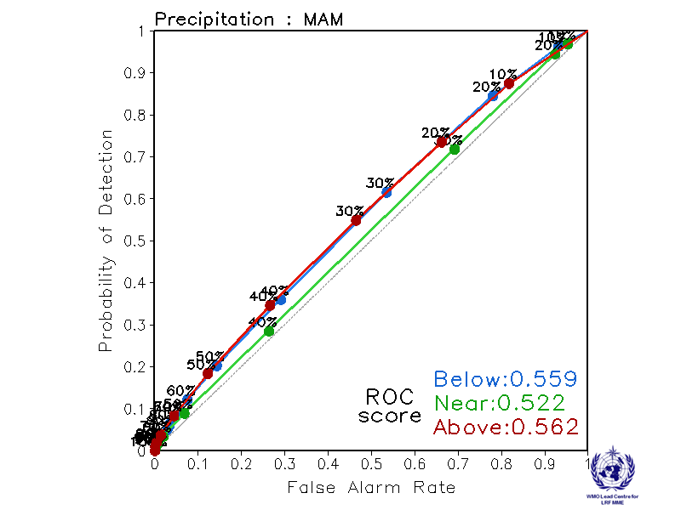 | Seoul  Verification period: 1996-2009  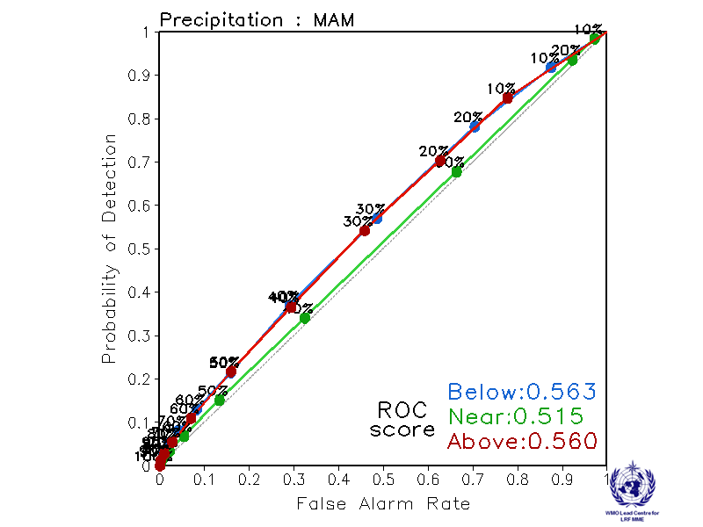

2.2.10 Verification of GPC precipitation probabilistic forecasts, 1983-2001
Verification measure: Reliability Diagram over globe
Verification dataset: GPCP

PMME  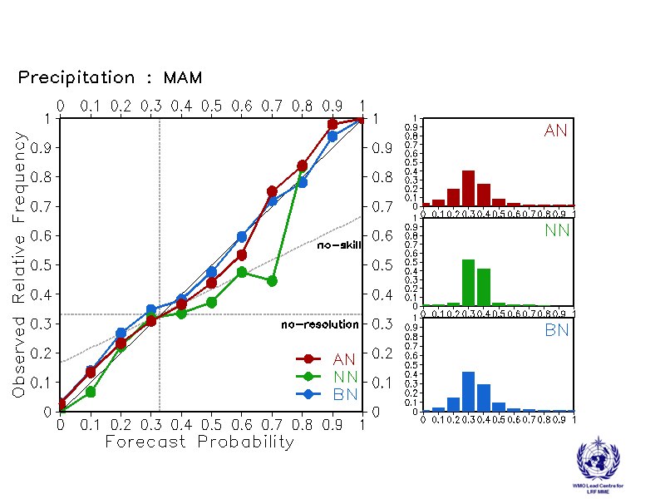 | CPTEC  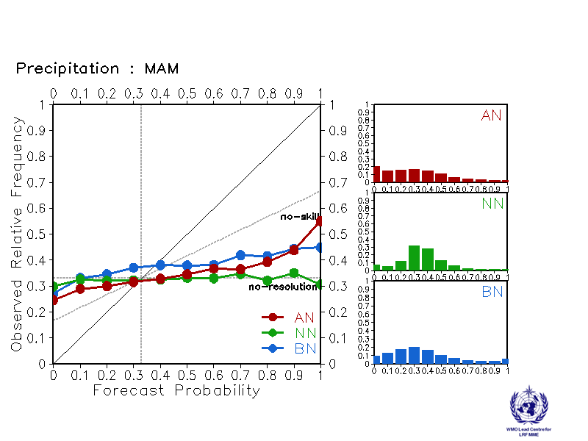
Melbourne  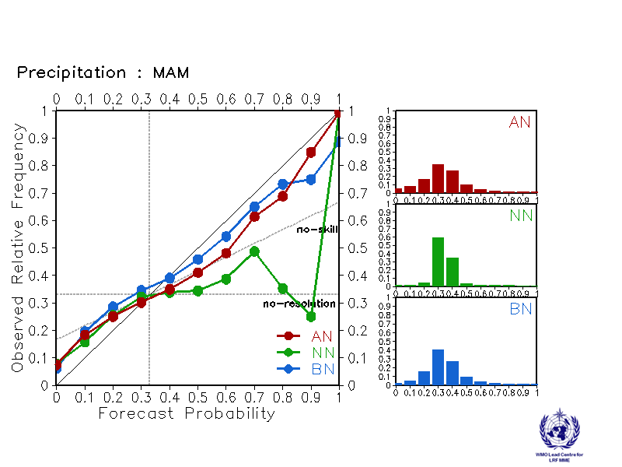 | Montreal  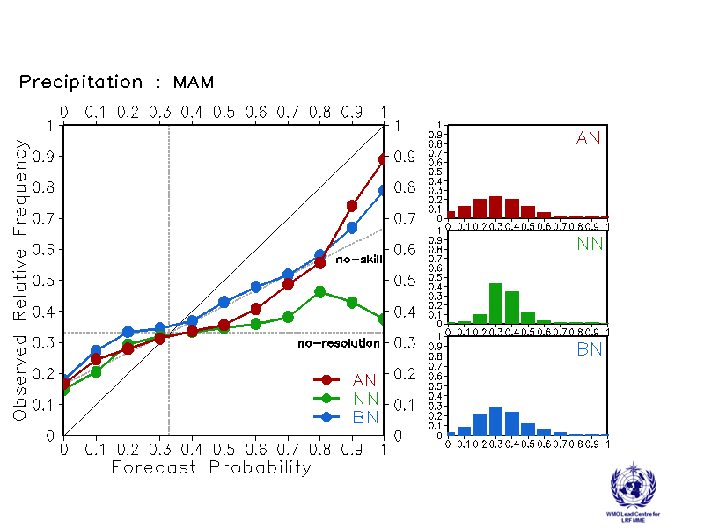
Moscow  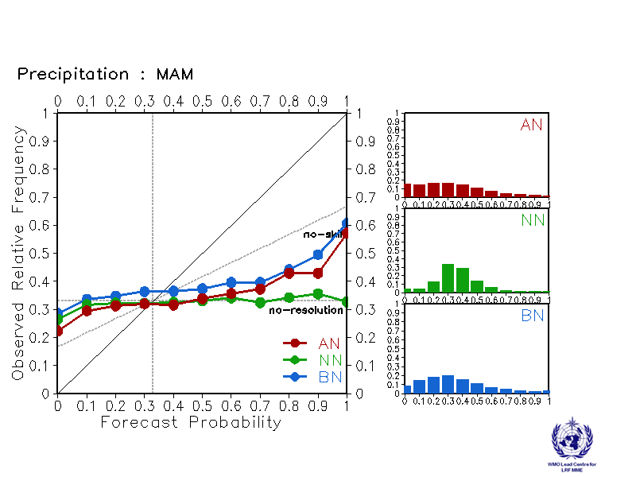 | Washington  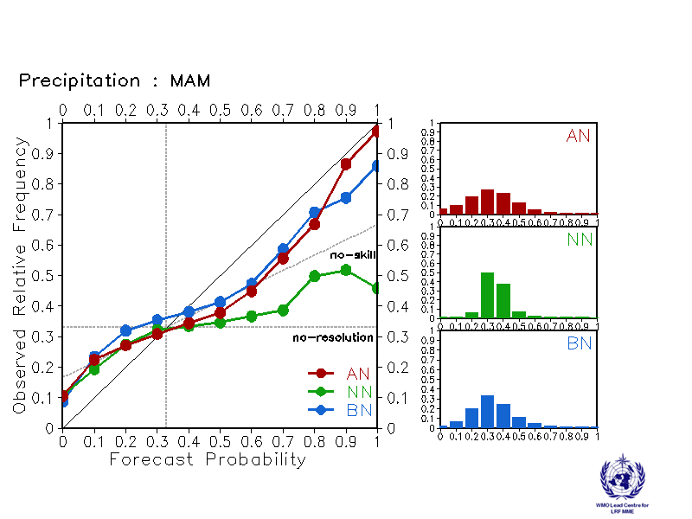

Reliability Diagram verification of precipitation probabilistic forecasts from other GPCs

Exeter  Verification period: 1996-2009  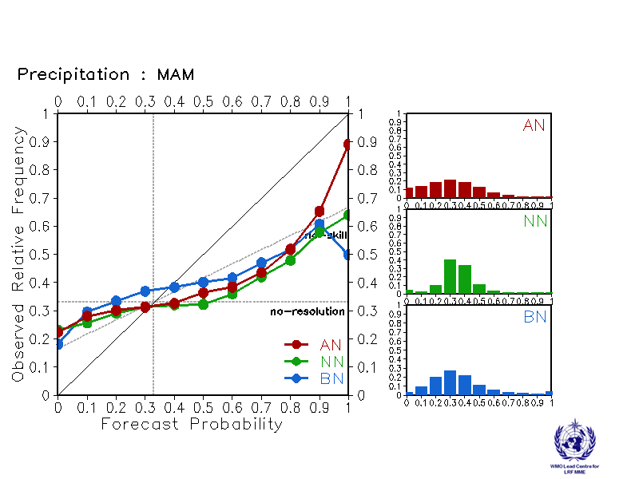 | Seoul  Verification period: 1996-2009  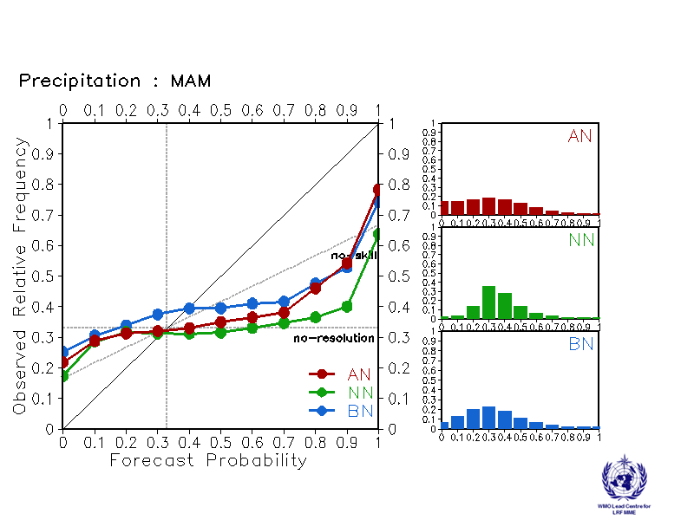

2.3 Sea Surface Temperature (SST)

2.3.1 Individual GPC ensemble mean forecasts of SST anomalies relative to 1983-2001
Melbourne  Baseline : 1983-2001  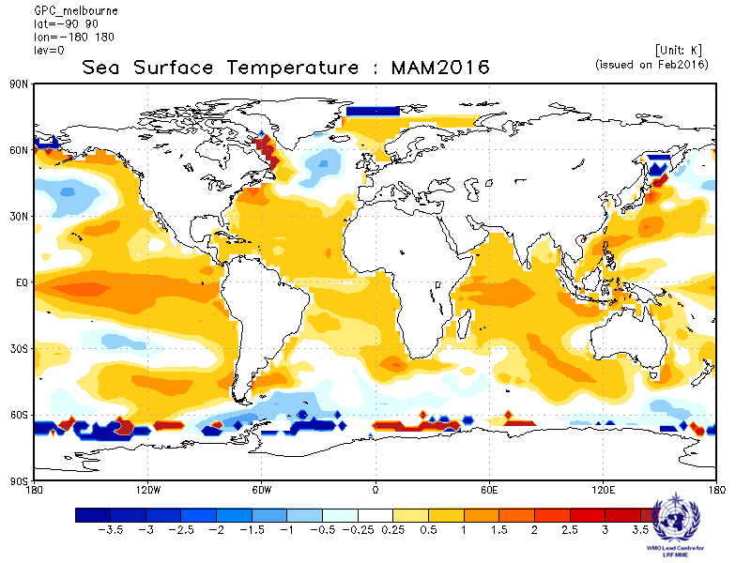 | Montreal  Baseline : 1983-2001  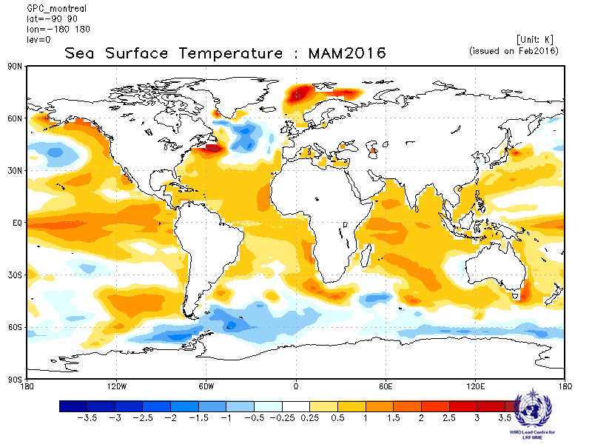
Washington
Baseline : 1983-2001
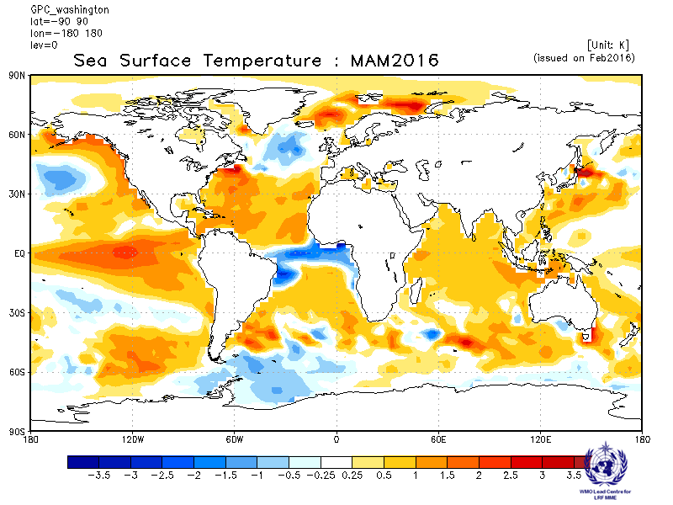

2.3.2 Individual GPC ensemble mean forecasts of SST anomalies from other GPCs for which forecast anomalies relative to 1983-2001 are not available.

ECMWF  Baseline: 1981-2010  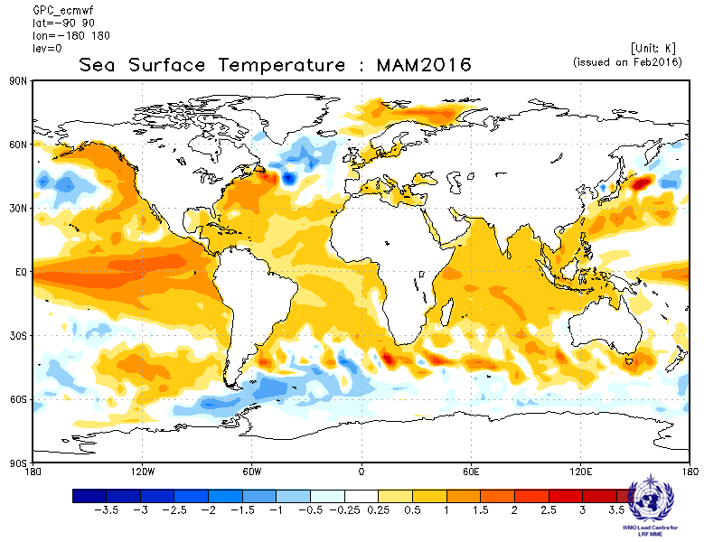 | Exeter  Baseline: 1996-2009  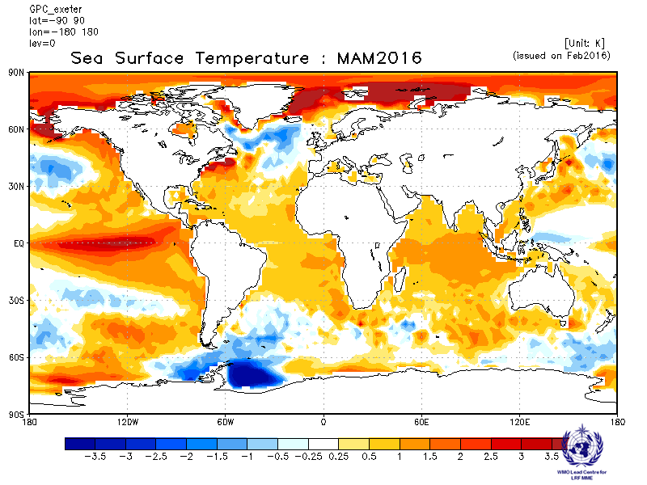
Seoul  Baseline: 1996-2009  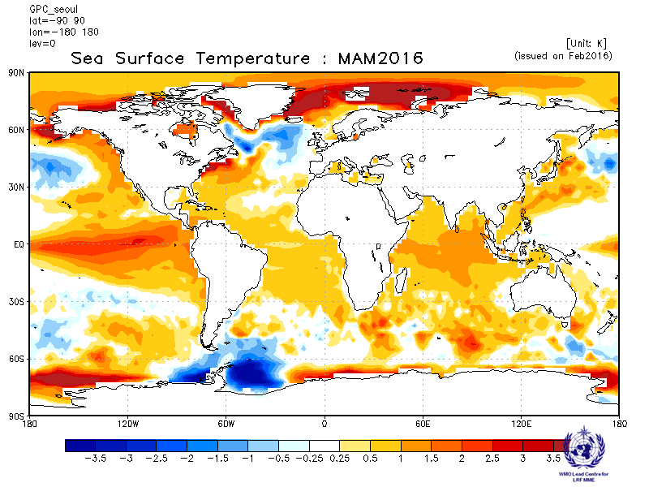 | Toulouse  Baseline: 1979-2007  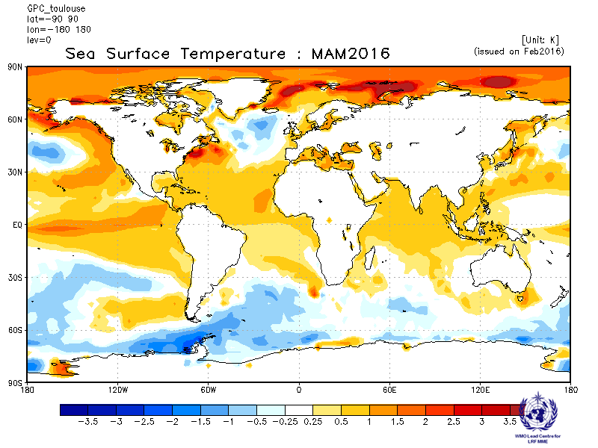

2.3.3 Forecast consistency map (7 GPCs): SST
(number of GPCs with positive/negative ensemble mean anomalies – relative to own baseline)
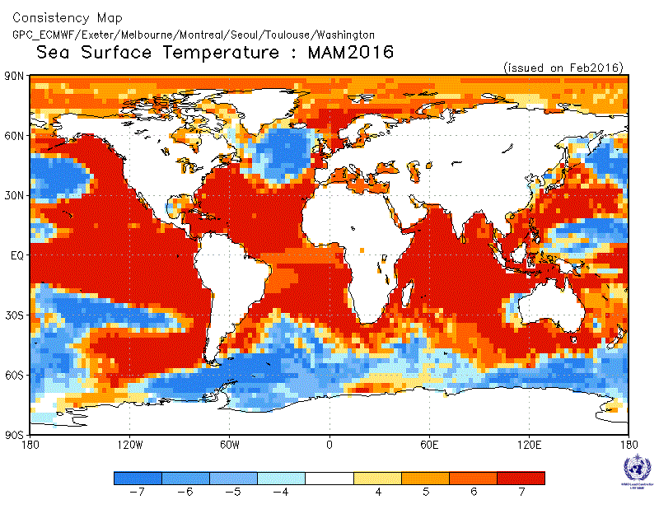
2.3.4 DMME (3 GPCs), using the same baseline for all models (1983-2001): SST

Ensemble mean anomaly
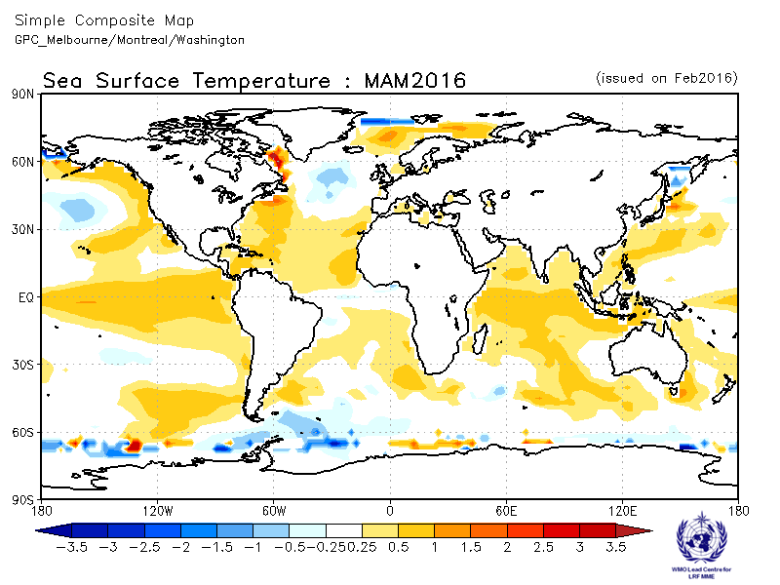

2.3.5 DMME (7 GPCs), for each model using its own baseline: SST

Ensemble mean anomaly
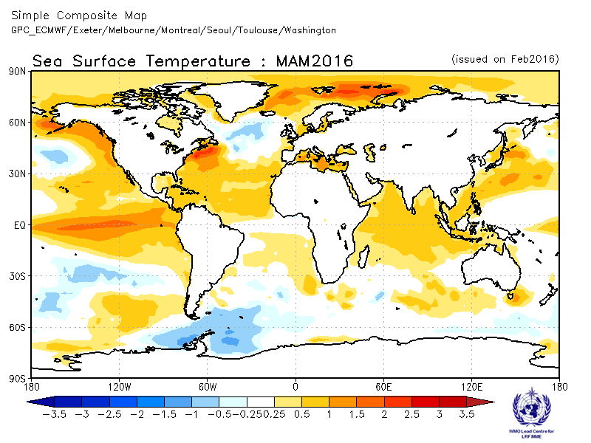
2.3.6 Verification of GPC ensemble mean SST anomaly forecasts, 1983-2001
Verification measure: Anomaly Correlation Coefficient (ACC)
Verification dataset: Reynolds SST

DMME  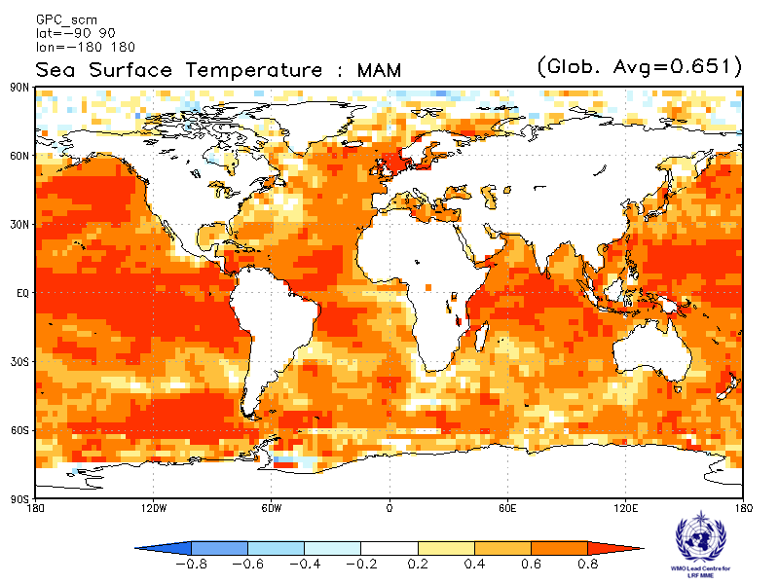 | Melbourne  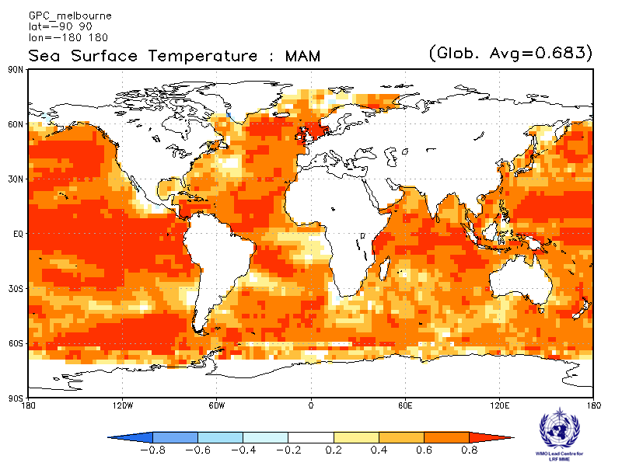
Montreal  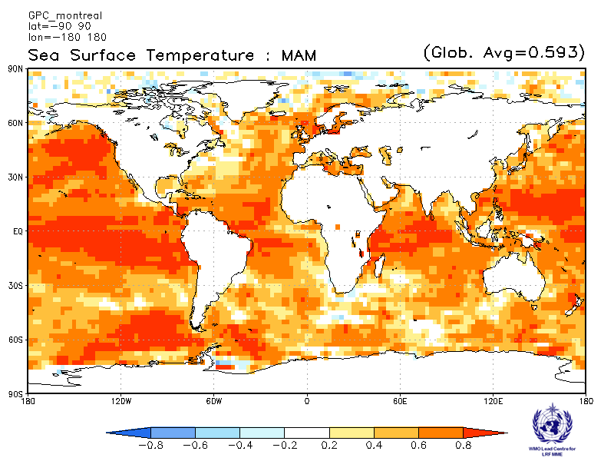 | Washington  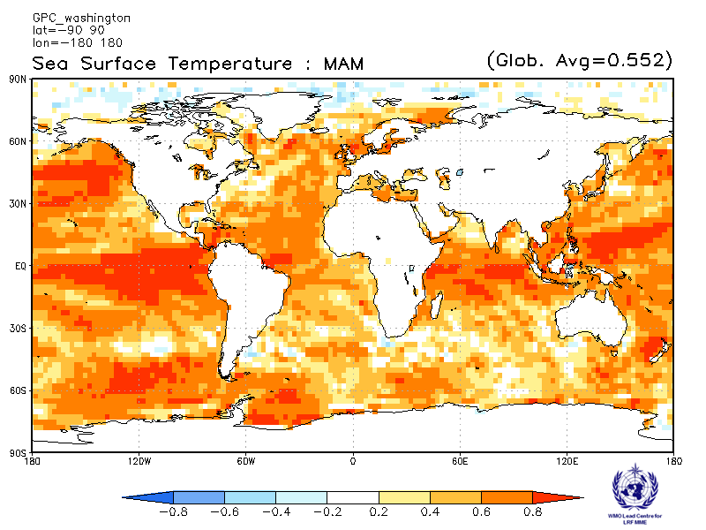

ACC verification of SST anomaly forecasts from other GPCs

Exeter  Baseline: 1996-2009  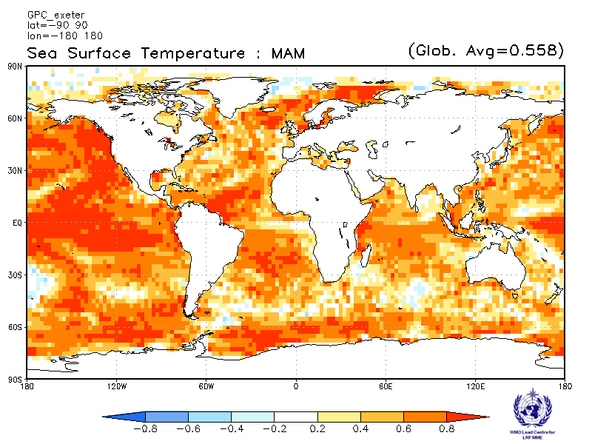 | Seoul  Verification period: 1996-2009  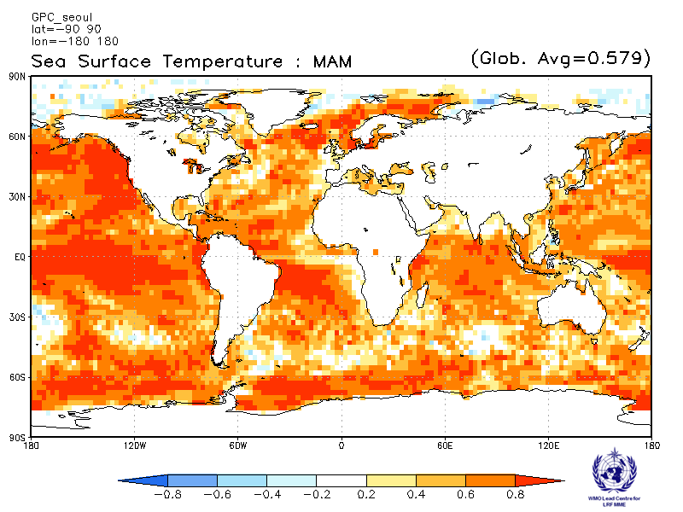

2.4 500 hPa Geopotential Height

2.4.1 Individual GPC ensemble mean forecasts of 500hPa height anomalies relative to 1983-2001
CPTEC  Baseline : 1983-2001  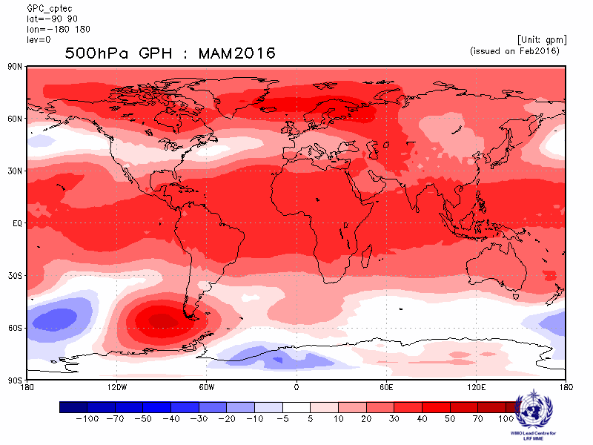 | Melbourne  Baseline : 1983-2001  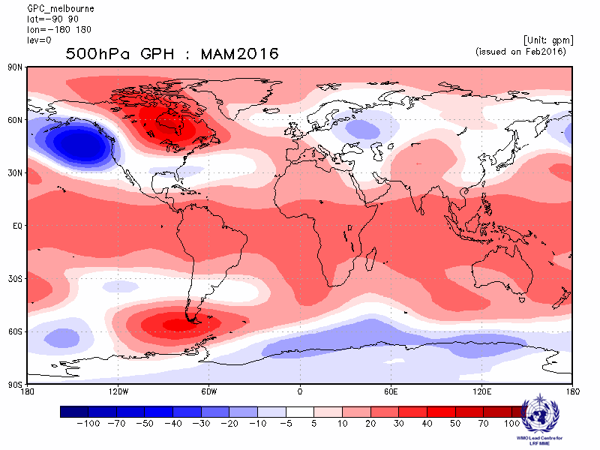
Montreal  Baseline : 1983-2001  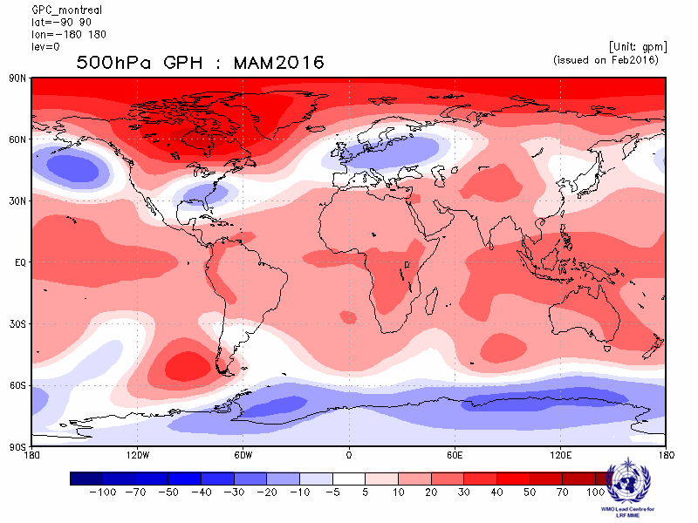 | Moscow  Baseline : 1983-2001  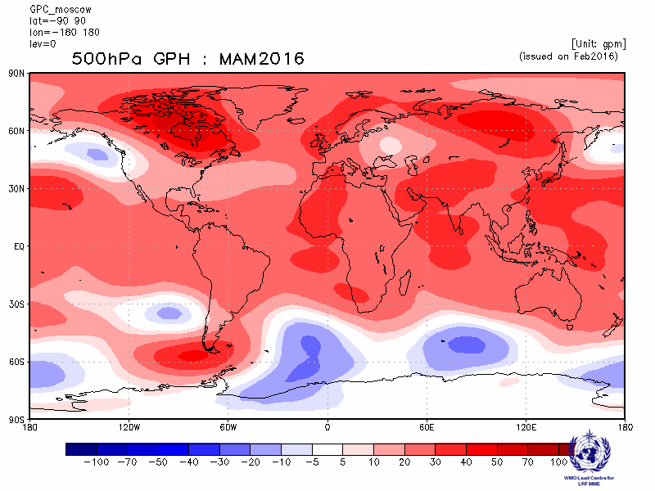
Washington
Baseline : 1983-2001
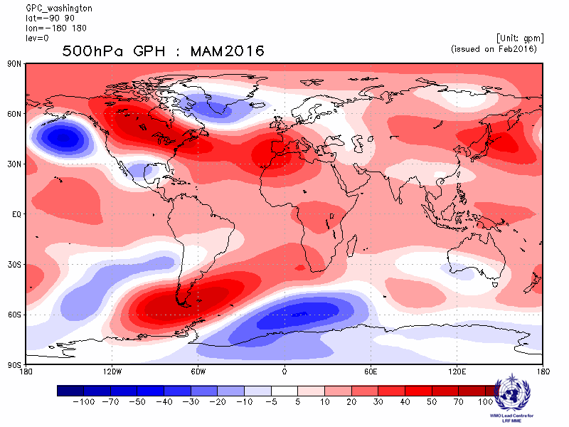

2.4.2 Individual GPC ensemble mean forecasts of 500hPa height anomalies from other GPCs for which forecast anomalies relative to 1983-2001 are not available.

ECMWF  Baseline: 1981-2010  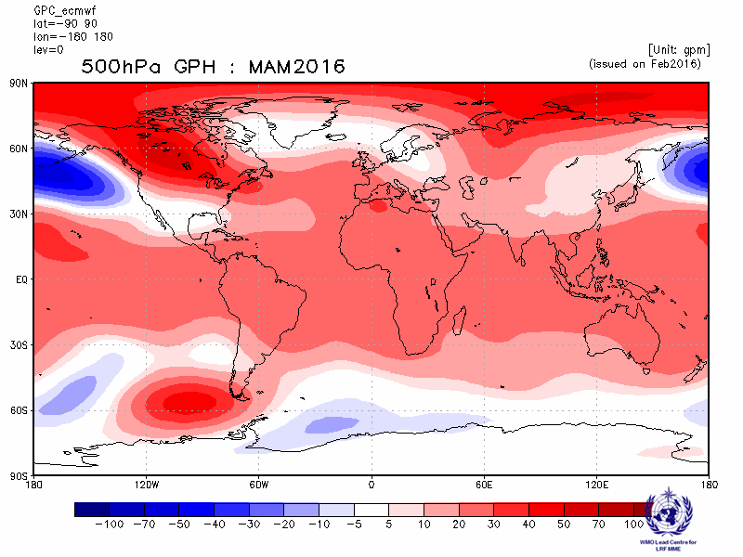 | Exeter  Baseline: 1996-2009  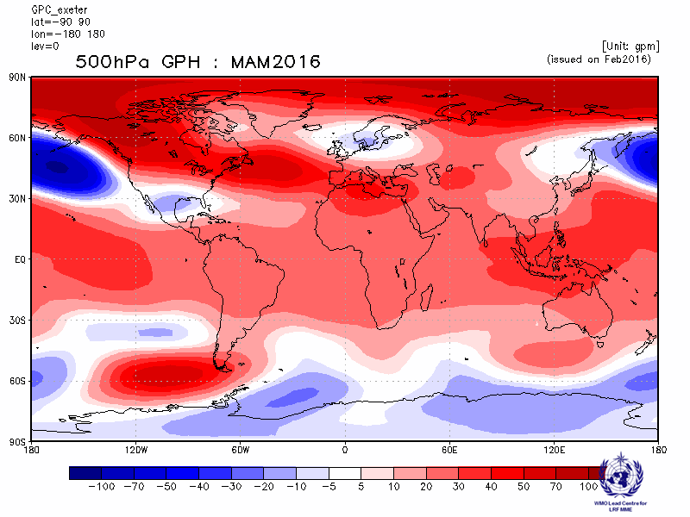
Seoul  Baseline: 1996-2009  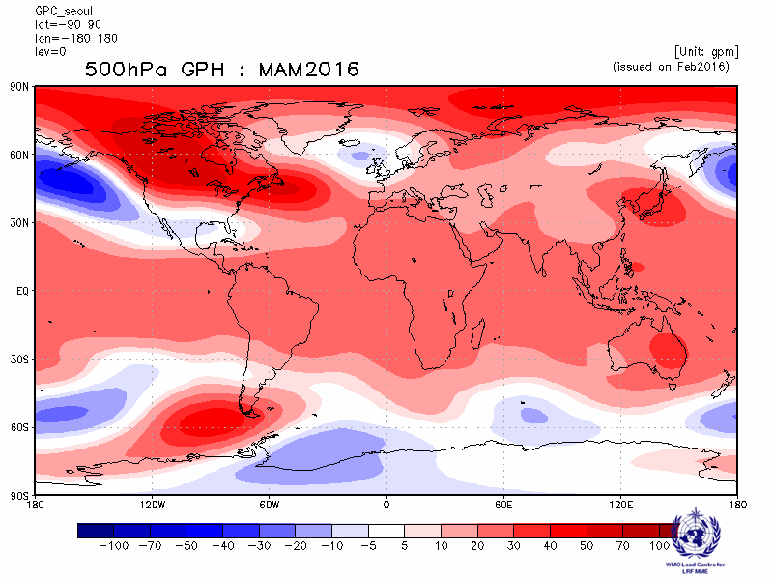 | Toulouse  Baseline: 1979-2007  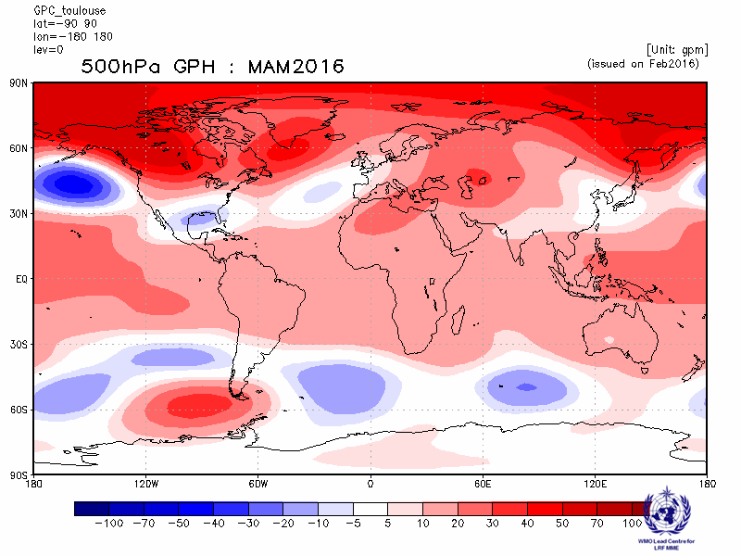

2.4.3 Forecast consistency map (9 GPCs): 500hPa height
(number of GPCs with positive/negative ensemble mean anomalies – relative to own baseline)

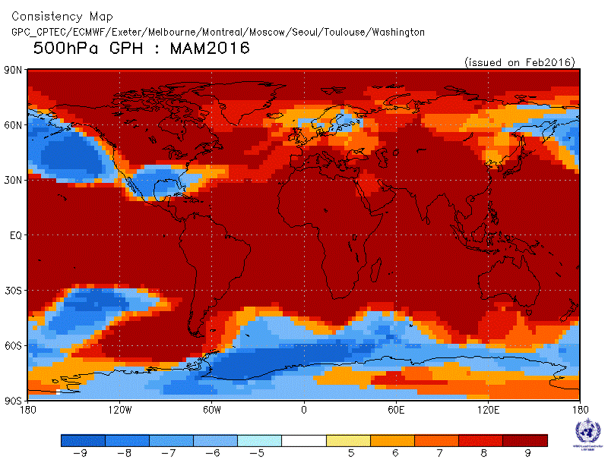

2.4.4 DMME (5 GPCs), using the same baseline for all models (1983-2001): 500hPa height

Ensemble mean anomaly
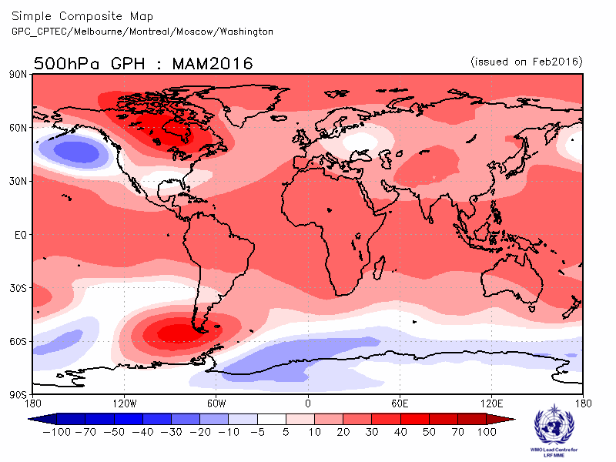

2.4.5 DMME (9 GPCs), for each model using its own baseline: 500hPa height

Ensemble mean anomaly
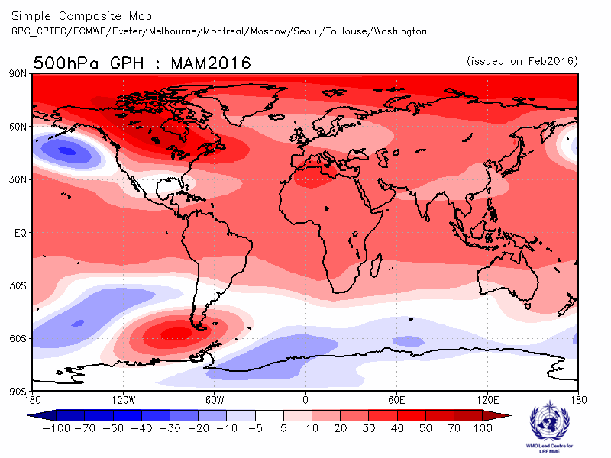

2.4.6 PMME (5 GPCs), using the same baseline for all models (1983-2001): 500hPa height

Probability of most likely tercile category
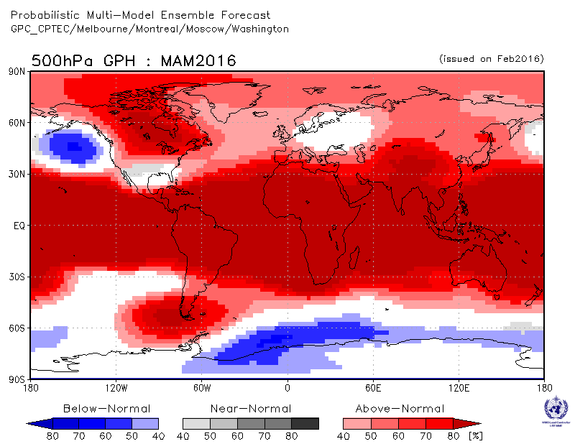

2.4.7 Verification of GPC ensemble mean 500hPa height anomaly forecasts, 1983-2001
Verification measure: Anomaly Correlation Coefficient (ACC)
Verification dataset: ERA-Interim
DMME  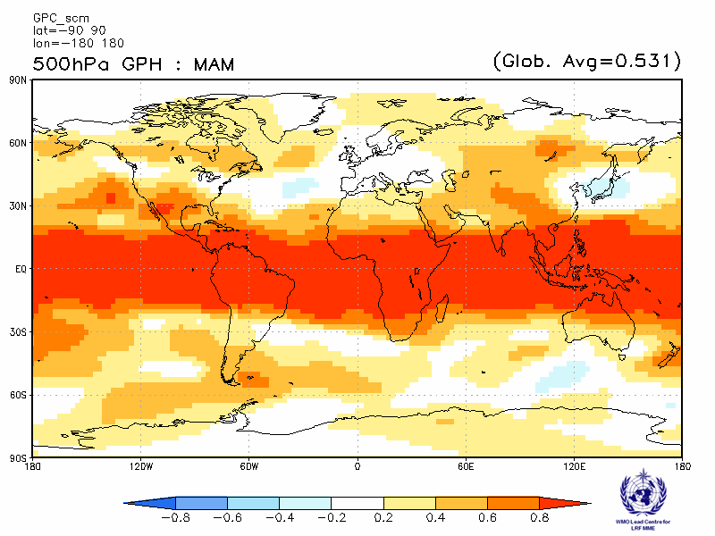 | CPTEC  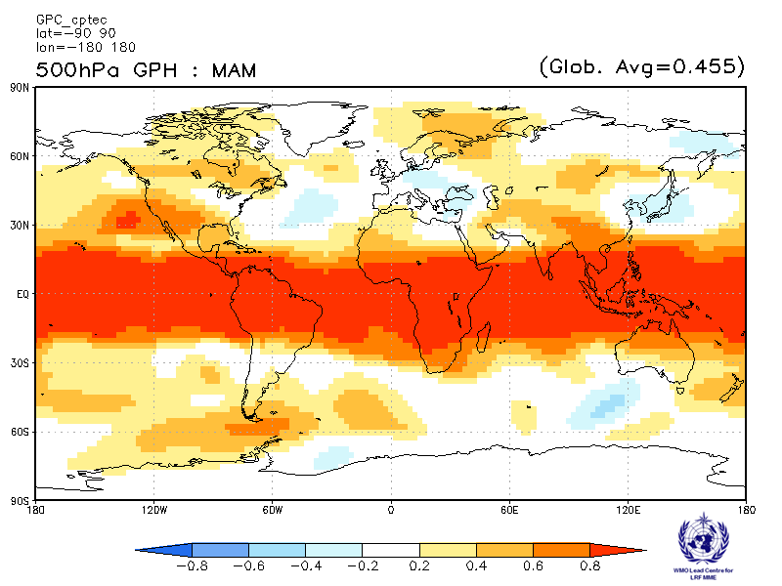
Melbourne  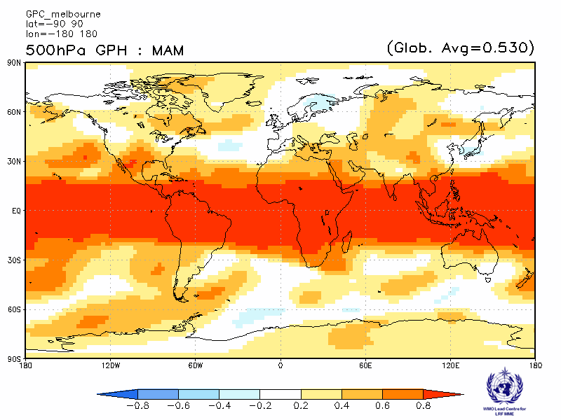 | Montreal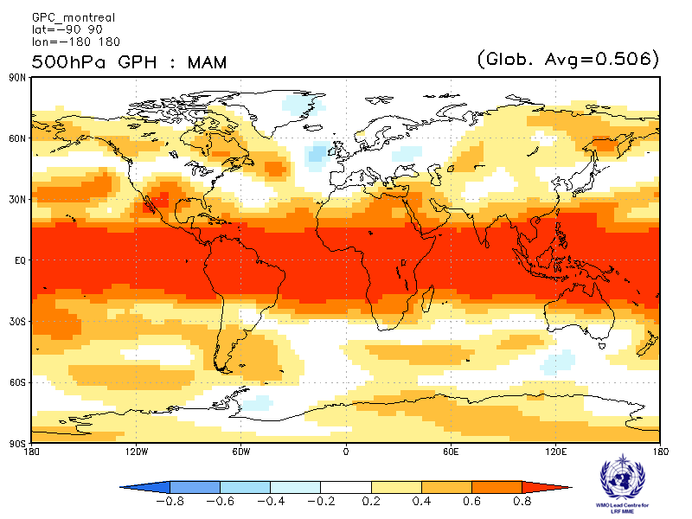
Moscow  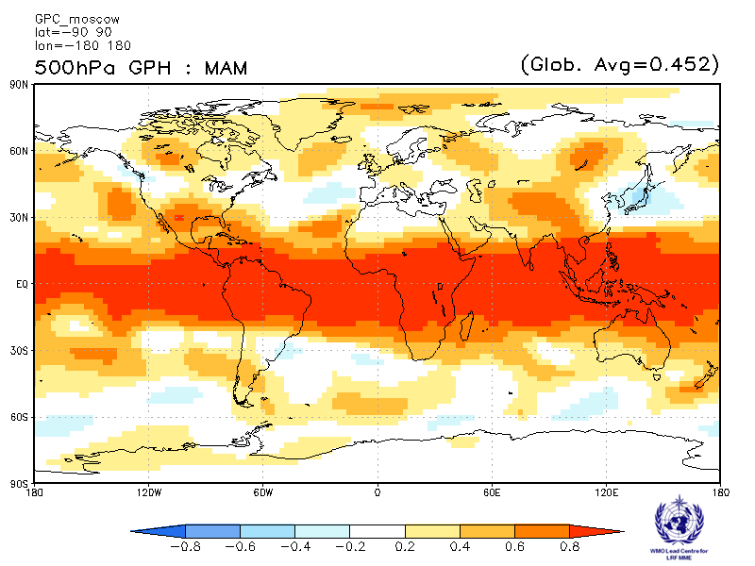 | Washington  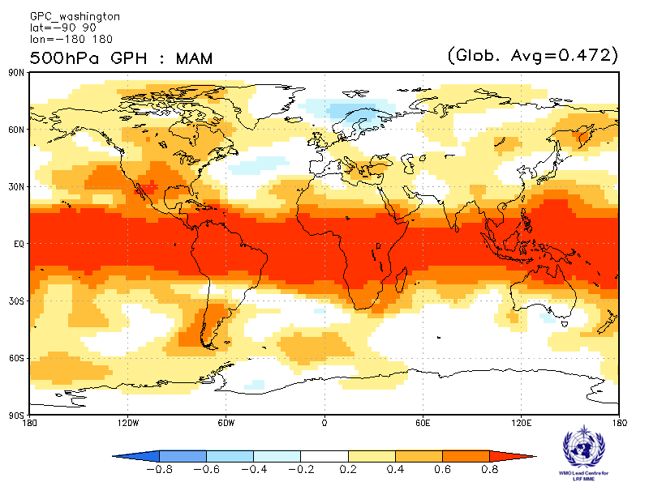

ACC verification of 500hPa height anomaly forecasts from other GPCs

Exeter  Verification period: 1996-2009  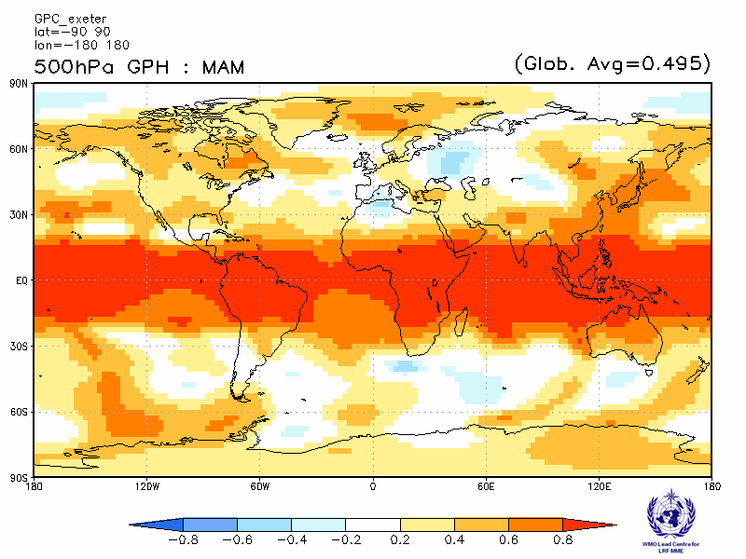 | Seoul  Verification period: 1996-2009  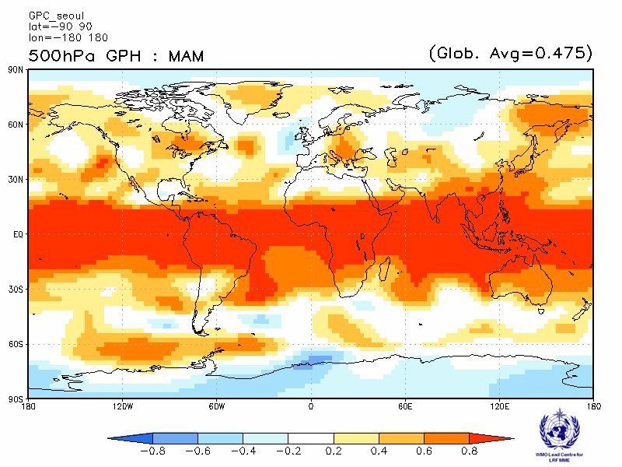
2.4.8 Verification of GPC 500hPa height probabilistic forecasts, 1983-2001
Verification measure: Relative Operating Characteristics (ROC) score for tercile forecast
Verification dataset: ERA-Interim

PMME  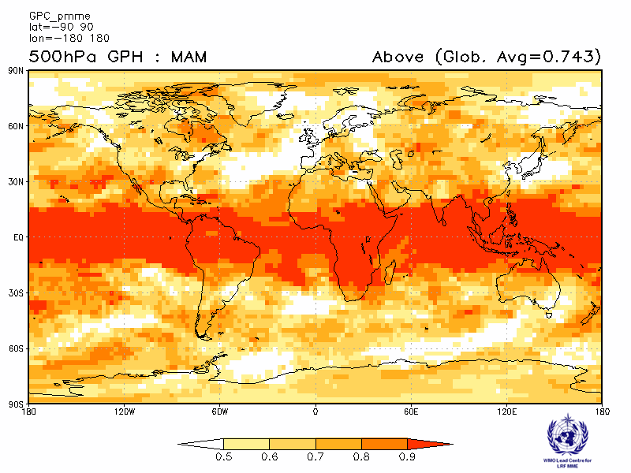 | CPTEC  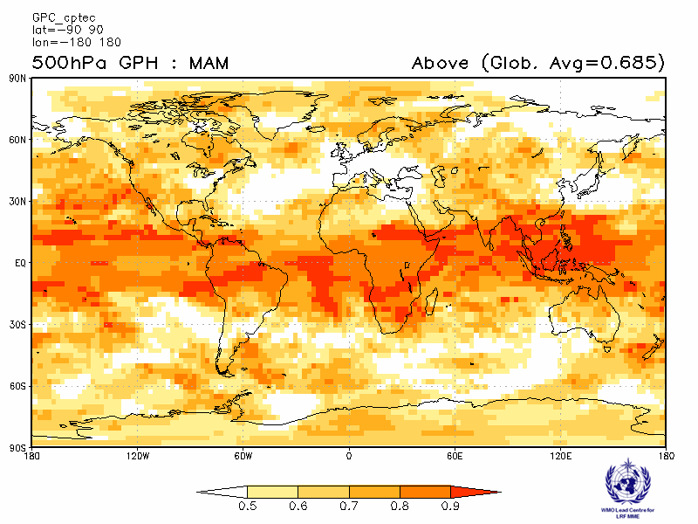
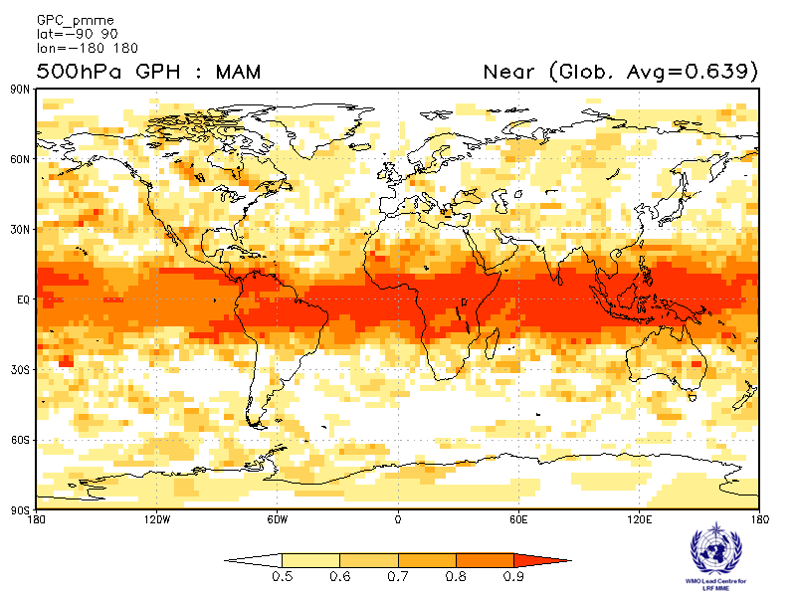 | 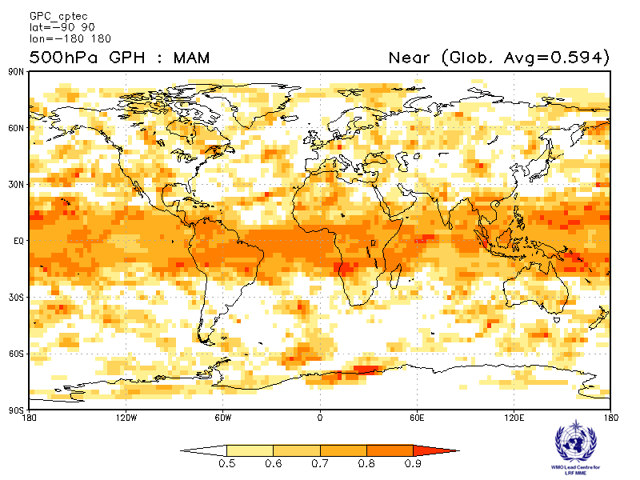
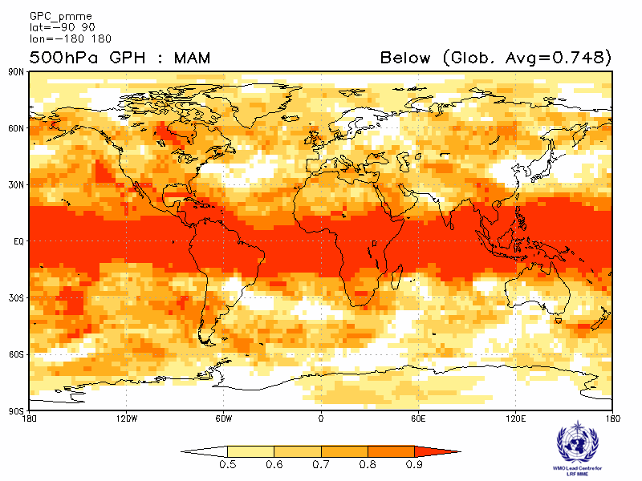 | 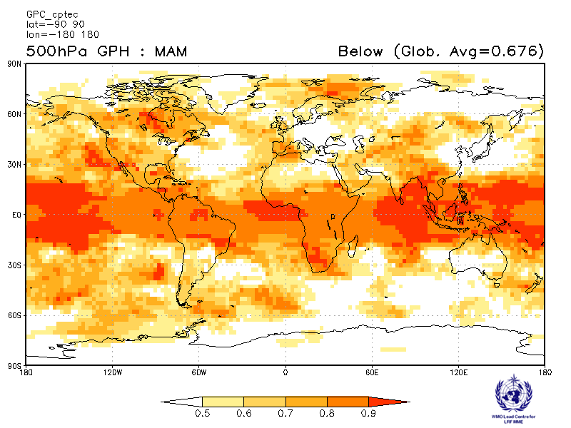

Melbourne  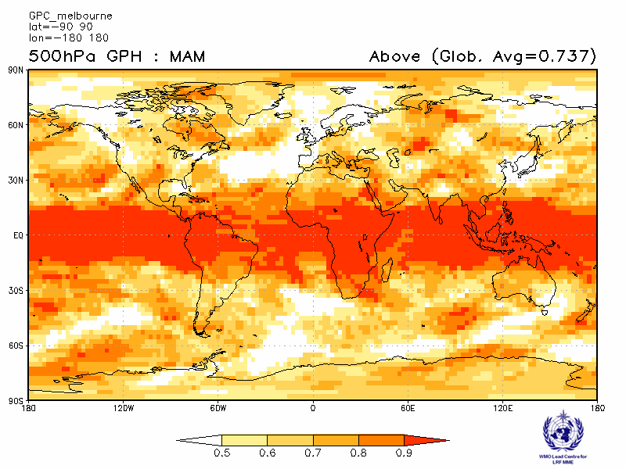 | Montreal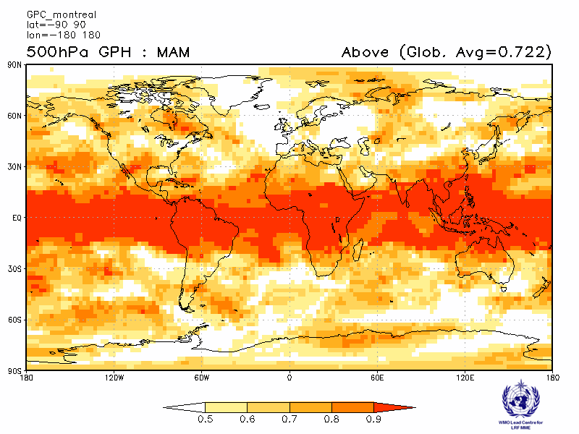
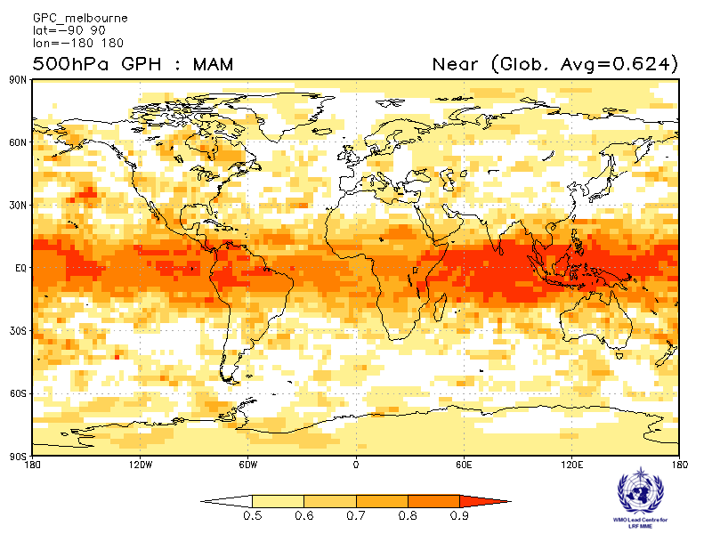 | 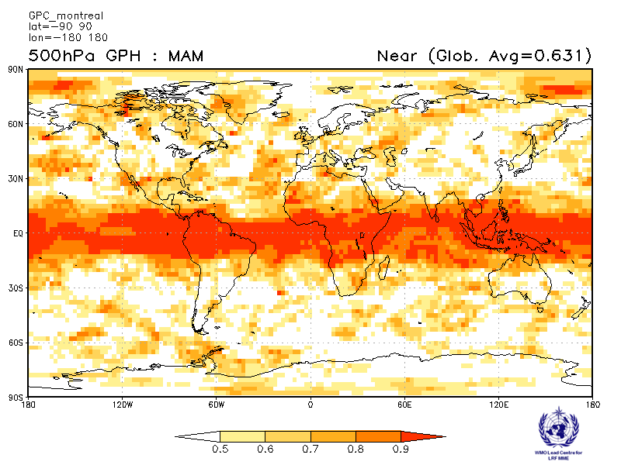
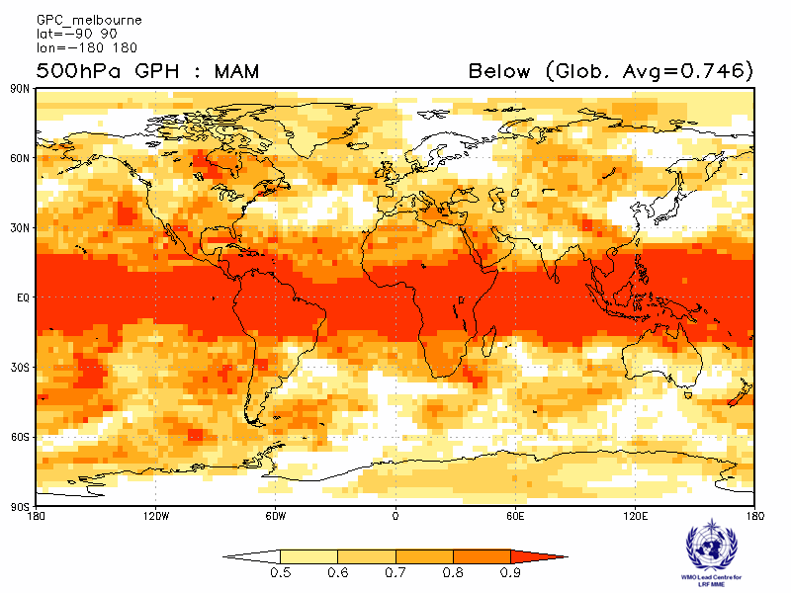 | 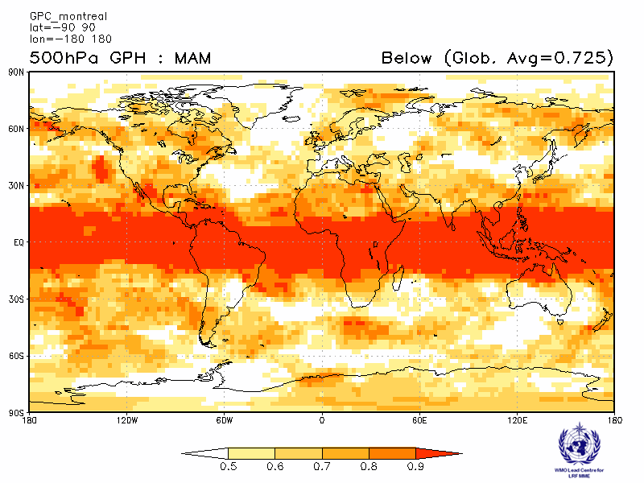

Moscow  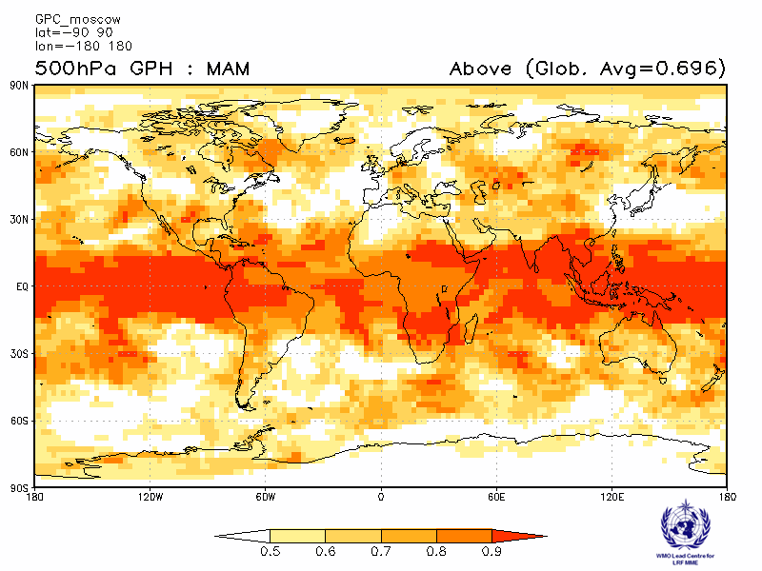 | Washington  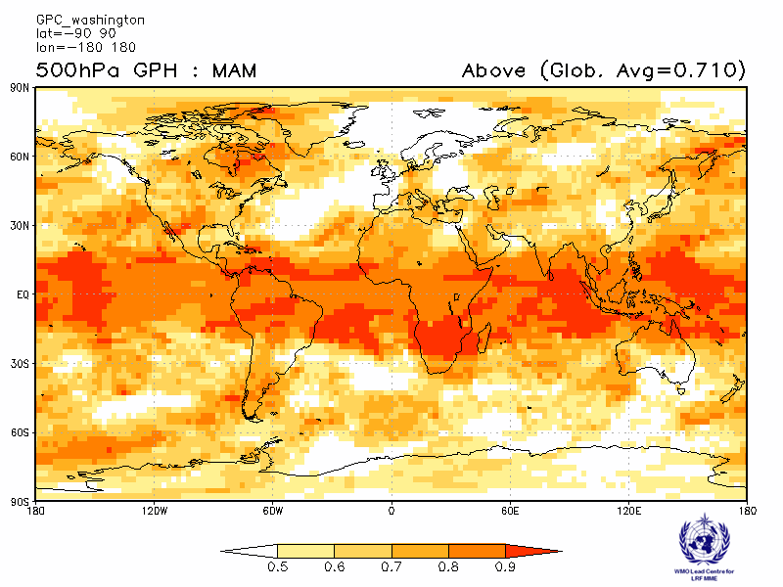
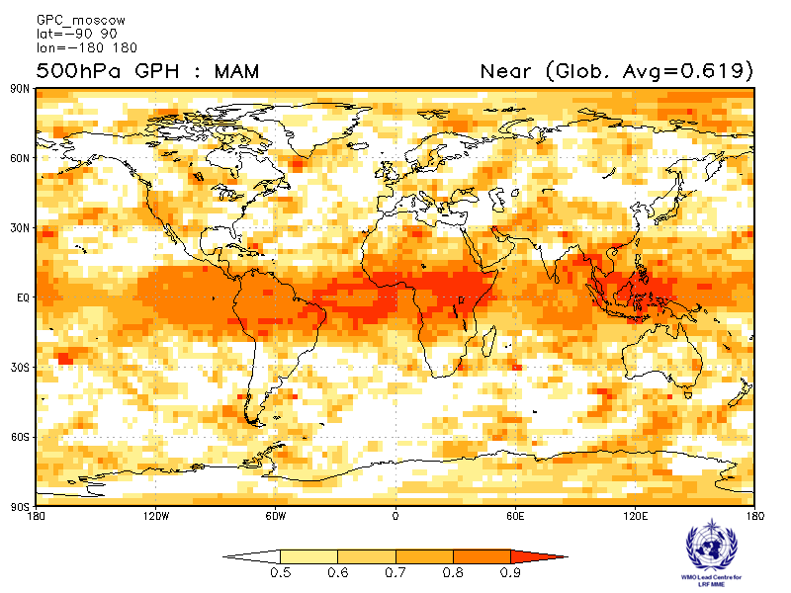 | 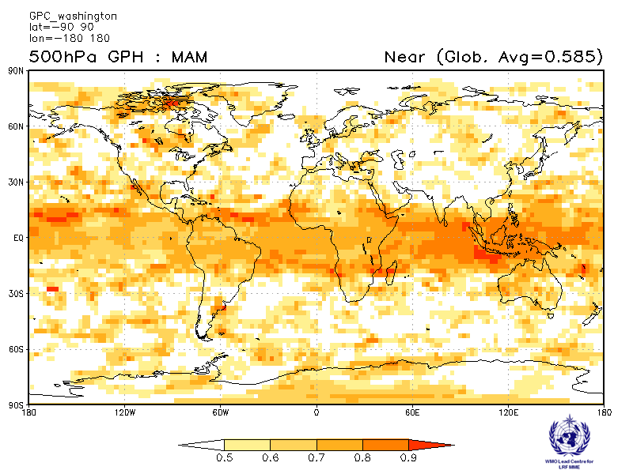
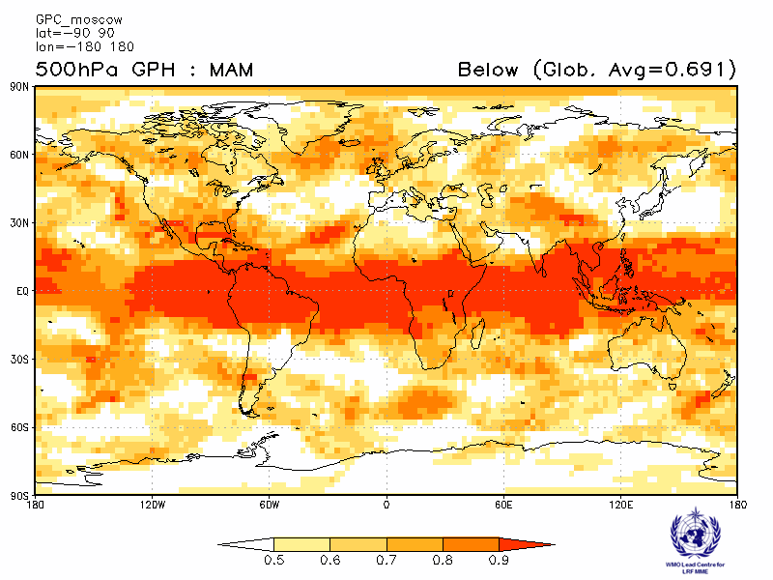 | 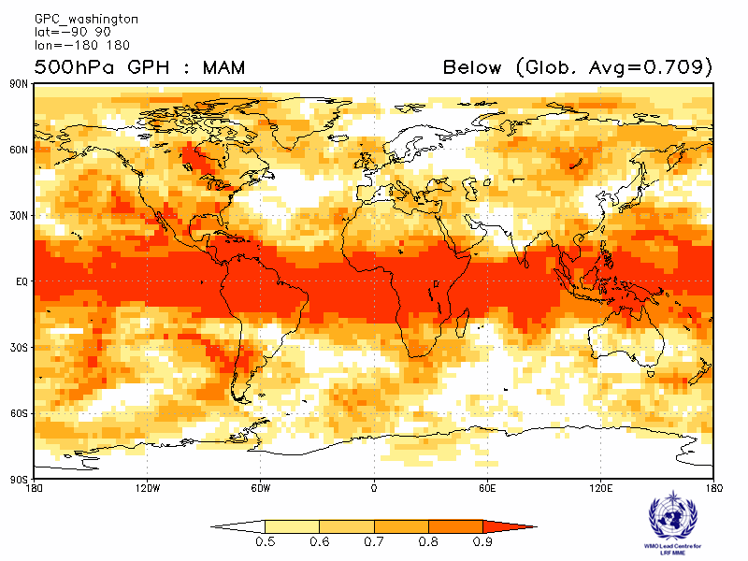

ROC score verification of 500hPa height probabilistic forecasts from other GPCs

Exeter  Verification period : 1996-2009  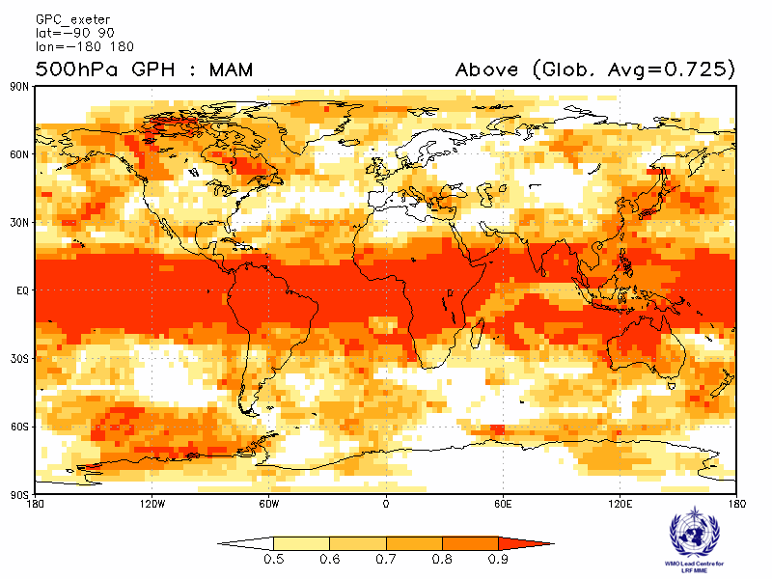 | Seoul  Verification period : 1996-2009  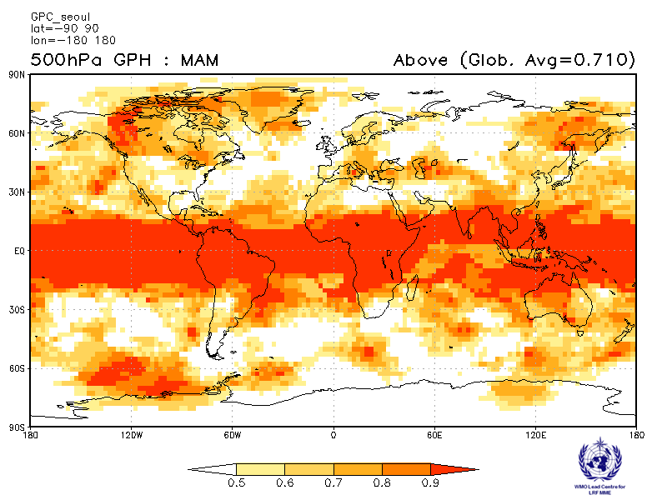
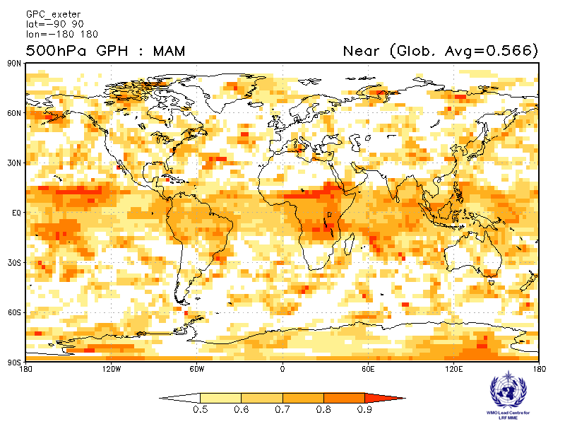 | 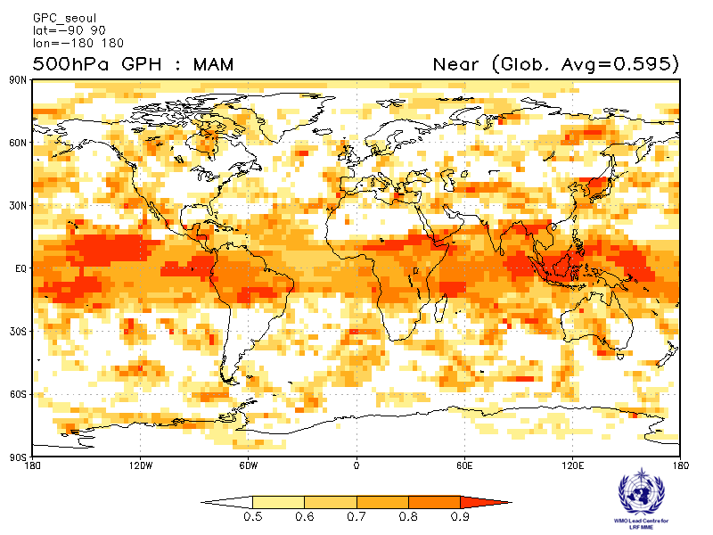
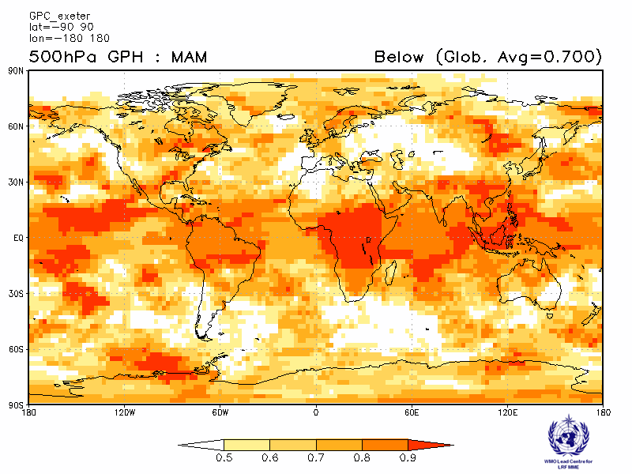 | 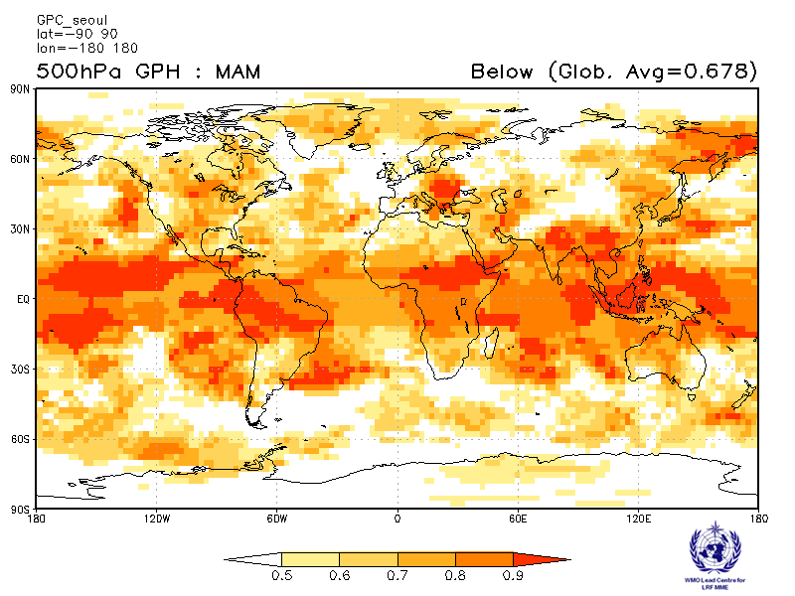

2.4.9 Verification of GPC 500hPa height probabilistic forecasts, 1983-2001
Verification measure: Relative Operating Characteristics Curve (ROC) and Score over globe
Verification dataset: ERA-interim

PMME  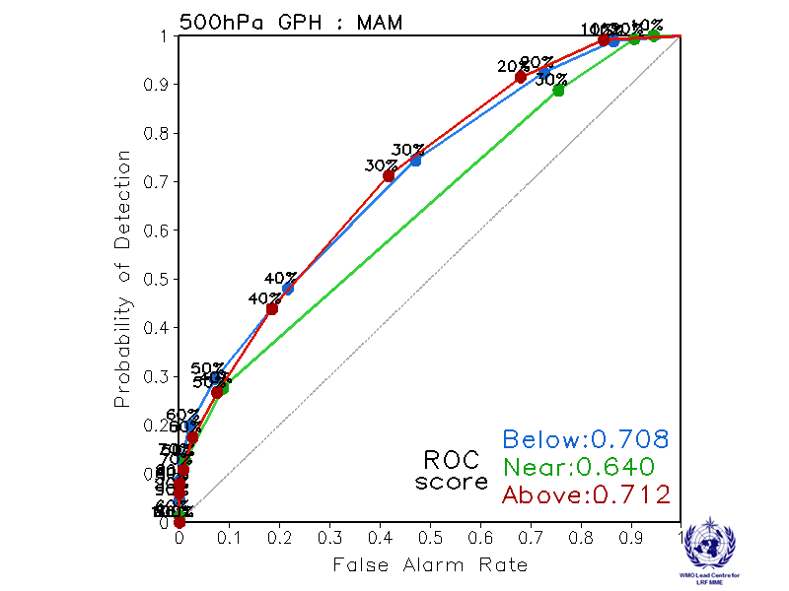 | CPTEC  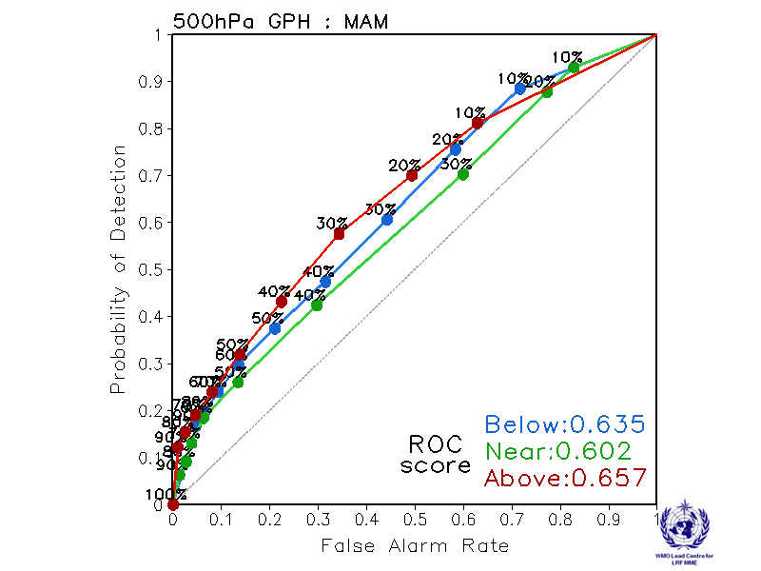
Melbourne  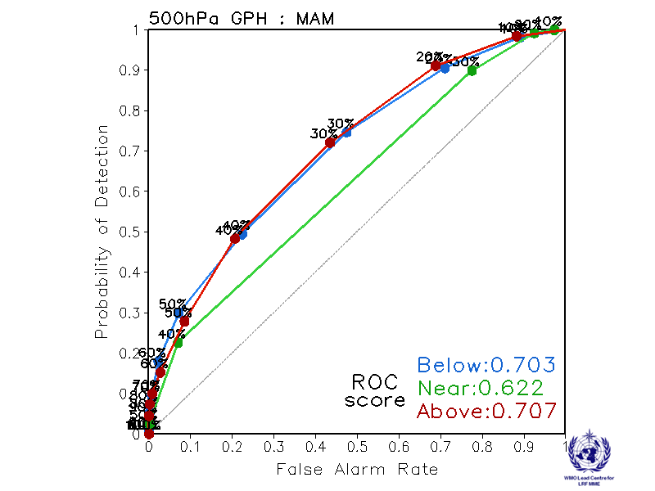 | Montreal  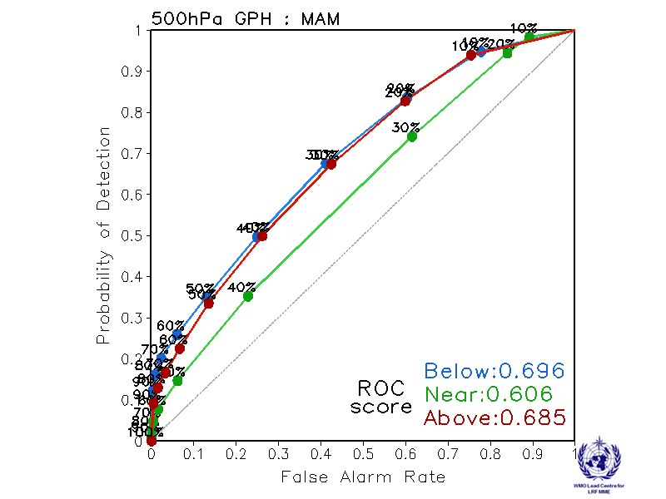
Moscow  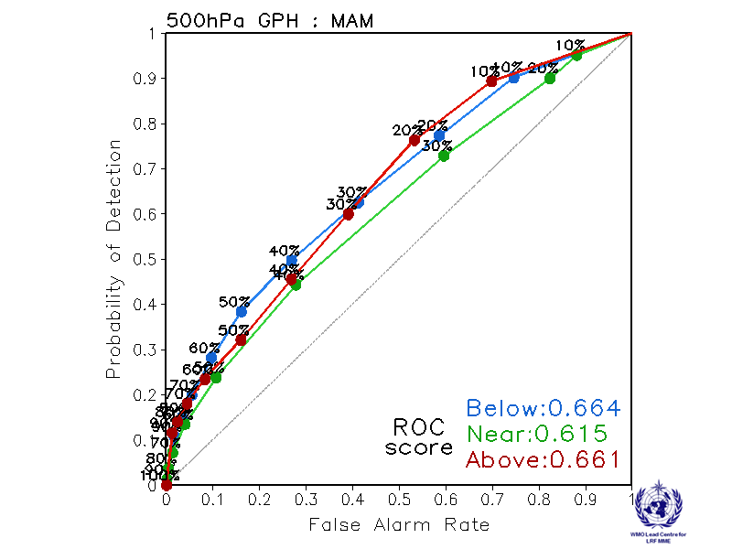 | Washington  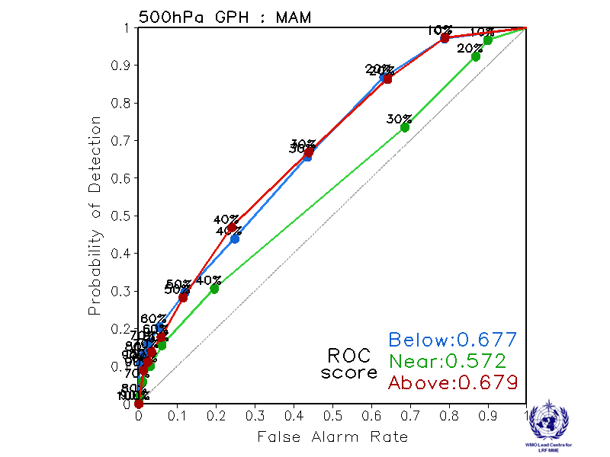

ROC curve and Score verification of 500hPa height probabilistic forecasts from other GPCs

Exeter  Verification period: 1996-2009  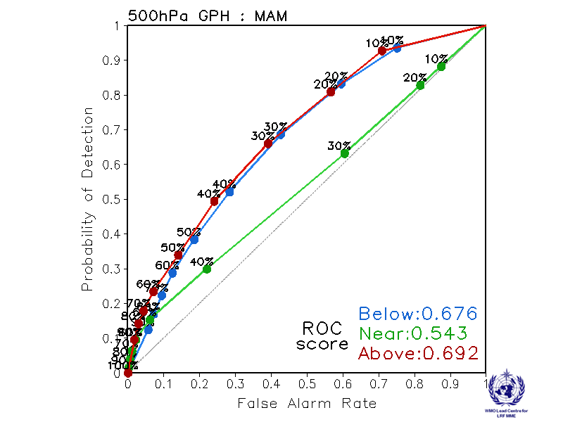 | Seoul  Verification period: 1996-2009  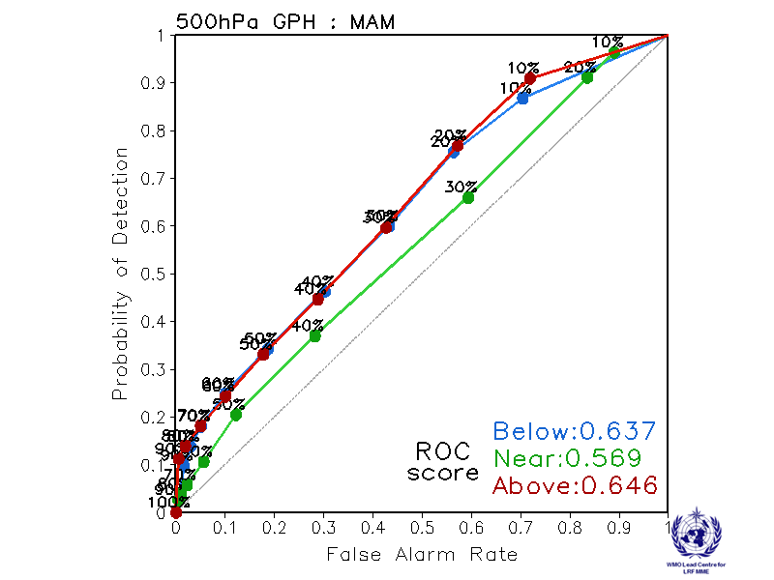

2.4.10 Verification of GPC 500hPa height probabilistic forecasts, 1983-2001
Verification measure: Reliability Diagram over globe
Verification dataset: ERA-interim

PMME  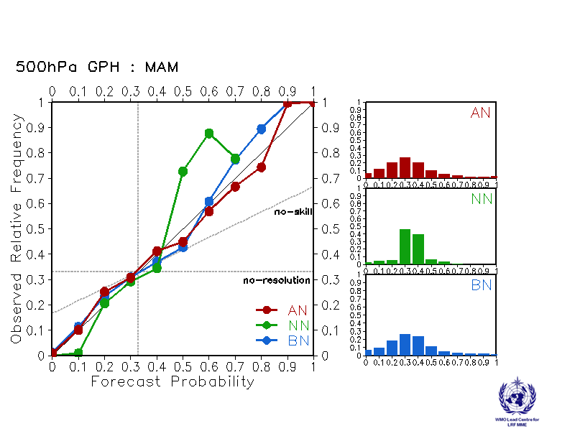 | CPTEC  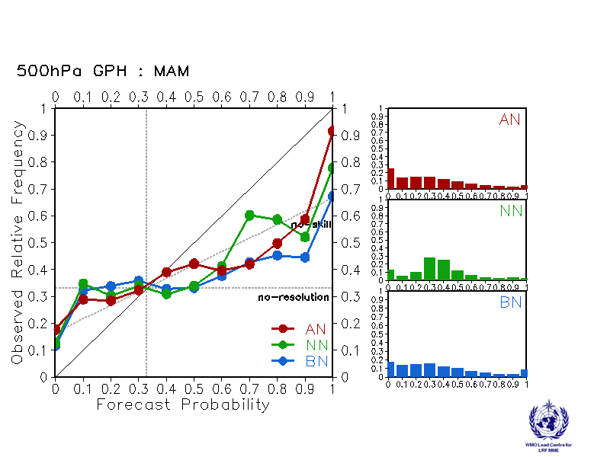
Melbourne  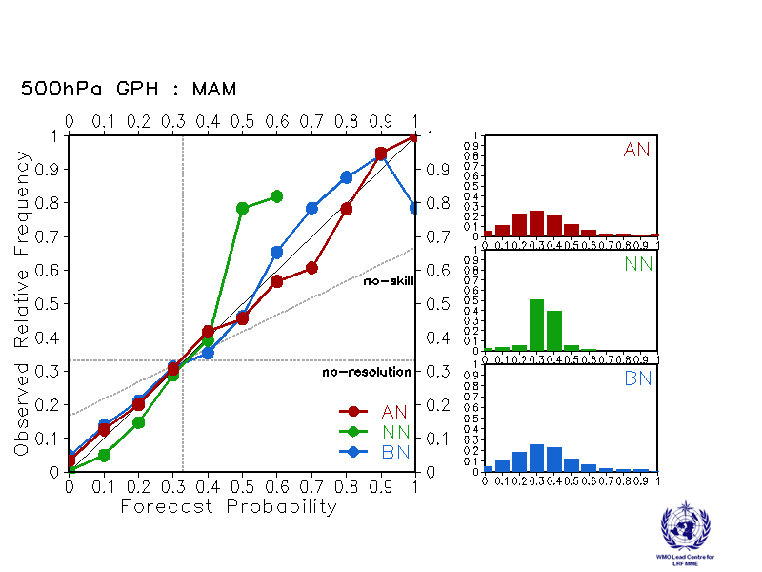 | Montreal  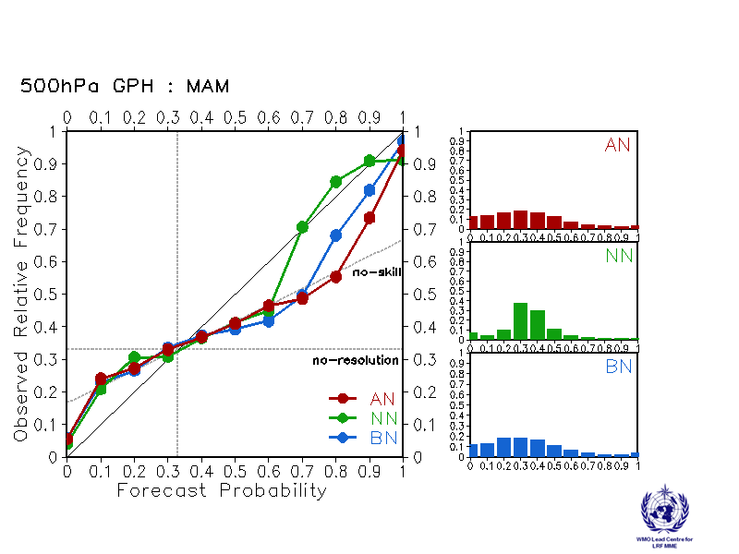
Moscow  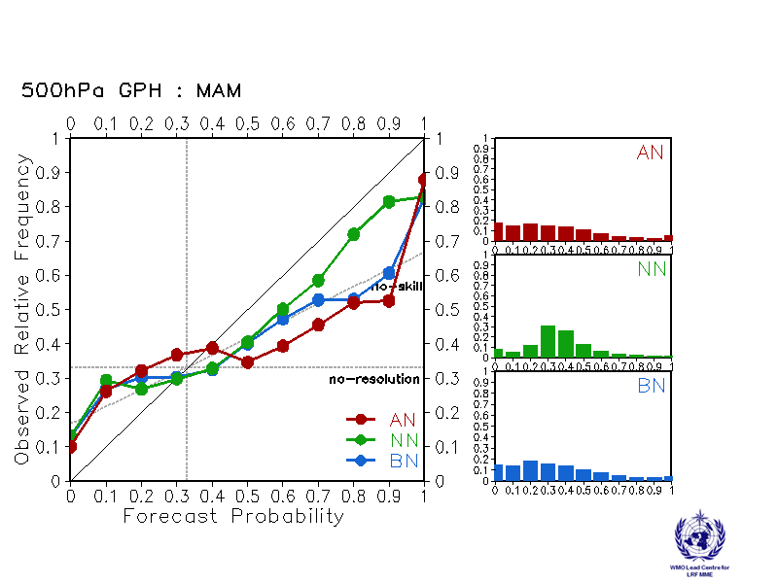 | Washington  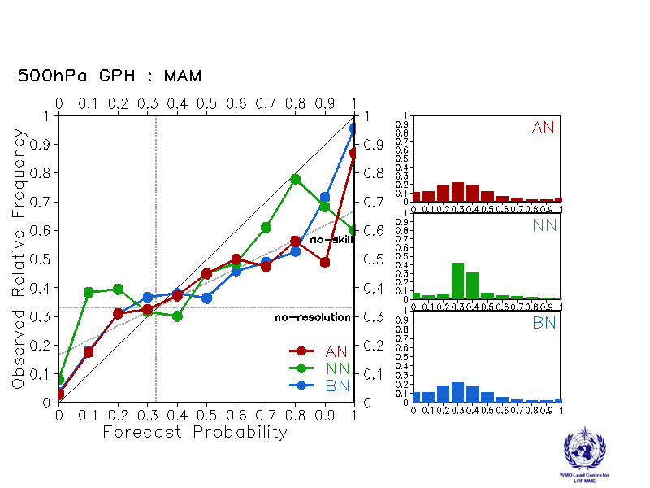

Reliability Diagram verification of 500hPa height probabilistic forecasts from other GPCs

Exeter  Verification period: 1996-2009  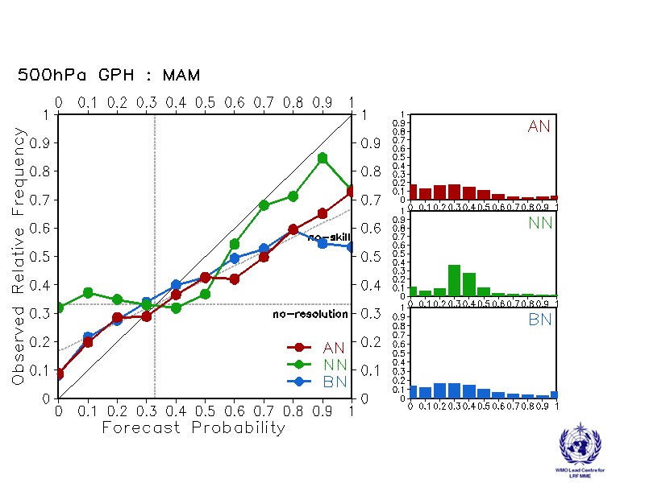 | Seoul  Verification period: 1996-2009  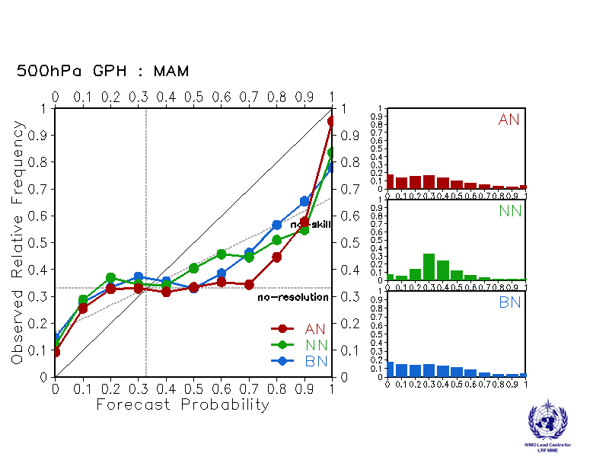

2.5 Mean Sea Level Pressure

2.5.1 Individual GPC ensemble mean forecasts of MSLP anomalies relative to 1983-2001

CPTEC  Baseline : 1983-2001  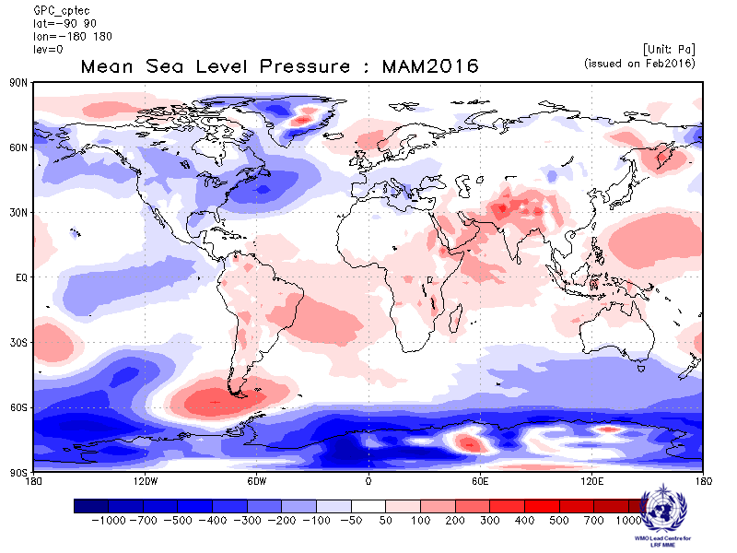 | Melbourne  Baseline : 1983-2001  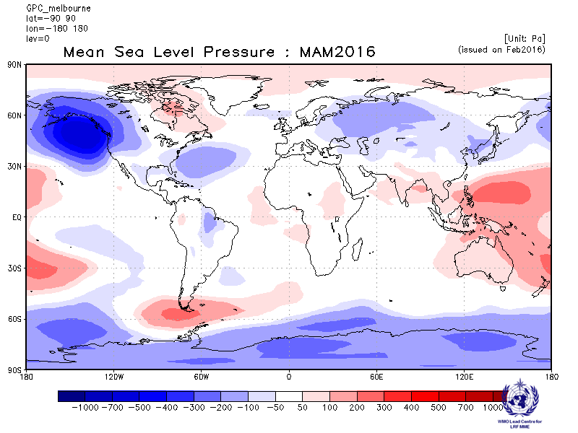
Montreal  Baseline : 1983-2001  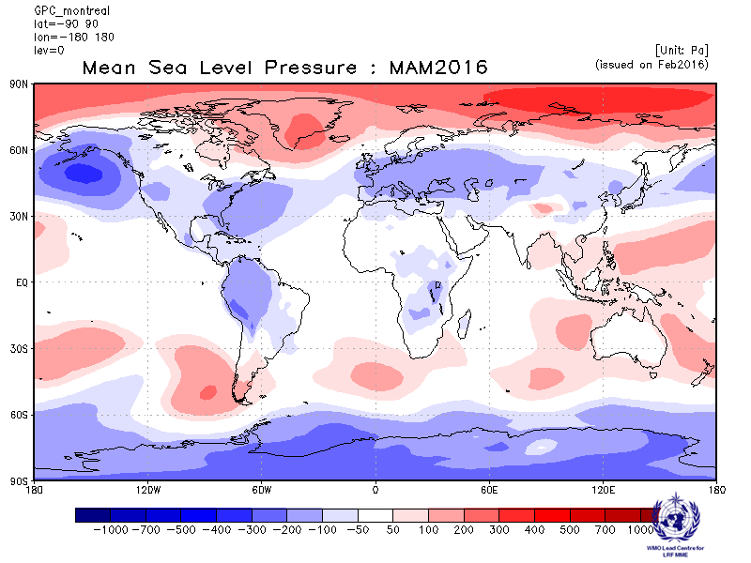 | Moscow  Baseline : 1983-2001  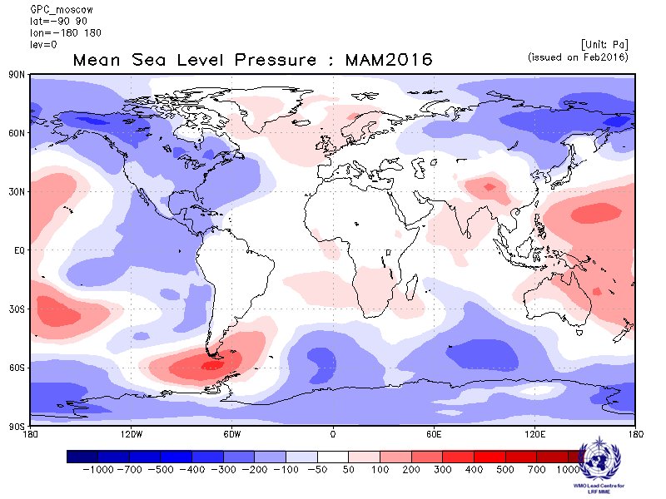
Washington
Baseline : 1983-2001
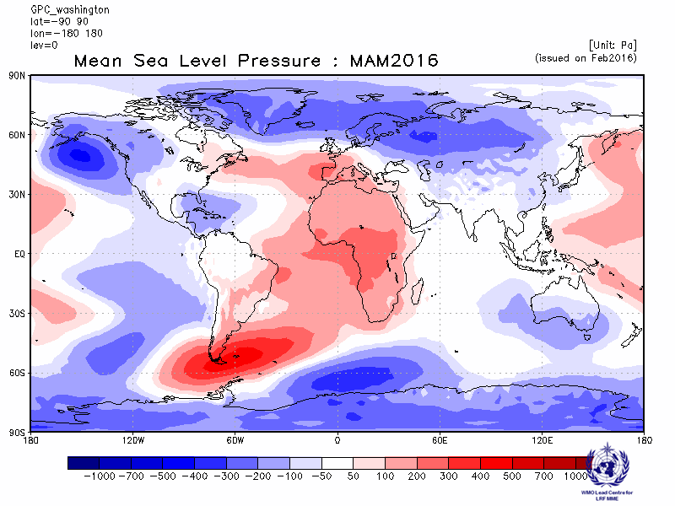

2.5.2 Individual GPC ensemble mean forecasts of MSLP anomalies from other GPCs for which forecast anomalies relative to 1983-2001 are not available.

ECMWF  Baseline: 1981-2010  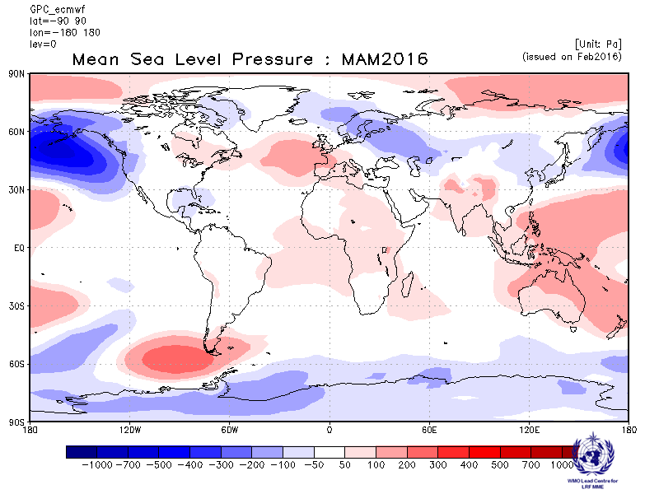 | Exeter  Baseline: 1996-2009  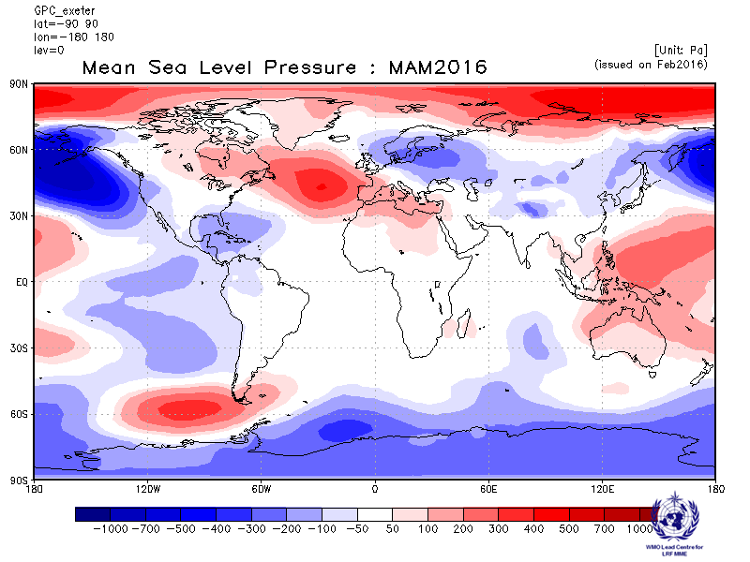
Seoul  Baseline: 1996-2009  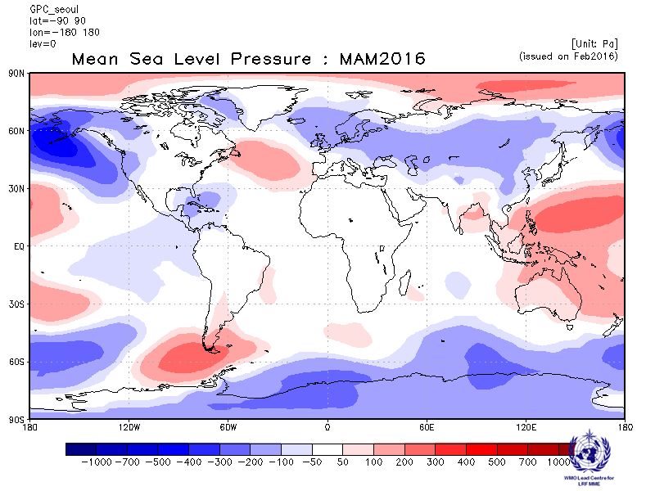 | Toulouse  Baseline: 1979-2007  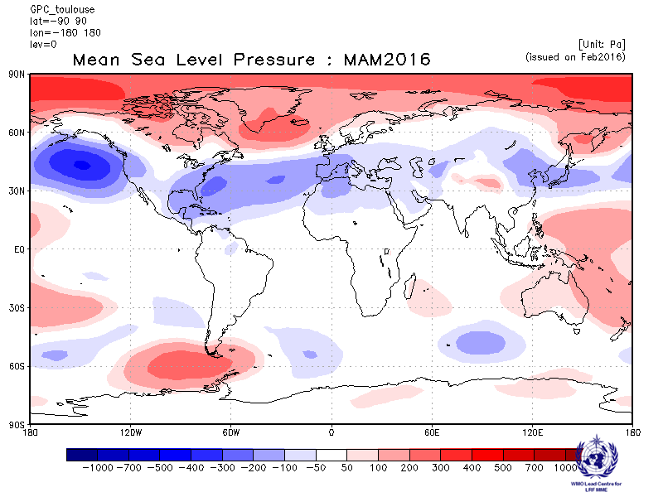

2.5.3 Forecast consistency map (9 GPCs): MSLP
(number of GPCs with positive/negative ensemble mean anomalies – relative to own baseline)

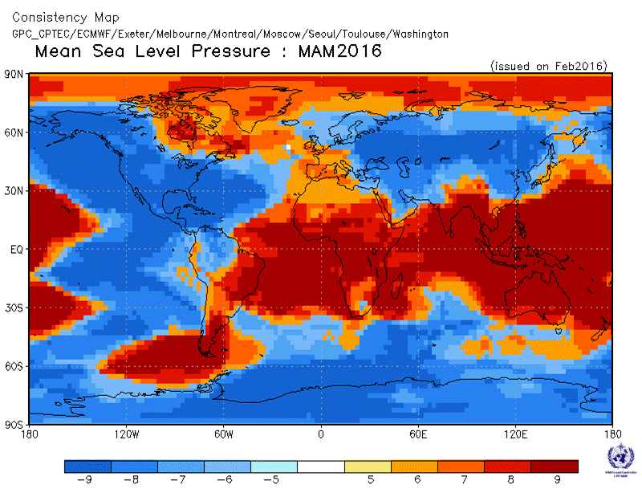
2.5.4 DMME (5 GPCs), using the same baseline for all models (1983-2001): MSLP

Ensemble mean anomaly
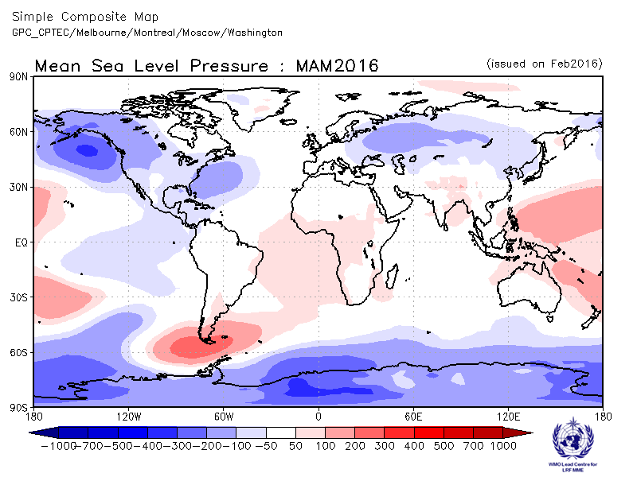

2.5.5 DMME (9 GPCs), for each model using its own baseline: MSLP

Ensemble mean anomaly
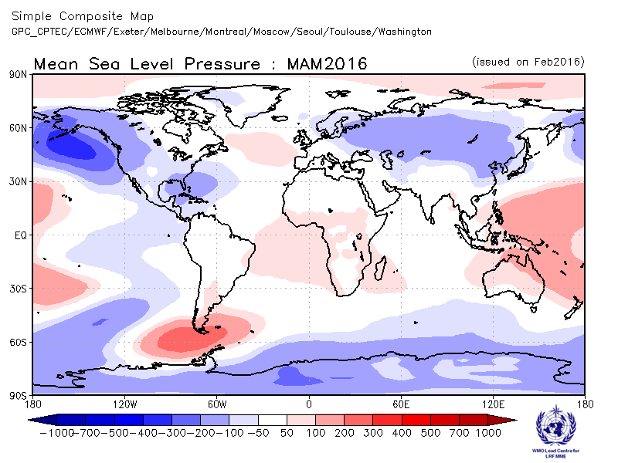

2.5.6 PMME (5 GPCs), using the same baseline for all models (1983-2001): MSLP

Probability of most likely tercile category
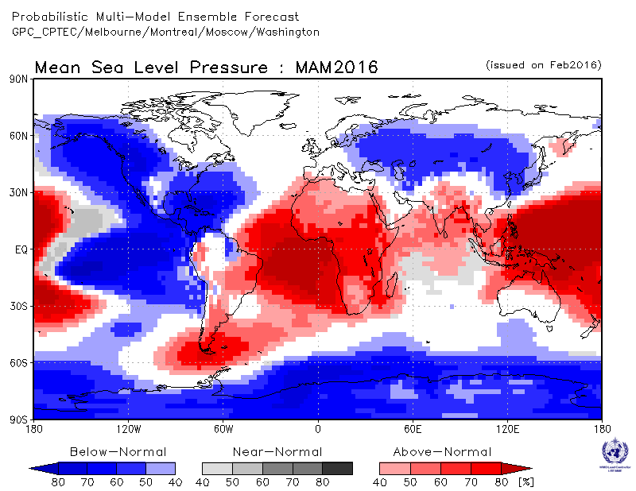
2.5.7 Verification of GPC ensemble mean MSLP anomaly forecasts, 1983-2001
Verification measure: Anomaly Correlation Coefficient (ACC)
Verification dataset: ERA-interim
DMME  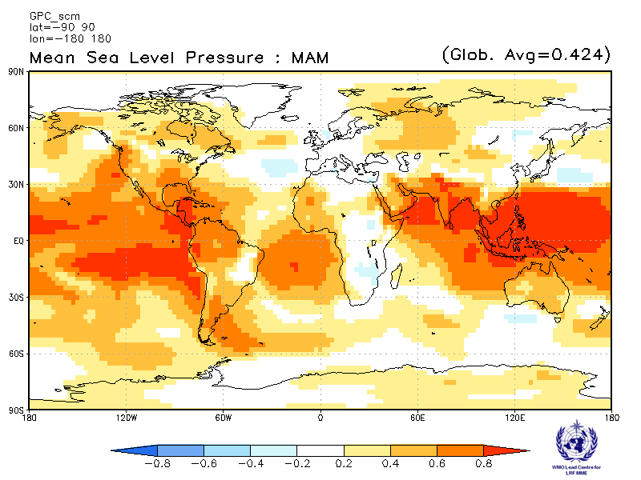 | CPTEC  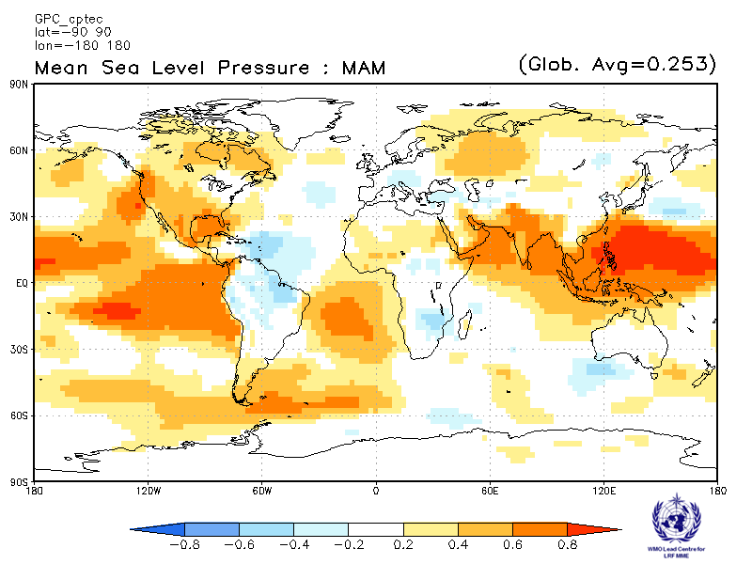
Melbourne  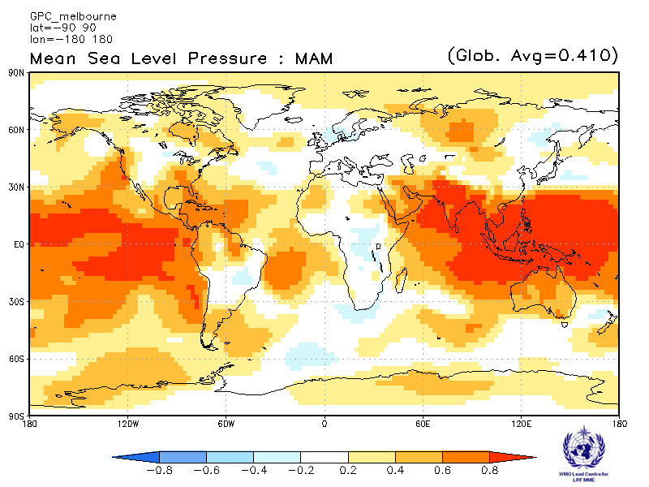 | Montreal  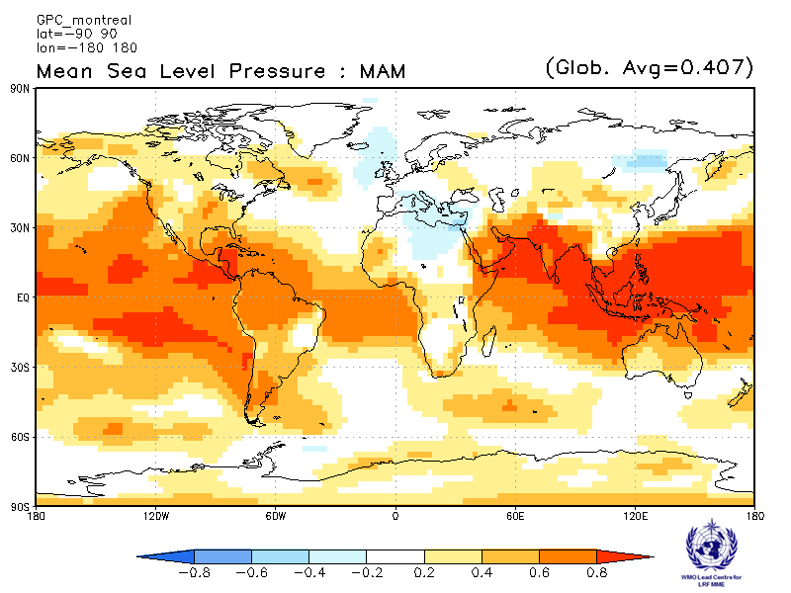
Moscow  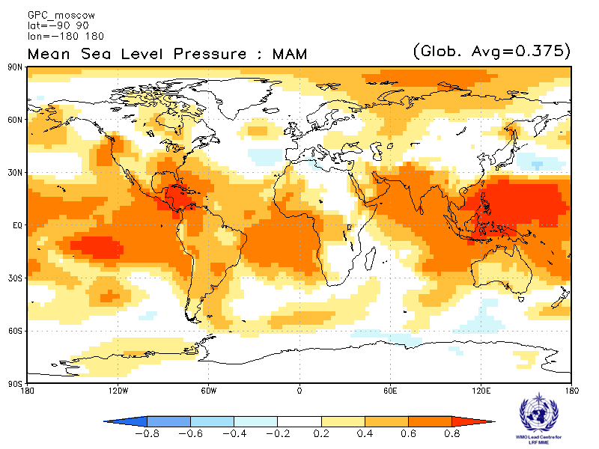 | Washington  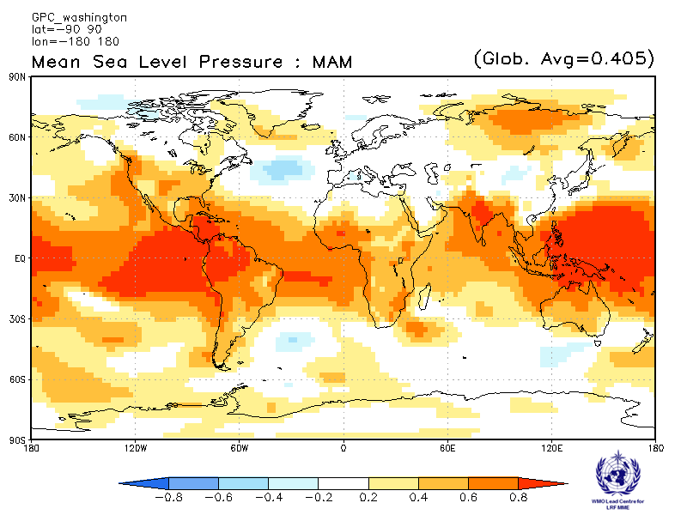

ACC verification of MSLP anomaly forecasts from other GPCs

Exeter  Verification period: 1996-2009  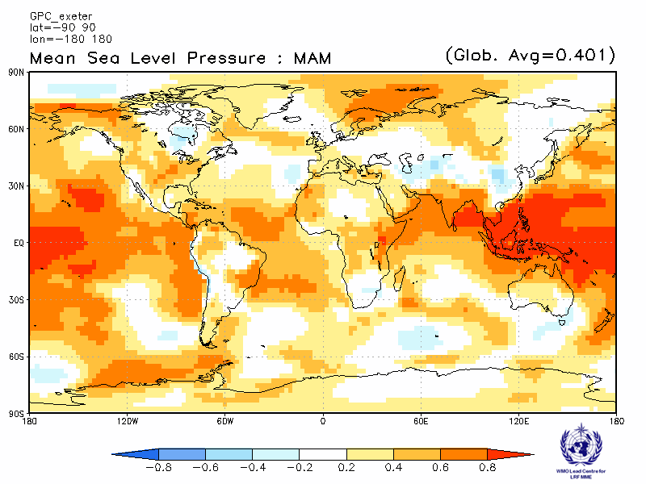 | Seoul  Verification period: 1996-2009  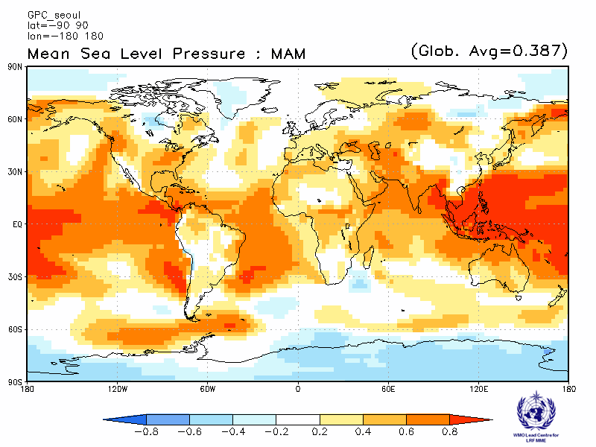
2.5.8 Verification of GPC MSLP probabilistic forecasts, 1983-2001
Verification measure: Relative Operating Characteristics (ROC) score for tercile forecast
Verification dataset: ERA-interim

PMME  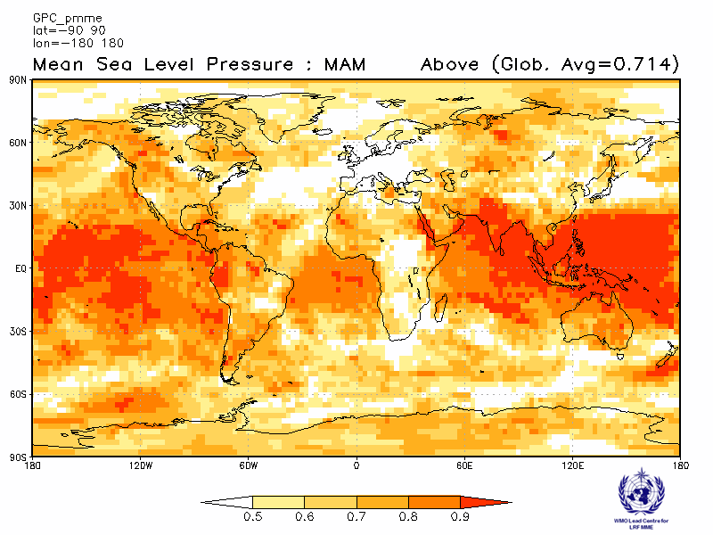 | CPTEC  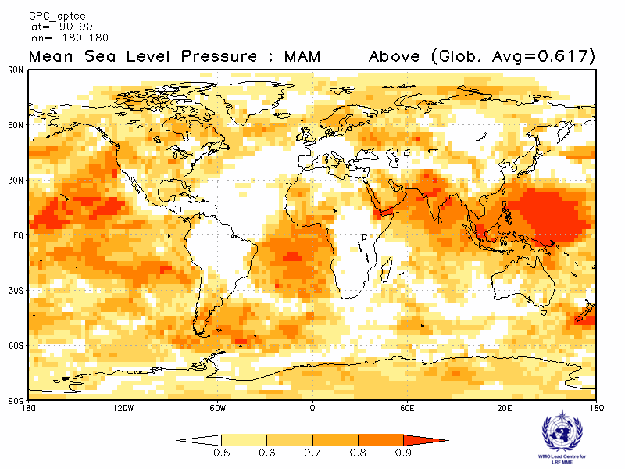
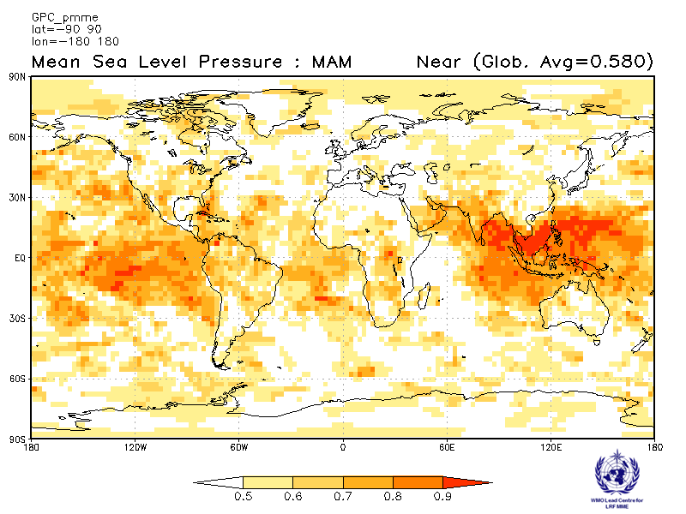 | 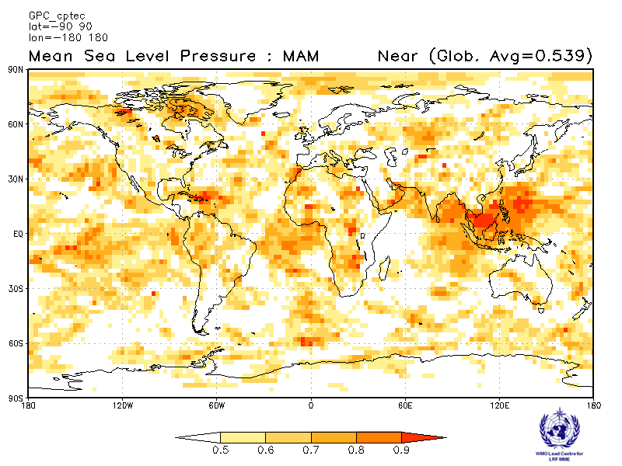
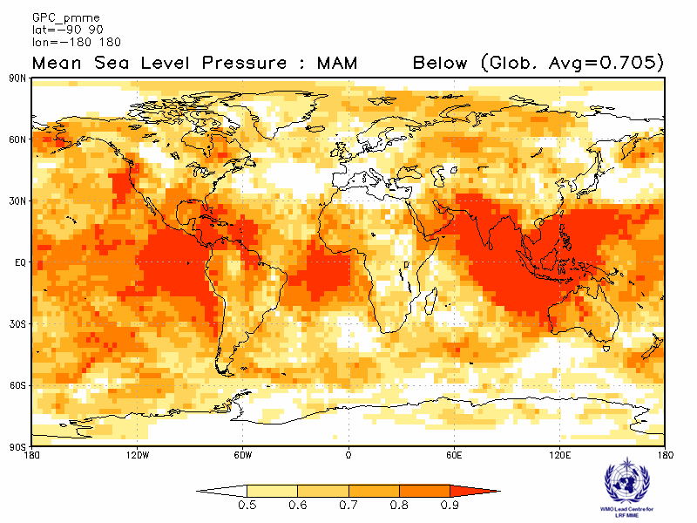 | 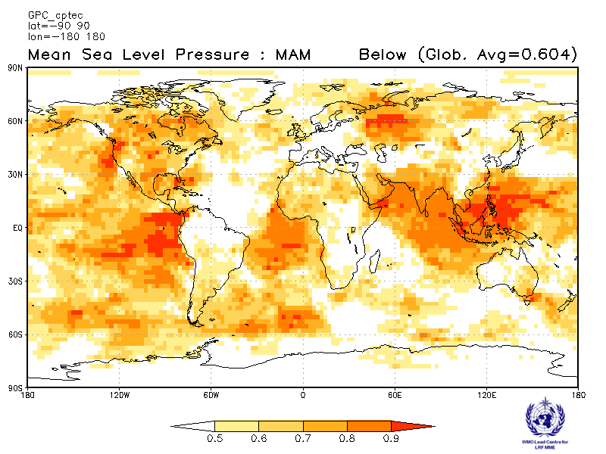

Melbourne  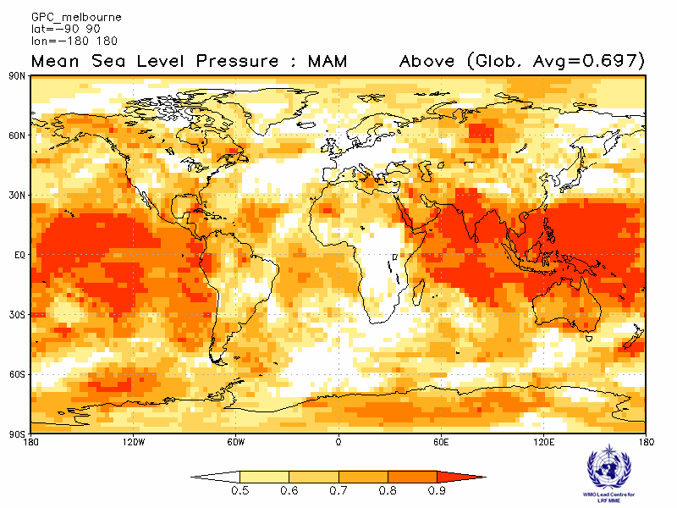 | Montreal  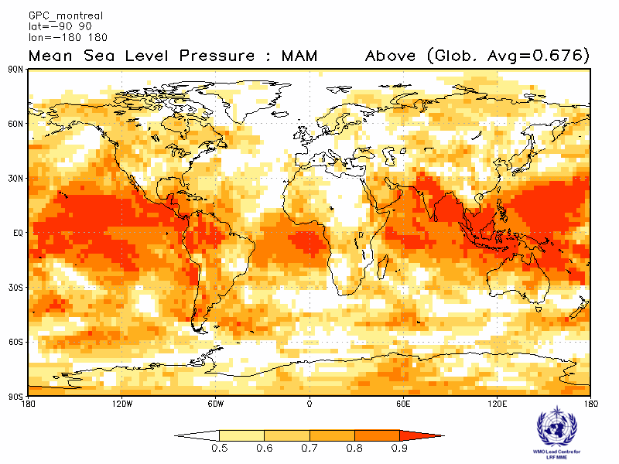
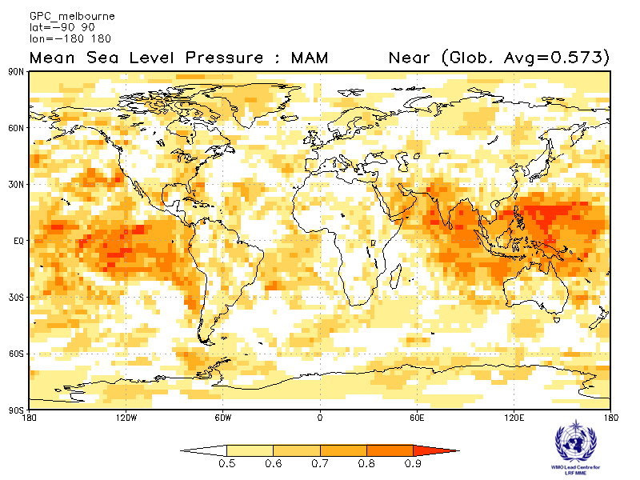 | 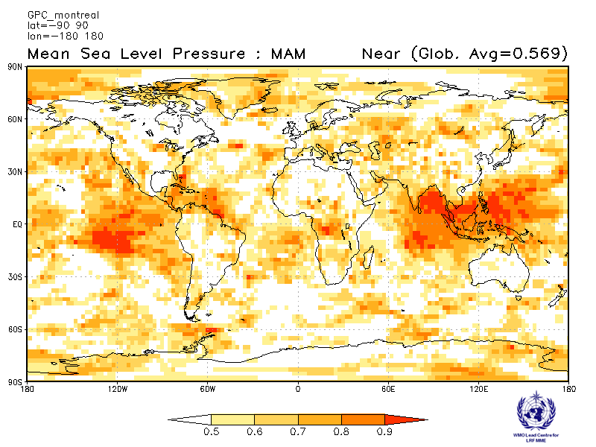
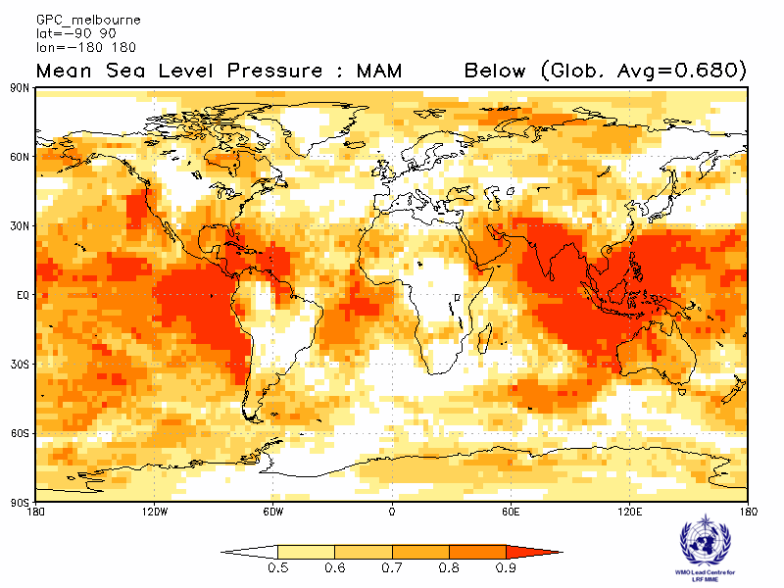 | 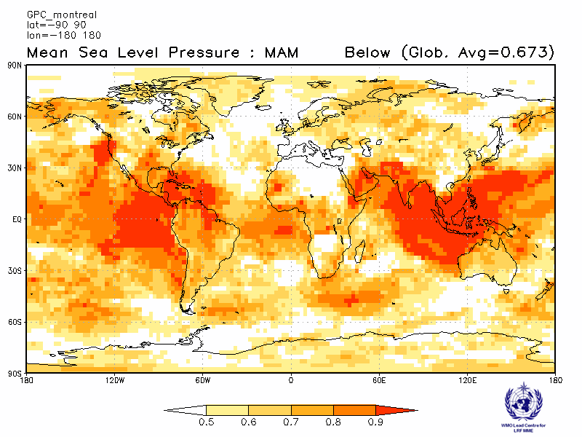

Moscow  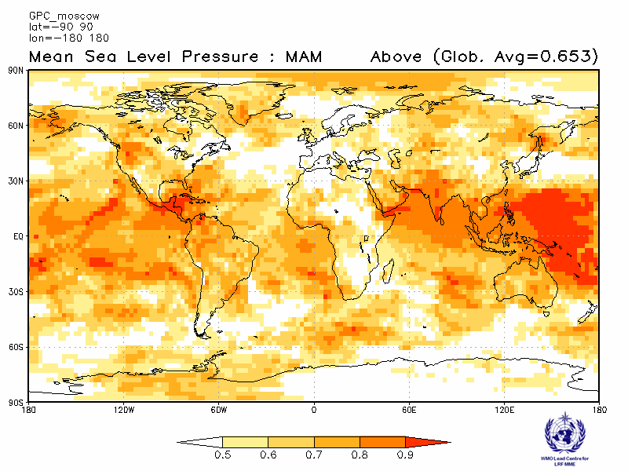 | Washington  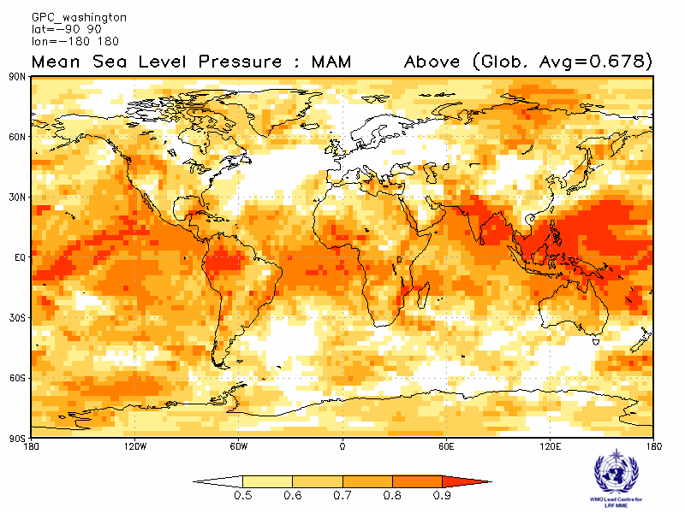
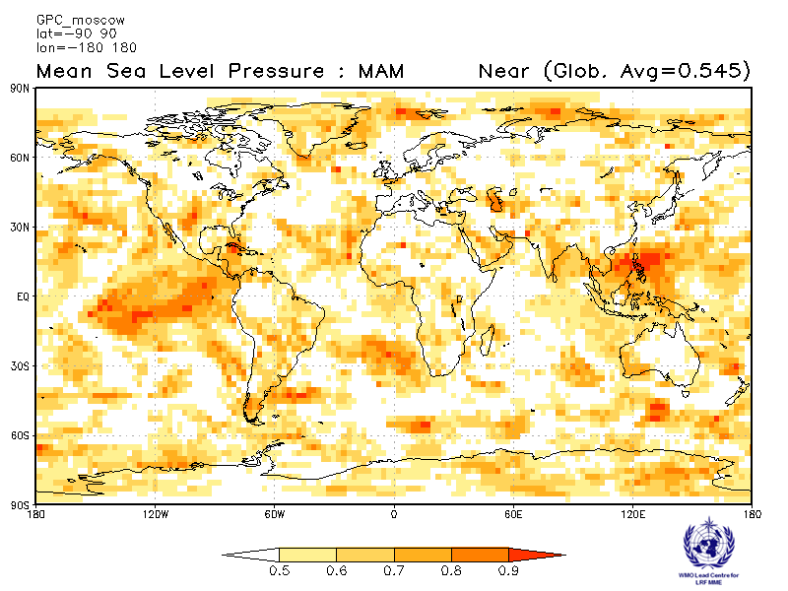 | 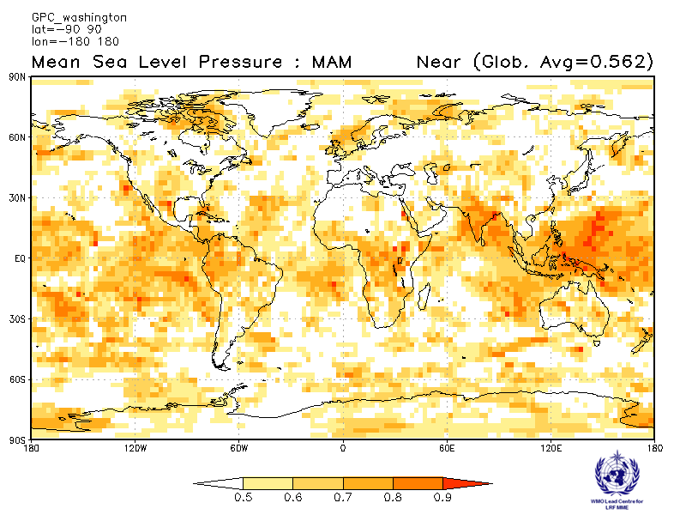
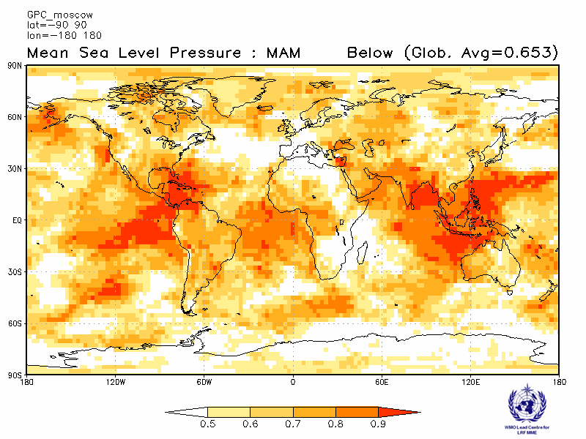 | 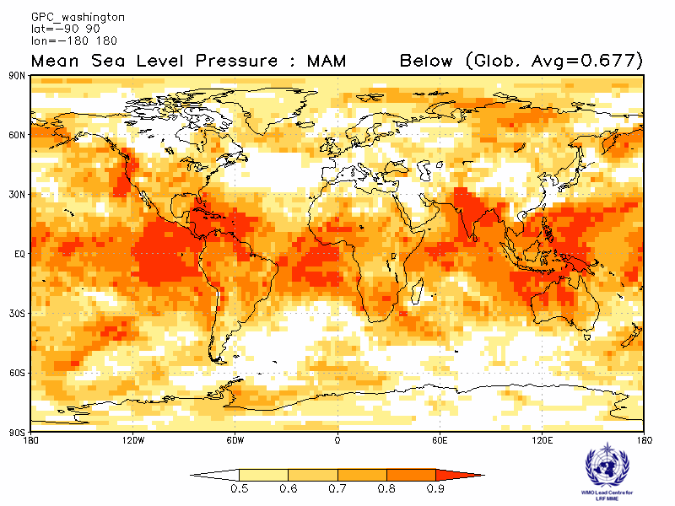

ROC score verification of MSLP probabilistic forecasts from other GPCs

Exeter  Verification period : 1996-2009  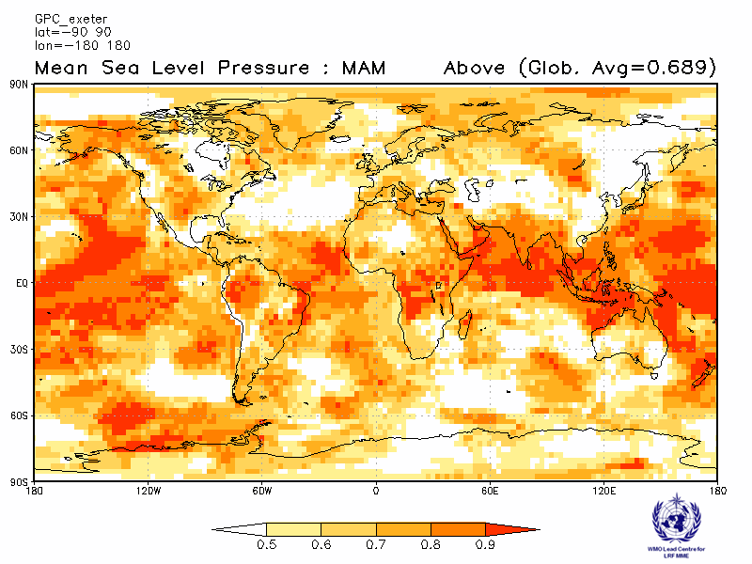 | Seoul  Verification period : 1996-2009  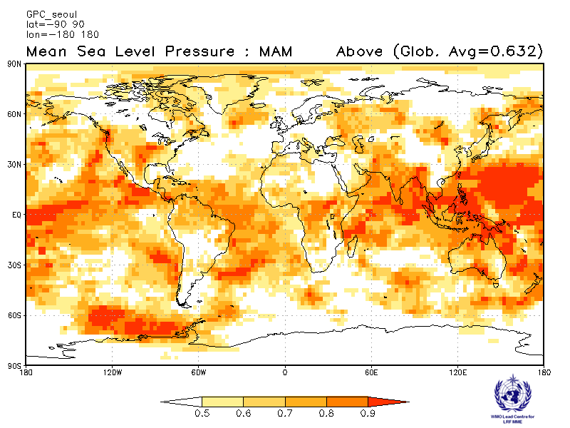
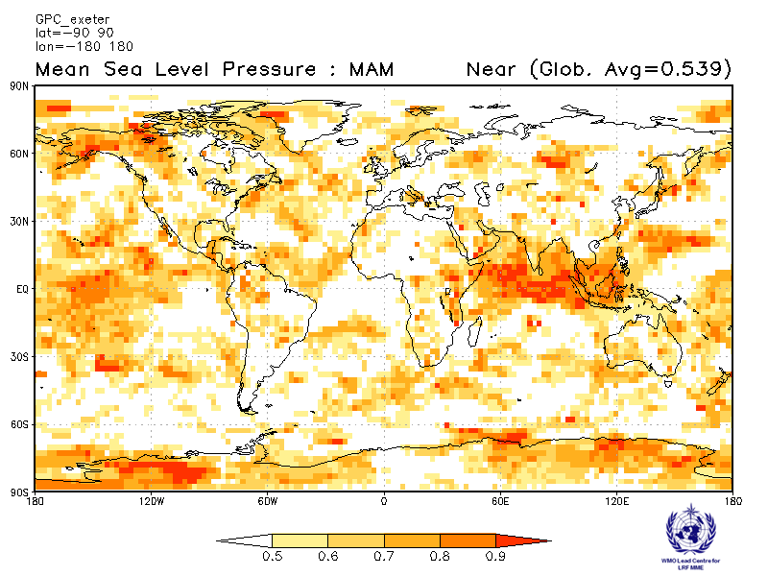 | 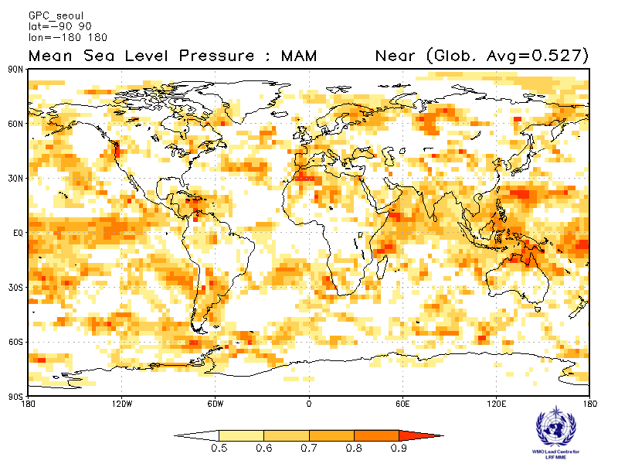
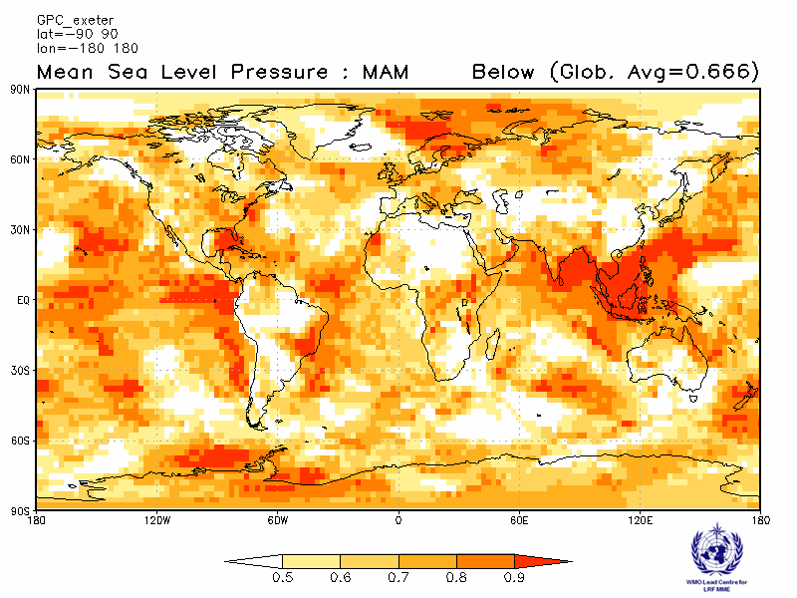 | 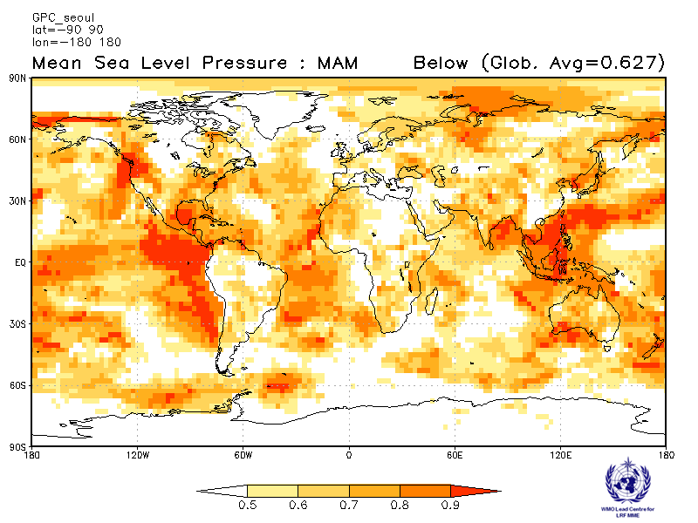

2.5.9 Verification of GPC MSLP probabilistic forecasts, 1983-2001
Verification measure: Relative Operating Characteristics (ROC) Curve and Score over globe
Verification dataset: ERA-interim

PMME  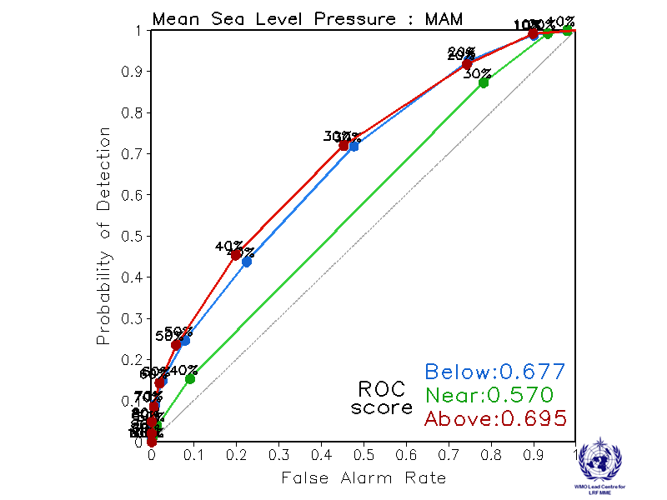 | CPTEC  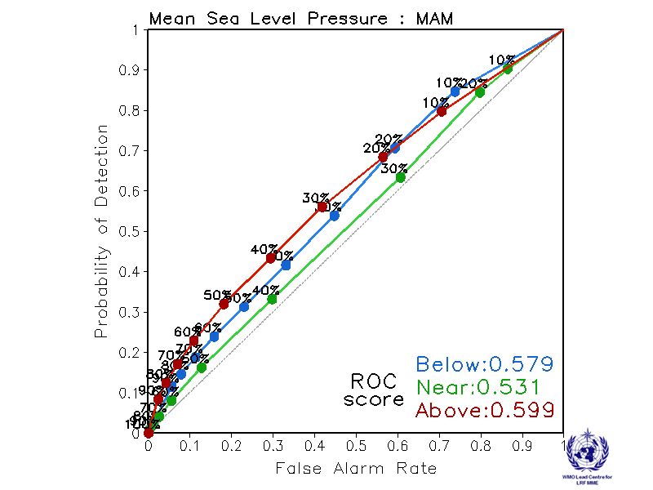
Melbourne  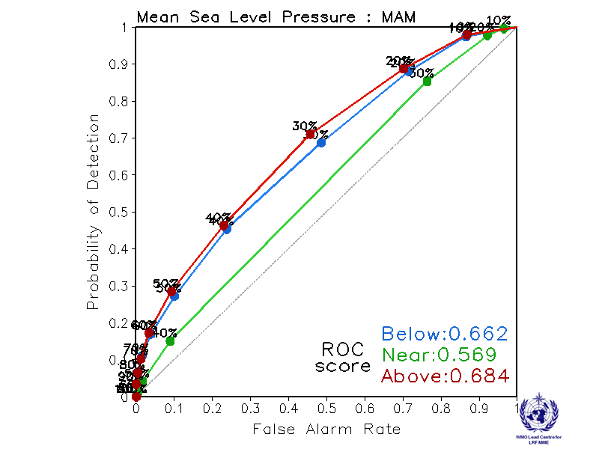 | Montreal  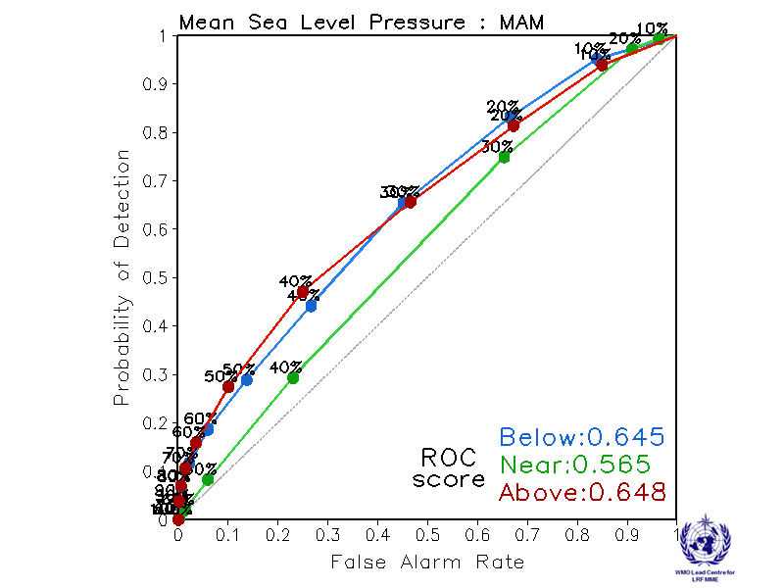
Moscow  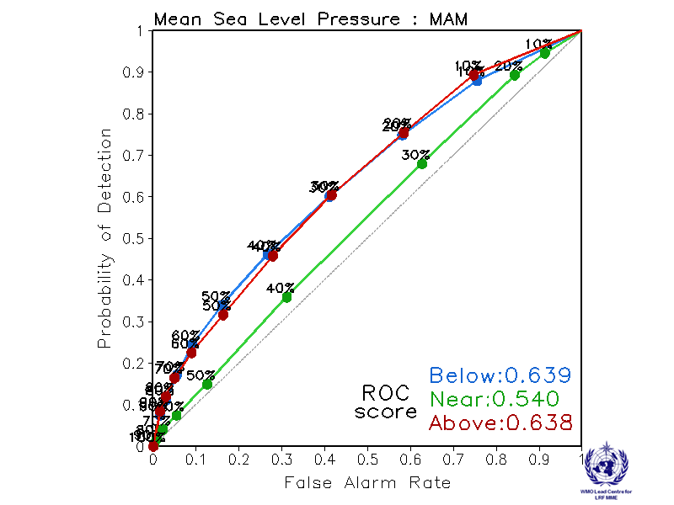 | Washington  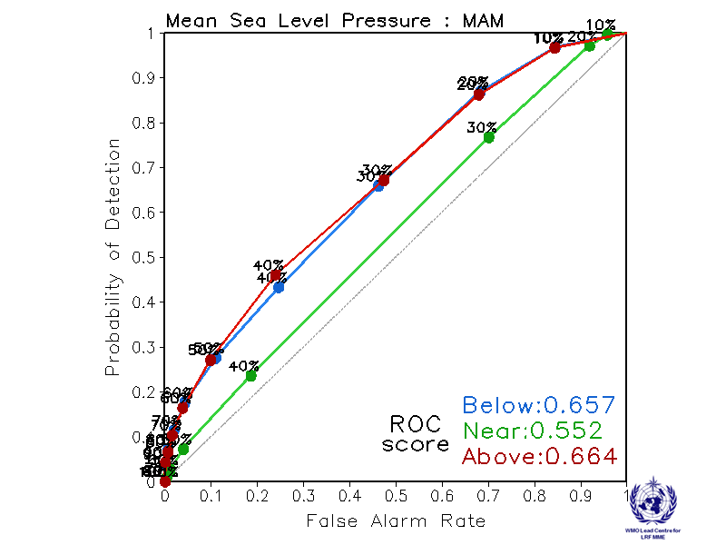

ROC curve and Score verification of MSLP probabilistic forecasts from other GPCs

Exeter  Verification period: 1996-2009  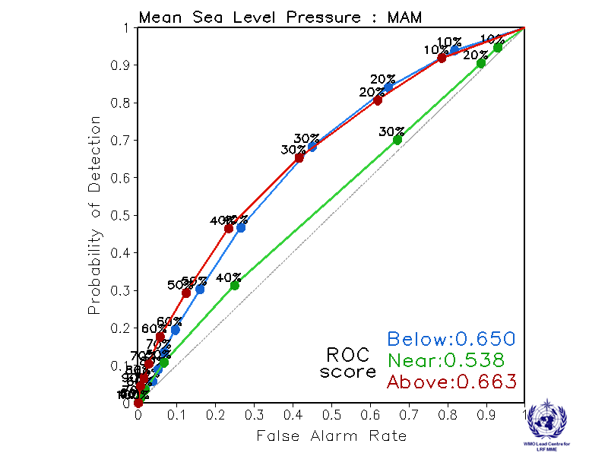 | Seoul  Verification period: 1996-2009  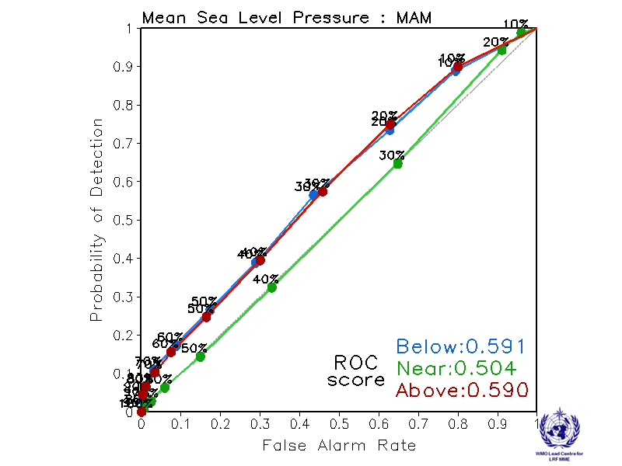

2.5.10 Verification of GPC MSLP probabilistic forecasts, 1983-2001
Verification measure: Reliability Diagram over globe
Verification dataset: ERA-interim

PMME  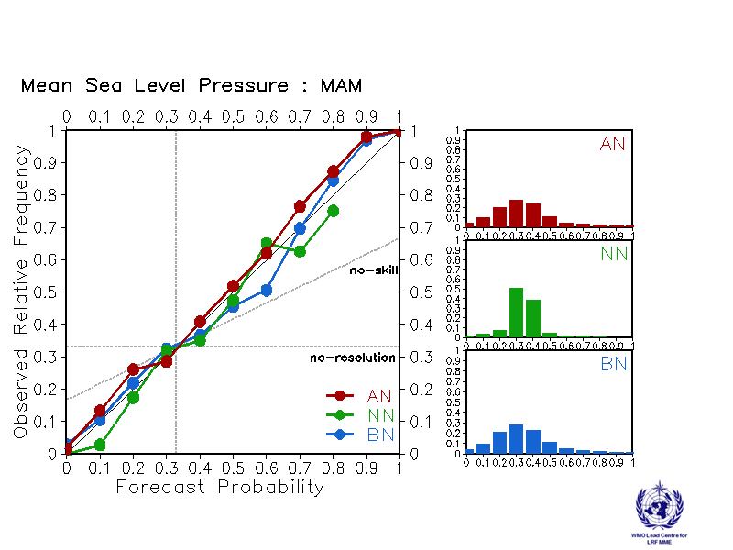 | CPTEC  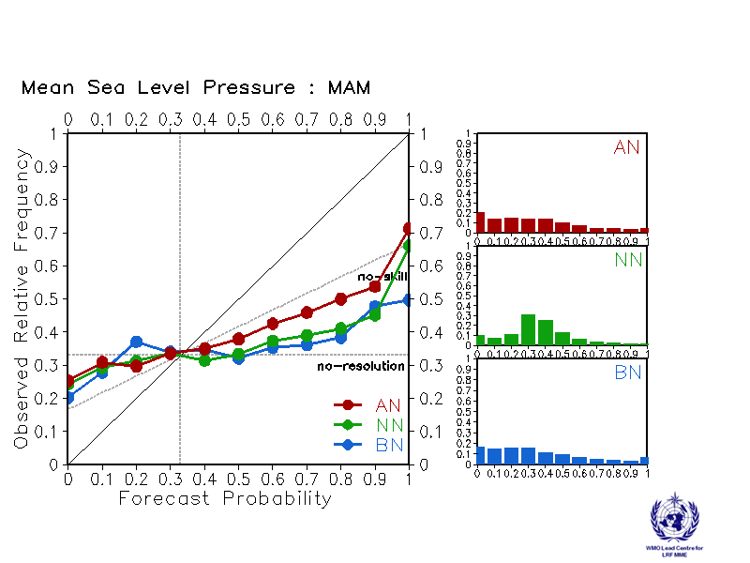
Melbourne  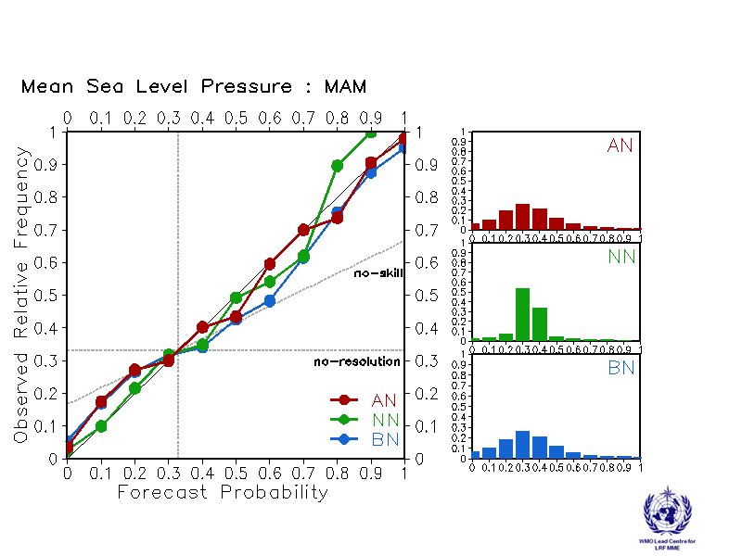 | Montreal  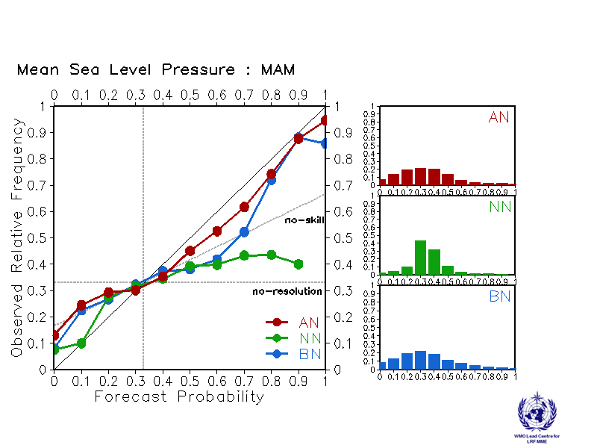
Moscow  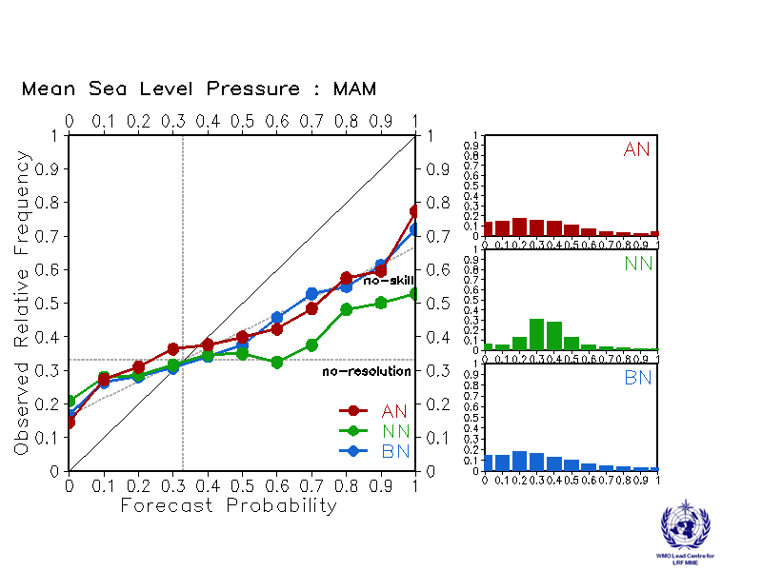 | Washington  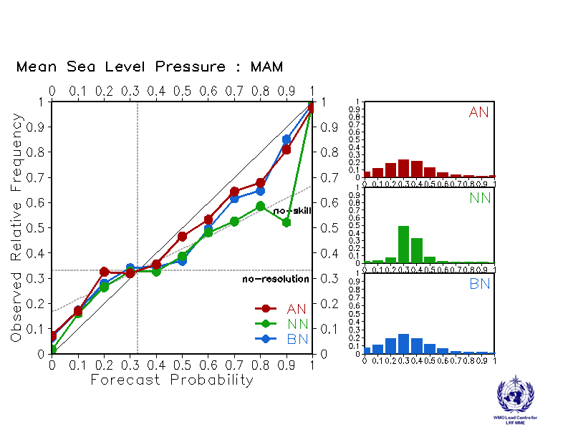

Reliability Diagram verification of MSLP probabilistic forecasts from other GPCs

Exeter  Verification period: 1996-2009  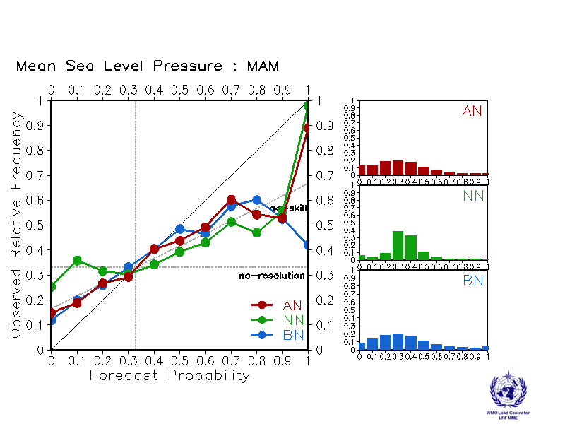 | Seoul  Verification period: 1996-2009  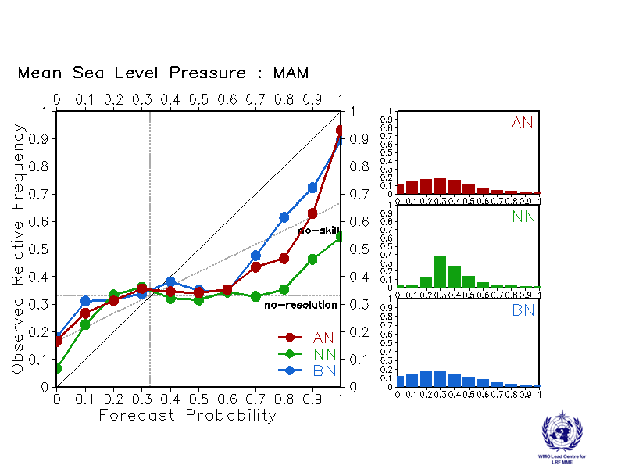
2.6 Ensemble mean predictions of global mean seasonal temperature anomaly for March-April-May 2016

GPC | Global average Temp.(K)  (baseline of 1983-2001) | Global average Temp.(K)  (with models own baseline)
CPTEC | 1.06 | 1.08
ECMWF | N/A | 0.62
Exeter | N/A | 0.86
Melbourne | 0.48 | 0.43
Montreal | 0.57 | 0.54
Moscow | 0.89 | 0.86
Seoul | N/A | 0.80
Toulouse | N/A | 0.58
Washington | 0.58 | 0.50
MME (9 GPCs) | N/A | 0.72
MME (5 GPCs) | 0.70 | 0.68
2.7 Predictions of monthly SST indices: each model with its own baseline
Nino 1+2
SSTA[90°W-80°W, 10°S-0°]
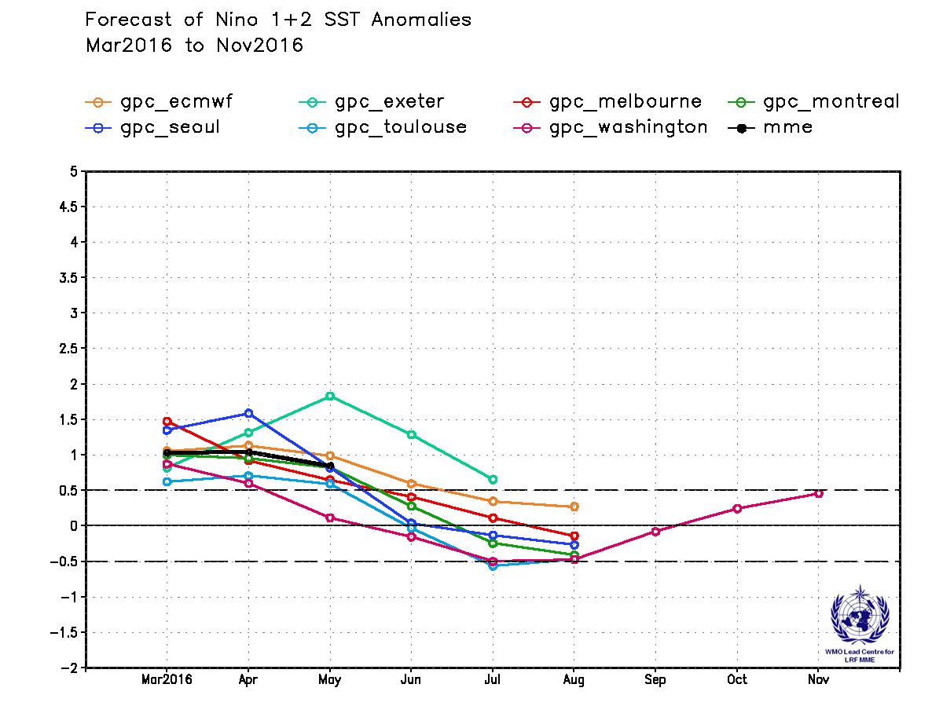

Nino 3
SSTA[150°W-90°W, 5°S-5°N]
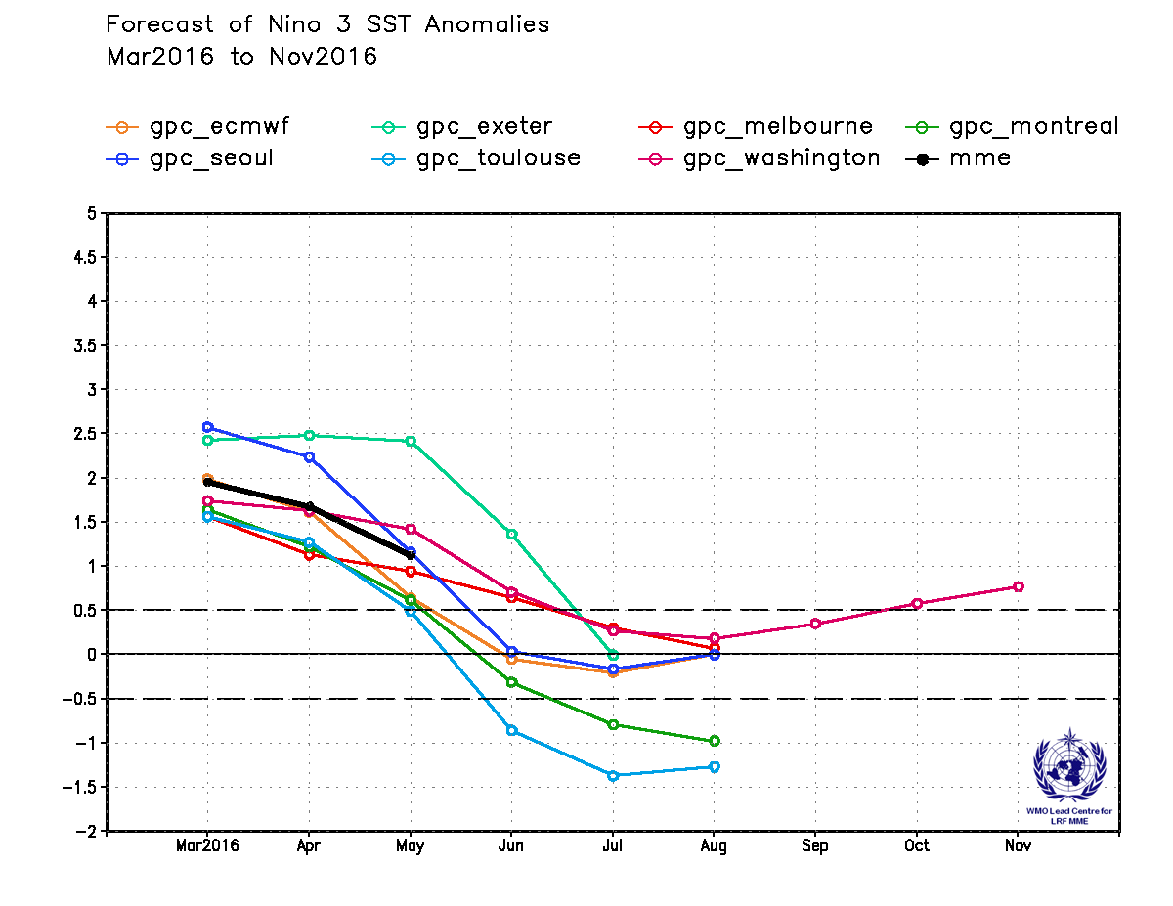

Nino 4
SSTA[160°E-150°W, 5°S-5°N]
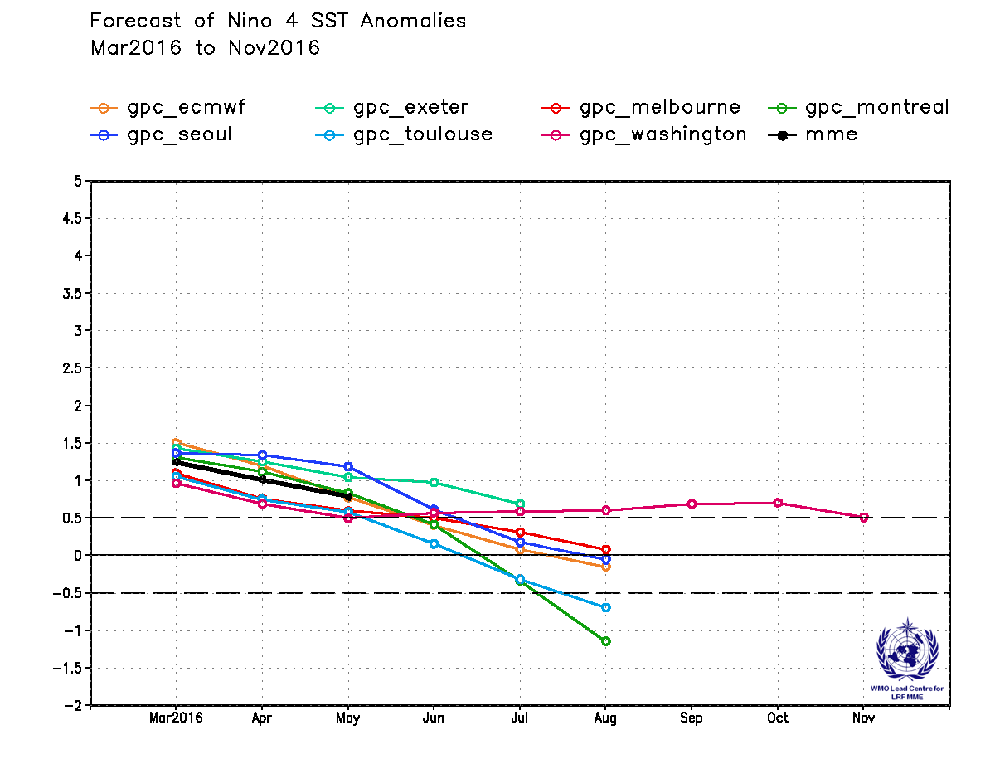

Nino 3.4
SSTA[170°W-120°W, 5°S-5°N]
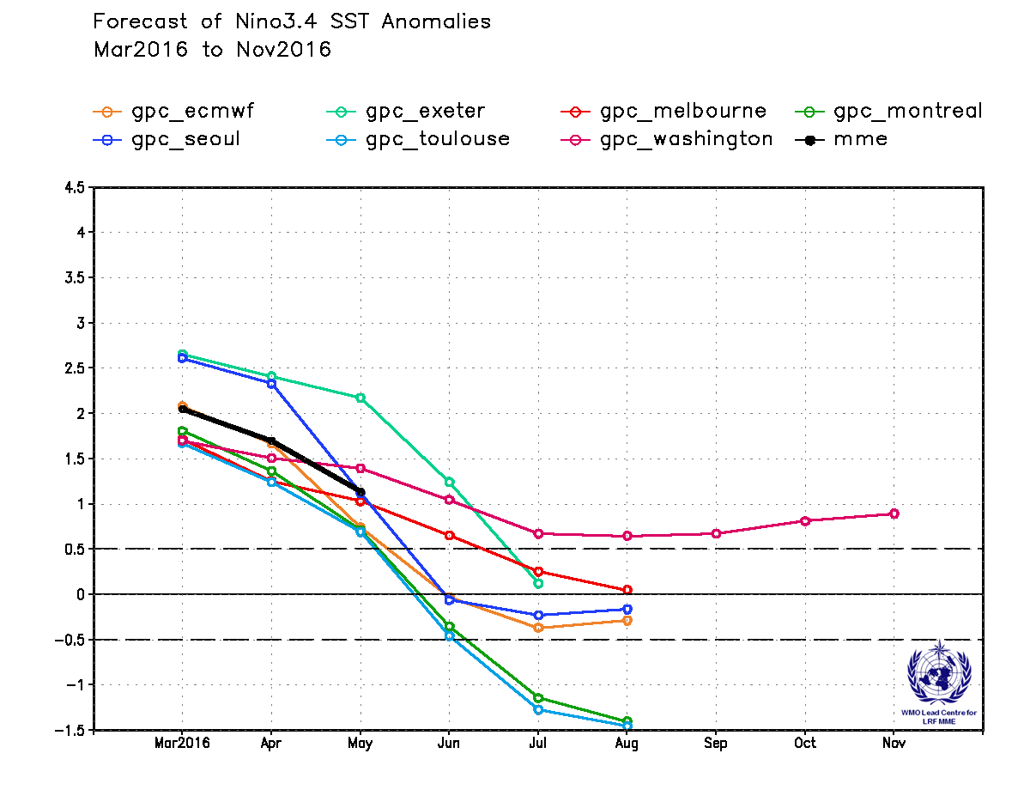

IOD
SSTA[50°E-70°E, 10°S -10°N]-SSTA[90°E-110°E, 10°S -0°]
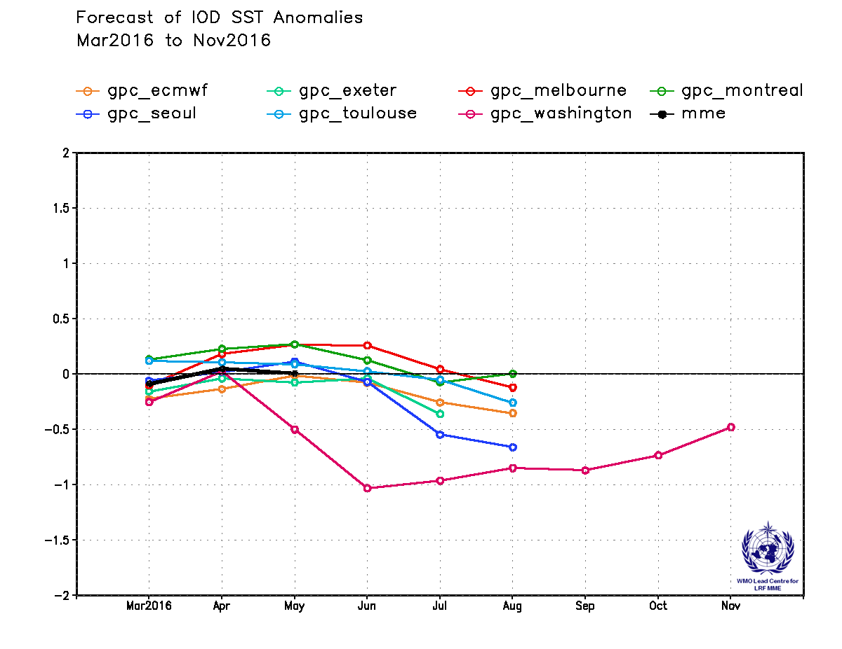

North Tropical Atlantic (NTA)
SSTA[60°W-30°W, 5°N-20°N]
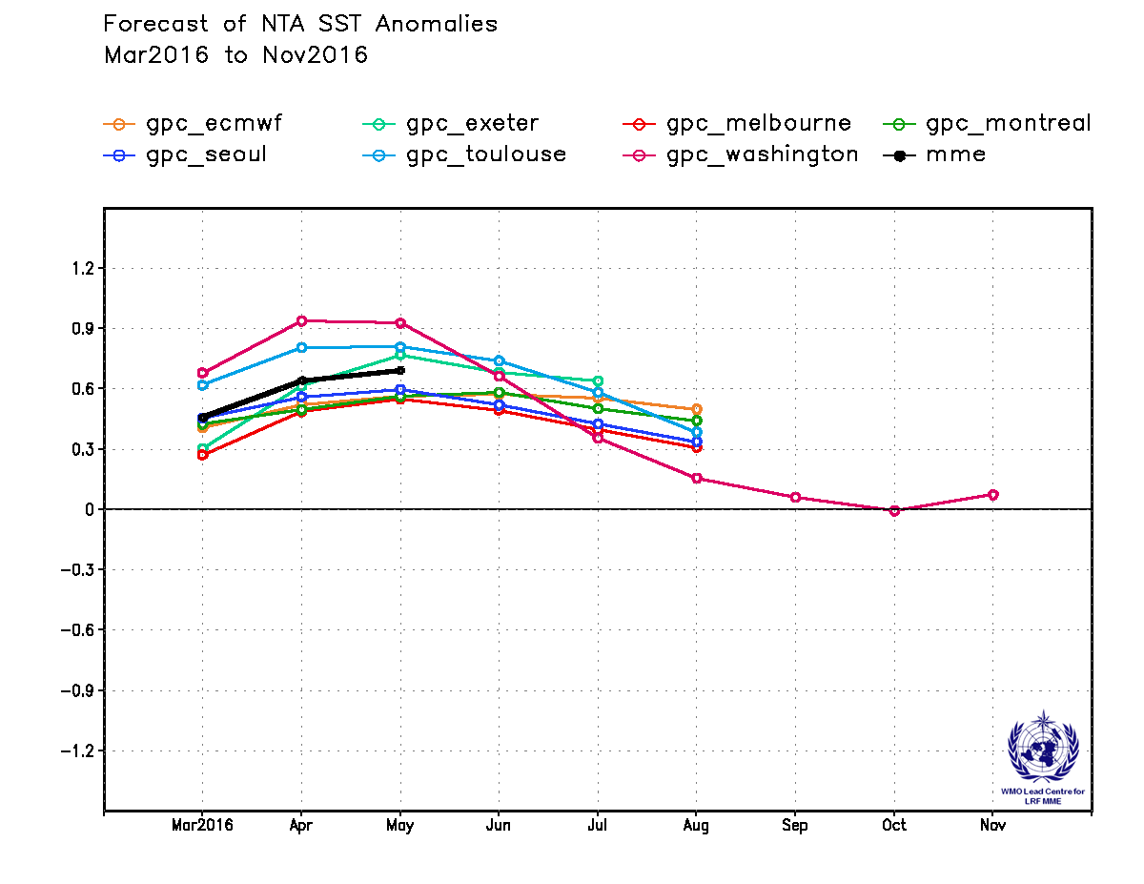

Southern Tropical Atlantic (STA)
SSTA[30°W-10°E, 20°S-0°]
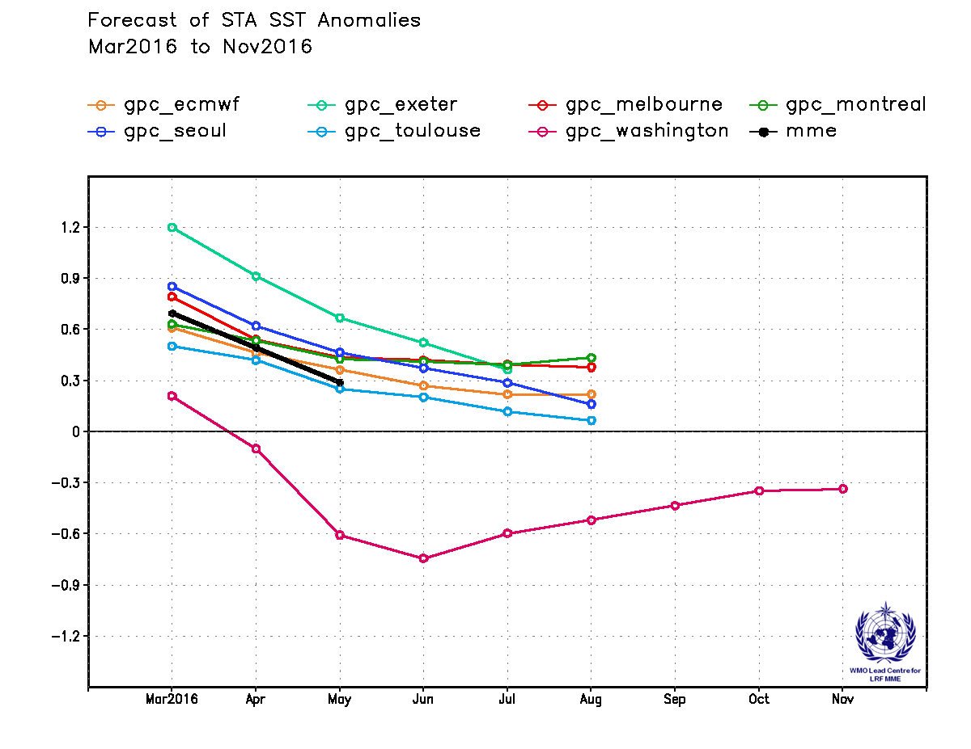
2.8 Further information on GPC hindcasts and forecasts

The probabilistic multi-model ensemble (PMME) prediction maps are generated from 5 GPCs operating models with hindcast periods that include the 1983-2001 (19 year) period, which is used as a common baseline in the multi-model products. The following table summarizes the information on the hindcast period, number of hindcast members and number of forecast members supplied by each of the 9 GPCs. An “X” indicates that hindcast data is not currently available from the corresponding GPC.

GPC | Hosting  Agency | Hindcast Period | Hindcast Data | Hindcast Members | Forecast Members | Model Type
CPTEC | CPTEC | 1979-2001 | O | 10 | 15 | Tier-2
ECMWF | ECMWF | 1981-2010 | X | 15 | 41 | Tier-1
Exeter | UKMO | 1996-2009 | O | 12 | 42 | Tier-1
Melbourne | BoM | 1980-2011 | O | 99 | 33 | Tier-1
Montreal | CMC | 1981-2010 | O | 10 x 2 | 10 x 2 | Tier-1
Moscow | HMC | 1981-2010 | O | 10 | 20 | Tier-2
Seoul | KMA | 1996-2009 | O | 12 | 42 | Tier-1
Toulouse | Météo-France | 1979-2007 | X | 11 | 41 | Tier-1
Washington | NCEP | 1981-2010 | O | 20 | 40 | Tier-1

