WORLD METEOROLOGICAL ORGANIZATION  COMMISSION FOR BASIC SYSTEMS  OPAG on DPFS  Meeting of the Expert Team on Operational Prediction from  Sub-seasonal to Longer-time Scales  Beijing, China, 11-15 April 2016 |  | CBS-DPFS/ET-OPSLS /Doc. 6.3.1  (22.III.2016)  _______  Agenda item : 6.3.1  ENGLISH ONLY

TASK TEAM 3: DEVELOPMENT OF SUB-SEASONAL FORECASTS

STATUS / PROGRESS REPORT FOR SUB-SEASONAL FORECAST MME

(Submitted by Suhee Park)

Summary and purpose of document

This document provides information on the implementation activities for sub-seasonal forecasts MME conducted by the Lead Centre for Long-Range Forecast Multi-Model Ensemble (LC-LRFMME).

Action Proposed

The meeting is invited to note and comment the contents.

Annex(es): - …….
- …….

Reference(s): - …….
- …….

STATUS / PROGRESS REPORT FOR LC-LRFMME

1. INTRODUCTION

The WMO and many operational centers realized the necessity of international collaborations to improve the predictability on the sub-seasonal time-scale. In 2011, Cg-XVI requested the LC-LRFMME to explore the possibility of extending its role to include exchange of extended range predictions, and invited GPCs to also provide data from their monthly forecast systems so that the LC-LRFMME would be able to provide sub-seasonal forecast products through the LC-LRFMME web pages. The expert meeting of ET-ELRF in 2012 prepared a minimum list of variables based on the minimum products list for seasonal forecast exchange and extended to include the MJO diagnostics particularly relevant to the sub-seasonal range. The extraordinary meeting of the Implementation Coordination Team of the Open Programme Area Group (OPAG) for the DPFS (ICT-DPFS) in 2013 set up a Task Team (TT3) under the CBS ET-OPSLS to scope the implementation of real-time sub-seasonal forecasts, and to establish the necessary links with the WWRP-THORPEX/WCRP research project on sub-seasonal to seasonal prediction (S2S).

In December 2015, the pilot real-time sub-seasonal MME prediction system was developed with agreed subset of S2S models. Currently, WMO LC-LRFMME is downloading the real-time data of GPC ECMWF, Exeter (UKMO), Washington (NCEP/CPC) and Tokyo (JMA) from the ECMWF S2S archive and producing MME products on a regular basis. Displays in the website of WMO LC-LRFMME are available about a week delayed date from starting date of MME prediction, because of the time required for data collection. This report describes main features of sub-seasonal MME prediction system and its website for display of MME products.

2. OPERATIONAL SET UP: PILOT REAL-TIME SUB-SEASONAL MME PREDICTION

This section describes the operational set up of pilot MME prediction system.

2.1 Getting data

• How to get the data: Access to ECMWF S2S archive
• Variables: SST, T2m, precipitation, u200, v200, u850, and OLR
• Frequency of model output: Daily model output
• Data types: Full fields of both forecast and hindcast (reforecast)
• Participating Models: ECMWF, UKMO, JMA, NCEP/CPC (Note: KMA will be included soon.)

2.2 Deriving the multi-model

The ensemble initialization for the multi-model is described in Figure 1. For simplicity, we select an optimal issuing date of ‘Wednesday’ in order to minimize lead-times of individual models. And, then The first four weeks (i.e. Thursday to Wednesday) of each forecast ensemble member are time averaged into 5 forecast lead times: Period 1 (forecast week 1, days 1 to 7), Period 2 (forecast week 2, days 8 to 14), Period 3 (forecast week 3, days 15 to 21), Period 4 (forecast week 4, days 22 to 28), Period 5 (forecast weeks 3 and 4, days 15 to 28) and Period 6 (forecast weeks 1 to 4, days 1 to 28) are averaged together from daily data. Because initialization dates of individual models are slightly different as shown in Figure 1, forecast time ranges of each model are also different as in Table 1. To estimate the model’s climatological distribution at each forecast start date, the same hindcast start dates (ECMWF and Washington) or the closest hindcast start dates (Tokyo and Exeter) are chosen for the common period 1999 to 2009 as in Table 2.

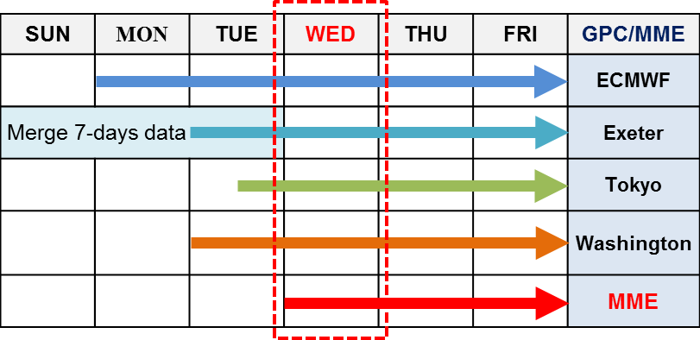
Figure 1. The issue timing of sub-seasonal prediction for 4 GPCs and MME (Red).

Table 1. Characteristics of sub-seasonal prediction systems of participating Centres
Center | Forecast  Frequency | Forecast  Time range | Forecast  Ens. Size | Hindcast  Frequency | Hindcast  Ens. Size | Hindcast  length
ECMWF | 2/week  (Mon,Thu) | 0-46 days | 51 | 2/week  (Mon, Thu) | 11 | 1996-2015  (Past 20 years)
Tokyo  (JMA) | 2/week  (Tue,Wed) | 0-34 days | 25 | 3/month  (10/20/last day) | 5 | 1981-2010
Washington  (NCEP/CPC) | Daily | 0-44 days | 16 | Daily | 4 | 1999-2010
Exeter  (UKMO) | Daily | 0-60 days | 4 | 4/month  (1,9,17,25 day) | 3 | 1996-2009

Table 2. Inputs of sub-seasonal MME prediction system
Center | Forecast  Init. date | Forecast  Time range | Forecast  Ens. Size | Hindcast  Init. Date | Hindcast  Ens. Size | Hindcast  length
ECMWF | Mon | 3-30 days | 51 | Same date as fcst | 11 | 1999-2009
Tokyo | Tue | 2-29 days | 25 | Closest date to fcst | 5 | 1999-2009
Washington | Tue | 2-29 days | 16 | Same date as fcst | 4 | 1999-2009
Exeter | Last Wed  - Tue | 2(8)-29(35) days | 28 (4x7) | Closest date to fcst | 3 | 1999-2009

2.3 Producing probabilistic MME prediction: 2-m air temperature and precipitation

The parametric estimation approach is adopted to produce probabilistic forecast. When defining tercile boundaries, a theoretical distribution is assumed as Normal distribution for 2-m air temperature and Gamma distribution for precipitation. And then forecast probabilities are calculated with a distribution of forecast ensemble compared to hindcast distribution. Probabilistic MME (PMME) is produced in the form of tercile-based categorical probabilities: the below-normal (BN), near-normal (NN) and above-normal (AN) categories with respect to climatology, where the tercile boundaries are defined at each grid point.

Meanwhile, there is alternative method to generate probabilistic forecast, which is non-parametric estimation method, so called “Ranking and counting method”. When defining tercile boundaries, hindcast data are ranked with ascending order and values of 1/3 and 2/3 boundaries are determined by averaged value between biggest value of lower boundary and smallest value of upper boundary. And then, forecast probabilities are calculated with counting the number of forecast ensemble based on two tercile-boundary values. This method is free of variable’s distribution properties and easy to understand, but strongly influenced by local characteristics. We had investigated the sensitivity of two estimation method on skill of global probabilistic forecast. The results indicated that, in case of temperature, two methods showed almost similar probabilistic forecast and its skill scores are also no significant difference (not shown here). In case of precipitation, general features are similar between both methods, but there are two advantages in parametric estimation method compared with non-parametric method. First, non-parametric estimation method cannot determine appropriate two boundary values in extremely dry regions, such as a desert area, but, parametric estimation method can produce it (Fig. 2). Because two boundary values in extremely dry regions are equal values of “zero”, we cannot determine categories of each forecast ensembles. Of course, there are different viewpoints on how to treat forecast category in extremely dry regions. But, because the primary purpose of MME prediction of WMO LC-LRFMME is to provide global prediction data, we choose a parametric estimation method that can produce forecast values over whole globe. Second, skills of probabilistic forecast using a parametric estimation method are slightly better than those of a non-parametric method (Fig. 3).

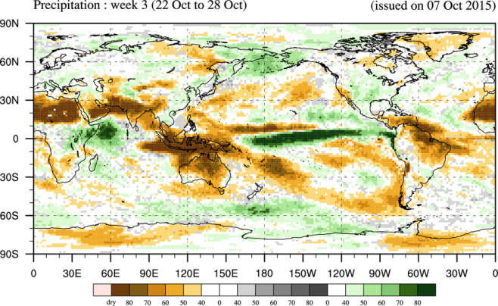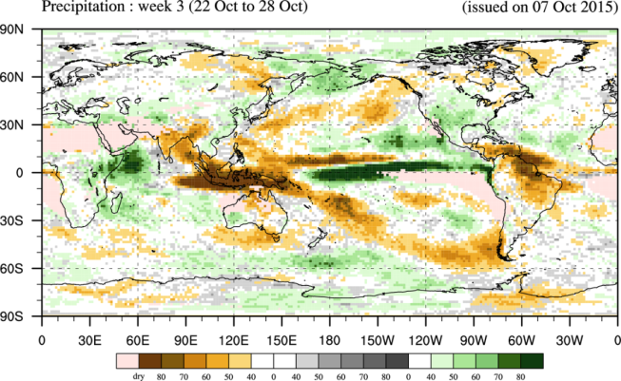
Figure 2. Probabilistic forecast of precipitation using parametric estimation method (left) and non-parametric estimation method (right) for week-3 forecast issued 7th October 2015. In the result from non-parametric method, grid points that cannot be determined to a specific tercile category are shaded by pale pink color.

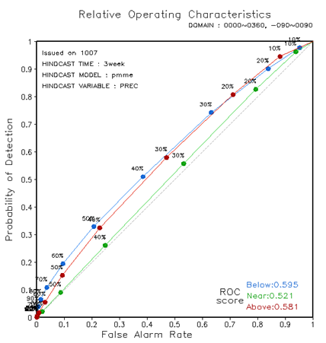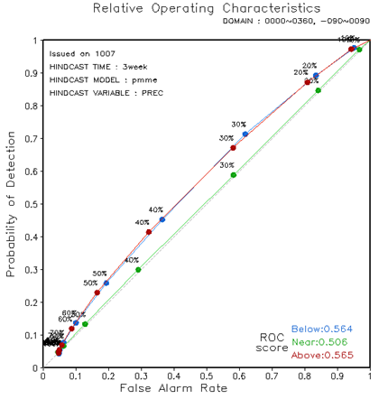
Figure 3. Relative operating characteristics (ROC) score over globe of probabilistic forecast of precipitation using parametric estimation method (left) and non-parametric estimation method (right) for week-3 forecast issued 7th October 2015.
2.4 Producing deterministic MME prediction: MJO/BSISO and Atmospheric circulation

The deterministic MME (DMME) forecast is constructed with the simple arithmetic mean, which is equal-weighting average so that the contribution of each single-model is equal.

2.4.1 Madden-Julian Oscillation (MJO)

The MJO index follows closely that developed by Wheeler and Hendon (2004). The input data for this index are latitudinally-averaged (15°S-15°N) fields of zonal winds at the 850 hPa and 200 hPa levels, and outgoing longwave radiation. After some pre-processing procedures proposed by Gottschalck (2010), these fields are projected onto a pair of observationally-derived global structures of the MJO, giving a pair of numbers to measure its state each day, called the Real-time Multivariate MJO (RMM) indices (RMM1 and RMM2).

2.4.2 Boreal Summer Intraseasonal Oscillation (BSISO)

The BSISO index developed by Lee et al. (2013) is adopted. This index is similar to the RMM indices of Wheeler and Hendon (2004), except that the focus is on the intraseasonal variability that is specific to the Asian monsoon region (10.5°S-40.5°N, 39°E-160.5°E). Two propagating modes, each comprising a pair of multivariate EOF, are respectively called BSISO1 and BSISO2. BSISO1 captures the canonical northward-propagating BSISO component and BSISO2 captures the higher-frequency pre-monsoon and onset component. Compared to the MJO monitoring and prediction activity, which uses only latitudinally-averaged data, the BSISO indices require latitude-longitude grids of outgoing longwave radiation and 850-hPa zonal wind.

3. WEBSITE DESIGN

New ‘subseasonal’ menu are developed in WMO LC-LRFMME website (http://www.wmolc.org). Currently, this content is protected with password. There are 4 sub-menus: Information, data exchange, plot and verification.

- Information: MME configuration and information about adopted methods.
- Data exchange: daily MME raw data in format of grib
- Plot: prediction graphics of PMME and DMME
- Verification: verification graphics using hindcast data for DMME and PMME

4. VERIFICATION: PRELIMINARY RESULTS

For assessment of benefits of multi-model ensemble approach, forecast skills of between individual model and MME were compared. We selected January 2016 case, because there are strong cold spells over Europe, East Asia and eastern North America.

Preliminary results show that forecast skills of deterministic MME (simple averaged MME) in both real-time forecast and hindcast dataset are similar with those of best model, but skills of probabilistic MME are better than best model.

However, further evaluation with sufficient samples is needed to get more robust assessment.

4.1 Deterministic forecast: Anomaly pattern correlation over globe and Tropics

- Forecast issued on 6th January 2016 (2m air temperature)
  - ECMWF, Tokyo, Washington, Exeter and MME results
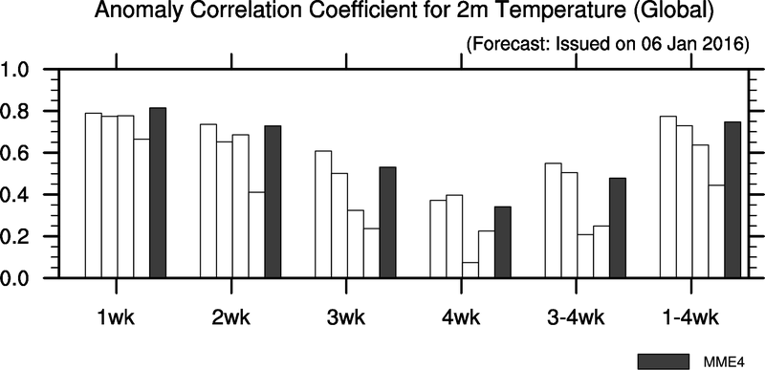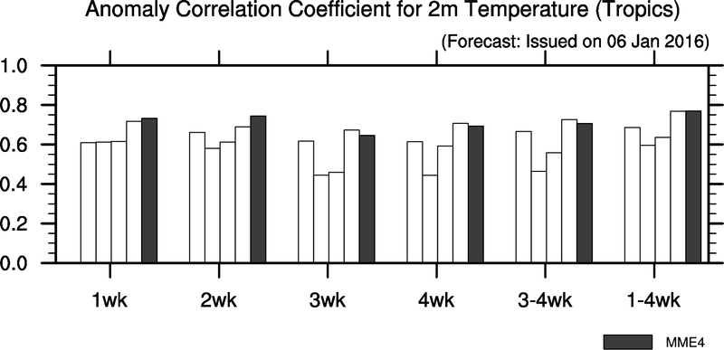

- Hindcast (6th January for 1999-2009) corresponded to forecast of 6th January 2016
    - ECMWF, Washington, Exeter and MME results
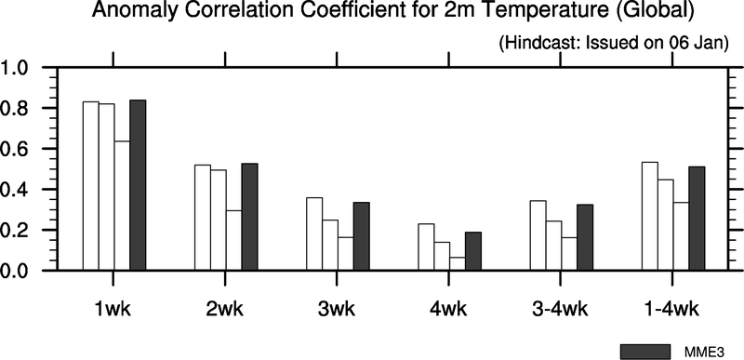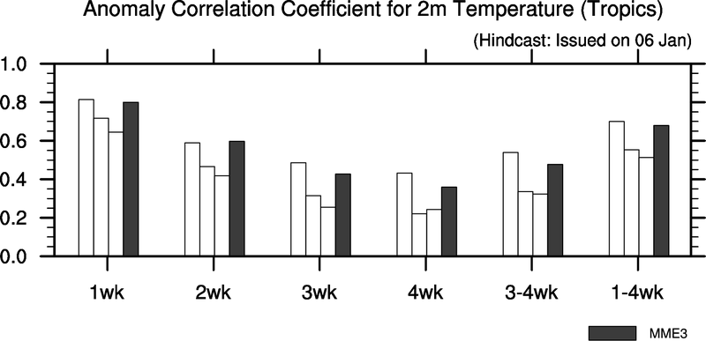

4.2 Probabilistic forecast: ROC score over globe and Tropics

- Forecast issued on 6th January 2016 (2m air temperature)
    - ECMWF, Tokyo, Washington, Exeter and MME results
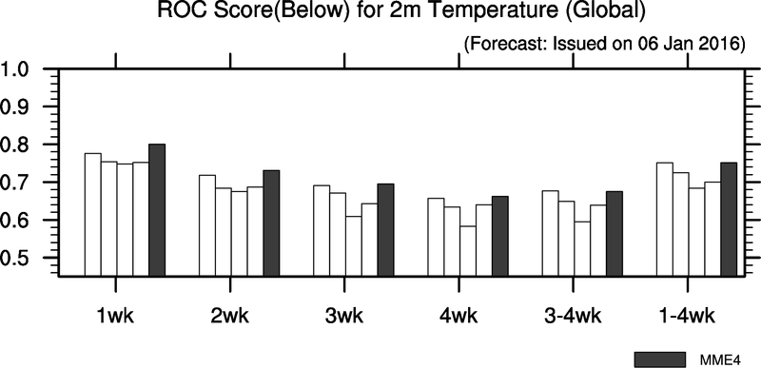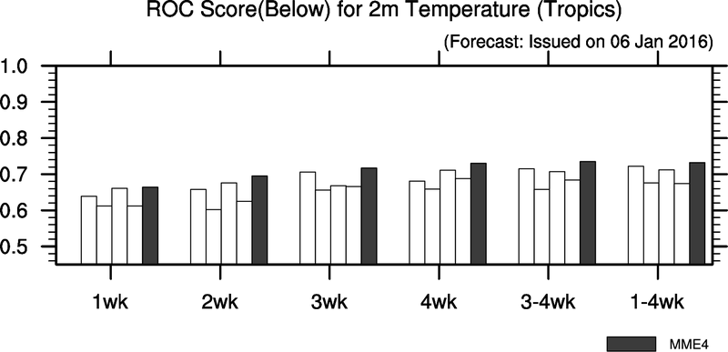

- Hindcast (6th January for 1999-2009) corresponded to forecast of 6th January 2016
  - ECMWF, Washington, Exeter and MME results
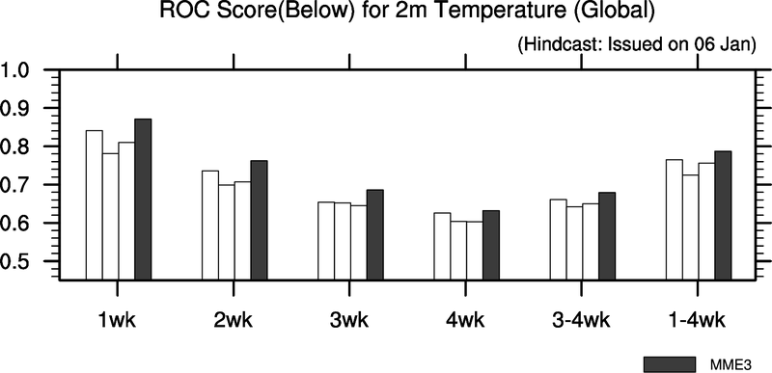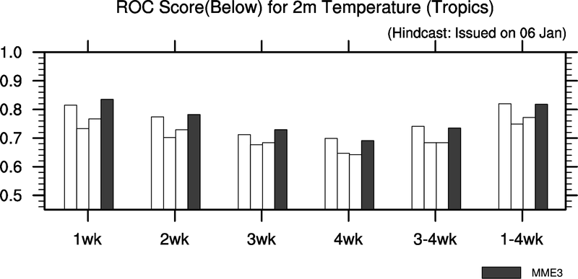

5. FUTURE PLANS TO BE DISCUSSED

There are necessary steps to move to the operational phase.

5.1 Improvement of usefulness

- Change ‘week’ range in forecast: From ‘Thursday to Wednesday’ to ‘Monday to Sunday (Calendar week)’
- Expand forecast period: From ‘4 weeks’ to ‘6 weeks (for available model)’

5.2 Development of additional products

- Graphical products for Individual model results
- Deterministic forecast (forecast anomalies) for 2m air temperature and precipitation
- New variables: 500hPa geopotential height, Mean sea level pressure, 850hPa wind
  - Note that it means we have to agree adding ‘Z500, MSLP and v850’ in exchange variables.

5.3 Improvement of user conveniences for use of web site

- Multiple ‘pop-up window’ function
- Consistency in web-page design, etc.

5.4 Satisfaction of timeliness

- Currently, sub-seasonal forecast products by LC-LRFMME are available on 1-week delayed date from issuing date of MME prediction, because of the time required for data collection from ECMWF S2S archive. Therefore, alternative approach to reduce a data-collection time should be investigated to move to the operational phase.

6. MILESTONE

- February 2016: Start to be reviewed by WMO CBS/CCl ET-OPSLS
- April 2016: Discussion in the meeting of ET-OPSLS
- December 2016: Improvement of sub-seasonal MME system and website

__________________

