WORLD METEOROLOGICAL ORGANIZATION  COMMISSION FOR BASIC SYSTEMS  OPAG on DPFS  MEETING OF THE CBS (DPFS) EXPERT TEAM ON OPERATIONAL PREDICTIONS FORM SUB-SEASONAL TO LONGER-TIME SCALES (ET-OPSLS)  BARCELONA, SPAIN, 2 AND 4 TO 6 JUNE 2018 |  | DPFS/ET-OPSLS/Doc. 6.6  (15.V.2018)  _______  Agenda item : 6.6  ENGLISH ONLY

Annual Summary of LC-LRFMME Seasonal Forecasts

(Submitted by Arun Kumar)

Summary and purpose of document

This document discusses a proposal for developing an annual summary of seasonal forecasts provided by LC-LRFMME

Action Proposed

The meeting is invited to discuss the document and propose possible follow up actions.

Annex(es): - …….

Reference(s): - …….

ANNUAL SUMMARY OF LC-LRFMME SEASONAL FORECASTS

1. Lead Center for Long-Range Forecast Multi-Model Ensemble (LC-LRFMME) provides seasonal forecasts each month. These forecasts are based on input provided by 13 GPCs for LRF. Multi-model forecasts in deterministic and probabilistic formats are provided. Forecasts are displayed at the lead center website https://www.wmolc.org/ .

2. LC-LRFMME also provides verification statistics for real-time forecasts. These verifications are provided for deterministic forecasts (e.g., anomaly correlation and MSSS) and probabilistic forecasts (ROC, reliability diagrams). An example of anomaly correlation for JFM 2018 forecast is shown in Fig. 1

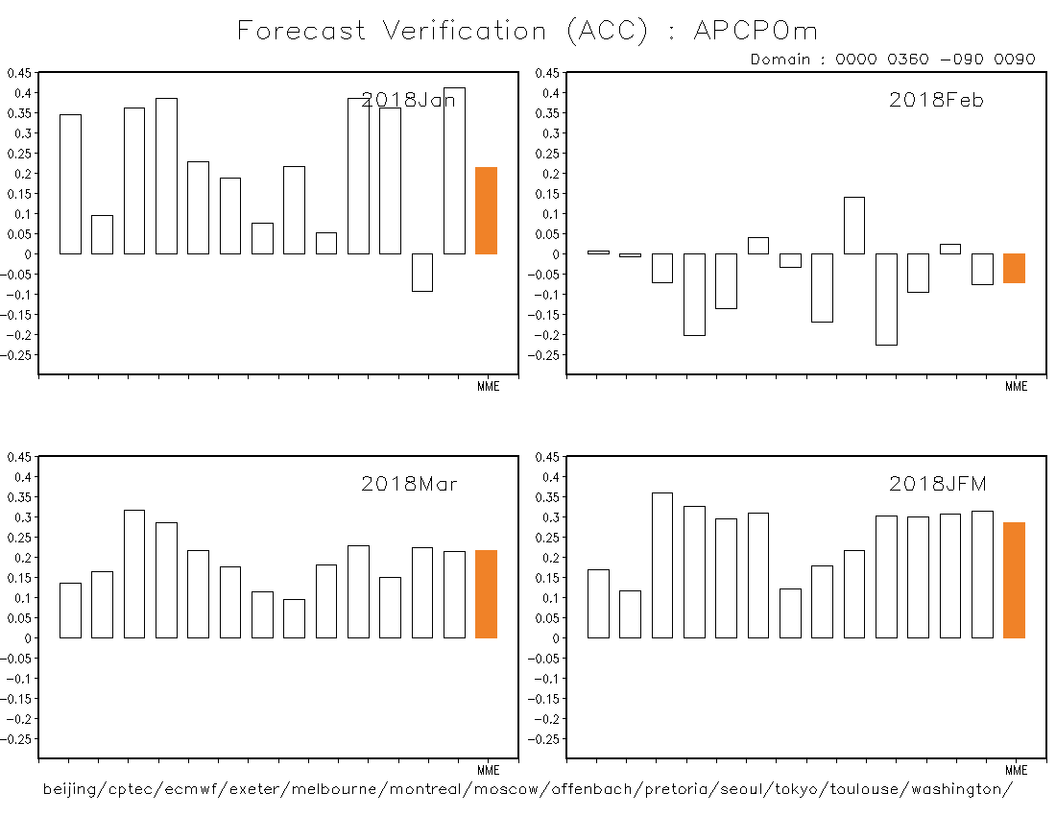

Fig. 1: Anomaly correlation coefficient (ACC) for monthly and seasonal mean precipitation for JFM 2018. Each bar is for forecast from individual GPC; the orange bar is forecast for multi-model ensemble.

3. To develop an assessment of how seasonal forecasts performed over recent months, what are expected skill levels over different regions, identifying possible issues with the forecasts submitted to LC-LRFMME etc., it will be useful to develop an annual summary of LC-LRFMME seasonal forecasts. A record of such annual summaries can be archived at the LC-LRFMME website, and can also be pushed in some form.

4. Such an annual summary will complement similar efforts on climate monitoring (e.g., WMO Statement on the State of the Global Climate; https://public.wmo.int/en/wmo-statement-state-of-global-climate ) and climate attribution (e.g., BAMS annual report on assessment of extreme events; https://www.ametsoc.org/ams/index.cfm/publications/bulletin-of-the-american-meteorological-society-bams/explaining-extreme-events-from-a-climate-perspective/ ).

5. Annual assessment of seasonal forecasts will also complement efforts of Global Seasonal Climate Update (GSCU) and will enhance the visibility of coordinated efforts within WMO.

6. IPET-OPSLS is invited to consider this proposal, and based on discussions, recommend possible follow up actions (e.g., form a sub-team to develop this concept further).

