WORLD METEOROLOGICAL ORGANIZATION  COMMISSION FOR BASIC SYSTEMS  OPAG on DPFS  expert team on emergency response activitIes (et-era)  VIENNA, AUSTRIA, 1 – 5 OCTOBER 2018 |  | CBS-DPFS/ET-ERA/Doc. 5.3(1)  (15.IX.2018)  _______  Agenda item: 5.3  ENGLISH ONLY

Proposed Amendment to the Manual on the GDPFS

(Submitted by the co-Chair)

Summary and purpose of document

Minor modifications are proposed to a few sections of the Manual on the GDPFS to harmonize the texts between nuclear and non-nuclear ERA and to identifiy the specific activity specialization of each RSMCs (nuclear, non-nuclear and backtracking).

Action Proposed

The meeting is invited to discuss the paper and recommend
amendments to the Manual on the GDPFS.

1. Appendix 2.2.23 (nuclear ERA; see Annex 1) in the Manual of the GDPFS covers basic products in section 1 and general rules for displaying products in section 4. For the non-nuclear ERA, the same topics are covered in appendix 2.2.29 (see Annex 2) and attachment 2.2.5 (See Annex 3).

2. The nuclear and non-nuclear texts are in fact very similar. This is not surprising given that the former were used to develop the latter. There is therefore no justification for the differences in the Manual. Another reason for reorganizing some of the texts is that attachment 2.2.5 is at the very end of the Manual and can easily go unnoticed given that the rest of the nuclear and non-nuclear texts are grouped elsewhere.

3. There is another part of the Manual that needs to be modified. Annex 4 is taken from Part III of the Manual and lists the RSMCs designated for the provision of ATDM for EER and/or backtracking. The list does mention of the designation is for nuclear, non-nuclear or backtracking. It would be useful to include that information for each RSMC.

4. Annex 5 shows in track mode the changes proposed to the Manual. In summary, they are:
- Merge the attachment 2.2.5 to appendix 2.2.29 to make is similar to Annex 2.2.23
- Delete attachement 2.2.5 and any reference to it
- Indicate for each RSMC the specific designation(s)

5. Annex 6 shows the text with all the changes accepted.

Actions proposed

The meeting is invited to discuss the paper and recommend amendments to the Manual on the GDPFS.

Reference

Manual on the Global Data-Processing and Forecasting System, 2017 edition (WMO-No.485).

annex 1

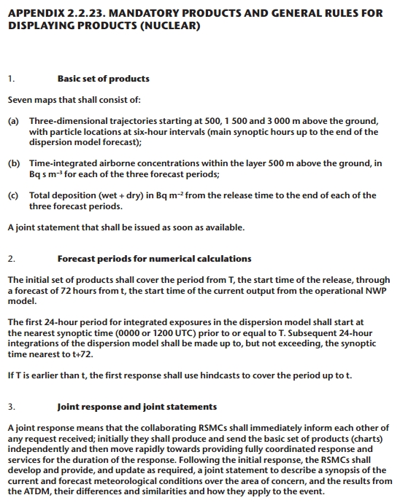
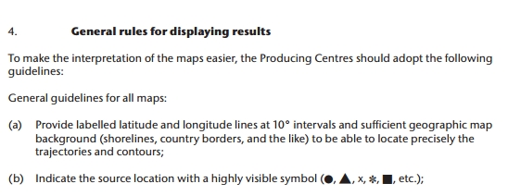
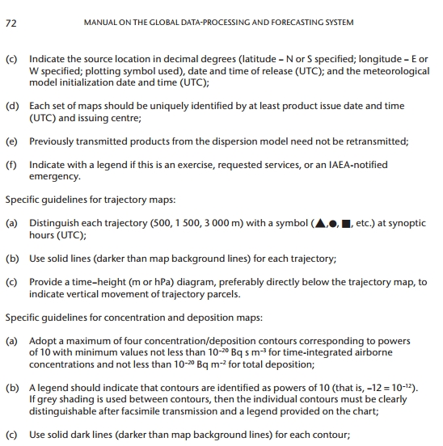

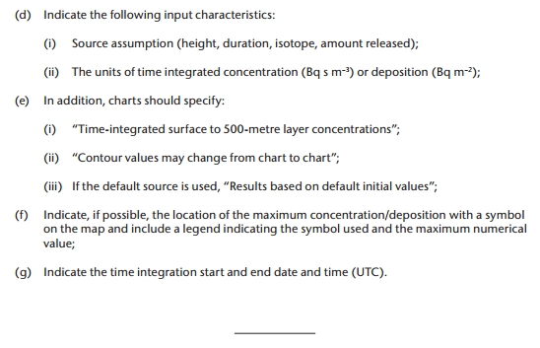

ANNEX 2

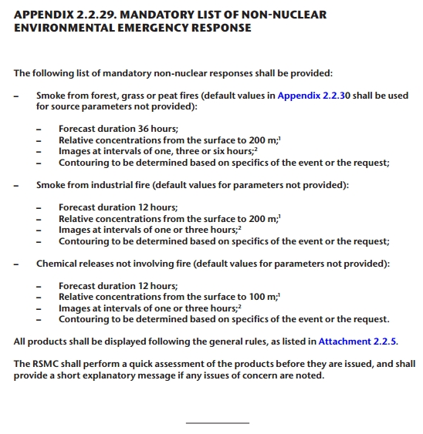

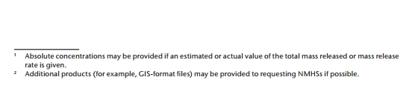

annex 3:

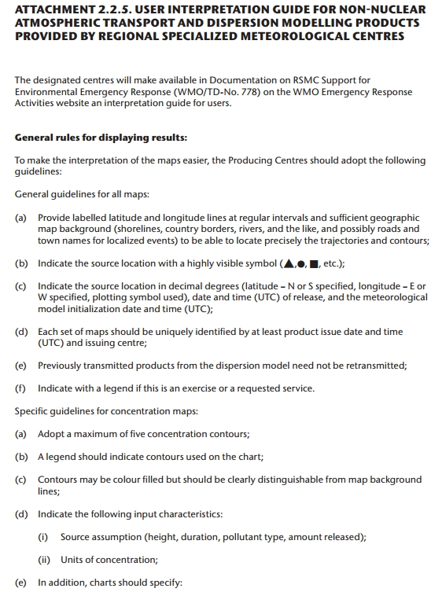

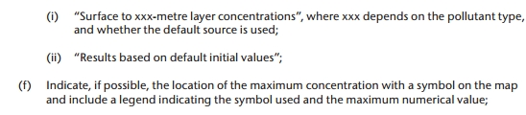

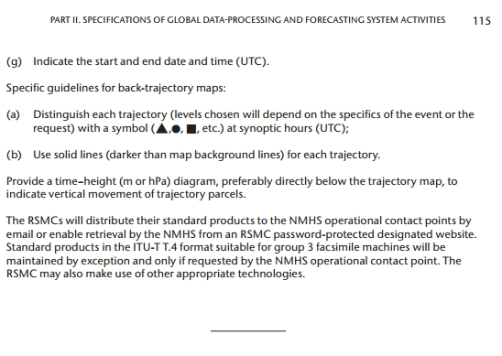
ANNEX 4: From Part III In the Manual

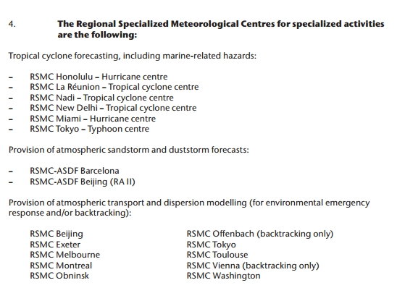

NOTE: EC-70 (June 2018) has since designated RSMCs Offenbach for nuclear and non-nuclear ERA and RSMC Toulouse for non-nuclear ERA.

ANNEX 5: PROPOSED AMENDMENT TO THE MANUAL ON THE GPPFS

2.2.2.8 Non-nuclear environmental emergency response
...
(d) Make available on a website up-to-date information on the characteristics of their ATDM systems (minimum information to be provided is given in Appendix 2.2.31) and a user interpretation guide for ATDM products.

APPENDIX 2.2.29. MANDATORY PRODUCTS AND GENERAL RULES FOR DISPLAYING PRODUCTS (NON-NUCLEAR)
1. The following mandatory non-nuclear products shall be provided:
– Smoke from forest, grass or peat fires (default values in Appendix 2.2.30 shall be used for source parameters not provided):
– Forecast duration 36 hours;
– Relative concentrations from the surface to 200 m;
– Images at intervals of one, three or six hours;
– Contouring to be determined based on specifics of the event or the request;
– Smoke from industrial fire (default values for parameters not provided):
– Forecast duration 12 hours;
– Relative concentrations from the surface to 200 m;1
– Images at intervals of one or three hours;2
– Contouring to be determined based on specifics of the event or the request;
– Chemical releases not involving fire (default values for parameters not provided):
– Forecast duration 12 hours;
– Relative concentrations from the surface to 100 m;1
– Images at intervals of one or three hours;2
– Contouring to be determined based on specifics of the event or the request.

The RSMC shall perform a quick assessment of the products before they are issued, and shall provide a short explanatory message if any issues of concern are noted.

2. General rules for displaying results

The designated centres will make available in Documentation on RSMC Support for Environmental Emergency Response (WMO/TD-No. 778) on the WMO Emergency Response Activities website an interpretation guide for users.

To make the interpretation of the maps easier, the Producing Centres should adopt the following guidelines:
General guidelines for all maps:
(a) Provide labelled latitude and longitude lines at regular intervals and sufficient geographic map background (shorelines, country borders, rivers, and the like, and possibly roads and town names for localized events) to be able to locate precisely the trajectories and contours;
(b) Indicate the source location with a highly visible symbol (▲,●, ■, etc.);
(c) Indicate the source location in decimal degrees (latitude – N or S specified, longitude – E or W specified, plotting symbol used), date and time (UTC) of release, and the meteorological model initialization date and time (UTC);
(d) Each set of maps should be uniquely identified by at least product issue date and time (UTC) and issuing centre;
(e) Previously transmitted products from the dispersion model need not be retransmitted;
(f) Indicate with a legend if this is an exercise or a requested service.
Specific guidelines for concentration maps:
(a) Adopt a maximum of five concentration contours;
(b) A legend should indicate contours used on the chart;
(c) Contours may be colour filled but should be clearly distinguishable from map background lines;
(d) Indicate the following input characteristics:
(i) Source assumption (height, duration, pollutant type, amount released);
(ii) Units of concentration;
(e) In addition, charts should specify:
(i) “Surface to xxx-metre layer concentrations”, where xxx depends on the pollutant type, and whether the default source is used;
(ii) “Results based on default initial values”;
(f) Indicate, if possible, the location of the maximum concentration with a symbol on the map and include a legend indicating the symbol used and the maximum numerical value;
(g) Indicate the start and end date and time (UTC).
Specific guidelines for back-trajectory maps:
(a) Distinguish each trajectory (levels chosen will depend on the specifics of the event or the request) with a symbol (▲,●, ■, etc.) at synoptic hours (UTC);
(b) Use solid lines (darker than map background lines) for each trajectory.
Provide a time–height (m or hPa) diagram, preferably directly below the trajectory map, to indicate vertical movement of trajectory parcels.
The RSMCs will distribute their standard products to the NMHS operational contact points by email or enable retrieval by the NMHS from an RSMC password-protected designated website. Standard products in the ITU-T T.4 format suitable for group 3 facsimile machines will be maintained by exception and only if requested by the NMHS operational contact point. The RSMC may also make use of other appropriate technologies.

PART III, page 117:

4. The Regional Specialized Meteorological Centres for specialized activities are the following:
...
Provision of atmospheric transport and dispersion modelling for environmental emergency response and backtracking (N: nuclear, nN: non-nuclear, B: backtracking):

RSMC Beijing (N) | RSMC Offenbach (N, nN, B)
RSMC Exeter (N, B) | RSMC Tokyo (N, B)
RSMC Melbourne (N, B) | RSMC Toulouse (N, nN, B)
RSMC Montreal (N, B) | RSMC Vienna (B)
RSMC Obninsk (N, B) | RSMC Washington (N, B)

ANNEX 7: PROPOSED AMENDMENT TO THE MANUAL ON THE GPPFS WITH ALL CHANGED ACCEPTED

2.2.2.8 Non-nuclear environmental emergency response
...
(d) Make available on a website up-to-date information on the characteristics of their ATDM systems (minimum information to be provided is given in Appendix 2.2.31) and a user interpretation guide for ATDM products.

APPENDIX 2.2.29. MANDATORY PRODUCTS AND GENERAL RULES FOR DISPLAYING PRODUCTS (NON-NUCLEAR)
1. The following mandatory non-nuclear products shall be provided:
– Smoke from forest, grass or peat fires (default values in Appendix 2.2.30 shall be used for source parameters not provided):
– Forecast duration 36 hours;
– Relative concentrations from the surface to 200 m;¹
– Images at intervals of one, three or six hours;²
– Contouring to be determined based on specifics of the event or the request;
– Smoke from industrial fire (default values for parameters not provided):
– Forecast duration 12 hours;
– Relative concentrations from the surface to 200 m;1
– Images at intervals of one or three hours;2
– Contouring to be determined based on specifics of the event or the request;
– Chemical releases not involving fire (default values for parameters not provided):
– Forecast duration 12 hours;
– Relative concentrations from the surface to 100 m;1
– Images at intervals of one or three hours;2
– Contouring to be determined based on specifics of the event or the request.
The RSMC shall perform a quick assessment of the products before they are issued, and shall provide a short explanatory message if any issues of concern are noted.

2. General rules for displaying results

The designated centres will make available in Documentation on RSMC Support for Environmental Emergency Response (WMO/TD-No. 778) on the WMO Emergency Response Activities website an interpretation guide for users.

To make the interpretation of the maps easier, the Producing Centres should adopt the following guidelines:
General guidelines for all maps:
(a) Provide labelled latitude and longitude lines at regular intervals and sufficient geographic map background (shorelines, country borders, rivers, and the like, and possibly roads and town names for localized events) to be able to locate precisely the trajectories and contours;
(b) Indicate the source location with a highly visible symbol (▲,●, ■, etc.);
(c) Indicate the source location in decimal degrees (latitude – N or S specified, longitude – E or W specified, plotting symbol used), date and time (UTC) of release, and the meteorological model initialization date and time (UTC);
(d) Each set of maps should be uniquely identified by at least product issue date and time (UTC) and issuing centre;
(e) Previously transmitted products from the dispersion model need not be retransmitted;
(f) Indicate with a legend if this is an exercise or a requested service.
Specific guidelines for concentration maps:
(a) Adopt a maximum of five concentration contours;
(b) A legend should indicate contours used on the chart;
(c) Contours may be colour filled but should be clearly distinguishable from map background lines;
(d) Indicate the following input characteristics:
(i) Source assumption (height, duration, pollutant type, amount released);
(ii) Units of concentration;
(e) In addition, charts should specify:
(i) “Surface to xxx-metre layer concentrations”, where xxx depends on the pollutant type, and whether the default source is used;
(ii) “Results based on default initial values”;
(f) Indicate, if possible, the location of the maximum concentration with a symbol on the map and include a legend indicating the symbol used and the maximum numerical value;
(g) Indicate the start and end date and time (UTC).
Specific guidelines for back-trajectory maps:
(a) Distinguish each trajectory (levels chosen will depend on the specifics of the event or the request) with a symbol (▲,●, ■, etc.) at synoptic hours (UTC);
(b) Use solid lines (darker than map background lines) for each trajectory.
Provide a time–height (m or hPa) diagram, preferably directly below the trajectory map, to indicate vertical movement of trajectory parcels.
The RSMCs will distribute their standard products to the NMHS operational contact points by email or enable retrieval by the NMHS from an RSMC password-protected designated website. Standard products in the ITU-T T.4 format suitable for group 3 facsimile machines will be maintained by exception and only if requested by the NMHS operational contact point. The RSMC may also make use of other appropriate technologies.

PART III, page 117:

4. The Regional Specialized Meteorological Centres for specialized activities are the following:
...
Provision of atmospheric transport and dispersion modelling for environmental emergency response and backtracking (N: nuclear, nN: non-nuclear, B: backtracking):

RSMC Beijing (N) | RSMC Offenbach (N, nN, B)
RSMC Exeter (N, B) | RSMC Tokyo (N, B)
RSMC Melbourne (N, B) | RSMC Toulouse (N, nN, B)
RSMC Montreal (N, B) | RSMC Vienna (B)
RSMC Obninsk (N, B) | RSMC Washington (N, B)

Absolute concentrations may be provided if an estimated or actual value of the total mass released or mass release rate is given.
Additional products (for example, GIS-format files) may be provided to requesting NMHSs if possible.
¹ Absolute concentrations may be provided if an estimated or actual value of the total mass released or mass release rate is given.
² Additional products (for example, GIS-format files) may be provided to requesting NMHSs if possible.

