WORLD METEOROLOGICAL ORGANIZATION  COMMISSION FOR BASIC SYSTEMS  OPAG on DPFS  EXPERT TEAM ON EMERGENCY RESPONSE ACTIVITIES (ET-ERA)  VIENNA, AUSTRIA, 1-5 OCTOBER 2018 |  | CBS-DPFS/ET-ERA/Doc. 5.2(1)  (18.IX.2018)  _______  Agenda item : 5.2  ENGLISH ONLY

Application of RSMC / RTH Offenbach to become a RSMC for Non-Nuclear Emergency Response – Capabilities and Future Challenges

(Submitted by Jochen Förstner, RSMC / RTH Offenbach)

Summary and purpose of document

This document provides background information on the application of RSMC / RTH Offenbach to become a RSMC for Non-Nuclear Environmental Emergency Response. It will summarize the capabilities of the online-coupled dispersion modeling system ICON-ART used at DWD. Furthermore, views on how to progress in the area of non-nuclear emergency response and thoughts on future challenges are given.

Action Proposed

The meeting is invited to review the summary for their information.

1. Introduction

The submission of DWD’s application to the WMO ET-ERA group for consideration took place in Q1/2018. After valuable comments from the chair and co-chair respectively the group and some iteration of the application document it got the approval by the President of WMO RA VI before finally being approved by WMO EC-70 in June (Reference: section 4 in document EC-70-d08(1)).

2. The online-coupled dispersion modeling system ICON-ART at DWD

The main aspects of the non-hydrostatic atmospheric modelling framework ICON (Zängl et al. 2015) and ICON-ART (Rieger et al. 2015) and the implementation status of the system are already given in the document on DWD’s application to become a RSMC for Nuclear Emergency Response under agenda item 4.2. Please refer to the according sections in that document.

This document will highlight the aspects which are of special interest with respect to non-nuclear emergency response.

The non-nuclear emergencies listed in the WMO manual are smoke from vegetation fires, smoke from industrial fire and chemical releases not involving fire. The use cases differ in the requested forecast durations (vegetation fire: 36 h, industrial hazards: 12 h) and therefore implicitly in the envisioned regional scale for the hazard. Especially for the industrial hazards a high-resolution forecast on a limited area is to be asked for.

In this respect two capabilities of ICON, respectively of the dispersion modeling system ICON-ART which inherits these capabilities, are of particular interest.
The first one is the option to employ mesh refinement in form of two-way nests for specific geographical regions, e.g. among other reasons to better resolve local topographical effects.
The second one is the option to run the model in a limited area mode (LAM). It is planned at DWD to replace the current regional model COSMO-D2 with ICON-LAM on the D2 domain (Figure 1) at a resolution of approximately 2 km in 2020. The first application of ICON-ART-LAM in Q1/2020 will be the pollen forecast on a European domain at 6.5 km resolution.
For both options time is a serious constraint in case of an emergency. The grid definition and external parameters for the individual nest region or limited area domain must be available. For the latter option boundary data must be provided in addition. Both options can be combined, i.e. it is possible to have nests also in the limited area mode.
In principle it is possible to start a nest region during runtime, but it is more convenient to start from available analysis and first guess fields. At the moment the dispersion simulations would be done using the grid configuration of the current global operational NWP at DWD, i.e. at a resolution of 13 km.

With the operational implementation of ICON-LAM at DWD initial and boundary data will be available at least on an hourly basis for the domain given in Figure 1.

The system is highly configurable for a wide range of applications (Schröter et al. 2018) via XML files, where tracers including their specific metadata as well as emission sources can be defined, while in general there is no need to recompile the code.
The emission scenario is as well specified in an XML file and read in by ICON-ART. The file consists of one or more source definitions for specific points, where the start and end time, the bottom and top height, the released substance and its source strength are specified. In addition, a vertical profile in relation to a normalized height can be specified. The formula for the profile is parsed within ICON. For the realization of areal emissions, a set of sources for the grid points covering the requested area can be specified.

Smoke from vegetation fires needs some special thoughts since operational systems are available. Most likely this topic will be addressed under agenda item 5.5.
Some information on DWD’s own plans in this area will be given below.

3. Examples of products for non-nuclear environmental emergency response

In DWD’s application to become a RSMC for Non-Nuclear Emergency Response examples for two of the three use cases were given.
A high-resolution simulation for the tracer dispersion related to a fire in an industrial compound and the dispersion of smoke from forest fires in a given area – both examples are based on real events.
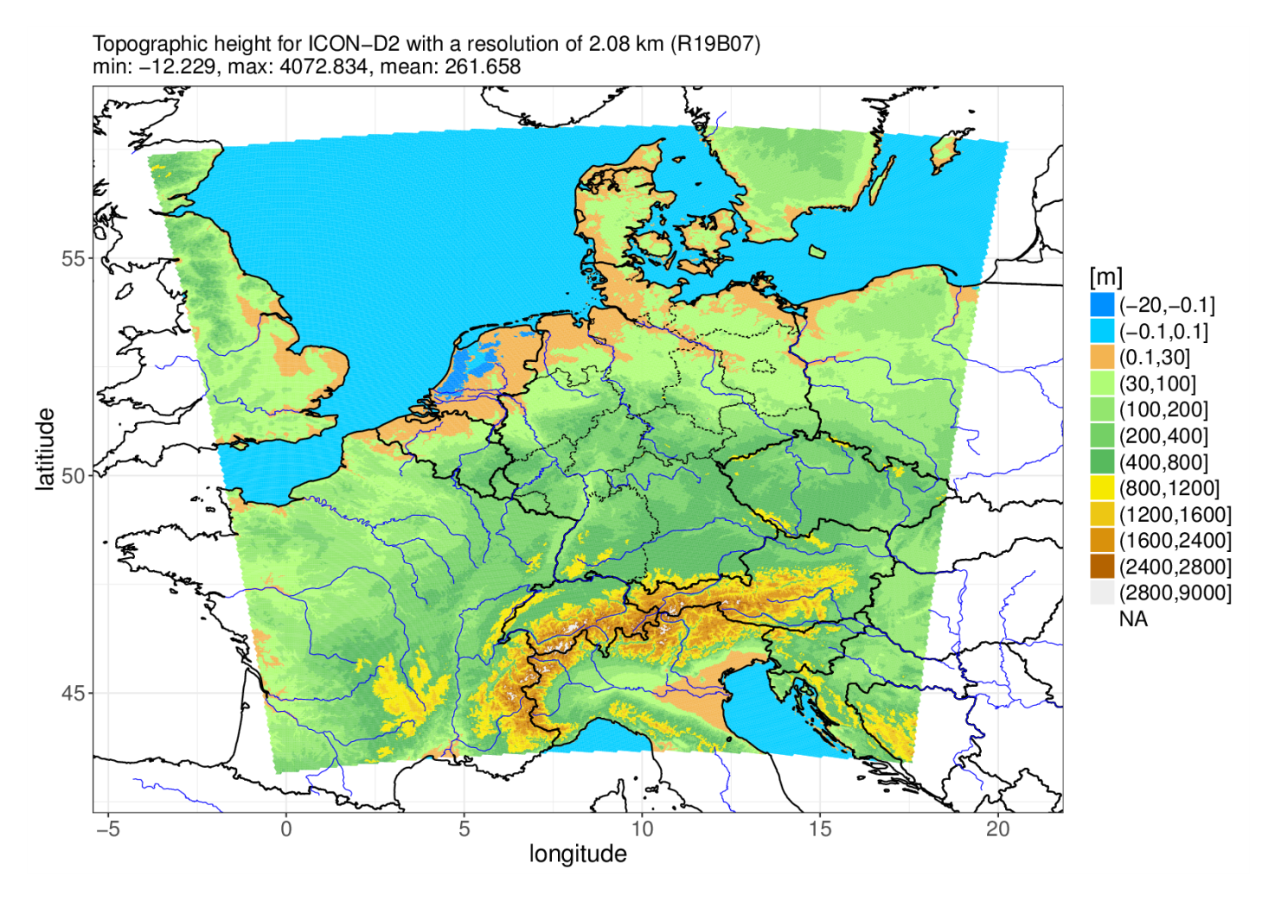
Figure 1: Illustration of planned domain for ICON-D2. Shown is the topographic height in meters.
A dispersion simulation for a chemical release not involving a fire would be carried out in similar way to the first example. According to the list of mandatory products given in Appendix 2.2.29 of the Manual on GDPFS relative concentrations for the layer surface to 100 m (instead of 200 m) would be provided for such a case.

For convenience only a few figures from the application document will be shown. Please refer to the application document for further details.

- Release of a tracer from an industrial compound in Ludwigshafen, Germany on 17 October 2016 (Figure 2).
The result shown is from a simulation run of ICON-ART in limited area mode on a nested subdomain of the domain given in Figure 1 with a resolution of approximately 1 km.
The visualization is done using data on the original triangular grid of ICON.

- Smoke from forest fires in the area of Pedrógão Grande, Portugal which started in the night of 17–18 June 2017 (Figure 3). Results from two different simulation runs are shown which in addition have been visualized in different ways.
Left panel: Result for a global simulation at a resolution of 40 km. The analysis data is taken from an arbitrary member of DWD’s ICON-EPS system. The visualization is done using data on the original triangular grid of ICON.
Right panel: Result for a global simulation at a resolution of 13 km. The analysis data is taken from DWD’s operational deterministic run of ICON. The visualization is done using data interpolated on a 0.25x0.25° lat/lon grid.

The visualization in the right panel follows the guidelines for displaying concentration maps given in Appendix 2.2.23 of the Manual on GDPFS for nuclear environmental emergency response.

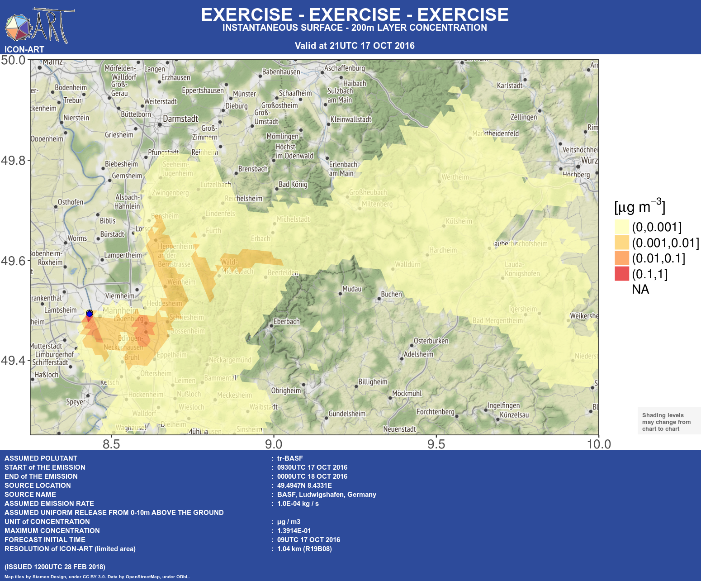
Figure 3: Instantaneous concentration averaged in the layer surface to 200 meters of a smoke tracer released at 0000 UTC 18 JUN 2017 for 12 UTC 19 June 2017.
Figure 2: Instantaneous concentration averaged in the layer surface to 200 meters of a tracer released at 0930 UTC 17 OCT 2016 for 21 UTC 17 October 2016.
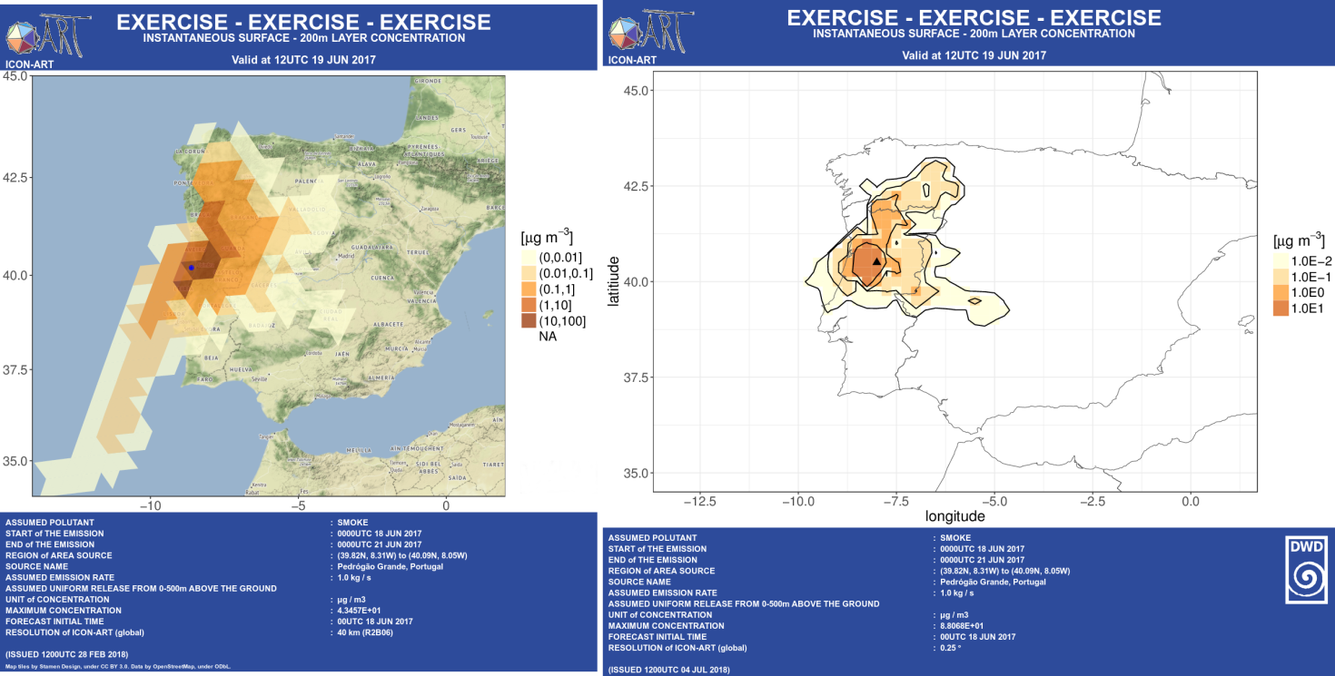

4. Views on on how to progress in the area of non-nuclear emergency response

First of all we do not have to reinvent the wheel. Instead, the non-nuclear ERA program should inherit procedures which have been already established for nuclear ERA for quite some time.
Most notably the implementation of regular exercises and the possibility to share results on RSMC mirrored websites.

With respect to the desired high-resolution dispersion simulation for a limited area, it will be difficult to provide such a forecast for arbitrary regions on the globe. This might be due to the lack of highly resolved NWP data or respectively external parameter data for the desired area. Most likely exercises with emission scenarios outside the area of responsibility of the individual RSMC can only be carried out based on global NWP data.

The request form to activate RSMC support for non-nuclear environmental emergency response given in Appendix 2.2.32 of the Manual on GDPFS includes the option to provide the name or type of the pollutant(s) to be modeled. As examples smoke, natural gas, SO₂ are given. But it is not clear, if the different substances should be treated in different ways in the actual dispersion simulation. At least with respect to visualization different concentration thresholds should be applied to show areas of potential danger for human health. Another potential threshold is related to the minimum concentration necessary to discern a pollutant by the sense of smell.
If the released quantity and the substance(s) are known, there is an option in the request form to specify concentration levels for the output. To do so, the requesting party needs quite some basic knowledge. Instead it might be worthwhile to think about the implementation of a list of pollutant(s) together with their specific concentration thresholds.

Furthermore, what about the release of pollutants in liquid phase? For example, the evaporation rate could be calculated based on chemical properties and atmospheric conditions (Kawamura and Mackay 1987).

5. Future challenges and developments

A challenge will be to implementation of procedures to provide higher resolution forecasts in the area of responsibility of RSMC Offenbach. In particular the possibility to switch on mesh refinement in the form of two-way nests during runtime might be a good way to tackle this task. This needs serious planning with respect to the provision of the necessary external datasets and computational resources.

As already mentioned in section 2 DWD has plans for the operationalization of the forecast of aerosols from vegetation fires. In a current project the routine forecast of mineral dust is realized based on the ICON-ART system. In a follow-up project which has still to be applied for and approved, the operational system shall be extended by other aerosol types in about five to six years.
The functionality to simulate aerosols from vegetation fires was first implemented by colleagues at the Karlsruhe Institute for Technology (KIT) in the modeling system COSMO-ART. The model includes a plume rise model and the parameterization of emission fluxes based on the fire radiative power (FRP) product from the MODIS satellites Aqua and Terra (Walter et al. 2016). At KIT the routines are currently being ported to the ICON-ART system.
With the availability of global routine forecasts of aerosol concentrations from vegetation fires and the provision of such products the requests for on-demand dispersion simulations of the related non-nuclear environmental emergency response use case will likely to become less important in future.

References

Kawamura, P. I., and Mackay, D.: The evaporation of volatile liquids. Journal of hazardous Materials, 15(3), 343-364, 1987.

Rieger, D., Bangert, M., Bischoff-Gauss, I., Förstner, J., Lundgren, K., Reinert, D., Schröter, J., Vogel, H., Zängl, G., Ruhnke, R., and Vogel, B.: ICON–ART 1.0 – a new online-coupled model system from the global to regional scale, Geosci. Model Dev., 8, 1659–1676, doi:10.5194/gmd-8-1659-2015, 2015.

Schröter, J., Rieger, D., Stassen, C., Vogel, H., Weimer, M., Werchner, S., Förstner, J., Prill, F., Reinert, D., Zängl, G., Giorgetta, M., Ruhnke, R., Vogel, B., and Braesicke, P.: ICON-ART 2.1 – A flexible tracer framework and its application for composition studies in numerical weather forecasting and climate simulations, Geosci. Model Dev. Discuss., https://doi.org/10.5194/gmd-2017-286, accepted for final publication, 2018.

Walter, C., Freitas, S. R., Kottmeier, C., Kraut, I., Rieger, D., Vogel, H., and Vogel, B.: The importance of plume rise on the concentrations and atmospheric impacts of biomass burning aerosol, Atmos. Chem. Phys., 16, 9201-9219, https://doi.org/10.5194/acp-16-9201-2016, 2016.

Zängl, G., Reinert, D., Rípodas, P., and Baldauf, M.: The ICON (ICOsahedral Non-hydrostatic) modelling framework of DWD and MPI-M: Description of the non-hydrostatic dynamical core, Q. J. Roy. Meteor. Soc., 141, 563–579, doi:10.1002/qj.2378, 201

