WORLD METEOROLOGICAL ORGANIZATION  COMMISSION FOR BASIC SYSTEMS  OPAG on DPFS  EXPERT TEAM ON EMERGENCY RESPONSE ACTIVITIES (ET-ERA)  VIENNA, AUSTRIA, 1-5 OCTOBER 2018 |  | CBS-DPFS/ET-ERA/Doc. 4.2(7)  (17.IX.2018)  _______  Agenda item : 4.2  ENGLISH ONLY

Application of RSMC / RTH Offenbach to become a RSMC for Nuclear Emergency Response – Overview and Current Status

(Submitted by Jochen Förstner, RSMC / RTH Offenbach)

Summary and purpose of document

This document provides background information on the application of RSMC / RTH Offenbach to become a RSMC for Nuclear Environmental Emergency Response. It will summarize the main aspects of the online-coupled dispersion modeling system ICON-ART used at DWD. Furthermore the current status and missing steps towards the full operationalization of the system are discussed. Finally some information and thoughts on future developments are given.

Action Proposed

The meeting is invited to review the summary for their information.

1. Introduction

The submission of DWD’s application to the WMO ET-ERA group for consideration took place in Q1/2018. After valuable comments from the chair and co-chair respectively the group and some iteration of the application document it got the approval by the President of WMO RA VI before finally being approved by WMO EC-70 in June (Reference: section 4 in document EC-70-d08(1)).

2. The online-coupled dispersion modeling system ICON-ART at DWD

ICON-ART (Rieger et al. 2015) is developed in close collaboration between DWD and the Karlsruhe Institute for Technology (KIT). It is used at DWD for a variety of applications related to atmospheric dispersion modelling and inherits a number of advantageous features of the underlying numerical weather prediction (NWP) system ICON, e.g. mesh refinement via two-way coupled nests for areas of specific interest. As an online-coupled atmospheric dispersion model it allows for the interaction between the tracers and the simulated meteorological state of the atmosphere during the forecast integration. ICON-ART operates at the same grid resolution as the NWP model in which it is embedded and uses the same algorithms for tracer advection and diffusion as employed for other atmospheric constituents (e.g. hydrometeors). Because of this harmonized approach ICON-ART benefits from the full flexibility and continuous improvement of the underlying non-hydrostatic atmospheric modelling framework ICON (Zängl et al. 2015).

DWD employs ICON as a global operational NWP model with a two-way nested mesh refinement for the European region. In the operational NWP configuration, a mesh of 13 km resolution is used on the global domain, whereas the European sub-domain is covered by a mesh with 6.5 km distance between grid points.

The system is highly configurable for a wide range of applications (Schröter et al. 2018) via XML files, where tracers including their specific metadata as well as emission sources can be defined, while in general there is no need to recompile the code.

Apart from the RSMC functionalities the main applications of the system at DWD include volcanic ash dispersion forecasts for aviation in case of an emergency affecting the European respectively German air space and the global forecast of mineral dust. The later includes the direct aerosol effect on radiation and aims at a better forecast of the direct and diffuse short wave fluxes at the surface in order to improve the forecast of photovoltaic power production in Germany.

The capability of ICON to employ nests for specific geographical regions might be of particular interest due to the fact that in the case of nuclear accidents the source of atmospheric contaminants is very localized. But in this respect time is a serious constraint in case of an emergency. The grid definition and external parameters for the individual nest region have to be available. In principle it is possible to start a nest region during runtime, while it is more convenient to start from available analysis and first guess fields. So in general ICON-ART will use the same grid configuration as the operational global NWP model of DWD.

3. Generation of products for nuclear environmental emergency response

A set of products is shown in DWD’s application. It was decided to run the scenarios of the ConvEx-3 exercise of 21/22 June 2017. While not mandatory yet, the “Time of Arrival” test products were prepared as well.

Base for the mandatory products are runs of DWD’s trajectory model and a global 72 h run of ICON-ART at a resolution of approximately 13 km. The trajectory calculations use the output of the operational ICON NWP run on a global 0.25x0.25° lat/lon grid for the same initial time as the one used for the dispersion simulation. The 72 h forecast takes about 35 min on Cray XC40 HPC system. Some thoughts on ways to speed up the production are given below.

So far DWD participated in the two quarterly exercises on 15 May and 21 August 2017. For the first exercise in May products were sent per E-Mail to RSMCs Exeter and Toulouse, while for the second one in August they were uploaded to the test RSMC webpage at NOAA implemented by Glenn Rolph. Thanks to Glenn for his great support!

Both exercises were valuable and revealed shortcomings of the procedures established so far at DWD.
During the first exercise the dispersion run was based on the default scenario given in the WMO manual. Lesson learned was that the USIE exercise EMERCON report does not give all details of the exercise scenario at hand. After e-mail communication with Anton Muscat the runs were redone based on the real exercise scenario.
As for the second exercise there was a misunderstanding of the following paragraph in the WMO manual:

2. Forecast periods for numerical calculations

The initial set of products shall cover the period from T, the start time of the release, through a forecast of 72 hours from t, the start time of the current output from the operational NWP model.
The first 24-hour period for integrated exposures in the dispersion model shall start at the nearest synoptic time (0000 or 1200 UTC) prior to or equal to T. Subsequent 24-hour integrations of the dispersion model shall be made up to, but not exceeding, the synoptic time nearest to t+72.

In the meantime, it has been clarified (personal communication with Anton Muscat), that the most recent forecast (NWP) run should be used, and only the output should start at the nearest synoptic time (0000UTC or 1200UTC) to T, the start of the release. The misunderstanding led to a retardation of approximately one hour. Nevertheless, the products of the dispersion calculation were ready about two hours after reception of the request.
Further delay was related to the visualization of the trajectory run, more specifically the data format used and the placement of markers at the main synoptic hours if the trajectory calculation does not start at a full hour as in the August exercise. The problems are fixed and as an example the trajectory product for this exercise is given in Figure 1.

4. Current status and steps toward full operationalization

Scripts for automatic postprocessing of the trajectory data and the dispersion model data as well as the generation of the set of mandatory products have been developed. The operational implementation of these scripts has still to be done.
The emission scenario is specified in an XML file and read in by ICON-ART. At the moment this file is generated in a text editor. For the operators a browser-based GUI will be provided. Such a GUI already exists at DWD for the volcanic ash application and the forms for the RSMC nuclear emergency response have to be implemented accordingly.
A web server for the RSMC mirror web page based on the scripts provided by Glenn Rolph from NOAA will be set up at DWD.
Operators at DWD have to be instructed about their responsibilities in case of request. Followed by a testing and training phase of the system.

A coordination group as well as a working group has been established at DWD to tackle these tasks. DWD aims at an operationalization in Q1/2019.

5. Future developments

In addition to the nesting functionality of ICON, the model can also be run in a limited area mode (LAM). It is planned at DWD to replace the current regional model COSMO-D2 with ICON-LAM in 2020. The first application of ICON-ART-LAM will be the pollen forecast on a European domain at 6.5 km resolution. Instead of a global forecast, a LAM forecast might be a feasible option for nuclear emergency response and might save time. This has to be elicited.
There are options to save computing time with respect to tracer transport. E.g. through the use of a cheaper flux limiter and the restriction of the transport to model level up to a given height. The option for the later measurement has just been implemented.
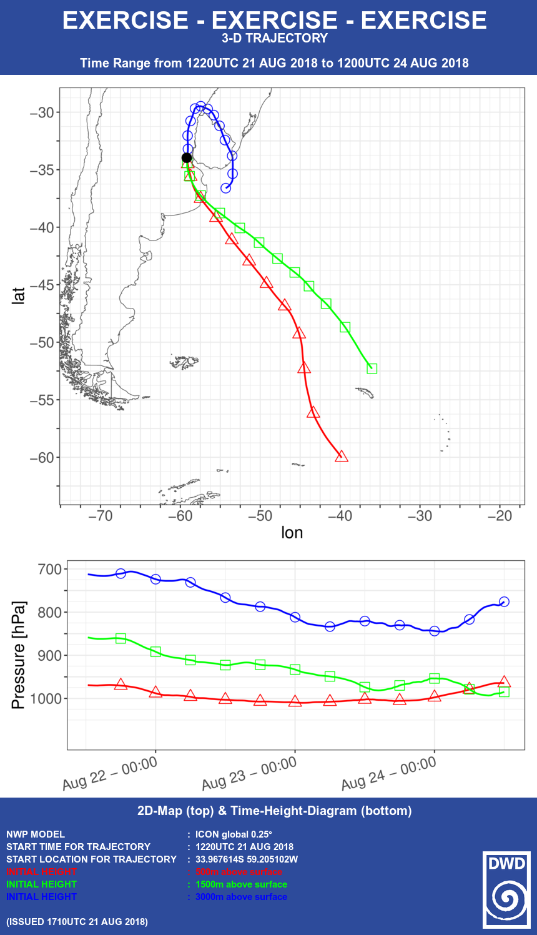

References
Figure 1: Chart showing forward trajectories starting at heights of 500, 1500 and 3000 m above ground level.

Rieger, D., Bangert, M., Bischoff-Gauss, I., Förstner, J., Lundgren, K., Reinert, D., Schröter, J., Vogel, H., Zängl, G., Ruhnke, R., and Vogel, B.: ICON–ART 1.0 – a new online-coupled model system from the global to regional scale, Geosci. Model Dev., 8, 1659–1676, doi:10.5194/gmd-8-1659-2015, 2015.

Schröter, J., Rieger, D., Stassen, C., Vogel, H., Weimer, M., Werchner, S., Förstner, J., Prill, F., Reinert, D., Zängl, G., Giorgetta, M., Ruhnke, R., Vogel, B., and Braesicke, P.: ICON-ART 2.1 – A flexible tracer framework and its application for composition studies in numerical weather forecasting and climate simulations, Geosci. Model Dev. Discuss., https://doi.org/10.5194/gmd-2017-286, accepted for final publication, 2018.

Zängl, G., Reinert, D., Rípodas, P., and Baldauf, M.: The ICON (ICOsahedral Non-hydrostatic) modelling framework of DWD and MPI-M: Description of the non-hydrostatic dynamical core, Q. J. Roy. Meteor. Soc., 141, 563–579, doi:10.1002/qj.2378, 20

