WORLD METEOROLOGICAL ORGANIZATION  COMMISSION FOR BASIC SYSTEMS  OPAG on DPFS  EXPERT TEAM ON EMERGENCY RESPONSE ACTIVITIES (ET-ERA)  VIENNA, AUSTRIA, 1-5 OCTOBER 2018 |  | CBS-DPFS/ET-ERA/Doc. 4.2 (11)  (1.10.2018)  _______  Agenda item : 4.2  ENGLISH ONLY

NMS Argentina Results and Analysis from nuclear exercises

(Soledad Osores and Martina Suaya)

Summary and purpose of document

This document provides analysis and discussion from two nuclear accidents exercises involving NMS Argentina and RSMC Montreal and Washington

Action Proposed

The meeting is invited to revise the results of the exercise and discuss possible amendments in procedures and standards on manual GDPFS

Reference: -

- Introduction

NMS Argentina performs annual exercises following National Nuclear Authority requests. Argentina has at the present time two nuclear power plants providing 24/7 energy to the country: Atucha (with two operational reactors) and Central Embalse. Additionally there other two locations dedicated to research and others in Ezeiza and Bariloche.

The exercise in 2017 involved Nuclear Plant Atucha, while Central Embalse was chosen for the 2018 exercise.

The exercises proposes by the National Authority starts near 9 am (local time) with information to the Forecast officer on duty about an ongoing crisis with or without emissions. If emissions are present they sent the appropriate request form soliciting large scale ATDM modelling and giving details about time, location and isotopes emitted. This form is forward asap to RSMC Montreal and RSMC Washington as well. Simultaneously there are other actions taken by NMS and the emergency procedures run by the National Nuclear Authority. The exercise finishes around 12pm with canceletion messages. There`s no new or additional information or updates provided in the meantime.

- Results

For both exercises RSMCs answer the requests in the two hours time lapse (actually within the hour) and results are displayed at the mirror web page. At the last simulation a phone call was necessary to confirm the request because some emails delays where detected.

Request Form from 2017 | Request Form from 2018
STATUS: EXERCISE Date/time of request: 2/11/2018 10:30(UTC)  NAME OF DELEGATED AUTHORITY: NUCLEAR REGULATORY AUTHORITY  COUNTRY: REPUBLICA ARGENTINA  NAME OF RELEASE SITE: CENTRAL NUCLEAR ATUCHA– PROVINCIA DE BUENOS AIRES (facility and place)  GEOGRAPHICAL LOCATION OF RELEASE: (lat./long. decimal degrees)  RELEASE CHARACTERISTICS:  START OF RELEASE: 02/11/2017, 13:00 UTC  DURATION: 0,5 (hours) or end of release  RADIONUCLIDE SPECIES: Please see attached page.  TOTAL RELEASE QUANTITY: 5,53 E+17.(Becquerel)  OR POLLUTANT RELEASE RATE: . . . . . . . . . . . . . . .. . . . . . . . . . . . . ……………………….(Becquerel/hour)  EFFECTIVE HEIGHT OF RELEASE: Surface: . . . . . . . . . . . . . .. . . . . . . . . . . . . . . . . . . . . . . . . .or  Stack height: 40 (m)  SITE ELEVATION: 45 (m)  LOCAL METEOROLOGICAL CONDITIONS NEAR ACCIDENT:  wind speed at 10 m height: 4m/s direction: N Stability class: D  OTHER INFORMATION: . . . . . . . . . . . . . . . . . . . . . . . . . . . . . . . . . . . . . . . . . . . . . . . . . . . . . . . . . . . . . . . . . . . . . . . . . . . . . . . . . .  Nuclide Amount Units  Kr-85 2.56E+14 Bq  Kr-85m 3.22E+16 Bq  Kr-87 6.18E+16 Bq  Kr-88 8.70E+16 Bq  Xe-133 2.34E+17 Bq  Xe-135 1.17E+16 Bq  I-131 1.17E+16 Bq  I-132 1.72E+16 Bq  I-133 2.42E+16 Bq  I-134 2.64E+16 Bq  I-135 2.26E+16 Bq  Cs-136 2.10E+14 Bq  Cs-137 2.54E+14 Bq  Te-127 1.16E+15 Bq  Te- 127m 9.36E+13 Bq  Te-129 3.70E+15 Bq  Te- 129m 5.18E+14 Bq  Te-131m 1.77E+15 Bq  Te-132 1.67E+16 Bq | STATUS: EXERCISE Date/time of request: 27/09/2018 12:00(UTC)  NAME OF DELEGATED AUTHORITY: NUCLEAR REGULATORY AUTHORITY  COUNTRY: REPUBLICA ARGENTINA  NAME OF RELEASE SITE: CENTRAL NUCLEAR EMBALSE– PROVINCIA DE CORDOBA (facility and place)  GEOGRAPHICAL LOCATION OF RELEASE: 32.233527 S / 64.44333 W (lat./long. decimal degrees)  START OF RELEASE:27/09/2018, 11:30 UTC  DURATION: 0.5 (hours) or end of release  RADIONUCLIDE SPECIES: IODINE (SEE ATTACHED)  TOTAL RELEASE QUANTITY:9.10792E+16.(Becquerel)  OR POLLUTANT RELEASE RATE: . . . . . . . . . . . . . . .. . . . . . . . . . . . . . . . ……………………….(Becquerel/hour)  EFFECTIVE HEIGHT OF RELEASE: Surface: . . . . . . . . . . . . . .. . . . . . . . . . . . . . . . . . . . . . . . . .or  Stack height: 70(m), or  SITE ELEVATION: 665 (m)  LOCAL METEOROLOGICAL CONDITIONS NEAR ACCIDENT: wind speed at 10 m height: 4m/s. . . . . . . . . . . . . . . . .  winddirection: 22, 5º / NO PRECIPITATION / STABILITY CLASS: C . . . . . . . . . . . . . . . . . . . . . . . . . . . . . . . . . . . . . . . . . .  Nuclide Amount Units  I-131 1.04192E+16 Bq  I-132 1.51515E+16 Bq  I-133 2.1719E+16 Bq  I-134 2.3643E+16 Bq  I-135 2.01465E+16 Bq

After this two forms we received the following ATDM forecasts from the two Centres where delivered:

 | RSMC WASHINTON | .RSMC MONTREAL
2017  Atucha Nuclear Power Plant  Exercise | 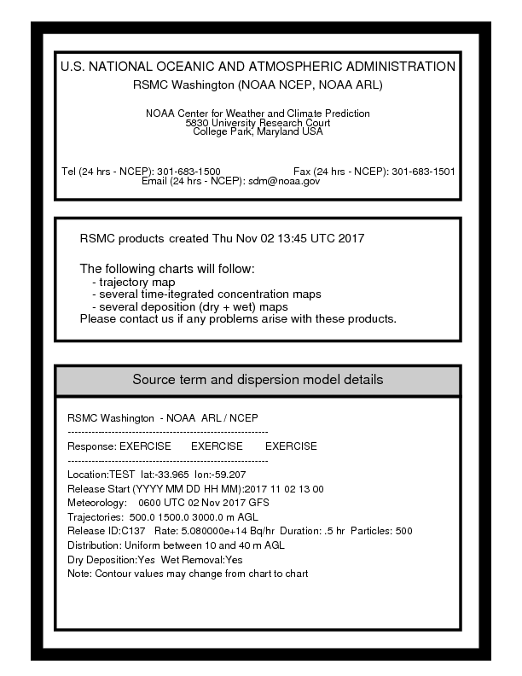 | 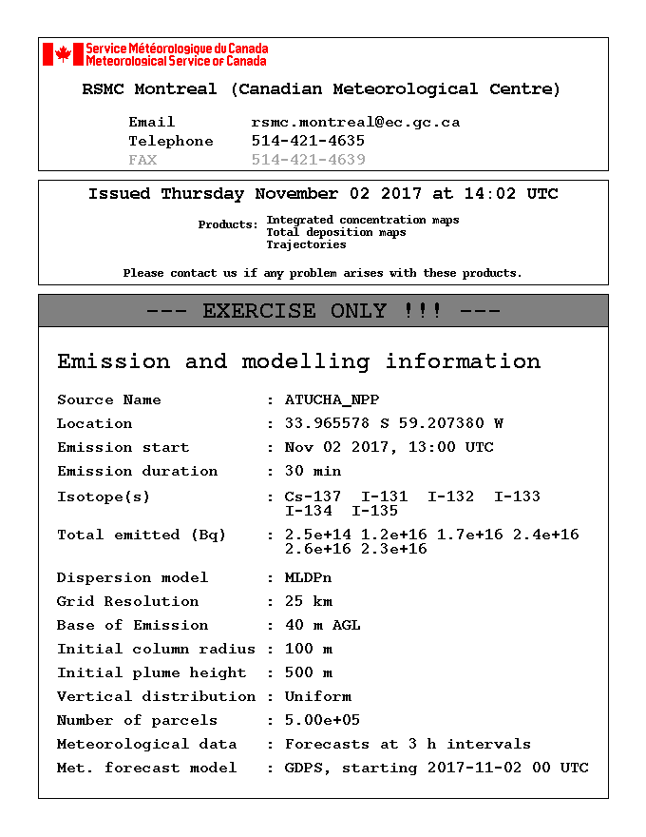
2018  Embalse Power Plant  Exercise | 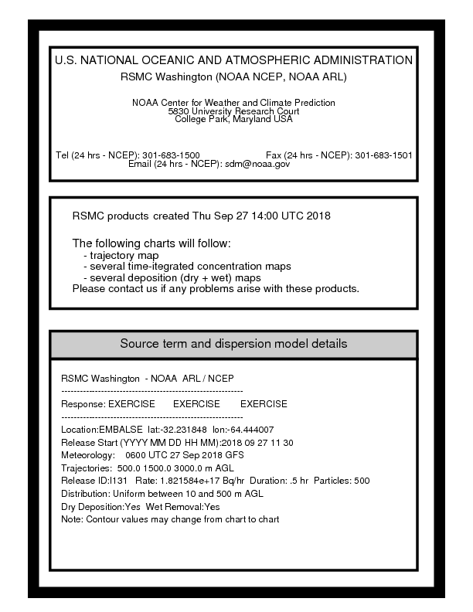 | 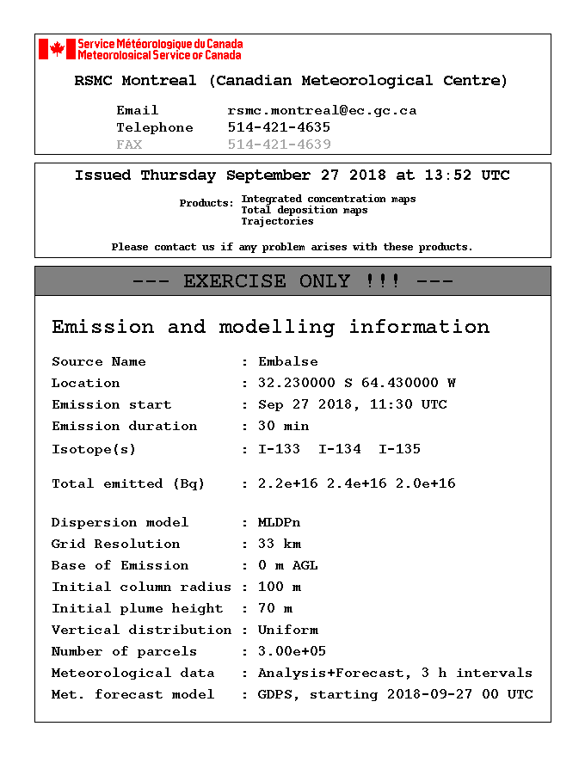

They provided products following GDPFS Manual standards and some other products
- Daily Concentration Maps up to 72hs
- Trajectories at 500, 1500 and 3000m every 6 hours at least up to 72hs
- Accumulated deposition maps on daily periods up to 72hs

Additional products available:
- ToA maps at surface and 500m
- Concentration in kmz format
- Concentrations map every 3 hours

- Discussion

Results (Appendix 1) where quite different from both simulations, because differences in the input data on the ATDM among other things.

On the first case was very important the meteorology, and the cycle of 6utc proved to be more suitable than 00utc. On the second exercise meteorology wasn’t that determinant to explain differences.

But on other order of things attention was given to the following information

 | Request Form Atucha exercise | RSMC Washington ATDM | CanadaRSMC Montreal ATDM
Emission | Kr-85 2.56E+14 Bq  Kr-85m 3.22E+16 Bq  Kr-87 6.18E+16 Bq  Kr-88 8.70E+16 Bq  Xe-133 2.34E+17 Bq  Xe-135 1.17E+16 Bq  I-131 1.17E+16 Bq  I-132 1.72E+16 Bq  I-133 2.42E+16 Bq  I-134 2.64E+16 Bq  I-135 2.26E+16 Bq  Cs-136 2.10E+14 Bq  Cs-137 2.54E+14 Bq  Te-127 1.16E+15 Bq  Te- 127m 9.36E+13 Bq  Te-129 3.70E+15 Bq  Te- 129m 5.18E+14 Bq  Te-131m 1.77E+15 Bq  Te-132 1.67E+16 Bq | C-137  2.54E+14 Bq | C-137 2.5e+14 Bq  I-131 1.2e+16 Bq  I-132 1.7e+16 Bq  I-133 2.4e1+16 Bq  I-134 2.6e+16 Bq  I-135 2.3e+16 Bq
Maps based on |  | C-137  2.54e14Bq | I-131  1.2e+16Bq
Height initial cloud column | -- | 40m (stack height) | 500m (standard)

 | Request Form Embalse exercise | RSMC Washington ATDM | CanadaRSMC Montreal ATDM
Emission | I-131 1.04192E+16 Bq  I-132 1.51515E+16 Bq  I-133 2.1719E+16 Bq  I-134 2.3643E+16 Bq  I-135 2.01465E+16 Bq  Total 9.10792E+16.Bq in 0.5 hr | I-131 1.82E+17 Bq/hr | I-133 2.2e+16 Bq  I-134 2.4e+16 Bq  I-135 2.0e+16 Bq
Maps based on |  | I-131 1.82e+17 Bq/hr (assumes that the total amount sent in the form is of I-131) | I-133 4.34e+16 Bq/hr
Height initial cloud column | -- | 500m (standard) | 70m (stack height)

When contrasting results, it’s very difficult to arrive at conclusions when such different configurations are used. And the different criteria. Users can´t assess the impact of simulating different isotops and concentration. More important is the assumption of such different heights for the initial cloud.

The request form sent in both scenario doesn’t provide information of type of emergency, and doesn’t specify neither the height of the initicial clouds.

According to GDPFS manual, when information is missing from the request form the following standards should be used

APPENDIX 2.2.24. DEFAULT EMISSION SOURCE PARAMETERS (NUCLEAR)

Default values to be used in response to a request for products for the unspecified source parameters:
(a) Uniform vertical distribution up to 500 m above the ground;
(b) Uniform emission rate during six hours;
(c) Starting date and time: Date and time specified at “START OF RELEASE” on request form or, if not available, then the “date/time of request” specified at the top of the request form;
(d) Total pollutant release 1 Bq over six hours;
(e) Type of radionuclide 137Cs.

The adoption of default values is based on the understanding that some runs of the transport/dispersion models need to be carried out with default parameters because little or no information (except location) will be available to the RSMC at an early stage. RSMCs are, however, requested to conduct and propose subsequent model runs with more realistic parameters as they become available (products based upon updated parameters will be provided on request only or confirmed from IAEA or a delegated authority). This may, for example, refer to a more precise assumption of the vertical distribution or the need to conduct a model run for the release of noble gases.

The exercises proposed by the National Nuclear Authority involved releases on the order of Exp+16 Bq while the standard from the manual is 1 Bq. This standard is very far from real scenario.

Whe information of multiple isotopes is given, it’s not clear wich isotope should be forecasted, and in what concentrations. Some guidelines in the manual about this issue is recomeneded.

The initial cloud height althoug given a value in the manual, there’s seem to be different criteria on how to assume this value.

The Request Form has this item as “helpfull information”: nature of accident, cause, fire explosion, controlled release, foreseeable development, normal activity, projected conditions, etc.
This information, if provided, is essential to optimized ATDM and reduce uncertainty. It’s suggested here to study and discuss moving this request of information to “mandatory”

- Conclusions

It’s indiscussed the capability of both Montreal anD Washington RSMCS are capable of responding effectivily at this kind of emergency.

The mirror web page is very helpfull, and the storage of past simulations or exercises ir very valuable

The ET-ERA is invited to revised the discussion of the differences found in the products provided as an example of future improvements of the RSMCs ATDM and product delivery.

The expert team is invited as well to review the GDPFS Manual and Standards to better respond at possible real scenarios.

APPENDIX 1

Results from ATDM from Montreal and Canada

- Exercise Atucha Nuclear Power Plant 2 Nov2017

RSMC WASHINGTON | RSMC MONTREAL
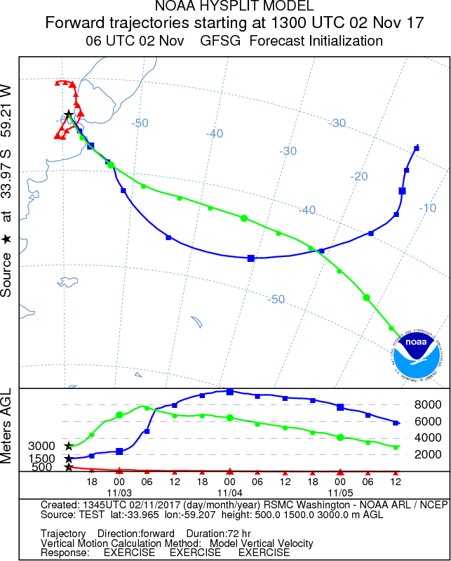 | 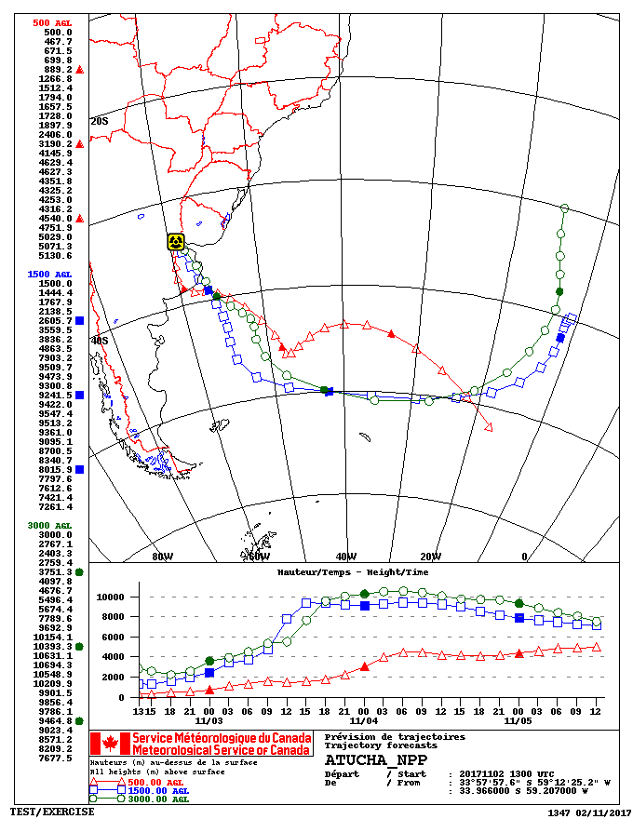
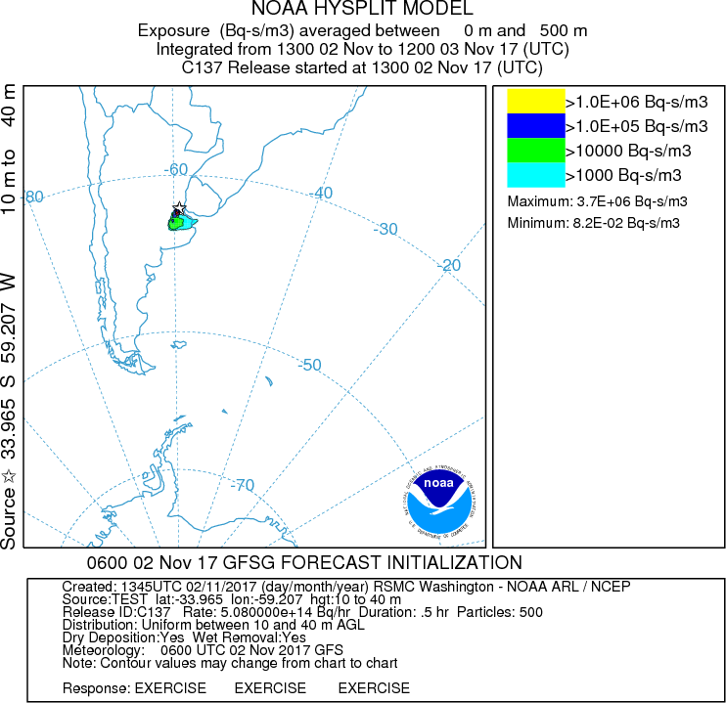 | 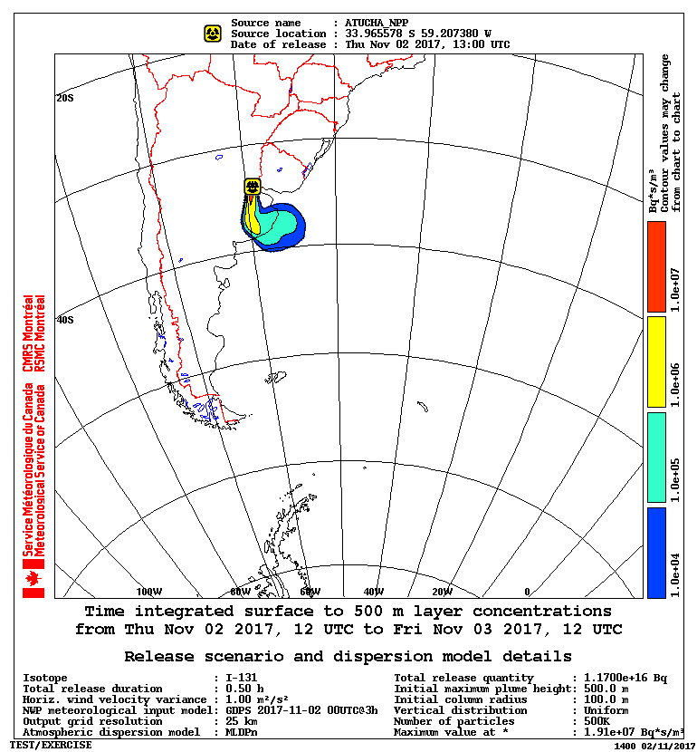
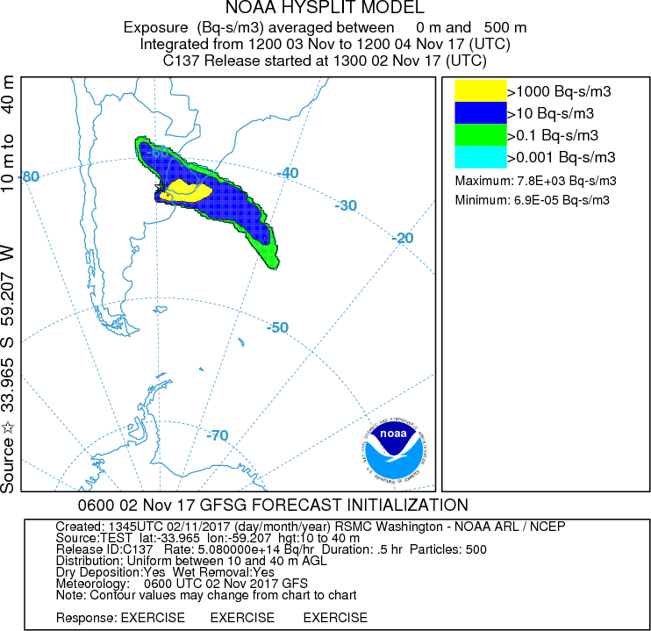 | 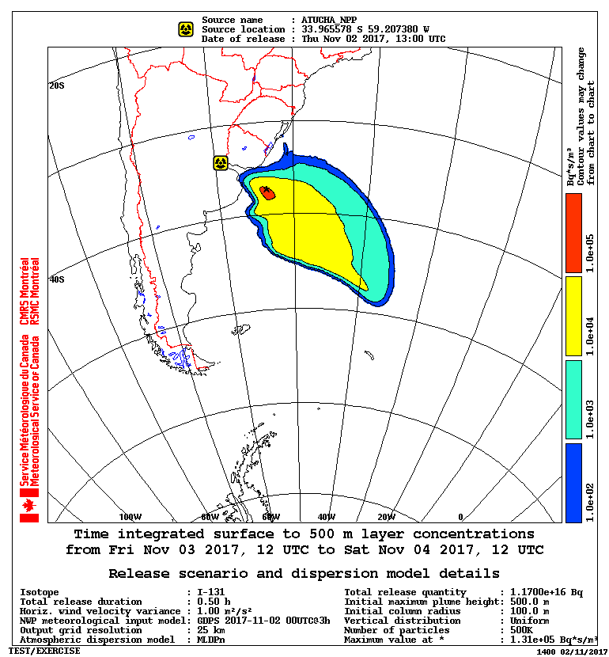

- Exercise Embalse Power Planta 27 Sept 2018

RSMC WASHINGTON | RSMC MONTREAL
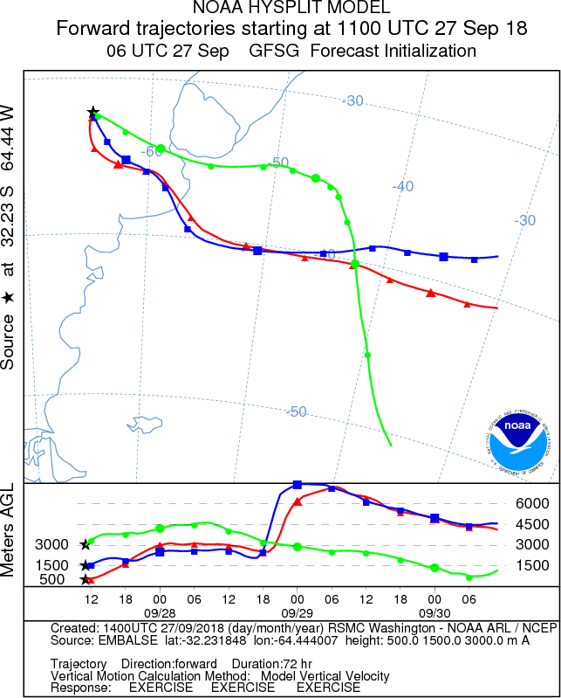 | 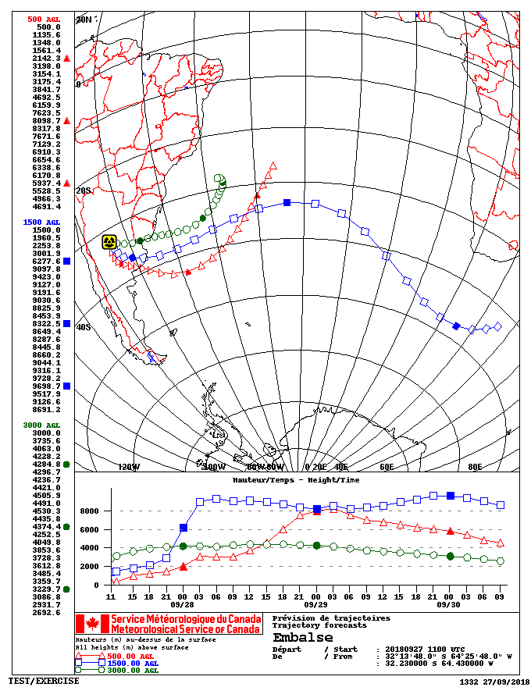
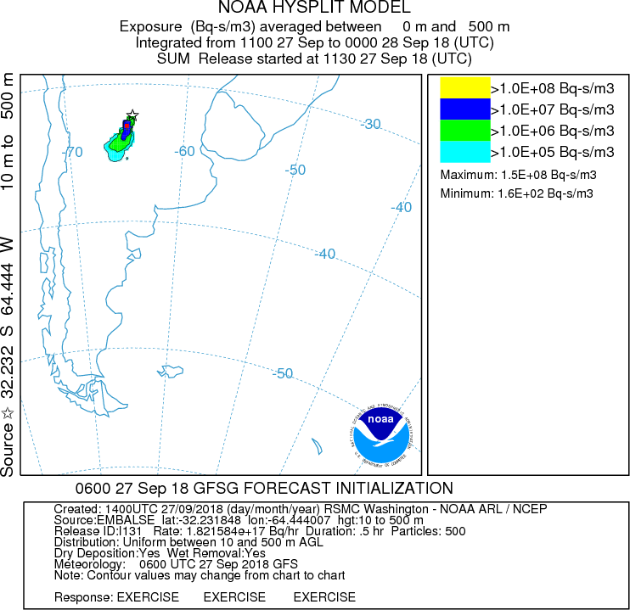 | 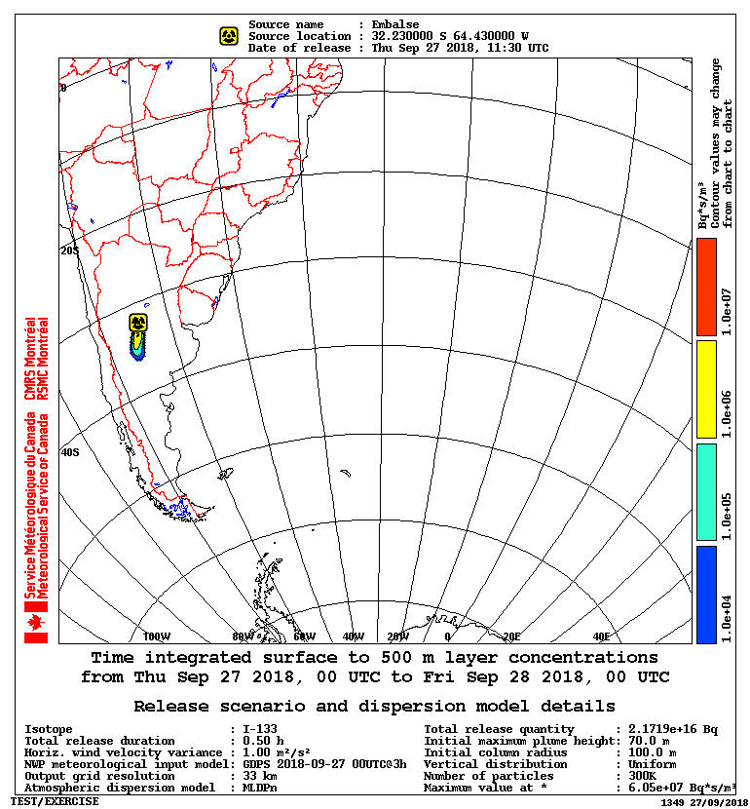
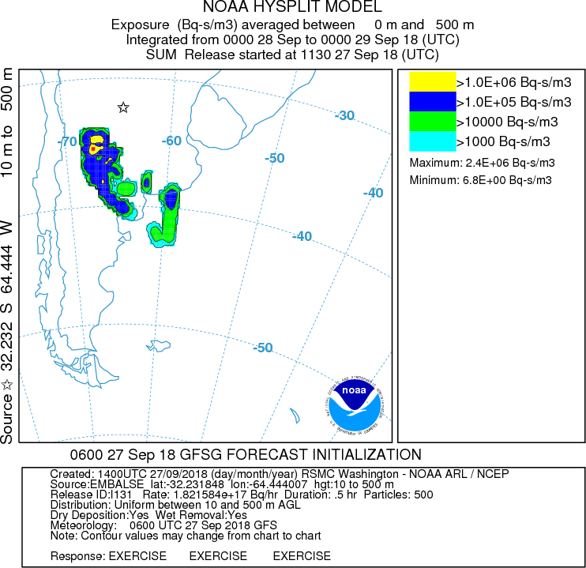 | 