WORLD METEOROLOGICAL ORGANIZATION  ________  COMMISSION FOR BASIC SYSTEMS  EXPERT TEAM ON  EMERGENCY RESPONSE ACTIVITIES  VIENNA, AUSTRIA, 1-5 OCTOBER 2018 |  | CBS-DPFS/ET-ERA/Doc. 6.1  (13.IX.2018)  _______  Agenda item : 6  Original: ENGLISH

NEED TO UPDATE NUCLEAR ERA AND TO CREATE NON-NUCLEAR ERA
WEB PAGES

(Submitted by the co-Chair)

Summary and purpose of document

At the ET-ERA meeting in 2015, the group carried over an action to continue updating the nuclear ERA web pages. Some minor changes have been done on the nuclear side. Nothing has materialized on the non-nuclear ERA side.

The Manual on the GDPFS has undergone major changes since. As a result, the nuclear ERA web pages and WMO TD/NO. 778 now require more important modifications. The need to develop the non-nuclear ERA web pages/WMO TD/No. 778 is also magnified since it is now part of the Manual and that RSMCs have been designated for this activity.

Members of the ET-ERA are therefore sought to work on the web pages.

Action Proposed

The meeting is invited to discuss the paper and to identify members that can contribute to the revision/development work of the nuclear and non-nuclear ERA web pages and WMO TD/No. 778.
1.1 The last major update to the WMO ERA website was done in May 2014. At ET-ERA meeting in 2015, the group carried over an action to continue updating the nuclear ERA web pages, which involves mainly small changes and maintenance, and to develop the non-nuclear ERA web pages, which is a major undertaking. Some minor changes have been done since on the nuclear side. Nothing has materialized on the non-nuclear ERA side, for a number of reasons.

1.2 Since the Buenos Aires meeting, the Manual on the GDPFS has undergone major changes. The nuclear ERA web pages are in need of more important modifications now, mainly due to new appendices in the Manual as well as changes in the numbering/structure of sections and appendices. The need to develop the non-nuclear ERA is also magnified by the fact that it is now part of the Manual on the GDPFS and that RSMCs have been designated for this activity.

1.3 The structure of the web site is summarized in Annex 1. The following points were agreed on at previous ET-ERA meeting but are adapted to reflect today’s reality:

1.3.1 The nuclear ERA information is mature but requires significant adjustments to reflect new and changes in numbering of sections/appendices in the Manual on the GDPFS.

1.3.2 The non-nuclear ERA web pages have to be developed. The structure of the web pages must be flexible enough to easily accommodate new information and procedures with a minimum of restructuring.

1.3.3 The basic structure of the website and its main sections is sound and can easily be adapted to include non-nuclear ERA information such as new procedures, documentation, references, case studies, etc. With this in mind, the ET-ERA agreed to keep the main sections as they are now:
Emergency Response Activities (ERA) Overview (main page)
1- Procedures
2- Activities, resources and tools
3- Background and WMO TD/No. 778
4- Case Studies & examples of ERA events and products
5- Purpose, objectives and organization of the ERA programme
6- Contacts

1.3.4 We should keep/adapt as much as possible existing text to cover nuclear and non-nuclear ERA on the same page. For example, the page describes in general terms the ERA programme, such as on the main page.

ACTION PROPOSED: Members of the ET-ERA are sought to work on updating/developing the nuclear and non-nuclear web pages and WMO TD/No. 778. Most of the work can be done remotely, except for the posting on the WMO intranet server that can only be done in-house.

References:

Manual on the Global Data-Processing and Forecasting System, 2017 edition (WMO-No.485).

WMO TD/No.778: http://www.wmo.int/pages/prog/www/DPFSERA/td778.html

ANNEX 1

STRUCTURE OF CURRENT WMO WEBSITE ON EMERGENCY RESPONSE ACTIVITIES (2014 update)

Sections that are specific to nuclear ERA are identified by **

—Emergency Response Activities (ERA) Overview

1- Procedures
A) **Regional and Global Arrangements (Appendix I-3 of the Manual on the GDPFS)
B) **Delegated Authority Request for RSMC Support
C) **IAEA Request for RSMC Support
D) **Standards of Service by RSMCs (Appendix II-7 of the Manual on the GDPFS)
Related items menu on the right-hand side:
E) Technical Document No. 778—RSMC SUPPORT FOR ENVIRONMENTAL EMERGENCY RESPONSE (see 3D below for details)
F) **Role of WMO Secretariat in nuclear accident

2- Activities, resources and tools
A) Contains the annual report of activities from RSMCs/RTH Offenbach starting in 2010
Related items menu on the right-hand side:
B) Links to Modelling Tools
C) Overview of Modelling Tools
D) Training Resources
E) Real-Time Remote Sensing of Large Fires

3- Background and WMO-TD/No. 778
A) Bibliography
B) Meetings & Reports
C) Expert Team on Emergency Response Activities (ET-ERA)
D) Technical Document No. 778—DOCUMENTATION ON RSMC SUPPORT FOR ENVIRONMENTAL EMERGENCY RESPONSE (targeted at meteorologists at NMSs) **Section 1—Introduction to the RSMC specialization for the provision of atmospheric transport model products for environmental emergency response
** Section 2—Contacts for
—Designated RSMCs for nuclear accidents and radiological emergencies and International Organizations
-Designated RSMCs with specialization in ATDM and/or backtracking and International Organizations
Section 3—Aim of an atmospheric transport model in connection with numerical weather prediction (NWP) model (scientific information)
**Section 4—Users’ interpretation guide for atmospheric transport model products provided by RSMCs
PDF Version
Information on RSMC models and specific outputs
Section 5—Annexes
**Annex 1—Regional and global arrangements for the provision of transport model products for environmental emergency response
Annex 2—Contacts for
—Designated RSMCs for nuclear accidents and radiological emergencies and International Organization
—Designated SMCs with specialization in ATDM for environmental emergency response and/or backtracking and International Organization
**Annex 3—Request forms for WMO RSMC support from Delegated Authorities and IAEA
**Annex 4—Information on RSMC models and specific outputs
**Annex 5—Scenarios demonstrating RSMC support for ERA
**Annex 6— Principles of environmental emergency response exercises
Annex 7—Announcement about a planned EER exercise
Annex 8 - Guidance on response to chemical incidents - definitions of requirements concerning chemical incidents
Annex 9—Role of national meteorological services (NMSs) in response to chemical incidents
Annex 10—Guidance for development of the interface between a national meteorological service and other emergency response agencies in case of chemical incidents
Annex 11—KNMI experience in setting up an emergency response organization on serious chemical accidents
Annex 12—Procedures to integrate and activate NMSs/RSMCs in case of chemical incidents or forest fires

4- Case Studies & examples of ERA events and products

5- Purpose, objectives and organization of the ERA programme
—Purpose and scope
—Main long-term objectives
—Programme organization

6- Contacts
a) Expert Team on Emergency Response Activities (ET-ERA)
b) **Delegated Authorities for ERA
c) **NMHS Operational Contact Points for ERA
d) **Contact Points for Nuclear Accidents and Radiological Emergencies (RSMCs and International Agencies)
e) Contact Points for Atmospheric Transport Modelling for Environmental Emergency Response and/or Backtracking (RSMCs and International Agencies)
f) Contact Points for Backtracking Support (RSMCs)
g) Weather and Disaster Risk Reduction Services Department
Related items menu on the right-hand side:
—Websites (RSMCs and International Agencies)

7- Questionnaires
—Delegated Authority and NMHS’ Operational Contact Point (September 2014)
The following are images of the main page and the 7 sections:

Emergency Response Activities (ERA) Overview

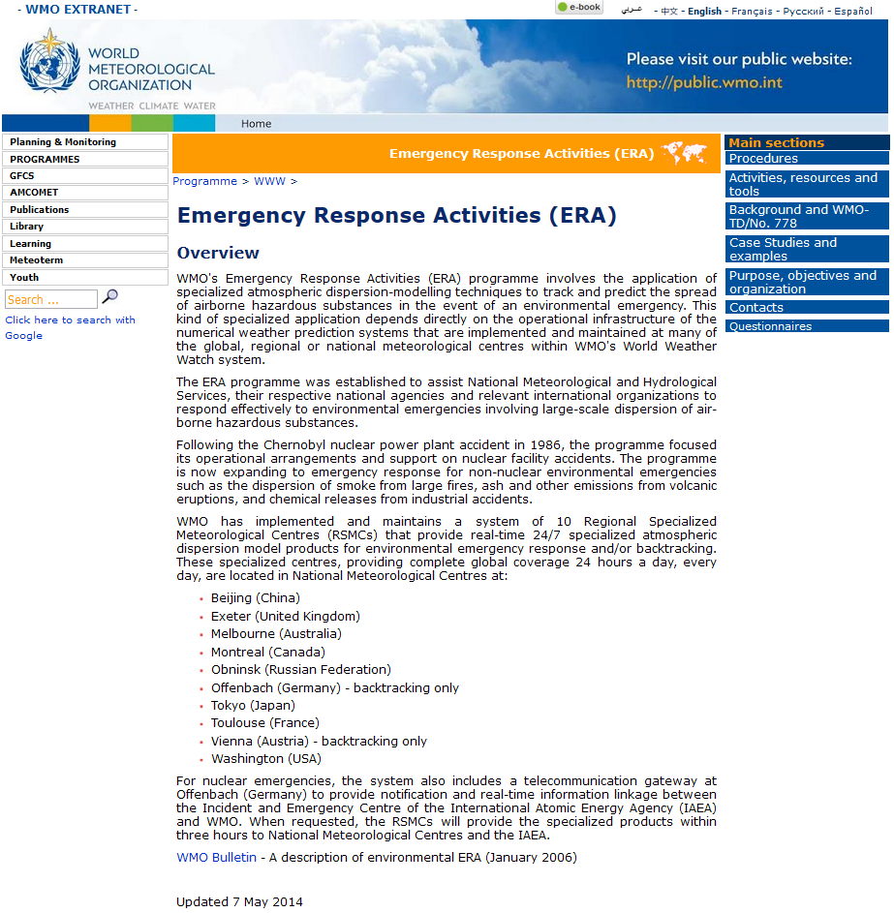

The links in the upper right corner of the main page lead to the following:

1. Procedures

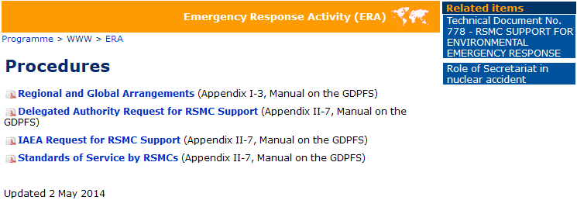

2. Activities, resources and tools

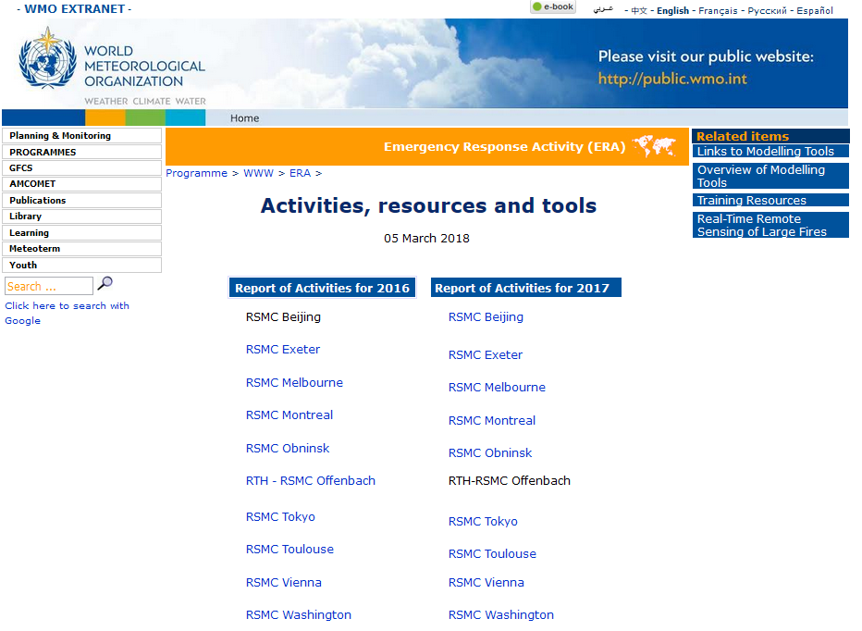

3. Background and WMO TD/No. 778

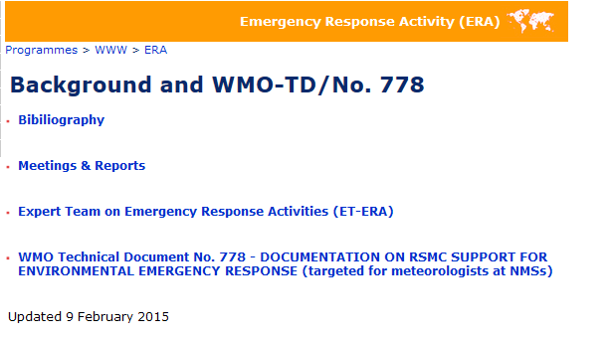

4. Case Studies and examples

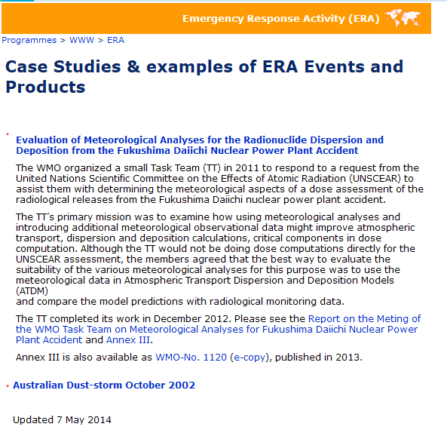

5. Purpose, objectives and organization

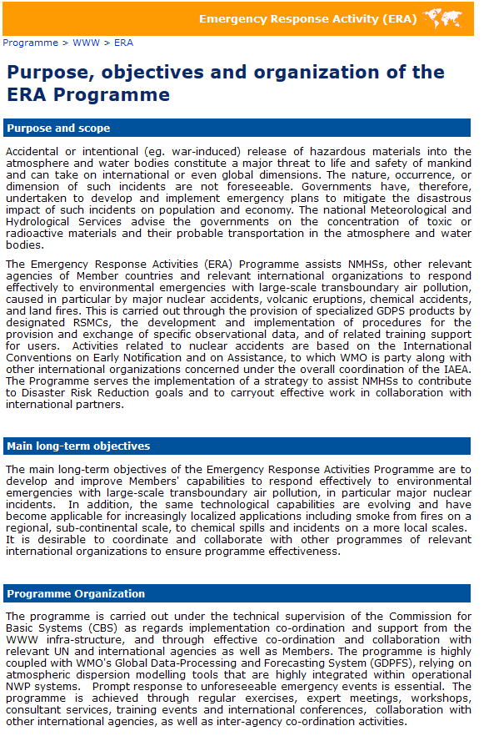

6. Contacts

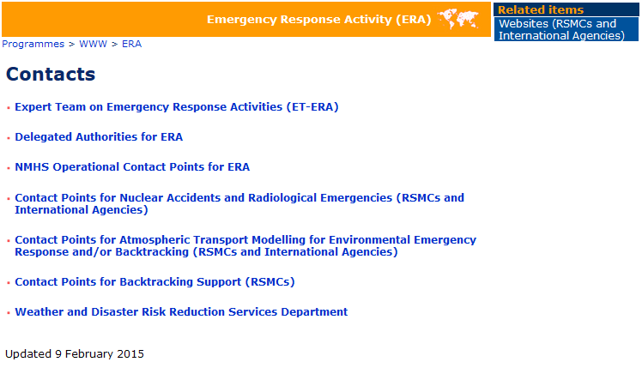

7. Questionnaires

