WORLD METEOROLOGICAL ORGANIZATION  COMMISSION FOR BASIC SYSTEMS  OPAG on DPFS  EXPERT TEAM ON EMERGENCY RESPONSE ACTIVITIES (ET-ERA)  VIENNA, AUSTRIA, 1-5 OCTOBER 2018 |  | CBS-DPFS/ET-ERA/Doc. 5.2(3)  (19.IX.2018)  _______  Agenda item : 5.2  ENGLISH ONLY

Request by RSMC Montreal to be designated RSMC with activity specialization in Non-Nuclear Environmental Emergency Response

Submitted by Canada

Summary and purpose of document

This document summarizes the application of RSMC Montreal for designation as an RMSC for Non-nuclear Environmental Emergency Response. The application was submitted to the WMO in July 2018. An outline is provided describing of the capabilities of RSMC Montreal that satisfy the requirements specified in the revised manual on the GDPFS.

Action Proposed

The meeting is invited to review and comment on the application by RSMC Montreal to be designated as a RSMC for Non-Nuclear Environmental Emergency Response
RSMC Montreal is already designated as an RSMC for nuclear environmental emergency response, sharing joint responsibility for RA III and RA IV with RSMC Washington.

RSMC Montreal was actively involved in establishing the modelling and product standards for non-nuclear response, and has participated in all the associated non-nuclear tests and exercises.

Responsibility for RSMC Montreal is with the operational Environmental Emergency Response Section (EERS), within National Forecast Operations of the Canadian Centre for Meteorological and Environmental Prediction (CCMEP), in Dorval, Quebec, Canada. This operational centre runs Canada’s analysis and forecast cycle with on the numerical weather prediction model, GEM (Global Environmental Multiscale), assimilating data with a global Ensemble Kalman filter. Forecasts are produced using the GEM model several times daily at global, regional and high-resolution configurations.

The EERS is tasked with providing atmospheric dispersion modelling guidance products in support of emergency response for environmental incidents within Canada, such as forest fires, industrial fires, chemical spills, CRBN incidents. The section also serves as the Montreal Volcanic Ash Advisory Centre (VAAC Montreal), responsible for producing transport model forecasts of volcanic ash within Canadian airspace.

Two types of dispersion modelling tools are used by the EERS. A simple trajectory model can be run using single particles at one or more levels, in either forward or backward model. MLCD and MLDP are off-line Lagrangian particle transport and dispersion models (D’Amours et al 2015), used for incidents requiring plume modelling at local and regional to global scales, respectively. These models are developed and maintained in-house and are undergoing continual improvement.

RSMC Montreal is able to perform atmospheric transport and dispersion modelling and provide products for
- forest, grass or peat fires,
- major industrial fire,
- chemical release not involving fire,
- backtracking (retro-trajectories),
- other incidents for which emergency response may require guidance based on atmospheric dispersion modelling.

Exercises testing the procedures and modelling have been held together with the National Weather Service of Argentina, the most recent being in January 2016. The requests and some examples of guidance products from the 2016 exercise are presented in the Appendices.

RSMC Montreal is capable of providing guidance products in support of non-nuclear response in adherence of standards outlined in Appendix A.II.2.2.9-f, USERS INTERPRETATION GUIDE FOR NON-NUCLEAR ATMOSPHERIC TRANSPORT and Dispersion MODELLING PRODUCTS PROVIDED BY RSMCs.

Atmospheric dispersion modelling capabilities of RSMC Montreal satisfy requirements for non-nuclear environmental emergency response as documented in WMO (2011)

References
D'Amours, R., Malo, A., Flesch, T., Wilson, J., Gauthier J.-P., Servranckx, R. (2015). The Canadian Meteorological Centre's Atmospheric Transport and Dispersion Modelling Suite, Atmosphere-Ocean, 53 (2), 176–199, doi:10.1080/07055900.2014.1000260

WMO, 2011: Documentation on RSMC Support for Environmental Emergency Response. WMO-TD/No.778. Available online at http://www.wmo.int/pages/prog/www/DPFSERA/td778.html
Appendix A1. Non-Nuclear RSMC Exercise with NWS Argentina: Grass Fire Request

REQUEST FORM TO ACTIVATE RSMC SUPPORT

ENVIRONMENTAL EMERGENCY RESPONSE ALERT REQUEST FOR WMO RSMC SUPPORT BY AUTHORIZED PERSON

- This form should be sent by e-mail to the RSMC operational contact in the Regional Association when support is needed for releases that have the potential for long-range impacts (distances greater than 50 km). The RSMC operational contact information is available on
http://www.wmo.int/pages/prog/www/DPFSERA/transport_model_products.htm

rsmc.montreal@ec.gc.ca

- The requester shall confirm reception of email at RSMC by phone.

- The RSMC shall make available its products as soon as possible but within 2 hours.

DATE AND TIME OF REQUEST: 6 JAN 2016, 17:00 UTC

1) MANDATORY INFORMATION:

- Status: (Exercise/Event) : Exercise
- Name, title, Organization/Agency, Country, phone number and email of requester: National Weather Service, Argentina, +541151676767 Ext:18272, msuaya@smn.gov.ar

- Select type of event and provide brief description or details:

Forest, grass or peat fire:
x

Chemical incident:

Industrial Fire/Smoke:

Backtracking request:

Other:

- Date and Start time of release (DD/MM/YYYY and UTC): 6 jan 2016, 0:00utc
- Location of release (as accurately as possible) in order of preference: Delta and Pre Delta of La Plata River, area sourrounded by San Nicolas, Victoria, Gualeguay and Zarate
- Geographic coordinates (decimal degrees or degrees, minutes and seconds):

Latitude | -33.1281353
Longitude | -60.0162655

- (if appropriate) Address, City, Country: Buenos Aires and Entre Rios Provinces, Argentina

2) OTHER INFORMATION: If known, the following would be useful for the modelling and should be provided as well (if not provided, modeller will use default parameters or make a reasonable assumption):

- Name of location (name of chemical plant, factory, etc.): Delta del Parana
- Meteorological conditions at location at the start of the release (wind speed and direction, weather, cloudiness, presence of inversion, etc.): 18kt SE, clear sky, inversion around 600m
- Name or type of pollutant(s) to be modelled if known (smoke, natural gas, sulphur dioxide, etc). If unknown, a tracer will be used. Grassland
- Quantity (mass) or release rate (mass per unit time) of pollutant. If unknown, one unit mass or one unit mass per hour will be used.
- Expected or estimated release duration: 2 days.

- Duration of simulation for the dispersion model run

- Size of area of interest (for example, within 300 km of source).

- Base of release (surface or meters above surface), dimension of release area and estimated maximum height in meters reached by the release (top of smoke plume for example). 30.000 hectare (700km2)

- If quantity (mass) and name of pollutant(s) are provided, what concentrations should be displayed on modelling outputs? Please specify. Any other information that may be useful: many source locations, center of fire area in section one
Appendix A2. Non-Nuclear RSMC Exercise with NWS Argentina: Grass Fire Modelling Guidance
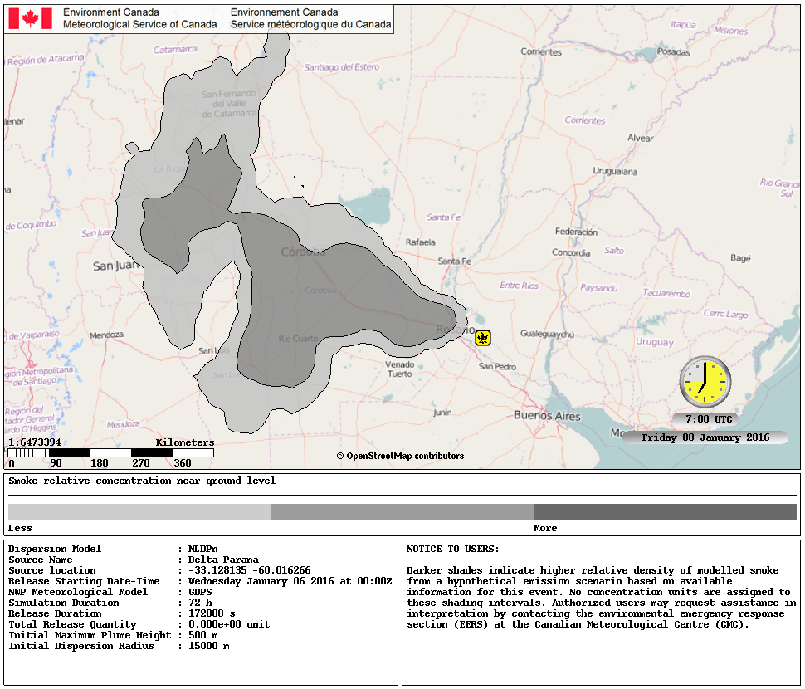
Appendix B1. Non-Nuclear RSMC Exercise with NWS Argentina: Industrial Fire Request

REQUEST FORM TO ACTIVATE RSMC SUPPORT

ENVIRONMENTAL EMERGENCY RESPONSE ALERT REQUEST FOR WMO RSMC SUPPORT BY AUTHORIZED PERSON

- This form should be sent by e-mail to the RSMC operational contact in the Regional Association when support is needed for releases that have the potential for long-range impacts (distances greater than 50 km). The RSMC operational contact information is available on
http://www.wmo.int/pages/prog/www/DPFSERA/transport_model_products.htm

rsmc.montreal@ec.gc.ca

- The requester shall confirm reception of email at RSMC by phone.

- The RSMC shall make available its products as soon as possible but within 2 hours.

DATE AND TIME OF REQUEST: 7 JAN 2016, 13:00 UTC

1) MANDATORY INFORMATION:

- Status: (Exercise/Event) : Exercise
- Name, title, Organization/Agency, Country, phone number and email of requester: National Weather Service, Argentina, +541151676767 Ext:18272, msuaya@smn.gov.ar

- Select type of event and provide brief description or details:

Forest, grass or peat fire:

Chemical incident:

Industrial Fire/Smoke:
x

Backtracking request:

Other:

- Date and Start time of release (DD/MM/YYYY and UTC): 7 jan 2016, 12:00utc
- Location of release (as accurately as possible) in order of preference: Burzaco, Buenos Aires province, Argentina
- Geographic coordinates (decimal degrees or degrees, minutes and seconds):

Latitude | -34.8339593
Longitude | -58.4950262

- (if appropriate) Address, City, Country: Guatambú and Carlos Viel, Burzaco, Buenos Aires, Argentina

2) OTHER INFORMATION: If known, the following would be useful for the modelling and should be provided as well (if not provided, modeller will use default parameters or make a reasonable assumption):

- Name of location (name of chemical plant, factory, etc.): Chemical Plant
- Meteorological conditions at location at the start of the release (wind speed and direction, weather, cloudiness, presence of inversion, etc.): South 6kt, clear sky, inversion around 900m
- Name or type of pollutant(s) to be modelled if known (smoke, natural gas, sulphur dioxide, etc). If unknown, a tracer will be used. Smoke and acid material
- Quantity (mass) or release rate (mass per unit time) of pollutant. If unknown, one unit mass or one unit mass per hour will be used.
- Expected or estimated release duration: 2 hours.

- Duration of simulation for the dispersion model run

- Size of area of interest (for example, within 300 km of source).

- Base of release (surface or meters above surface), dimension of release area and estimated maximum height in meters reached by the release (top of smoke plume for example).

- If quantity (mass) and name of pollutant(s) are provided, what concentrations should be displayed on modelling outputs? Please specify. Any other information that may be useful:
Appendix B2. Non-Nuclear RSMC Exercise with NWS Argentina: Industrial Fire Modelling Guidance

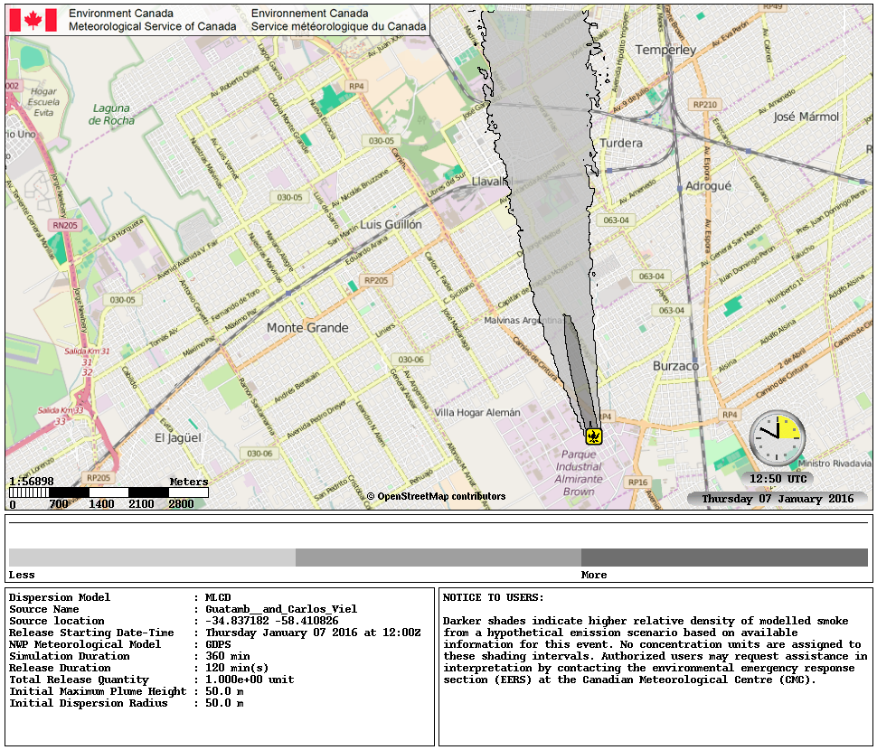
Appendix C1. Non-Nuclear RSMC Exercise with NWS Argentina: Chemical Incident Request

REQUEST FORM TO ACTIVATE RSMC SUPPORT

ENVIRONMENTAL EMERGENCY RESPONSE ALERT REQUEST FOR WMO RSMC SUPPORT BY AUTHORIZED PERSON

- This form should be sent by e-mail to the RSMC operational contact in the Regional Association when support is needed for releases that have the potential for long-range impacts (distances greater than 50 km). The RSMC operational contact information is available on
http://www.wmo.int/pages/prog/www/DPFSERA/transport_model_products.htm

rsmc.montreal@ec.gc.ca

- The requester shall confirm reception of email at RSMC by phone.

- The RSMC shall make available its products as soon as possible but within 2 hours.

DATE AND TIME OF REQUEST: 6 JAN 2016, 19:30 UTC

1) MANDATORY INFORMATION:

- Status: (Exercise/Event) : Exercise
- Name, title, Organization/Agency, Country, phone number and email of requester: National Weather Service, Argentina, +541151676767 Ext:18272, msuaya@smn.gov.ar

- Select type of event and provide brief description or details:

Forest, grass or peat fire:

Chemical incident:
x

Industrial Fire/Smoke:

Backtracking request:

Other:

- Date and Start time of release (DD/MM/YYYY and UTC): 6 jan 2016, 19:00utc
- Location of release (as accurately as possible) in order of preference: city of Maipu, Mendoza province, Argentina
- Geographic coordinates (decimal degrees or degrees, minutes and seconds):

Latitude | -32.930373
Longitude | -68.805753

- (if appropriate) Address, City, Country: Rodriguez Peña 3000, Coquimbito, Mendoza, Argentina

2) OTHER INFORMATION: If known, the following would be useful for the modelling and should be provided as well (if not provided, modeller will use default parameters or make a reasonable assumption):

- Name of location (name of chemical plant, factory, etc.): Maldonado Plant
- Meteorological conditions at location at the start of the release (wind speed and direction, weather, cloudiness, presence of inversion, etc.): SE 5KT, 6/8 low and mid level clouds, some instablility
- Name or type of pollutant(s) to be modelled if known (smoke, natural gas, sulphur dioxide, etc). If unknown, a tracer will be used. Sulfur dioxide
- Quantity (mass) or release rate (mass per unit time) of pollutant. If unknown, one unit mass or one unit mass per hour will be used.
- Expected or estimated release duration: 3 hours.

- Duration of simulation for the dispersion model run

- Size of area of interest (for example, within 300 km of source).

- Base of release (surface or meters above surface), dimension of release area and estimated maximum height in meters reached by the release (top of smoke plume for example).

- If quantity (mass) and name of pollutant(s) are provided, what concentrations should be displayed on modelling outputs? Please specify. Any other information that may be useful: Explosion of a container in a plant with sulfur dioxide

Appendix C2. Non-Nuclear RSMC Exercise with NWS Argentina: Chemical Incident Modelling Guidance

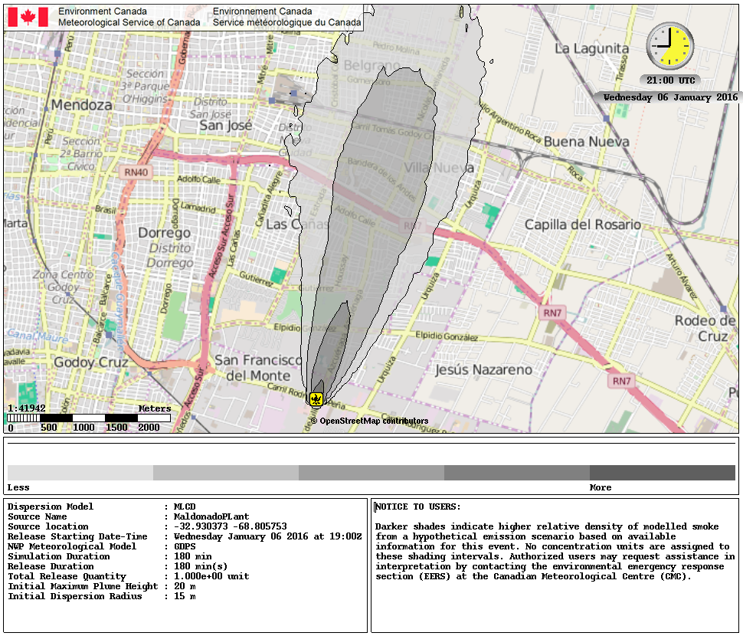
Appendix D1. Non-Nuclear RSMC Exercise with NWS Argentina: Backtracking Request

REQUEST FORM TO ACTIVATE RSMC SUPPORT

ENVIRONMENTAL EMERGENCY RESPONSE ALERT REQUEST FOR WMO RSMC SUPPORT BY AUTHORIZED PERSON

- This form should be sent by e-mail to the RSMC operational contact in the Regional Association when support is needed for releases that have the potential for long-range impacts (distances greater than 50 km). The RSMC operational contact information is available on
http://www.wmo.int/pages/prog/www/DPFSERA/transport_model_products.htm

rsmc.montreal@ec.gc.ca

- The requester shall confirm reception of email at RSMC by phone.

- The RSMC shall make available its products as soon as possible but within 2 hours.

DATE AND TIME OF REQUEST: 7 JAN 2016, 15:00 UTC

1) MANDATORY INFORMATION:

- Status: (Exercise/Event) : Exercise
- Name, title, Organization/Agency, Country, phone number and email of requester: National Weather Service, Argentina, +541151676767 Ext:18272, msuaya@smn.gov.ar

- Select type of event and provide brief description or details:

Forest, grass or peat fire:

Chemical incident:

Industrial Fire/Smoke:

Backtracking request:
x

Other:

- Date and Start time of release (DD/MM/YYYY and UTC): detection started at 7 jan 2016, 11:00utc, and ended 7 jan 14:00utc
- Location of release (as accurately as possible) in order of preference: Rosario, Santa Fe, Argentina
- Geographic coordinates (decimal degrees or degrees, minutes and seconds):

Latitude | -32.9496865
Longitude | -60.6749427

- (if appropriate) Address, City, Country: Rosario City, Argentina

2) OTHER INFORMATION: If known, the following would be useful for the modelling and should be provided as well (if not provided, modeller will use default parameters or make a reasonable assumption):

- Name of location (name of chemical plant, factory, etc.): Rosario city
- Meteorological conditions at location at the start of the release (wind speed and direction, weather, cloudiness, presence of inversion, etc.): East 10kt, 1/8 low clouds
- Name or type of pollutant(s) to be modelled if known (smoke, natural gas, sulphur dioxide, etc). If unknown, a tracer will be used. Contaminated cloud
- Quantity (mass) or release rate (mass per unit time) of pollutant. If unknown, one unit mass or one unit mass per hour will be used.
- Expected or estimated release duration: 3 hours of contaminated cloud was observed

- Duration of simulation for the dispersion model run

- Size of area of interest (for example, within 300 km of source).

- Base of release (surface or meters above surface), dimension of release area and estimated maximum height in meters reached by the release (top of smoke plume for example). A contaminated cloud affected de city of Rosario, at around 13utc this morning and lasted for 3 hours. Source is unknown.

- If quantity (mass) and name of pollutant(s) are provided, what concentrations should be displayed on modelling outputs? Please specify. Any other information that may be useful: the cloud affected the first 300mts

Appendix D2. Non-Nuclear RSMC Exercise with NWS Argentina: Backtracking Guidance

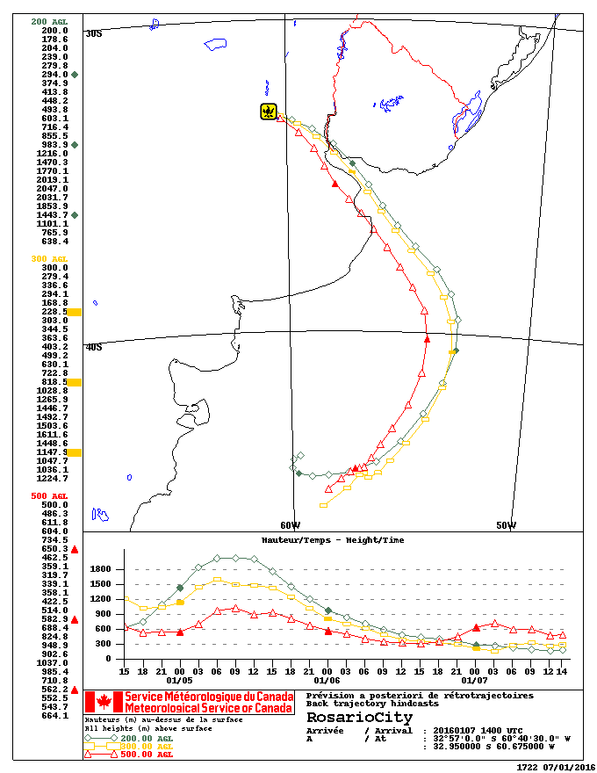
Example of modelling guidance in support of request for backtracking. Full plume modelling is also available.

The person authorized by the Permanent Representative of the WMO Member to request RSMC Support or from a relevant international organization
The person authorized by the Permanent Representative of the WMO Member to request RSMC Support or from a relevant international organization
The person authorized by the Permanent Representative of the WMO Member to request RSMC Support or from a relevant international organization
The person authorized by the Permanent Representative of the WMO Member to request RSMC Support or from a relevant international organization

