WORLD METEOROLOGICAL ORGANIZATION  COMMISSION FOR BASIC SYSTEMS  OPAG on DPFS  EXPERT TEAM ON EMERGENCY RESPONSE ACTIVITIES (ET-ERA)  VIENNA, AUSTRIA, 1-5 OCTOBER 2018 |  | CBS-DPFS/ET-ERA/Doc. 4.5(2)  (7.IX.2018)  _______  Agenda item : 4.5  ENGLISH ONLY

Report on the Joint Time of Arrival Test in June 2017

(Submitted by Mr. Masami Sakamoto, RSMC Tokyo)

Summary and purpose of document

This document summerises results of the joint Time of Arrival (ToA) test in June 2017, which was coincident with ConvEx-3. This activity was in accordance with Action 18 of the ET-ERA meeting, Buenos Aires, Argentina, November – December 2015. This document is to encourage the ET-ERA members to have further discussions necessary to explore appropriate definitions of ToA.

Action Proposed

The meeting is invited to discuss the results and outcomes of the joint Time of Arrival (ToA) test. The members are encouraged to talk over the following points:
- Usages of ToA (including professional usages by radiological observers),
- Definitions of ToA (including designs of the charts, instantaneous / averaged / time-integrated concentrations, initial time, and thresholds for ToA),
- Operational measures to transmit and present ToA charts.

Reference:
- Annex-I: Instructions on the Time of Arrival test
- Annex-II: Test charts presented by the participants of the joint ToA test in June 2017.

1. Introduction
The expert team on the emergency response activities (ET-ERA) had a meeting at the Servicio Meteorológico Nacional of Argentina in Buenos Aires, from 30 November to 4 December, 2015. The meeting adopted an action item to pursue further development of the Time of Arrival (ToA) products. That is,

“ACTION 18: RSMCs and IAEA – Coordination by experts from RSMC Obninsk (Mr Kosykh), RSMC Japan (Mr Sakamoto),IAEA (Mr Winkler) and RSMC Vienna (Mr Wotawa)
Time of arrival products
DUE DATE: 2016
‘Time of Arrival’’ Product Tests’
- Produce document to define and clarify details and specifications for next ToA test to ensure consistency between RSMCs products
- Conduct new test
- IAEA to propose threshold value for cloud boundaries.”

Although Dr. Kosykh initiated a discussion to identify remaining issues in the document on the definitions of ToA charts in December 2016, there was no chance to conduct an additional joint test by the end of 2016.

In February 2017, some of the members of ET-ERA were engaged in the discussions on the large-scale exercise ConvEx-3, which was planned during 21 – 22, June, 2017. The chair of ET-ERA suggested conducting a joint ToA test using the release scenarios of ConvEx-3. Dr. Kosykh was trying to liaise with the members to restart the discussion. However, he had to move to his new position in the Roshydromet in early March, and asked the remaining members to take care of his leading work for the ToA development. The ET-ERA chair assigned Mr. Sakamoto of RSMC Tokyo to organize the ToA test in June 2017.

2. Preparations and Discussions for the Joint Test
Mr. Sakamoto took over the discussions raised by Dr. Kosykh, and asked the members for opinions and suggestions regarding the following points:
- general rules for displaying results (continuation of the document proposed by Dr. Kosykh),
- definitions of ToA (i.e. whether it is based on instantaneous or time-integrated concentration),
- time-frame of products (what should be the initial time of ToA?),
- measures to transmit and present ToA chars.
Discussions by the members had continued from March to May 2017, and the outlines of the discussions on each subject are found in this section. Mr. Sakamoto organized practical procedures for the participants of the joint test, and issued an instruction note by the end of May (see Annex-I).

2.1 Discussions on Purposes and Usages of ToA Charts
In the course of the discussions among the ET-ERA members, Mr. Winkler of the International Atomic Energy Agency (IAEA) / the Incident and Emergency Centre (IEC) mentioned usages of the ToA charts on Friday, 21 April as follows;
“a) the ToA product should be used to identify when a sufficient activity concentration is reaching a point in space so that the relevant authorities can decide to start the radiation monitoring programme. When they do this they will likely use mobile equipment. This means that these equipment is not so sensitive and therefore the value should not be too low. Because if it is below the detection limit then, they will not agree with us that the plume has arrived.

b) the inconsistency with the exposure charts is not going to be a big problem since both charts serve a different purpose. I believe actually that on the long run, we might change the sequence of the standard products meaning once the ToA are a standard product it will be requested earlier than the exposure and deposition ones.”
ET-ERA rarely had had relevant discussions to the atmospheric transport, dispersion, and deposition model (ATDM) forecast services for pre-warning for radiological monitoring programmes by then, and therefore this was a newly introduced usage.

However, reliable release amount information is seldom obtained at an early stage, while it is vital to scientifically estimate concentrations at observatories. Therefore the members have to consider and devise some appropriate definitions of ToA, because the pre-warning for the observational specialists can be a promising usage of the product.

2.2 Definitions of ToA charts
Dr. Kosykh had mainly concentrated on deciding general rules for displaying results. Namely what had been chiefly discussed through the two joint tests in 2015 were:
- each chart should cover each 24 hour time slot, and a set of ToA charts for a 72 hour forecast have 3 pages in total,
- the contour interval should be 6 hours, and second and third charts have gray areas where the plume already has arrived by the beginning of their temporal scopes,
- it is desirable to present each 6 hour time step with colored hatching; colours used in the three pages should be consistent.
Dr. Kosykh contributed to maintaining consistency in the appearances of ToA charts. While some members have proposed to adopt coloured shades instead of hatching, the graphical definitions by Dr. Kosykh were basically adopted for the test in 2017.

On the other hand, Mr. Sakamoto has been requiring discussing more technical and physical aspects of ToA since the joint tests in 2015. What he has asked the members for opinions and discussions are:
- ToA can be processed using the instantaneous or time-integrated concentrations, and these two concentrations are physically different things and therefore they have different units / dimensions. Previously Dr. Kosykh had proposed the following:
“6. To define cloud boundary in terms of concentration value we have to use the same value as the current lowest value plotted on the other plots”,
the members needed to adopt the time-integrated ToA when the threshold of ToA corresponded to ‘the current lowest value’ seen in their exposure charts.
- Previously Dr. Kosykh described
“1. RSMCs generate three ToA plots – for periods 0-24, 25-48, 49-72 hours after release – like concentrations and depositions”,
the members needed to note that the initial times for exposure and deposition charts are not the start release time, they are the initial time of the numerical weather predictions (NWP) used for the ATDMs according to the GDPFS manual. Therefore the members had to understand more about the definition of the initial time of ToA.

Mr. Sakamoto also suggested that the members needed to decide how to handle the requests that only specify the lowest (base) release height (while the top is unspecified), because such requests were found during the joint tests in 2015.

During the discussions before the joint ToA test in 2017, Mr. Sakamoto kindly presented explanatory memos on such technical and physical issues regarding ToA, and most of the members recognized such underlying problems. Then the participants of the ToA test 2017 examined various types of definitions at the joint test (see section 3). ET-ERA needs to have further discussions ‘to define and clarify details and specifications’ from these aspects.

Another important point to be clearly defined is the ‘threshold value for cloud boundaries’. This time the ET-ERA members also had discussions on the thresholds for both instantaneous and time-integrated ToAs. The action item of the ET-ERA meeting Buenos Aires described “3. IAEA to propose threshold value for cloud boundaries”, and Mr. Sakamoto kindly presented some preliminary ATDM results in Europe to help Mr. Winkler identify appropriate threshold values. However there were no specified values this time, because of lack of considerations and understanding of ToA beforehand.

Some of the members expressed their positions regarding the thresholds, which include;
- for instantaneous ToAs: 0 [Bq /m³] (by Dr. Wotawa),
- for time-integrated ToAs: the minimum value shown in the exposure charts at each centre (By Dr. Kosykh for the tests in 2015).
The participating members were encouraged to adopt the thresholds above, and they also were requested to clearly indicate their thresholds on each ToA chart especially when different thresholds from the ones shown above were used.

When discussing appropriate thresholds, the members need to take into consideration the fact that reliable release amount information can rarely be obtained at an early stage of an accident and/or incident. An ATDM is just a tool to scientifically predict atmospheric dispersions of a target material according to a given release scenario, and therefore there is no practical way to predict quantitative concentrations at specific locations when a reliable release amount is unavailable. It should be noted that ATDMs cannot predict whether the concentration of the target isotope does or does not reach the proposed threshold without reliable release amount information.

2.3 Measures to Transmit and Present ToA charts
ToA charts were shared among the participants by email for the joint tests in 2015, and this time again the participating members exchanged their test charts by email.

As with the joint test in 2015, there had been no pertinent discussion to the operational measures to transmit charts and present them to users for the 2017 test. Mr. Sakamoto created an experimental web system to present test charts to the participants. He provided Perl-script programs necessary to establish such a web system at RSMCs’ servers. Some members were interested, however there was no participant (only except for Mr. Sakamoto) who could set up such a system at their server. Mr. Sakamoto also provided the participants with instructions on how to upload test charts to his experimental web system. The upload to the server had been voluntarily examined by the participants from Tuesday, 16 May to Thursday, 6 July 2017.

3. Results
The joint test was conducted during 21 – 23 June. The participants processed their test charts using the release scenarios of ConvEx-3. Table 1 shows the release scenarios provided by IEC at ConvEx-3. There were five request forms sent by IEC, while RSMC Melbourne and Toulouse received only three of them. Therefore two remaining release scenarios were sent to Mr. Fraser and Mr. Nicolau by other ET-ERA members, and they processed their test charts after the termination of ConvEx-3.
Table 1. Release Scenarios used in the joint test in June 2017
request | 1st request | 2nd request |  |  | 3rd request
Isotope | not specified | ¹³¹I | ⁹⁰Sr | ¹³⁷Cs | ¹³¹I
start of release | 2017/6/21 06:00 | 2017/6/21 12:00 |  |  | 2017/6/21 05:30
end of release | 2017/6/21 12:00 | 2017/6/21 18:00 |  |  | 2017/6/22 00:00
total release quantity | 1 Bq | 1.38E+18 Bq | 6.82E+16 Bq | 9.71E+16 Bq | 1.38E+18 Bq
top release height | surface | surface |  |  | none
base release height | surface |  |  |  | 100 m
The release site: Paks NPP, Humgary [46.574013N, 18.85362(3)E].

3.1 Participation and Issuance of the Charts
The participating ET-ERA members, who provided their charts for the joint ToA test, were (in alphabetical order of their centres’ names):
- Dr. Zhenxin Song (RSMC Beijing),
- Mr. Anton Muscat (RSMC Exeter),
- Mr. Jim Fraser (RSMC Melbourne),
- Mr. Nils Ek (RSMC Montreal),
- Dr. Dmitriy Kamaev (RSMC Obninsk),
- Mr. Masami Sakamoto (RSMC Tokyo),
- Mr. Jean Nicolau (RSMC Toulouse),
- Dr. Gerhard Wotawa (RSMC Vienna).
Dr. Wotawa (and his colleague Mr. Skomorowski) voluntarily participated in the joint test, while RSMC Vienna operationally serves only the back-tracking products. On the other hand, Mr. McQueen of RSMC Washington attended just as an observer, because he (and his colleagues) was not fully equipped for the production of the ToA charts. Dr. Foerstner of RTH/RSMC Offenbach, Co-chair of ET-ERA Mr. Servranckx, and Mr. Winkler of IAEA/IEC attended as observers too.

Mr. Sakamoto kindly asked participants and confirmed what they had issued by the deadline, and many times suggested them to add and / or update the charts when necessary. They had been encouraged to process and provide as many charts as possible, and all participants successfully presented their ToA and standard charts for all scenarios.

The upload to the experimental web for the joint ToA test was only examined by two members. They are Dr. Kamaev of RSMC Obninsk and Mr. Sakamoto of RSMC Tokyo.

  - Test Charts by Each Participants
Test charts processed by the participating ET-ERA members are shown in Annex-II. Table 2 presents the NWP and ATDM systems used for the joint test. Note that the grid intervals for the Lagrangian ATDMs are the output intervals of estimated (instantaneous, averaged, or time-integrated) concentrations, depositions, and ToA. Lower resolution grid point values of NWP forecasts were adopted in some centres for their ATDM forecasts.
As for the release heights, the 1st and 2nd requests required the surface release. Dr. Kamaev of RSMC Obninsk pointed out that the top and base heights used by the participants for the surface release are different. The 3rd request specified only the base height as 100 m, while the top height was not given. The release heights for this request were also different among the participants. Table 3 shows the release heights adopted by the participants, and some participants seemed to adopt wrong choices for the 3rd request. Dr. Kamaev kindly presented the ATDM results for the 1st request using the release heights: 0 – 500m AGL. His additional exposure, deposition, and the instantaneous ToA charts for the 48-72 hour after the initial are shown in Fig 1 as references. Comparisons with his original charts (with 0 – 10m AGL release) indicated that ATDM results with the different release heights for the 1st scenario resulted in the almost the same distributions by 72hours after the initial time. There are no set values for the top and base heights for the surface release and for the case in which only a base height is specified, the ET-ERA members need to have discussions and then need to have appropriate decisions in this regard.
Table 2. NWP and ATDM systems used for the test in June 2017
centre | NWP system |  |  | ATDM system
centre | name | grid interval | model levels | name | type | grid interval
Beijing | GRAPES GFS | 25km | 60 | HYSPLIT4.9 | Lagrangian | 0.25deg
Exeter | GM (UM) | 17km | 70 | NAME III | Lagrangian | 0.5625 x 0.375 deg
Melbourne | ACCESS-G | 25km | 70 | HYSPLIT 4.9 | Lagrangian | 0.25 deg
Montreal | GDPS (GEM) | 25km | 58 | MLDP0 | Lagrangian | 25 km
Obninsk | GSM | 75km | 31 | STADIUM | Lagrangian | 0.5 deg
Tokyo | GSM | 20km | 100 | [no name] | Lagrangian | 0.5 deg
Toulouse | IFS cy41r2 | 9km | 137 | MOCAGE | Eulerian | 0.5 deg
Vienna | IFS cy41r2 | 0.2 deg | 137 | FLEXPART | Lagrangian | 0.2 deg

Table 3. Release Heights adopted by the participants
centre | 1st request (surface) |  | 2nd requests (surface) |  | 3rd request (base: 0 m)
centre | top | base | top | base | top | base
Beijing | 500 m | 0 m | 500 m | 0 m | 500 m | 0 m
Exeter | 500 m | 0 m | 500 m | 0 m | 100 m | 0 m
Melbourne | 0 m |  | 0 m |  | 500 m | 100 m
Montreal | 500 m | unknown | 500 m | unknown | 100 m | unknown
Obninsk | 10 m | 0 m | 500 m | 0 m | 500 m | 100 m
Tokyo | 10 m | 0 m | 10 m | 0 m | 500 m | 100 m
Toulouse | 500 m | 0 m | 500 m | 0 m | 100 m | 0 m
Vienna | 0 m | 0 m | 0 m | 0 m | 100 m | 100 m

ATDM calculations for three different radiological species, which were simultaneously released from the same site, were required by the 2nd request. Because the half-lives of all three are longer than the 72 hour forecast period of ATDMs, distributed domains of exposures, depositions, and ToAs for the three isotopes were much the same for the charts submitted by most of the participants (with some exceptions).
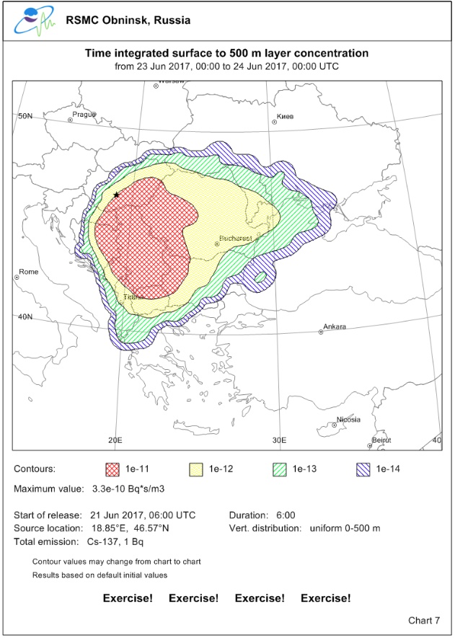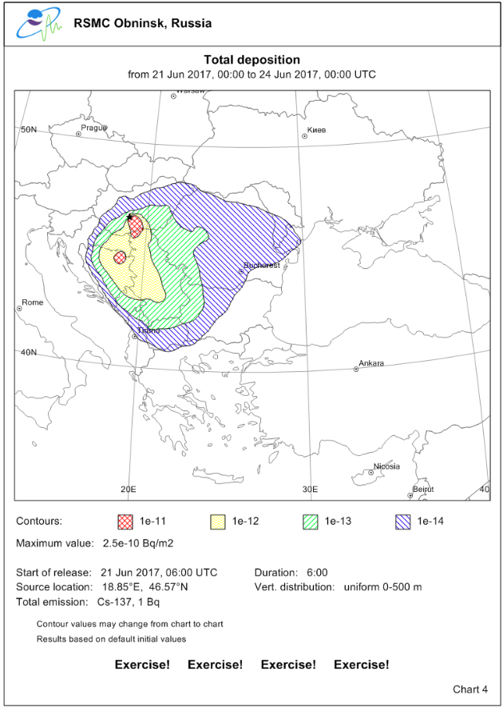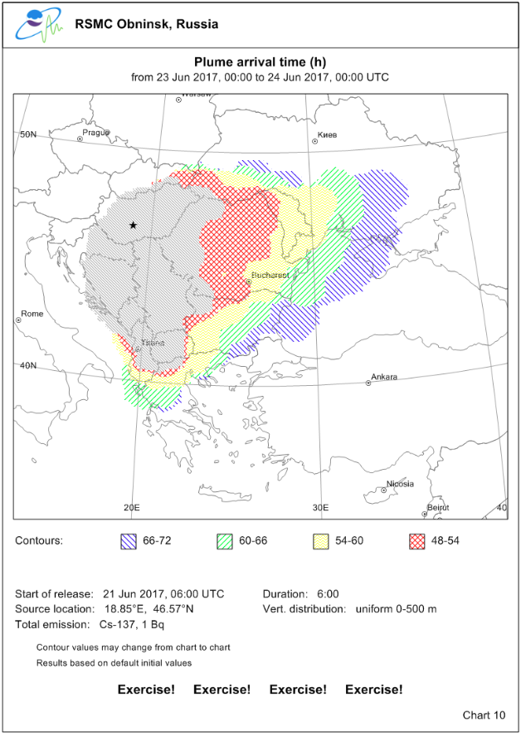
Fig 1. Exposure (left), Deposition (middle), and instantaneous ToA (right) by Dr. Kamaev using Stadium with the release height: 0 – 500m AGL for the 1st scenario (48–72 hours after the initial).
Table 4 shows the list of types of ToA the participants had planned to process before the joint test. Despite their initial intent, some members presented the ‘averaged’ ToA instead of the instantaneous ToA. Mr. Ek and his colleagues processed two types of ToA (‘averaged and time-integrated) and this was another change from the initial plan.
Table 4. Production Plans of ToAs (at the end of May 2017)
centre name | Type(s) of ToA | Time-integration period
Beijing | instantaneous and time-integrated | all through (since start release)
Exeter | instantaneous and time-integrated | all through (since start release)
Melbourne | instantaneous
Montreal | time-integrated | 3 hours
Obninsk | Instantaneous
Tokyo | Instantaneous and time-integrated | all through (since start release)
Toulouse | Instantaneous and time-integrated
Vienna | instantaneous

As discussed above, the standard charts are processed referring the global NWP initial time. Table 5 is the list of NWP initial times the participants used to run their ATDMs. Because the ToA test was not done in an operational manner, most participants seem to have adopted latest NWP forecasts that can cover the release periods. For some centres, 12:00UTC global NWP can not be available for the 2nd requests (in their operational timeframe) because the issued time of 14:15 UTC is too early to adopt 12:00 UTC NWPs. Mr. Sakamoto adopted 06-21 00:00UTC initial NWP for the 2nd requests taking his organization’s NWP production cycle into consideration. Mr. Nicolau and Mr. Deslandes adopted 12 hours older initial of ECMWF’s global forecasts for the 1st and 2nd requests. It is noted that Dr. Song and Dr. Wotawa presented the standard charts referring to the start release time as the initial time of ATDMs. Mr. Sakamoto processed his ATDM charts for the 3rd request using the latest NWP forecast and the accumulation of past global analyses (means partly include a hind cast), and it seems that Dr. Wotawa presented similar results for the 3rd request.
Details of the charts by each participant and comments on them are found after this. The thresholds and initial times of ToA are also the points to be checked, while they were not pre-declared. Therefore values and times printed on the charts are included in the details below.
Table 5. List of NWP Initial Time to run ATDMs (time in UTC)
centre | 1st request | 2nd request | 3rd request
centre | issued: 06-21 06:10 | issued: 06-21 14:15 | issued: 06-21 18:30
centre | start release: 06-21 06:00 | start release: 06-21 12:00 | start release: 06-21 05:30
Beijing | 06-21 06:00 (06-21 00:00)* | 06-21 12:00 | 06-21 05:00 (06-21 00:00)*
Exeter | 06-21 00:00 | 06-21 12:00 | 06-21 00:00
Melbourne | 06-21 00:00 | 06-21 12:00 | 06-21 00:00
Montreal | 06-21 00:00 | 06-21 12:00 | 06-21 00:00
Obninsk | 06-21 00:00 | 06-21 12:00 | 06-21 00:00
Tokyo | 06-21 00:00 | 06-21 00:00 | 06-21 12:00
Toulouse | 06-21 00:00 (06-20 12:00)* | 06-21 12:00 (06-21 00:00)* | 06-21 00:00
Vienna | 06-21 06:00 (06-20 00:00)* | 06-21 12:00 | 06-21 05:30 (06-21 12:00)*
NWP initial time estimated from the integration period of the exposure charts. (MM-DD HH:MM)* are the actual NWP initial time printed on their standard charts.

3.2.1 Comments on the charts by Dr. Zhenxin Song (RSMC Beijing)

Dr. Song of RSMC Beijing presented the 0 deposition for Strontium 90 for the 2nd request, while other participants predicted more than 0 Bq / m². Depositions for Iodine 131 for the 2nd request also seem too little.

He processed both types of ToAs, and his thresholds were 0.0 Bq / m³ for the instantaneous and 1.0E-10 Bq s / m³ for the time-integrated ToAs for the all scenarios. The integration period for the time-integrated ones seems to start at the start release time as he initially planned. The initial times of not only ToAs but also of the standard charts seem to be set to the start release times (not to the NWP initial times).

3.2.2 Comments on the charts by Mr. Anton Muscat (RSMC Exeter)

Exposures, Depositions, and ToAs were calculated with NAME III, but the standard charts were processed by different procedures than ones RMSC Exeter uses for the operational purpose. There were more than 4 contours seen in the exposure and deposition charts, while the GDPFS manual described “adopt a maximum of four concentration/deposition contours corresponding to powers of 10”. In some charts, values larger than the maximum in the legend were not colored, and look like holes. This issue has been highlighted to the appropriate teams within RSMC Exeter and a solution is expected to be rolled out in the near future.

Mr. Muscat presented ‘averaged’ and time-integrated ToAs, while the definition of the ‘averaged’ ToA was not fully explained. Thresholds used for the ‘averaged’ ToA were not 0 Bq / m³, and were different depending on the release scenarios. Thresholds for the time-integrated were the minimum value shown in the exposure charts. The time-integration type was the all through, and the initial times of ToAs seem to be the NWP initial time.

3.2.3 Comments on the charts by Mr. James Fraser (RSMC Melbourne)

Mr. Fraser and his colleague Mr. Wain processed ‘averaged’ ToAs adding to the corresponding standard charts for all scenarios. They firstly intended to process the instantaneous ones, but they were not yet fully equipped. The threshold of their ToA was 1.0 e -18 Bq / m³ regardless of the released amount and species. The initial times of ToAs seem to be set to the start release.

As is described earlier in this subsection, the distributed areas for ¹³¹I, ⁹⁰Sr, and ¹³⁷Cs for the 2nd request resemble each other with regards to the charts submitted by most participants. However those of ToAs by Mr. Fraser and Mr. Wain look a little different. They have been trying to identify the reasons for the differences, but not yet fully understand why such differences can occur.

3.2.4 Comments on the charts by Mr. Nils Ek (RSMC Montreal)

Mr. Ek and his colleagues presented the ‘averaged’ and time-integrated ToAs. The threshold for the averaged ToA was 0.0 Bq / m³, while ones for the time-integrated ToA were different values depending on the scenarios and were not the minimum values found in their exposure charts. The initial time of the ToAs was the start of release.

Total depositions presented by Mr. Ek have relatively wide spreads mainly toward east-north-east direction in comparison with his average ToAs (especially for the 2nd requests). This might occur when strong wet-scavenging including rainout happened above 500 m AGL. However there is no fixed reason for this problem so far because of lack of his resources and priority for the development in this regard.

3.2.5 Comments on the charts by Dr. Dmitriy Kamaev (RSMC Obninsk)

Dr. Kamaev and his colleagues presented the instantaneous ToAs and the standard charts for all scenarios. The threshold was found to be 0.0 Bq / m³, because this is the recommended value in the instruction and there are no specific threshold values printed on his ToA charts. The initial time of ToA was one of the NWP forecast.

3.2.6 Comments on the charts by Mr. Masami Sakamoto (RSMC Tokyo)

Mr. Sakamoto presented the instantaneous and time-integrated ToAs for all cases. He used 1,000,000 tracer particles for each ATDM calculation, and added some revisions (which were chiefly treatments for minor species and radionuclides with short half-lives adding to the arrival time calculations) to the operational ATDM of RSMC Tokyo.

The thresholds were 0.0 Bq / m³ for the instantaneous ToAs, and the minimum values shown in corresponding exposure charts for the time-integrated ToAs as described in the instruction book. The initial time of ToAs was one of the global NWP forecast.

3.2.7 Comments on the charts by Mr. Jean Nicolau (RSMC Toulouse)

Mr. Nicolau and his colleagues Mr. Deslandes processed both instantaneous and time-integrated ToAs for all cases. The thresholds for the instantaneous ToA were not 0.0 Bq / m³, and they were different among the scenarios. The thresholds of the time-integrated ToAs were the minimum values shown in the corresponding exposure charts. The initial time of ToAs was the nearest synoptic time (0000 or 1200 UTC) prior to or equal to the start of release, and was not necessarily the same as the initial time of the global NWP forecast.

Mr. Nicolau and Mr. Deslandes initially adopted some nested (regional) NWP forecast to process their ToA charts. Therefore, there were some inconsistencies between their operational ATDM (exposure) charts and experimental ToA charts. Mr. Deslandes pointed out the issues, and kindly provides all the ATDM charts he reprocessed using the global NWP forecasts.

3.2.8 Comments on the charts by Dr. Gerhard Wotawa (RSMC Vienna)

Dr. Wotawa and his colleague Mr. Skomorowski processed and presented the instantaneous ToAs and the standard charts for all cases. They used 200,000 tracer particles per 24 hours for each ATDM calculation. The threshold was found to be 0.0 Bq / m³, because there are no threshold values printed on their ToA charts. The initial time of ToA was the start of release.

As a minor issue with their ToA charts, tiny uncovered areas are seen in some cases in the vicinity of the source, while the corresponding exposure charts don’t have such. This might be related to some issues in their drawing procedures.

3.3 Considerations and Comparisons of the Charts
Since the late 1980s, WMO RSMCs for the nuclear emergency response (ERA) have been contributing to users providing ATDM results for release scenarios. The definitions of the standard set of products, which consist of 72 hour trajectory, exposures and depositions up to 24, 48, 72 hours after the initial time, are time-honoured. ET-ERA (and former CG-NERA) has been exploring useful new additions to the standard charts, and ToA is one of them.

When considering limitations of ATDM forecasts, as we commonly understand, the jet steam in the winter hemisphere can transport atmospheric mass (and tracer particles) around the zonal circle in 10 days (in the mid latitudes). This can make us confused when processing ATDM forecast for weeks and identifying the first arrival and the path of the plume. Fig 2 shows the root mean square errors (RMSEs) of 500 hPa geopotential heights of the global NWP forecasts in May 2017 (by the WMO CBS Lead Centre for Deterministic Forecast Verification: WMO-LCDNV at ECMWF). The RMSEs of the global forecasts rapidly increase after 72 hours from the initial time. This might also affect the results when we process ATDM forecasts for longer than 72 hours. As is seen the fact we usually use the logarithm of 10 to present distributions of the exposures and depositions, concentrations at the ends of the plume, which we estimate with ATDMs, are almost always steep by 72 hours after the initial time. This is because the transportation by atmosphere (wind) is dominant in comparison with the dispersion and mixing processes. Considering all issues above, ToA experiments for 72 hours, which is our familiar forecast period, were appropriate starting points for us. The steep shapes of the plumes might help us identify appropriate threshold values for ToAs.
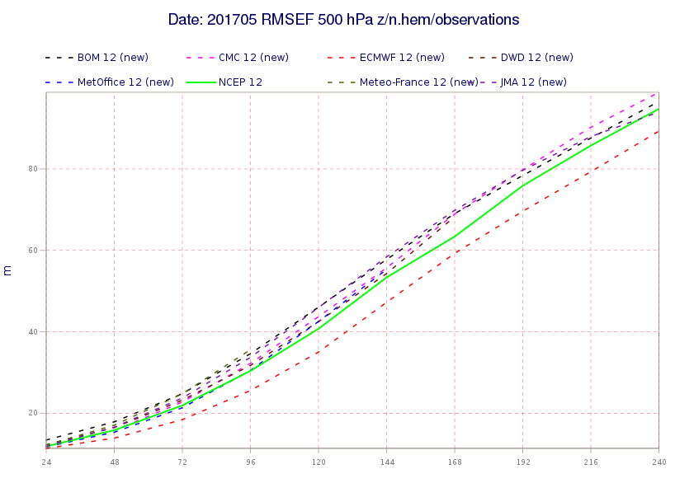
Fig 2. the root mean square errors (RMSEs) of the geopotential height at 500 hPa in the northern hemisphere of the global forecasts in May 2017 by WMO-LCDNV at ECMWF.
Basically, when exposure charts by two centres look different, ToAs by them necessarily differ from each other. Conversely speaking when members presented similar results of exposure forecasts, ToAs by them in most cases resemble one another (if there are no technical problems to estimate exposure and ToAs). As an example, Fig. 3 and 4 show exposures and instantaneous (or averaged) ToAs up to 72 hours (the 3rd time slot) for the 1st request respectively. (Please consider which charts look similar.) ToA test charts can suggest us problems of exposure and deposition charts as seen above. This is because those outputs of ATDMs are closely related to one another. This might be another benefit of examining ToA charts as a candidate product.

Fig 3 and 4 suggest that the agreement among the ATDM forecasts are not good enough to identify coverage over each specific country/state in Europe, where there are many relatively small countries / states. This may be a depressing result for some users, because such charts are not necessarily suitable to determine possibilities of arrival of the influence by the released isotopes to each specific country / state. However, when we take a closer look at the charts, we can find the following points from the charts:
- all forecasts commonly suggest the plume would move south and eastward, and the isotope released from the source would not be found in western and northern parts of Europe,
- all ATDM forecasts predict a similar extent of the influenced areas by 72 hours after the initial time. There is no chart that suggests several times wider reachable areas in comparison with others.
You might take these points for granted. But, please consider what if there was no ATDM forecast in the world. For instance, residents in Paris or London might be worrying about a direct attack of the radionuclide plumes. People in Berlin might think that their city would be contaminated by gradual expansions of the toxic isotopes by dispersions and mixing process of atmosphere in a day or two. Such misunderstanding could have happened in the region where the accident occurs, as we experienced for the accident in Chernobyl. In a sense, the agreement of ATDMs forecasts is good enough to suggest to users where the plume won’t reach in a few days. This might be useful information.
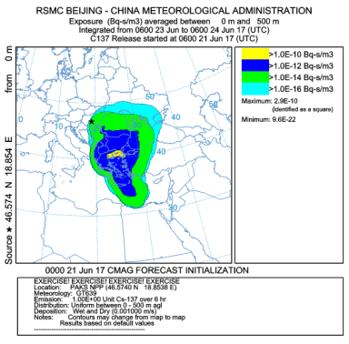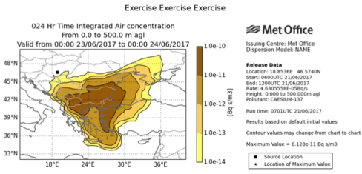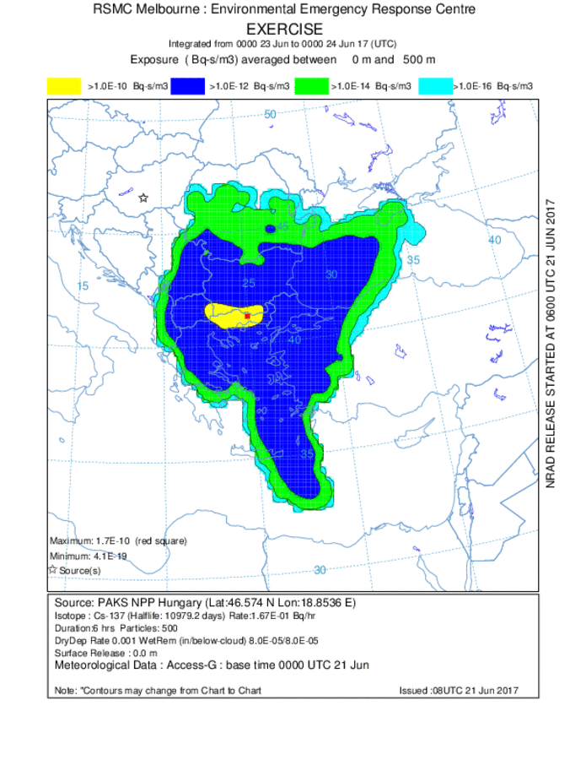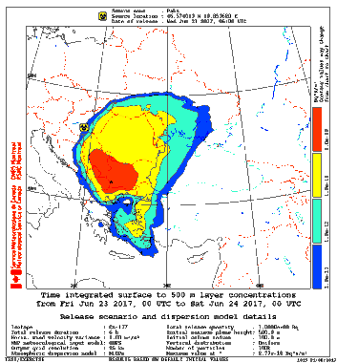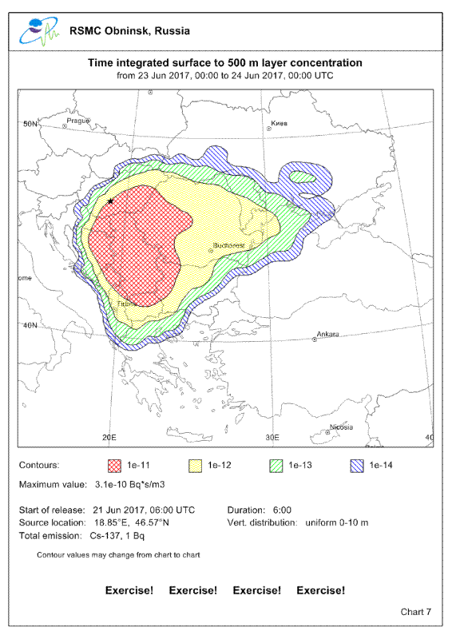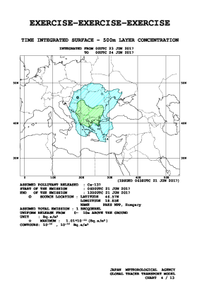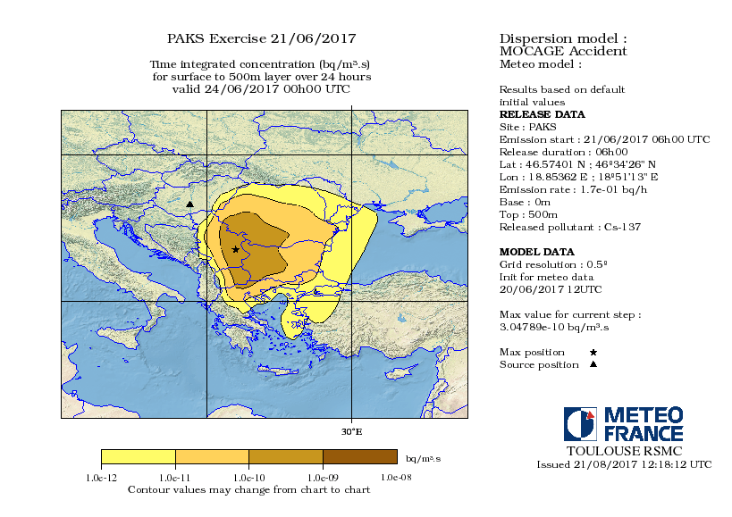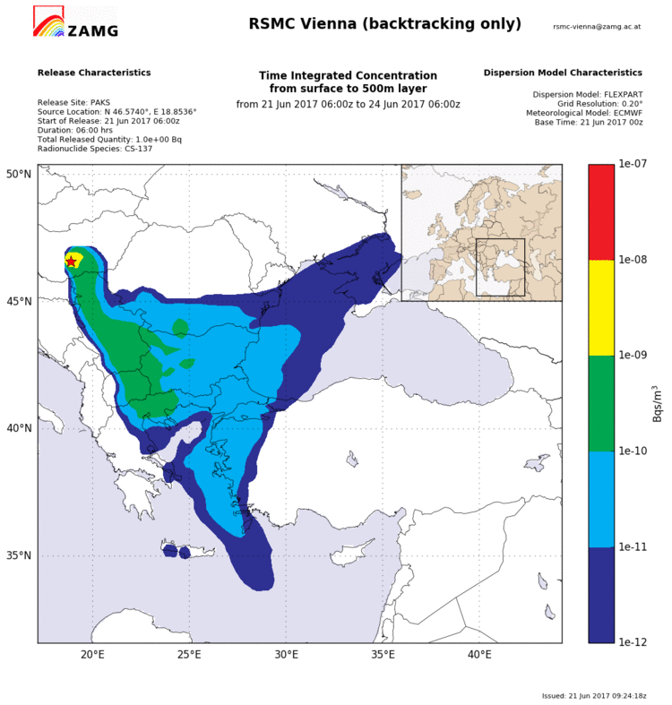
Fig 3. Exposure (Bq s/m³) for the 1st scenario (48–72 hours after the initial) by the participants from RSMCs Beijing, Exeter, Melbourne, Montreal (upper panels), Obninsk, Tokyo, Toulouse, and Vienna (lower panels).
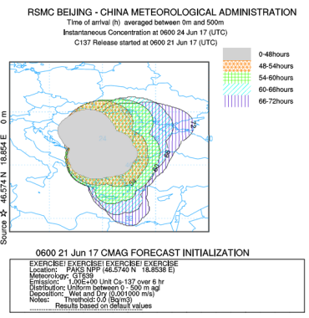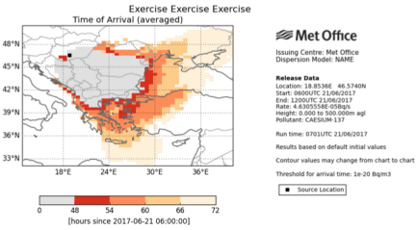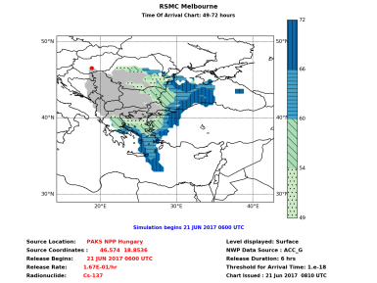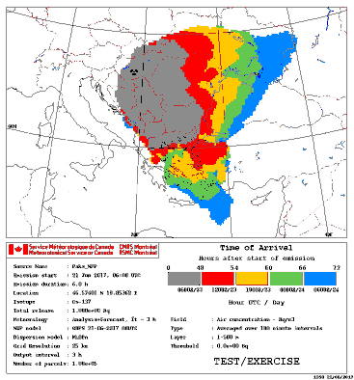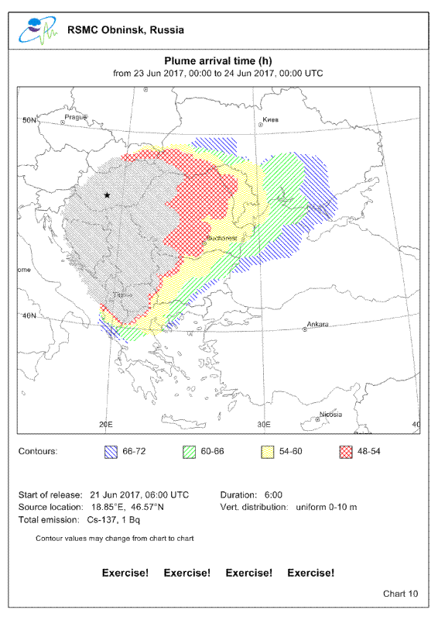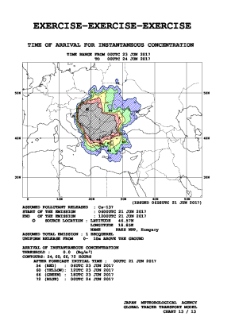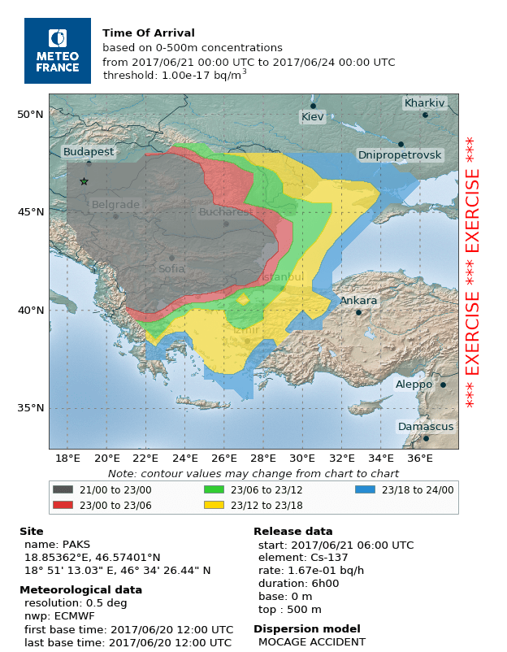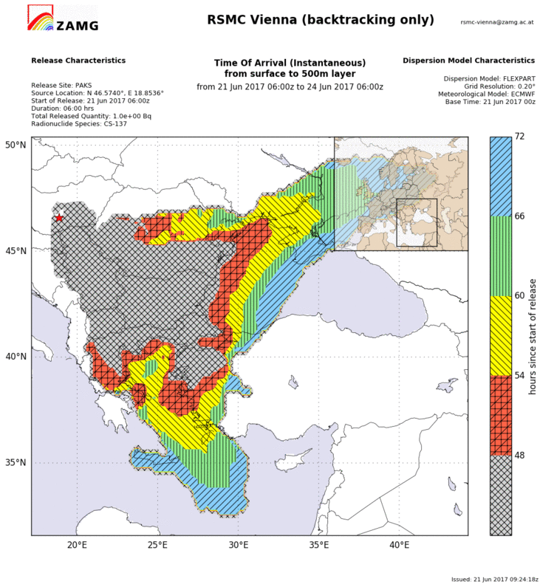
Fig 4. Instantaneous or averaged ToAs for the 1st scenario (48–72 hours after the initial) by the participants from RSMCs Beijing, Exeter, Melbourne, Montreal (upper panels), Obninsk, Tokyo, Toulouse, and Vienna (lower panels).

Similarly, all the forecasts commonly predict the influence would be found in very limited areas: the southeast part of WMO Regional Association (RA) VI (Europe) and the northeast end of RA-I (Africa). Therefore we can confidently predict that the influence won’t be found in RA II (Asia), RA V (southwest Pacific), and RA III and IV (south, central and north America) in 72hours. Therefore, when considerable concentrations of contaminants were found in China or Japan in 48 hours after the accident, we can scientifically conclude that there should be some different source than the accident concerned. That is to say, ATDMs can tell us how far the plume can reach in a specific forecast period (usually up to about 72 hours from the initial time, because the precisions of the global NWP forecasts rapidly deteriorate after that). This might contribute to a network of radiological observatories.

As described above, we may confidently believe that ADTM forecasts can be useful, when users can understand these products appropriately (even when our forecasts don’t have a perfect agreement). Actual problems might be how well users can understand the underlying issues of our ATDM forecasts and how they can make use of our products.

4. Concluding Remarks on the Joint ToA Test
The members of ET-ERA planned and conducted the joint ToA test in June 2017 using the release scenarios provided at ConvEx-3. The members had discussions on the issues:
- Usages of ToA (including professional usages by radiological observers),
- Definitions of ToA (including designs of the charts, instantaneous / averaged / time-integrated concentrations, initial time, and thresholds for ToA),
- Operational measures to transmit and present ToA charts.
ET-ERA should continue discussions to pursue practical solutions for such issues.

The ToA test was successfully done, but this time the expert form RSMC Washington did not participate in the production of ToA charts. Hopefully we would like to devise new products, for which all current RSMCs can continue their active participation. Therefore clear, practical, and achievable definitions of the ToA service are needed.

To attain such necessary definitions, the discussions the members had before the joint test were really meaningful. The discussions provided the members with an understanding of underlying technical and physical problems of the standard charts and ToAs.

The discussions on the usages of ToA were also important. Pre-warnings for radiological monitoring observers, which were suggested by Mr. Winkler, can be an ideal professional usage. There are some newly added associate members of ET-ERA from NMHS who are very familiar with the radiological monitoring. We may expand this discussion to such experts to make our services more useful for the users.

I would like to highly recommend the ET-ERA members to continue their efforts to establish a new useful, practical, and achievable service of ToA. Finally, I really appreciate the active discussions and practical commitments to the joint ToA test by the ET-ERA members and their colleagues.

5. References (other than Annex)
Kosykh, Valery 2015: Status of implementation of time of arrival products. A document submitted to the meeting of the CBS expert team on emergency response activities (ET-ERA), Buenos Aires, Argentina, 30 November to 4 December 2015.
http://www.wmo.int/pages/prog/www/DPFSERA/Meetings/ET-ERA_BuenosAires2015/DocPlan_000.html
WMO the CBS expert team on emergency response activities, 2015: Final Report of the meeting of the CBS expert team on emergency response activities (ET-ERA), Buenos Aires, Argentina, 30 November to 4 December 2015.
http://www.wmo.int/pages/prog/www/CBS-Reports/DPFSERA-index.html

http://apps.ecmwf.int/wmolcdnv/scores/mean/500_z
http://www.wmo.int/pages/prog/www/CBS/Lists_WorkGroups/CBS/opag%20dpfs/et-era/members

