WORLD METEOROLOGICAL ORGANIZATION  COMMISSION FOR BASIC SYSTEMS  OPAG on DPFS  MEETING THE CBS EXPERT TEAM ON ENSEMBLE PREDICTION SYSTEMS (ET-EPS)  Geneva, Switzerland, 14-18 November 2011 |  | DPFS/CBS/ET-EPS/Doc. 4.2(2)  (01.11.2011)  _______  Agenda item : 4.2  ENGLISH ONLY

Regional Ensemble Progress at the Met Office

(Submitted by Ken Mylne)

Summary and purpose of document

This document informs the Meeting of significant progress since the last meeting.

Action Proposed

The meeting is invited to note and comment on plans.
1. Description

1.1 The Met Office runs a regional ensemble (MOGREPS-R) over the North Atlantic and Europe at ~18km grid resolution with 24 members. This is a downscaling ensemble which takes its initial condition perturbations downscaled from the MOGREPS-G global ensemble initialized 6h earlier, and adds them to a higher resolution regional analysis. LBCs are also provided from MOGREPS-G. This configuration is currently undergoing a major upgrade – see 2.1 below.

1.2 Verification and individual case studies have shown considerable benefits from the enhanced resolution of the regional model compared to MOGREPS-G. An example from a recent heavy rain event in Italy is shown below where the regional ensemble was able to predict 80% probability of over 100mm in 24h two days in advance in exactly the location of severe damage.

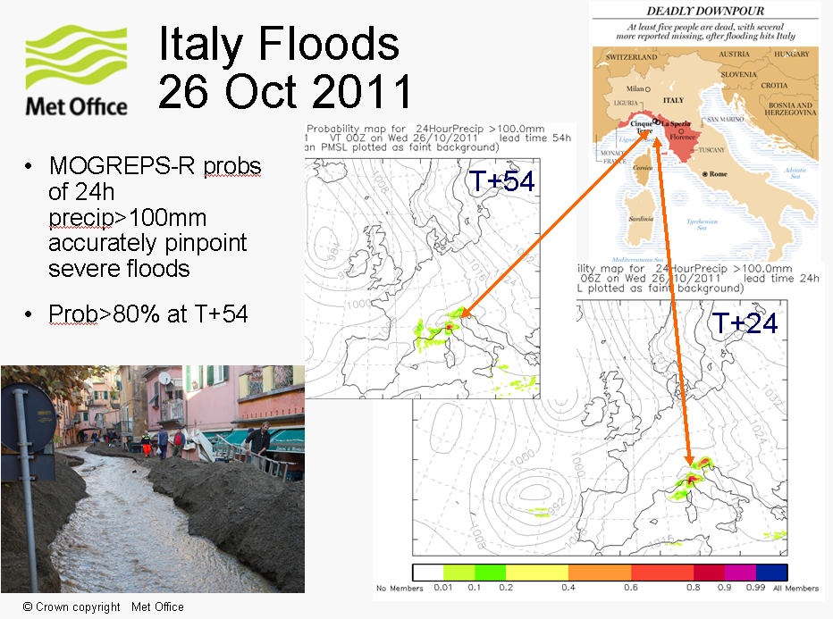

2. Current Upgrades

2.1 At the time of the 2011 meeting, MOGREPS-R is in the process of being upgraded to run 4 times per day with 12 members per cycle (along with MOGREPS-G which has a similar upgrade). The global ETKF is thus running on a 6h cycling instead of the previous 12h cycling. The upgraded MOGREPS-R runs 3h after the global cycle providing the LBCs and perturbations (instead of 6h in the previous system) so MOGREPS-R is initiated at 03, 09, 15 and 21 UTC. Ensemble product generation continues to use a 24-member ensemble comprising a time-lagged combination of the latest two cycles.

2.2 This change is approximately neutral in terms of forecast skill. The purpose is to allow improved better integration of ensemble forecasts into the Met Office’s operational forecasting system, the rest of which operates on 4-cycles per day, and to support the development of a downscaled convective-scale UK ensemble which will run on 4 cycles per day. It is anticipated that some benefit for customers will be seen by reduced jumpiness from cycle to cycle of the forecast due to the time-lagging effect.

3. Future Plans

3.1 MOGREPS-R is planned to be upgraded to 12km resolution on a slightly reduced European domain on the new supercomputer in 2012. It will be re-named MOGREPS-EU to reflect this new domain.

3.2 Consideration is being given to the option of discontinuing MOGREPS-R/EU and nesting the convective-scale UK ensemble directly in the global ensemble. This matches the long-term strategic aim, but it is not yet clear whether this is achievable at this stage.

