WORLD METEOROLOGICAL ORGANIZATION  COMMISSION FOR BASIC SYSTEMS  OPAG on DPFS  EXPERT TEAM ON EXTENDED  AND LONG-RANGE FORECASTING  Geneva, Switzerland, 26-30 March 2012 |  | CBS-DPFS/ET-ELRF /Doc. 4.1(10)  (19.III.2012)  _______  Agenda item : 4.1  ENGLISH ONLY

REVIEW OF THE WORK, FUNCTIONS AND SPECIFIC NEEDS OF THE GLOBAL PRODUCING CENTRES (GPCs)

STATUS / PROGRESS REPORT FOR Toulouse

(Submitted by JP Céron and I. Charon)

Summary and purpose of document

This document provides the ET on Extended and Long-Range Forecasting with an update on the Météo-France seasonal forecast system.

Action Proposed

The meeting is invited to note the information provided.

STATUS / PROGRESS REPORT FOR Toulouse GPC

1. LRF FORECASTING SYSTEM

  - Description of the forecasting system specification : LC-MME, LC-SVSLRF

Meteo-France system for Global Seasonal Forecasts :

Type of system : Oceanic Atmospheric General Circulation Model (Numerical)
Description of models :
Atmosphere: Arpege Model v4 T63L91, full set of parametrisations,
Ocean : Oceanic Model OPA8.2 and Orca grid (2°) with free surface,
Coupling : Oasis coupling,
Type of forecasts :
Ensemble forecast with 41 members ; 8 different atmospheric conditions from
ECMWF analysis (24 h lag), each being associated with 5 different oceanic
conditions from Mercator analysis (random sampling) + 1 additional member using
last available atmospheric and oceanic conditions (last forecast),
Details of forecasts :
Forecasted period of 7 months,
Lead-time 1 month,(possibility of 2 3 and 4 months)
3 month forecasts (m+2 to m+4) (possibility of m+3/m+5,m+4/m+6,m+5/m+7)
Monthly update,
Date of issuance at the beginning of each month (commitment for the 8th),
Details on products :
Deterministic Production (Ensemble mean, significance test)
Probabilistic Production (Ensemble Member frequency into Tercile categories and Extreme categories (above +1 standard deviation and below -1 standard deviation)).
All products are calibrated (model climatology corrected - cf. Hindcast experience).
Format of products :
Standard : Gif files ,
On request : Ascii files, Grib files
Hindcasts experience :
Climatology of the forecasting suite over 1979-2007, 11 members
atmosphere : ERA40
ocean : Mercator PSY2G2
Verification dataset : T2m - ERA40 , SST - Reynolds , Niño Indices - Reynolds , Precipitation - Xie & Arkins,

1.2 Content of basic forecast outputs [response options in brackets; change or delete as appropriate. For non-compliant elements, please indicate intended date of compliance]

Issue frequency: | Monthly (beginning of the month)
Temporal resolution: | 1 month and 3 month averages
Spatial resolution: | 2.5X2.5
Spatial coverage: | Global
Lead time: | From month 1 to month 4
Output types: | Graphical images at http://elaboration.seasonal.meteo.fr  forecast/seasonal_range_forecast
Verification as per WMO SVSLRF | Verification is available only at http://elaboration.seasonal.meteo.fr  And the LC-SVS web site. The verification covers 1979-2003 years (not all the available hindcast); the prediction system used in operations is identical to that used in hindcast mode excepted the ensemble size (11 members)

- PRODUCTS [response options in brackets; change or delete as appropriate. For non-compliant elements, please indicate intended date of compliance]
Variable: |  | Probabilities for tercile categories of 2m temperature | Probabilities for tercile categories of precipitation | Probabilities for tercile categories of SST (coupled models only)
Spatial resolution: |  | [2.5° x 2.5°] | [2.5° x 2.5°] | [2.5° x 2.5°]
Temporal Resolution: |  | [3 months] | [3 months] | [3 months]
Coverage: |  | [Global] | [Global] | [Global]
Issue frequency: |  | [montly] | [montly] | [montly]
Lead-time | L0 | N | N | N
Lead-time | L1 | Y | Y | Y
Lead-time | L2 | Y | Y | Y
Lead-time | L3 | Y | Y | Y
Lead-time | L4 | Y | Y | Y
Lead-time | L4+ | N | N | N
Location of rendered images: |  |  | idem | idem
  http://elaboration.seasonal.meteo.fr
  Password protected
Location of digital data (if available): |  | idem | idem | idem
[For non-compliant elements, please indicate intended date of compliance]

3. VERIFICATION [response options in brackets; change or delete as appropriate. For non-compliant elements, please indicate intended date of compliance]

3.1 SVSLRF Level 1 scores

Variable: | 2m temperature | Precipitation | SST (coupled models only) | Niño region indices
Seasons: | All 12 | All 12 | All 12 | All 12
Leads: | All leads (as for products) | All leads (as for products) | All leads (as for products) | All leads (as for products)
ROC curves: | Ne/Se/T | Ne/Se/T | Ne/Se/T | Y
ROC area: | Ne/Se/T | Ne/Se/T | Ne/Se/T | Y
Reliability curve: | Ne/Se/T | Ne/Se/T | Ne/Se/T | Y
Frequency histograms (sharpness) | Ne/Se/T | Ne/Se/T | Ne/Se/T | Y
MSSS | Ne/Se/T | Ne/Se/T | Ne/Se/T | Y
Location of scores: | LC-SVSLRF web site | LC-SVSLRF web site | LC-SVSLRF web site | LC-SVSLRF web site
Scores’ availability on the LC-SVSLRF web site | All | All | All | All
[For non-compliant elements, please indicate intended date of compliance]

3.2 SVSLRF Level 2 scores

Variable: | 2m temperature | Precipitation | SST (coupled models only)
Seasons: | All 12 | All 12 | All 12
Leads: | All leads (as for products) | All leads (as for products) | All leads (as for products)
ROC maps: | Y | Y | Y
MSSS maps: | Y | Y | Y
MSSS 1 maps: | Y | Y | Y
MSSS 2 maps: | Y | Y | Y
MSSS 3 maps: | Y | Y | Y
Location: | LC-SVSLRF web site | LC-SVSLRF web site | LC-SVSLRF web site
[For non-compliant elements, please indicate intended date of compliance]

4. DISSEMINATION

GPC products are disseminated through a password protected web site at http://elaboration.seasonal.meteo.fr at the beginning of each month (commitment for the 8th).

5. LRF MULTI-MODEL ENSEMBLE

participation in EUROSIP multi-model (including Tropical Cyclone activity).

6. ADDITIONAL INFORMATION PROVIDED BY THE GPC

Global Climate Bulletin (monthly edition – French and English)
“Extreme” categories (above +1 std, below –1 std)
Additional parameters (MSLP, Z500, U and V 850, Velocity Potential and Stream Function at 200hPa)

Zoom over Europe and Tropics

SVS scores for monthly values (SST, T2m, Rainfall)

Atlantic Ocean box plumes and Indian Ocean box plumes (cf figures)
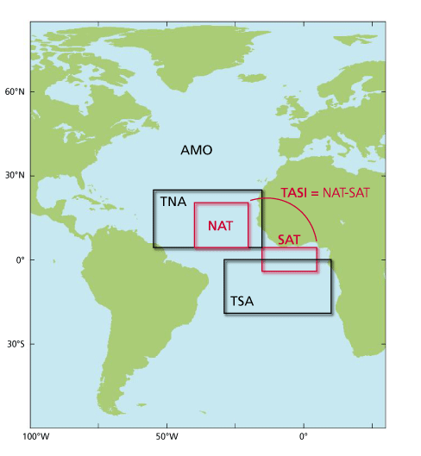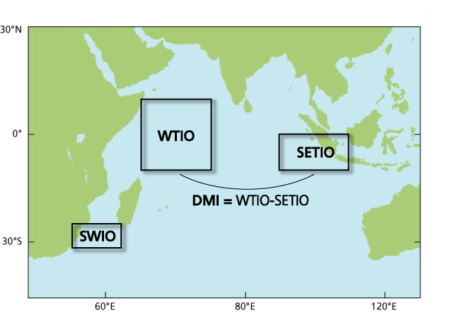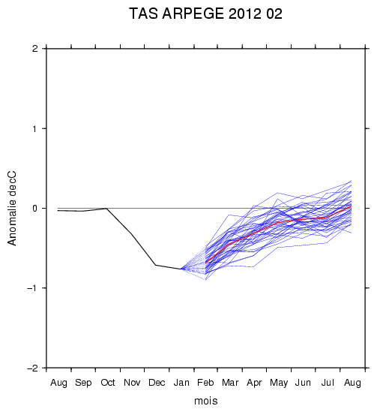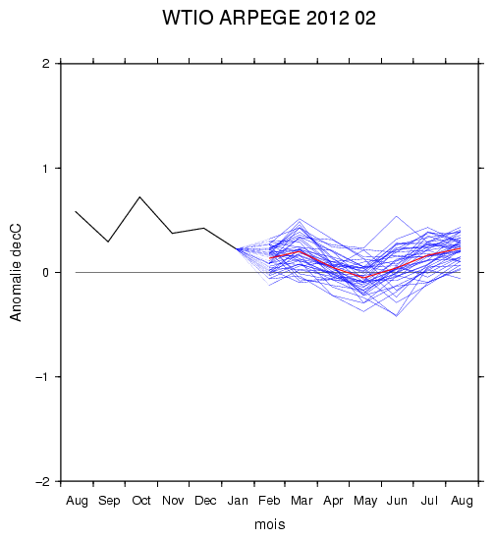

Circulation regime over the North Atlantic sector

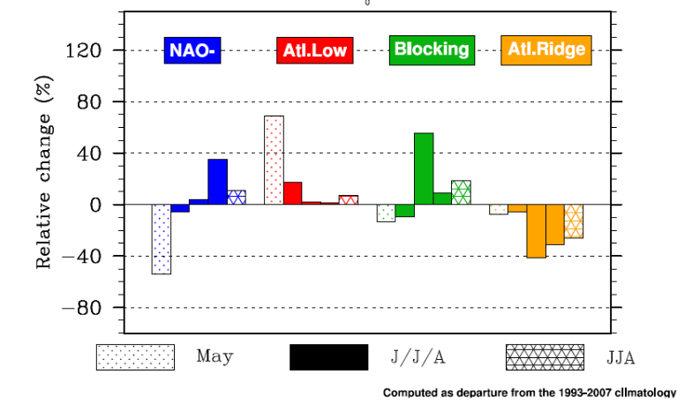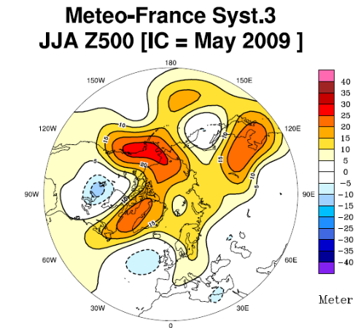

Velocity Potential and Stream Function in the high troposphere (200hPa)

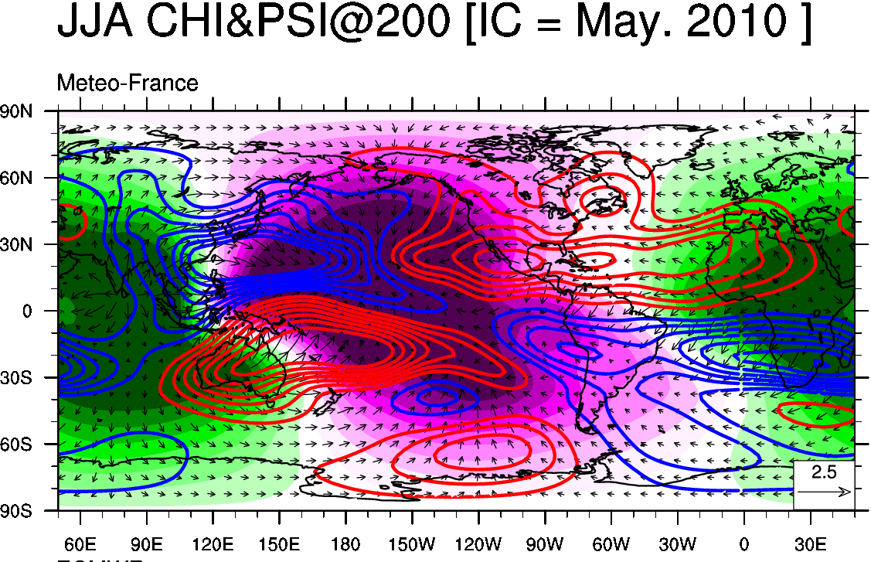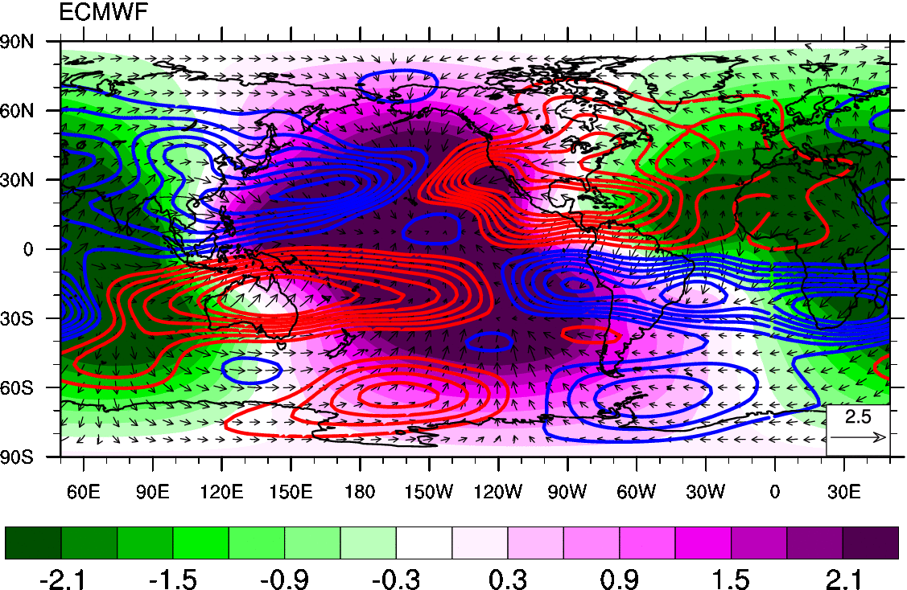

Specific land boxes and climagrams

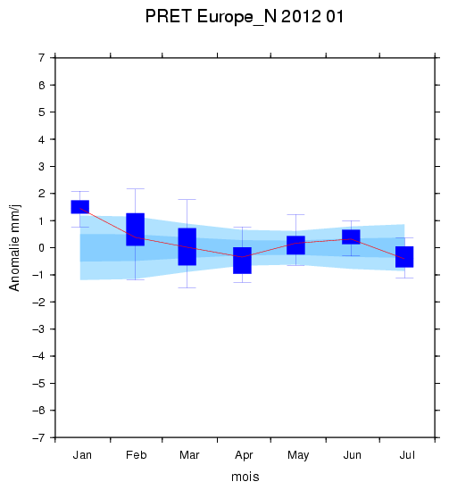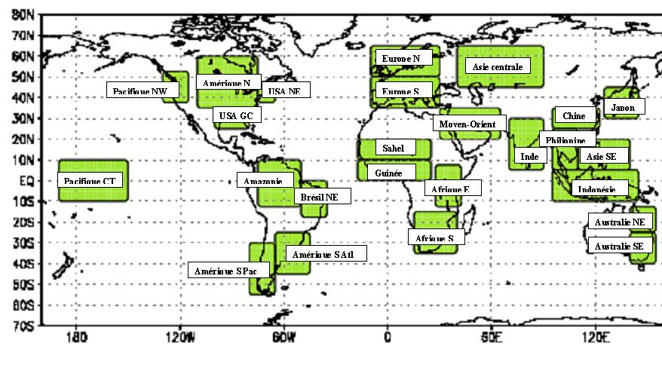

7. CAPACITY BUILDING AND TRAINING

Seasonal Forecasting training in Toulouse (Science of seasonal forecasting, Climate modeling, interpretation and use of products, downscaling and verification techniques, user oriented evaluations, … ).
Participation to RCOFs’ trainings (especially on downscaling and tailoring).
Participation to the special session in ECAC 2011 (also planned in ECAC 2012) on RCC-network for RA VI (LRF-Node).

8. SPECIFIC NEEDS

Specific needs : Standardized Anomaly Forecasts, Large Scales indices, common land boxes.
Velocity Potential field in high troposphere and Stream Function, U and V (925 hPa instead of 850 hPa ?), needs for more parameters ?
Updated verification datasets (especially for our new system).

9. FUTURE DEVELOPMENTS

Development of specific products and Global bulletin (in progress - extension to European regions in the frame of the RCC node on LRF jointly coordinated with Moscow GPC).
Development of a consensus discussion for AR VI (twice a year ?) through a wiki page.
Development of regional and downscaled products (both RA VI and Tropics).
Change of the forecasting suite to system 4 (which is close to the one use in IPCC–AR 5 simulations – expected by summer 2012) : increase of the horizontal resolution (T127) and decrease of the vertical resolution. Change of the ocean model (Nemo) and consistent increase of the resolution (1° and 42 levels). Use of ISBA-TRIP (for hydrology). Coupler OASIS 3. New ice climatology. Hindcast likely on 1991-2010 period.
Change to system 5 schedule quite soon after system 4 (2 years : refined stratosphere, Sea-ice model, stochastic dynamic, … )

10. USERS OF THE LRF

Users of the LRF provided by Toulouse GPC :
WMO Niño update, IRI Niño synthesis, BoM (Niño 3.4 forecasts), RCOFs (notably PRESAO, SEECOF, SASCOF, …), RA VI RCC, users of Global Bulletin (Magrebhian NMHS, CIIFEN, ACMAD, Spain, Belgium).
Forecasts of monthly ensemble mean and monthly ensemble mean anomaly for SST, T2m, Rainfall, T850, MSLP, and Z500 are provided on the 7 month range to the WMO LC-MME.
__________________

